Project 4: The orbital architecture of 2+2 quadruple stars with Gaia DR4 epoch radial velocities
Supervisor I: Dr. Dolev Bashi (db975@cam.ac.uk)
Supervisor II: Prof. Vasily Belokurov (vasily@ast.cam.ac.uk)
Supervisor III: Prof. Cathie J. Clarke (cclarke@ast.cam.ac.uk)
UTO: Prof. Vasily Belokurov (vasily@ast.cam.ac.uk)
Project Summary
A 2+2 quadruple is a hierarchical system in which both components of a wide binary are themselves close binaries. If close companions formed independently around the two wide-binary components, the 2+2 occurrence rate would be the product of the two individual close-binary fractions. Bashi, Clarke & Belokurov (2026) instead found that 2+2 systems are roughly 2.34 times more common than this independent expectation in Gaia DR3, providing strong evidence for correlated binary formation. Their analysis identified close binaries statistically from the robust peak-to-peak radial-velocity (RV) amplitude rather than from the individual epoch RVs.
Gaia DR4 will make it possible to test this result at the orbital level. The student will use the Gaia epoch RV measurements and cross-correlation information to search for, validate and fit the two inner close-binary orbits in wide pairs. The first objective is a direct confirmation of the 2+2 enhancement with measured periodic RV signals and an explicit detection-efficiency model. The second is to determine whether the two inner binaries have other correlated properties such as periods, eccentricities and mass ratios, and whether those properties depend on the separation and projected orbital geometry of the outer wide pair. These correlations can distinguish common fragmentation and accretion histories from later dynamical processing.
Background
The architecture of a stellar hierarchy is a fossil record of star formation. Wide binaries are associated with core or filament fragmentation, unfolding multiples and cluster dissolution, whereas very close binaries cannot form at their present separations and are thought to harden through disc interactions, accretion, migration or, in a minority of cases, later secular evolution. A 2+2 system links these scales: two close binaries share the same wide environment. Correlated properties between the two subsystems would be difficult to explain if each close binary formed independently.
Earlier, heterogeneous multiplicity catalogues already hinted that 2+2 systems are overabundant and that their inner periods can be similar (Tokovinin 2008, 2014). Fezenko et al. (2022) used Gaia EDR3 and eclipsing binaries to identify eight wide 2+2 systems and found a 7.3 ± 2.6 enhancement relative to random field pairings, although the small, geometry-selected sample limited interpretation. Bashi, Clarke & Belokurov (2026) used Gaia DR3 RVS measurements for 9,411 main-sequence wide binaries and obtained a much more precise enhancement factor of 2.34 (+0.12/-0.11). The enhancement remained strong below 5,000 au and declined toward the widest separations (See Fig.1). Its decrease with peculiar velocity further suggests that older populations may lose an inner binary to merger or disruption, turning some 2+2 systems into 1+2 triples.

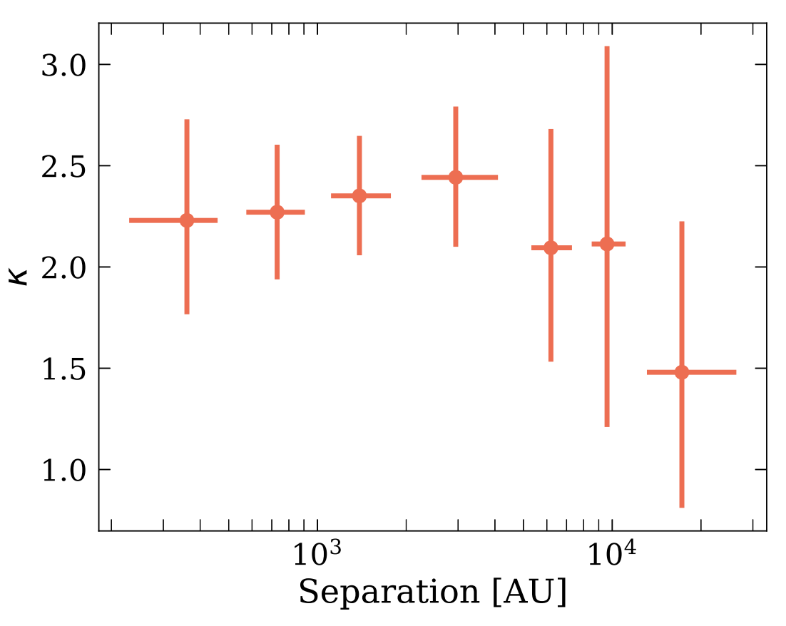
Figure 1. Enhancement factor κ = P₂₊₂/p² (quadruple-to-close binary fraction ratio) as a function of WB separation. Values of κ = 1 indicate independent binary formation, while κ > 1 suggests correlated formation. Points show measurements in separation bins with 1σ uncertainties from MCMC posteriors. The enhancement is strong (κ ≈ 2–3) at separations of 5,000 au. At wider separations, large uncertainties prevent strong conclusions, though there is a suggestion of a decreasing enhancement. Reproduced from Bashi, Clarke & Belokurov (2026).

The DR3 result is statistical: peak-to-peak RV amplitudes identify variability but do not establish periods or Keplerian orbits for individual inner pairs. Epoch RVs offer a stronger test. A periodic orbit separates binaries from outliers, pulsation, activity and magnitude-dependent noise, and supplies the periods and eccentricities needed to test formation models. Disc fragmentation and accretion-driven migration predict correlations in mass ratio and orbital scale (Tokovinin & Moe 2020), whereas later dynamics can modify eccentricities, merge close pairs and erase initial correlations.
The outer orbit is generally too long to fit for a wide pair, but its projected geometry is still informative. The angle θ_{v-r} between the sky-projected relative velocity and separation vectors constrains the wide-binary eccentricity distribution (Hwang et al. 2022). Bashi, Clarke & Belokurov (2026) found no significant difference in θ_{v-r} between their 140 high-confidence 2+2 candidates and a matched wide-binary control sample, but the sample was small. DR4 should enable a more sensitive test and, for systems with combined astrometric-spectroscopic or resolved orbits, a direct comparison of inner and outer orbital planes.
Project Details
The project will proceed through the following stages:
- Build the wide-binary parent sample. Start from a high-purity Gaia wide-pair catalogue, updated to DR4 astrometry where possible. Require consistent parallaxes and proper motions, low chance-alignment probability and suitable RVS epoch coverage for both components. Construct control samples matched in distance, sky position, magnitude, colour, metallicity and projected separation.
- Search the epoch RVs for close binaries. For each wide-binary component, model the epoch RVs under constant, trend, SB1 and, where supported by the cross-correlation functions, SB2 hypotheses. Search for periods with the actual Gaia sampling window, then fit Keplerian orbits and compare model evidence or an information criterion. Quality checks will reject scan-angle systematics, blended spectra, hot-star template failures, pulsators and poorly sampled aliases.
- Measure completeness by injection and recovery. Inject synthetic SB1/SB2 signals across a grid of period, eccentricity, semi-amplitude, mass ratio, magnitude and number of transits. Re-run the detection pipeline to determine the probability that each close binary would be found. This makes it possible to estimate intrinsic close-binary and 2+2 fractions rather than compare raw candidate counts.
- Confirm the quadruple enhancement. Classify a wide pair as 2+2 only when both components contain independently validated inner-binary signals. Infer the close-binary fraction p, the 2+2 fraction P₂₊₂ and the enhancement κ = P₂₊₂/p² in a hierarchical model that includes the recovery efficiency. Reproduce the dependence on wide separation, metallicity and kinematics reported by Bashi, Clarke & Belokurov (2026), and establish which trends remain after direct orbital confirmation.
- Test for correlated inner architectures. Compare the two measured inner periods, eccentricities, RV amplitudes and inferred mass functions within each 2+2 system. Test whether period ratios cluster near unity, whether the inner mass ratios are correlated, and whether either property varies with the wide-pair separation, θv-r, metallicity or age/kinematic proxies. Scrambled wide-pair catalogues will provide the null expectation for independent formation.
- Connect the inner systems to the outer geometry. Compute θ_{v-r} from the Gaia relative position and tangential-velocity vectors, propagate the full astrometric covariance, and infer the outer eccentricity distribution through forward modelling. Compare 2+2 systems with matched 1+1 and 1+2 samples. RV-only inner orbits do not provide the longitude of ascending node and therefore cannot yield a true inner-outer mutual inclination. For the subset with Gaia combined astrometric-spectroscopic solutions, eclipses plus astrometry, or externally resolved orbits, calculate the orbital angular-momentum vectors and test inner-inner and inner-outer alignment directly.
The core deliverable is a validated catalogue of Gaia DR4 2+2 quadruples with two measured inner orbits and a selection-corrected measurement of their enhancement. Depending on progress, the project can extend to population modelling that compares correlated formation with scenarios in which one inner binary is removed through merger or disruption over time.
Prerequisite Skills Required
Basic Python programming, undergraduate statistics (Part III courses in Astrostatistics are recommended) and familiarity with Keplerian orbits are required (Part III courses in Planetary System Dynamics are recommended). Previous experience with spectroscopy, period searches or Bayesian methods is helpful but not essential.
Other Skills Used in the Project
- Gaia Archive queries and catalogue cross-matching.
- Radial-velocity time-series analysis and Keplerian orbit fitting.
- Working with Gaia RVS cross-correlation functions and survey quality flags.
- Injection-recovery experiments and selection-function modelling.
- Circular statistics for the θv-r distribution.
- Hierarchical Bayesian inference and construction of matched control samples.
Acceptable Programming Languages
Python.
Useful References
- Bashi, D., Clarke, C. J. & Belokurov, V. 2026, A Quadruple Excess in Wide Binary Systems: Evidence for Correlated Binary Formation, MNRAS, stag730. https://doi.org/10.1093/mnras/stag730
- Fezenko, G. B., Hwang, H.-C. & Zakamska, N. L. 2022, Enhancement of Double-Close-Binary Quadruples, MNRAS, 511, 3881. https://doi.org/10.1093/mnras/stac309
- Tokovinin, A. 2008, Comparative Statistics and Origin of Triple and Quadruple Stars, MNRAS, 389, 925. https://doi.org/10.1111/j.1365-2966.2008.13613.x
- Tokovinin, A. & Moe, M. 2020, Formation of Close Binaries by Disc Fragmentation and Migration, and its Statistical Modelling, MNRAS, 491, 5158. https://doi.org/10.1093/mnras/stz3299
- Hwang, H.-C., Ting, Y.-S. & Zakamska, N. L. 2022, The Eccentricity Distribution of Wide Binaries and their Individual Measurements, MNRAS, 512, 3383. https://doi.org/10.1093/mnras/stac675
General References
- Tokovinin, A. 2014, From Binaries to Multiples II: Hierarchical Multiplicity of F and G Dwarfs, AJ, 147, 87. https://doi.org/10.1088/0004-6256/147/4/87
- Hwang, H.-C. et al. 2022, Wide Twin Binaries Are Extremely Eccentric: Evidence of Twin Binary Formation in Circumbinary Disks, ApJL, 933, L32. https://doi.org/10.3847/2041-8213/ac7c70
- El-Badry, K., Rix, H.-W. & Heintz, T. M. 2021, A Million Binaries from Gaia eDR3: Sample Selection and Validation of Gaia Parallax Uncertainties, MNRAS, 506, 2269. https://doi.org/10.1093/mnras/stab323
- Offner, S. S. R. et al. 2023, The Origin and Evolution of Multiple Star Systems, in Protostars and Planets VII, ASP Conf. Ser. 534, 275. https://arxiv.org/abs/2203.10066
- ESA Gaia DR4 content and data-model overview. https://www.cosmos.esa.int/web/gaia/dr4

