Watermarking Images

In this project we have implemented SVD and DWT technique to embed watermark images inside cover image and then calculate SSIM, PSNR and MSE between cover image and watermark embedded image.

To run project double click on ‘run.bat’ file to get below screen

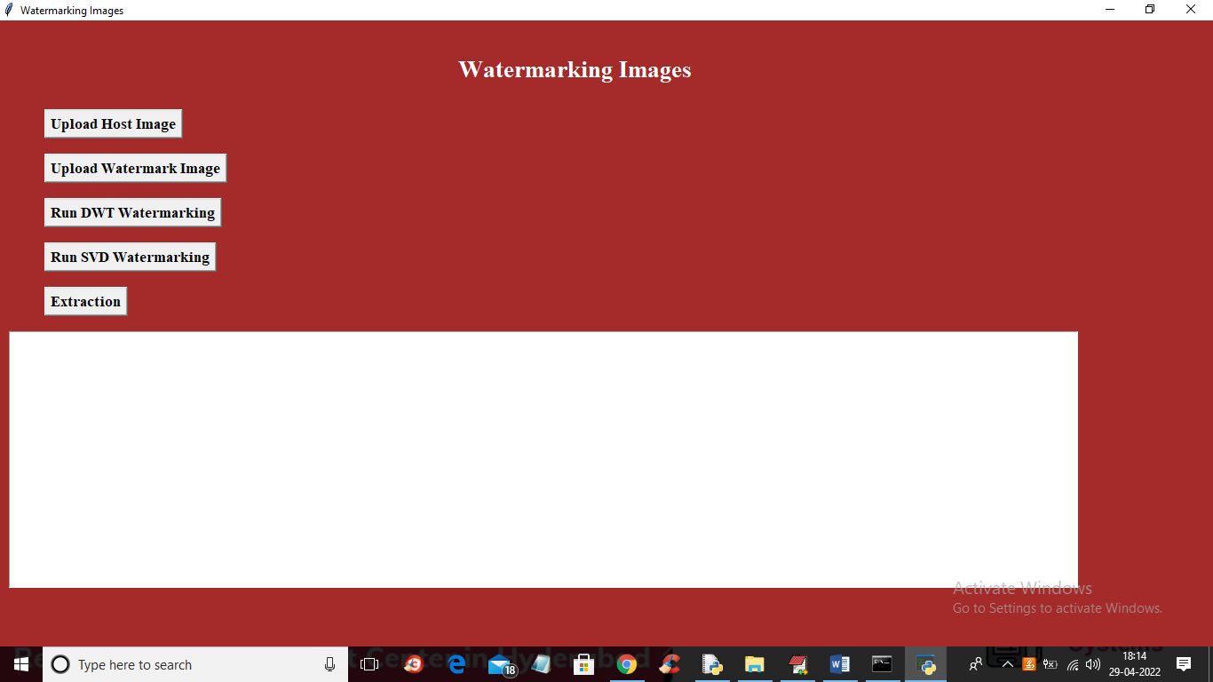

In above screen click on ‘Upload Host Image’ button to upload host or cover image like below screen

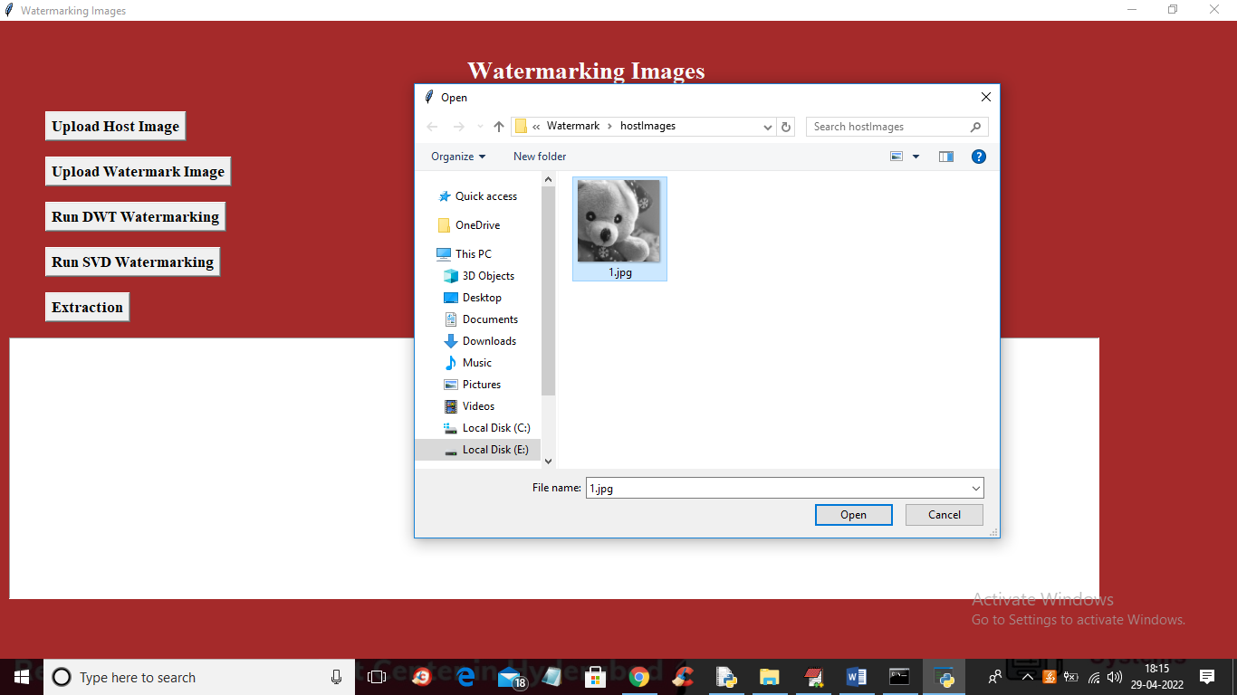

In above screen selecting and uploading 1.jpg as cover image and you can image from any folder or put your desired images in this folder and upload and now click ‘Open’ button to get below screen

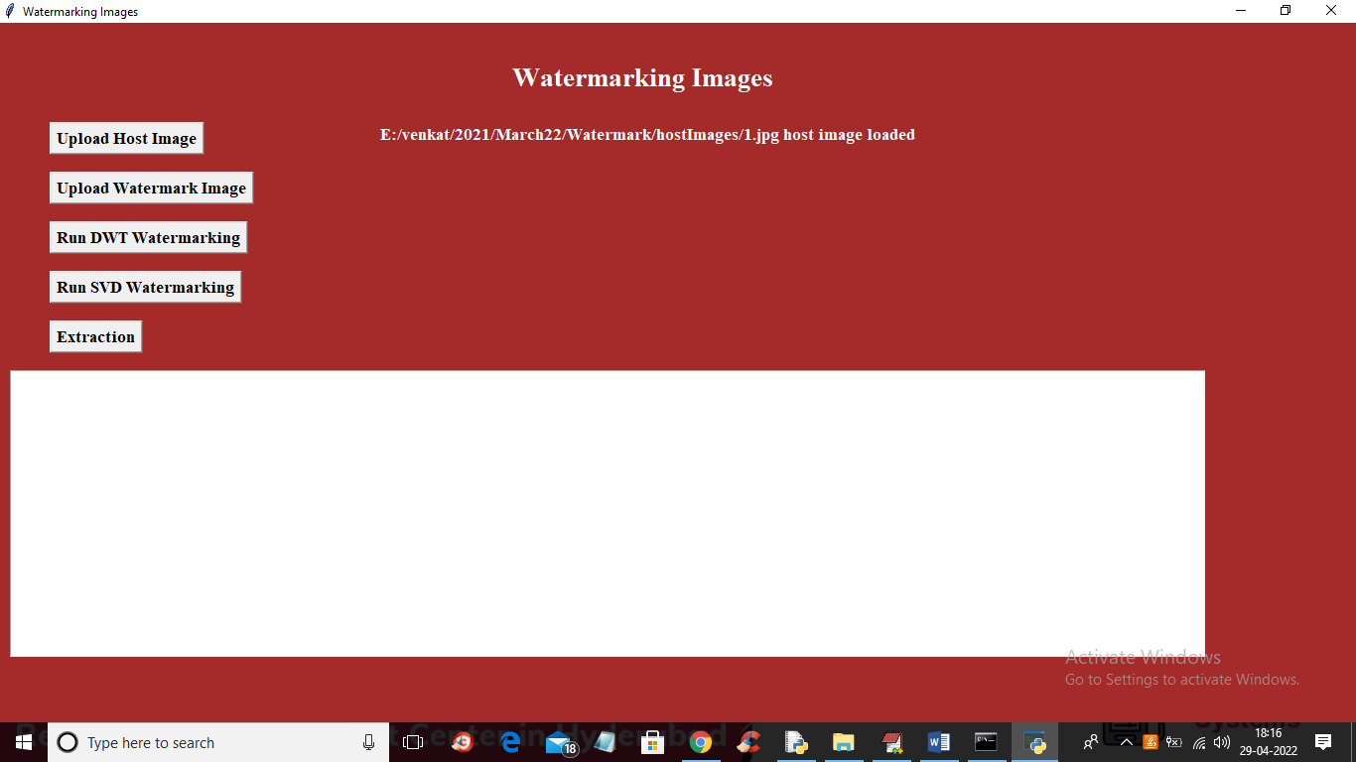

In above screen cover image is loaded and now click on ‘Upload Watermark Image’ button to upload watermark image

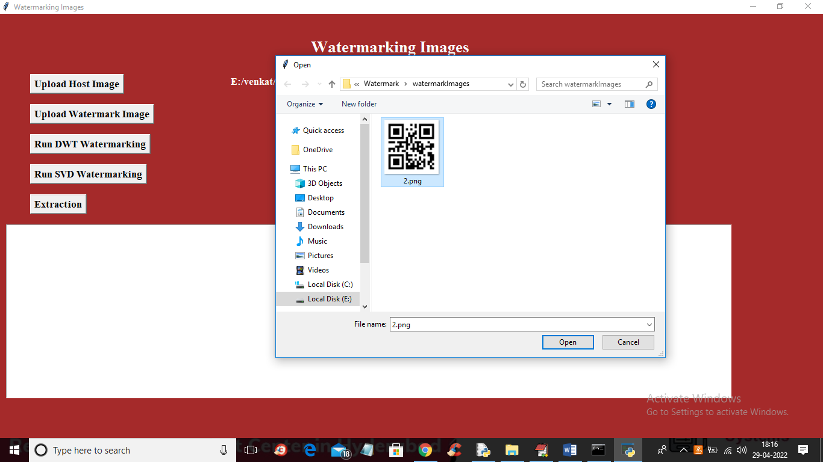

In above screen selecting and uploading watermark image and then click on ‘Open’ button to load image and get below output

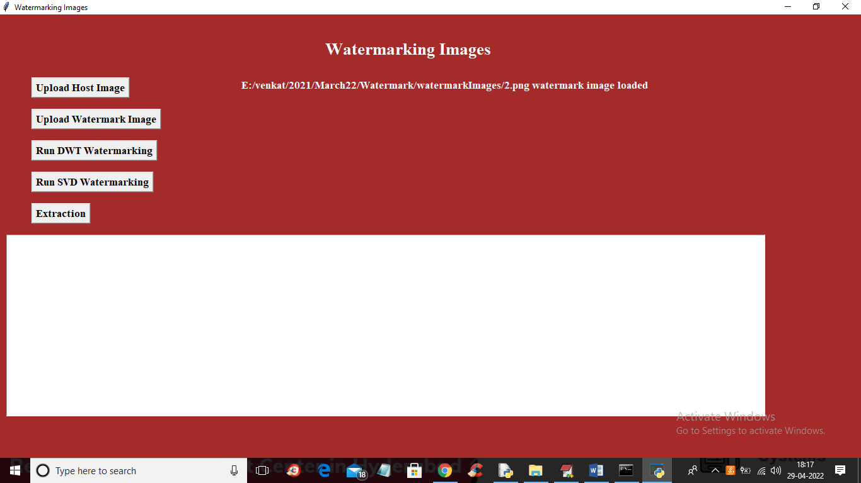

In above screen in white colour text we can see watermark image is loaded and now click on ‘Run DWT Watermarking’ button to embed image and get below output

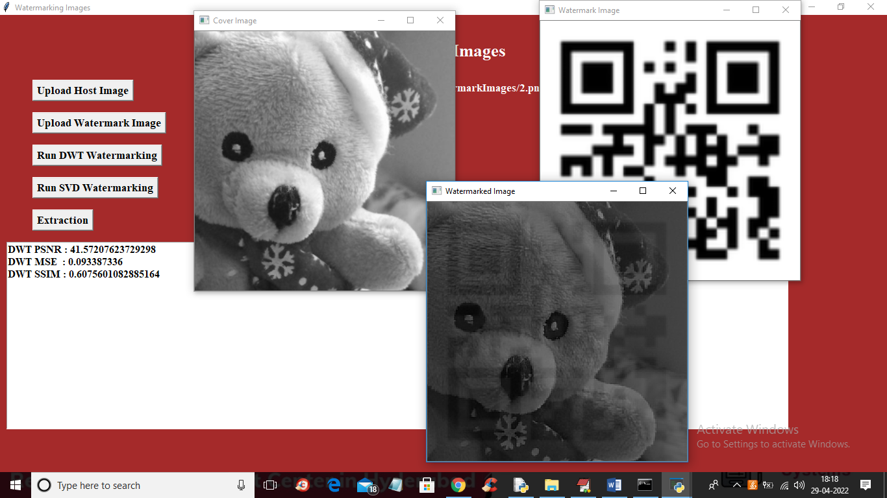

In above screen first image is the cover image and second is the watermarking image and 3r is the embedded watermarked image and we can see DWT PSNR and other values in the text area for DWT. Now click on ‘Run SVD Watermarking’ button to embed watermarking using SVD

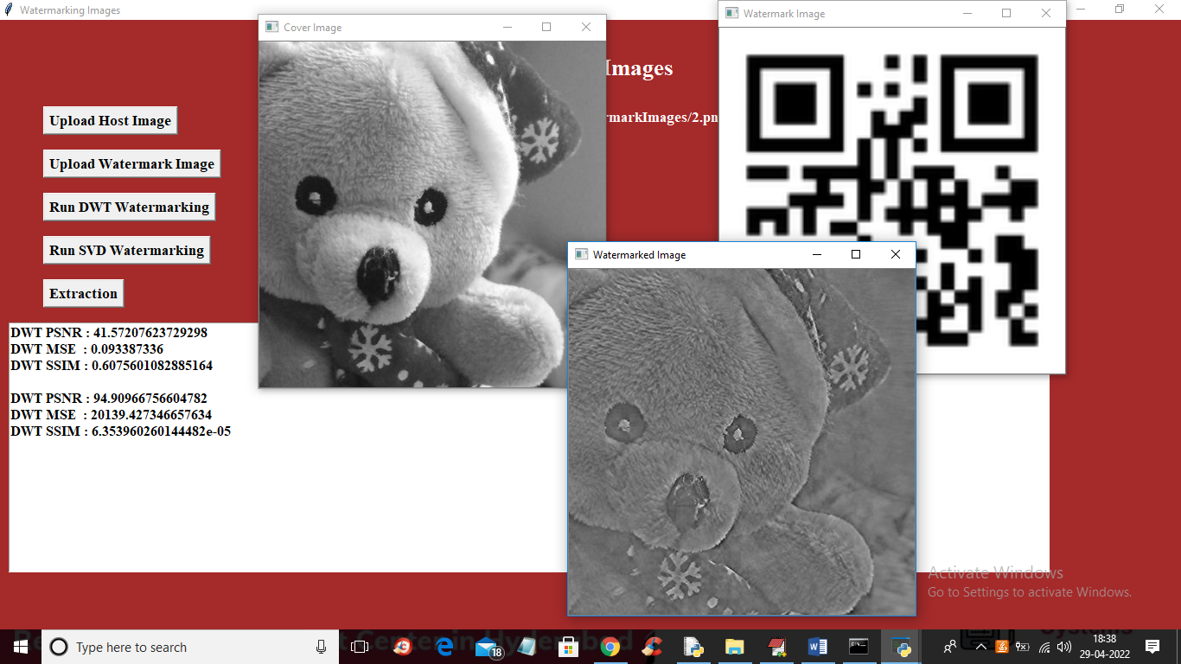

In above screen first image is the original image and second is the water mark image and 3rd is the embedded water marked image using SVD algorithm and we can see PSNR, MSE and SSIM for both SVD and DWT. PSNR must be closer to 100% to consider as high quality image and MSE must be closer to 0 and SSIM must be closer to 100. Now click on ‘Extraction’ button to upload Watermarked image and then extract embedded image from it

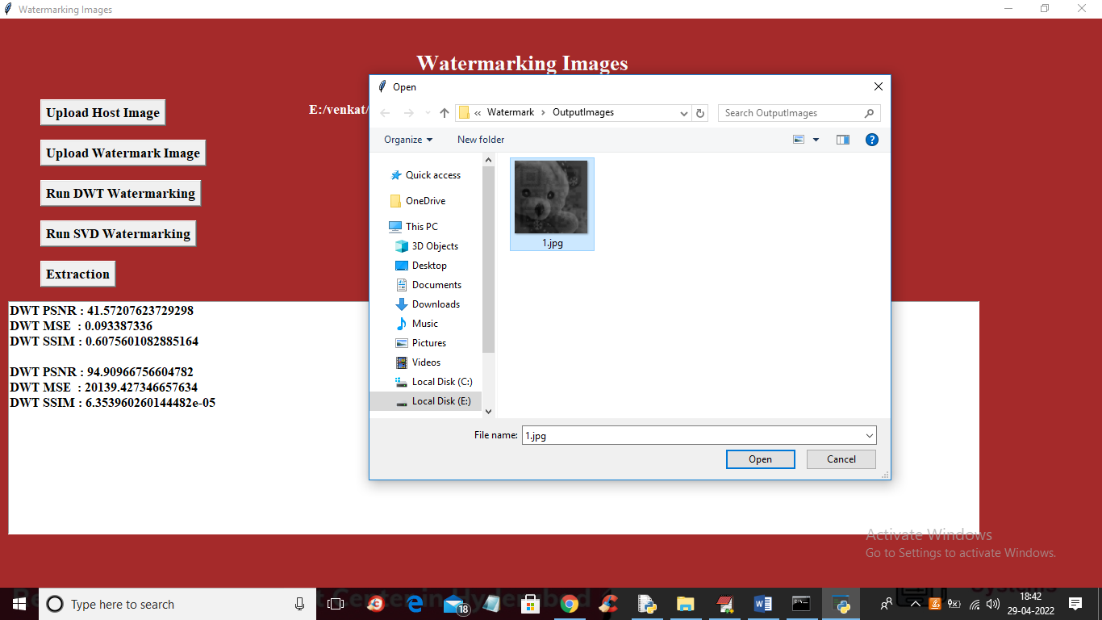

In above screen selecting and uploading embedded watermark image and then click on ‘Open’ button to get below output

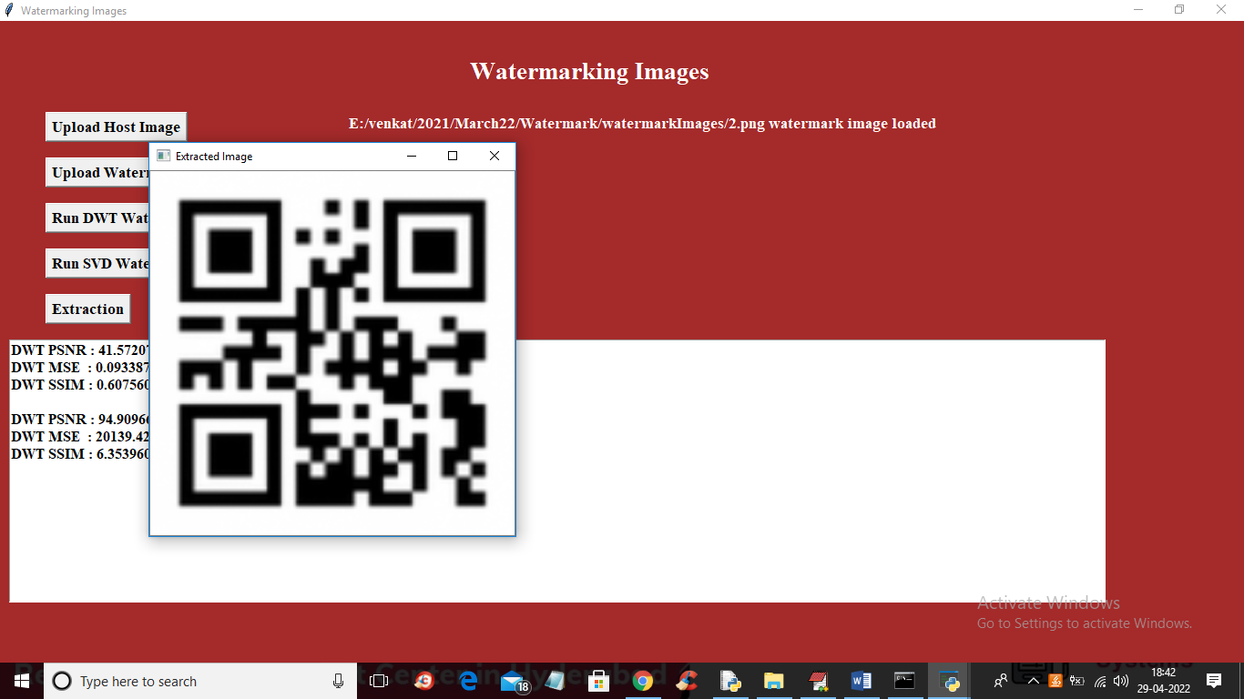

In above screen we can see the extracted image and similarly you can upload any image and get output