TECHNICAL CONCEPTS • FLOWS • DIAGRAMS
Karya
Architecture, Concepts, and End-to-End Flows
A detailed source-grounded guide to the estimator, C4 workspace, planning layers, governance, AI services, security, frontend, and desktop runtime
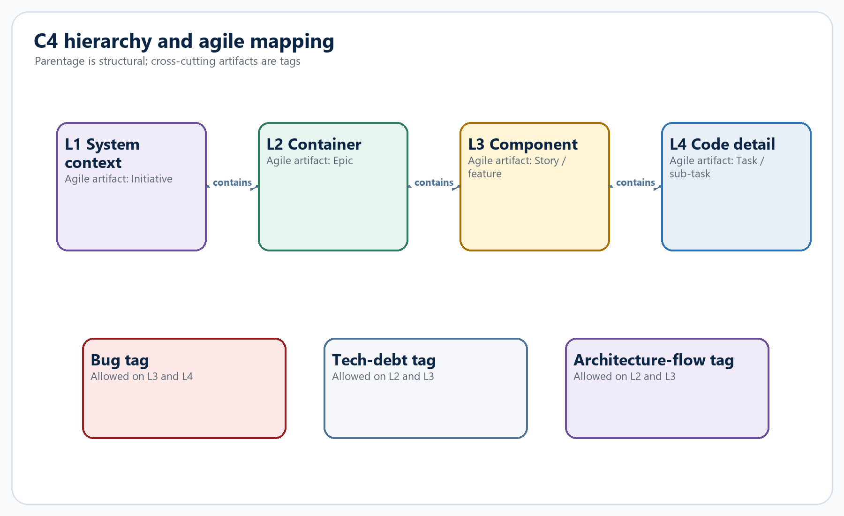
Repository snapshot: 21 July 2026 | Karya 2.0 architecture
Prepared from the complete repository inventory and the implementation source

Executive overview
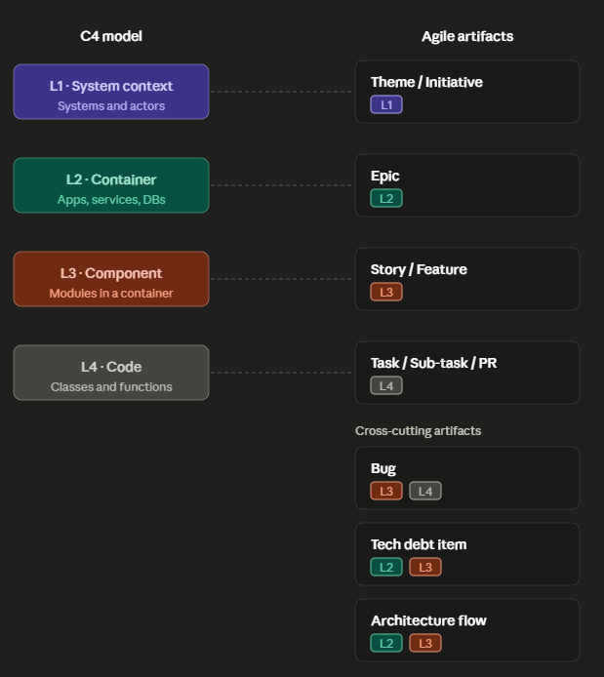
C4 levels → Agile artifacts → Software activities
L1 → Theme / Initiative / Product Goal
L2 → Epic / Capability / Platform Slice
L3 → Feature / Story / Architecture Flow
L4 → Task / Sub-task / Pull Request

Karya is an evidence-led delivery-planning platform centered on a modified-Fibonacci story-point estimator. Its core idea is that an estimate should be the last step in a traceable reasoning chain: score evidence, identify the dominant drivers, compare fixed calibration stories, derive points, and then explain the result in plain language. The estimator is embedded in a persistent project workspace that connects system architecture, delivery scope, people, cost, governance, and implementation detail.
CORE DESIGN LLMs propose and explain; deterministic code validates, persists, aggregates, authorizes, and calculates.

- A React 19 + Vite client presents a Material 3 workspace, C4 canvas, architecture planners, Mermaid editing, roll-ups, and assistant.
- A FastAPI backend organizes each domain into router, service, and store boundaries; LangGraph powers estimation and the concurrent chat pipeline.
- SQLite persists projects, architecture artifacts, planning data, access assignments, connector configuration, and conversations; a second SQLite file stores LangGraph checkpoints.
- The C4 hierarchy maps L1/L2/L3/L4 to initiative/epic/story/task. L3 and L4 are estimable; L1 and L2 aggregate child points deterministically.
- AI features use a proposal/review/apply contract. Store invariants and RBAC remain authoritative when a proposal is accepted.
- The same web and backend code ships as an Electron desktop app, with per-user local data and a bundled PyInstaller API executable.

Scope and method
This guide covers all code areas in the repository and focuses on concepts, interactions, invariants, and extension points rather than reproducing source line by line. The analyzed inventory contains 217 Python/JavaScript/Markdown files and approximately 28,264 lines across backend, frontend, desktop, scripts, and docs. The source currently defines 43 SQLite tables, 24 backend test files with 182 test functions, and 18 frontend test files with about 69 test cases.
Source basis: Repository inventory, backend/storage/db.py, backend/tests, frontend/src, package manifests, and architecture documentation.

How to use this guide
- Read Sections 1-4 for the product mental model, C4 hierarchy, estimator, and request flow.
- Use Sections 5-11 as a subsystem reference for persistence, planning, architecture, AI, security, integrations, frontend, and desktop.
- Use the appendices for readiness weights, schema domains, API families, module boundaries, and extension checklists.

Content map
Part | Focus | Primary reader
I. Foundations | Purpose, system architecture, C4 model, estimator | Product, engineering, architecture
II. Workspaces | Planning, L1-L4 architecture, requirements, diagrams | Architects, delivery leads, analysts
III. Platform services | AI, chat, workflow, security, integrations | Engineers, admins, governance
IV. Runtime | Frontend, desktop, reliability, testing, extension | Developers and operators
Appendices | Weights, data groups, routes, modules, glossary | Reference use

SECTION 1

Product purpose and design principles
Karya connects estimation to architectural evidence and then carries that evidence into planning, governance, and implementation.

1.1 The problem Karya solves
Story points often fail when teams jump directly from a short story description to a number. Karya inserts an explicit evidence chain and makes the number auditable. It also addresses a second problem: estimates are usually isolated from the architecture and operating plan that created the work. Karya therefore makes the estimator one capability inside a broader project workspace.
Evidence-led estimation — A modified-Fibonacci conclusion supported by a parameter scorecard, deciding drivers, named calibration anchors, plain-language reasoning, effort ranges, risks, assumptions, and split guidance.
Architecture as context — An L3 or L4 estimate receives the element's parent chain, relations, technology, code path, and repository links as c4_context. The architecture model becomes estimation evidence rather than decorative documentation.
Deterministic roll-up — Parent points are sums of accepted child L3 estimates. The roll-up is not generated by an LLM and excludes proposed elements until a user accepts them.
Proposal-first AI — Generative features return a typed draft. The user reviews it, selects what to accept, and only then invokes deterministic persistence APIs.

1.2 Design principles visible in the code
Principle | Implementation consequence
Explain before displaying points | SSE node events carry progress only. The final result is emitted atomically after plain_language_why and tldr exist.
Keep provider knowledge at one boundary | Only backend/llm/factory.py maps provider names to model implementations.
Reuse domain invariants | AI apply functions call the same stores used by normal UI writes, including allocation caps and C4 parent rules.
Prefer deterministic calculations | Readiness, cost metrics, reporting, workflow progress, roll-ups, and traceability are computed in code.
Make risky writes explicit | Jira writes require configuration enablement, a confirmation flag, and user confirmation in the UI.
Let startup degrade safely | Configuration errors are captured in app state so /health and /config remain available.

SECTION 2

System architecture
The product is a monorepo with a React client, a FastAPI domain API, two LangGraph workflows, SQLite persistence, external adapters, and an Electron shell.
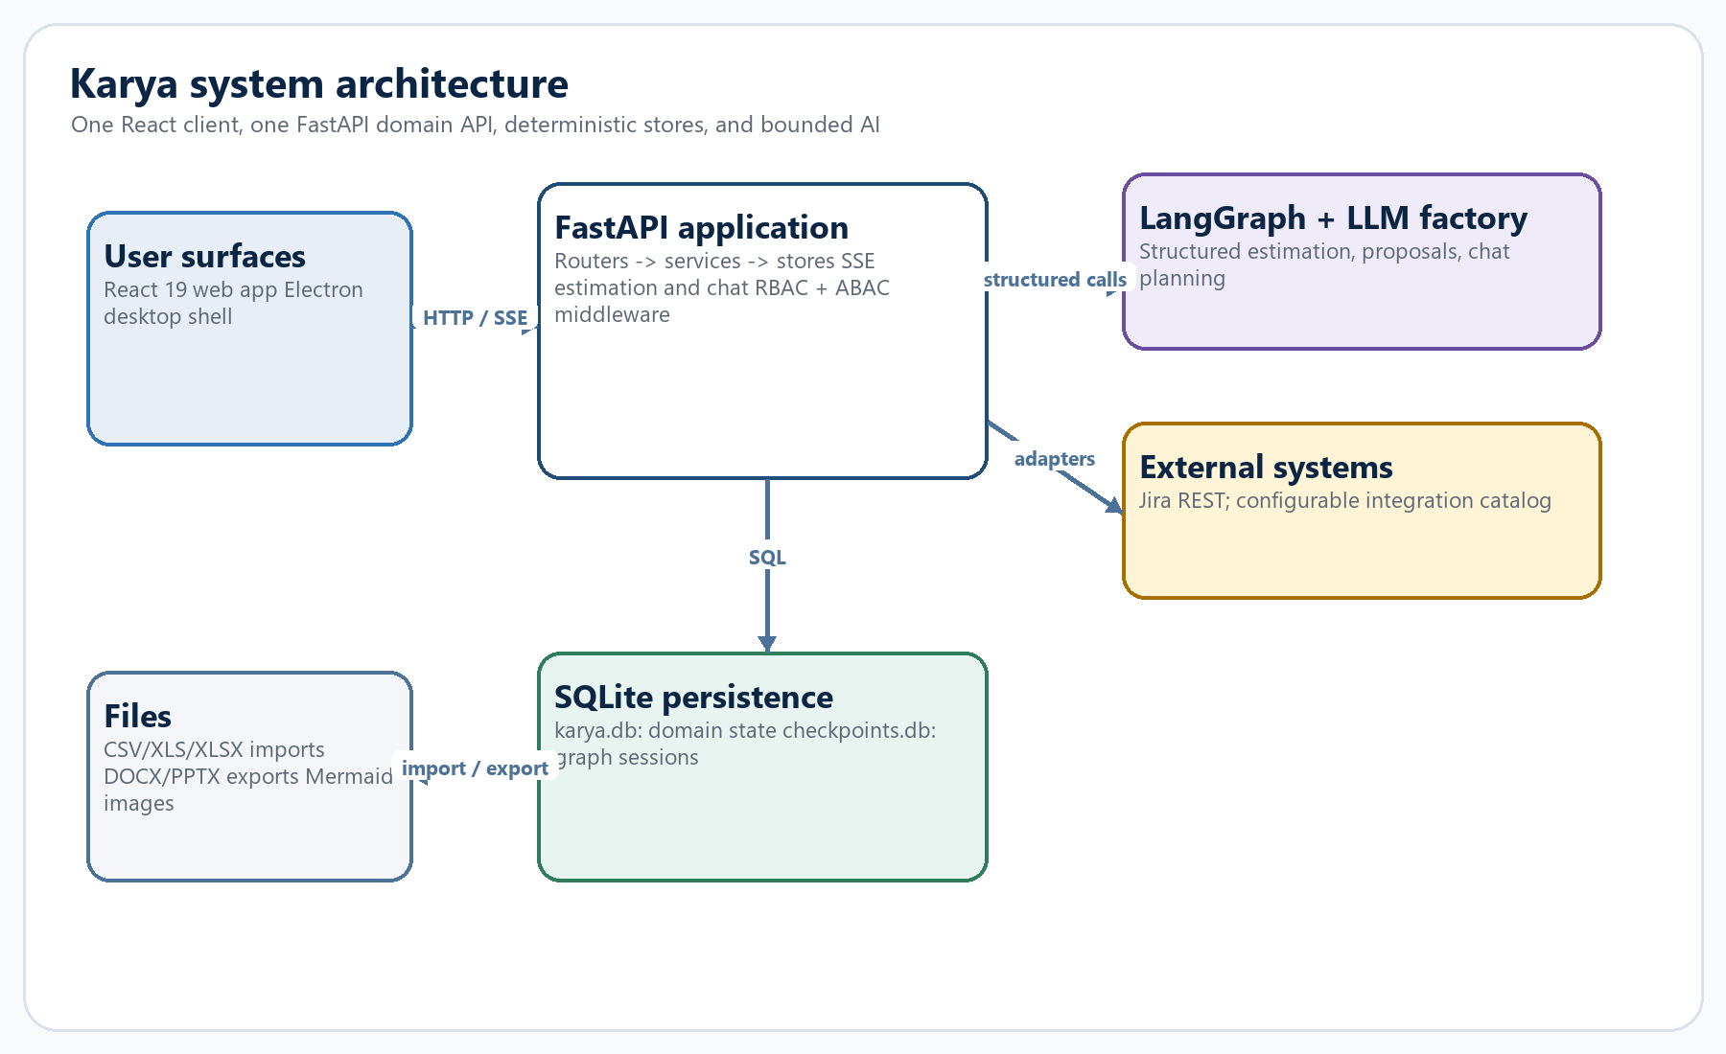
Figure 1. High-level Karya system architecture

2.1 Runtime components
Component | Responsibilities | Key technologies
Web client | Navigation, C4 editing, planning workspaces, streaming progress, Mermaid rendering, RBAC UI gating | React 19, Vite, React Flow, Mermaid 11
API | Authentication policy, domain routes, SSE, error envelopes, exports, integration adapters | FastAPI, Pydantic, httpx
Estimation graph | Ordered evidence-to-points pipeline with conditional escalation and checkpoints | LangGraph StateGraph
Chat graph | Concurrent planning, retrieval, and deterministic tools followed by a barrier/judge/respond flow | LangGraph StateGraph
Domain store | Projects, C4, planning, architecture, people, access, integrations, chat | stdlib sqlite3 / karya.db
Checkpoint store | Durable estimation session state keyed by thread_id | AsyncSqliteSaver / checkpoints.db
Desktop shell | Starts/reuses the backend, injects API URL, owns per-user data, packages the app | Electron, PyInstaller, electron-builder

2.2 Monorepo boundaries
- The root package.json orchestrates Python, web, tests, and desktop commands.
- frontend/package.json owns React/Vite dependencies and Vitest.
- desktop/package.json owns Electron development and packaging.
- requirements.txt owns backend dependencies; requirements-local.txt and requirements-desktop.txt are opt-in extensions.
- The production web build is emitted to dist/ and consumed by Electron in packaged mode.
Source basis: package.json, frontend/package.json, desktop/package.json, docs/monorepo.md, backend/api/main.py.
SECTION 3

C4 model and agile artifact mapping
The C4 tree is the structural backbone: architecture, estimates, planning, traceability, and chat all resolve through the same elements.
Figure 2. C4 levels, agile artifacts, and cross-cutting tags

3.1 Structural rules
- L1 is top-level. L2 must parent to L1, L3 to L2, and L4 to L3.
- A parent must be in the same project and exactly one level above; the store rejects invalid parentage.
- Deleting a C4 element cascades to its children, relations, and artifact links.
- Relations connect elements in the same project and use sync, async, or data kinds.
- Proposed status is the quarantine state for imports and AI-generated scope; proposed elements are reviewable but excluded from deterministic roll-up.
- Cross-cutting artifacts attach through artifact_links instead of parentage: bugs on L3/L4, tech debt on L2/L3, and architecture flows on L2/L3.

3.2 Estimation context assembly
Before an element is estimated, c4.service.element_to_story builds a standard Story with an architecture evidence bundle:
c4_context = {
level, kind, artifact_type,
parent_chain: [{level, name, description}, ...],
relations: [{source, target, label, kind}, ...],
code_path, repositories
}
This is intentionally a thin integration. The graph does not need a separate C4-specific branch because every estimation node serializes the story through the shared context helper.

3.3 Estimation persistence and decomposition
- Persist the estimate on the element's level-mapped artifact link, including points, spike/split flags, session ID, and estimated time.
- If an L3 estimate exposes hidden tasks, create proposed L4 children when a same-name child does not already exist.
- If the split recommendation is accepted by the estimation result, create proposed sibling L3 stories under the same L2 parent.
- Keep all proposed scope out of roll-up until a user changes status to active.

3.4 Deterministic roll-up
Metric | Rule
estimated_stories | Count active L3 nodes with points
unestimated_stories | Count active, non-proposed L3 nodes without points
rolled_up_points | Sum L3 points through descendants
spikes | Count estimated L3 artifacts with spike_recommended
pending_splits | Count estimated L3 artifacts with split_recommended

SECTION 4

Estimation engine
The graph makes the scoring logic explicit and keeps every node under a typed output contract.
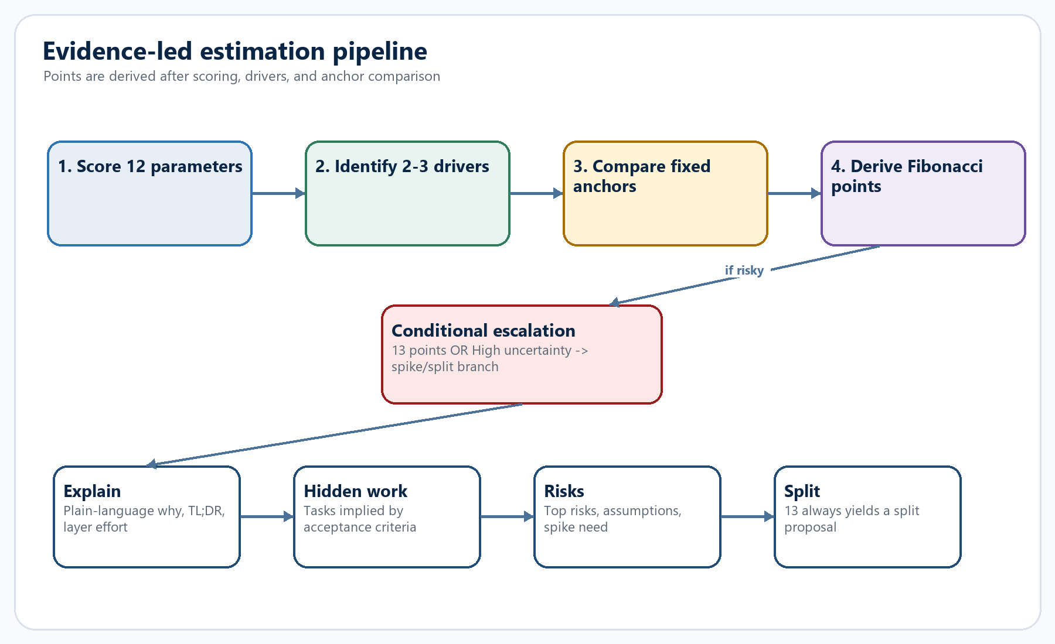
Figure 3. Estimation graph and conditional escalation branch

4.1 Inputs and session semantics
- Story inputs include title, user story, acceptance criteria, technical breakdown, existing reference points, source metadata, and optional c4_context.
- Every request receives a session ID. LangGraph uses it as thread_id, so a refinement can resume the prior checkpoint instead of starting a disconnected estimate.
- The initial messages contain either the refinement text or a simple Estimate: <title> prompt; anchors are injected into state as fixed data.

4.2 The 12-parameter scorecard
Parameter | What it represents
complexity | Algorithmic/domain difficulty and branching
volume | Amount of behavior, data, screens, endpoints, or rules
uncertainty | Unknown requirements, technology, integrations, or outcomes
react_scope | Frontend work and interaction complexity
spring_scope | Service, domain, API, persistence, or orchestration work
existing_code_scope | Breadth and risk of modifying established code
dependencies | Internal/external teams, services, vendors, and sequencing
nfrs | Performance, availability, resilience, privacy, and other qualities
testing | Unit, integration, contract, end-to-end, and regression burden
compliance_audit | Entitlement, auditability, residency, control evidence
familiarity | Team knowledge of the domain, stack, and patterns
dod_overhead | Deployment, documentation, review, release, and operational tasks

4.3 Structured-output resilience
Each node calls get_structured_llm(schema). The parser tolerates common provider variations without weakening the Pydantic contract:
- Raw/parsed/parsing_error envelopes returned by structured-output APIs.
- Markdown-fenced JSON and valid JSON embedded after a short sentence.
- Provider list echoes where the actual object is one of several returned values.
- Nested text/content/output wrappers.
- A second attempt with a corrective message after invalid output.
BOUNDARY RULE Structured-output quirks are handled in backend/graph/nodes.py, not scattered across node implementations.

4.4 Calibration anchors
Points | Anchor | Signal
3 | Inline validation on a React payment form | Bounded React-only change with known patterns
5 | Entitlement-protected account preference | Small cross-stack change plus entitlement/audit
5 | Search/filter existing transaction endpoint | Bounded cross-stack and performance work
8 | Cross-market eKYC status integration | External integration, regulation, failure modes
8 | Transaction-wide AI summary with audit | Broad data, consistency, compliance, operations
13 | New multi-market payment orchestration | New layers, multiple systems, high uncertainty; split

SECTION 5

Streaming, errors, and end-to-end estimation flow
SSE is used to make long-running model work observable while preserving the rule that points and explanations arrive together.
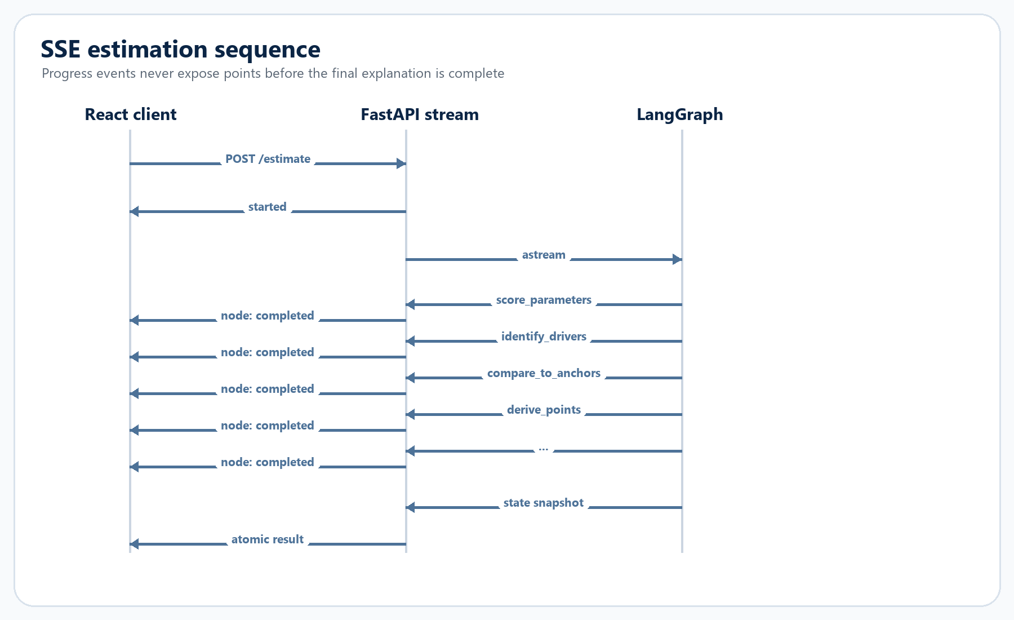
Figure 4. Server-Sent Events sequence for one estimate

5.1 Event contract
Event | Payload purpose
started | Session ID and story title
node | Node name and completed status only
result | Complete public graph state after required explanations are present
error | Structured estimation error with retryable flag
batch_started | Batch count, root session, skipped rows
item_started / item_node / item_result / item_error | Per-story progress and outcomes
batch_result | Collected results and skipped rows

5.2 Atomic final result
After graph streaming completes, stream_story reads the checkpointed state, removes internal fields such as anchors/messages/refinement, and verifies both plain_language_why and tldr. If either is absent, it raises instead of returning an unexplained point value. An optional on_result callback persists C4 estimates only after this gate passes.

5.3 Uniform failures
- Normal HTTP failures use { error: { code, message, details, retryable } }.
- Validation errors, Jira errors, spreadsheet errors, auth failures, and route-specific domain errors are mapped into the same envelope.
- In-stream failures become SSE error events because headers have already been sent.
- Startup LLM errors degrade health instead of crashing the application, keeping diagnostics usable.
SECTION 6

Persistence and domain data
Karya uses SQLite deliberately: the schema is broad, but every write remains local, transactional, and organized by domain stores.
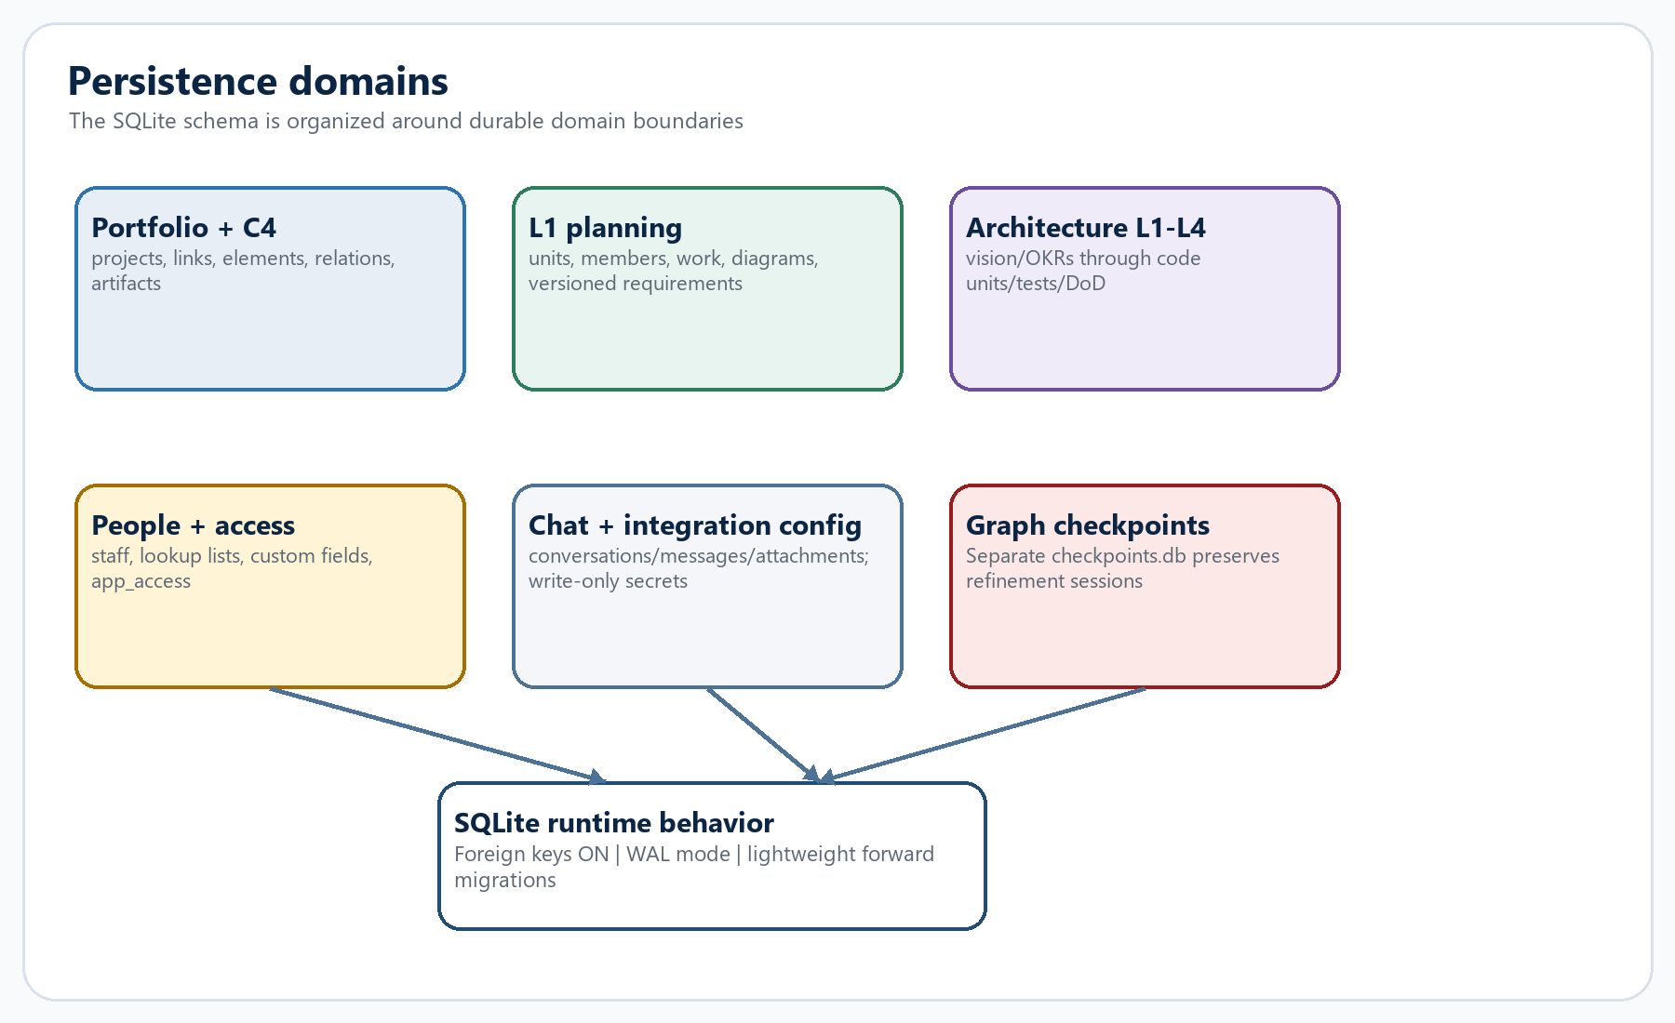
Figure 5. Persistence domains and the separate checkpoint store

6.1 Database behavior
- KARYA_DB overrides the primary path; otherwise data/karya.db is used.
- Foreign keys are enabled for every connection and journal_mode=WAL is configured during initialization.
- The API lifespan initializes the schema and installs AsyncSqliteSaver when available.
- Tests and bare imports fall back to MemorySaver so graph code remains usable without application startup.
- Forward migrations add columns and rebuild the L1 diagram constraint when the supported Mermaid type catalog expands.

6.2 Important relational behaviors
Behavior | Why it matters
Cascade C4 parent deletion | A subtree, its relations, and level artifacts do not become orphaned
ON DELETE SET NULL for trace links | Deleting a linked element preserves the L1 artifact but clears its target
Self-reference for capability hierarchy | Capabilities can form L1/L2/L3 business maps independent of C4
Separate app_access row | Directory identity and application authorization stay related but distinct
JSON fields | Leads, custom values, RACI matrices, diagram metadata, chat payloads, and connector settings remain extensible
Immutable requirement versions/audit | Content history and review activity remain attributable

SECTION 7

Project workspace, imports, and roll-up
Projects bind the C4 model to repository and Jira context, then expose every planning and architecture surface through a common workspace.

7.1 Project lifecycle
- Create a project with name, description, leads, and standard or restricted sensitivity.
- Optionally attach repository links and one or more Jira links.
- Seed the C4 model manually, with a deterministic repo scan, with Jira imports, or from an AI scaffold proposal.
- Review proposed elements and accept the scope that should participate in planning and roll-up.
- Use the level workspaces to build strategy through implementation evidence, estimate L3/L4, and review roll-up.

7.2 Repository scan
The repository scanner is deterministic. It skips common build/cache/data directories, detects known code extensions up to a bounded depth, and proposes:
- One L1 system named for the project.
- Top-level code directories as L2 containers, with inferred technology labels and code paths.
- Code-bearing subdirectories as L3 components.
- Idempotent application through same-name child checks.

7.3 Jira import
A Jira import resolves an explicit instance/project key or the project's first saved link, fetches issues through the registry, maps them to Story objects, and creates proposed L3 elements under an Imported from Jira L2 container. Existing Jira points remain reference-only: a Karya roll-up point requires a justified Karya estimate.

7.4 Workspace navigation
Tab | Purpose
C4 canvas | Create, edit, position, relate, inspect, estimate, and accept elements
L1 plan | Baseline, requirements, teams, work/cost, and diagrams
L2 arch | Container architecture, imports, RACI, governance, traceability
L3 arch | Component architecture, RACI, governance, traceability
L4 detail | Code/test/DoD implementation detail and traceability
Roll-up | Initiative-to-task tree, points, spikes, pending splits
Quick | Manual/Jira/spreadsheet estimates outside the C4 flow
Overview | Project metadata, leads, links, and seed/import actions

SECTION 8

L1 operating plan and requirements lifecycle
An L1 initiative is not only a strategy object; it can own people, funded work, versioned requirements, and architecture diagrams.

8.1 Operating plan structure
Area | Data and rules
Tribes and squads | Tribes are top-level; a squad's parent must be a tribe in the same plan
Members | Can reference global staff; total allocation across teams cannot exceed 100%
Work items | Must be dated; optional squad is in-plan; optional C4 link must be an L2-L4 descendant
Cost | Monthly cost x allocation drives run-rate; budgets and actuals drive variance
Currency | Stored per L1 as a presentation label; no exchange-rate conversion
Diagrams | Mermaid source and editor metadata for a broad diagram catalog

8.2 Deterministic metrics
allocated_fte = Σ(member.allocation_percent / 100)
monthly_run_rate = Σ(member.monthly_cost × allocation_percent / 100)
planned_cost = Σ(work_item.budget_cost)
actual_cost = Σ(work_item.actual_cost)
cost_variance = planned_cost - actual_cost
at_risk_work = count(status == 'at_risk')

8.3 Versioned requirements
- Create a requirement document at version 1 and record a document_created audit event.
- Edit with expected_version optimistic concurrency. A stale editor receives a conflict instead of overwriting newer content.
- Every successful edit increments the version, saves an immutable snapshot, resets status to draft, and invalidates prior approval.
- Comments are anchored to a document version and move among open, approved, and resolved states.
- Review actions move the current document among draft, in_review, and approved and append audit events.
- DOCX/PPTX exports render Mermaid images supplied by the frontend while preserving source Markdown as the system of record.
AUDIT CAVEAT The repository uses an application-level actor label. Connect it to real SSO/session identity before treating the audit as identity-assured compliance evidence.

SECTION 9

L1-L4 architecture workspaces
The four workspaces form a progressive evidence ladder, each with deterministic readiness and traceability.
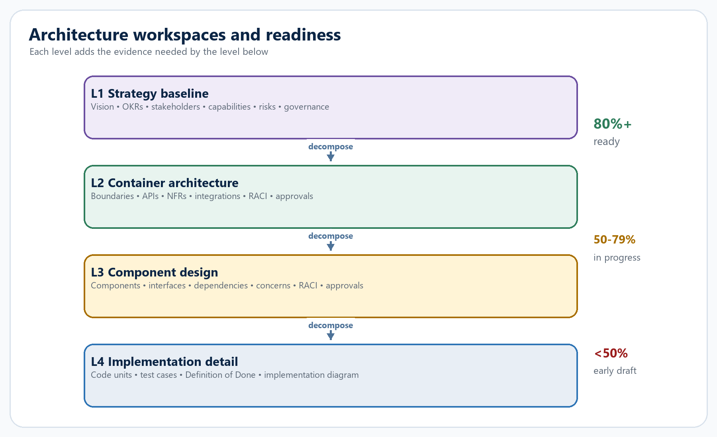
Figure 6. Architecture workspaces from strategy to implementation

9.1 L1 strategy baseline
- Vision and business problem, with optional detailed notes and lifecycle status.
- Measurable OKRs with baseline, target, current value, owner, status, and optional C4 link.
- Stakeholder map with influence, interest, RACI, ownership, status, and optional directory reference.
- Hierarchical capability map with maturity, ownership, criticality, priority, and optional C4 link.
- Portfolio risk and funding register with mitigation, budget, forecast, actual, owner, date, and optional C4 link.
- Impact analysis detects inconsistent or stale governance evidence without an LLM.

9.2 L2 container architecture
- Workspace summary and Mermaid container diagram, with a fallback generated from container records.
- Containers capture capability, responsibilities, owned data, team, security classification, NFR criticality, and status.
- API/data contracts capture provider, consumer, endpoint, type, classification, authentication, version, owner, and lifecycle.
- NFRs capture scenario, metric, baseline, target, owner, risk, and status; integrations capture systems, exchange, security, and state.
- OpenAPI and Kubernetes YAML/JSON imports convert live definitions into APIs or container records.

9.3 L3 component design
- Internal components: controller/service/repository/gateway/model/client/config/UI/other with responsibility, tech, pattern, owner, and status.
- Provided and consumed interfaces with contract, counterpart, authentication, and lifecycle.
- Internal/container/external/library dependencies with reason and criticality.
- Cross-cutting concerns for logging, caching, validation, security, error handling, configuration, observability, and resilience.

9.4 L4 implementation detail
- Code units: class, interface, function, module, config, migration, or test with responsibility, technology, path, complexity, and status.
- Test cases: unit, integration, end-to-end, contract, or manual with scenario, expected outcome, and status.
- Definition-of-Done items across code, tests, docs, security, review, and deploy.
- No approval chain or RACI at L4; the workspace is intentionally lean and execution-focused.

9.5 Governance and traceability
Level | Approval chain | Traceability direction
L1 | Product -> architecture -> security -> risk -> finance -> sponsor | Strategy artifacts link into the C4 model
L2 | Engineering -> security -> NFR -> data -> architecture -> sponsor | L1 -> L2 -> L3
L3 | Design -> interfaces -> security -> testing -> architecture -> tech lead | L2 -> L3 -> L4
L4 | No chain | L2 -> L3 -> selected L4

L1, L2, and L3 approval chains are sequential. A later stage cannot be approved before earlier stages. Full approval baselines the artifact. Rejection reopens the baseline for rework according to the level's status model.
SECTION 10

AI services and the proposal-first safety model
Generative capabilities are specialized, typed, PII-masked where appropriate, and separated from persistence.
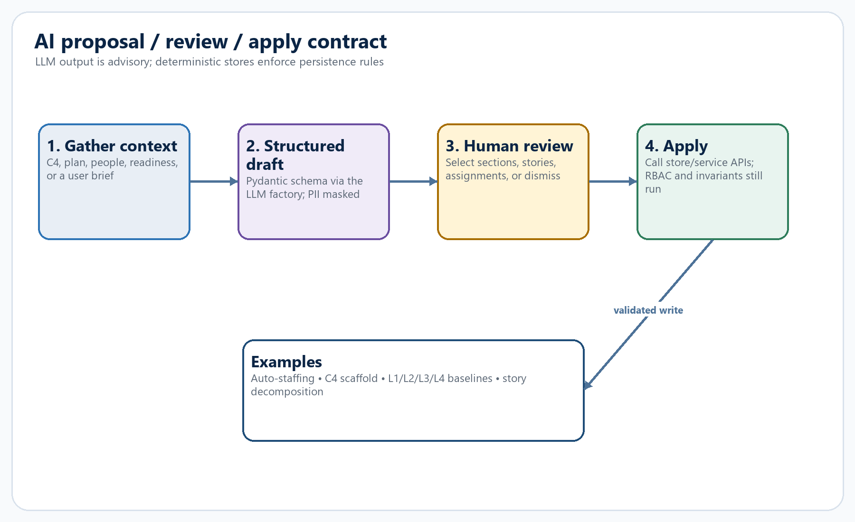
Figure 7. AI proposal, human review, and deterministic apply

10.1 Agentic services
Service | Context | Proposal | Apply behavior
Auto-staffing | Squads, open work, active staff, remaining allocation | Staff-to-squad assignments | Creates members; allocation cap rechecked
Reporting narrative | Deterministic portfolio overview | Executive briefing | Read-only narrative
Story decomposition | Selected C4 element and guidance | 3-8 child stories | Creates proposed children one level down
C4 scaffold | System description | L1/L2/L3 graph with temporary refs | Creates proposed elements, resolves refs, creates relations
L1 baseline | Initiative + brief | Vision, OKRs, stakeholders, capabilities, risks | Applies selected sections through L1 store
L2/L3/L4 baseline | Element, parent context, brief | Level-specific architecture artifacts | Applies selected sections through level stores
Orchestrator | Natural-language request | Route to a specialized agent | UI navigates to the owning workspace

10.2 Defensive controls around model output
- Pydantic schemas constrain every structured proposal.
- Free-text briefs and guidance pass through deterministic email/phone/ID masking.
- Auto-staffing discards unknown staff/squads and clamps assignments to remaining capacity before review.
- Apply functions reconstruct domain models and call normal stores; the model never writes SQL.
- Mutation endpoints still traverse RBAC middleware, project sensitivity checks, and store invariants.
- Mock mode provides deterministic schema-valid proposals for offline development and tests.

10.3 LLM factory boundary
Provider family | Factory behavior
Native | LangChain init_chat_model for OpenAI, Anthropic, Google, Groq, Mistral
OpenAI-compatible | ChatOpenAI with base_url for Moonshot, DeepSeek, OpenRouter, Ollama, vLLM, or generic endpoints
Local / localpath | Lazy in-process Transformers adapter; localpath requires a physical offline checkpoint
Mock | Deterministic offline structured outputs; no key or network

STRICT BOUNDARY Provider names and provider-specific validation belong only in backend/llm/factory.py. Callers request plain or structured models without provider conditionals.

SECTION 11

Workflow guide and conversational assistant
Two coordination layers help users navigate the model: a fully deterministic next-best-action guide and a proposal-aware conversational assistant.

11.1 Deterministic workflow guide
The workflow service evaluates active elements level by level. For each level it computes count, proposed count, average readiness, number ready, status, whether the level is expected yet, and targeted actions with a frontend tab destination.
overall_progress = mean(expected_level_average_readiness[, estimation_coverage])
ready_threshold = 80
next_action = first expected stage that is not ready
- A level becomes expected after its parent level exists; L1 is always expected.
- Estimation coverage comes from the deterministic roll-up, not a model summary.
- The Workflow Wizard can navigate directly to the recommended workspace tab.

11.2 Concurrent chat graph
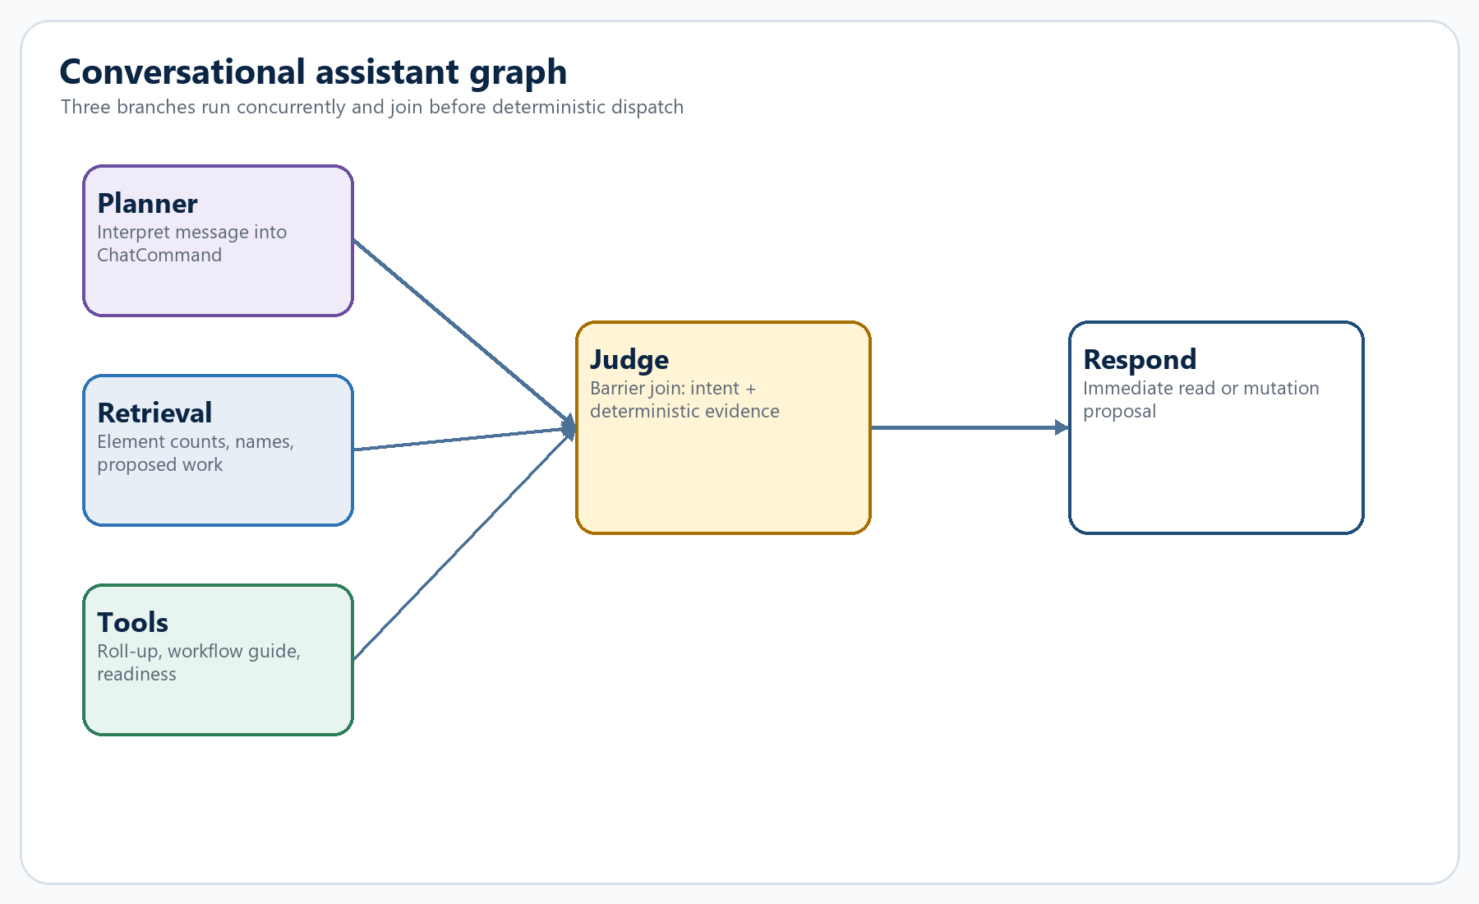
Figure 8. Concurrent planner/retrieval/tools chat graph

11.3 Read versus write semantics
Command type | Execution
Overview / list / readiness / report | Runs immediately against deterministic services and returns exact calculated data
Answer / code / image / document | Returns a mode-appropriate response; explicit modes prevent accidental C4 writes
Create / update / delete element; create relation | Resolves names and returns a mutation proposal only
Apply | Re-resolves names, infers/validates parents, and calls C4 store after explicit confirmation
Research | Uses bounded public web search and returns linked results or an explicit failure

11.4 Conversation persistence and attachments
- Conversations are scoped by project and effective user ID and include ordered messages and JSON payloads.
- Attachments are limited to 10 MB and extracted from text/code, Word, or spreadsheets; image attachments are represented as metadata in the local runtime.
- The streaming endpoint emits branch events, a judge event, and a final result compatible with the non-streaming endpoint.
SECTION 12

Authentication, authorization, and data sensitivity
Karya's local demo sign-in is intentionally lightweight, but the backend still applies a capability policy and project-sensitivity check to every protected request.
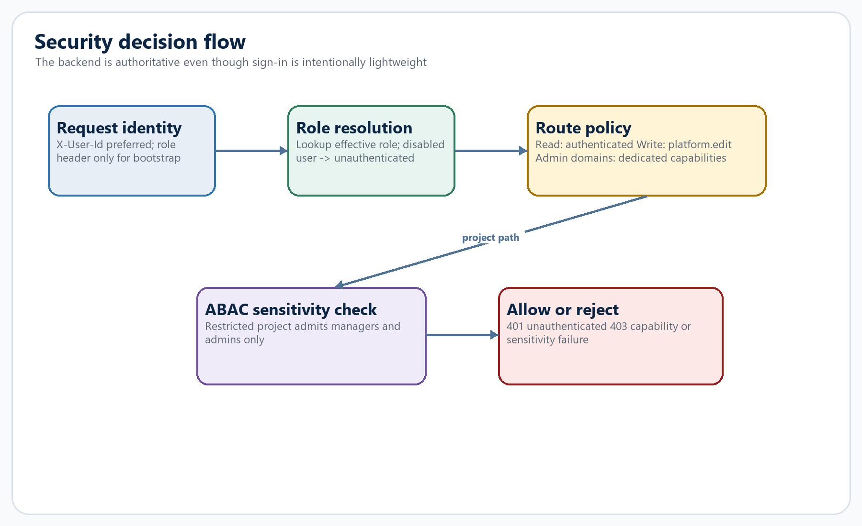
Figure 9. Backend RBAC and restricted-project ABAC flow

12.1 Identity model
- Application users are resource-directory people. The UI stores the selected identity in localStorage; there are no passwords or tokens.
- The client sends X-User-Id. The server looks up the effective role and treats unknown/disabled people as unauthenticated.
- X-User-Role supports the bootstrap identity path, but a staff ID takes precedence.
- If no enabled admin exists, the earliest-created staff member is promoted to admin so the app cannot lock itself out.

12.2 Role capability matrix
Role | Capabilities
Admin | All capabilities
Manager | Admin shell, reporting, resources, platform create/edit
Contributor | Platform create/edit
Viewer | Authenticated reads only

12.3 Route policy
- Public: health, config, login users, roles, Jira instance list, OpenAPI/docs.
- Authenticated reads: ordinary project, C4, workflow, chat proposal, and resource reads.
- Writes: platform.edit unless a more specific admin capability applies.
- Access management, reporting, resource writes, and connector configuration use dedicated capabilities.
- Restricted projects allow only managers and admins on any /projects/{id}/... path.
PRODUCTION NOTE The current login is demo identity selection, not identity assurance. Replace it with real authentication while preserving the backend role/capability and sensitivity checks.

SECTION 13

Integrations, Jira, and spreadsheet ingestion
The integration layer distinguishes live adapters, saved connector configuration, and a broader capability catalog.

13.1 Integration catalog
The catalog groups roughly 42 tools across product/delivery, documentation, architecture, people, engineering, and risk/operations. Status is computed at request time:
adapter — A working in-app capability exists now: document import, Mermaid, or the resource directory.
connected — A connector has an enabled saved configuration, or Jira has configured instances.
available — The tool is catalogued but does not yet have a live adapter or enabled configuration.

13.2 Connector configuration security
- Connectors map to reusable archetypes: Atlassian, token, API key, basic auth, webhook, directory, or OAuth.
- Secret fields are write-only. Reads return non-secret values and the names of secrets that have been set, never the secret values.
- Blank secret input means keep the existing value; a nonblank value replaces it.
- A connector cannot be enabled until required fields exist.
- The test endpoint validates completeness and URL syntax; it is not a live external connection test.

13.3 Jira boundary
Concern | Implementation
Instance registry | Named env configurations parsed at startup; credentials checked lazily when used
Cloud | REST v3, Basic auth with email + API token, ADF descriptions, search/jql pagination
Server/DC | REST v2, Bearer PAT, startAt pagination
Mapping | ADF flattening, custom acceptance-criteria and points fields, description fallback
Reliability | Two attempts for retryable status/network failures; typed JiraError
Writes | Globally enabled, explicitly confirmed, and field-configured

13.4 Spreadsheet flow
- Accept CSV, XLSX, or legacy XLS up to 15 MB.
- Parse all rows, return columns, a 20-row preview, and fuzzy column suggestions.
- Require the user to map Title; optional fields include description, acceptance criteria, technical notes, and existing points.
- Skip blank-title rows with a reason; do not fail the entire batch.
- Stream mapped stories sequentially using the same batch estimation engine.
SECTION 14

Frontend architecture and user flow
The React application is a single stateful shell that progressively exposes the same domain model through canvas, planners, roll-up, and chat.
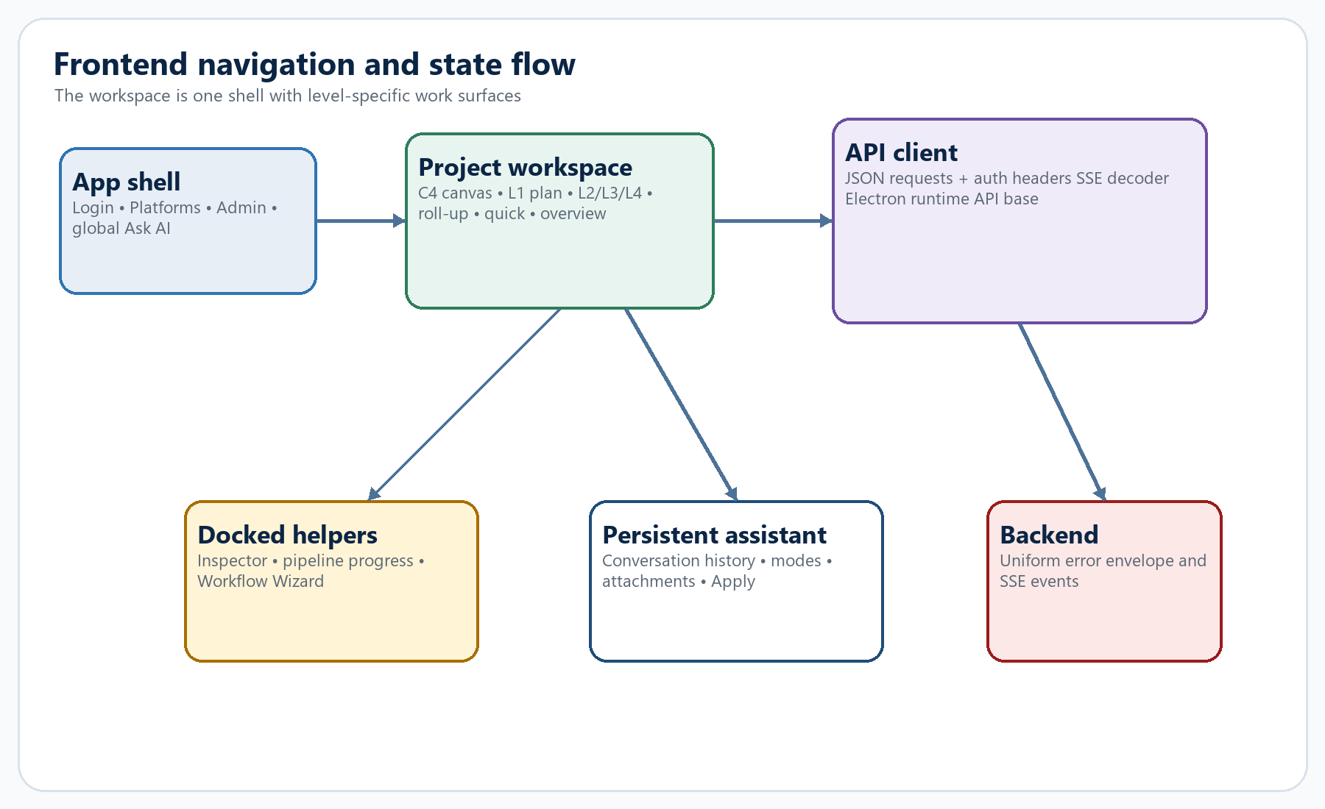
Figure 10. Frontend navigation, docked tools, API client, and backend

14.1 Application shell
- AuthProvider and ToastProvider wrap the application at startup.
- Signed-out users see Login; signed-in users see Platforms, optional Admin, global Ask AI, Guide, model/Jira status, and user menu.
- Navigation is state-based rather than a URL router; opening a project mounts ProjectWorkspace with the project ID.
- A new sign-in resets the route to Home so a prior user's privileged screen is not retained.

14.2 API client responsibilities
- Resolve API base from window.karya.apiBaseUrl in Electron, then VITE_API_BASE_URL, then localhost:8000.
- Read local identity and attach X-User-Id/X-User-Role to JSON, upload, download, and SSE requests.
- Convert the uniform backend error envelope into JavaScript Error objects with payload details.
- Incrementally decode SSE blocks from a ReadableStream, preserving named event types.
- Centralize every domain endpoint so UI modules never assemble ad hoc base URLs or auth headers.

14.3 C4 canvas interaction
- Load graph data, compute the visible children of the current drill path, and map elements to React Flow nodes.
- Use persisted pos_x/pos_y when available; otherwise apply a predictable grid layout.
- Double-click non-L4 nodes to drill; use breadcrumbs to move back up the hierarchy.
- Persist drag positions, create relations through connectors, and delete relations from edge interaction.
- Select a node to open the docked inspector for descriptions, artifacts, estimation, Jira, proposal acceptance, decomposition, and L1 plan summary.

14.4 Mermaid and requirements UX
The shared Markdown editor supports Edit, Split, and Preview modes, live Mermaid blocks, source/copy controls, and a bridge into Diagram Studio. Flowcharts can round-trip through a React Flow visual model; non-flowchart Mermaid source remains in safe text mode to avoid destructive conversion.
SECTION 15

Desktop runtime and packaging
Desktop mode is a shell, not a fork: it starts the same API, loads the same web build, and injects only the resolved runtime URL.
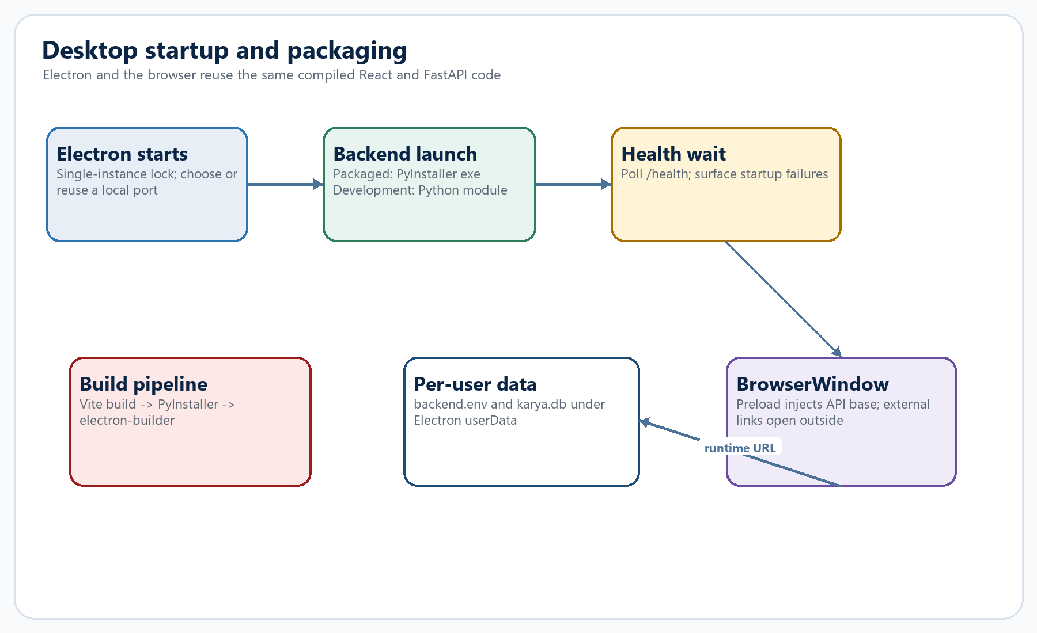
Figure 11. Electron backend startup and packaging flow

15.1 Startup flow
- Acquire a single-instance lock and focus the existing window on a second launch.
- Use KARYA_EXTERNAL_API_URL when supplied; otherwise prefer port 8765, reuse a healthy service there, or choose a random free port.
- Create per-user backend.env and data/karya.db under Electron userData when not explicitly overridden.
- Launch the PyInstaller executable in packaged mode or python -m desktop.backend_launcher in development.
- Poll /health before creating the BrowserWindow; show a startup dialog if the process exits or the health wait times out.
- Inject --karya-api-base into the renderer and expose it through a context-isolated preload bridge.

15.2 Packaging
desktop:prepare
-> generate icon
-> Vite production build (dist/)
-> PyInstaller API bundle (desktop/backend-dist/)
-> electron-builder (NSIS/portable or DMG/ZIP)
- Dynamic provider/LangGraph/docx/pptx modules are listed as PyInstaller hidden imports.
- Local Transformers bundling is opt-in because PyTorch/Transformers substantially increase installer size.
- Model weights remain in the user's Hugging Face cache rather than inside the installer.
SECTION 16

Reliability, tests, and operational behavior
The architecture favors recoverable startup, explicit retry boundaries, deterministic validations, and focused tests around invariants.

16.1 Reliability patterns
Pattern | Location | Effect
Startup-safe configuration | FastAPI lifespan | Diagnostics remain available when the LLM is misconfigured
Durable checkpoints | AsyncSqliteSaver | Refinements survive API restart
Provider retry hints | graph.nodes | Structured calls honor retry delays and retry once
Jira retry | jira.client | Retry transient network/429/5xx failures
Optimistic concurrency | planning.requirements | Prevents stale requirement overwrite
Uniform validation | Pydantic + stores | Rejects invalid payloads and cross-domain references
Proposal quarantine | status=proposed | Generated/imported scope cannot silently affect roll-up
Local LLM background load | llm.local + factory | API remains usable while weights load

16.2 Test inventory
The repository contains broad automated coverage. Static collection from the source finds 182 backend test functions in 24 files and about 69 frontend cases in 18 files.
Test family | Examples of covered behavior
Deep flow/invariants | Cross-level happy paths, deletions, links, allocation, planning rules
RBAC/ABAC | Authentication, capabilities, restricted projects, backend enforcement
Estimator | Graph routing, mock outputs, structured-output parsing, mapping
Architecture | L1/L2/L3/L4 stores, readiness, approvals, traceability, summaries, imports
AI/chat | Proposal/apply behavior, chat modes, name resolution, streaming graph
Frontend | Inspector, roll-up, chat dock, diagram studio/model, planning screens

ENVIRONMENT NOTE The repository's .venv launcher is currently broken because it points at a missing C:\Python311\python.exe. This guide therefore records the test inventory from source rather than claiming a fresh full test run.

16.3 Operational checks
# web development
npm run dev:all
# offline deterministic mode in backend/.env
LLM_PROVIDER=mock
LLM_MODEL=mock
# test/build commands once the Python environment is valid
npm run test:all
npm run build
SECTION 17

Extension playbooks
The strongest extension strategy is to preserve existing boundaries and reuse deterministic stores rather than introducing parallel paths.

17.1 Add an LLM provider
- Classify it as native, OpenAI-compatible, offline, local, or path-based in backend/llm/factory.py.
- Add provider-specific validation only in validate_factory_config.
- Return a normal LangChain chat model and verify structured-output behavior.
- If desktop packaging imports the provider dynamically, add it to the PyInstaller spec hidden imports.
- Add tests for configuration, plain invocation, structured output, and packaging assumptions.

17.2 Add an AI proposal service
- Define a Pydantic output schema in backend/ai/schemas.py.
- Gather bounded domain context and mask user free text where relevant.
- Generate a draft through the factory; never persist in the generate function.
- Expose separate propose and apply endpoints.
- Apply accepted data through existing stores so invariants, RBAC, and audit behavior remain consistent.
- Provide deterministic mock output and UI review/dismiss/apply states.

17.3 Add a new architecture artifact
- Define the SQLite table and safe forward migration.
- Create Pydantic create/update models, store functions, service semantics, and router endpoints.
- Decide whether the artifact contributes to readiness and document the weight/criteria.
- Include it in Markdown/Mermaid summaries and traceability only when it improves the evidence chain.
- Add frontend table/dialog/editor behavior and tests around invariants.

17.4 Add a connector
- Add it to the catalog and map it to an existing field archetype or define a new archetype.
- Keep secrets write-only and ensure required fields are enforced before enablement.
- Distinguish deterministic saved-configuration validation from a true live connection test.
- If it becomes a live adapter, implement a bounded client boundary similar to Jira and update status computation.
SECTION A

Appendix A — readiness weights
Readiness scores are transparent weighted sums; they are guidance and workflow signals, not model-generated opinions.
L1 area | Weight
Vision and OKRs | 15%
Stakeholders | 15%
Capability map | 15%
System context | 20%
Risk and funding | 15%
Traceability | 10%
Approval | 10%

L2 area | Weight
L1 alignment | 10%
Container diagram | 15%
Service boundaries | 15%
API contracts | 15%
Deployment topology | 10%
NFR coverage | 15%
Security review | 10%
People/RACI | 5%
Approval | 5%

L3 area | Weight
L2 alignment | 10%
Component diagram | 15%
Component breakdown | 15%
Interfaces | 15%
Dependencies | 10%
Design concerns | 15%
Security review | 10%
People/RACI | 5%
Approval | 5%

L4 area | Weight
L3 alignment | 15%
Code units | 25%
Test coverage | 25%
Definition of Done | 25%
Diagram | 10%

INTERPRETATION 80-100% is ready; 50-79% is in progress; below 50% is an early draft. The checklist can still expose incomplete items even when the weighted score is high.

SECTION B

Appendix B — database domain map
Forty-three tables support the platform; this map groups them by responsibility.
Domain | Tables
Portfolio | projects, repo_links, jira_links
C4 and estimation | c4_elements, c4_relations, artifact_links
L1 operating plan | l1_agile_units, l1_plan_settings, l1_team_members, l1_work_items, l1_diagrams
Requirements | l1_requirement_documents, l1_requirement_versions, l1_requirement_comments, l1_requirement_audit
Resources and access | resource_staff, resource_lookups, resource_custom_fields, app_access
L1 architecture | l1_vision, l1_okrs, l1_stakeholders, l1_capabilities, l1_risks, l1_approvals, l1_comments
L2 architecture | l2_arch, l2_approvals, l2_containers, l2_apis, l2_nfrs, l2_integrations
L3 architecture | l3_arch, l3_approvals, l3_components, l3_interfaces, l3_dependencies, l3_concerns
L4 implementation | l4_arch, l4_code_units, l4_test_cases, l4_checklist
Integrations | integration_configs
Assistant | chat_conversations, chat_messages, chat_attachments

SECTION C

Appendix C — API families
Routes follow domain ownership and largely mirror the frontend API client.
Family | Representative routes
Platform | /health, /config, /projects, /jira, /upload, /estimate
C4 | /projects/{id}/c4/*, /elements/{id}/estimate, /rollup
Planning | /projects/{id}/l1/{l1}/plan, units, members, work, diagrams, requirements
Architecture | /projects/{id}/l1|l2|l3|l4/{element}/arch/*
AI | /projects/.../ai/*, /reporting/narrative, /ai/orchestrate, /ai/summarize
Workflow/chat | /projects/{id}/workflow, /chat, /chat/stream, /chat/apply, conversations/attachments
Admin | /access, /reporting, /resources, /integrations

C.1 Route authorization summary
Route class | Requirement
Public diagnostics/login | No sign-in
Authenticated reads | Resolved enabled role
Project/chat proposals | Authenticated; restricted-project ABAC still applies
Normal writes | platform.edit
Access / reporting / resource writes / connector config | Dedicated admin capability

SECTION D

Appendix D — module boundary guide
These are the best starting points when navigating the source.
Area | Responsibility
backend/api | Application lifespan, middleware, shared SSE, top-level routes
backend/graph | Estimator state, node prompts/contracts, graph wiring, checkpoint registry
backend/llm | Provider factory, local runtime, deterministic mock
backend/c4 | C4 models, CRUD/invariants, story context, roll-up, scans/imports
backend/planning | L1 teams/work/diagrams, requirements lifecycle, Office exports
backend/l1arch..l4arch | Level-specific architecture stores, readiness, summaries, governance
backend/ai | Proposal generators, schemas, PII masking, orchestration
backend/chat | Concurrent chat graph, deterministic dispatch, conversation store
backend/auth + access | Role resolution, route policy, ABAC, access assignments
backend/resources + reporting | Global people directory and deterministic portfolio metrics
backend/integrations + jira | Catalog/configuration framework and live Jira boundary
frontend/src/api | Single client for JSON, downloads, auth headers, SSE
frontend/src/c4 | Canvas, inspector, estimation dialog, roll-up
frontend/src/planning | L1-L4 workspaces, requirements, Mermaid studio/model
frontend/src/screens | Home, project workspace, quick estimate, admin, workflow
desktop | Electron process, preload bridge, backend launcher, packaging spec

SECTION E

Appendix E — glossary
Shared vocabulary keeps product, architecture, and engineering discussions aligned.
Anchor — A fixed calibration story with an agreed point value and rationale.
Artifact link — The record connecting a C4 element to its agile artifact, Jira key, points, flags, and session.
C4 context — Architecture evidence injected into an estimation story: hierarchy, relations, code path, repositories.
Checkpoint — Serialized LangGraph state keyed by thread_id, enabling refinement and resume.
Cross-cutting artifact — Bug, tech debt, or architecture flow attached as a tag rather than a parent-child node.
Deterministic service — Code that calculates from persisted facts without generative model output.
Proposed — Review state for imported or AI-generated elements; excluded from roll-up.
Readiness — Weighted completeness score and checklist for an architecture level.
Refinement — A follow-up estimate using the same checkpointed session and an added assumption or scope change.
RACI — Responsible, Accountable, Consulted, Informed assignment matrix.
Roll-up — Deterministic aggregation of L3 story points and flags through L2 and L1.
SSE — Server-Sent Events stream used for estimator and chat progress.
Structured output — Model response validated against a Pydantic schema.

Source reference
Representative source files used throughout this guide:
- AGENTS.md; README.md; docs/monorepo.md; docs/local-llm.md
- backend/api/main.py; backend/api/streaming.py; backend/storage/db.py
- backend/graph/build.py; backend/graph/nodes.py; backend/graph/state.py; backend/anchors.py
- backend/c4/models.py; backend/c4/store.py; backend/c4/service.py; backend/c4/router.py
- backend/planning/store.py; backend/planning/requirements.py; backend/planning/exports.py
- backend/l1arch, backend/l2arch, backend/l3arch, backend/l4arch
- backend/ai/agents.py; backend/ai/schemas.py; backend/ai/masking.py
- backend/chat/graph.py; backend/chat/service.py; backend/chat/router.py
- backend/auth/deps.py; backend/auth/permissions.py; backend/access/store.py
- backend/integrations; backend/jira; backend/ingest; backend/resources; backend/reporting
- frontend/src/App.jsx; frontend/src/screens/ProjectWorkspace.jsx; frontend/src/api/client.js
- frontend/src/c4; frontend/src/planning; frontend/src/components; frontend/src/auth
- desktop/electron/main.cjs; desktop/electron/preload.cjs; desktop/pyinstaller/karya-api.spec
- backend/tests; frontend/src/**/*.test.js(x)

