CHAPTER 1

INTRODUCTION

1.1 General
Internet security is a branch of computer security specifically related to the Internet. Its objective is to establish rules and measures to use against attacks over the Internet. The Internet represents an insecure channel for exchanging information leading to a high risk of intrusion or fraud, such as phishing, SQL injection, cross site scripting etc. Different methods have been used to protect user credentials, transfer of data over the Internet using techniques like encryption, hashing and so on.

Phishing, basically is a criminally fraudulent process of attempting to acquire sensitive information such as usernames, passwords and credit card details by masquerading as a trustworthy entity in an electronic communication. Phishing is a form of online identity theft.
Phishing attacks combines social engineering and technical spoofing techniques to persuade users into giving away sensitive information that the attacker can then use to make a financial profit. Such an attack is typically carried out using an email or an instant message, in an attempt to entice recipients to a phished of fake web site to disclose personal credentials.
Phishing scams have been receiving extensive press coverage because such attacks have been increasing in number and sophistication. Many online service providers believe that their reputation is at stake and fear that users will lose confidence in electronic commerce. These attacks have seriously afflicted Internet users and financial institutions with identity thefts and brand reputation damage. According to recent Anti-Phishing Working Group (APWG) reports [22] and Gartner surveys [16], there is an increase in the number of phishing sites, victims, and the amount of financial losses stemming from phishing attacks.
1.2 Motivation
To defend against phishing attacks, a number of countermeasures have been proposed and developed. Server-side defenses employ SSL certificates, user selected site images, and other security indicators to help users verify the legitimacy of web sites. Client-side defenses equip web browsers with automatic phishing detection features or add-ons to warn users away from suspected phishing sites. However, usability study demonstrates that neither server-side security indicators nor client-side toolbars and warnings are successful in preventing vulnerable users from being deceived [10, 11].

Existing mechanisms are less efficient in completely protecting users because (1) Phishers can convincingly imitate the appearance of legitimate web sites, (2) users tend to ignore security indicators or warnings, and (3) users do not necessarily interpret security cues appropriately. Educational defenses teach users to understand and avoid phishing attacks [13]. However they cannot completely foil phishing attacks. Takedown defenses exploit spams and suspicious URLs to discover and shut down newly-emerged phishing sites. However, the efficacy of this approach is limited, due to the ease of setting up and the short online time of phishing sites, as well as the application of takedown evasion methods by Phishers [14, 16]. These different approaches are all preventive by nature. They endeavor to prevent users from being tricked into revealing their credentials to phishing sites. Nevertheless, these prevention-based approaches alone are insufficient to shield vulnerable users from falling prey to the phishing attack and defeat Phishers.

The ever-increasing prevalence and severity of phishing attacks clearly indicate that there is a strong urge for the development of some efficient anti-phishing mechanisms.

1.3 Problem Description
Many anti-phishing mechanisms currently focus on helping users verify whether a web site is genuine. However, prevention based approaches alone fail to effectively suppress phishing attacks and protect Internet users from revealing their credentials to phishing sites.

Therefore a new approach is implemented to prevent users from phishing attacks with the use of a unique client-side anti-phishing tool, PhishProtector, in form of a Firefox Extension, which transparently feeds a relatively large number of bogus credentials into a suspected phishing site. It conceals a victim's real credential among bogus credentials, and enables a legitimate web site to identify stolen credentials in a timely manner.

1.4 Related Work
The process going on this web portal was previously maintained through mails. The process was that the members used to mail questions to the administrator. Then the administrator used to have a team working on it. This team included people with different level of expertise. These questions were distributed among the members of the team considering their area of interest. Few experts come to the office get the list of printed questions on their area of expertise. These people used to work on these problems answer the questions and then there were guys who type and mail back the answers. This gradually increased from a small circle of users to 6000 users. So now we are given this to make it automated. This should basically not involve so much of admin time to maintain it and should be user friendly in both cases regarding money transactions and timeozones. This is bacially designed to be generic model so that it can be extended to any further applications of this kind. Namely be it a telehealth care or a jobpost. When we take telehealth care it will be like there will be doctors who come online to meet his patients from home rather than maintaining a clinic and all. Depending on the doctors availability the patients are allowed to book a slot. Then it can be extended to video conference with the patient and all. There are a few existing system on this but not very user friendly and it did not support business models like video conferencing, instant messaging and all.

1.5 System Requirements
Hardware Requirements
- System/PC.
- Wi-Fi/ Internet connectivity.
Software Requirements
- WampServer.
- Photoshop.
- MySQL.
- Text editor.

1.6 Report Organization
The document is further organized in form of chapters with each chapter giving a detailed overview in a particular area. Chapter 2 gives an overview of the proposed system including limitations with the existing systems. Chapter 3 discusses in great depth about the requirement and the design of the system. Chapter 4, however, discusses about the implementation of the system, its interface and the testing process involved. Chapter 5 concludes with the result. Chapter 6 concludes the report with future enhancements that can be one to make a better system.

CHAPTER 2

OVERVIEW OF THE PROPOSED WORK

2.1 Introduction of Problem and its Related Concepts
The existing system was built back in year 2000 when automation was scarce in the web based applications. The system couldn’t handle huge data volumes and added to that doing the things manual has become an overhead. With the development of Paypal, Sage Pay and other such online payment service providers, now we have a way to integrate these payment gateways in our applications and automate the transactions.
Since the data being handled in the existing system using only the server resources the load on the server is affecting the application performance. To reduce the load on the server scripting languages such as PHP and Javascript have to be used.
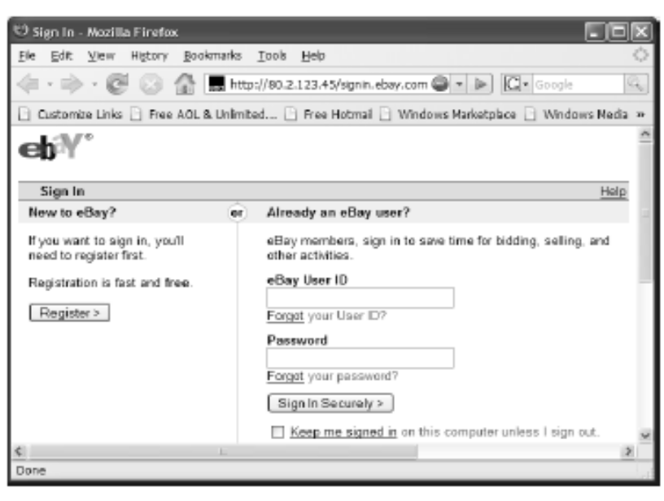
Figure 2.1.1: A Phishing site designed to attack EBay users

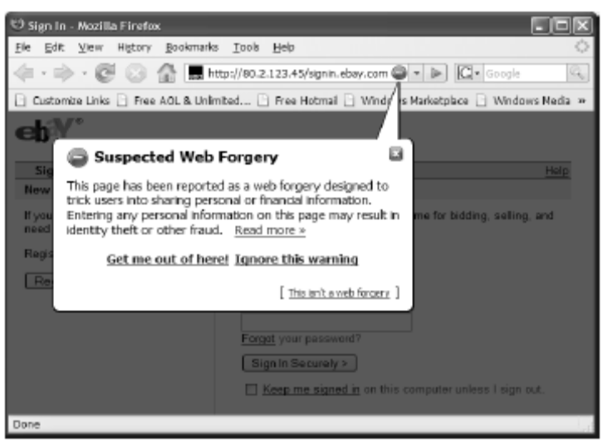
Figure 2.1.2: Phishing detection mechanism of Firefox
Figure 2.1.1 as shown above shows a phished eBay page made to trap innocent users. Figure 2.1.2 shows the warning given by built in Phishing detection mechanism of Mozilla Firefox.

2.2 Gaps Identified from the Existing Systems
The existing systems are good enough and had implemented novel ideas but no system is 100 percent efficient and hence some limitations exist with their working. Here are some of them:

- Server resources are being used extensively for fetching data from the database
- Bad user interface limiting the interaction between user and the system
- No automation for managing the payments
- Loopholes in the application restricting the information that has to be given to the administrator
- Managing the data has become difficult to understand considering the fact that the application is getting huge amounts of data.
- Topics are limited to education domain only
- Cost of maintaining the system is too high

2.3 Proposed Solutions
- Integrating the automated payment gateway
- Using SSL(Secure Socket Layer) for transactions
- Writing Web services so that mobile applications can interact with system
- Re-designing the system by using client side scripting where ever possible and reducing the load on the server

CHAPTER 3

ANALYSIS AND DESIGN

3.1 Brief Introduction
NetSchoolZone is basically designed for offering online tutoring to students by giving them access to carefully screened Experts educated at top universities such as Harvard, Stanford, MIT, UC Berkeley, Yale, Princeton, Columbia, Cornell, and Penn. NetSchoolZone Experts provide comprehensive explanations and clarifications on the problems you are stuck with.
"To provide an online res once for students and professionals to receive individual help from highly qualified PhD and Masters level experts."

3.2 Requirement Analysis
The Requirement Analysis follows the practice mentioned in IEEE Std. 830-1998 IEEE Recommended Practice for Software Requirements Specifications [1].

3.2.1 Functional Requirements
- Product Perspective
The System takes questions from the registered members and provides an interface for the administrator and experts to answer the questions. When a member posts a question the system takes the posted time in the time zone of that of the member and stores it in the database. While retrieving the questions the system automatically converts all the times to respective time zones of the users.
The system provides an interface for experts to talk to member and administrator and to provide an answer for the question. Details related to payments are dealt only by the administrator. The system accepts the payments via PayPal in an automated manner and keeps a log of the transactions. The system also provides web services for mobile applications.

- Product Features
NetSchoolZone has the following features:
      - Light-weight and secured web application
      - Its working is triggered automatically whenever a fake page is identified and hence no manual work is required is for protection.
      - Offensive line - It creates a number of bogus credentials and pass on to Phisher.
      - Defensive line - It allows the legitimate web site to identify the stolen credentials in a timely manner.
      - There is no side effect of user’s account being blocked because all the usernames are different for the S login requests sent out by PhishProtector, the “account with many failed login attempts" alarm will not be triggered.
      - It is completely transparent to users.
      - It has no security issues.
- User Characteristics
The different categories of users using this product will range from naïve internet user to people with technical expertise in the field of computers. Majority of the users are from the education domain while there might be few users from the working section.

- Operating Environment
The application runs on Linux operating system with apache web server, PHP and MYSQL. Together these software components called LAMP Architecture. The user intending to use the application must have a web browser and internet access.
- Assumptions and Dependencies
It is assumed that a Phisher does not have a complete list of valid usernames for a targeted legitimate web site, and cannot directly query a targeted legitimate web site for the validity of a specific username. Although this assumption may not be strictly correct for email service web sites and community web sites, it is generally true for financial institutions, which are the main targets of phishing attacks. Financial institutions seldom have valid username lists publicly accessible. Meanwhile, for a failed login attempt, web sites often try to hide whether the failure is due to an incorrect username or due to an incorrect password by returning the same error message, making it very hard to test the validity of a given username.
PhishProtector’s working is dependent on the phishing detection mechanism of the underlying web browser.

      - Domain Requirements
- Feeding of Bogus Credentials
The key feature is to transparently feed a relatively large number of bogus credentials into a suspected phishing site, rather than attempt to prevent vulnerable users from phishing. These bogus credentials conceal victims' real credentials among bogus credentials, and enable legitimate web sites to identify stolen credentials in a timely manner.

- Integration with the Web Browser
PhishProtector is seamlessly integrated with the phishing detection and warning mechanisms in modern web browsers. Present day browsers come with built in phishing detection mechanism. PhishProtector makes use of this instead of implementing the detection module again.
- Transparent to the Users
At a user's web browser, PhishProtector is turned on once a login web page is classified as a phishing page by a web browser's built-in phishing detection component or a third-party detection toolbar. It can also be launched through menu items or using a PhishProtector bar button. However, if user did not launch and has come across a phished page, it triggers itself automatically after the generation of the warning. For a victim who is beguiled into divulging a real credential, PhishProtector hides the real credential among a set of automatically generated bogus credentials, and then submits these credentials one by one to the phishing site. For a security-conscious user who does not reveal a real credential, PhishProtector also generates a set of bogus credentials, and then submits them to the phishing site in the same way as it does for a victim. This whole process runs in background and user is unaware of this.

- Detection of Fraudulent Process at the Legitimate Website
PhishProtector makes it difficult for a Phisher to distinguish who are real victims and which are real credentials. The only effective way for a Phisher to sift out bogus credentials is to visit the legitimate web site and verify whatever credentials have been collected from the phishing site. At the legitimate web site, if the Phisher assumes the burden of verifying all the collected credentials to single out the real credentials, the unique design of bogus credential generation will facilitate the legitimate site to identify victims' stolen credentials in a timely manner and make it harder for a Phisher to succeed. In other words, the bogus credential filtering process becomes the trigger for detecting stolen credentials at the legitimate web site.

- Independent of Underlying Phishing Detection Mechanism
While leveraging the power of widely used client-side automatic phishing detection techniques, PhishProtector is not bound to any specific phishing detection scheme. Thus, it can utilize the latest advances in phishing detection techniques such as blacklists and heuristics to protect against a wide range of phishing attacks.
3.2.1.2 User Requirements
- User Interface
The basic user interface should be in the form of a tool bar button and a menu item. This can be used to manually launch PhishProtector. Rest of the work will be transparent to the user and therefore not much of user interface is required.
- Hardware interface
There is no additional hardware required. Minimal requirements include a system/PC with internet/Wi-Fi connectivity as PhishProtector is designed for an internet user.
- Software Interface
PhishProtector is seamlessly integrated with the built-in phishing protection feature of Firefox. There is no involvement of any other software or database.
- Communication Interface
PhishProtector will be used as an extra “add on” with the Mozilla Firefox browser. This will work as the interface for the communication. From user’s perspective it’ll be used for just giving warning messages regarding the web site he or she is visiting.

3.2.2 Non Functional Requirements
- Performance Requirements
- PhishProtector should be able to identify that an identity has been compromised.
- It should not create any overhead to users for remembering extra passwords.
- PhishProtector should be smart enough to trigger its working and not waiting for users to do that.
- Additional computations should not incur any overhead.
- It should be cost effective.
- The generation of bogus credentials should be such that the Phisher should not be able to identify the existence of any non human versions of protection.
- Submission of extra credentials should not incur delay in the users communication with the server.
- Safety Requirements
No additional safety measures are to be taken into consideration while installing the product. There is no harm in any way in using this extension. It doesn’t breach any level of security.
- Security Requirements
None.

3.3 Design of the Proposed System
3.3.1 Design
The description of the design of the system follows the guidelines mentioned in IEEE Std. 1016-1998 IEEE Recommended Practice for Software Design Descriptions [2]. The design approach is discussed in detail and the reasons as to why a particular architecture design is selected.

3.3.1.1 Design Overview
NetSchoolZone is a web portal where people called members post any kind of questions, might be related to any base like studies, music or general knowledge. The admin who takes care of the portal have a number of quality experts related to each domain. Once the question is posted admin selects the expert who can answer the question based on the question subject and the expert domain then the question is assigned to the expert. Status of the question keeps changing from new to open then complete just to be aware of the process going on. The payment is also expected by the admin from the member once the question status changes. If the question is answered the expert is paid by the admin. The expert can negotiate on the due time and the amount processed by the member.

A context level diagram as in Fig 3.3.1.1 shows the basic modules present in the tool.

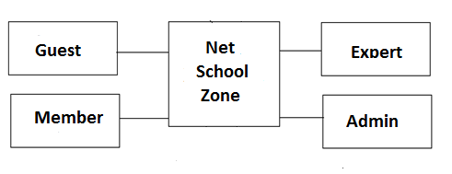
Figure 3.3.1.1: Context Level Diagram

      - Requirements Traceability Matrix

Table 3.3.1.2.1 Requirement traceability matrix

Req.  Spec. No. | Req. Statement | S/w Module | Test Case# | Verification
DR 1 | Feeding bogus credentials | Bogus credential generation module | 2 | Available
DR2 | Integration with the browser | Phishing detection module | NA | Available
DR3 | Transparency to users | Request Submission module | NA | Available
DR4 | Detection of fraud | Stolen Credential Identification Module | NA | Available
DR5 | Independent of underlying phishing detection | Phishing Detection module | NA | Available
PR1 | Detection of identity theft | Stolen Credential Identification Module | NA | Available
PR6 | Correlation and Indiscernibility | Bogus Credential generation module | 2 | Available
UR1 | System Interface | Phishing detection component | NA | Available

    - System Architectural Design
Architectural design should satisfy functional and non functional requirements. System architecture affects the performance, robustness, durability, and maintainability of the system. Therefore, considering all the aspects a proper design is to be selected. There can be different conventions followed for choosing a proper design.

3.3.2.1 Chosen System Architecture
The design approach followed here is the layered design. The system is organized in form of layers, each of which provides a set of services. There are basically five layers in this design.
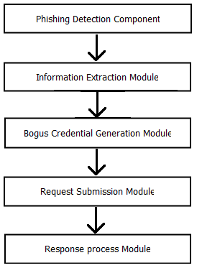
Figure 3.3.2.1.1 Architectural diagram of the system
The reason for selecting the layered approach is that it supports incremental development of the system. As a layer is developed, some of the services provided by that layer can be made available to the users. This architecture is also changeable and portable. As far as the interface is unchanged, a layer can be replaced by another equivalent layer. Further when layer interfaces change or new facilities are added to a layer, only the adjacent layer is affected. As layered systems localize machine dependencies in inner layers, this makes it easy to provide multi platform implementation of an application system.

      - Discussion of Alternative Designs
Design of any project can be done either using the structured analysis or using the object oriented analysis. Depending upon the requirements and the nature of the project, a design approach is selected. Both the traditional and object oriented approaches have distinct features, advantages and disadvantages of their usage.

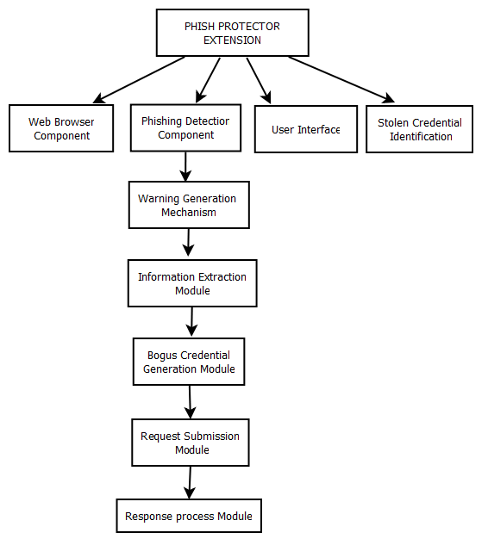
Figure 3.3.2.2.1: Alternative architectural diagram 1

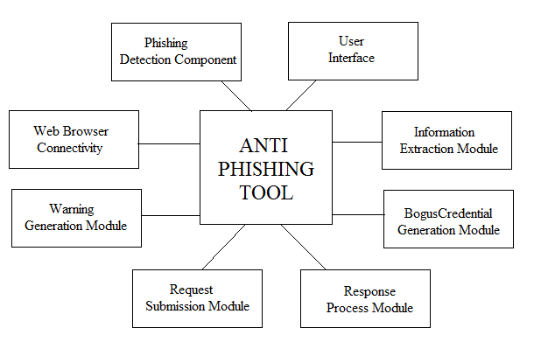 Figure 3.3.2.2.2: Alternative architectural diagram 2

Though the project could have followed the architectures specified above in Figures 3.3.2.2.1 and 3.3.2.2.2, it has been chosen to follow a layered architecture instead. In a modular approach, various modules are supposed to be communicating with each other but such an interaction is clumsy and does not suit the requirements. The project requires a systematic interaction through proper interfaces between layers and hence a layered architecture is chosen.

    - System Interface Description
System interface description discusses about all the modules in depth. It gives a deep insight to the working of the system. The basic idea behind the working PhishProtector is very simple. When a login page is classified as a phishing page by a browser's built-in detection component or a third-party detection toolbar, working is triggered. At this point, the PhishProtector will perform differently based on a user's response to the browser's phishing warning page.

For a vulnerable user who ignores the warning message and submits a real credential, the tool will intercept the victim's real credential, generate similar looking another S credentials, and then submit these credentials one by one to the phishing site within a few milliseconds.
For a security-conscious user who responds to the warning, the PhishProtector will generate a username/password pair first. Then using this credential pair it’ll generate a set of S bogus credentials, and then feed them one by one into the phishing site in the same way as it does for a vulnerable user. These actions are completely transparent to both vulnerable and security-conscious users.
PhishProtector installed on users' browsers make up the offensive line. Later on, when a Phisher verifies the collected credentials at the legitimate site, the defensive line enabled by the PhishProtector will help a legitimate site to detect victims' stolen credentials in a timely manner.

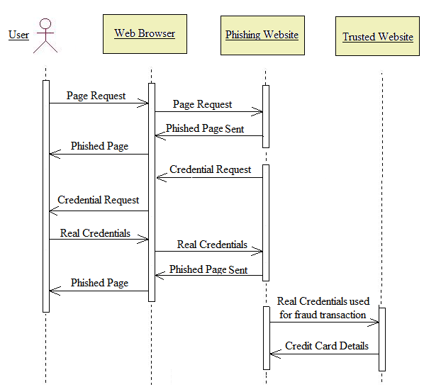
Figure 3.3.3.1: Phishing attack without PhishProtector

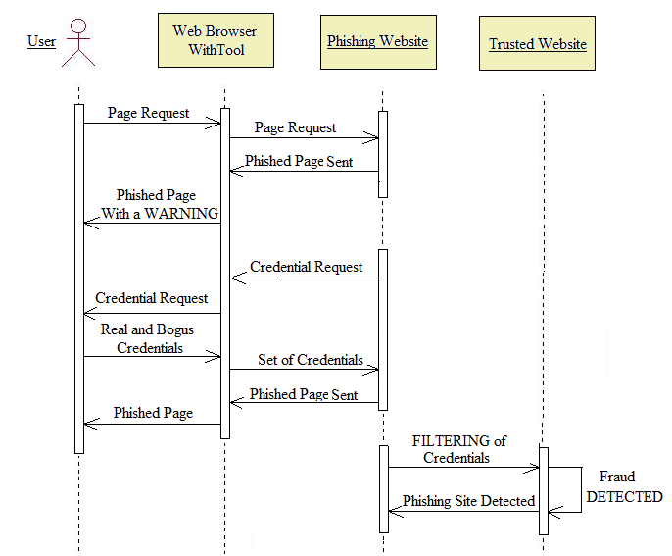
Figure 3.3.3.2: Phishing attack with PhishProtector

There are two key objectives:
1. User friendly
It is taken care that the website is build mainly on the user point of view. Considering the important things necessary in each users perspective.
2. Security
- Password encryption
The password details taken from the user while registering as member or an expert is encrypted and then sent to the database and then decrypted while we need to use it in the time of login.
- Captcha
This is used to check if the user is really a human or not. The problem when this is not used is any ex-party can crash the system by writing script to create multiple users in seconds. The captcha prevents it from happening.
- Usability
The usage of the tool at the client-side should not incur undue overhead or unwanted side effects, nor should it produce any security or privacy concerns.

3.3.3.1 Detailed Description of the Components
The complete system flow is shown above as in figure 3.3.1. It is decomposed into following modules:
- Guest
The guest is neither logged in as a expert nor a member. So we consider him to be new to this site so we need to five him the basic structure of the sit meaning what is the site about and what actually goes on. To make this happen I have considered to present five pages which are Home, About us, Testimonials, Terms and conditions and Contact us. The home page as shown in the demo would give the guest a gist of what NetSchoolZone is basically about. The About us would give them the idea of how things happen so that they could trust us. The Testimonials page presents the feedback from the members who are satisfied with the answers given by our experts. Terms and conditions are the general rules to be follows about the content they are posting and about the blocking and unblocking of cookies and usage policy. The contact us page will give them the order enquiry, payment and advertising details.

- Member
Member is the one who is part of Netschoolzone to clarify his doubts. He is here basically to post a question. Then he will be allotted a expert to answer his question based on the question subject field taken from the member. He is provided with multiple optlions like Post a question, Mange questions asked, Search question and Profile view. Each question posted is allotted a question id automatically. This is used while searching for a question which which the member has already posted. Then his profile view which gives his details along with the member id allocated to him. The home page for the member once he is logged in will be the list of question he has asked in the latest to oldest order. The member need to pay the amount in advance i.e right along with the posting of his question.

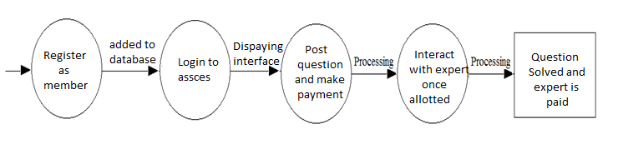
Figure 3.3.3.1.1: Data Flow Diagram for Information Extraction Module
- Expert
Expert is the one who also can register normally like a member. But he will be activated by the administrator only after crosschecking with his qualifications. Once the administrator is sure of his capabilities of answering questions he will be activate it and from then he will be a active part of NetSchoolZone. The expert once he is active gets the list of recently posted questions by the members. If he thinks he can answer that question he will intimate it to the admin. Then admin checks with it and assigns the question to the expert with some estimation time. The expert will be paid accordingly by the admin after getting the review from the member. The expert is also provided with multiple options like managing questions, status of the question updated by the member and all. The home page for the expert will be the list of questions he is answering at the moment.

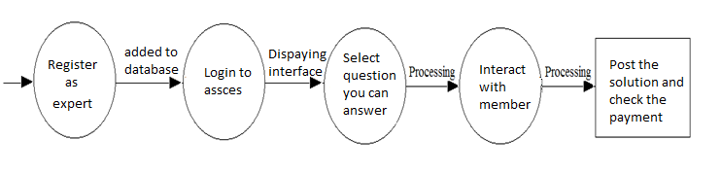
Figure 3.3.3.1.2: Data Flow Diagram for Bogus Credential Generation Module

- Admin
After receiving and interpreting an HTTP request, a web site replies with an HTTP response message. For a legitimate web site, if the credential carried in a request is valid, a successful login page is returned in the response message; otherwise, a failed login page is returned in the response message. Phishing sites may take different response actions after receiving credential submission requests. In every case, Tool parses and renders the response message of the first HTTP request on the browser window, and processes the response messages of the S-1 requests behind the screen using a callback function. Therefore, Tool can always correctly match responses to their corresponding requests and work transparently to users.

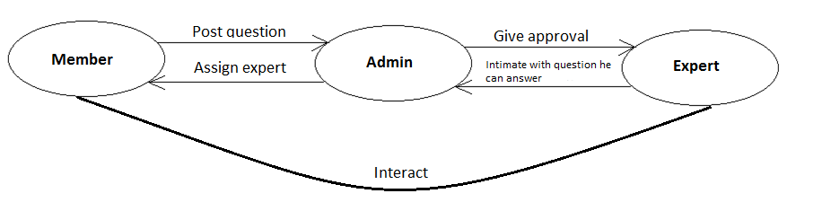
Figure 3.3.3.1.3: Request response cycle

3.4 Design Constraints
PhishProtector is designed keeping in mind the following design constraints:
1. Economic:
One of the largest limiting factors of any design project is the economic constraint. Keeping this in mind, PhishProtector was designed as an open source application. As, it is an extension to Mozilla Firefox, which is itself an open source web browser, PhishProtector is also available free of cost.
2. Environmental:
Environment can be defined as the surroundings, and conditions that influence performance of a design. The project will not bring about any harm to the internet environment.
3. Sustainability:
Sustainability refers to the ability of an engineering design to perform under normal operating conditions for given length of time. As PhishProtector is an extension to Mozilla Firefox, its version has to be upgraded every time a new version of Firefox is released to maintain the compatibility.

4. Manufacturability:
The ability of a system to be produced with as few resources possible, be it parts, labour, or maintenance alludes to a system’s manufacturability. As this project is an extension to an open source browser, it can be created by anyone and everyone.
5. Ethical:
Ethical constraint can be identified by using the IEEE code of ethics. If a design or system violates the IEEE code of ethics in any way then it should not be considered as a viable solution to a design problem. Subsequently, during the duration of the PhishProtector project, consideration is made by all team members to not violate this ethical code.
6. Health and Safety:
Next, in order for a system to be ethically plausible it must also be safe. PhishProtector does not pose any health hazard to its users as it uses only software components.
7. Social:
With any design, the social impact must be considered. The project PhishProtector can be used by any user to prevent himself from falling prey to phishing attacks.
8. Political
Just as the social impact of a design must be considered, a design’s political impact must also be taken into account. Although, the social and political aspects are generally similar or the same, for this project they differ. As the nature of the project is related to web security, it has no political impact.

CHAPTER 4

IMPLEMENTATION

4.1Tools Used
The project is implemented using JavaScript, XUL, AJAX and CSS. The objects and classes used in the implementation follows W3C standards [25]. JavaScript is used for the functional coding while XUL is being used for browser connectivity and user interface development. Ajax is used in the modules dealing with requesting the server and getting response from it. Css is used for improved look and feel of the system.

4.1.1 General Introduction
- JavaScript
JavaScript, also known as ECMAScript is a prototype-based object-oriented scripting language that is dynamic, weakly typed and has first-class functions. It is also considered a functional programming language like Scheme and OCaml because it has closures and supports higher-order functions. JavaScript is an implementation of the ECMAScript language standard and is primarily used in the form of client-side JavaScript, implemented as part of a web browser in order to provide enhanced user interfaces and dynamic websites. This enables programmatic access to computational objects within a host environment.
JavaScript's use in applications outside web page, for example in PDF-documents, site-specific browsers and desktop widgets—is also significant. Newer and faster JavaScript VMs and frameworks built upon them have also increased the popularity of JavaScript for server-side web apps.
JavaScript uses syntax influenced by that of C. JavaScript copies many names and naming conventions from Java, but the two languages are otherwise unrelated and have very different semantics. The key design principles within JavaScript are taken from the Self and Scheme programming languages.
- XUL
In computer programming, XUL, pronounced "zool", the XML User Interface Language, is an XML user interface markup language developed by the Mozilla project. XUL operates in Mozilla cross-platform applications such as Firefox and Flock. The Mozilla Gecko layout engine provides an implementation of XUL used in the Firefox browser.
XUL has no formal specification and does not inter-operate with non-Gecko implementations. However, it uses an open source implementation of Gecko, tri-licensed under the GPL, LGPL, and MPL.
Mozilla provides experimental XULRunner builds to let developers build their applications on top of the Mozilla application framework and of XUL in particular.
While XUL serves primarily for constructing Mozilla applications and their extensions, it may also feature in web applications transferred over HTTP.
- CSS
Cascading Style Sheets (CSS) is a style sheet language used to describe the presentation semantics (the look and formatting) of a document written in a markup language. Its most common application is to style web pages written in HTML and XHTML, but the language can also be applied to any kind of XML document.
CSS is designed primarily to enable the separation of document content written in HTML or a similar markup language from document presentation, including elements such as the layout, colors, and fonts. This separation can improve content accessibility, provide more flexibility and control in the specification of presentation characteristics, enable multiple pages to share formatting, and reduce complexity and repetition in the structural content. CSS can also allow the same markup page to be presented in different styles for different rendering methods, such as on-screen, in print, by voice when read out by a speech-based browser or screen reader and on Braille-based, tactile devices. While the author of a document typically links that document to a CSS style sheet, readers can use a different style sheet, perhaps one on their own computer, to override the one the author has specified.
CSS specifies a priority scheme to determine which style rules apply if more than one rule matches against a particular element.
The CSS specifications are maintained by the World Wide Web Consortium (W3C).
- AJAX
Ajax (shorthand for asynchronous JavaScript and XML) is a group of interrelated web development methods used on the client-side to create interactive web applications. With Ajax, web applications can retrieve data from the server asynchronously in the background without interfering with the display and behavior of the existing page. Data is usually retrieved using the XMLHttpRequest object. Despite the name, the use of XML is not needed, and the requests need not be asynchronous.
Like DHTML and LAMP, Ajax is not one technology, but a group of technologies. Ajax uses a combination of HTML and CSS to mark up and style information. The DOM is accessed with JavaScript to dynamically display, and to allow the user to interact with the information presented. JavaScript and the XMLHttpRequest object provide a method for exchanging data asynchronously between browser and server to avoid full page reloads.

4.1.2 Reason for Selecting the Tools

- JavaScript
- JavaScript code can run locally in a user's browser rather than on a remote server, the browser can respond to user actions quickly, making an application more responsive.
- JavaScript code can detect user actions which HTML alone cannot, such as individual keystrokes.

- XUL
- XUL is relatively easy to learn for people with a background in web-programming and design.
- XUL provides a portable definition for common widgets, allowing them to move easily to any platform on which Mozilla applications run.
- CSS
- CSS has a simple syntax and uses a number of English keywords to specify the names of various style properties.
- It is very flexible.
- A style sheet is usually stored in the browser cache, and can therefore be used on multiple pages without being reloaded, reducing data transfer over a network.

- AJAX
- The term Ajax represents a broad group of web technologies that can be used to implement a web application that communicates with a server in the background, without interfering with the current state of the page

4.2 Implementation
4.2.1 Developing the Extension

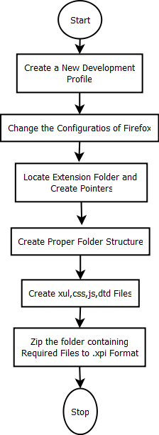
Figure 4.2.1.1: Flowchart for creating an extension from scratch

The flowchart as in Figure 4.2.1.1 shows the steps of creating an extension from the scratch. All the steps are discussed in detailed below.
  - Creating a Different Development Profile
The first step is to create a different profile in Firefox, which is required because some settings are to be changed to create an extension.

Profile manager on Windows - On opening Windows Start menu and choosing the Run option, executing firefox -P command and following appropriate steps a profile can be created. (say “developement”)
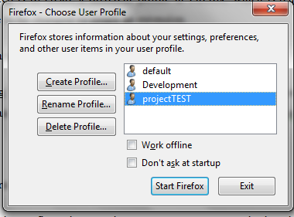
Figure 4.2.1.2: Screenshot for creating a Firefox profile
- Configuration Settings for Firefox
To change the configurations one has to type about:config in the address bar. Following changes are then made. These are good to enable extension errors in the Firefox Error Console.
- javascript.options.showInConsole = true
- nglayout.debug.disablefixulficache = true
- browser.dom.window.dump.enabled = true
- javascript.options.strict = true
- extensions.logging.enabled = true

- Pointing to an Extension
In the development profile folder, a folder named extensions exists. This contains the code of all the installed extensions. The code can either be placed here or a pointer file can be created by creating a file with a unique name. (this will have to be the same as you chose for your em:id value in your install.rdf file – more on that below).
- Creating Folder Structure and Files
To have a good base for extension development, this hierarchy is followed:
- chrome
- content
- about.xul
- options.xul
- overlay.xul
- overlay.js
- locale
- en-US
  - about.dtd
  - options.dtd
  - overlay.dtd
  - overlay.properties
- skin
- overlay.css
- images (if any)
- defaults
- preferences
- prefs.js
- chrome.manifest
- install.rdf

install.rdf
This contains all the meta information about the extension, e.g. which versions of Firefox it supports and other assorted information. install.rdf looks like this:
<?xml version="1.0" encoding="UTF-8"?>
<RDF xmlns="http://www.w3.org/1999/02/22-rdf-syntax-ns#" xmlns:em="http://www.mozilla.org/2004/em-rdf#">
<Description about="urn:mozilla:install-manifest">
<em:id>phishProtector@project.do.org</em:id>
<em:type>2</em:type>
<em:name>Phish Protector</em:name>
<em:version>1.0</em:version>
<em:creator>Divyajyoti Khandelwal</em:creator>
<em:contributor>Bhargav Teja Manikonda</em:contributor>
<em:contributor>V Vijayasherly</em:contributor>
<em:description>This extension helps you identify that the page you are visiting is a genuine page or not. It provides a warning if you try to visit a phished page. If you still continue surfing it protects you from falling prey to phishing attacks by securing your Credentials. </em:description>
<em:aboutURL>chrome://phishProtector/content/about.xul</em:aboutURL>
<em:homepageURL>http://www.onehalt.com/</em:homepageURL>
<em:optionsURL>chrome://phishProtector/content/options.xul</em:optionsURL>

<em:iconURL>chrome://phishProtector/content/p.png</em:iconURL>

<em:targetApplication>
<Description>
<em:id>{ec8030f7-c20a-464f-9b0e-13a3a9e97384}</em:id> <!-- Firefox -->
<em:minVersion>3.6</em:minVersion>
<em:maxVersion>3.6.*</em:maxVersion>
</Description>
</em:targetApplication>
</Description>
</RDF>

chrome.manifest
The chrome of Firefox is everything around the content window. i.e. web browser PhishProtectorbar, menus, statusbar etc. This one, however, is in conjunction with install.rdf the key to how the extension will be added to Firefox, and how it will work. chrome.manifest file looks like this:
content phishProtector chrome/content/
skin phishProtector classic/1.0 chrome/skin/
locale phishProtector en-US chrome/locale/en-US/

overlay chrome://browser/content/browser.xul chrome://phishProtector/content/ff-overlay.xul
style chrome://global/content/customizePhishProtectorbar.xul chrome://phishProtector/skin/overlay.css

chrome folder
This folder contains the XUL and their corresponding .js files. It is developed by Mozilla to create interfaces in Firefox, Thunderbird etc.

options.xul
This file is used for the options/preferences dialog for your extension, and its path is pointed out in the install.rdf file in the Description/em:optionsURL node. The complete options file for the extension looks like this:
<?xml version="1.0" encoding="UTF-8"?>
<?xml-stylesheet href="chrome://global/skin/" type="text/css"?>
<!DOCTYPE prefwindow SYSTEM "chrome://phishProtector/locale/options.dtd">
<prefwindow id="phishProtector-preferences" xmlns="http://www.mozilla.org/keymaster/gatekeeper/there.is.only.xul" title="&prefwindow.title;">
<prefpane id="pane1" label="&pane1.title;">
<preferences>
<preference id="boolpref1" name="extensions.phishProtector.mozilla" type="bool"/>
<preference id="boolpref2" name="extensions.phishProtector.phishTankSiteChecker" type="bool"/>
<preference id="boolpref3" name="extensions.phishProtector.netCraftPhishProtectorbar" type="bool"/> <!-- note that this is only an ASCII string - use unichar for unicode strings -->
</preferences>

<radiogroup>
<radio id="checkboolpref1" preference="boolpref1" label="&checkboolpref1.label;" accesskey="&checkboolpref1.accesskey;"/>
<radio id="checkboolpref2" preference="boolpref2" label="&checkboolpref2.label;" accesskey="&checkboolpref2.accesskey;"/>
<radio id="checkboolpref3" preference="boolpref3" label="&checkboolpref3.label;" accesskey="&checkboolpref3.accesskey;"/>
</radiogroup>
</prefpane>
</prefwindow>

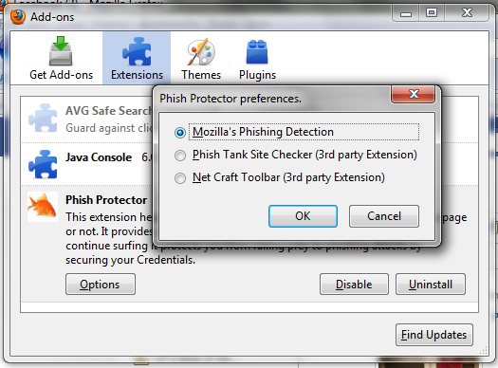
Figure 4.2.1.3: Screenshot of options available for users for detection
This file connects the user input to the actual settings for the extension which are to be found in the prefs.js file.

defaults folder
Within the defaults folder, you create a preferences folder and in that one a file named pref.js. This is used for the preferences you want to use for your extension, and looks like this:
prefs.js
pref("extensions.phishProtector.mozilla", true);
pref("extensions.phishProtector.phishTankSiteChecker", false);
pref("extensions.phishProtector.netCraftPhishProtectorbar", false);
// https://developer.mozilla.org/en/Localizingfiextensionfidescriptions
pref("extensions.divs@phishprotector.com.description", "chrome://phishProtector/locale/overlay.properties");
locale folder
This is completely meant for localization. There is only one child folder for en-US content, but it can be easily extended. That folder has a file named about.dtd, which contains translations for entities used in XUL files.
about.dtd
<!ENTITY about "Phish Finder is an extension to Firefox!! It tests the current website to see if the site is a known phishing site and then protects you from it.">
<!ENTITY version "Version 1.0">
<!ENTITY createdBy "Created By:Divya Khandelwal,Bhargav Teja;Under the guidance of Ms V Vijayasherly">
<!ENTITY homepage "Home Page:www.onehalt.com">

skin folder
This completely deals with the look and feel of the extension. The CSS in overlay.css is used for setting the image for the PhishProtectorbar, the size and space for the statusbar icon etc.
overlay.css
#phishProtector-hello{ color: orange !important; }
#phishProtector-PhishProtectorbar-button{
list-style-image:url("chrome://phishProtector/skin/PhishProtectorbar-button.png");
-moz-image-region: rect(0px 24px 24px 0px);}
#phishProtector-PhishProtectorbar-button:hover{ -moz-image-region: rect(24px 24px 48px 0px);}
[iconsize="small"] #phishProtector-PhishProtectorbar-button{
-moz-image-region: rect( 0px 40px 16px 24px);}
[iconsize="small"] #phishProtector-PhishProtectorbar-button:hover{
-moz-image-region: rect(24px 40px 40px 24px);}
- Packaging and Installing
Firefox extensions are delivered like XPI files, and those are basically just ZIP files with another extension. Therefore, when creation of files is over, files are to be zipped. Its extension is then changed to xpi. Once the XPI file is available, it can be just dragged and dropped into Firefox, and it will automatically install.

4.2.2 Developing the Modules
Section 4.2.2.1, 4.2.2.2, 4.2.2.3 and 4.2.2.4 discusses about the implementation of various modules involved in the design. These sections also include flowcharts which describes the implementation in a step by step manner.

- Information Extraction Module
The information extraction module extracts the username and password pair and its corresponding form element on a login page. First, all the HTMLInputElement objects within the HTMLDocument object of the login page are collected. Next, the password object is located by examining its special attribute type= “password”. Finally, the field right before password field is extracted which is the username.

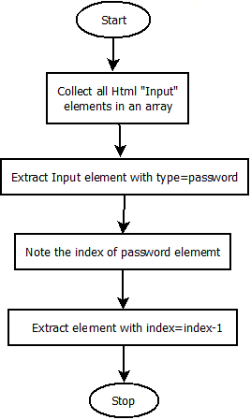
Figure 4.2.2.1: Flowchart for Information Extraction Module

- Bogus Credential Generation Module
The bogus credential generation module generates S - 1 bogus credentials based on an original credential. For a victim, the original credential is the victim's real credential. For a security-conscious user, this module will randomly generate a username/password pair composed of upper/lower case letters and digits as the original credential.

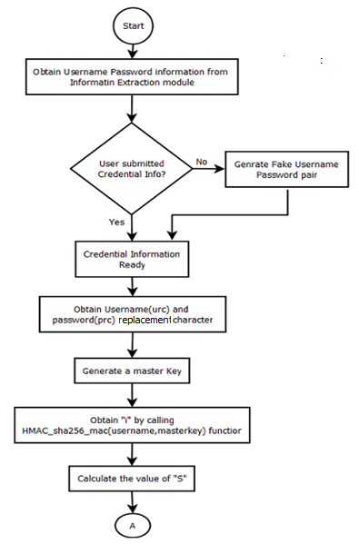
Figure 4.2.2.2: Flowchart part 1 for Bogus Credential Generation Module
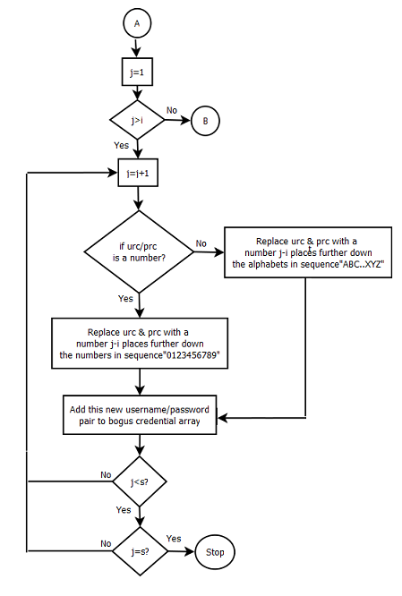
Figure 4.2.2.3: Flowchart part 2 for Bogus Credential Generation Module

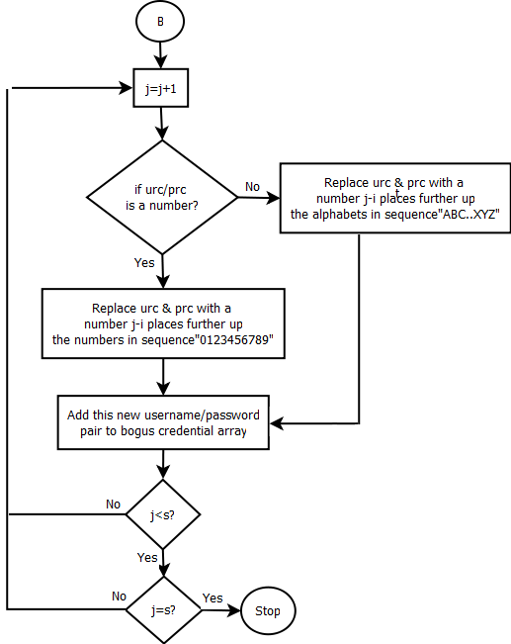
Figure 4.2.2.4: Flowchart part 3 for Bogus Credential Generation Module

- Request Submission Module
The request submission module is responsible for spawning and submitting multiple HTTP requests. The main challenge here lies in how to efficiently spawn S-1 new HTTP requests and schedule the submission of all the S requests. PhishProtector creates and uses internal HTTP channels to submit requests behind the screen. In order to make the extension code more portable, XMLHttpRequest objects is chosen to create internal HTTP channels. XMLHttpRequest allow JavaScript to perform HTTP client functionalities such as submitting form data or loading data from a server. The first HTTP request is also associated with an HTTP channel, which is created by the browser. For this first HTTP request, all its contents, such as message header and message body can be extracted from its HTTP channel. Then, S-1 XMLHttpRequest objects are created and their corresponding HTTP channels are established based on the contents extracted from the first HTTP channel. More specifically, PhishProtector executes the following four steps: request initialization, message body replacement, header fields setting, and header fields reordering:

(1) Request Initialization: For each of the S -1 XMLHttpRequests, the same request type and URL as those in the first HTTP request are used. Asynchronous mode is used so that request sending is non-blocked and all the corresponding HTTP responses can be handled in a specified callback function.

(2) Message Body Replacement: For each of the S -1 XMLHttpRequests, PhishProtector only needs to make a copy of the message body extracted from the first HTTP request, and then replace the original username/password pair with a bogus username/password pair. Nothing else needs to be changed in the message body. Meanwhile, since the first HTTP request's message body is extracted before its HTTP channel is encrypted, this message body replacement also works correctly for secured (HTTPS) connections.

(3) Header Fields Setting: For each of the S-1 XMLHttpRequest, the “Content-Type" request header field is set as “application/x-www-form-urlencoded" to mimic the case of submitting a form on a browser window. The “Content-Length" request header field is set to the same value as that of the first HTTP request, because the message body length is unchanged. The “Referrer" request header field also needs to be set as the same value as that of the first HTTP request. The “Cookie" request header field is automatically set by the Firefox web browser because the same URL has been specified. For each of the S – 1 XMLHttpRequest, PhishProtector also makes sure that “no-cache" is assigned to both the “Pragma" request header field and the “Cache-Control" request header field so that the form submissions will not be cached, and the “close" is assigned to the “Connection" request header field so that its TCP connection will not be persisted and shared with any other requests. The first HTTP request also needs to be adjusted to have the same values for these three request header fields.

(4) Header Fields Reordering: For each of the S-1 XMLHttpRequest, the request header fields must be reordered so that the same order used in the first HTTP request will be used. Since the order of request header fields is not significant, this reordering will not cause any problem. In the implementation, only the order of “Content-Type", “Content-Length", “Pragma", “Cache-Control", “Cookie", and “Referrer" is adjusted by PhishProtector, due to some subtle implementation differences between an XMLHttpRequest and a regular HTTP request in Firefox. After the completion of the four steps above, the S-1 XMLHttpRequest and the first HTTP request all have the same request type, URL, header fields, and header field order. All the S requests are sent out within a few milliseconds, and no timing clue can be observed on a web server or proxy.
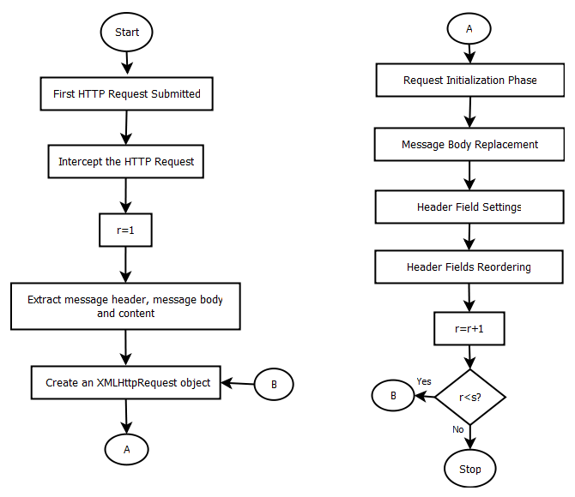
Figure 4.2.2.5: Flowchart for Request Submission Module

- Response Process Module
After receiving and interpreting an HTTP request, a web site replies with an HTTP response message. For a legitimate web site, if the credential carried in a request is valid, a successful login page is returned in the response message otherwise, a failed login page is returned in the response message. PhishProtector parses and renders the response message of the first HTTP request on the browser window, and processes the response messages of the S - 1 XMLHttpRequests behind the screen using a callback function. Therefore, PhishProtector can always correctly match responses to their corresponding requests and work transparently to users.

    - User Interface Design

The user interface follows

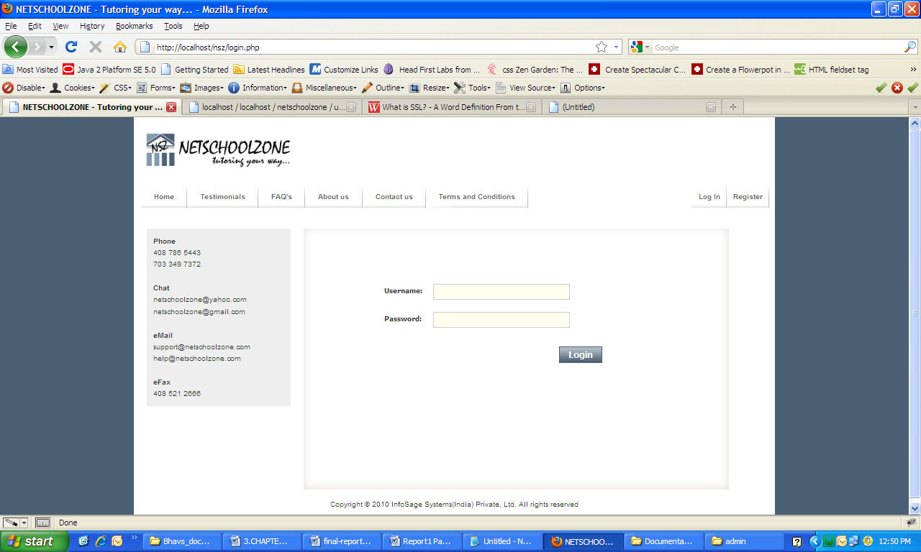
Figure 4.2.3.1: Screen shot showing the login form

The screenshot as in Figure 4.2.3.1 shows the login form where the credentials are requested from the user and on providing correct credentials the user is redirected to his home page.

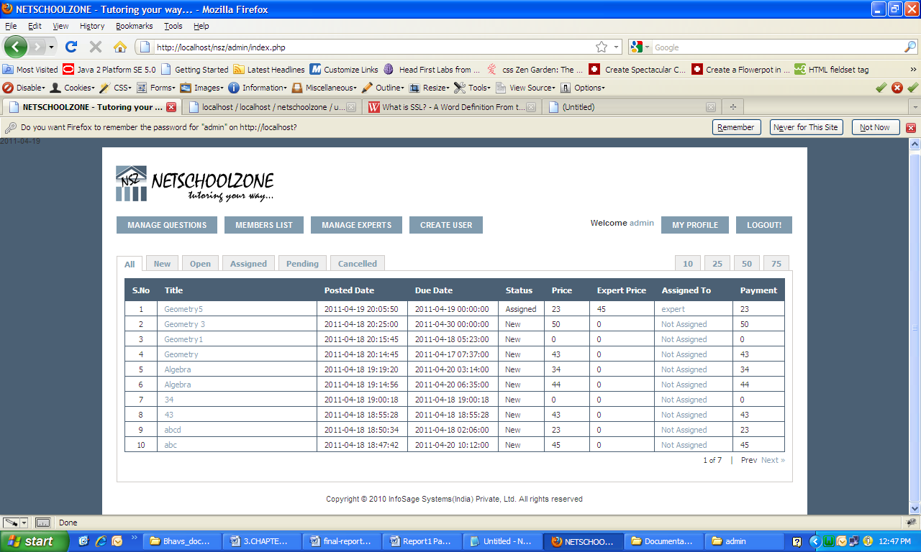
Figure 4.2.3.2: Screenshot showing the list of questions under manage question

The screen shot in Figure 4.2.3.2 shows the list of question which differs for with the user type. His own questions for member, all the questions for the admin and open questions for the expert.

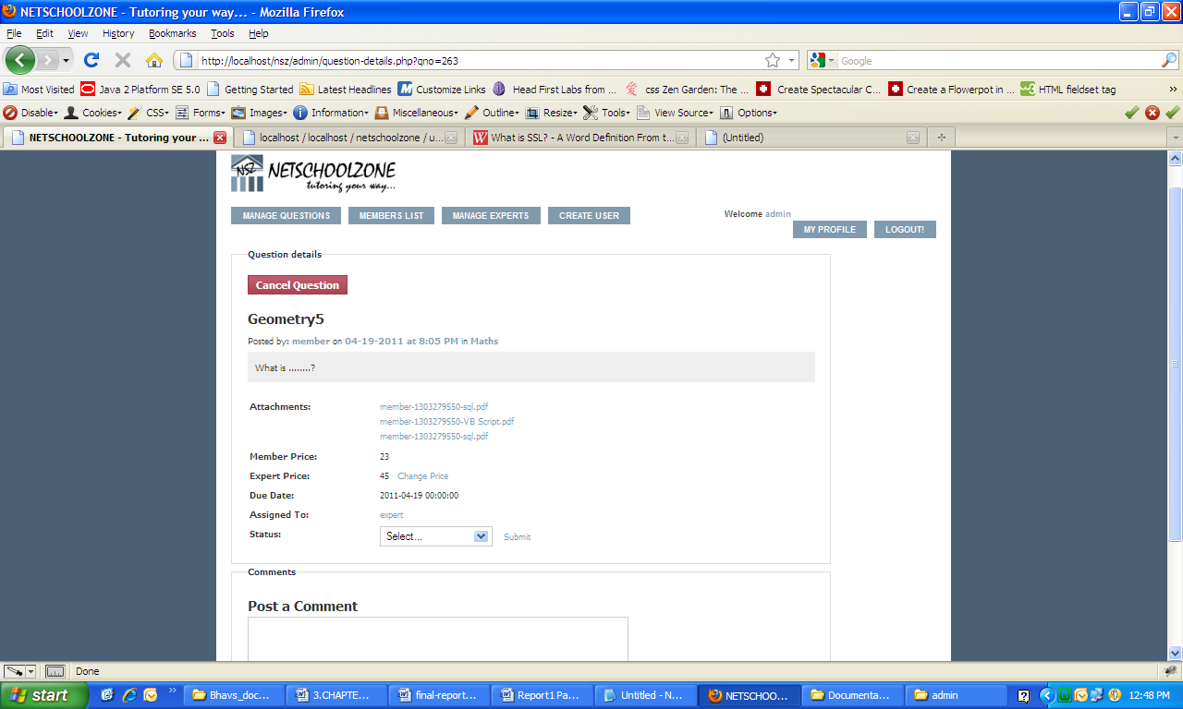
Figure 4.2.3.3: Screenshot showing the question details

The screen shot as in Figure 4.2.3.3 shows the question details form where all the details related to the question are displayed and the view differs for different type of user (member, admin, expert).

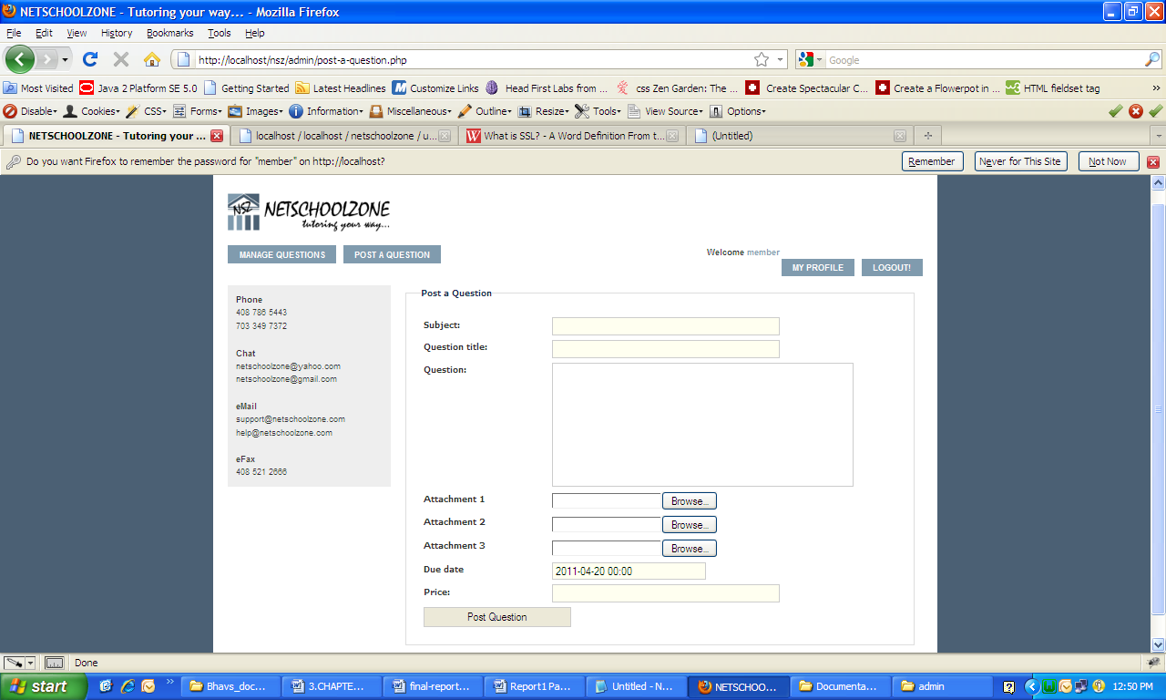

Figure 4.2.3.4: Screenshot showing the output post a question form

The screen shot in Figure 4.2.3.4 shows the post a question from with the details necessary, price to b quoted and the attachments.

4.3 Testing
The testing of the entire system is carried out as per the specifications in IEEE-829, IEEE-1008, IEEE-1012 - IEEE Standard for Software Test Documentation [3, 4].

4.3.1 Test Approach
The approach to be followed for the testing of the project starts with unit testing. Unit testing involves each and every module to be tested individually. Then all the modules are integrated together in a Big Bang approach and the entire system is tested again and again until all the issues (if any) are resolved.

4.3.2 Test Plan
The test plan discusses about the various features that needs to be tested and the others that don’t need to be tested. It also discusses about the use of testing tools and the environment in which the testing is to be carried out.

4.3.2.1. Features to be tested
- The web page is successfully opening.
- Member \ Expert \ Admin registration is successfully done.
- Member \ Expert \ Admin login is successfully done.
- Member \ Expert \ Admin operations are successfully done.

4.3.2.2 Features not to be tested
- The User interface.
- Phishing detection feature of Mozilla Firefox.

4.3.3 Testing Tools and Environment
No testing tools are used for the testing phase. Testing environment is an important factor here. PhishProtector is tested on a system having Firefox browser and internet connectivity. It is tested on various kinds of phishing and legitimate sites.

4.3.4 Test Cases

Test case: Open the NetSchoolZone webpage. |  | Priority: High
Test Objective: To check if the webpage is opening successfully.
Test Description: Enter the http address and click ok.
Test Environment:
Input | Expected Output
Enter the http address in the address bar. | View the webpage.
Pass: Yes | Fail: No
Problems/Issues: None

Test case: Registration form |  | Priority: High
Test Objective: To check if the registration is successfully done.
Test Description: The registration is mandatory for the member, expert and admin. Hence, it is mandatory. Enter all the required mandatory fields and register. Check if the login operation is successful with the valid username and password.
Test Environment:
Input | Expected Output
Enter the mandatory fields in the registration form and login after the successful registration. | Login is successful.
Pass: Yes | Fail: No
Problems/Issues: None

Test case: Login form |  | Priority: High
Test Objective: To check if the validation provided to the fields in the login page.
Test Description: After the successful registration, member can login. If member misses any field, the login is not successful. So, the mandatory fields are needed to be filled with valid data and the validation is provided for the fields. Hence, it should pass the message if any mandatory field is left blank.
Test Environment:
Input | Expected Output
Enter the data and leave some mandatory fields blank. | The alert message to be displayed.
Pass: Yes | Fail: No
Problems/Issues: None

Test case: Member account |  | Priority: High
Test Objective: To check if the question is posted successfully.
Test Description: Login as a member and click on “Post a Question”. Post the question with the attachments and fix the price.
Test Environment:
Input | Expected Output
Post the question with the attachments. | The question is posted successfully and the question is displayed in the manage questions list with all the details provided visible.
Pass: Yes | Fail: No
Problems/Issues: None

Test case: Admin account. |  | Priority: High
Test Objective: To check if the price changed is intimated to the member.
Test Description: The posted question by the member is displayed in the admin account which is in write mode. So, admin can modify the price fixed by the member. Hence, if the price is modified, it should be intimated to the member.
Test Environment:
Input | Expected Output
Change the price for the question. | The message is passed to the member that the price is modified by the admin.
Pass: No | Fail: Yes
Problems/Issues: The payment is done by the member. Hence, if the price is modified, the message or pop up window is to be displayed in the member account where the member should accept it.

Test case: Expert account. |  | Priority: High
Test Objective: To check if the question is assigned to the expert.
Test Description: The question posted by the member can be assigned to the expert and only the assigned question is visible to the expert.
Test Environment:
Input | Expected Output
The question is assigned to the expert. | The assigned question is visible and only that question is displayed.
Pass: Yes | Fail: No
Problems/Issues: None

Test case: Member account |  | Priority: High
Test Objective: To check if the member data is correct in My Profile.
Test Description: The data provided in the registration form should be matched with the “My Profile”..
Test Environment:
Input | Expected Output
The successful registration is done. | All the fields data should be matched with the “My Profile” data.
Pass: No | Fail: Yes
Problems/Issues: The Time Zone is not reflecting correctly.

Test case: Expert account |  | Priority: High
Test Objective: To check if the password can be modified and it is acceptable.
Test Description: In the member “My Profile”, password can be modified. Now, it is saved and logout. Login with the username and the new password.
Test Environment:
Input | Expected Output
Enter the username and new password. | The account is opened.
Pass: No | Fail: Yes
Problems/Issues: Password is accepted but it is not possible to Login.

CHAPTER 5

RESULTS AND DISCUSSION

5.1 Results
PhishProtector was checked against some verified phishing sites chosen from PhishTank [24]. PhishTank is a community based anti-phishing service and its data have been widely used for evaluating phishing detection techniques. These chosen phishing sites are diverse in terms of their locations, design styles, and targeted brand names. For each phishing site, when it was online, PhishProtector was tested with different set sizes of S. Our major experiential findings are summarized as follows.

First, The web application is giving a very good user interface where the un known people can get to know the application well and the members and experts are directed in a easy simple way. PhishProtector is capable of attacking all the phishing sites. Acting as either a victim or a security-conscious user, PhishProtector always works correctly: it sends out all the S requests within 10 milliseconds, and then processes all the responses properly.

Second, the delay caused by PhishProtector is minimal. Here the delay means the submission interaction time difference between using PhishProtector and not using PhishProtector. The submission interaction time is the time elapsed between the transmission of the first request and the reception of the last response. This delay measure is common to either a security-conscious user or a victim, but the delay effect is different. A security-conscious user is unaware of such a delay because the user is actually redirected to a default web page by Firefox. A victim may perceive this delay because the victim is waiting for the response from the phishing site. Nevertheless, it is definitely worthwhile adding a small delay on revealing a victim's credential, in order to make it less likely for phishers to succeed.

Third, phishing sites take three different response actions after receiving a user's credential submission request. Most of the phishing sites simply redirect a user to the invalid login pages of the targeted legitimate web sites, some of them keep a user at their local sites by using more faked web pages; and the last phishing site is very tricky because it verifies the received credential in real time at the legitimate web site and then sends back a response based on the verification result. If a user submits a valid credential, the phishing site steals the credential and then redirects the user to the legitimate web site; otherwise, it lets the user re login on the phishing site. All three types of response actions attempt to continue deceiving a victim and prevent the victim from realizing that an attack has happened. But the third type of response action not only obtains and verifies a credential in real time; it is also more deceptive to vulnerable users.

The defensive line of PhishProtector indeed provides an excellent opportunity for a legitimate web site to defend against such attacks in real time. Therefore, a defensive line and PhishProtector together enable a legitimate web site to exploit the verification process initiated (either manually or automatically) by the phisher to detect victims' stolen credentials in a timely manner.

5.2 Performance Analysis

  - PhishProtector's design is independent of any specific detection scheme, it can leverage advances in both blacklist based techniques and heuristic-based techniques to combat the majority of phishing attacks.
  - PhishProtector sends out all the S requests within a few milliseconds, so that the round-trip times of the S submissions can be overlapped as much as possible. Accordingly, as long as the set size S is not too large, the additional delay incurred by PhishProtector should be minimal and unobtrusive. Our experimental results confirm that the additional delays are negligible.
  - To defend against password guessing attacks, some web sites may lock a user's account for a period of time after several failed login attempts. However, because all the usernames are different for the S login requests sent out by PhishProtector, the “account with many failed login attempts" alarm will not be triggered.
CHAPTER 6

CONCLUSIONS AND FUTURE ENHANCEMENTS

Issuing warnings and expecting users to leave a suspected phishing site have become the most common actions employed by modern web browsers but there are fair chances of a user making wrong decisions because they do not interpret security warnings properly. PhishProtector, unlike other client side protection mechanism, instead of trusting its vulnerable users’ decisions, behaves smartly and takes care of the phishing protection on its own as automated mechanisms are less likely to commit mistakes. It protects those who install it.

The requirements stated in section 3.2.1 are met and the web portal is found to be efficient enough in answering the members questions within the due time with perfection. NetSchoolzone is a web portal open to everyone for getting answers at minimal costs. This is a advantageous portal for general society waiting for someone to solve their queries related to any subject.

However, this is not 100 percent efficient yet. A lot of efforts have been put into this project but there are some shortcomings which needs further study and development. Considering the current working scenario, there are few things which are to be added to the portal to make it fully efficient.
- Payment Gateway – The transactions between member, admin and the expert are to be maintained through a payment gateway like paypal which will be used in our portal.
- Secure Socket Layer – To maintain the private documents secure we will be using these separate letters which uses cryptographic system to make it secure.
- IPhone apps – This would be a mobile application where the users would be able to post questions and deal with transactions with much ease.

REFERENCES
Books
[1] Tata McGrrawHill, “The Complete Reference to Java2”,Herbert Schildt.
[2] Dustin R.Callaway,”Inside Servlets”,in ServerSide Programming for the JAVA Platform.
[3] Tommaso Melodia ,Francesca Cuomo, Introduction to web portal programming, Web Programming, Rome, Italy, 31 July 2003.
[4] Headfirst CSS, XTML.
[5] Headfirst PHP, MySQL.

Web Links
[17] AJAX - http://www.w3schools.com/ajax/default.asp
[21] www.google.com for images.
[22] www.webtemplates.com for designs.
[23] http://www.w3schools.com/php/default.asp.
[24] http://php.net.
[25] World Wide Web Consortium http://www.w3c.org

APPENDIX -I

CODE

Pseudo Code for Information Extraction Module:
findInfo : function()
{
var currentForm = content.document.forms[0];
var formElements = new Array();
formElements = currentForm.elements[];

var input,index,passInfo,unameInfo;
var inputs = document.getElementsByTagName('input');
for (index = 0; index < inputs.length; ++index)
{
input = inputs[index];
if (input.type === 'password')
passInfo = input.value;
unameInfo = inputs[index-1].value;
}

Pseudo Code for Bogus Credential Generation Module:

function genBogusCredentials(unameInfo,passInfo,sval){
var uname,pwd;
uname=unameInfo||getFakeUname(); //if user doesnt submit his credentials, fake credentials are submitted by PhishProtector
pwd=passInfo||getFakePwd();
unamefiunchanged = uname; //storing a copy of original username password pair
pwdfiunchanged = pwd;
var i=getI(uname);
urc=getUrc(uname);
prc=getPrc(pwd);
var s=sval;
var bogusUname = new Array(s+1); //storing bogus credentials in an array
var bogusPwd = new Array(s+1);
bogusUname[0] = "";
bogusPwd[0] = "";
bogusUname[i] = uname;
bogusPwd[i] = pwd;
for (j=1;j<=s;j++){ //generating s sets of credentials
if(i>j)
{
if (isDig(urc)===true){ //if user replacement char is a number
var p=i-j;
var digSeq="0123456789"
p=p%10;
p=p+1;
var x=digSeq.charAt(p);
uname.charAt(j)=x;
bogusUname[j] = uname; } //replace with another digit at position j
else { //if user replacement char is an alphabet
var p=i-j;
var alphaSeq="ABCDEFGHIJKLMNOPQRSTUVWXYZ"
p=p%10;
p=p+1;
var x=alphaSeq.charAt(p);
uname.charAt(j)=x;
bogusUname[j] = uname; }
if (isDig(prc)===true) { //replacing characters in password too as in username
var p=i-j;
var digSeq="0123456789"
p=p%10;
p=p+1;
var x=digSeq.charAt(p);
pwd.charAt(j)=x;
bogusPwd[j] = pwd; }
else{
var p=i-j;
var alphaSeq="ABCDEFGHIJKLMNOPQRSTUVWXYZ"
p=p%10;
p=p+1;
var x=alphaSeq.charAt(p);
pwd.charAt(j)=x;
bogusPwd[j] = pwd; } }
else {
if (isDig(urc)===true)
{
var p=i-j;
var digSeq="9876543210"
p=p%10;
p=p+1;
var x=digSeq.charAt(p);
uname.charAt(j)=x;
bogusUname[j] = uname;
}
else
{
var p=i-j;
var alphaSeq="ZYXWVUTSRQPONMLKJIHGFEDCBA"
p=p%10;
p=p+1;
var x=alphaSeq.charAt(p);
uname.charAt(j)=x;
bogusUname[j] = uname;
}
if (isDig(prc)===true)
{
var p=i-j;
var digSeq="9876543210"
p=p%10;
p=p+1;
var x=digSeq.charAt(p);
pwd.charAt(j)=x;
bogusPwd[j] = pwd;
}
else
{
var p=i-j;
var alphaSeq="ZYXWVUTSRQPONMLKJIHGFEDCBA"
p=p%10;
p=p+1;
var x=alphaSeq.charAt(p);
pwd.charAt(j)=x;
bogusPwd[j] = pwd;
}
}
}
function getFakeUname() //if user navigates away after warning, PhishProtector generates fake credentials in form of user1 and a random password
{
var num = Math.floor(Math.random()*1000);
var un = "user";
un=un+"num";
return un;
}
function getFakePwd() //generating fake and password
{
var text = "";
var possible = "ABCDEFGHIJKLMNOPQRSTUVWXYZabcdefghijklmnopqrstuvwxyz0123456789";
for( var c=0; c < 7; c++ )
text += possible.charAt(Math.floor(Math.random() * possible.length));
return text;
}
function getUrc(username) //finding username replacement character
{
var urc="";
var pos=username.search(/\d/);
if(pos=== -1)
{
urc=username.charAt(0);
}
else
{
pos+=1;
urc=username.charAt(pos);
}
return urc;
}
function getPrc(password) //finding password replacement character
{
var prc="";
var pos=password.search(/\d/);
if(pos=== -1)
{
prc=password.charAt(0);
}
else
{
pos+=1;
prc=password.charAt(pos);
}
return prc;
}
function isDig(num) //checks if the variable passed is a digit and returns Boolean var true or false
{
var patt=/\d/;
return patt.test(num);
}
function getI(originalfiusername) //finding the value of i
{
function stringfitofiarray(str) //convert a string to a character (byte) array
{
var len = str.length;
var res = new Array(len);
for(var i = 0; i < len; i++)
res[i] = str.charCodeAt(i);
return res;
}
function arrayfitofihexfistring(ary) //convert a byte array to a hexadecimal string
{
var res = "";
for(var i = 0; i < ary.length; i++)
res += SHA256fihexchars[ary[i] >> 4] + SHA256fihexchars[ary[i] & 0x0f];
return res;
}

/*
HERE - Implementation of HMAC SHA256 MAC() function
*/

function genKey() //generating master key
{var randfino = Math.random();
randfino = randfino*10000000000000000;
randfino = Math.ceil(randfino);
return randfino;}
var masterfikey=genKey();
var almostfii = HMACfiSHA256fiMAC(masterfikey, originalfiusername);
}

