Movie Reviews

Sandeep V

October,12, 2017

## R Markdown

This is an R Markdown document. Markdown is a simple formatting syntax for authoring HTML, PDF, and MS Word documents. For more details on using R Markdown see <http://rmarkdown.rstudio.com>.

When you click the **Knit** button a document will be generated that includes both content as well as the output of any embedded R code chunks within the document. You can embed an R code chunk like this:

library(rvest)

## Loading required package: xml2

library(tidyr)  
library(dplyr)

##   
## Attaching package: 'dplyr'

## The following objects are masked from 'package:stats':  
##   
## filter, lag

## The following objects are masked from 'package:base':  
##   
## intersect, setdiff, setequal, union

library(ggplot2)

## Frame

* 5 graphs for movie rating xlsx
* Correlation between audience and critic ratings evolved throughout year by genre ## Acquire Data Getting data from Movies-ratings.xslx

setwd("C:/Users/vasistas/Documents/From_Mydownloads/PGP-BDA/In_class/2nd_Residency/SVAP_Amit/Assignment/Subjective_quiz")  
movie_ratings=read.csv("Movie-Ratings.csv",header=TRUE)  
Remove unwanted data

* Format data types
* Missing data

dim(movie_ratings)

## [1] 562 6

str(movie_ratings)

## 'data.frame': 562 obs. of 6 variables:  
## $ Film : Factor w/ 562 levels "(500) Days of Summer ",..: 1 2 3 4 5 6 7 8 9 10 ...  
## $ Genre : Factor w/ 7 levels "Action","Adventure",..: 3 2 1 2 3 1 3 5 3 3 ...  
## $ Rotten.Tomatoes.Ratings..: int 87 9 30 93 55 39 40 50 43 93 ...  
## $ Audience.Ratings.. : int 81 44 52 84 70 63 71 57 48 93 ...  
## $ Budget..million... : int 8 105 20 18 20 200 30 32 28 8 ...  
## $ Year.of.release : int 2009 2008 2009 2010 2009 2009 2008 2007 2011 2011 ...

column_name <- c('Film','Genre','Rot','Aud','Budget','Year')  
colnames(movie_ratings)<-column_name  
str(movie_ratings)

## 'data.frame': 562 obs. of 6 variables:  
## $ Film : Factor w/ 562 levels "(500) Days of Summer ",..: 1 2 3 4 5 6 7 8 9 10 ...  
## $ Genre : Factor w/ 7 levels "Action","Adventure",..: 3 2 1 2 3 1 3 5 3 3 ...  
## $ Rot : int 87 9 30 93 55 39 40 50 43 93 ...  
## $ Aud : int 81 44 52 84 70 63 71 57 48 93 ...  
## $ Budget: int 8 105 20 18 20 200 30 32 28 8 ...  
## $ Year : int 2009 2008 2009 2010 2009 2009 2008 2007 2011 2011 ...

## Explore

library(ggplot2)  
library(RColorBrewer)  
library(caTools)

summary(movie_ratings)

## Film Genre Rot   
## (500) Days of Summer : 1 Action :154 Min. : 0.0   
## 10,000 B.C. : 1 Adventure: 29 1st Qu.:25.0   
## 12 Rounds : 1 Comedy :172 Median :46.0   
## 127 Hours : 1 Drama :101 Mean :47.4   
## 17 Again : 1 Horror : 49 3rd Qu.:70.0   
## 2012 : 1 Romance : 21 Max. :97.0   
## (Other) :556 Thriller : 36   
## Aud Budget Year   
## Min. : 0.00 Min. : 0.0 Min. :2007   
## 1st Qu.:47.00 1st Qu.: 20.0 1st Qu.:2008   
## Median :58.00 Median : 35.0 Median :2009   
## Mean :58.83 Mean : 50.1 Mean :2009   
## 3rd Qu.:72.00 3rd Qu.: 65.0 3rd Qu.:2010   
## Max. :96.00 Max. :300.0 Max. :2011   
##

#structure and data types will be provided by str functions  
str(movie_ratings)

## 'data.frame': 562 obs. of 6 variables:  
## $ Film : Factor w/ 562 levels "(500) Days of Summer ",..: 1 2 3 4 5 6 7 8 9 10 ...  
## $ Genre : Factor w/ 7 levels "Action","Adventure",..: 3 2 1 2 3 1 3 5 3 3 ...  
## $ Rot : int 87 9 30 93 55 39 40 50 43 93 ...  
## $ Aud : int 81 44 52 84 70 63 71 57 48 93 ...  
## $ Budget: int 8 105 20 18 20 200 30 32 28 8 ...  
## $ Year : int 2009 2008 2009 2010 2009 2009 2008 2007 2011 2011 ...

ggplot(movie_ratings, aes(x=Genre, y=0)) + geom_jitter() + scale_y_continuous(limits = c(-2,2))

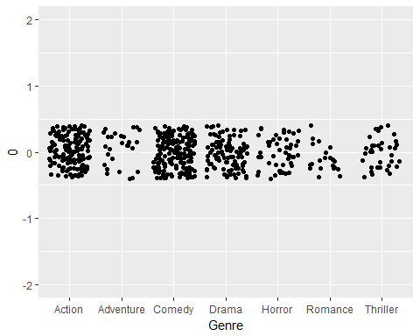

# The above plot is known as stripchart which is a univariate plot  
# We can see Sction, comedy and Drama are dense while Romance and Adventure have less dense distribution of films

ggplot(movie_ratings, aes(x = Genre, y = Budget)) + geom_point()

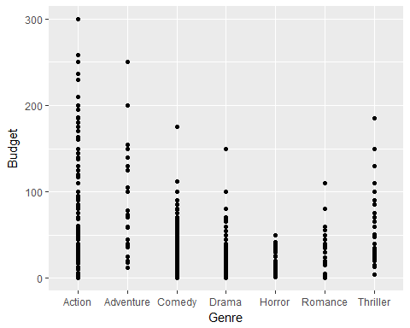

# if we observe the dataset movie_ratings we will get to know   
# that the variable Genre is categorical in nature   
# So we will need to tell ggplot2 that Genre is a categorical variable.  
# We can see Highest budget movie is action and Horror combines for least budget.

ggplot(movie_ratings, aes(x = Year, y = Rot, color = Aud)) + geom_point()

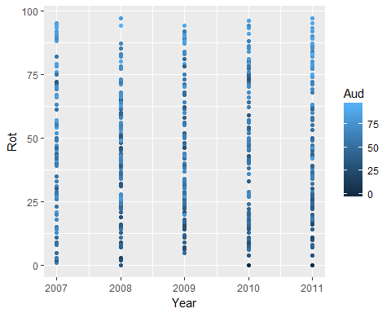

# The above plot shows relationship between critic rating and Audience rating with Year realesed of the movie_ratings   
# with varying critic rating of the movie rating Audience rating shown in different colors.

ggplot(movie_ratings, aes(x = Genre, y = Rot, size = Aud)) + geom_point()

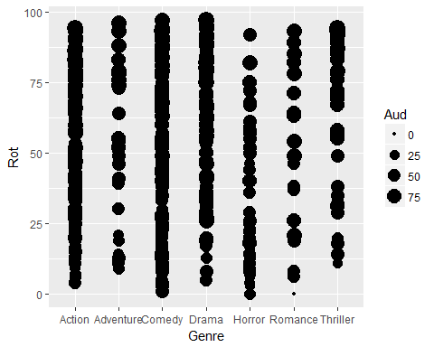

#This plot also same as above, but this Audience ratings of   
#Movies is shown with varying sizes for Fenre type

ggplot(movie_ratings, aes(x = Budget, y = Rot)) +  
 geom_point() + geom_smooth()

## `geom_smooth()` using method = 'loess'

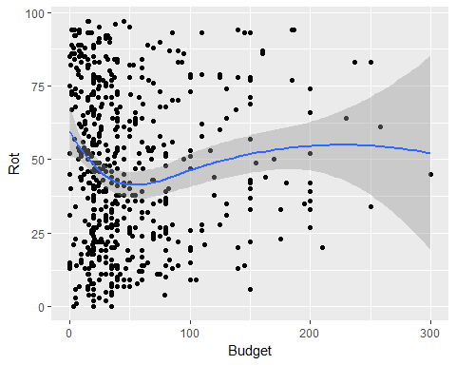

# Smoothing means to use algorithms to remove noise from a data set,   
# allowing some important patterns to stand out.   
# To add smoothing lines we would the geom geom_smooth() by default   
# it uses LOESS smoothing which stands for Locally Weighted Scatterplot Smoothing

ggplot(movie_ratings, aes(x = Rot, y = Aud)) +  
 geom_point() + geom_smooth(method = "lm")

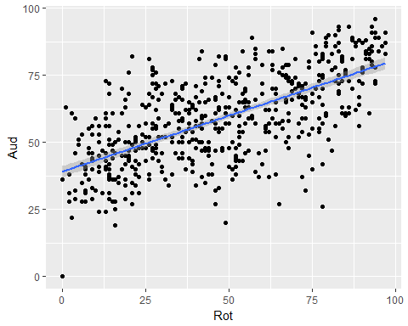

# If we want to change the previous plot to use   
# ordinary linear model smoothing we can use the method = "lm" argument.  
# The shaded portion in the above plots shows the 95% Confidence Intervals   
# which also known as the standard error, we can remove this shaded portion   
# using the argument se = FALSE

ggplot(movie_ratings, aes(x = Rot, y = Aud, col = factor(Year))) +  
 geom_point() +  
 stat_smooth(method = "lm", se = FALSE)

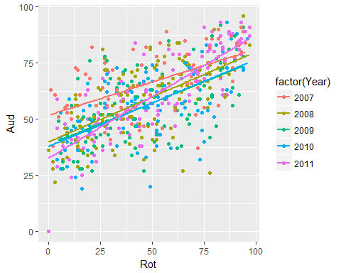

# Sometimes in our data we might like to see patterns in the   
# data based on some subgroups or categorical variables which   
# can be shown using the aesthetic col  
# In the above ggplot command our smooth is calculated for each   
# subgroup because there is an invisible aesthetic group which inherits from col.

ggplot(movie_ratings, aes(x = Rot, y = Aud, col = factor(Year), fill = factor(Genre))) +   
 geom_point(shape = 21, size = 5, alpha = .5)

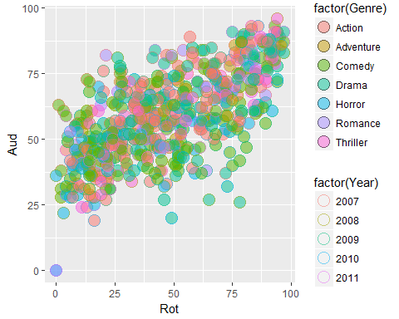

# The above plot is used whenever we need to distinguish the   
# data points based on four categorical variables - Audience rating, Rotten tomatoes, Genre and Year