**Html**

**Lists**

**Ordered lists (<ol> )**

An ordered list is used when the order of items is important. Each item is numbered automatically.

**Unordered Lists (<ul>)**

An unordered list is used when the order of items doesn't matter. Items are usually marked with bullets.

**List Items (<li>)**

Both ordered and unordered lists use the <li> tag to define individual items within the list

**Nested Lists**

Lists can be nested inside one another to create sublists.

Here is the code and output of all the lists:

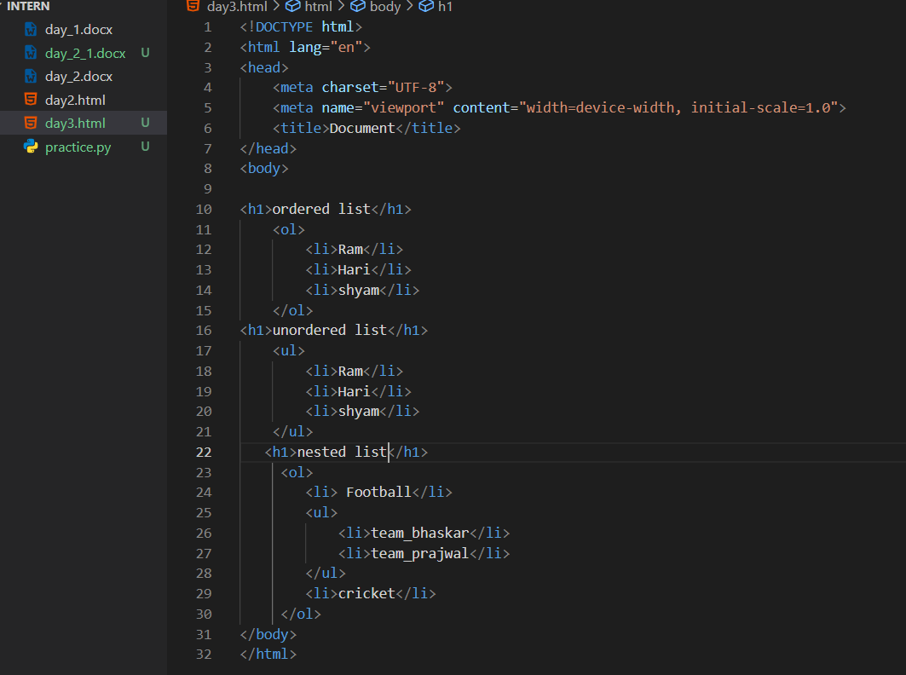

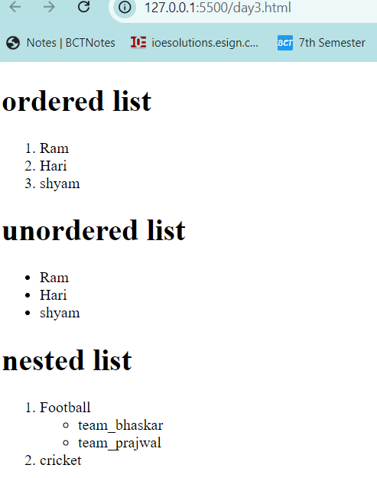

**HTML Tables**

**1. Table Structure (<table>, <tr>, <td>, <th>)**

A basic table is structured using these tags:

* <table>: Defines the table.
* <tr>: Defines a row in the table.
* <td>: Defines a cell within the table (used for data).
* <th>: Defines a header cell (bold and centered by default).

**2. Table Headers and Footers (<thead>, <tfoot>)**

To create well-structured tables, we can group the table header, footer, and body using:

* <thead>: Contains the table headers (usually the first row).
* <tfoot>: Contains the footer (can be used for summary or totals).

### 3. ****Merging Cells**** (colspan, rowspan)

We can merge table cells horizontally or vertically using the following attributes:

* colspan: Merges cells across columns.
* rowspan: Merges cells across row

### 4. ****Accessibility in Tables****

Accessibility is important when designing tables to ensure that they are usable by everyone. Here's how we can make tables more accessible:

* **Use <th> for headers**: Screen readers often read out table headers in conjunction with the data.
* **Add the scope attribute**: Define the scope of a header, such as scope="col" for column headers or scope="row" for row headers.

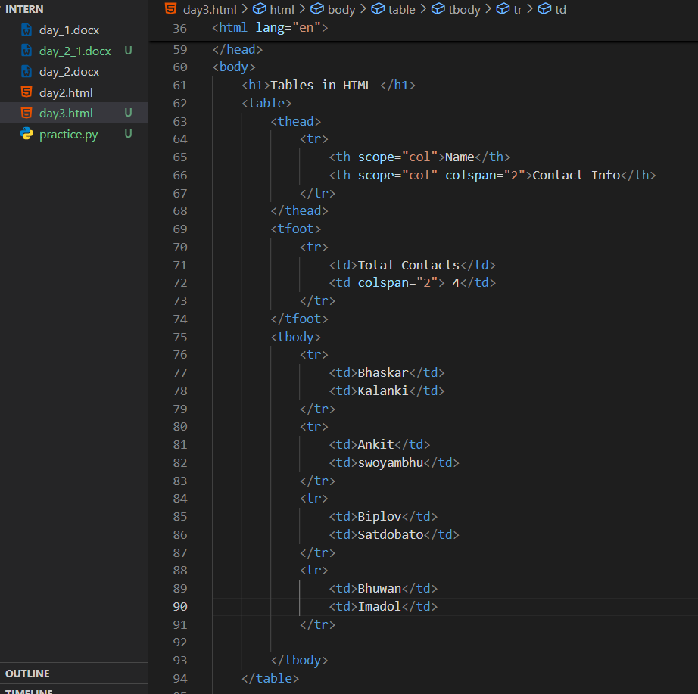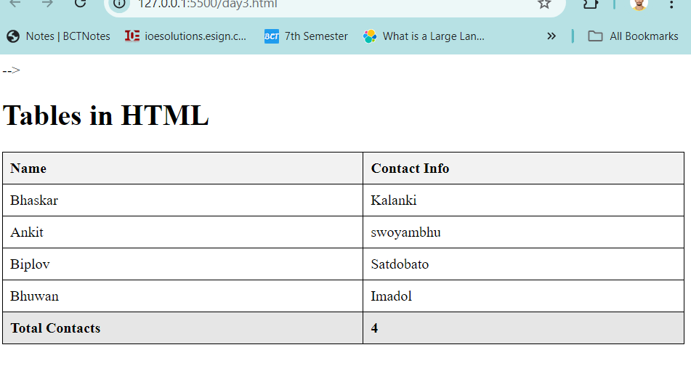

HTML Forms

HTML forms allow users to input and submit data. Here's a breakdown of the key components and attributes:

**1. Form Elements (<form>, <input>, <label>, <textarea>, <select>)**

Forms are defined using the <form> tag, which contains various input elements:

* <form>: Wraps the entire form.
* <input>: Defines input fields (text, password, email, etc.).
* <label>: Links labels to input fields for accessibility.
* <textarea>: Allows for multi-line text input.
* <select>: Defines a dropdown list.

### 2. ****Form Attributes**** (action, method, name)

Forms have attributes that define how data is sent to the server:

* action: Specifies where the form data is sent (e.g., URL).
* method: Defines the HTTP method (GET or POST).
* name: Used to identify the form elements when data is sent.

### 3. ****Input Types**** (text, password, email, number, radio, checkbox, etc.)

HTML provides different types of inputs to capture specific types of data:

* text: For single-line text input.
* password: For password fields (masked).
* email: For email addresses (validates format).
* number: For numeric input.
* radio: For selecting one option from a group.
* checkbox: For selecting multiple options.

### 4. ****Button Elements**** (<button>, <input type="submit">)

Buttons allow users to submit forms or perform actions:

* <button>: A clickable button that can include text or HTML.
* <input type="submit">: Submits the form when clicked.

### 5. ****Form Validation**** (Basic HTML5 Validation)

HTML5 provides built-in validation attributes to ensure correct input:

* required: Ensures the field is filled out.
* minlength and maxlength: Sets minimum and maximum length for input.
* pattern: Allows for regular expression pattern matching.
* type="email": Ensures a valid email format is entered.

