**Settings**

1. Install CLOC:

<https://sourceforge.net/projects/cloc/files/cloc/v1.64/>

<http://cloc.sourceforge.net/#Overview>

After successfully installed rename the executable file to **cloc**.

**Alternatively, you can use the file that is this repository.**

1. Install Python

<https://www.python.org/downloads/>

1. Download the repository files.
2. Put **scangit.py** and **cloc.exe** in the same folder.

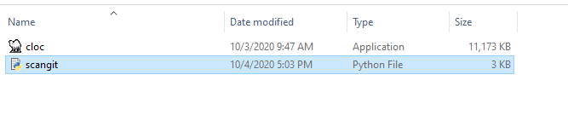

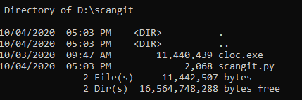

1. Edit the **scangit.py** file and fill the variables **sender** and **server**

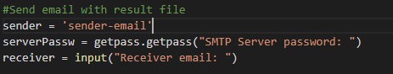

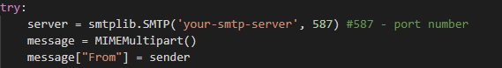

**Script Execution**

1. Open the command prompt and go to the directory that contains the **scangit.py** and **cloc.exe** files.
2. Type the command **python scangit.py**

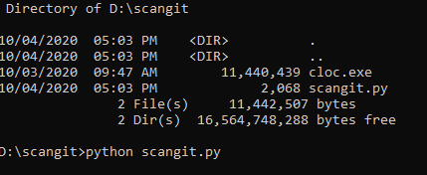

1. When asked, you must type the **zip repository url download**, that you can get by choose **Copy link address** in the **Download ZIP** option.

