Documentation coming…

To run the LOS GUI:

1. Make sure you have Java installed and included in your execution path. To check type “java -version” at the command line and you should see something like this. Java 1.7 and above should be fine.

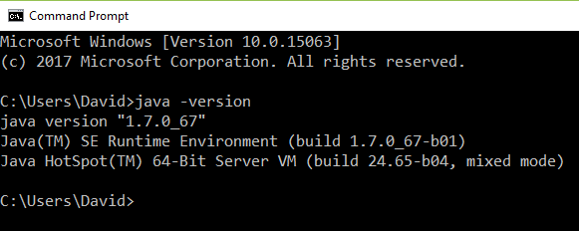

1. Download the los-gui.zip file from [here](https://github.com/vasl-developers/los-gui/blob/master/distribution/los-gui.zip) (press the Download button) and unzip into a new folder.
2. Edit the LOSEditor.properties file. Set the “LOSEditorHome” path to your los-gui folder (the folder containing the unzipped files from above) and set the “BoardDirectory” path to your VASL boards folder. Note: it’s a good idea to make a copy of the board you are editing and not edit your “master” VASL boards directory.
3. Double-click “los-gui.bat” to start the LOS GUI. You can also start the GUI from a command prompt by changing directory into your los-gui folder and typing “los-gui”.