Reaction Diffusion model

Model L-Systems:

Mathematical model and parameters:
Taken from:
Christopher G. Jennings, PhD (http://cgjennings.ca/toybox/lsystems/index.html)
Equations:
Reaction:
du/dt=U*V - U – 12
dv/dt=16-U(c)*V(c)
Diffusion:
Interconnection Shape: Torus
U'=Cdu*(U(i-1, j) + U(i+1, j) + U(i, j-1)+U(i,j+1) – 4*U(i,j))
Cdu is the constant diffusion coefficient of morphogen U

Color Mapping Method:

Algorithm scaleColors:
Input:
A vector V of a morphogen concentration values for every cell
Output:
A scale value to divide any morphogen concentration and retrieving a color value from 0-1
Begin
find the maximum max and the minimum min value of the morphogen in Vector V
return max – min
End

Movies:
How to create a movie in matlab:
Movies are considered an array of frames. Each frame is an array representing the pixels of the picture in each frame. The dimensions therefore are FxNxM, where N, M are the size of each frame and F is the Time the number of frames in that array
To record frames in matlab use:
A=moviein(numframes,figure1,winsize);
Each time a call to imshow() or plot is done the figure1 is updated. By executing
A(:,i)=getframe(fig1,winsize);
after a figure update a new frame is captured at position i.
Finally you can play the movie using:
movie(fig1,A,1,5,winsize);
And save it:
movie2avi(A, 'movie.avi');

Sound:
Instead of producing a movie we can take the morphogen values and output sound. It is easier to scale the morphogen values to sound values thanks to the function soundsc(values, sample_rate, bit_rate). The final application is at its final stage.

Matlab documentation:
- Very simple to do it with bash and some html.
- For each file with the '.m' extension take a pair of function and the comments above that function and output in an appropriate html format.
To prepare a matlab file and make the scripts work, put '%%' in front of a function description, above that function, instead of a single '%'.

Diffusion Inspired scheduler
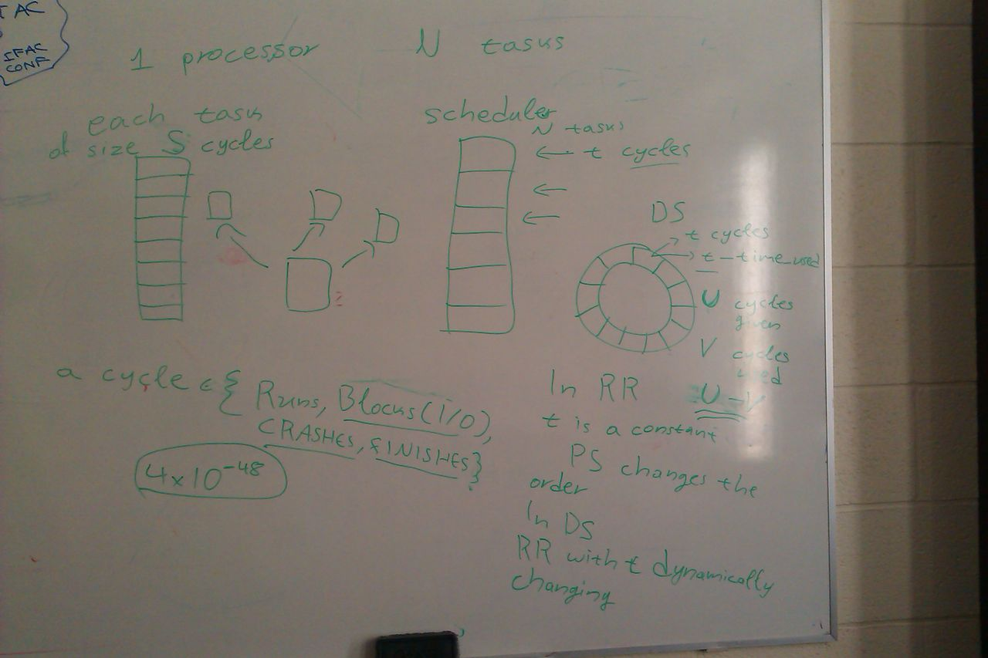
figure: Designing and explaining the Scheduling problem in terms of reaction-diffusion.

