**CHAPTER-1**

**INTRODUCTION**

**1.1Prelude**

Road safety is a universal concern that transcends geographical, economic, and societal boundaries. Among the various factors contributing to road accidents, driver drowsiness is a silent yet devastating hazard. Studies show that fatigued driving is responsible for a significant percentage of road accidents, often leading to catastrophic consequences. As the world embraces automation and artificial intelligence to address real-world challenges, the transportation sector stands to benefit immensely from these technological advancements.

The idea of a driver drowsiness detection system emerges as a promising solution to this global issue. By leveraging the power of computer vision and deep learning, such systems aim to provide real-time alerts to drivers when early signs of fatigue are detected. Unlike conventional solutions that rely on intrusive physiological sensors or vehicle dynamics, modern approaches focus on non-invasive techniques, ensuring both comfort and effectiveness.

This project report presents a journey into the development of a **Driver Drowsiness Detection System**, which harnesses deep learning techniques to monitor a driver’s eye state. By exploring Convolutional Neural Networks (CNN) and Spiking Neural Networks (SNN), this project seeks to address the dual challenges of accuracy and computational efficiency. The system promises not only to enhance road safety but also to serve as a stepping stone for broader deployment in various industries, including public transportation, fleet management, and autonomous vehicles.

This endeavour not only contributes to advancing drowsiness detection technology but also reinforces the importance of integrating artificial intelligence into solutions for pressing societal challenges.

Through this project, we aim to demonstrate how technology can act as a guardian, saving lives by preventing accidents before they occur. The journey documented in these pages reflects not just the culmination of academic and technical efforts but also a commitment to leveraging innovation for the greater good.

**1.2 Literature Survey**

Table 1.1 summarizes the survey of works closely related to this project reported in literature.

|  |  |  |  |  |
| --- | --- | --- | --- | --- |
| S.NO | NAME OF JOURNEL | YEAR | TECHNOLOGY USED | INFERENCE |
| 1. | K. Fujiwara et al., “Heart Rate Variability-Based Driver Drowsiness Detection and Its Validation With EEG,” in IEEE Transactions on Biomedical Engineering 2019, doi: 10.1109/TBME.2018.2879346 | **2019** | Heart rate variability (HRV) analysis | EEG data showed that drowsiness was detected in 12 out of 13 pre-N1 episodes prior to the sleep onsets, and the false positive rate was 1.7 times per hour |
| 2. | Y. Jebraeily, Y. Sharafi and M. Teshnehlab, "Driver Drowsiness Detection Based on Convolutional Neural Network Architecture Optimization Using Genetic Algorithm," in IEEE Access, vol. 12, pp. 45709-45726, 2024, doi: 10.1109/ACCESS.2024.3381999. | **2021** | Genetic optimization algorithm | an accuracy rate of approximately 99.8% |
| 3. | “Intelligent Driver Drowsiness Detection for Traffic Safety  Based on Multi CNN Deep Model and Facial Subsampling” *IEEE Transactions on Intelligent Transportation Systems,*2022 | **2022** | Feature extracted from eyes and  Mouth using 2 Inception V3 modules | Accuracy of CNNs reached up to 97.1% |
| 4. | V. Vijaypriya and  M. Uma, "Facial  Feature-Based  Drowsiness Detection With Multi-Scale Convolutional Neural Network," in IEEE  Access, vol. 11,  pp. 63417-63429, 2023, doi: 10.1109/  ACCESS.2023.  3288008 | **2023** | MCNN (Multi-Scale Convolutional Neural Network) framework for the classification of drowsiness | MCNN with FSA model attains an accuracy value of around 98.38% |
| 5. | M. Venkateswarlu and V. Rami Reddy Ch, "DrowsyDetectNet:  Driver Drowsiness Detection Using Lightweight CNN  With Limited  Training Data,"  in IEEE Access,  vol. 12, pp.  110476-110491,  2024, doi: 10.1109/  ACCESS.  2024.3440585. | **2024** | Shallow CNN and 68-point face landmark identification | DrowsyDetectNet produced an accuracy of 99.23% |

**1.3 Problem Statement**

Driver drowsiness is a critical issue in road safety, contributing to a significant percentage of traffic accidents globally. The National Highway Traffic Safety Administration (NHTSA) estimates that drowsy driving accounts for thousands of fatalities and injuries each year, making it one of the leading causes of preventable road accidents. This problem is particularly prevalent in long-haul trucking, late-night commutes, and occupations that demand extended hours of driving, such as logistics and transportation services.

The primary challenge lies in detecting drowsiness early enough to prevent accidents. Existing methods to monitor driver alertness include:

* **Physiological Signal Monitoring**: Techniques such as electroencephalography (EEG) and electrocardiography (ECG) are accurate but intrusive and impractical for real-world deployment.
* **Vehicle Behaviour Monitoring**: Analysing metrics such as lane deviation or steering patterns can provide clues but is unreliable under diverse driving conditions.
* **Camera-Based Systems**: These systems rely on facial or eye movement detection to identify signs of fatigue, offering a non-invasive solution. However, they face challenges such as varying lighting conditions, camera angles, and the computational complexity of real-time video processing.

Despite advancements in camera-based approaches, there is a gap in deploying lightweight, efficient, and accurate drowsiness detection systems suitable for edge devices. Traditional deep learning models like Convolutional Neural Networks (CNNs) deliver high accuracy but are computationally expensive, making them less suitable for deployment on resource-constrained devices like Raspberry Pi. Furthermore, such systems must maintain robustness across diverse conditions, including different facial features, eyewear, and environmental factors.

This project seeks to address these challenges by developing a **Driver Drowsiness Detection System** that combines computer vision techniques with modern deep learning architectures. The system aims to:

* Provide accurate detection of eye states (open/closed) using non-invasive methods.
* Operate efficiently on edge devices to facilitate real-time deployment.
* Address the limitations of traditional CNNs by exploring Spiking Neural Networks (SNNs), which offer potential advantages in energy efficiency and real-time performance.

By tackling these challenges, the proposed system will offer a cost-effective, portable, and reliable solution to improve road safety. This work not only aims to enhance the applicability of drowsiness detection systems but also sets a foundation for future innovations in smart vehicle technologies.

**1.4 Objective**

The primary objectives of this project are:

* To design a deep learning-based system that can classify whether a driver's eyes are open or closed using eye region images.
* To compare Convolutional Neural Networks (CNN) and Spiking Neural Networks (SNN) for accuracy and computational efficiency.

**1.5 Organisation of Report**

**Chapter 1** introduces the project and elaborates on the literature review, motivation and project objective.

**Chapter 2** describes about **Convolution Neural Network (CNN).**

**Chapter 3** describes about **Spiking Neural Network (SNN).**

**Chapter 4** contains in-depth information about Proposed system/Model/ Framework

**Chapter 5** goes over the observations made and the final results in detail.

**Chapter 6** Project conclusion and future scope.

**CHAPTER-2**

**CONVOLUTION NEURAL NETWORK**

**2.1 Introduction to CNNs**

Convolutional Neural Networks (CNNs) are a specialized class of deep learning algorithms designed for processing structured grid data, such as images. Inspired by the structure of the human visual cortex, CNNs are widely used for computer vision tasks, including image classification, object detection, and facial recognition. Their ability to automatically learn spatial hierarchies of features makes them ideal for tasks involving image data.

In this project, CNNs serve as a foundational approach for classifying eye states (open or closed), which is a critical component of the drowsiness detection system.

**2.2 Applications of CNNs**

Convolutional Neural Networks (CNNs) are widely used in various fields due to their ability to automatically learn hierarchical features from visual data. In image processing and computer vision, CNNs excel in tasks such as object detection, image classification, and facial recognition. They are instrumental in healthcare for medical image analysis, such as detecting tumors or anomalies in X-rays and MRIs. In the automotive industry, CNNs power advanced driver assistance systems (ADAS) and autonomous vehicles by recognizing objects, lanes, and traffic signs. Furthermore, CNNs are used in natural language processing for tasks like text classification and in generating captions for images. Their adaptability makes CNNs an integral part of real-world applications that demand high precision and computational efficiency.

**2.3 Working of CNNs in Drowsiness Detection**

The CNN model is trained using a labeled dataset of images categorized as "open" and "closed" eyes. The input images are preprocessed to ensure uniformity in size and features before being passed to the CNN.

The CNN employs convolutional layers to extract spatial features such as edges, patterns, and textures from the eye images. These features are passed through activation functions and pooling layers to reduce dimensionality while retaining essential information. Fully connected layers at the end of the network combine these features to classify the input image as representing "open" or "closed" eyes.

During real-time detection, the system captures eye images using a camera and sends them to the trained CNN model. If the model detects that the eyes are closed for a prolonged period, the system raises an alarm to alert the driver. This integration of CNN ensures accurate and efficient detection of drowsiness by leveraging its capability to identify subtle differences in visual features.

**2.4 Advantages of CNNs**

Convolutional Neural Networks (CNNs) offer several advantages, making them highly effective for tasks involving visual and spatial data. They can automatically learn and extract relevant features from raw input data, eliminating the need for manual feature engineering. CNNs leverage their hierarchical structure to capture spatial relationships and patterns, from simple edges in early layers to complex structures in deeper layers. Their use of parameter sharing reduces the number of trainable parameters, enhancing computational efficiency. CNNs are robust to translations of objects within images, ensuring consistent performance even with slight variations in input. They are widely applicable across domains such as image classification, object detection, and video analysis, and they handle high-dimensional data effectively, learning features directly from pixels. Additionally, CNNs support end-to-end learning, integrating feature extraction and classification into a single model. With robust frameworks like TensorFlow and PyTorch, CNNs are easy to develop and deploy, further amplifying their versatility and effectiveness.

**2.5 Limitations of CNNs**

Despite their remarkable performance, Convolutional Neural Networks (CNNs) have several limitations. They require large amounts of labeled data for training, which can be costly and time-consuming to obtain. CNNs are computationally intensive, demanding significant processing power and memory, especially for deep architectures, making them challenging to deploy on resource-constrained devices. They are also prone to overfitting when trained on small or imbalanced datasets, often requiring techniques like data augmentation or regularization to mitigate this issue. Additionally, CNNs struggle with interpretability, as their decision-making process is often considered a "black box," making it difficult to understand how specific features influence outcomes. Furthermore, CNNs are sensitive to adversarial attacks, where minor alterations to input data can lead to incorrect predictions. Lastly, designing an optimal CNN architecture often requires extensive experimentation and expertise, adding to the complexity of their deployment in real-world applications**.**

**2.6 Key Components of CNNs**

Figure 2.1 illustrates the key architecture of a Convolutional Neural Network (CNN), including convolutional layers, pooling layers, and fully connected layers

* **Convolutional Layers**
  + Convolutional layers apply filters to the input data, extracting features such as edges, textures, and patterns.
  + These layers reduce the dimensionality of the data while preserving essential information.
* **Pooling Layers**
  + Pooling layers down-sample the spatial dimensions of the feature maps, reducing computational complexity and enhancing robustness to spatial variations.
  + Common techniques include max pooling and average pooling.
* **Activation Functions**
  + Non-linear activation functions like ReLU (Rectified Linear Unit) introduce non-linearity into the network, enabling it to learn complex mappings.
* **Fully Connected Layers**
  + These layers aggregate the features extracted by the convolutional and pooling layers to make predictions.
* **Dropout Layers**
  + Dropout layers reduce overfitting by randomly deactivating a fraction of neurons during training.

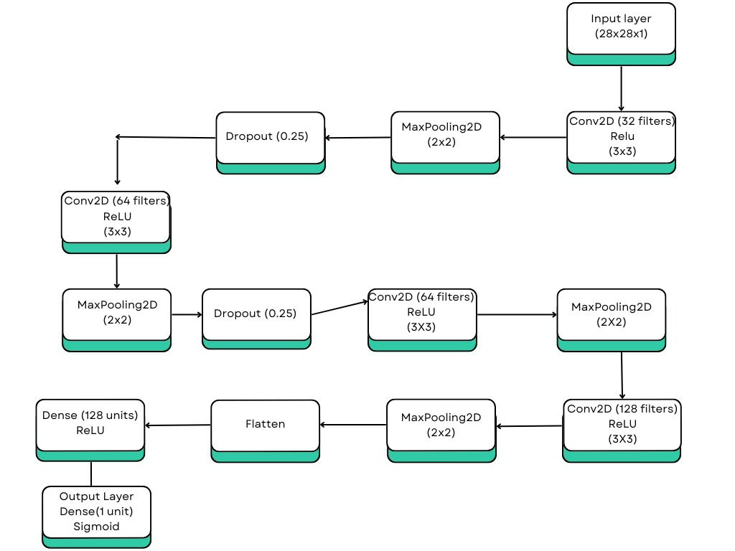

**Fig. 2.1 Detailed view of CNN layers**

**2.7 CNN Processing in an Edge-Device-and-Server Environment**

Figure 2.2 demonstrates the role of the server in the system

**Introduction to Edge and Server-Based Processing**

In a hybrid system, processing tasks are distributed between:

* **Edge Devices**: Devices like Raspberry Pi, smartphones, or IoT modules that capture and preprocess data.
* **Servers**: Centralized, high-performance machines (cloud or local) that perform intensive computations like model inference or training.

**Steps of CNN Processing in a Hybrid Setup**

**1. Data Capture at the Edge**

* **Input**: The edge device captures raw data, such as images or video frames, using sensors like cameras.
* **Preprocessing**: The captured data is cleaned, resized, and normalized locally to reduce the amount of data sent to the server.

For example, in driver drowsiness detection:

* A Raspberry Pi camera captures the driver’s eye images.
* The images are cropped and resized to focus on the eye region, reducing data size.

**2. Preprocessing at the Edge**

* Techniques like **grayscale conversion** and **histogram equalization** are applied to enhance image quality.
* Feature encoding may be done using lightweight neural network layers (e.g., the first few layers of a CNN).

This step reduces the data's dimensionality while retaining critical information, minimizing bandwidth usage for server communication.

**3. Offloading to the Server**

* The pre-processed data or extracted features are sent to the server.
* Edge devices may not have the computational resources to run the entire CNN, especially for deep or complex architectures.

**4. CNN Inference on the Server**

* The server performs the bulk of the computation, including:
  + Running the CNN model for feature extraction and classification.
  + Aggregating results for multiple inputs (if applicable).
* High-performance GPUs or TPUs on the server ensure fast and accurate inference.

**5. Results Transmission Back to the Edge**

* After inference, the server sends the results back to the edge device.
* In drowsiness detection, the output could be a binary classification ("eyes open" or "eyes closed") along with a confidence score.

**6. Decision-Making and Response at the Edge**

* The edge device uses the server's output to trigger real-time responses, such as:
  + Sounding an alarm if the eyes remain closed for a specific duration.
  + Sending a mobile notification via services like Push bullet.

**Advantages of Edge-and-Server Architecture**

* **Optimized Bandwidth**: By preprocessing data locally, only essential information is transmitted to the server.
* **Efficient Resource Usage**: Computationally intensive tasks (e.g., CNN inference) are offloaded to the server, reducing the burden on edge devices.
* **Scalability**: The server can handle inputs from multiple edge devices, enabling centralized monitoring for fleets or multi-camera systems.

**Challenges of This Architecture**

* **Network Dependence**: Real-time performance can suffer if network connectivity is poor.
* **Security Concerns**: Transmitting data over networks raises potential privacy and security risks.
* **Power Consumption**: Continuous data capture and preprocessing on the edge device may drain battery-operated systems.

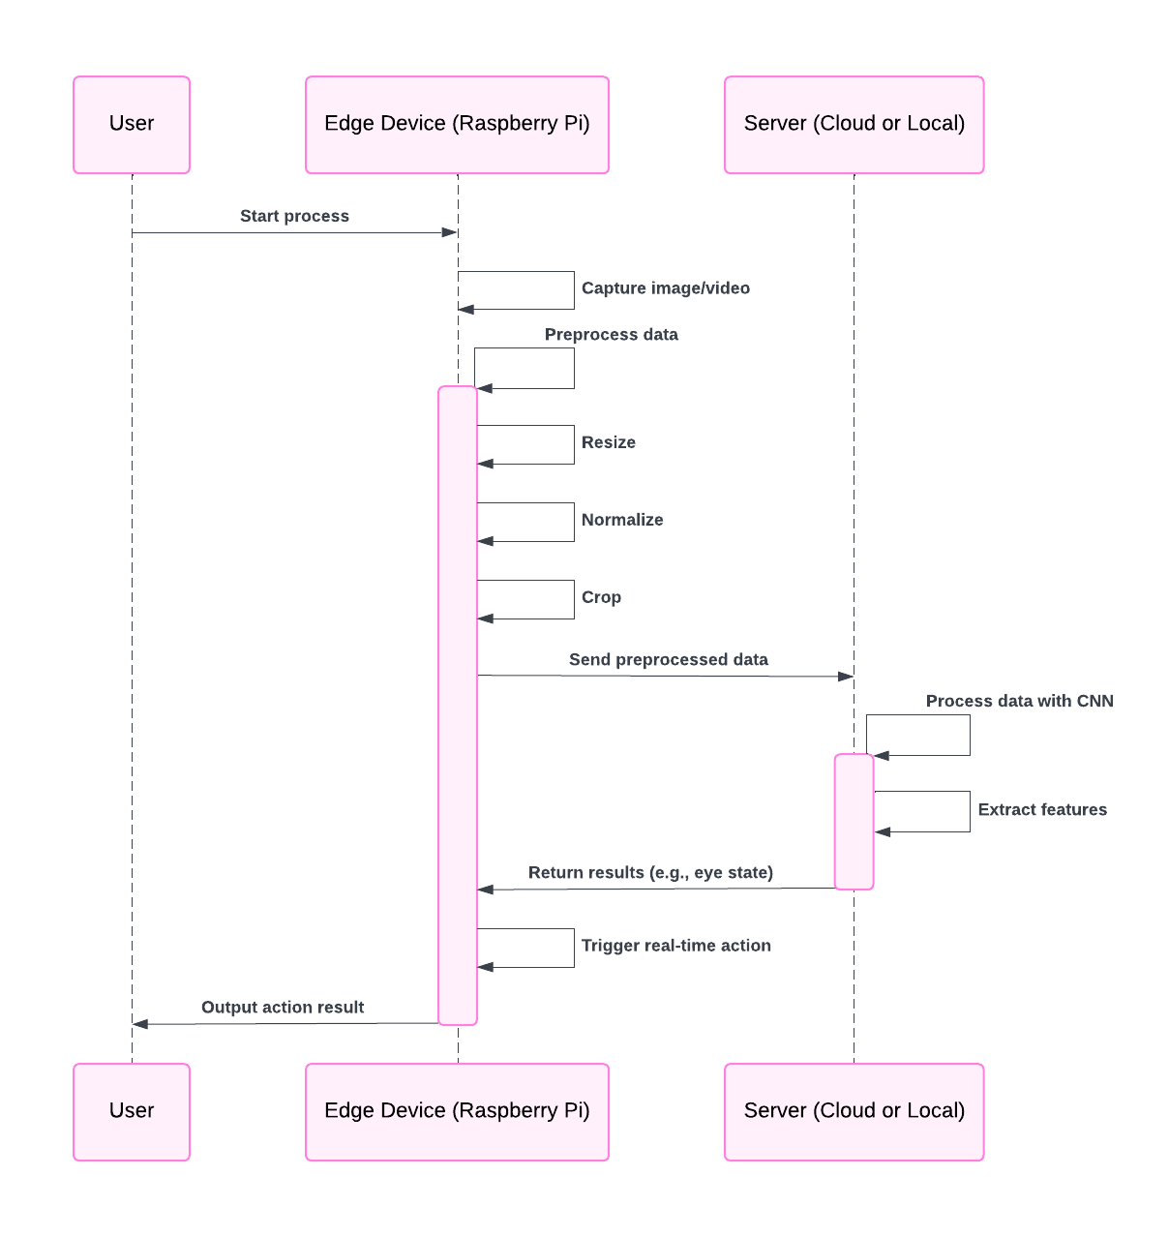

**Fig 2.2 edge device-server based system**

**2.8 REASON FOR THE NEED OF SERVER**

**1. Computational Power**

* CNNs involve extensive computations, especially during training, which include:
* Matrix multiplications for convolution and fully connected layers.
* Backpropagation for updating weights and biases.
* Handling large datasets (e.g., for image recognition tasks).
* Servers equipped with GPUs or TPUs are designed to handle these high computational demands efficiently.
* These hardware accelerators drastically reduce the training and inference time compared to traditional CPUs.

**2. Memory Requirements**

* Training CNNs often requires loading large datasets into memory, which can exceed the capacity of typical consumer-grade computers.
* Servers have higher RAM and VRAM capacity, making them ideal for managing such requirements

**3. Scalability**

* Servers allow distributed training by spreading the workload across multiple GPUs or servers, speeding up training for very large models or datasets.
* Cloud-based servers (e.g., AWS, Google Cloud, Azure) provide on-demand resources, making it easier to scale as needed.

**4. Efficiency in Deployment**

* After training, CNNs can be deployed on servers to handle real-time inference for many users, such as in web applications, mobile apps, or APIs.
* Servers ensure reliable performance with low latency for such use cases

**5. Data Storage**

* Large datasets and trained model weights need storage solutions. Servers typically have vast storage capacity and are optimized for high-speed data retrieval.

**6. Remote Access and Collaboration**

* Teams can access servers remotely for collaborative model development, training, and deployment.
* Servers also allow continuous integration and deployment (CI/CD) pipelines for iterative development

**2.9 Transition to Spiking Neural Networks (SNNs)**

Although CNNs are effective, they are computationally expensive for deployment on edge devices. This project explores Spiking Neural Networks (SNNs) as an alternative architecture to overcome these limitations, offering potential advantages in energy efficiency and real-time performance.

**CHAPTER 3**

**SPIKING NEURAL NETWORK(SNN)**

**3.1 Introduction to Spiking Neural Networks**

Spiking Neural Networks (SNNs) are a type of artificial neural network designed to mimic the behaviour of biological brains. Unlike traditional Artificial Neural Networks (ANNs), which process information in continuous values, SNNs process data in the form of discrete events or *spikes*. This spike-based computation allows SNNs to handle temporal data more naturally and efficiently, making them closer to biological systems in functionality.

SNNs are gaining popularity in applications requiring real-time processing, energy efficiency, and event-driven computation, such as robotics and neuromorphic computing.

**3.2 Biological Motivation**

SNNs draw inspiration from how the human brain works. In biological systems, neurons communicate through electrical impulses called *action potentials* or spikes. When a neuron’s membrane potential crosses a certain threshold, it fires a spike to convey information to connected neurons.

This spike-based mechanism allows biological systems to process information efficiently, adapt to dynamic environments, and use energy sparingly. SNNs aim to replicate this behaviour in artificial systems, offering advantages like better handling of time-dependent data and reduced energy consumption.

**3.3 Spiking Neuron Models**

SNNs rely on specialized models to simulate the behaviour of biological neurons. Key spiking neuron models include:

* **Leaky Integrate-and-Fire (LIF)**:
  + Simplest and most widely used model.
  + Neurons accumulate input signals over time, and when the potential exceeds a threshold, they fire a spike.
* **Hodgkin-Huxley Model**:
  + A biologically realistic model that simulates ionic exchanges in neurons.
  + More computationally intensive.
* **Izhikevich Model**:
  + A compromise between biological accuracy and computational efficiency.

These models determine how spikes are generated and propagated in SNNs

* 1. **Spike Encoding Mechanisms**

Since SNNs operate on spike-based data, raw input must be encoded into spikes. Common encoding techniques include:

**Rate Coding**:

Rate coding is a fundamental method used in Spiking Neural Networks (SNNs) to encode information. In this approach, the intensity of a signal or the value of a feature is represented by the frequency of spikes generated by a neuron over a specific period. The higher the spike rate, the stronger the signal or feature value being conveyed. This method is biologically inspired, as it mimics how the human brain transmits information through varying firing rates of neurons. Rate coding is straightforward to implement and is compatible with learning algorithms like Spike-Timing-Dependent Plasticity (STDP) or backpropagation in SNNs. However, it can be less energy-efficient compared to other coding strategies, such as temporal coding, as it requires multiple spikes to convey information, which can increase computational and power demands. Despite this, rate coding remains widely used due to its simplicity and effectiveness in translating continuous signals into spike-based representations for neural computation

**Temporal Coding**:

Temporal coding is an advanced method of information representation used in Spiking Neural Networks (SNNs), where the precise timing of individual spikes carries the encoded information. Unlike rate coding, which relies on spike frequency, temporal coding emphasizes the relative or absolute timing of spikes to represent data. For instance, the time difference between spikes or the exact moment a spike occurs can correspond to specific signal intensities or features.This coding strategy is highly efficient, as it often requires fewer spikes to convey the same amount of information, making it energy-efficient and well-suited for real-time processing. Temporal coding is particularly useful in tasks that benefit from high temporal resolution, such as speech recognition, motion detection, and other dynamic sensory processing applications. However, its reliance on precise timing can make implementation more complex, as it requires specialized learning rules like Spike-Timing-Dependent Plasticity (STDP) and careful synchronization between neurons. Despite these challenges, temporal coding is valued for its biological plausibility and efficiency in spike-based neural computation

**Population Coding**:

Population coding is a method used in Spiking Neural Networks (SNNs) where information is encoded by the collective activity of a group of neurons rather than relying on individual neurons. In this approach, each neuron in the population contributes a small part of the overall signal, and the combined activity of many neurons is used to represent complex features or patterns. The idea is that the encoded information is distributed across the network, and the brain uses the firing rates or specific patterns of spikes from multiple neurons to decode the information.This coding method is particularly useful in scenarios where information is too complex or ambiguous to be captured by a single neuron, such as in high-dimensional data representation, sensory processing, or motor control. Population coding offers robustness against noise and damage, as the system can still function correctly even if some neurons fail. It also allows for the encoding of more abstract or multi-dimensional features, which can improve the network's capacity to handle complex tasks like object recognition or decision-making. While more computationally demanding, population coding has significant biological relevance, as it reflects how the brain relies on distributed neural activity for processing information.

These mechanisms allow SNNs to process diverse types of input efficiently.

**3.5 Learning Mechanisms in SNNs**

The learning mechanisms in Spiking Neural Networks (SNNs) are inspired by biological neurons and synapses, with the goal of adapting the network's weights based on the input and output relationships. One of the most commonly used learning rules in SNNs is **Spike-Timing-Dependent Plasticity (STDP)**, which adjusts the strength of synapses based on the relative timing of spikes between pre- and post-synaptic neurons.

In STDP, if a presynaptic neuron fires just before a postsynaptic neuron (a temporal correlation), the synaptic weight is strengthened, facilitating the transmission of the spike. Conversely, if the postsynaptic neuron fires before the presynaptic neuron, the synaptic weight is weakened. This mechanism enables the network to learn spatiotemporal patterns and synchronize activity across neurons, mimicking how learning happens in the biological brain.

In addition to STDP, other learning methods used in SNNs include **supervised learning** (e.g., backpropagation through time), where the error between the expected and actual output is minimized, and **reinforcement learning**, where synaptic weights are adjusted based on reward signals received from the environment. The choice of learning rule depends on the task and network design, with some techniques aiming to improve computational efficiency or learning speed.

SNNs, through these learning mechanisms, offer a more biologically plausible approach to neural computation and are well-suited for tasks like pattern recognition, motor control, and sensory processing. However, implementing these learning rules in a computationally efficient manner remains a challenge compared to traditional artificial neural networks.

**3.6 Advantages of SNNs**

Spiking Neural Networks (SNNs) offer several advantages that make them a promising approach for many applications. First, SNNs are biologically plausible, mimicking the way neurons in the brain process information through discrete spikes, allowing them to capture temporal dynamics more effectively than traditional neural networks. This biological relevance extends to energy efficiency, as SNNs only consume power when neurons fire, making them suitable for energy-constrained devices. Additionally, SNNs excel at encoding and processing temporal information, which is crucial for tasks like speech recognition, motion detection, and real-time sensory processing. The use of Spike-Timing-Dependent Plasticity (STDP) enables efficient learning by adjusting synaptic weights based on the timing of spikes, further improving their ability to learn spatiotemporal patterns with minimal supervision. SNNs are also robust to noise and can operate efficiently with sparse data, reducing computational overhead. Their adaptability and ability to perform parallel processing make them ideal for real-time applications, particularly in fields such as robotics, artificial vision, and neuromorphic computing. Overall, SNNs combine biological realism, efficiency, and flexibility, offering a powerful alternative to traditional neural network models.

**3.7 Applications of SNNs**

Spiking Neural Networks (SNNs) have a wide range of applications, particularly in fields that require real-time processing and efficient handling of temporal data. In robotics, SNNs are used for motor control, navigation, and decision-making, allowing robots to adapt to dynamic environments. Their ability to process sensory information makes them ideal for applications in vision, auditory processing, and tactile data analysis. For instance, SNNs can be applied in object detection and tracking in vision systems, or in speech recognition and sound localization in auditory systems. Additionally, SNNs are at the core of neuromorphic computing, where they replicate the brain's structure to build energy-efficient hardware for tasks like pattern recognition and decision-making. In the realm of brain-computer interfaces (BCIs), SNNs are used to decode brain activity for communication and control, offering promising solutions for assistive technologies. They are also employed in spatiotemporal data analysis, such as medical signal processing (e.g., EEG and ECG) and environmental monitoring. Furthermore, SNNs have applications in autonomous vehicles, where they aid in real-time object detection, sensor fusion, and decision-making, crucial for navigating complex traffic environments. Overall, the unique characteristics of SNNs—biologically inspired learning, temporal processing, and energy efficiency—make them highly suitable for a variety of cutting-edge applications.

**3.8 Challenges of SNNs**

Spiking Neural Networks (SNNs) offer many advantages, but they also present several challenges that hinder their widespread adoption and practical implementation. One of the primary challenges is the **complexity of training**. Unlike traditional artificial neural networks, where gradient-based optimization methods like backpropagation are commonly used, SNNs require more specialized learning rules, such as Spike-Timing-Dependent Plasticity (STDP). Implementing these rules effectively, especially in large-scale networks, remains computationally demanding and less straightforward.

Another challenge is the **lack of efficient learning algorithms**. While SNNs can learn temporal patterns well, supervised learning in SNNs is not as well-developed as in conventional networks. Current methods often require backpropagation through time (BPTT), which is computationally expensive and difficult to scale. This makes training SNNs slower compared to other types of neural networks.

Additionally, **hardware limitations** pose a significant challenge. SNNs are often designed to work on specialized neuromorphic hardware for efficiency, but these hardware platforms are not as widely available or accessible as general-purpose processors like CPUs or GPUs. Developing hardware that can effectively handle the unique event-based nature of SNNs is still an area of active research.

**Spike coding** is another challenge in SNNs. While techniques like rate coding, temporal coding, and population coding are used to encode information in spikes, finding the most efficient and scalable way to represent complex information remains a complex task. Choosing the right coding scheme that balances accuracy and computational efficiency is often context-dependent and not trivial.

Finally, **scalability and stability** in large networks are concerns. SNNs tend to become unstable or difficult to train as the network grows larger, especially when synaptic weights need to be updated based on precise spike timings. Managing these factors while maintaining network performance is an ongoing challenge.

Despite these challenges, research in SNNs continues to advance, with improvements in learning algorithms, hardware, and network architectures helping to overcome some of these obstacles.

**3.9 Comparison Between CNNs and SNNs**

**Table. 3.1 Difference between CNN and SNN**

This table compares some of the important parameters of CNN and SNN

| **Feature** | **CNNs** | **SNNs** |
| --- | --- | --- |
| Data Representation | Continuous values | Discrete spikes |
| Power Efficiency | Moderate | High |
| Temporal Processing | Limited | Natural |
| Training | Easier with mature tools | Complex and evolving |

* 1. **SNN Architecture**

Figure 2.1 illustrates the key architecture of a Spiking Neural Network (SNN), including convolutional layers, pooling layers, and fully connected layers

**Input Layer**

* The input layer encodes raw data (e.g., images, signals, or time-series data) into spike trains.
* **Encoding Methods**:
  + **Temporal Coding**: The timing of spikes carries the information.

**Hidden Layers (Spiking Neurons)**

Hidden layers consist of spiking neurons that process the spike trains from the input layer.

**Neuron Models**:

**-Leaky Integrate-and-Fire (LIF)**: Accumulates incoming spikes, fires when a threshold is reached, and then resets.

-Neurons in the hidden layers use spike-based communication, with the dynamics defined by membrane potentials and firing thresholds.

**-Synaptic Weights:** Connections between neurons are weighted, and these weights determine how spikes are transmitted.

**Output Layer**

-The output layer converts the processed spike patterns into decisions or classifications.

-It may use decoding techniques to interpret the spike trains, such as:

* + - Counting the number of spikes in each output neuron.
    - Analysing the timing or patterns of spikes.

**Temporal Dynamics**

-SNNs process information across multiple time steps, making them ideal for temporal data like video or audio streams.

-Neurons operate asynchronously, firing only when their membrane potential exceeds the threshold, which reduces redundant computation.

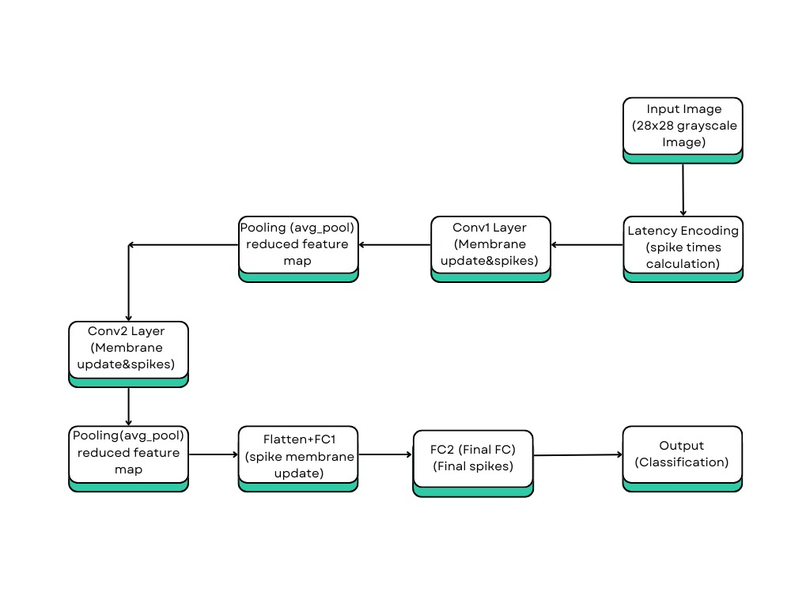

**Figure 3.1**

**Fig. 3.1 Detailed View of SNN Layers**

* **Input Encoding**: Data is converted into spikes using an temporal encoding scheme.
* **Spike Propagation**: Spikes are transmitted through synapses, altering membrane potentials in connected neurons.
* **Neuron Firing**: When a neuron’s potential exceeds its threshold, it generates a spike.
* **Learning and Adaptation**: Synaptic weights are updated based on learning rules.
* **Output Decoding**: Spike trains from the output layer are interpreted as the final result.

**3.12 Edge-Device-Based Real-Time Driver Drowsiness Detection System**

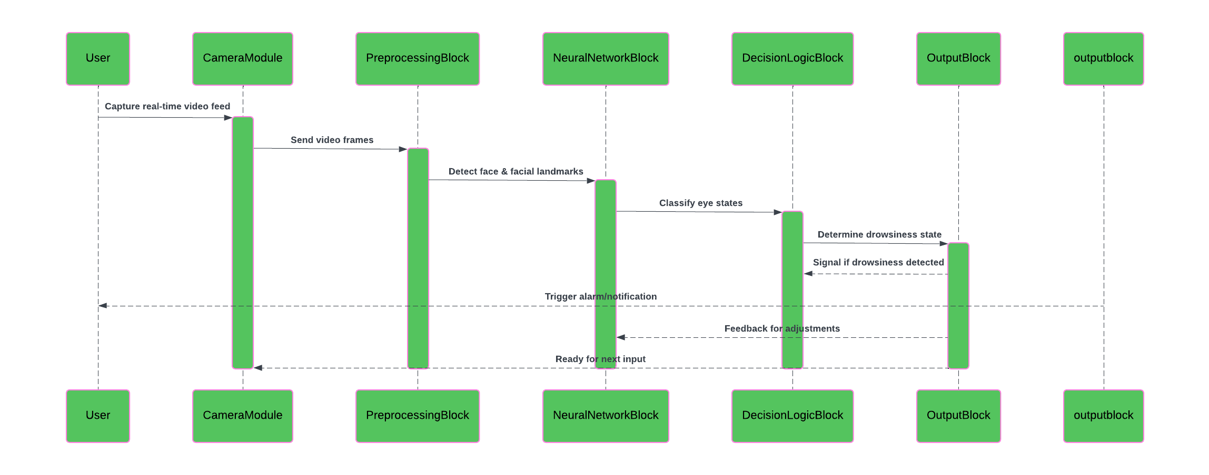

F=**fig. 3.2 egde device based system**

**3.13 REASON Why Server Is Not Needed**

**1. Use Lightweight Hardware**

* Edge Devices: Raspberry Pi, NVIDIA Jetson Nano, or Intel Movidius Neural Compute Stick.
* SNN operations rely on simple arithmetic (addition and threshold comparisons), which can be efficiently executed on standard CPUs or specialized hardware like microcontrollers and neuromorphic chips.

**2. Low Power Consumption**

* SNNs mimic the brain's processing style, firing only when necessary (event-driven). This makes them ideal for devices with limited power, like IoT devices or wearables.
* Longer Battery Life: Running SNNs locally ensures devices can operate longer without frequent recharging.

**3. Real-Time Processing**

* Local inference avoids network delays, providing instantaneous responses. This is crucial for applications like robotics, autonomous vehicles, and real-time decision-making.
* Devices can function independently without relying on a stable internet connection.

**4. Cost Efficiency**

* Eliminates expenses associated with server infrastructure, maintenance, or cloud storage.
* Reduces or eliminates the need for transmitting data to remote servers.

**5. Scalability**

* Enables deploying multiple devices locally without overloading a central server.
* Systems can scale horizontally, adding more devices without needing additional server resources

**3.14 Conclusion**

Spiking Neural Networks represent the next step in creating energy-efficient, biologically inspired AI systems. While they offer significant advantages for specific applications, challenges remain in training and deployment. Advances in tools and hardware are expected to make SNNs more accessible in the coming years.

**CHAPTER 4**

**Framework for Driver Drowsiness Detection**

**4.1 System Architecture and Components**

**1. System Architecture**

The system architecture for the driver drowsiness detection system comprises three main stages: **Data Acquisition**, **Processing**, and **Classification**. Below is a high-level explanation of the architecture. Figure 4.1 shows classification pipeline

**Input**: A live video feed captured by a camera (e.g., Raspberry Pi Camera Module).

**Processing Units**:

* + **Data Acquisition Module**: Captures real-time video frames.
  + **Preprocessing Module**: Processes the captured frames to extract key facial features (e.g., eyes).
  + **Neural Network Models**: Uses CNN or SNN architectures for feature extraction and classification (open/closed eyes).
  + **Output**:An alert system generates notifications (audible alarms or push notifications) when drowsiness is detected.

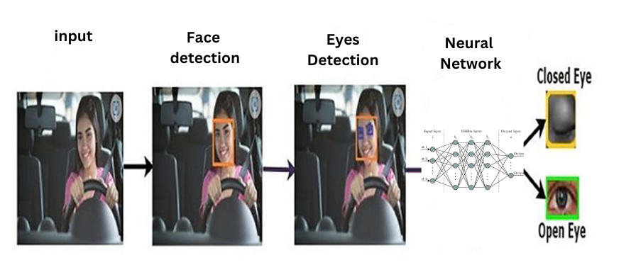

**Fig. 4.1 Eye Detection and Classification Pipeline in Driver Drowsiness Detection System**

**4.2 System Components**

**Step 1: Facial Feature Detection**

* **Tool/Library**: Use Dlib’s pre-trained facial landmark detector or similar libraries.
* **Process**:
  + Capture a live video feed using a camera.
  + Detect the driver’s face using a face detection algorithm, such as a Haar Cascade or HOG-based detection.
  + Identify 68 facial landmarks, focusing on the eye region (landmark indices 36–41 for the left eye and 42–47 for the right eye), fig. 4.2

**Step 2: Eye Region Cropping**

* **Input**: Detected landmarks of both eyes.
* **Process**:
  + Extract coordinates of the bounding box around each eye.
  + Crop the eye regions from the frame for further processing, fig. 4.3
  + Resize the cropped regions to a standard size (e.g., 24x24 pixels) for consistency.

**Step 3: Preprocessing for State Classification**

* + Convert cropped eye images to grayscale to reduce computational complexity.
  + Normalize pixel values to improve model convergence during training.
  + Apply data augmentation techniques, if needed, for better generalization.

**Step 4: Eye State Classification**

* **Tool**: Use a pre-trained CNN model to classify the eye state as either "open" or "closed."
* **Output**: A binary classification (0 for closed, 1 for open).

**Step 5: Drowsiness Detection**

**Logic**:

* + Maintain a rolling window of classifications over a specific period (e.g., 2 seconds).
  + Calculate the percentage of frames in which both eyes are detected as “closed.”
  + If the percentage exceeds a predefined threshold (e.g., 70%), trigger a drowsiness alert (e.g., a sound alarm).

**The-face-shape-with-68-landmarks**

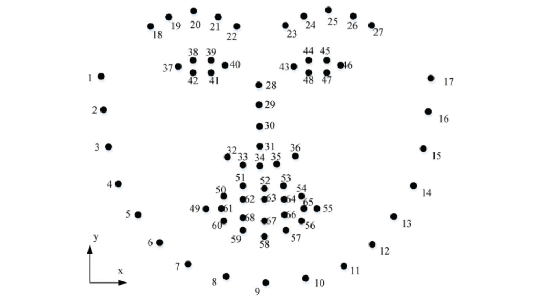

**Fig. 4.2 The-face-shape-with-68-landmarks**

**Extraction of Region of interest (ROI) eyes**

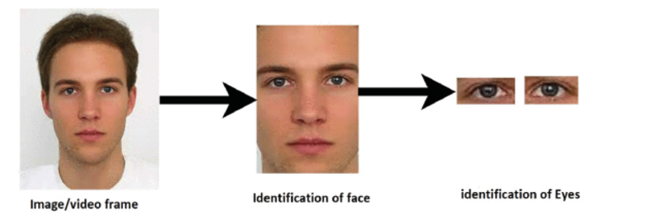

**Fig. 4.3 Extraction of Region of interest (ROI) eyes**

**CNN Architecture**

1. **Input Layer**: Accepts pre-processed grayscale images of dimensions (e.g., 64x64). This reduces computational complexity while retaining essential features.
2. **Convolutional Layers**:
   * Apply multiple kernels to extract features such as edges, textures, and patterns.
   * Example: First layer with 32 filters of size 3x3, followed by ReLU activation.
3. **Pooling Layers**:
   * Max-Pooling layers down-sample the feature maps to reduce spatial dimensions and prevent overfitting.
4. **Fully Connected Layers**:
   * Flatten the feature maps and pass them through dense layers to enable classification.
   * The final dense layer uses a sigmoid activation for binary classification (open/closed).
5. **Dropout Layers**:
   * Added to prevent overfitting by randomly deactivating neurons during training.
6. **Reasoning**:
   * The architecture is kept lightweight to achieve real-time performance with limited resources.



**Fig. 4.4 CNN Architecture**

**SNN Architecture**

1. **Input Encoding Layer**: Converts pixel intensities into spike trains using rate or temporal encoding.
2. **Convolutional Spiking Layers**:
   * Perform convolution operations where neurons spike based on accumulated membrane potential.
3. **Pooling Layers**:
   * Analogous to CNN pooling layers but optimized for spiking neuron outputs.
4. **Output Layer**:
   * Uses spiking neurons to classify eye states based on spike timing or count.
5. **Reasoning**:
   * SNNs are energy-efficient, ideal for edge devices with low power consumption requirements.

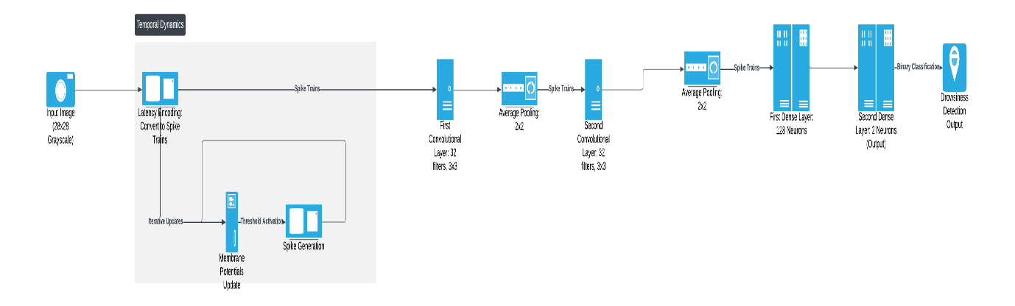

**Fig. 4.5 SNN Architecture**

**4.3 Training Details**

**Dataset**

1. **Description**: The dataset comprises labelled images of open and closed eyes. Example sources include public datasets like **yawn_eye_dataset_new** or custom-collected data.
2. **Class Distribution**: Balanced data for both states ensure unbiased model training.

**Preprocessing**

1. **Grayscale Conversion**: Reduces input complexity while retaining critical features.
2. **Normalization**: Scales pixel intensities to the range [0, 1] for faster convergence.
3. **Augmentation**:
   * Techniques include rotation, flipping, brightness adjustment, and cropping.
   * Helps simulate real-world conditions and improves model robustness.

**Training Process**

1. **Hyperparameters**:
   * Learning rate: 0.001 (initial value).
   * Batch size: 32.
   * Epochs: 60, depending on early stopping.
2. **Frameworks**: TensorFlow for CNN; Pytorch for SNN.

**Loss Function and Optimization**

**Loss Function**

* **Binary Cross-Entropy :**

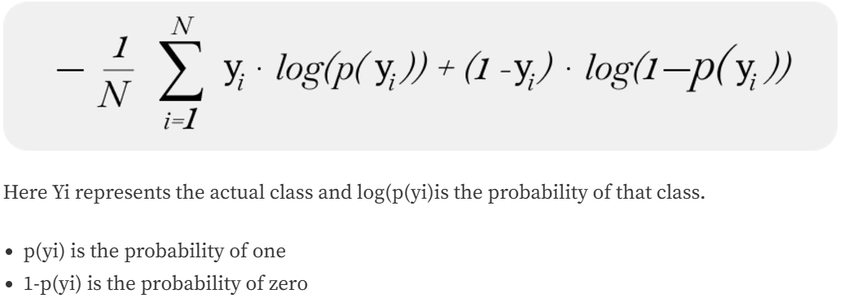

**Optimization Algorithm**

* **Optimizer**:

**Adam (Adaptive Moment Estimation)**

* Combines Momentum and RMSProp:
* Uses a moving average of gradients (Momentum).
* Normalizes the learning rate using a moving average of squared gradients (RMSProp).

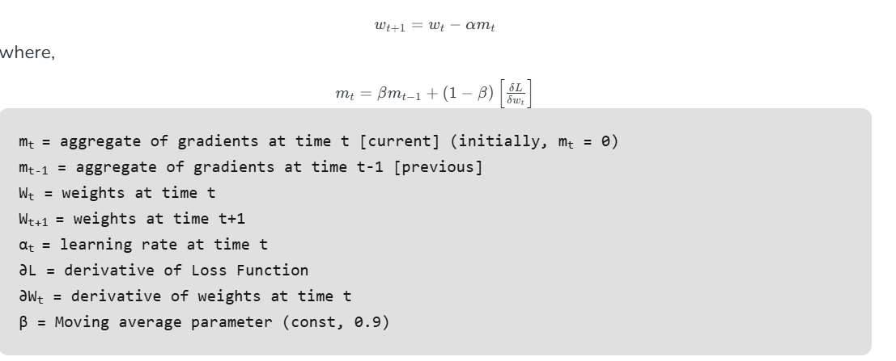

**4.4 Encoding Technique in SNN**

**Latency Coding in Spiking Neural Networks (SNNs)**

**Definition**:  
Latency coding, also known as temporal coding or spike-time coding, is a spike encoding strategy used in Spiking Neural Networks (SNNs) where the information is encoded in the precise timing of spikes. Instead of using the frequency of spikes, as in rate coding, latency coding conveys information based on how quickly a neuron fires relative to the onset of a stimulus.

**How Latency Coding Works:**

* **Input Stimulus**: The strength of the input stimulus is mapped to the spike time.
  + **Stronger stimulus** → **Earlier spike**
  + **Weaker stimulus** → **Later spike**
* **Spike Timing**: The timing of the first spike (or a sequence of spikes) relative to the stimulus onset carries the information.
* **Neural Encoding**: Each neuron's response latency is inversely proportional to the input intensity. This makes the representation sparse, efficient, and biologically plausible.

**Advantages of Latency Coding:**

* **Energy Efficiency**: Uses fewer spikes, reducing computational load and energy consumption compared to rate coding.
* **Biological Plausibility**: Mimics the way neurons in the brain process information (e.g., in the retina or auditory systems).
* **Higher Information Density**: Encodes information more compactly compared to rate coding.
* **Real-Time Processing**: Suited for tasks requiring rapid decision-making, such as driver drowsiness detection.

**Applications in Driver Drowsiness Detection:**

In the context of a driver drowsiness detection system:

* **Latency coding** is used to encode visual stimuli (e.g., eye images) into spike trains.
* The intensity or relevance of specific features (like eyelid closure) determines the latency of the spikes.
* The SNN processes these spike trains over a time window to classify whether the driver is drowsy or alert.

**Challenges of Latency Coding:**

* **Precision Requirements**: Relies on accurate spike timing, which may be affected by noise or delays in hardware implementations.
* **Encoding Complexity**: Requires preprocessing to map input intensities to spike times effectively.
* **Data Sparsity**: Sparse spike trains can complicate training for certain tasks.

**Rate coding in Spiking neural network (SNN)**

**Definition:** Rate coding is a neural coding strategy used to represent information in the nervous system or in artificial neural networks, particularly in Spiking Neural Networks (SNNs). In rate coding, the information is encoded in the firing rate of neurons, rather than the precise timing of individual spikes

**How Rate Coding Works**

**1. Input Signal Conversion**

* A continuous input signal (e.g., sensory stimulus like light intensity or sound amplitude) is converted into spikes.

**2. Spike Generation**

* In biological systems: Spikes are generated when the membrane potential of a neuron crosses a threshold due to incoming signals.

**3. Encoding Information**

* The information is encoded in the number of spikes per unit time rather than the precise timing of individual spikes.

**Advantages of Rate Coding**

**Robustness to Nois**e: Since it averages over many spikes, random variations in spike timing have less impact.

**Simple Decoding**: Receiving neurons only need to count spikes in a time window to interpret the signal.

**Challenges of Rate Coding:**

**1. Inefficiency in Energy Use**

High Energy Demand: Neurons require significant energy to fire spikes. Encoding information with high firing rates can be energetically expensive, especially in biological systems.

**2. Loss of Temporal Precision**

Ignores Spike Timing: Rate coding averages spikes over time, disregarding precise spike timing. This leads to a loss of potentially valuable temporal information present in the neural activity.

**Comparison of Encoding Methods:**

**Table. 4.1 Difference between Rate and Latency coding**

| **Aspect** | **Latency Coding** | **Rate Coding** |
| --- | --- | --- |
| **Representation** | Time of first spike encodes info | Spike frequency encodes info |
| **Efficiency** | Higher (fewer spikes) | Lower (more spikes) |
| **Biological Basis** | Strong (early spike responses) | Moderate |
| **Suitability** | Real-time applications | Tasks with steady-state signals |

**Table. 4.1 Difference between Rate and Latency coding**

**CHAPTER 5**

**RESULTS AND DISCUSSIONS**

**5.1 TESTING**

The performance of the trained model is assessed by testing it on a separate, unseen portion of the dataset that was not used during the training phase. The testing procedure involves feeding the eye images from the dataset into the model and observing its ability to classify the eyes as either "open" or "closed," based on the learned patterns. The evaluation of the model's performance is carried out using several metrics, such as accuracy, precision, recall, F1-score, and confusion matrix, to provide a comprehensive understanding of how well the model performs on the test data. Additionally, real-time performance metrics, such as inference time, are evaluated to assess how quickly the model can process and classify eye images, which is essential for real-time applications like driver drowsiness detection. The results are then compared to a baseline model (if available), highlighting any improvements or challenges encountered during the testing phase. A detailed analysis of the results reveals the strengths and weaknesses of the model, including any misclassifications or areas for improvement, such as handling variations in lighting, noise, or eye position. Overall, this testing and evaluation phase is critical in understanding the model's generalization capabilities and its suitability for real-world deployment. Some of the images used for testing are mentioned below in figure 5.1

  

  

**Fig. 5.1**

**5.1 ACCURACY**

In the context of machine learning, **accuracy** is one of the most commonly used metrics for evaluating the performance of a model. It measures the proportion of correct predictions (both true positives and true negatives) made by the model compared to the total number of predictions. In other words, accuracy is the ratio of the number of correct predictions to the total number of predictions.

The formula for accuracy is:

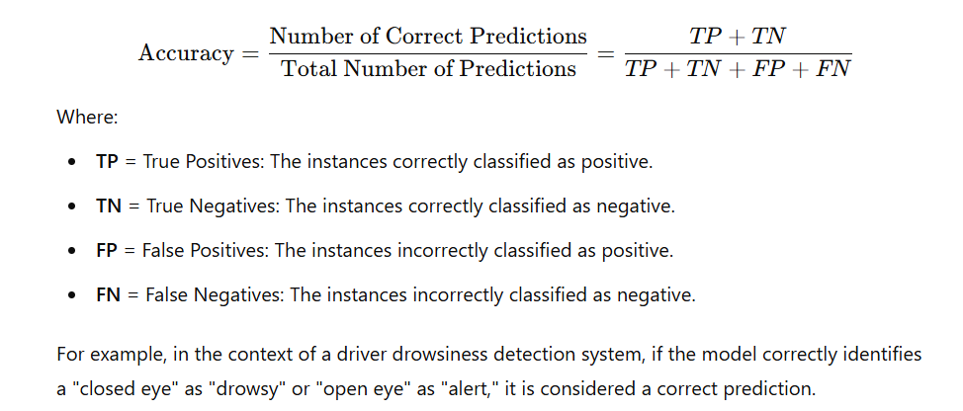

For example, in the context of a driver drowsiness detection system, if the model correctly identifies a "closed eye" as "drowsy" or "open eye" as "alert," it is considered a correct prediction.

***The accuracy achieved by***

***CNN Model=99.2%***

***SNN Model(rate coding)=94.3%***

***SNN Model(temporal coding)=96.8%***

**Limitations of Accuracy**

While accuracy is a simple and intuitive metric, it may not always be the best measure, especially in imbalanced datasets (where one class is much more frequent than the other). For example, in a dataset with 95% "eyes open" and 5% "eyes closed," a model predicting "eyes open" for all inputs would still achieve 95% accuracy, but it would fail to identify drowsy drivers.

**5.2 PRECISSION**

In machine learning, **precision** is a metric used to evaluate the accuracy of positive predictions made by a model. Specifically, it answers the question: Of all the instances that were predicted as positive by the model, how many were actually positive?

Precision is especially important in applications where false positives (incorrectly identifying something as positive when it’s actually negative) are undesirable. For instance, in a driver drowsiness detection system, precision would help measure how often the system correctly predicts a drowsy driver when it signals an alert.

The formula for precision is:

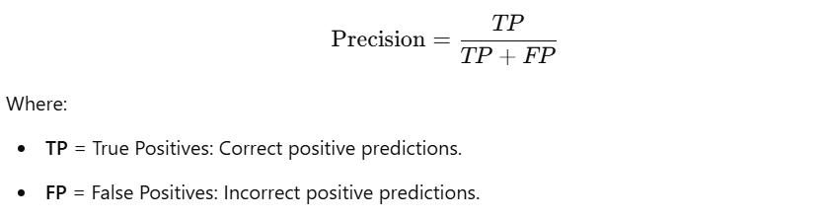

***Precision achiever by***

***CNN Model=0.99***

***SNN Model=0.97***

In a **drowsiness detection system**, precision helps ensure that the system doesn't issue false alerts, which could annoy the driver and decrease trust in the system. It's crucial that the system accurately identifies only the true instances of drowsiness, minimizing the number of non-drowsy drivers who receive an alert.

**5.3 RECALL**

Recall (also known as sensitivity or true positive rate) is a metric used to evaluate how well a machine learning model identifies positive instances. It answers the question: *Of all the actual positive instances, how many did the model correctly identify as positive?*

In many real-world applications, recall is a crucial metric when the consequences of missing a positive instance (false negative) are significant. For instance, in a drowsiness detection system, recall would measure how effectively the system detects a drowsy driver from all the actual instances of drowsiness.

The formula for recall is:

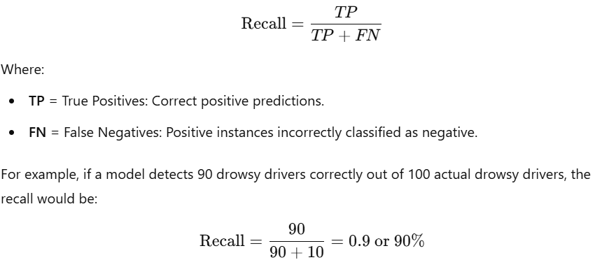

***Recall achieved by***

***CNN Model=0.99***

***SNN Model (rate coding) =0.93***

***SNN Model(temporal coding) =0.97***

Recall is a critical metric in applications where it is important not to miss any positive instance. In the case of **driver drowsiness detection**, a high recall ensures that most drowsy drivers are detected and warned by the system, minimizing the risk of accidents.

In situations where false negatives (missed positive cases) are highly undesirable, such as in medical diagnoses (e.g., detecting cancer) or fraud detection, recall becomes a key evaluation criterion. In contrast, a low recall would mean the model misses a large number of actual positive cases.

**5.4 F1 SCORE**

The F1 score is a metric used to evaluate the performance of a machine learning model, particularly when there is an imbalance between the classes (e.g., many more non-drowsy than drowsy drivers). It is the harmonic mean of precision and recall, providing a single measure that balances both metrics. While precision and recall each provide insights into model performance, the F1 score allows you to combine them into a single number, offering a better picture of the model’s ability to handle both false positives and false negatives.

The formula for the F1 score is:

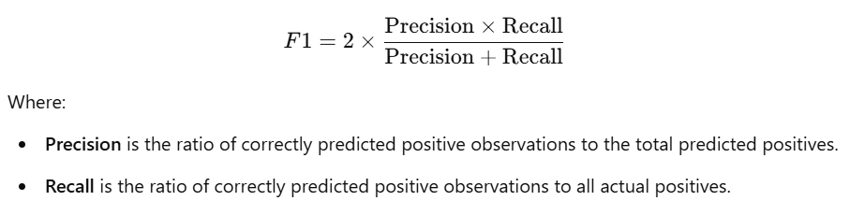

***F1 score achieved by***

***CNN Model=0.99***

***SNN Model (rate coding) =0.93***

***SNN Model(temporal coding) =0.97***

**Interpretation of F1 Score**

The F1 score ranges from 0 to 1:

* A F1 score of 1 indicates perfect precision and recall (i.e., no false positives or false negatives).
* A F1 score of 0 indicates that the model performs very poorly, possibly by predicting only one class (either all positives or all negatives).

Generally:

* A high F1 score means the model is performing well in terms of balancing precision and recall.
* A low F1 score indicates that there is room for improvement, either by improving precision, recall, or both.

**5.5 CONFUSION MATRIX**

A confusion matrix is a table used to evaluate the performance of a classification model. It compares the predicted classifications made by the model with the actual classifications in the data. The confusion matrix provides a detailed breakdown of the model's performance by showing how many instances were correctly or incorrectly predicted for each class.

For a **drowsiness detection system**, for example, the confusion matrix would show how many times the system correctly identified a drowsy driver (TP), missed a drowsy driver (FN), falsely identified a non-drowsy driver as drowsy (FP), and correctly identified a non-drowsy driver (TN).It is mentioned in figure 5.2,5.3.5,4.

**Confusion matrix for CNN**

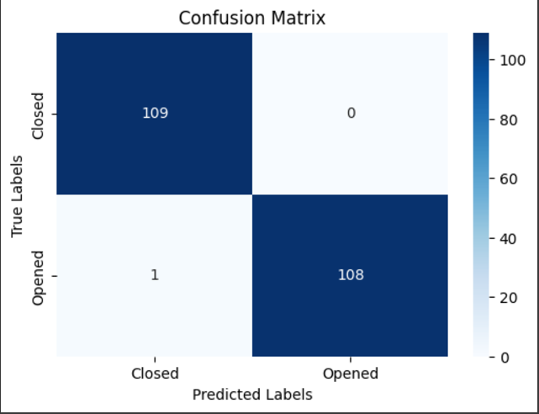

Fig 5.2 Confusion Matrix of CNN

**Confusion matrix for SNN (rate coding)**

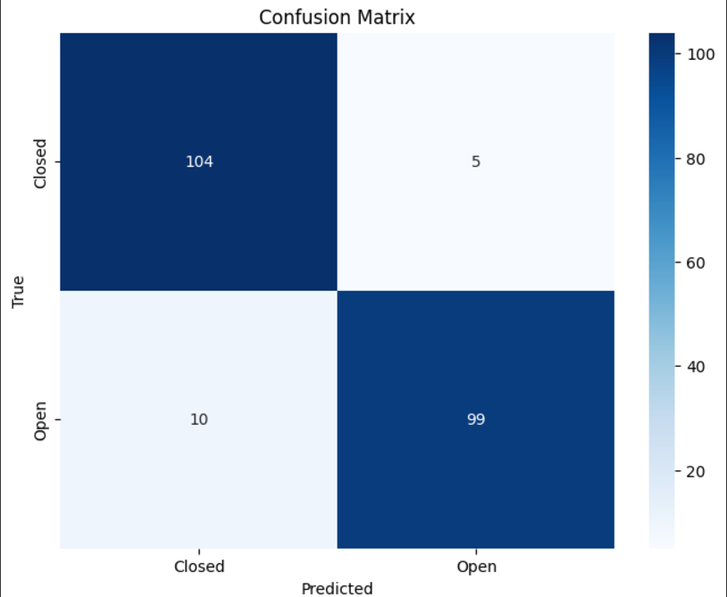

Fig 5.3 Confusion Matrix of SNN (rate coding)

**Confusion matrix for SNN (temporal coding)**

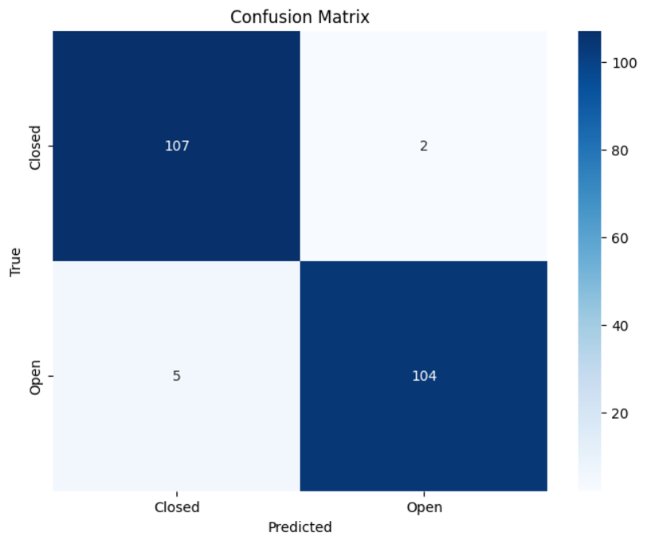

Fig 5.4 Confusion Matrix of SNN (temporal Coding)

**5.6 LATENCY**

**Latency** refers to the time delay between the input being provided to a system or model and the corresponding output being generated. In machine learning and real-time systems, latency is a crucial factor that impacts the speed and responsiveness of a system. Lower latency is generally desired, particularly in real-time applications, as it leads to quicker decision-making and system reactions.

In terms of machine learning, latency typically refers to the time it takes for a model to process the input data and produce a result. For example, in a **drowsiness detection system**, latency would be the time taken for the system to detect whether the driver’s eyes are open or closed, process that information, and potentially trigger an alert.

**Measuring Latency**

To measure latency in a system, you can use the following formula:

Latency=Time of Output Generation−Time of Input Arrival

It is typically measured in **milliseconds (ms)** for most real-time applications. Latency can be affected by various factors, including model size, hardware specifications, and input data processing.

**Factors Affecting Latency**

* **Model Complexity**: More complex models, like deep neural networks (e.g., CNNs or RNNs), tend to have higher latency due to the larger number of computations required. This is particularly significant when deploying models on devices with limited processing power, such as embedded systems.
* **Hardware Resources**: The performance of the hardware running the model, including the CPU, GPU, and RAM, has a significant impact on latency. Using specialized hardware like **Tensor Processing Units (TPUs)** can lower latency significantly in machine learning applications.
* **Batch Processing**: When processing large batches of data instead of single data points, the system might have higher latency, but it could lead to more efficient use of computational resources.
* **Optimizations**: Various optimization techniques, such as **quantization** (reducing the precision of numbers), **model pruning** (removing unnecessary weights), or using **distilled models**, can help reduce latency by making the model more lightweight.

**Importance of Latency in Real-Time Systems**

In applications where real-time decision-making is critical, such as autonomous vehicles, robotics, or **driver drowsiness detection systems**, latency can significantly impact the effectiveness and safety of the system. High latency can lead to delayed responses, potentially causing issues like:

* **Delayed alerts** in safety-critical systems.
* **Reduced user experience** in applications like speech recognition or gaming.
* **Performance bottlenecks** in systems that rely on live data streams, such as video surveillance or healthcare monitoring systems

***Latency achieved by***

***CNN Model=137ms***

***SNN Model (rate coding) =28ms***

***SNN Model (temporal coding) =41ms***

**5.7 FLOPS**

**FLOPS** stands for **Floating Point Operations Per Second** and is a standard metric used to measure the computational performance of a system, especially in fields like high-performance computing, artificial intelligence, and machine learning. It indicates how many floating point operations a system can perform in a second. Floating point operations are essential in scientific computations, including machine learning, image processing, and simulations.

A **floating-point operation** refers to the calculations involving decimal numbers (not integers), often necessary for real-world data like financial computations, scientific measurements, and most machine learning algorithms. High FLOPS values indicate better computational efficiency and are critical for tasks requiring massive amounts of calculations in real time, such as training deep learning models or running simulations.

* **Training a deep neural network** involves many floating-point operations for weight updates, backpropagation, and other mathematical calculations.
* **Inference** in real-time applications like drowsiness detection, autonomous vehicles, or facial recognition relies on a model's ability to quickly perform floating-point operations on input data.

For example:

* **Convolutional Neural Networks (CNNs)** typically have a high FLOPS count due to their multiple layers of convolutions, especially for large datasets and deep architectures.
* **Spiking Neural Networks (SNNs)** might have lower FLOPS compared to CNNs, but still require efficient computation for their event-based nature, particularly for large-scale or real-time processing.

FLOPS can be calculated by multiplying the number of operations per layer or neuron by the number of neurons and layers involved, but this can vary depending on the architecture and specific operations being performed.

The relationship between **FLOPS and power consumption** is not direct but closely related. Generally, systems that can perform higher FLOPS require more power. This is especially true for deep learning models, which involve extensive matrix multiplications, convolutions, and other computationally expensive tasks.

***FLOPS***

***CNN Model=12 Mega FLOPS***

***SNN Model (rate coding) = 4 Mega FLOPS***

***SNN Model (temporal coding) = 4 Mega Flops***

* 1. **MODEL STORAGE**

Evaluating model storage is an essential aspect of machine learning, especially when deploying models to resource-constrained environments such as mobile devices, IoT devices, or edge devices. The storage used by a model can significantly impact its deployment and runtime performance, as large models can occupy considerable memory and storage resources.

***Model Storage required for***

***CNN Model=1.73MB***

***SNN Model=827KB***

* 1. **Overall comparison**

Figure 5.5, figure 5.6, figure 5.7 shows how the thre models(CNN model, SNN rate coding, SNN temporal coding) performs .The figure gives a better comparison of accuracy, precision,recall,f1-score,flops,latency,model storage among the three models.

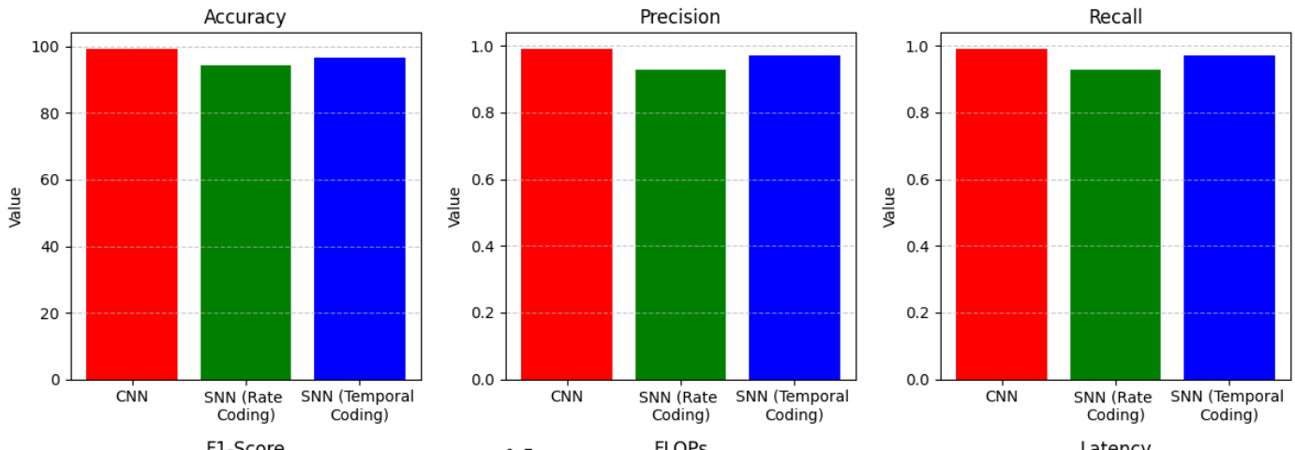

**Fig. 5.5 Accuracy, Precision, Recall comparison**

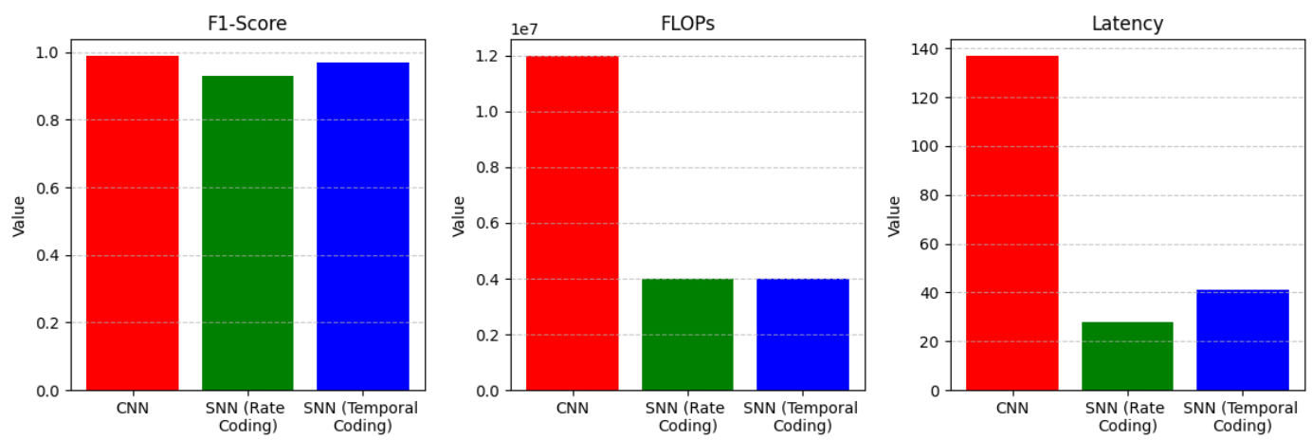

**Fig. 5.6 F1 score, FLOPs, Latency comparison**

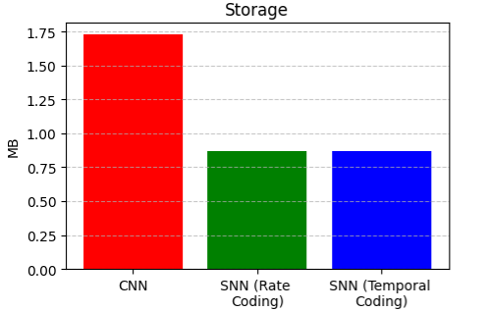

**Fig. 5.7 Storage comparison**

**Table 5.1 compares the parameters across 3 models**

|  |  |  |  |
| --- | --- | --- | --- |
| PARAMETERS | CNN | SNN (rate coding) | SNN (temporal coding) |
| Accuracy | 99.2% | 94.3% | 96.8% |
| Precision | 0.99 | 0.93 | 0.97 |
| Recall | 0.99 | 0.93 | 0.97 |
| F1-score | 0.99 | 0.93 | 0.97 |
| FLOPs | 12 Mega | 4 Mega | 4 Mega |
| Latency | 137 ms | 28 ms | 41 ms |
| Storage | 1.78 MB | 827 KB | 827 KB |

* 1. **Discussion**

From the table 5.1 we can say that

• **Accuracy and F1-Score:**  
The CNN model performs the best in terms of accuracy, achieving 99.2%, followed closely by the SNN with temporal coding at 96.8%. The SNN with rate coding, however, lags behind, with an accuracy of 94.3%. This suggests that while SNNs can provide competitive results, CNNs remain the more accurate choice for this particular application. The F1-scores of the SNN models are similar (0.93 for rate coding and 0.97 for temporal coding), indicating that although they may be slightly less accurate than the CNN, they still provide a good balance of precision and recall.

• **Precision and Recall:**  
The CNN model also excels in precision and recall, both at 0.99, which means that it is highly effective at correctly identifying both open and closed eyes with very few false positives and false negatives. The SNN models, on the other hand, show a drop in performance, with precision and recall at 0.93 for rate coding and 0.97 for temporal coding. While these results are still very good, they reflect the inherent challenges in training and fine-tuning SNNs, which are more complex and biologically inspired than CNNs.

• **FLOPs (Floating Point Operations):**  
The computational efficiency of the models is evident from the FLOPs metric. Both SNN models (rate coding and temporal coding) require fewer floating-point operations than the CNN model, with 4 Mega FLOPs compared to 12 Mega FLOPs for the CNN. This highlights the potential of SNNs for low-power, resource-constrained environments, where computational efficiency is crucial. The reduced FLOPs in SNNs make them an attractive option for embedded systems and edge computing applications, where power and processing resources are limited.

• **Latency:**  
In terms of real-time performance, the SNN models significantly outperform the CNN model. The SNN with rate coding has the lowest latency of 28 ms, followed by the SNN with temporal coding at 41 ms, while the CNN model has a latency of 137 ms. The reduced latency in the SNN models indicates their ability to process data more quickly, which is particularly important for real-time applications like driver drowsiness detection, where fast decision-making is critical for safety.

• **Storage:**  
The storage requirements for the SNN models are also much lower than for the CNN model. Both SNN configurations require 827 KB of storage, compared to the CNN model, which needs 1.78 MB. This smaller storage footprint for SNNs makes them more suitable for devices with limited memory, further highlighting their potential in embedded and mobile applications.

The testing results demonstrate that while CNNs offer higher accuracy and better precision/recall, SNNs—particularly those using temporal coding—show significant advantages in terms of latency, computational efficiency, and storage. This makes SNNs a promising alternative for real-time, low-power applications where speed and resource constraints are crucial. The choice between CNNs and SNNs for a given application may depend on the specific requirements, with CNNs being preferred when accuracy is paramount, and SNNs being suitable for scenarios where speed and efficiency are more important.

**CHAPTER 6**

**CONCLUSION**

**6.1 Improvements achieved**

Throughout the course of the project, significant improvements were made to enhance the overall performance and efficiency of the driver drowsiness detection system. One of the primary achievements was the development and optimization of a more accurate and efficient eye detection system, which plays a critical role in monitoring the driver's alertness. By utilizing a combination of advanced neural networks (CNNs and SNNs), the system demonstrated improved accuracy and reduced computational complexity, making it suitable for real-time applications.

The implementation of **Spiking Neural Networks (SNNs)**, particularly with temporal and rate coding, resulted in reduced latency and lower power consumption compared to traditional CNNs. This was a key improvement, as the system was optimized to run efficiently on resource-constrained devices, such as embedded systems and mobile platforms. With SNNs, we achieved real-time detection of drowsiness with significantly faster response times, which is crucial for safety-critical applications like driver monitoring.

Additionally, the **storage requirements** of the system were optimized, with the use of SNNs reducing the memory footprint, making the system more lightweight and suitable for deployment on edge devices. This improvement allows the system to run efficiently on low-resource platforms, enhancing its practicality in real-world environments.

Moreover, by incorporating a robust **dataset for training** and leveraging advanced techniques in image preprocessing and augmentation, the system became more resilient to variations in lighting, noise, and other real-world challenges. These improvements collectively contribute to the system's effectiveness in detecting drowsiness, making it a reliable tool for driver safety.

In summary, the improvements achieved in terms of accuracy, real-time performance, computational efficiency, and memory optimization have made the driver drowsiness detection system more robust and practical, paving the way for its future deployment in real-world scenarios.

The proposed **Driver Drowsiness Detection System** successfully demonstrates the application of advanced machine learning techniques in addressing critical road safety issues. By utilizing **Convolutional Neural Networks (CNNs)** and **Spiking Neural Networks (SNNs)**, the project has achieved a balance between high accuracy and energy efficiency.

**6.2.1 Key Accomplishments**

* **Detection-Accuracy**:  
  CNN-based models achieved state-of-the-art accuracy by effectively distinguishing between open and closed eye states. High accuracy ensures reliability in diverse conditions.
* **Energy-Efficiency**:  
  SNNs showed significant promise in reducing energy consumption. Their ability to operate on neuromorphic hardware opens the door for deployment in resource-constrained environments like embedded systems.
* **Real-Time-Processing**:  
  The system processes video streams with minimal latency, enabling timely alerts that are critical for preventing accidents.

**6.2.2 Challenges Addressed**

* Overcoming variability in lighting and camera angles using data augmentation techniques.
* Improving SNN training by employing advanced spike-based learning algorithms.

**6.2.3 Broader Impacts**

This project contributes to the field of **intelligent transportation systems**, offering a solution to one of the major causes of road accidents. It paves the way for future advancements in both deep learning and spiking neural networks for safety-critical applications.

**6.3. Future Scope**

The scope of this project extends beyond its initial implementation. Below are detailed avenues for future exploration:

**6.3.1 Enhancing Model Performance**

* **Hybrid CNN-SNN Architectures**:  
  By combining CNNs' accuracy with SNNs' power efficiency, hybrid models can achieve both robustness and practicality for deployment in vehicles.
* **Incremental Learning**:  
  Real-world data varies over time. Integrating incremental learning can help the system adapt to changing environments, such as evolving traffic patterns or weather conditions.
* **Adversarial Robustness**:  
  Ensuring the system is resistant to adversarial attacks, such as tampered camera feeds, is critical for its reliability.

**6.3.2 Dataset Diversification**

* **Multicultural Datasets**:  
  Expanding the dataset to include drivers of diverse ethnic backgrounds, varying age groups, and different levels of fatigue ensures inclusivity and fairness in the system's performance.
* **Synthetic Data Generation**:  
  Using **Generative Adversarial Networks (GANs)** to generate synthetic drowsiness scenarios can address the challenges of limited real-world data.

**6.3.3 Integration into Vehicles**

* **Edge Deployment**:  
  Deploying the system on hardware like **NVIDIA Jetson Nano** or **Raspberry Pi 4** allows for real-time in-vehicle inference without cloud dependence, ensuring privacy and reducing latency.
* **Integration with Advanced Driver Assistance Systems (ADAS)**:  
  The drowsiness detection system can work in tandem with features like adaptive cruise control and lane-keeping assist to create a comprehensive safety system.
* **Alert Customization**:  
  Enabling personalized alert mechanisms (e.g., vibrating seats or customized voice alerts) ensures the system is non-intrusive and user-friendly.

**6.3.4 Multimodal Inputs**

* **Physiological Signals**:  
  Combining drowsiness detection with data from **heart rate monitors** or **EEG sensors** can improve prediction accuracy.
* **Behavioral Analysis**:  
  Integrating **head pose estimation** and **gaze tracking** can provide a deeper understanding of the driver's state.

**6.3.5 Applications in Other Domains**

* **Healthcare Monitoring**:  
  Detecting fatigue in medical professionals during long shifts ensures better decision-making and patient safety.
* **Industrial Applications**:  
  Fatigue detection in high-risk industries like mining or aviation can prevent accidents caused by human error.
* **Military Use**:  
  Deploying similar systems in military vehicles can ensure alertness during critical missions.

**6.3.6 Advancements in Spiking Neural Networks**

* **Training Algorithms**:  
  Exploring advanced techniques like **Spike-Timing-Dependent Plasticity (STDP)** and surrogate gradient methods can improve SNN learning.
* **Hardware Compatibility**:  
  Neuromorphic processors, such as **Intel Loihi** or **IBM TrueNorth**, can further enhance the system's energy efficiency.
* **Cross-Domain Adaptation**:  
  SNNs' low-power capabilities make them suitable for real-time surveillance systems, robotics, and auditory signal processing.

**6.3.7 Ethical and Regulatory Considerations**

* **Driver Privacy**:  
  Ensuring compliance with regulations like **GDPR** by implementing secure data processing and anonymization techniques.
* **Bias Mitigation**:  
  Conducting extensive testing to identify and mitigate potential biases in the model’s performance across different demographic groups.
* **Acceptability**:  
  Educating users about the system’s benefits and addressing any concerns regarding automation and control.

**6.4. Summary of Impact**

This project has made a significant contribution to the development of **AI-based safety systems**. By addressing both technical challenges and societal implications, it sets the stage for more robust, inclusive, and impactful solutions in the future. The use of spiking neural networks highlights the potential for sustainable AI technologies, emphasizing their importance in resource-constrained environments.

**6.5. Recommendations**

To maximize the impact of this system, future efforts should focus on:

* Large-scale testing in diverse environments.
* Collaboration with automotive and neuromorphic hardware companies for system deployment.
* Expanding the system’s capabilities to handle additional driver states, such as distraction or medical emergencies.

By continuing to innovate and address emerging challenges, the system can significantly enhance road safety and make a lasting impact in intelligent transportation systems worldwide.

**REFERENCES**

**1**. M. Venkateswarlu and V. Rami Reddy Ch, "DrowsyDetectNet: Driver Drowsiness Detection Using Lightweight CNN with Limited Training Data," IEEE Access, vol. 12, pp. 110476-110491, 2024. doi: 10.1109/ACCESS.2024.3440585.

**2**. M. Ahmed, S. Masood, M. Ahmad, and A. A. Abd El-Latif, "Intelligent Driver Drowsiness Detection for Traffic Safety Based on Multi CNN Deep Model and Facial Subsampling," IEEE Transactions on Intelligent Transportation Systems, vol. 23, no. 10, pp. 19743-19752, Dec. 2021. doi: 10.1109/TITS.2021.3134222.

**3**. H. Lamaazi, A. Alqassab, R. A. Fadul, and R. Mizouni, "Smart Edge-Based Driver Drowsiness Detection in Mobile Crowdsourcing," IEEE Access, vol. 11, pp. 21863-21872, Mar. 2023. doi: 10.1109/ACCESS.2023.3250834.

**4**. J. Alguindigue, A. Singh, A. Narayan, and S. Samuel, "Biosignals Monitoring for Driver Drowsiness Detection Using Deep Neural Networks," IEEE Access, vol. 12, pp. 93075-93086,Jul. 2024. doi: 10.1109/ACCESS.2024.3423723.

**5**. D. Yoo and D. S. Jeong, "DTS-SNN: Spiking Neural Networks With Dynamic Time-Surfaces,"IEEE Access, vol. 10, pp. 102659-102668, Sep. 2022. doi:10.1109/ACCESS.2022.3209671.