**Date Submitted:**

**Task 01:**

Youtube Link: <https://youtu.be/Gq6V5QqJleA>

**Modified Schematic (if applicable): N/A**

**Modified Code:**

**// Insert code here**

/*

* Copyright (c) 2015-2017, Texas Instruments Incorporated

* All rights reserved.

*

* Redistribution and use in source and binary forms, with or without

* modification, are permitted provided that the following conditions

* are met:

*

* * Redistributions of source code must retain the above copyright

* notice, this list of conditions and the following disclaimer.

*

* * Redistributions in binary form must reproduce the above copyright

* notice, this list of conditions and the following disclaimer in the

* documentation and/or other materials provided with the distribution.

*

* * Neither the name of Texas Instruments Incorporated nor the names of

* its contributors may be used to endorse or promote products derived

* from this software without specific prior written permission.

*

* THIS SOFTWARE IS PROVIDED BY THE COPYRIGHT HOLDERS AND CONTRIBUTORS "AS IS"

* AND ANY EXPRESS OR IMPLIED WARRANTIES, INCLUDING, BUT NOT LIMITED TO,

* THE IMPLIED WARRANTIES OF MERCHANTABILITY AND FITNESS FOR A PARTICULAR

* PURPOSE ARE DISCLAIMED. IN NO EVENT SHALL THE COPYRIGHT OWNER OR

* CONTRIBUTORS BE LIABLE FOR ANY DIRECT, INDIRECT, INCIDENTAL, SPECIAL,

* EXEMPLARY, OR CONSEQUENTIAL DAMAGES (INCLUDING, BUT NOT LIMITED TO,

* PROCUREMENT OF SUBSTITUTE GOODS OR SERVICES; LOSS OF USE, DATA, OR PROFITS;

* OR BUSINESS INTERRUPTION) HOWEVER CAUSED AND ON ANY THEORY OF LIABILITY,

* WHETHER IN CONTRACT, STRICT LIABILITY, OR TORT (INCLUDING NEGLIGENCE OR

* OTHERWISE) ARISING IN ANY WAY OUT OF THE USE OF THIS SOFTWARE,

* EVEN IF ADVISED OF THE POSSIBILITY OF SUCH DAMAGE.

*/

/*

* ======== empty.c ========

*/

/* For usleep() */

**#include** <unistd.h>

**#include** <stdint.h>

**#include** <stddef.h>

/* Driver Header files */

**#include** <ti/drivers/GPIO.h>

// #include <ti/drivers/I2C.h>

// #include <ti/drivers/SDSPI.h>

// #include <ti/drivers/SPI.h>

// #include <ti/drivers/UART.h>

// #include <ti/drivers/Watchdog.h>

/* Board Header file */

**#include** "Board.h"

/*

* ======== mainThread ========

*/

**void** \***mainThread**(**void** *arg0)

{

/* 1 second delay */

uint32_t time = 1;

/* Call driver init functions */

GPIO_init();

// I2C_init();

// SDSPI_init();

// SPI_init();

// UART_init();

// Watchdog_init();

/* Configure the LED pin */

GPIO_setConfig(Board_GPIO_LED0, GPIO_CFG_OUT_STD | GPIO_CFG_OUT_LOW);

/* Turn on user LED */

GPIO_write(Board_GPIO_LED0, Board_GPIO_LED_ON);

**while** (1) {

sleep(time);

GPIO_toggle(Board_GPIO_LED0);

}

}

**------------------------------------------------------------------------------------**

**Task 02 and Task 03: I combined task 2 and 3 together since task 2’s goal was to make the LED blink only when the ADC value exceeds the threshold and task3’s goal was to print the ADC value recordings onto a UART terminal. The code below accomplishes both tasks. The video also shows the code’s operation. I also changed the arbitrary threshold value to 608 because if it was left at 100, the LED would always be on since the ADC measurements fell between 605-612.**

Youtube Link: <https://youtu.be/H1o-VqvRBl4>

**Modified Schematic (if applicable): N/A**

**Modified Code:**

**// Insert code here**

/*

* ======== empty.c ========

*/

/* For usleep() */

**#include** <unistd.h>

**#include** <stdint.h>

**#include** <stddef.h>

/* Driver Header files */

**#include** <ti/drivers/GPIO.h>

**#include** <ti/drivers/ADC.h>

**#include** <ti/display/Display.h>

// #include <ti/drivers/I2C.h>

// #include <ti/drivers/SDSPI.h>

// #include <ti/drivers/SPI.h>

// #include <ti/drivers/UART.h>

// #include <ti/drivers/Watchdog.h>

/* Board Header file */

**#include** "Board.h"

/* global variables FOR GUI COMPOSER */

uint16_t adcValue = 0;

uint16_t threshold = 608; // arbitrary threshold value, change to any value

uint16_t trigger = 0;

/*

* ======== mainThread ========

*/

**void** \***mainThread**(**void** *arg0)

{

/* ~10 loops/second */

uint32_t time = 100000; // update ~10/second

/* Call driver init functions */

**GPIO_init**();

**ADC_init**();

// I2C_init();

// SDSPI_init();

// SPI_init();

// UART_init();

// Watchdog_init();

/* Open Display Driver */

Display_Handle displayHandle;

Display_Params displayParams;

Display_Params_init(&displayParams);

displayHandle = Display_open(Display_Type_UART, NULL);

/* Open ADC Driver */

ADC_Handle adc;

ADC_Params params;

**ADC_Params_init**(&params);

adc = **ADC_open**(Board_ADC0, &params);

**if** (adc == NULL) {

// Error initializing ADC channel 0

**while** (1);

}

**while** (1) {

int_fast16_t res;

res = **ADC_convert**(adc, &adcValue);

**if** (res == ADC_STATUS_SUCCESS) {

Display_printf(displayHandle, 1, 0, "ADC Reading %d", adcValue);

**if**(adcValue >= threshold){

**GPIO_write**(Board_GPIO_LED0, Board_GPIO_LED_ON);

trigger = 1;

} **else**{

**GPIO_write**(Board_GPIO_LED0, Board_GPIO_LED_OFF);

trigger = 0;

}

}

**usleep**(time);

}

}

**------------------------------------------------------------------------------------**

**Task 04:**

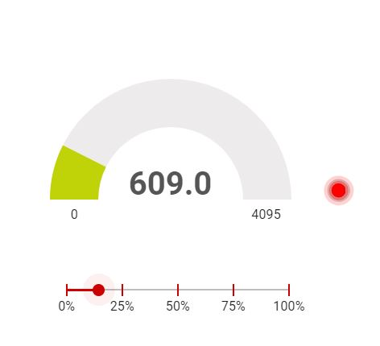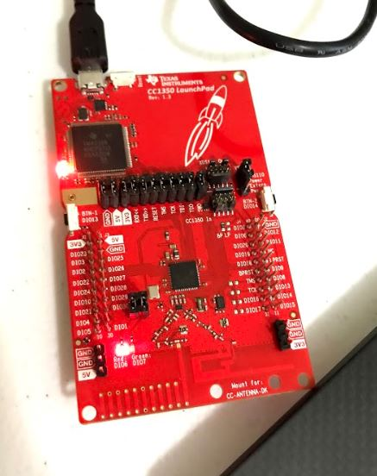

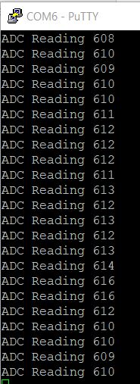

Youtube Link: <https://youtu.be/-cg26ZHGTFw>

**Modified Schematic (if applicable): N/A**

**Modified Code:**

**// Insert code here**

/*

* ======== empty.c ========

*/

/* For usleep() */

**#include** <unistd.h>

**#include** <stdint.h>

**#include** <stddef.h>

/* Driver Header files */

**#include** <ti/drivers/GPIO.h>

**#include** <ti/drivers/ADC.h>

**#include** <ti/display/Display.h>

// #include <ti/drivers/I2C.h>

// #include <ti/drivers/SDSPI.h>

// #include <ti/drivers/SPI.h>

// #include <ti/drivers/UART.h>

// #include <ti/drivers/Watchdog.h>

/* Board Header file */

**#include** "Board.h"

/* global variableS FOR GUI COMPOSER */

uint16_t adcValue = 0;

uint16_t threshold = 608;

uint16_t trigger = 0;

/*

* =======gpioButtonFxn0=======

* Callback function for the GPIO interrupt on Board_GPIO_Button0

*/

**void** **gpioButtonFxn0**(uint_least8_t index)

{

//clear the gpio interrupt and decrement threshold

**if**(threshold < 250){ //ensure threshold does not go below zero

threshold = 0;

}

**else**{

threshold -= 250; //decrement threshold by 250

}

}

/*

* =======gpioButtonFxn1======

* Callback function for the GPIO interrupt on Board+GPIO_BUTTON1

*/

**void** **gpioButtonFxn1**(uint_least8_t index)

{

//clear the gpio interrupt and increment threshold

**if**(threshold > 4095)

{

threshold = 4095;

}

**else**{

threshold += 250; //increment threshold by 250

}

}

/*

* ======== mainThread ========

*/

**void** \***mainThread**(**void** *arg0)

{

/* ~10 loops/second */

uint32_t time = 100000; // update ~10/second

/* Call driver init functions */

**GPIO_init**();

**ADC_init**();

// I2C_init();

// SDSPI_init();

// SPI_init();

// UART_init();

// Watchdog_init();

/* Open Display Driver */

Display_Handle displayHandle;

Display_Params displayParams;

Display_Params_init(&displayParams);

displayHandle = Display_open(Display_Type_UART, NULL);

/* Open ADC Driver */

ADC_Handle adc;

ADC_Params params;

**ADC_Params_init**(&params);

adc = **ADC_open**(Board_ADC0, &params);

**if** (adc == NULL) {

// Error initializing ADC channel 0

**while** (1);

}

**GPIO_setCallback**(Board_GPIO_BUTTON0,gpioButtonFxn0);

**GPIO_setCallback**(Board_GPIO_BUTTON1,gpioButtonFxn1);

//Enable interrupts

**GPIO_enableInt**(Board_GPIO_BUTTON0);

**GPIO_enableInt**(Board_GPIO_BUTTON1);

**while** (1) {

int_fast16_t res;

res = **ADC_convert**(adc, &adcValue);

**if** (res == ADC_STATUS_SUCCESS) {

Display_printf(displayHandle, 1, 0, "ADC Reading %d", adcValue);

**if**(adcValue >= threshold){

**GPIO_write**(Board_GPIO_LED0, Board_GPIO_LED_ON);

trigger = 1;

} **else**{

**GPIO_write**(Board_GPIO_LED0, Board_GPIO_LED_OFF);

trigger = 0;

}

}

**usleep**(time);

}

}

**------------------------------------------------------------------------------------**