**Date Submitted: 12/02/2018**

**Task 01: Building and loading the collector example**

The image below shows the modification of the channel mask in the config.h file of the collector project. We decided to use the 0x05 channel to communicate between the collector and sensor and turn every other channel off.

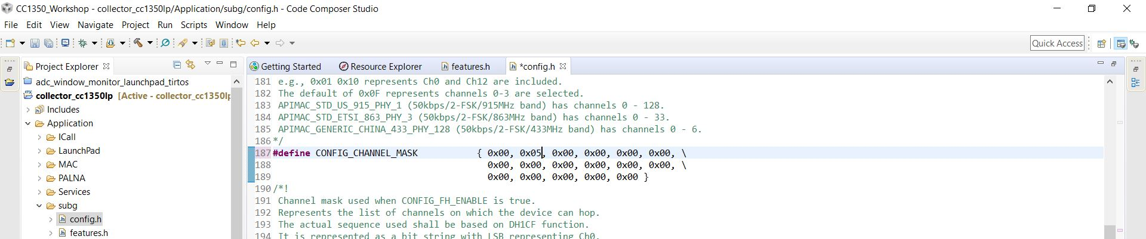

The image below shows the modification of the csf.c file to output temperature instead of the sensor ID.

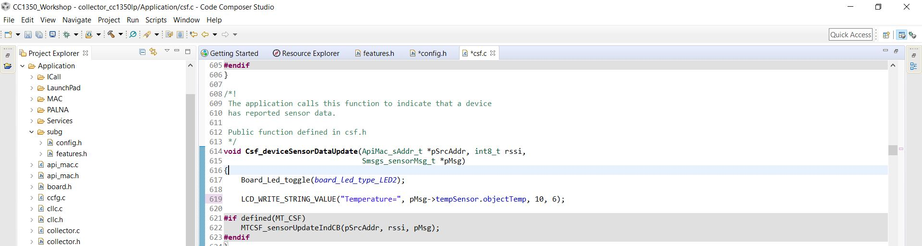

The image below shows a successful build and load of the collector project onto the CC1350 collector board.

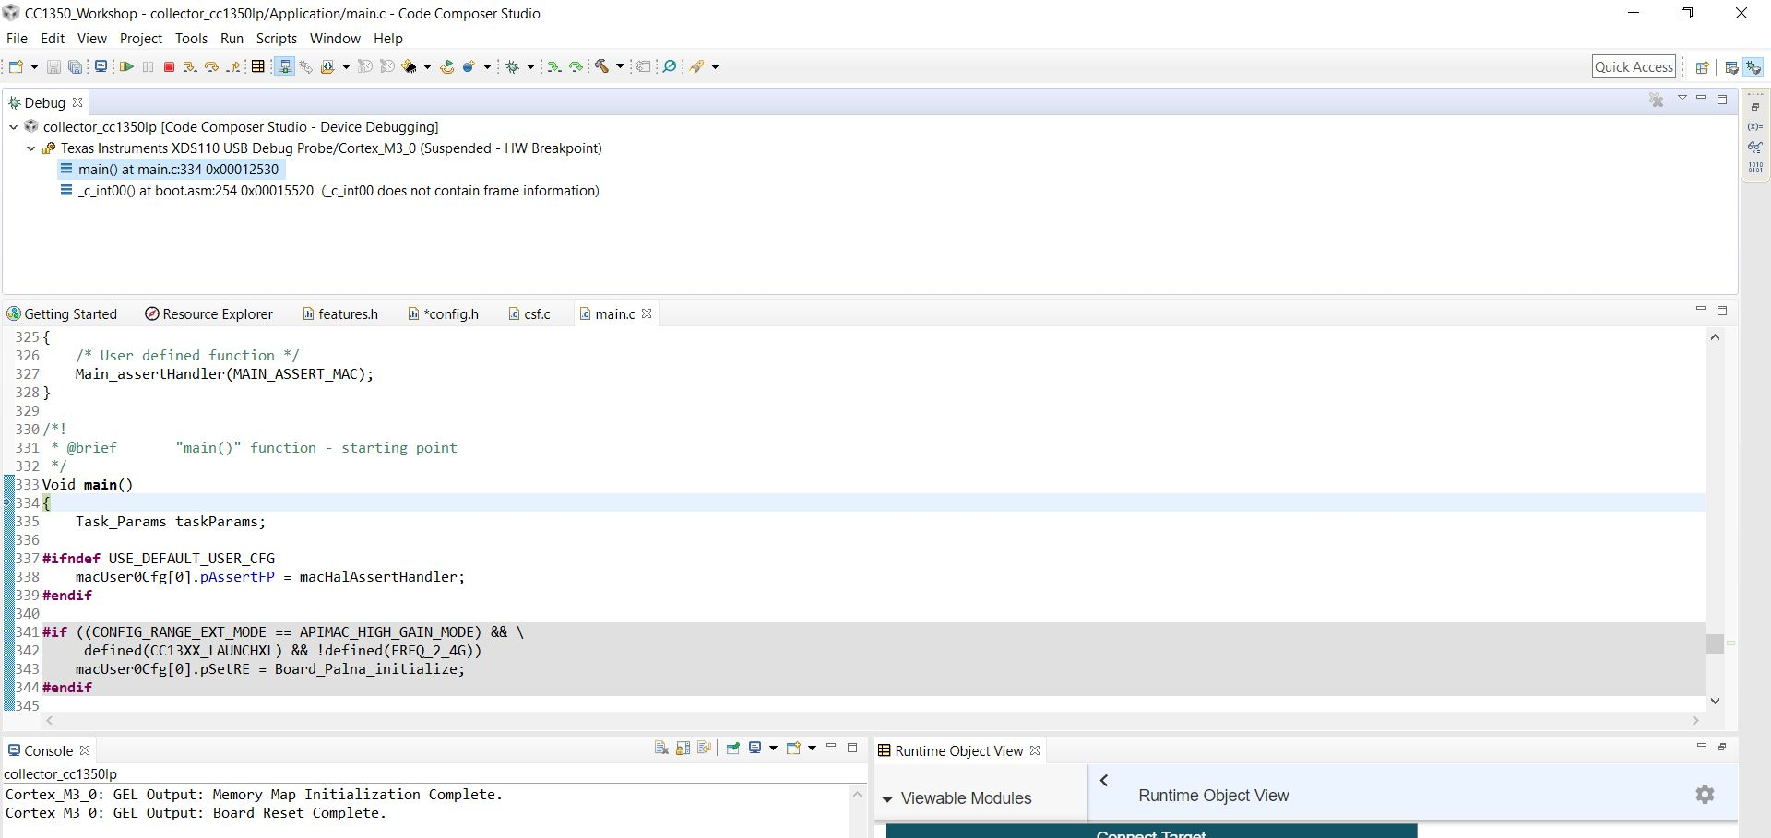

Youtube Link: no video required for this task. We just had to build and load the collector project onto the CC1350 board.

**Modified Schematic (if applicable): N/A**

**Modified Code: The modified code is shown in the first two images.**

**------------------------------------------------------------------------------------**

**Task 02: Building and loading the sensor example**

The image below shows the modification made in the config.h file of the sensor project. This was the channel we used when we were setting up the CONFIG_CHANNEL_MASK.

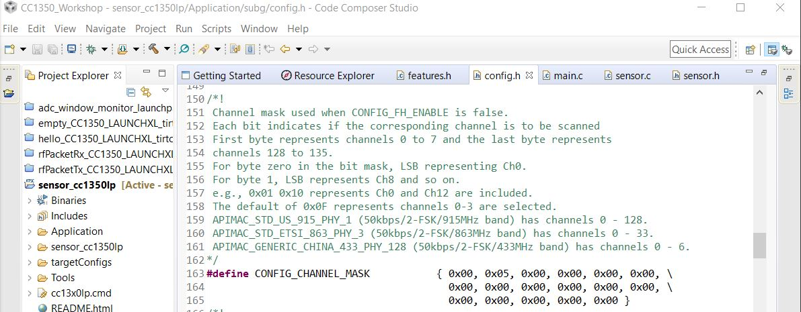

The image below shows a successful build of the sensor project.

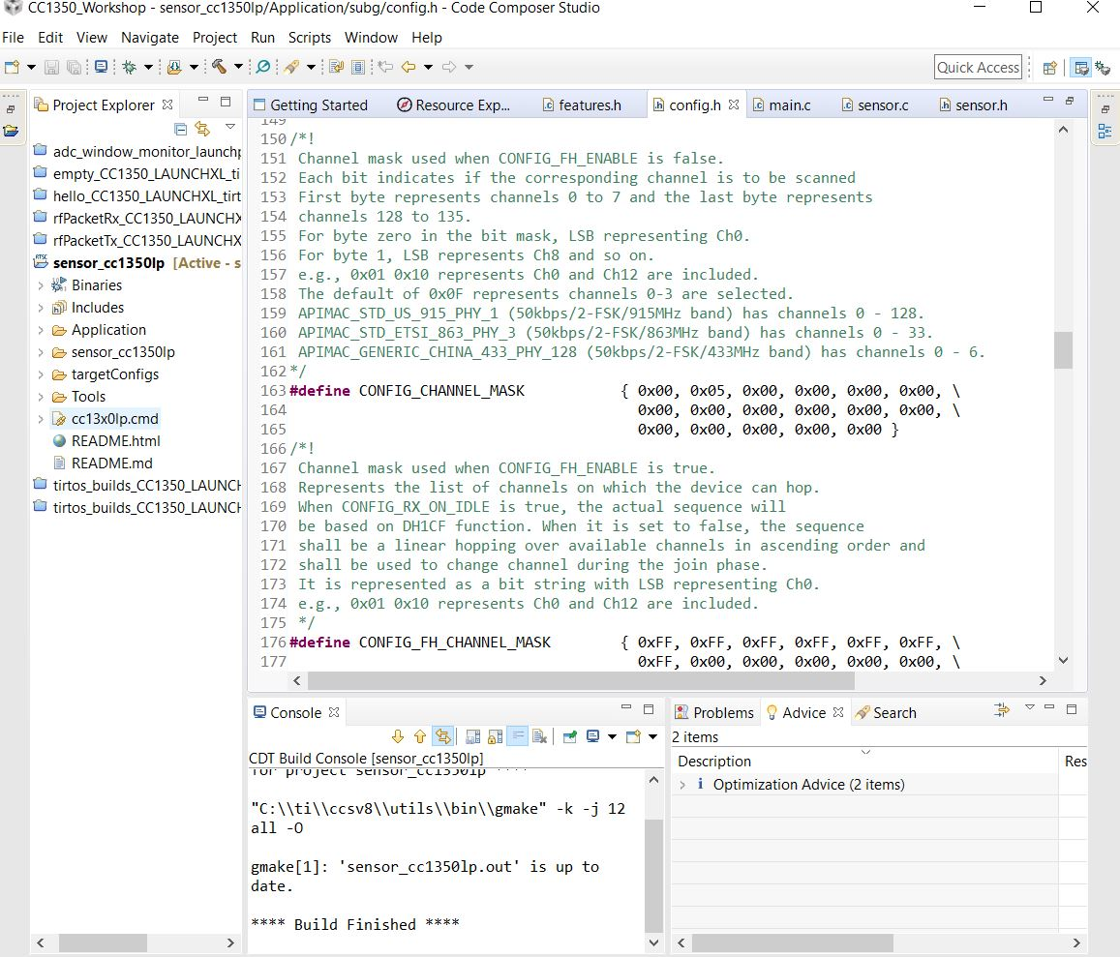

The image below shows a successful load of the sensor project onto the CC1350 sensor board.

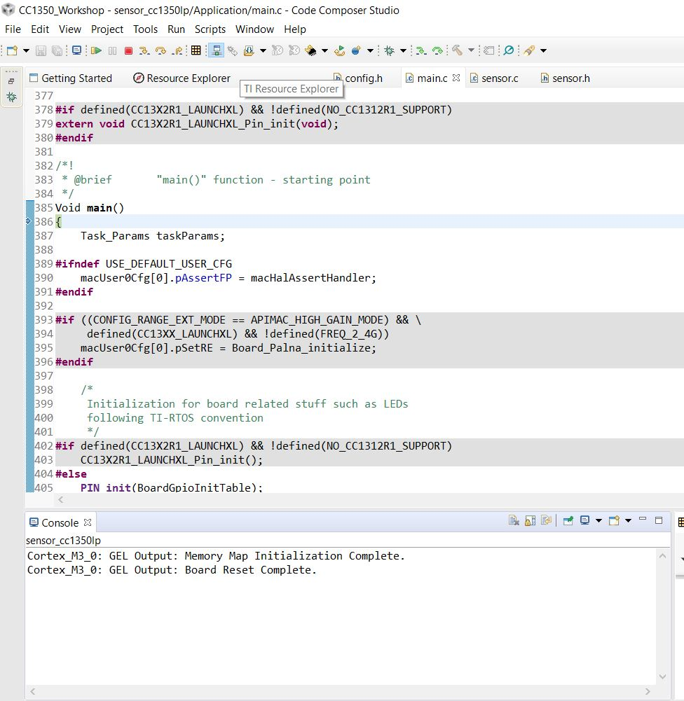

Youtube Link: no video required for this task. We just had to build and load the sensor project onto the CC1350 board.

**Modified Schematic (if applicable): N/A**

**Modified Code: The modification to the code is shown in the first image listed under Task 2.**

**------------------------------------------------------------------------------------**

**Task 03: Using the Collector and Sensor**

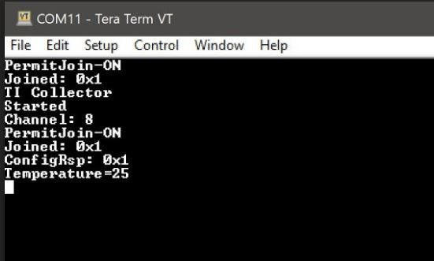

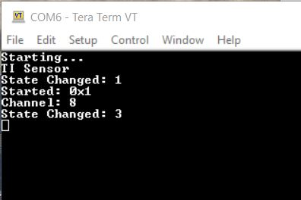

Youtube Link: <https://youtu.be/FUn3OLc6soY>

**Modified Schematic (if applicable): N/A**

**Modified Code: Task 3 does not instruct us to modify any code. We just have to run the collector and sensor and watch their outputs on the Tera Term terminal.**

**------------------------------------------------------------------------------------**

**Task 04: Updating the sensor’s reporting rate**

Youtube Link: <https://youtu.be/aqid5bUj5U4>

**Modified Schematic (if applicable): N/A**

**Modified Code:**

**The image below shows the modification of CONFIG_REPORTING_INTERVAL to 500 instead of 1000 in the config.h file of the sensor project.**

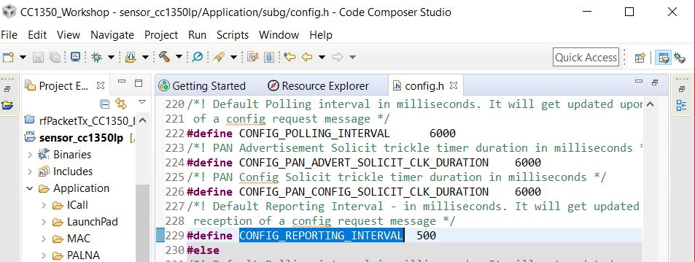

**The image below shows the modification of the config.h file in the collector project.**

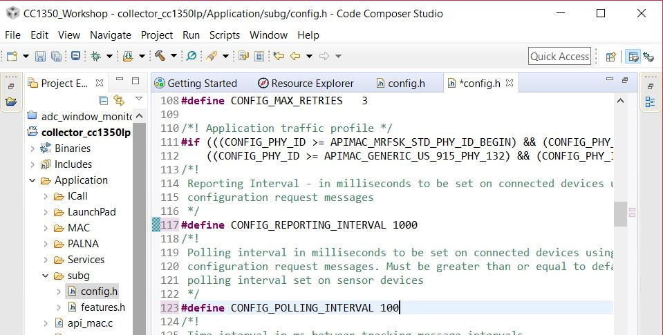

**The image below shows the modification of the sensor.c file in the sensor project. We had to change the MIN_POLLING_INTERVAL to 100 instead of 1000.**

