**Date Submitted: 12/02/18**

**Task 00: Getting Started: Install needed software and apps**

For this task we just needed to install the required software and apps to update the firmware of our CC1350 boards and load them with the concentrator and node bin files.

**Youtube Link: no video required for this task.**

**------------------------------------------------------------------------------------**

**Task 01: Update CC1350 Launchpad firmware**

The image below shows the first step of updating the launchpad firmware which is to load the image of the CC1350LaunchPad_ExtFlashErase.hex file which is done successfully as shown.

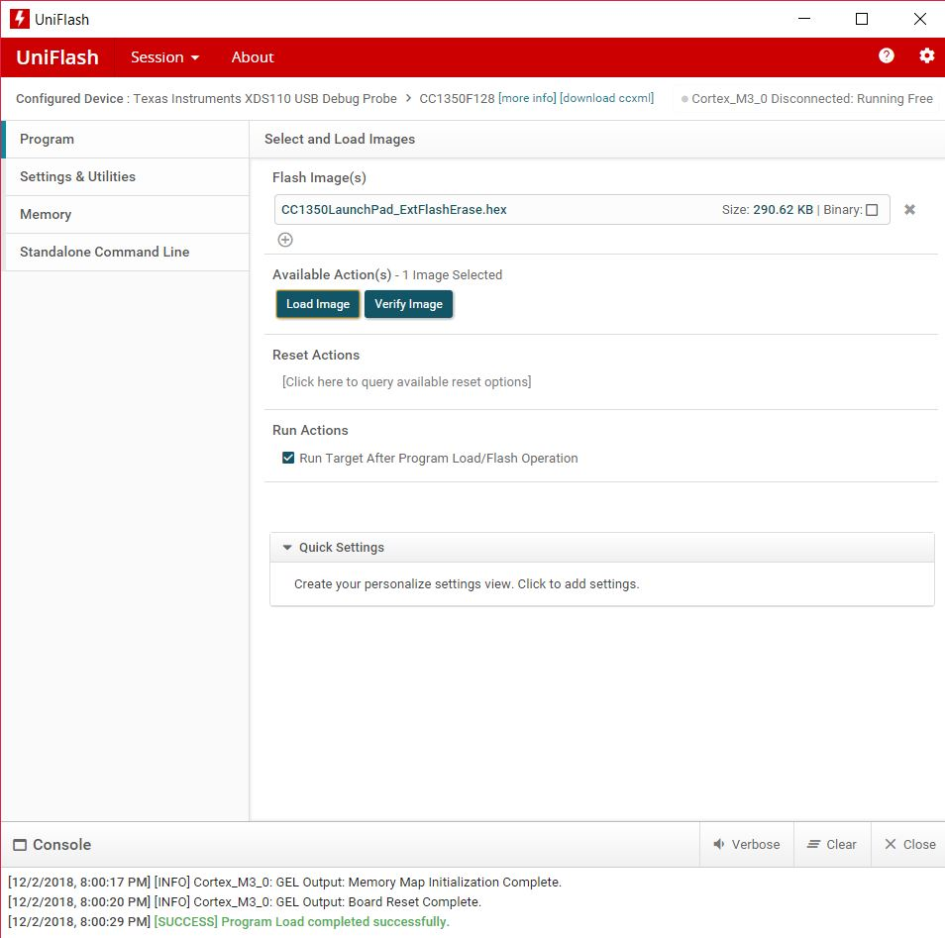

The image below shows the next step which is to load the image of the simple_peripheral_cc1350lp_all.hex file onto the board. This is done successfully as shown below.

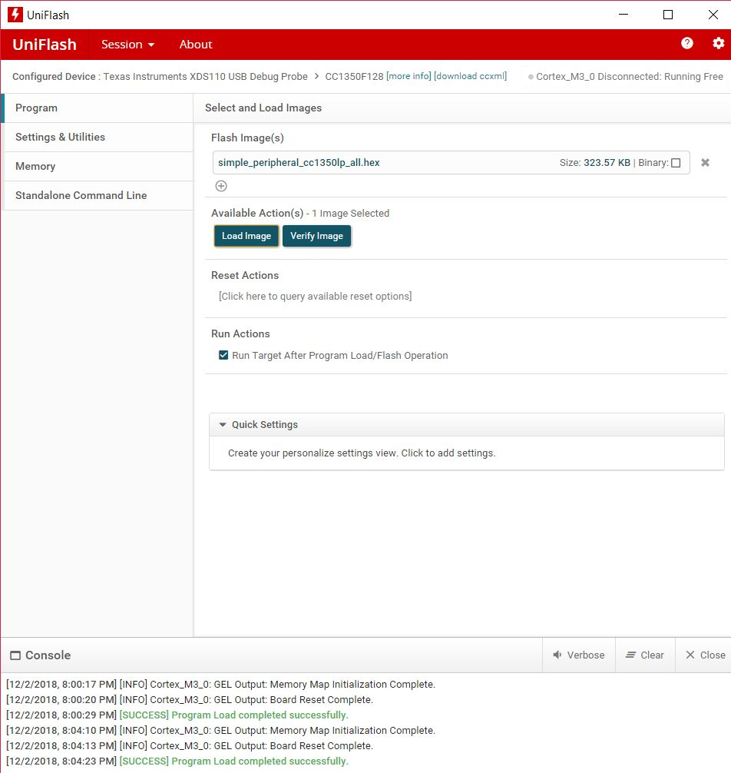

The two images below show the successful completion of the last step of task 1 which was to flash the CC1350 board with the simple_peripheral_cc1350lp_app_stack.bin using the SimpleLink Starter app on a mobile device.

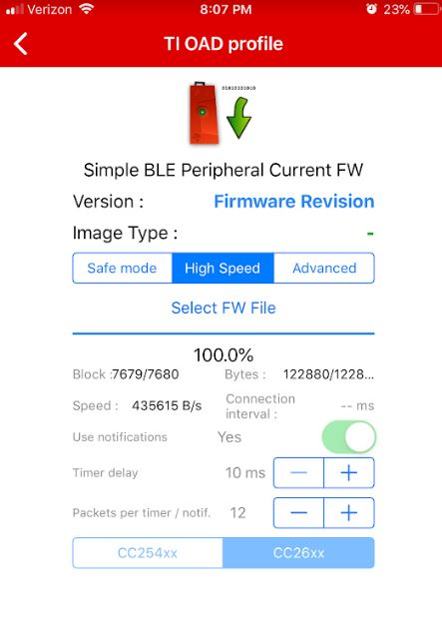 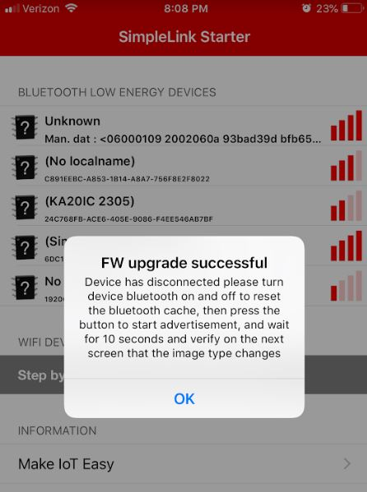

Youtube Link: No video required for this task. Just updating the firmware of the CC1350 board.

**Modified Schematic (if applicable): N/A**

**Modified Code: There is no code to modify for this task.**

**------------------------------------------------------------------------------------**

**Task 02: OAD download sub-1GHz firmware images**

In this task, we had to download the sub 1GHz firmware images of the concentrator and the node onto our first and second board respectively. The images below show the successful completion of this task. The left image is for the concentrator while the image on the right is for the node.

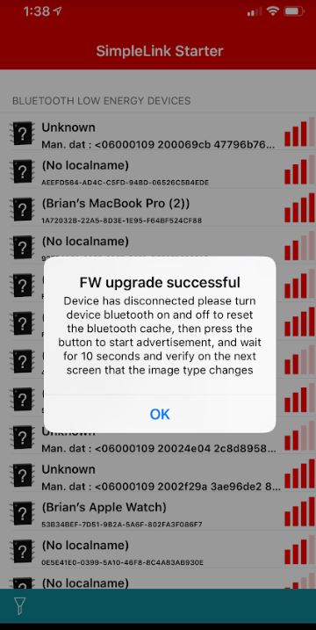 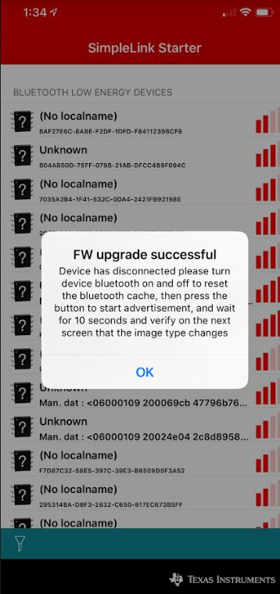

Youtube Link: no video required for this task.

**Modified Schematic (if applicable): N/A**

**Modified Code: There is no code to modify for this task.**

**------------------------------------------------------------------------------------**

**Task 03: Running the sub-1GHz firmware images**

After successfully downloading the concentrator and node files onto each of our boards, this is the output we get on the Tera Term terminal which states that the concentrator board is searching for the node boards.

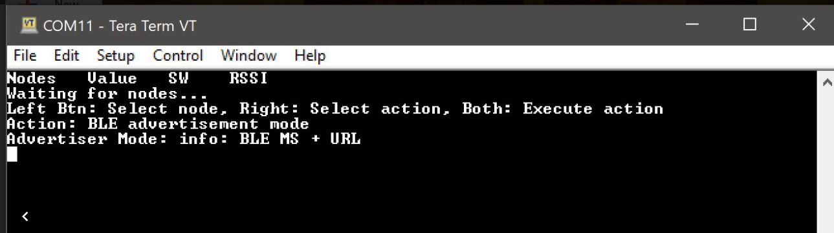

Youtube Link: No video required for this task.

**Modified Schematic (if applicable): N/A**

**Modified Code: There is no code to modify for this task.**

**------------------------------------------------------------------------------------**