LakeForcing: a σ-to-z coupling algorithm and open pipeline for hydrodynamic and wind-wave forcing of inland lakes to drive Lagrangian transport models
Vassilios Papaioannou^{1,*}, Christos G. E. Anagnostopoulos¹, Anastasia Moumtzidou¹, Ilias Gialampoukidis¹, Stefanos Vrochidis¹, Ioannis Kompatsiaris¹
¹ Information Technologies Institute, Centre for Research and Technology Hellas (CERTH-ITI), 6th km Charilaou-Thermi, 57001 Thessaloniki, Greece
E-mail addresses: vaspapa@iti.gr (Vassilios Papaioannou); anagn_c@iti.gr (Christos G. E. Anagnostopoulos); moumtzid@iti.gr (Anastasia Moumtzidou); heliasgj@iti.gr (Ilias Gialampoukidis); stefanos@iti.gr (Stefanos Vrochidis); ikom@iti.gr (Ioannis Kompatsiaris)
* Corresponding author: Vassilios Papaioannou, vaspapa@iti.gr, Tel. +30 697 285 4287

Abstract
Lagrangian particle tracking is a standard tool for transport of floating material (plastics, oil, harmful-algal-bloom cells, fish larvae), yet in inland lakes its use is blocked by the absence of ready-made forcing: ocean reanalyses stop at the coast, and lake models are built by hand. We present LakeForcing, an open, reproducible Python pipeline that assembles bathymetry and meteorology from open data, automatically runs a coupled Delft3D-FLOW/WAVE (SWAN) simulation for any lake, and exports CF-compliant NetCDF that drives Lagrangian particle trackers unmodified. The computational core is a σ-to-z coupling algorithm, mapping terrain-following σ-layer fields to fixed z-levels with per-cell velocity rotation and a surface Stokes-drift derivation, that makes a hydrodynamic engine interoperable with a generic tracker. We demonstrate it, unchanged, on twelve lakes (36°S–60°N); in a consistency check against an expert-built reference model of one reservoir it reproduces that model's surface temperature to 0.85 °C RMSE and current speed to 1.5 cm s⁻¹, and an independent satellite comparison bounds the absolute accuracy of the exported surface-temperature field. Toolchain and the twelve-lake forcing dataset are released openly with a pinned software environment and a continuous-integration test that reproduces the σ-to-z export from a clean checkout.
Keywords: Lake hydrodynamics; Wind-wave modelling (SWAN); Sigma-to-z coupling; OpenDrift; Lagrangian particle tracking; Reproducible open-source workflow; CF-NetCDF interoperability

Graphical abstract
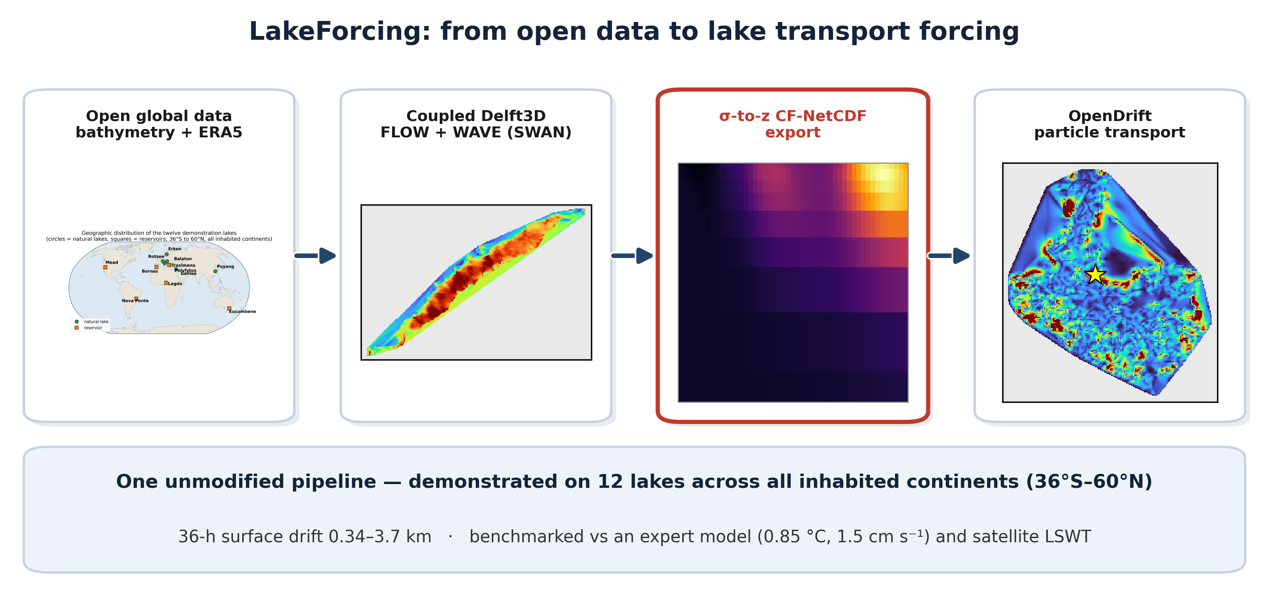

1. Introduction
Lagrangian particle-tracking models such as OpenDrift (Dagestad et al., 2018) and Parcels (Delandmeter and van Sebille, 2019) are now standard tools for simulating the transport and fate of floating material — plastic debris, spilled oil, harmful-algal-bloom cells, fish eggs and larvae — in aquatic environments, from river-borne plastic pathways (Iskandar et al., 2022) to harmful-algal-bloom forecasting in large lakes (Wynne and Stumpf, 2015; Zhou et al., 2023). In these models the velocity of a buoyant particle is reconstructed as the vector sum of the Eulerian near-surface current, a wind-induced windage term, and the wave-driven Stokes drift (van den Bremer and Breivik, 2018). The Stokes contribution is not a second-order correction: under realistic wind-sea conditions it can account for a large fraction of the net surface displacement, and omitting it systematically biases predicted transport pathways and accumulation zones (Kukulka et al., 2012; Onink et al., 2019; van Sebille et al., 2020; Chenillat et al., 2021). In the open ocean all three contributions are supplied operationally: gridded current, wind and spectral-wave products from services such as the Copernicus Marine Service are ingested directly by the tracker, so that the modelling task reduces to specifying the particle physics rather than producing the forcing.
Inland waters break this workflow. Lakes and reservoirs hold the large majority of the planet's liquid surface freshwater (Lehner et al., 2011; Messager et al., 2016) and act as acute receptors of plastic pollution, oil spills, harmful algal blooms and a range of ecological transport processes. The first standardised cross-national survey of lake plastic debris detected contamination in every one of 38 lakes and reservoirs sampled, with surface concentrations in the most affected systems exceeding those reported for the great oceanic accumulation zones (Cózar et al., 2014; Free et al., 2014; Nava et al., 2023); complementary global meta-analyses document pervasive microplastic pollution across lakes in 43 countries and identify lake morphometry and hydraulic residence time as primary controls on retention (Wagner et al., 2014; Chen et al., 2024). Quantifying where this material accumulates demands the same Lagrangian machinery used in the ocean — yet the forcing that machinery depends on is unavailable off the shelf for lakes, for three structural reasons.
First, global ocean reanalyses are masked to the marine domain: their land–sea masks terminate at the coastline and carry no information inside continental waterbodies, so for an inland lake there is simply nothing to read. Second, three-dimensional lake hydrodynamic models are well established and extensively validated (Wüest and Lorke, 2003; Hipsey et al., 2019; Ishikawa et al., 2022; Li et al., 2025), but they are almost always assembled by hand for a single waterbody — with a bespoke computational grid, hand-set bathymetry, and site-specific boundary and forcing conditions — so the effort is labour-intensive and non-transferable, and each new lake restarts it from scratch. Third, where this cost is avoided, modellers commonly substitute idealised or analytical flow fields that omit waves, Stokes drift and thermally driven circulation, precisely the processes that dominate the surface transport one is trying to resolve.
The net effect is a forcing bottleneck: the particle tracker itself is mature, open and free, but generating physically complete, transport-ready fields to drive it for an arbitrary lake remains the rate-limiting step. Existing inland-water transport frameworks narrow this gap without closing it; the TELEMAC-coupled CaMPSim-3D system (Pilechi et al., 2022), for example, couples three-dimensional hydrodynamics to particle transport with demonstrable skill, but remains tied to a specific hydrodynamic engine and configured per study site. To our knowledge no open, reproducible workflow exists that converts globally available data into transport-model-ready lake forcing — wind-waves and Stokes drift included — in a manner that is simultaneously lake-agnostic and decoupled from any single tracker.
This paper presents such a workflow. Given only a lake's geographic coordinates, the pipeline assembles bathymetry from open global datasets (HydroLAKES, Messager et al., 2016; GLOBathy, Khazaei et al., 2022) or from satellite-altimetry products where in-situ surveys are absent (DAHITI, Schwatke et al., 2015), and atmospheric forcing from the ERA5 reanalysis (Hersbach et al., 2020); it then automatically constructs and runs a coupled Delft3D-FLOW (Lesser et al., 2004) and Delft3D-WAVE/SWAN (Booij et al., 1999) simulation of the closed basin, and exports CF-compliant NetCDF that OpenDrift reads without modification. The central technical obstacle it resolves is a coordinate incompatibility: Delft3D-FLOW discretises the vertical with terrain-following σ-layers whose physical depth varies in space and time with the free surface and the bed, whereas OpenDrift's generic reader expects fields sampled on fixed metric z-levels. As recent inter-comparisons of vertical-coordinate choices for lakes emphasise (Ishikawa et al., 2022), reconciling the two representations is non-trivial, and without it Delft3D output cannot be ingested by the generic reader at all. We close this gap with an explicit, fully specified σ-to-z coupling that additionally carries the curvilinear-to-geographic velocity rotation and the surface Stokes-drift derivation needed to render lake hydrodynamics ingestible by an ocean-oriented tracker.
Table 1 situates the pipeline against the alternatives currently used for lake transport modelling. Its reusable contribution is the automated, lake-agnostic engine-to-tracker coupling — a Delft3D-to-OpenDrift workflow that propagates the wave-driven Stokes drift. We are not aware of any published, generalised, lake-agnostic Delft3D-to-OpenDrift workflow of this kind.
Table 1. Positioning of the proposed pipeline relative to existing approaches to lake transport forcing.
Existing approach | Limitation for lake transport | This pipeline
Global ocean reanalyses (CMEMS) to OpenDrift | coverage ends at the coast | forcing for any lake from open data
Hand-built per-lake hydrodynamic models | labour-intensive, non-reproducible | auto-generates the setup from open inputs
1-D vertical lake models (e.g., GLM) | no horizontal transport field | full 3-D currents + waves on a grid
Site-specific transport frameworks (e.g., CaMPSim-3D) | configured per site and per engine | engine output exported to a generic CF reader
Tracker native readers (e.g., ROMS-format, generic CF) | no Delft3D reader available; σ-fields not directly ingestible | σ-to-z coupling bridges the gap
GLOBathy / HydroLAKES | static bathymetry only | adds physics-based currents + waves
Idealised / analytical lake flow | no data, no waves/Stokes, no heat | data-driven FLOW+WAVE + Stokes

The specific contributions are twofold. The computational contribution is a σ-to-z coupling algorithm and the automated, lake-agnostic engine-to-tracker framework built around it: a fully specified reconstruction that maps Delft3D's terrain-following σ-layer currents, temperature and water level onto fixed metric z-levels — with the per-cell curvilinear-to-geographic velocity rotation, horizontal regridding and surface Stokes-drift derivation needed to render that output readable by a generic CF reader — together with the automated generation of closed-lake Delft3D models from open inputs that lets the whole chain run for an arbitrary lake without manual setup. The geoscientific contribution is to remove the forcing bottleneck that has kept Lagrangian transport modelling — of plastics, oil, harmful algal blooms and ecological dispersal — out of reach for most of the world's inland waters, demonstrated by applying one unmodified toolchain to twelve morphologically and climatically diverse lakes on all inhabited continents. The two are inseparable: the algorithm is what makes the geoscientific capability general and reproducible rather than a per-lake, hand-built exercise. This is thus a scientific-computing contribution — a reusable algorithm and open framework — rather than a site-specific application or a software-deployment study. The remainder of the paper is organised as follows: Section 2 develops the theory and governing equations of the coupling; Section 3 describes the software architecture and modules; Section 4 details the illustrative application and its physical configuration; Section 5 presents and discusses the twelve-lake results; and Sections 6 and 7 set out limitations and conclusions.

2. Theory and methods
This section sets out the theory underpinning the pipeline and the governing relations it implements. We first outline the end-to-end workflow and the file-based contracts that link its stages (Section 2.1), then describe how an open-data lake description is turned into a Delft3D-ready grid (Section 2.2), how the atmospheric forcing is assembled from reanalysis (Section 2.3), and how a closed-lake model is configured automatically (Section 2.4). The methodological core follows in Section 2.5, which specifies the σ-layer to z-level coupling together with the curvilinear-to-geographic velocity rotation and the surface Stokes-drift derivation that render Delft3D output ingestible by OpenDrift. Section 2.6 defines the transport demonstration used to exercise the resulting forcing. Throughout, the governing relations given are those actually evaluated in the released code, so that the description is reproducible rather than merely indicative.

2.1 Pipeline overview
The pipeline (Fig. 1) is implemented as a chain of single-purpose Python modules coupled exclusively through standard on-disk file formats rather than through shared in-memory state. This file-based contract is deliberate: every stage reads named input files and writes named output files, so each stage can be executed, inspected, cached or replaced in isolation, and any failure is localised to the artefact it produces rather than propagating silently through a monolithic run. From a single lake location, processing advances through five sequential stages, each consuming the artefacts written by the previous one:
- Grid construction ingests bathymetry and emits the Delft3D curvilinear grid triple (.grd geometry, .dep depths, .enc enclosure).
- Meteorological forcing queries the ERA5 reanalysis and writes the Delft3D time-series files for wind, surface heat exchange and the evaporation–precipitation mass balance.
- Automated model generation combines the grid and forcing into a complete FLOW master definition (.mdf) and a WAVE/SWAN control file (.mdw) together with their run configuration.
- Coupled simulation executes Delft3D-FLOW and Delft3D-WAVE/SWAN, producing the native terrain-following σ-coordinate current, water-level and temperature fields and the spectral-wave parameters.
- Coupling and export applies the σ-to-z transform, velocity rotation and horizontal regridding of Section 2.5 to emit a single CF-compliant NetCDF, optionally followed by the OpenDrift transport demonstration.
Two design goals shape this decomposition. First, the common case — a closed lake with no regulated open boundaries and no river discharges — must run end-to-end without manual intervention, because the hand editing of model control files is historically the most error-prone step in lake-model setup. Second, the general case must remain fully accessible: because every intermediate artefact is a standard, self-describing file, a user can inspect it, override it, or inject an external product — a surveyed grid, a hand-tuned .mdf, or the raw output of a pre-existing Delft3D model — at the corresponding stage without altering the surrounding code. The exporter, in particular, depends only on the engine output and not on how the run was configured, so it can be applied even to Delft3D models the pipeline did not generate (Section 3.2).
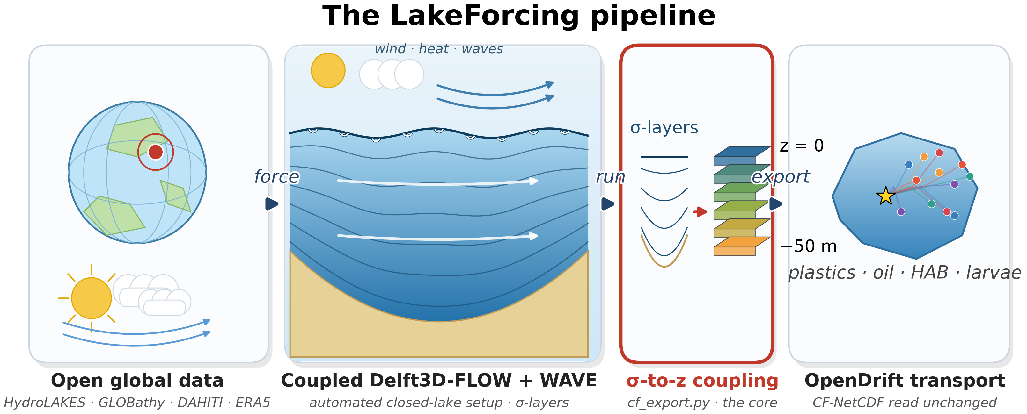
Figure 1. Architecture of the LakeForcing pipeline: single-purpose, file-coupled modules transform open global data into OpenDrift-ready CF-NetCDF; the σ-to-z coupling (cf_export.py) is the engine-to-tracker bridge.

2.2 Grid construction
Grid construction maps raw bathymetric data onto a Delft3D-compatible curvilinear grid through three operations — ingestion, projection and interpolation — and is the only stage whose inputs differ substantially between lakes. Bathymetry enters in one of two forms. In the first, per-depth shoreline contours digitised into a KMZ file are decoded into a (lon, lat, depth) point cloud, with every vertex of a contour assigned that contour's labelled depth. In the second, a gridded bed-elevation raster (a DAHITI- or GLOBathy-derived GeoTIFF) is read with windowed, decimated input/output: only the window covering the lake's bounding box is read, and it is downsampled on read, so that continental-scale source tiles are subset and coarsened during loading and peak memory use stays bounded independently of the source-tile size.
The ingested points are projected from geographic coordinates to the Universal Transverse Mercator zone containing the lake centroid, yielding a locally isometric metric frame in which horizontal distances are undistorted and grid cells are close to square. A regular, axis-aligned curvilinear grid is then laid over the lake's bounding box at a cell size scaled to the basin's longer horizontal axis, so that lakes differing by orders of magnitude in surface area are resolved with a comparable cell count — of order tens of metres for kilometre-scale basins, coarsening for the largest lakes — keeping the node count within the engine's practical limits while still resolving the dominant shoreline geometry. Bed depth is interpolated from the point cloud onto the grid nodes; for raster inputs the still-water depth is obtained as the difference surface_level − bed_elevation, following the Delft3D convention of positive-downward depths referenced to the still-water level. Grid nodes whose interpolated position lies outside the digitised shoreline are flagged as dry in the enclosure (.enc) file, which fixes the active computational domain and excludes land cells from the solution.
A single orientation constraint governs the entire construction: the grid is generated counter-clockwise. Delft3D-FLOW accepts either handedness, but the SWAN wave solver requires a counter-clockwise grid; emitting one counter-clockwise grid therefore allows the identical grid to drive both engines, which removes a grid-to-grid interpolation step and eliminates an entire class of FLOW–WAVE orientation-mismatch errors that would otherwise have to be diagnosed by hand.

2.3 Meteorological forcing
Three modules retrieve ERA5 hourly fields (Hersbach et al., 2020) sampled at the lake centroid and translate them into the three time-series forcing files Delft3D-FLOW expects. The first writes the wind forcing. From the ERA5 eastward and northward 10 m components u10 and v10, the scalar wind speed is the Euclidean magnitude
 | $U_{10} = \sqrt{u_{10}^{2} + v_{10}^{2}}$ | (1)

while the direction is converted to the nautical (meteorological, "blowing-from") convention that Delft3D requires,
 | $θ_{w} = \left[\frac{180}{π}atan2\left(−u_{10}, −v_{10}\right)\right] mod 360°$ | (2)

where negating both velocity components inside the four-quadrant arctangent maps the mathematical "blowing-towards" vector angle onto the meteorological "coming-from" bearing, and the modulo confines the result to the interval [0°, 360°).
The second module writes the heat-flux forcing that drives the Ocean heat-flux model (Delft3D heat model 5): relative humidity, 2 m air temperature, total cloud cover and net shortwave radiation. ERA5 provides temperature and dewpoint rather than humidity directly, so relative humidity is reconstructed from the 2 m air temperature Ta and dewpoint Td (in °C) as the ratio of saturation vapour pressures given by the improved Magnus approximation,
 | $RH = 100 exp\left[\frac{a T_{d}}{b + T_{d}} − \frac{a T_{a}}{b + T_{a}}\right], a = 17.625, b = 243.04$ | (3)

in which the coefficients a = 17.625 and b = 243.04 °C are the least-squares-optimised Magnus constants of Alduchov and Eskridge (1996), an optimised form of the classical Magnus (1844) relation; this parameterisation keeps the saturation-vapour-pressure error below 0.4 % over the −40 to +50 °C range that spans realistic lake-surface and air conditions, and is therefore preferable to the older Magnus–Tetens constants. The 0.4 % figure is the error Alduchov and Eskridge (1996) optimised for the saturation vapour pressure itself; because the relative humidity here is formed as a ratio of two such approximations, its error can exceed this under large dew-point depressions, although it remains small for the near-surface, moist lake conditions sampled in this work.
The third module writes the evaporation–precipitation forcing — precipitation, evaporation and rain temperature — that closes the surface water-mass balance. All three series share a single timing convention imposed by the Delft3D time-dependent-data reader: each is referenced to the model start epoch in the lake's local time zone and clipped to begin exactly at the simulation start, because the reader aborts on negative relative times. Because the meteorological query is centred on the lake centroid, each lake receives a single, spatially uniform atmospheric forcing — an approximation that is accurate for small to medium basins but becomes a limitation at the largest fetch scales (Section 6).

2.4 Automated closed-lake model generation
For a closed lake — one with no open tidal or river boundaries and no point discharges — the FLOW problem is fully determined by the grid, the time-series forcing and a small set of physical defaults (Table 2), so the generator can assemble a complete, well-posed configuration with no hand input. The momentum and continuity equations are integrated by Delft3D-FLOW (Lesser et al., 2004) under the shallow-water and Boussinesq approximations on the σ-grid, and the surface-wave field by the third-generation spectral model SWAN within Delft3D-WAVE (Booij et al., 1999); the two runs on a shared grid, so no wave-to-flow grid interpolation is required.
The generator writes the FLOW master-definition file (.mdf) and its run configuration with the following physical choices. Air–water exchange uses the Ocean heat-flux model (Delft3D heat model 5), which resolves the short-wave, long-wave, latent and sensible components separately from the meteorological forcing; the latent and sensible transfer are governed by a Dalton number of 0.0013 and a Stanton number of 0.0013 (both dimensionless bulk transfer coefficients), and the short-wave penetration by a prescribed Secchi depth. Vertical mixing is closed with the two-equation k–ε turbulence model (Umlauf and Burchard, 2003). The water column is discretised into 14 σ-layers progressively refined toward the surface, concentrating vertical resolution in the wind-driven shear layer that controls the transport of floating material. The evaporation–precipitation mass balance is enabled so that the free surface responds to the net surface water flux; the Coriolis parameter is set from the true lake latitude φ as f = 2Ω sin φ, capturing basin-scale rotation; and a freshwater density reference (salinity 0) is adopted, as appropriate to inland lakes. The wave generator emits the matching Delft3D-WAVE (SWAN) control file for a wind-forced, third-generation run with quadruplet wave–wave interactions active, on the same counter-clockwise grid.
Because both the physical defaults and the inter-file wiring — grid names, forcing filenames, time references and coupling intervals — are encoded in the generators rather than entered by hand, adding a new lake requires no manual editing of model control files, historically the most error-prone and least reproducible step in lake-model setup. The defaults of Table 2 are exposed as parameters, so a user needing a non-default closure, layer count or transfer coefficient can override any single value without altering the file-generation logic.
Table 2. Principal physical defaults of the automated closed-lake configuration.
Parameter | Value | Rationale
Vertical layers | 14 σ-layers, surface-refined | resolve surface shear for floating tracers
Turbulence closure | k–ε (Umlauf and Burchard, 2003) | standard two-equation closure
Heat flux | Ocean model (Delft3D model 5) | data-driven air–water exchange
Dalton number; Stanton number | 0.0013; 0.0013 | bulk latent; sensible transfer
Density reference | freshwater (salinity 0) | inland lakes
Coriolis | f from lake latitude | basin-scale rotation
Waves | SWAN 3rd-gen, quadruplets on | wind-sea growth
Open boundaries | none (closed lake) | common inland case

2.5 The σ-layer to z-level coupling
This coupling is a necessary component of the pipeline, because it is the step that makes terrain-following Delft3D output legible to a fixed-depth ocean reader. Delft3D-FLOW stores its prognostic variables on terrain-following σ-layers: layer k is pinned to a fixed fraction σ_{k} of the local water-column thickness, so its physical depth varies continuously in space and time as the free surface ζ and the bed depth d evolve (Fig. 2a). OpenDrift's generic reader, in contrast, expects every field on a single set of fixed metric z-levels common to the whole domain (Fig. 2b). The two vertical representations are mathematically incompatible: a σ-layer of given index does not correspond to a fixed depth, so without an explicit reconstruction the Delft3D fields cannot be read at all. Because the choice of vertical coordinate has a first-order effect on simulated stratification and transport in lakes (Ishikawa et al., 2022), the geometry of the reconstruction is handled exactly: the physical depth of each σ-layer centre is computed exactly from the instantaneous free surface and bed (Eq. 4 below), after which each field is mapped onto the fixed levels by linear interpolation in depth. The geometric step is therefore exact, while the depth interpolation is, by construction, a linear approximation rather than a conservative remapping (a distinction returned to at the end of this section). The export performs four operations in a fixed order: vertical reconstruction and regridding, velocity rotation, horizontal regridding, and surface Stokes-drift derivation.
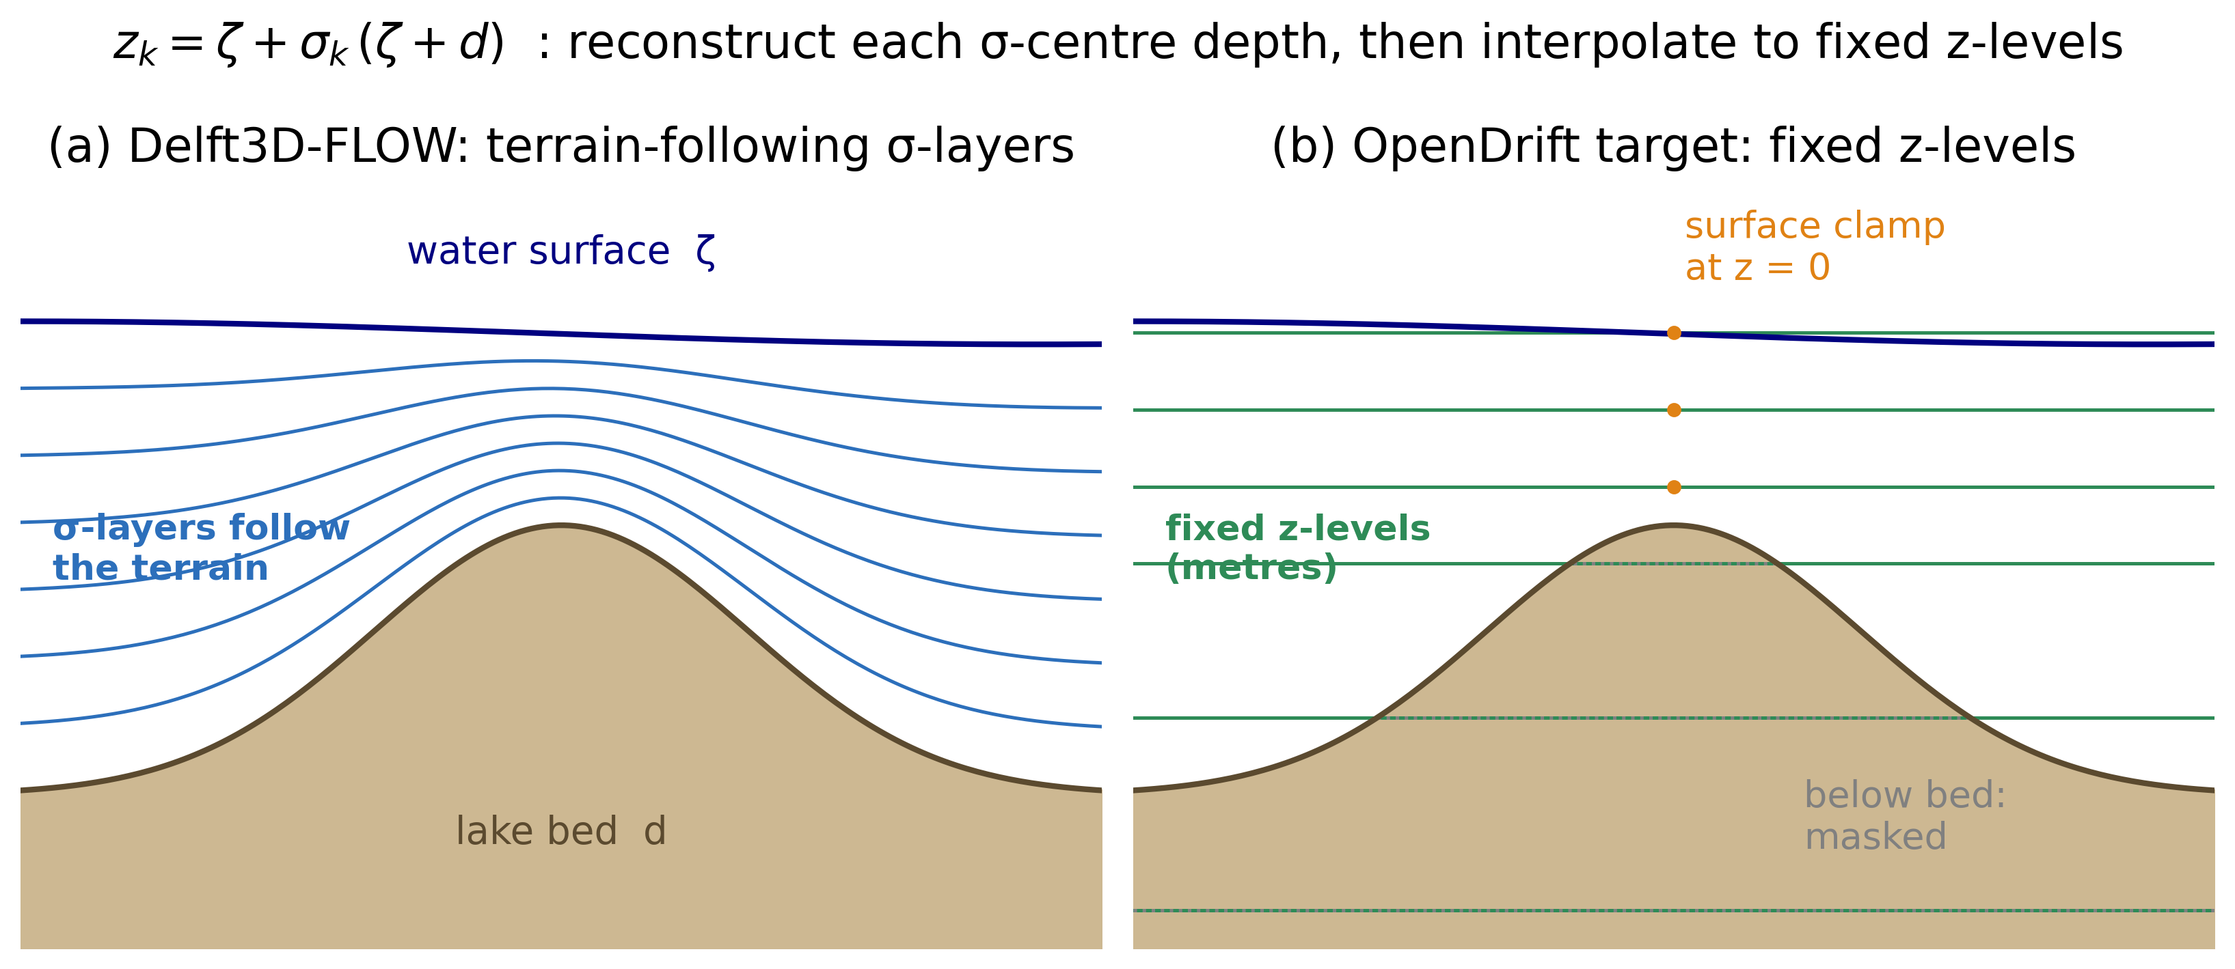
Figure 2. The σ-layer to z-level coupling. (a) Delft3D-FLOW stores fields on terrain-following σ-layers whose depths vary with water level and bathymetry; (b) each σ-centre depth is reconstructed and the field interpolated to fixed metric z-levels, clamped at the surface (z = 0) and masked below the bed.

(1) Vertical reconstruction and regridding. For each wet cell and output time, the physical depth of every σ-layer centre is reconstructed from the instantaneous water level ζ and the still-water bed depth d, whose sum is the total column thickness H = ζ + d:
 | $z_{k} = ζ + σ_{k}\left(ζ + d\right), σ_{k} ∈ [0, −1]$ | (4)

with σ_{k} = 0 at the free surface and σ_{k} = −1 at the bed. The layer-centre fractions σ_{k} are read directly from the SIG_LYR variable of the Delft3D-FLOW trim-*.nc map file, together with the water level (S1), the still-water bed depth (DPS) and the grid-orientation angle (ALFAS); the exporter applies no vertical offset and only a single sign normalisation — builds that store the fractions positive-down on [0, 1] are negated once so that Eq. (4) always receives σ = 0 at the surface and σ = −1 at the bed, with the surface-most layer (the one whose σ tends to 0) mapped to the top z-level. This fixes the orientation explicitly and removes any possibility of a silently inverted profile. The scalar and velocity fields are then interpolated in the vertical — by piecewise-linear interpolation in depth — from these reconstructed σ-centre depths onto the fixed z-level set {0, −1, −2, −3, −5, −7.5, −10, −15, −20, −30, −50} m. Two boundary treatments keep the result physically faithful: because the shallowest σ-centre lies a finite distance below the free surface, the interpolation is clamped to the uppermost layer value at z = 0, so that surface-trapped (floating) particles always sample a valid velocity; and target levels lying below the local bed are masked as missing rather than extrapolated, so that no spurious sub-bed flow is introduced (Fig. 2). Because this target z-level set is identical for every lake, the effective vertical resolution is lake-dependent: a deep basin populates all eleven levels, whereas in the shallowest lakes (~6 m, e.g., Poyang and the Sea of Galilee) only the upper four to five levels lie above the bed and the rest are masked. A reader should therefore not assume all eleven levels are populated everywhere. The deepest level (−50 m) is, by design, shallower than the maximum depth of the deepest basins (e.g., Polyfytos, ~80 m): the z-set is surface-focused because the tool targets near-surface, floating-material transport, so the weakly sheared structure below 50 m is intentionally not exported and is straightforward to extend if a deeper application requires it. The target set is not hard-wired into the algorithm: it is a single exposed parameter (Z_LEVELS in cf_export.py, overridable from the exporter's command line), so a user targeting a deep or benthic application — Lake Baikal, say, or near-bed transport — changes it in one place without altering the reconstruction logic. Figure 3 shows the depth-resolved result for one lake.
(2) Velocity rotation. Delft3D solves on a staggered (Arakawa C-type) curvilinear grid and returns the velocity as grid-aligned (ξ, η) components on the cell faces. These are first destaggered to the cell centres and then rotated from the grid axes to true geographic axes through the local grid-orientation angle α, because OpenDrift interprets the two horizontal components strictly as eastward and northward:
 | $u_{E} = u_{ξ}cosα − v_{η}sinα v_{N} = u_{ξ}sinα + v_{η}cosα$ | (5)

Applying the rotation per cell is essential on a curvilinear grid, where α varies across the basin and a single global rotation would systematically misalign the currents.
(3) Horizontal regridding. The curvilinear cell centres are projected from the UTM frame back to longitude/latitude, and the rotated fields are interpolated onto a regular longitude–latitude raster — the only horizontal structure the generic reader accepts. Inactive and dummy cells are masked before reprojection, so that land and padding cells cannot distort either the interpolation or the inferred grid extent.
(4) Surface Stokes drift. The wave-driven drift is reconstructed from the SWAN output rather than read directly. The three inputs are taken from named fields of the Delft3D-WAVE map file (wavm-*.nc): the significant wave height H_{s} from HSIGN, the peak period T_{p} from RTP (SWAN's relative peak period, i.e. the period at the spectral peak — not an integral mean period such as TM01 or TMM10), and the mean propagation direction from DIR. These fields are requested in the output section of the .mdw control file written by the wave generator (Section 2.4), so the mapping from SWAN variable to equation input is fixed and explicit. Stating it removes the principal ambiguity in reusing Eq. (6), because selecting a mean period in place of RTP would bias the Stokes magnitude by a factor of order two. From these, a deep-water monochromatic approximation yields the surface Stokes-drift magnitude (consistent with Breivik et al., 2014; van den Bremer and Breivik, 2018):
 | $ω = \frac{2π}{T_{p}}, k = \frac{ω^{2}}{g}, a = \frac{H_{s}}{2\sqrt{2}}, |U_{s}| = ω k a^{2}$ | (6)

evaluated through the peak radian frequency ω = 2π/T_{p}, the deep-water wavenumber k = ω²/g and the characteristic wave amplitude a = H_{s}/(2√2) — the amplitude of the monochromatic wave whose energy equals that of a sea state of significant height H_{s}, chosen so that the surface-elevation variance σ_{η}² = a²/2 = H_{s}²/8 is preserved rather than set ad hoc. The estimate is guarded against the integrable singularity where the interpolated period tends to zero at the wet/dry boundary — by imposing a minimum-period floor and a physical magnitude cap — and is finally projected onto eastward/northward components using the mean wave direction. The deep-water dispersion relation k = ω²/g assumes depth greater than about half the wavelength; for the short wind-sea periods of the shallowest basins (~6 m, e.g., Poyang and the Sea of Galilee) the dominant waves are in intermediate-to-shallow water, so this approximation degrades and bounds the Stokes magnitude there — a sensitivity that, as crossing-sea studies show, materially affects near-shore particle transport (Espenes et al., 2024). Substituting the finite-depth dispersion relation ω² = gk·tanh(kh) — or a spectral Stokes-drift profile (Breivik et al., 2016) — is a drop-in refinement that would remove this limitation (Section 6).
The four operations yield a single CF-compliant NetCDF that carries the currents, water level, temperature, wave parameters and surface Stokes drift on fixed z-levels in longitude/latitude, tagged with the CF standard_name attributes OpenDrift recognises. The output declares the CF-1.8 conventions, and every exported variable carries a CF standard_name and udunits-compatible units; Table 3 gives the complete data dictionary — NetCDF variable name, CF standard_name, units and dimensions, with the common fill value stated in the caption — so the product is self-documenting at the paper level and readable by any CF-aware client, not only by OpenDrift's reader. This metadata completeness is what lets the same file drive a generic tracker unchanged. Figure 3 illustrates the depth-resolved product for one lake: the export preserves the surface-intensified warming and the wind-driven current shear while correctly masking levels below the bed — exactly the vertical structure that a surface-only two-dimensional forcing would discard. Figure 4 shows the corresponding surface fields (currents, temperature and significant wave height) for a representative lake.
Table 3. Data dictionary of the exported forcing product (<lake>_forcing.nc, CF-1.8). All data variables are float32, zlib-compressed, with _FillValue = NaN; z-levels below the local bed are fill-masked (Section 2.5). The wave-derived fields are written when a Delft3D-WAVE map file is supplied and the wind components when the per-lake uniform wind file is supplied; all listed variables are present in the released twelve-lake dataset. Coordinate variables: time (standard_name time), depth (m, positive: down; the eleven fixed z-levels), lat (degrees_north) and lon (degrees_east).
NetCDF variable | CF standard_name | Units | Dimensions
u | x_sea_water_velocity | m s-1 | time, depth, lat, lon
v | y_sea_water_velocity | m s-1 | time, depth, lat, lon
temp | sea_water_temperature | degC | time, depth, lat, lon
zeta | sea_surface_height_above_geoid | m | time, lat, lon
Hs | sea_surface_wave_significant_height | m | time, lat, lon
Tp | sea_surface_wave_period_at_variance_spectral_density_maximum | s | time, lat, lon
wdir | sea_surface_wave_to_direction | degree | time, lat, lon
ust | sea_surface_wave_stokes_drift_x_velocity | m s-1 | time, lat, lon
vst | sea_surface_wave_stokes_drift_y_velocity | m s-1 | time, lat, lon
x_wind | x_wind | m s-1 | time, lat, lon
y_wind | y_wind | m s-1 | time, lat, lon

A note on conservation is in order. Both the vertical σ-to-z step and the horizontal curvilinear-to-regular step are linear interpolations, so the export is not, by construction, volume-conserving: the depth-integrated transport implied by the regridded velocity is not guaranteed to equal that of the native Delft3D field, and the regridded field is not exactly non-divergent. This is appropriate for the intended use. OpenDrift advects particles kinematically — it samples the interpolated velocity at each particle position and integrates the trajectory — and so does not require a divergence-free or flux-conservative field, unlike an Eulerian transport solver. To bound the magnitude of the effect we compared the depth-integrated horizontal transport of the regridded field with that of the native model output, per wet column, across lakes spanning the full depth range of the test set. The median relative discrepancy is small and, importantly, does not grow systematically as the basin shoals: it is about 2.1 % for the moderate-depth Bornos (~20 m), about 2.0 % for the shallow Sea of Galilee (~6 m) and about 0.5 % for the shallow Poyang (~6 m), and about 0.9 % for the deep Mead (~40 m) — so the linear σ-to-z step does not introduce a qualitatively larger error in the shallow basins, where fewer z-levels sample the column, than in the deep ones. The per-column mean is larger (up to ~10 % in some lakes) but is dominated by the slowest cells, where a relative error measure is ill-conditioned because its denominator vanishes; the absolute transport error there remains small. All of these discrepancies are small relative to the velocity uncertainty inherited from the forcing. Users who instead couple the exported fields to a conservative Eulerian advection scheme should re-derive transports on the native curvilinear grid rather than from the exported raster.
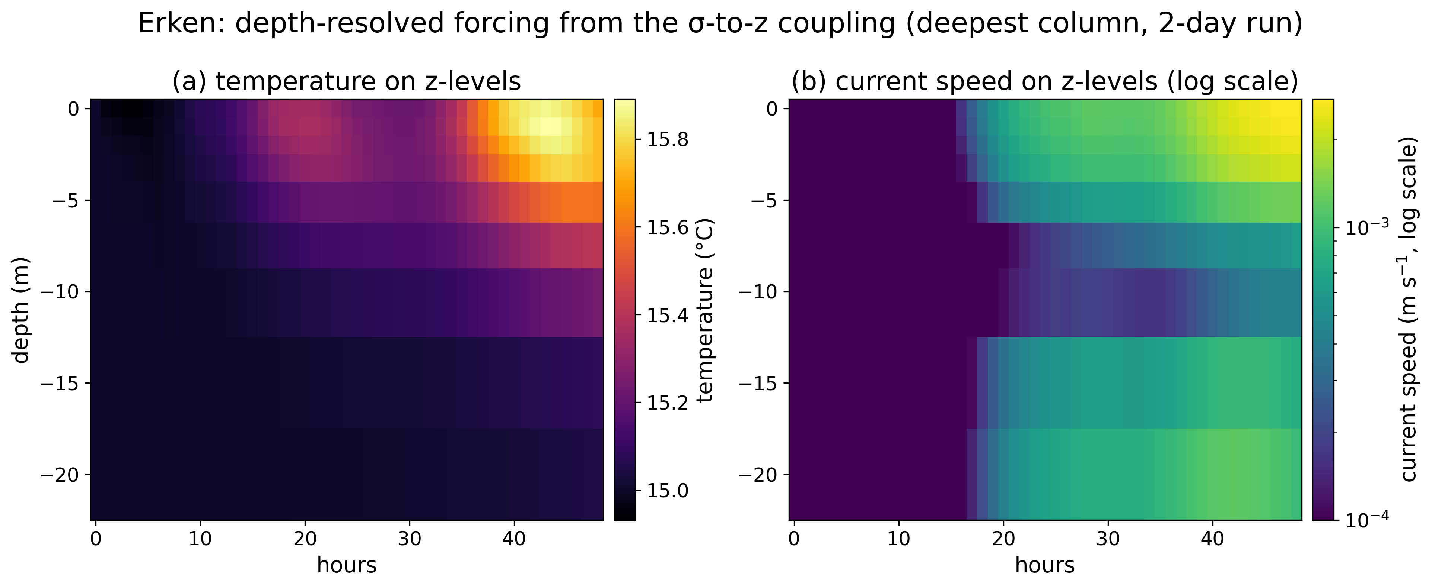
Figure 3. Depth-resolved exported product for Lake Erken: surface-intensified warming and wind-driven current shear are preserved, and levels below the local bed are masked.

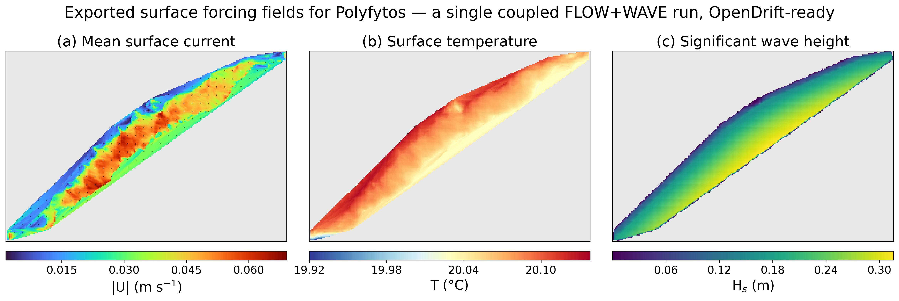
Figure 4. Exported surface forcing fields for a representative lake (Polyfytos): (a) mean current speed with vectors, (b) surface temperature, (c) significant wave height — all from a single coupled FLOW+WAVE run.

2.6 Transport demonstration setup
To exercise the exported forcing, a thin driver seeds buoyant particles and integrates their trajectories with OpenDrift (Dagestad et al., 2018) on the CF-NetCDF produced in Section 2.5. Two configuration changes adapt the otherwise ocean-oriented tracker to an inland basin. First, OpenDrift's default global coastline landmask is disabled: built for the marine domain, it classifies the entire lake interior as land and would deactivate every particle at the first-time step. Second, a constant all-water landmask is substituted in its place, so that stranding is governed solely by the data coverage of the forcing itself — a particle is deactivated only when it leaves the wet region defined by the exported fields, which is the physically correct shoreline for the modelled lake.
The release point is selected automatically and without bias toward any sub-basin. The naive choice, the centroid of the wet cells, is unsuitable because in a non-convex basin — the crescent-shaped Rotsee or the bent Balaton, for example — the centroid can fall on land or in a different arm of the lake. The driver instead seeds at the lake's pole of inaccessibility, the interior point lying farthest from any shore. This point is located as the maximiser of the Euclidean distance transform (EDT) of the binary water mask, evaluated with the exact linear-time algorithm of Maurer et al. (2003); the value of the transform at that point, D_{shore}, is the distance from it to the nearest dry cell. The release radius is then scaled to the basin so that the entire seed disk remains inside the lake at every scale:
 | $r = min\left(r_{max}, 0.6 D_{shore}\right), D_{shore} = max EDT\left(wet mask\right)$ | (7)

where the cap r_{max} = 300 m bounds the radius on large lakes while the term 0.6 D_{shore} contracts it on small ones, and particles are then drawn from a uniform distribution over the resulting disk. Without this adaptation a fixed 300 m radius overspills small basins — Rotsee is only ~2 km across — and seeds particles on dry ground, biasing every downstream statistic.
The net horizontal displacement of each particle after a time t is quantified as the distance D_{i} between its current position (λ_{i}, φ_{i}) and its release point (λ₀, φ₀):
 | $D_{i} = \sqrt{{\left[\left(λ_{i} − λ_{0}\right)cosφ R_{e}\right]}^{2} + {\left[\left(φ_{i} − φ_{0}\right) R_{e}\right]}^{2}}, R_{e} ≈ 111 km/deg$ | (8)

a local equirectangular (small-angle planar) approximation to the geodesic distance on a sphere of Earth radius R_{e} (Snyder, 1987), whose error is negligible over the kilometre-scale separations considered here. The particle ensemble is summarised below by the mean of D_{i} over all released particles.

3. Software description
This section describes the software that implements the methods of Section 2. We first set out its architecture — a collection of small, independently runnable modules wired together through standard files rather than a monolithic program (Section 3.1) — and then its implementation, external dependencies and the minimal commands needed to stage and process a lake (Section 3.2). The emphasis throughout is on reproducibility and reuse: each module performs one well-defined transformation with explicit file inputs and outputs, so the toolchain can be run end-to-end for a new lake, inspected stage by stage, or repurposed — in particular the σ-to-z exporter, which can be applied on its own to any existing Delft3D-FLOW/WAVE output.

3.1 Architecture and modules
The software is organised as a set of small, single-responsibility modules connected through files rather than through shared program state, so that the data flow of Section 2 maps one-to-one onto the code (Fig. 1). Each module is an independently runnable command-line script that reads named inputs and writes named outputs, which makes the stages individually testable and freely re-orderable or replaceable. The modules fall into six functional layers:
- Bathymetry ingestion — ingest_bathy_kmz.py (KMZ depth contours), dahiti_bathymetry.py (satellite-altimetry rasters) and gebco_subset.py (gridded bed-elevation tiles) — each emitting the common (lon, lat, depth) representation that the rest of the pipeline consumes.
- Grid construction — build_grid.py — projecting that point set and writing the Delft3D curvilinear grid triple (.grd, .dep, .enc).
- Meteorological forcing — the get_era5_*.py family — retrieving the ERA5 fields and writing the wind, heat-flux and evaporation–precipitation time series.
- Automated model generation — make_flow_mdf.py and make_wave_mdw.py — assembling the FLOW master-definition file and the WAVE/SWAN control file together with their run configuration.
- Coupling and transport — cf_export.py, which performs the σ-to-z reconstruction, velocity rotation, regridding and Stokes-drift derivation of Section 2.5, and run_opendrift_demo.py, which drives the Lagrangian demonstration on the exported forcing.
- Orchestration — setup_lake.py and postprocess_lake.py — chaining the per-lake stages on either side of the external Delft3D run.
A separate, self-contained tooling layer (make_figures.py, make_equations.py, build_docx.py) regenerates every figure, the equation set and this manuscript directly from the produced data, so that the reported results and the document itself are reproducible artefacts of the same repository. The submitted Word document is itself the output of build_docx.py rendering the manuscript source (paper/CAGEO_manuscript.md): the equations are emitted as native Office Math (OMML) from omml_equations.py and the figures are the very files written by make_figures.py, so the displayed equations and figures are, by construction, identical to those the pipeline produces. The README documents the single command that rebuilds the document.

3.2 Implementation, dependencies and usage
The implementation is pure Python 3.11 and deliberately rests on a small, widely used scientific stack: xarray and netCDF4 for labelled-array and CF-NetCDF input/output, numpy and scipy for the numerics and the distance transform, pyproj and rasterio for projection and raster access, cdsapi for ERA5 retrieval, and matplotlib with cartopy for visualisation. To make the environment reproducible, the repository root carries a requirements.txt that pins the packages whose minor releases have broken backward compatibility in this stack — the Lagrangian demonstration is pinned to opendrift==1.14.9 — and recommends a conda-forge Python 3.11 environment (so that rasterio/pyproj bind to a consistent GDAL/PROJ build, the usual source of cross-platform breakage); the remaining pure-Python packages are tolerant of patch-level drift. The twelve-lake runs reported here were produced on Windows 11 (64-bit); the pipeline also runs on 64-bit Linux.
The hydrodynamic engine, Delft3D 4.07.01 (FLOW + WAVE/SWAN), is the only heavyweight, non-Python dependency and is installed separately — a deliberate choice to wrap, rather than reimplement, a community-validated solver. We did not build Delft3D from source: the reported runs used the official Deltares pre-built Delft3D 4 binary distribution (tagged release 4.07.01, obtained from the Deltares open-source portal, oss.deltares.nl/web/delft3d), executed on Windows 11 (64-bit) through the distribution's own launch scripts. Using the vendor binary rather than a local build means the FLOW/WAVE results do not depend on a user's compiler, MPI variant or patch level; the exact version tag and download reference are recorded in the README and the Software-availability table. Because reproducing the full hydrodynamic runs nonetheless requires this external engine, the σ-to-z export — the pipeline's most reusable component — is made independently reproducible without it, as described below.
In normal use a lake is processed with two commands that bracket the external engine run: setup_lake.py stages the grid, forcing and model-definition files from open data; the user (or a batch script) then executes the Delft3D FLOW and WAVE runs; and postprocess_lake.py performs the σ-to-z export and the transport demonstration. The only per-lake inputs required are the lake location, its latitude (for the Coriolis parameter) and a seasonal initial water temperature; an ERA5 Copernicus CDS account is needed for the meteorological retrieval. The retrieval is fully specified in the get_era5_*.py modules and is documented in the README so that it survives the ongoing CDS migration: all three modules call cdsapi against the reanalysis-era5-single-levels dataset with product_type: reanalysis and request the exact short-names 10m_u_component_of_wind and 10m_v_component_of_wind (wind); 2m_temperature, 2m_dewpoint_temperature, total_cloud_cover and surface_solar_radiation_downwards (heat flux); and total_precipitation, evaporation and 2m_temperature (mass balance). Because the legacy CDS API was retired in favour of the new Climate Data Store (CDS-Beta) endpoint in 2024–2025, the README states the cdsapi version confirmed against the current endpoint and the steps a new user must follow to obtain CDS credentials and write ~/.cdsapirc; the variable names above are unchanged across the migration, so only the endpoint and key configuration differ. River discharge is supported as an optional open-boundary condition (used for the Polyfytos comparison of Section 5.6 and configured through _build_river_config.py); it is exercised in that benchmark but is not covered by the continuous-integration test, and is flagged accordingly in the Software-availability table. Because the exporter depends only on the engine output and not on how the run was configured, it can also be used on its own: pointing cf_export.py at the output of any pre-existing Delft3D-FLOW/WAVE lake model converts that model's fields into OpenDrift-ready CF-NetCDF — the component of the pipeline with the broadest independent utility. To make this component reproducible without the heavyweight engine, the repository bundles a small Delft3D sample under tests/fixtures/ together with a continuous-integration test that runs the exporter on it and checks the CF output, so the σ-to-z coupling can be exercised from a clean checkout with no Delft3D installation. The fixture and the check are described concretely so that any discrepancy can be localised to the data or the code. The fixture is a subset of the smallest demonstration lake, Erken (UTM zone 34N, EPSG:32634): the FLOW map file trim-erken_mini.nc keeps the first two output time steps and only the variables the exporter reads, on the lake's 125×52 horizontal grid with 14 σ-layers, and the wave map file wavm-erken_mini.nc is the corresponding SWAN output; both are produced from the full Erken run by the versioned tests/build_fixture.py and are committed (and checksummed) with the repository. The test (tests/test_cf_export.py) asserts quantitatively that the exporter exits cleanly, that the output declares CF Conventions, that the headline variables u, v, temp, zeta and Hs are present with the CF standard_name attributes OpenDrift keys on (e.g. u → x_sea_water_velocity), that the z-levels are monotonic downward with the surface at 0 m and levels below the bed masked, that the exported longitude/latitude axes are monotonic increasing, and that the wet surface contains finite current cells. For deterministic re-execution of this open portion of the workflow, the repository root also carries a container recipe (Dockerfile) and a pinned conda environment specification (environment.yml) covering the exporter and the OpenDrift transport demonstration (Python 3.11, opendrift==1.14.9); building the image and running it executes the same fixture test end-to-end, so the CF-export chain reproduces with one command on any Docker host, without a hand-built environment.

4. Illustrative application: twelve lakes
This section demonstrates the pipeline in practice. The aim is not to calibrate a single waterbody but to show that one unmodified toolchain produces physically plausible forcing across lakes that differ widely in size, depth, climate and bathymetry source. Section 4.1 describes the twelve lakes selected for this purpose and the open datasets from which each was built; Section 4.2 specifies the common simulation and particle-release configuration applied identically to all of them. The resulting fields and transport are analysed in Section 5.

4.1 Lake selection and data sources
We applied the pipeline to twelve lakes chosen to span, as widely as practical, the morphological and climatic factors that control lake surface transport (Fig. 5; Table 4). The set reaches from 36°S (Lake Eucumbene, Australia) to 60°N (Lake Erken, Sweden) and so samples all inhabited continents. Within that span it varies maximum depth by roughly an order of magnitude — from the ~6 m of the shallow floodplain and lowland lakes to the ~80 m of the deep peri-alpine Polyfytos basin — and surface area by more than three orders of magnitude, and it deliberately mixes morphological types: shallow lowland and large floodplain lakes, a deep stratifying basin, and several regulated reservoirs. It also samples both hemispheres, so that for the Southern-Hemisphere lakes the fixed July simulation window falls in winter rather than summer, exercising the seasonal heat forcing in both regimes. Finally, the lakes draw on two independent bathymetry sources — digitised survey contours and satellite-altimetry-derived DAHITI products (Schwatke et al., 2015) — so that the demonstration tests both ingestion paths of Section 2.2. The spread is intended to stress the generality claim directly: any single lake could be fitted by hand, but covering this range with identical code is the property under test.
Table 4. The twelve demonstration lakes and key model outputs. Regulation is the single natural/reservoir axis; morphology is conveyed by the depth columns. |U|_{max} = maximum surface current speed; H_{s,max} = maximum significant wave height. The drift columns give the 36-h mean net particle displacement: the single-release current+Stokes case, the median of a five-point release-point ensemble (Section 5.3), and the floating-litter case with 2 % windage added (Section 5.2). Comparing the ensemble median with the single-release value shows that the cross-lake ranking is robust (Spearman ρ = 0.74) while individual magnitudes are seed-sensitive, most strongly in basins with sheltered arms (Lagdo, Rotsee, Erken). All twelve lakes are auto-generated by the pipeline from open data except Polyfytos, which reuses an expert-built, hand-configured model (bold row, asterisk); it is the only row that does not demonstrate the pipeline's autonomous setup and should be read as the export-path control (Section 5.6), not as an auto-generated case.
Lake | Country | Regulation | Lat | Max depth (m) | Mean depth (m) | |U|_{max} (m/s) | H_{s,max} (m) | Drift, current+Stokes (m) | Drift, ensemble median (m) | Drift, +windage (m)
Lagdo | Cameroon | reservoir | 8.8 | ~9 | 4.5 | 0.030 | 0.39 | 2439 | 850 | 1970
Bornos | Spain | reservoir | 36.8 | ~20 | 8.0 | 0.028 | 0.21 | 1337 | 2520 | 5166
Mead | USA | reservoir | 36.3 | ~40 | 20.0 | 0.049 | 0.51 | 2933 | 3220 | 8315
Polyfytos* (hand-built) | Greece | reservoir | 40.2 | ~80 | 30.0 | 1.18 | 0.32 | 1743 | 2560 | 5874
Trasimeno | Italy | natural | 43.1 | ~7 | 4.7 | 0.012 | 0.33 | 3419 | 3320 | 2047
Balaton | Hungary | natural | 46.9 | ~9 | 3.2 | 0.005 | 0.36 | 3250 | 2950 | 4854
Rotsee | Switzerland | natural | 47.1 | ~16 | 9.0 | 0.018 | 0.14 | 341 | 260 | 819
Erken | Sweden | natural | 59.8 | ~20 | 9.0 | 0.010 | 0.20 | 2033 | 230 | 3771
Poyang | China | natural | 29.1 | ~6 | 3.0 | 0.020 | 0.41 | 3695 | 3360 | 11179
Sea of Galilee | Israel | natural | 32.8 | ~6† | 3.0 | 0.032 | 0.34 | 3506 | 3480 | 1102
Eucumbene | Australia | reservoir | −36.1 | ~38 | 18.0 | 0.052 | 0.33 | 3166 | 3440 | 9189
Nova Ponte | Brazil | reservoir | −19.1 | ~23 | 11.0 | 0.030 | 0.41 | 2881 | 3470 | 8803

*Polyfytos (bold row) is not auto-generated: it reuses an expert-built, hand-configured Delft3D model that includes river discharges, hence its larger peak currents; the other eleven are auto-generated closed-lake setups produced by the pipeline from open data alone. †For Sea of Galilee the value is the DAHITI satellite-observed depth band, not the absolute maximum depth (Section 6).
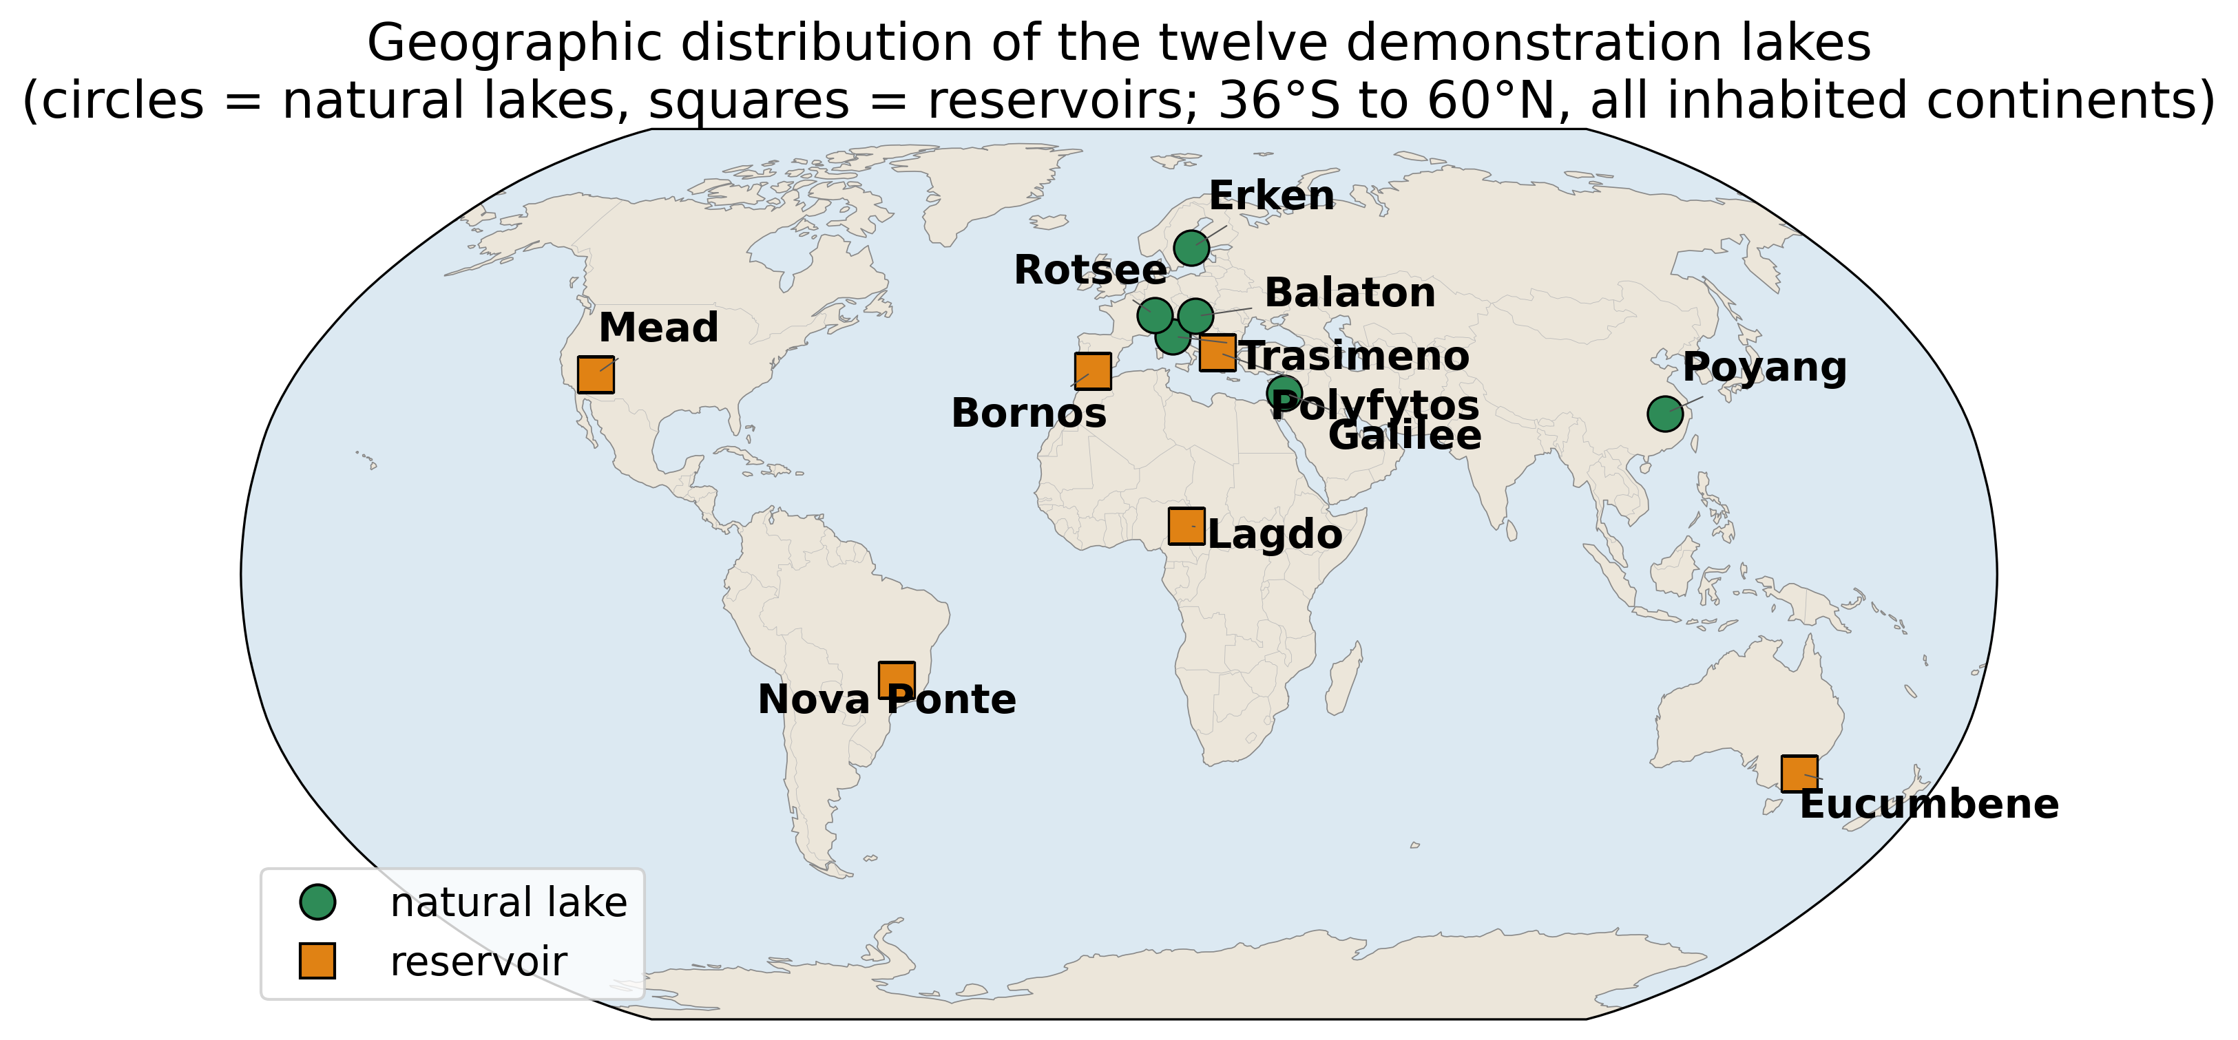
Figure 5. Geographic distribution of the twelve demonstration lakes (circles, natural lakes; squares, reservoirs), spanning all inhabited continents from 36°S to 60°N.

4.2 Configuration
All twelve lakes were run with an identical configuration, so that any difference in the results reflects the lakes themselves rather than per-lake tuning. The coupled hydrodynamic–wave simulation covered a common two-day window in July 2022, and the only quantities permitted to vary between lakes were the three physically necessary per-lake inputs: the geographic location, which fixes both the grid and the meteorological query; the latitude, which sets the Coriolis parameter; and a seasonal initial water temperature — a single basin-mean value taken from the climatological lake-surface temperature for the simulated month, which the surface heat-flux model (Section 2.4) then evolves over the run. Eleven of the twelve models were generated fully automatically from open data by the pipeline of Sections 2.2–2.4. The twelfth, Polyfytos, reused an existing hand-built Delft3D-FLOW model with prescribed river discharges (Papaioannou et al., 2025) and therefore serves as a control that isolates the export path of Section 2.5 from the automated model-generation path — if the coupling is correct, it should produce a valid OpenDrift forcing from a model the pipeline did not build. Polyfytos thus plays a dual role — the deep-basin end-member of the demonstration set (Section 4.1) and the export-path control of the benchmark (Section 5.6) — and is counted once; it is not an extra case introduced to reach twelve. For the transport demonstration, 400 buoyant particles were released at the adaptive interior point of Section 2.6 in every lake and advected on the exported forcing. The hydrodynamic–wave model is run for 48 h; the first 12 h are discarded as spin-up, so the transport is integrated over the final 36 h, after which the net-displacement statistic D_{i} is evaluated for each particle. The 12-h window allows the wind-driven surface circulation to adjust from rest to a quasi-steady response to the imposed forcing, which is the component that governs floating-material transport; in the deepest basins the slower, thermally driven circulation continues to develop beyond this window, so the transport statistics below are reported as a forced near-surface response rather than as a fully equilibrated, long-term circulation.

5. Results and discussion
The twelve runs are analysed below to assess whether a single unmodified pipeline yields forcing that is internally coherent and physically ordered across the full morphological and climatic range of the test set. We first examine the exported physical fields — circulation, temperature and waves (Section 5.1) — then the surface transport they drive (Section 5.2), before testing whether that transport varies with lake morphology in the physically expected way (Section 5.3). Section 5.4 reports an automated quality-control audit of the complete dataset and the single artefact it revealed, and Section 5.5 situates the results relative to existing lake-modelling and transport tools. The final two subsections test the forcing against reference fields: Section 5.6 checks the auto-generated configuration for consistency against an expert-built model of one reservoir (a prior model from the same group, not an independent third party), and Section 5.7 compares the exported surface temperature with independent satellite observations for four further lakes. Throughout, no parameter was tuned per lake, so the comparisons that follow are between lakes rather than between hand-fitted models.

5.1 Circulation, temperature and waves
Across all twelve lakes the pipeline produces spatially coherent, wind- and heat-driven circulation (Fig. 4, Fig. 6), even though the basins differ by an order of magnitude in depth, by more than three orders in surface area, and span 96° of latitude (36°S to 60°N). The wind stress organises the surface flow into basin-scale patterns — along-wind drift in the interior with compensating return flow, and recirculating gyres in the more enclosed basins — modulated by the shoreline geometry resolved on each grid. Surface current speeds range from a few mm s⁻¹ in the most sheltered lakes to ~1.2 m s⁻¹ in the river-influenced Polyfytos control (Table 4); excluding that control, the auto-generated closed lakes reach 0.5–5 cm s⁻¹, consistent with wind-driven drift currents of order a few percent of the wind speed. The depth-resolved export (Fig. 3) shows the expected vertical structure: a surface-intensified current that decays with depth, with a several-fold reduction in speed between the surface and ~20 m and the strongest shear concentrated in the uppermost layers that the σ-grid was refined to resolve (Section 2.4).
Surface temperatures track the seasonal heat forcing across both hemispheres, from 2–10 °C in the Southern-Hemisphere winter of Lake Eucumbene to 26–35 °C in the tropical and Mediterranean lakes, and the vertical sections (Fig. 3) show surface-intensified diurnal warming rather than a vertically uniform column. Over the 48-h integration from an isothermal start this is the developing daytime warming signal, not an equilibrium thermocline — a deep basin cannot establish realistic stratification on this timescale — so we describe it as surface-intensified warming and make no claim of equilibrium stratification; a seasonal initial profile and longer integration would be required for the latter (Section 6). The wind-sea is fetch-limited in every basin: significant wave heights span H_{s} = 0.14–0.51 m and scale with fetch and wind exposure, the largest waves arising on the long-fetch reservoirs (Mead) and the smallest in the short-fetch, sheltered Rotsee — the behaviour expected of the third-generation SWAN growth physics on enclosed water (Section 2.4).

5.2 Surface transport
Figure 6 overlays, for each lake, the time-mean surface-current field (on a per-lake colour scale) with the 36-h trajectories of the 400 released particles and their common release point. The trajectories remain within the basin in every case — confirming that the all-water landmask and data-coverage stranding of Section 2.6 behave as intended — and disperse from the compact release disk into elongated, wind-aligned plumes whose spread reflects the spatial variability of the current field. The resulting 36-h mean net displacement D_{i} varies over an order of magnitude, from 0.34 km in the small, deep, sheltered Rotsee to 3.7 km in the large, shallow, fetch-exposed Poyang (Table 4, "current+Stokes" column). Because every one of the twelve was carried through the same unmodified coupling and export code — and eleven of them also auto-configured by it from open data — this range is generated by the lakes' own physics and not by any per-lake adjustment, which is the central generalisation claim of the paper.
The trajectories above are for a buoyant near-surface tracer driven by the currents and the wave-induced Stokes drift; the distinction between surface-trapped and water-column transport is itself a recognised control on plastic fate (Oswald et al., 2025). For floating litter that additionally feels direct wind drag we ran each lake a second time with a windage term equal to 2 % of the 10 m wind (a wind_drift_factor of 0.02, the standard leeway for surface debris, following Breivik et al. (2011); Table 4, "+windage" column). Windage is not simply additive: because the ERA5 wind is spatially uniform over each basin it superimposes a near-uniform translation whose net effect depends on its alignment with the hydrodynamic drift. It amplifies the displacement where the two reinforce (Poyang 3.7 to 11.2 km, Eucumbene 3.2 to 9.2 km, Nova Ponte 2.9 to 8.8 km) and reduces it where the wind opposes the current and Stokes drift (Sea of Galilee 3.5 to 1.1 km, Trasimeno 3.4 to 2.0 km). Windage therefore typically dominates the net displacement of floating material — as it does in marine-debris studies (Chenillat et al., 2021; Iskandar et al., 2022), and with field surveys of macroplastic transport in transitional waters (Tramoy et al., 2020) — while the current and Stokes fields set the lake-specific spatial structure of the trajectories. Reporting both cases makes the relative roles explicit and exercises every exported field (currents, Stokes drift and wind).
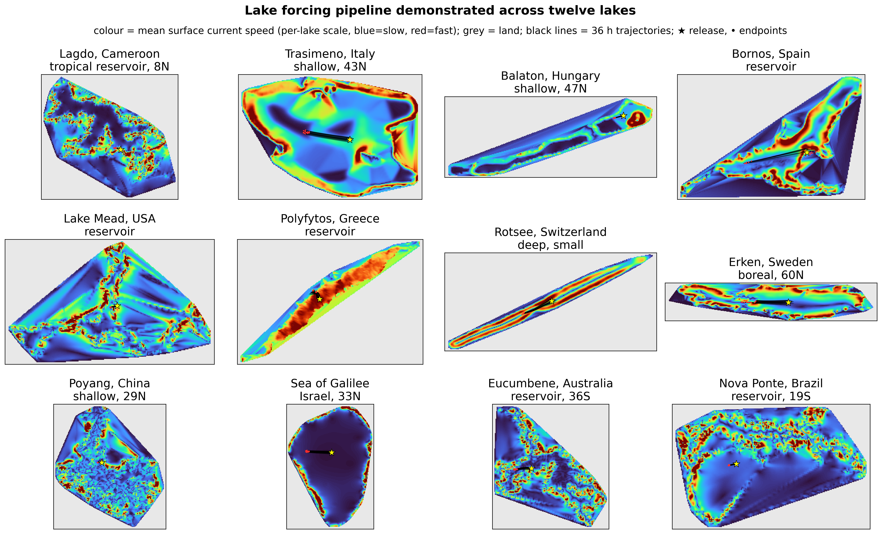
Figure 6. The pipeline demonstrated across the twelve lakes: mean surface-current speed (per-lake colour scale) with 36 h particle trajectories (black), release point (star) and endpoints (dots); land is grey.

5.3 Physical consistency
Figure 7 plots the 36-h current+Stokes drift against lake mean depth and against peak current speed. With only twelve lakes these relationships are best read as rank tendencies rather than fits, so we quantify them with Spearman rank correlations. The drift correlates positively and significantly with surface area (ρ = +0.63, p = 0.03) and, more weakly, with maximum fetch (ρ = +0.57, p = 0.06); it correlates negatively with depth (ρ = −0.55 with mean depth and −0.57 with maximum depth, p ≈ 0.05–0.06) and shows essentially no relation to mean wind speed (ρ = +0.04). With twelve lakes only the surface-area correlation reaches significance at the 5 % level, so we read these as physically coherent rank tendencies: surface transport is enhanced by basin size and fetch and damped by depth. Because Polyfytos is the one hand-built outlier in the set (a calibrated model with river discharges), we also recomputed the primary area–drift correlation with it removed: over the eleven auto-generated lakes the rank correlation weakens to ρ = +0.54 (p = 0.09) — still positive and of the same sign and magnitude, but no longer significant at the 5 % level. The significance of the twelve-lake result is therefore partly carried by Polyfytos, and we present the area–drift relation as a coherent tendency rather than an established law; the eleven auto-generated lakes alone support the same direction at marginal significance. (The other predictors are essentially unchanged by the exclusion: fetch ρ = +0.58, depth ρ ≈ −0.5, wind ρ = +0.20.) That depth is not the sole control is clear within the set — the deep Eucumbene (~38 m) and the comparably deep Mead (~40 m) both drift about 3 km, because both are large, long-fetch basins — so basin size and wind exposure, not depth alone, govern the outcome. Mechanistically, shallow wide basins couple the wind stress into a thin, fast-responding surface layer with long fetch, whereas deep basins spread the same stress over a thicker column. The one unambiguous diagnostic is that the highest peak current — Polyfytos, driven by a localised river inflow — does not yield the largest current+Stokes drift: a strong but spatially confined jet advects particles less, in net, than a weaker but basin-wide wind- and wave-driven drift, confirming that net transport is set by basin-scale fetch and wind exposure rather than by peak current magnitude. These tendencies are consistent with the morphometric controls on plastic retention reported observationally by Nava et al. (2023) and Chen et al. (2024), and they emerge here from open data alone, on lakes for which the pipeline was never tuned.
Because each lake's drift is computed from a single release point in one summer window, we tested its robustness to the release location by re-seeding every lake from an ensemble of five independent interior points and recomputing the 36-h drift. The cross-lake ranking is robustly preserved: the primary seeding and the ensemble median order the twelve lakes almost identically (Spearman ρ = 0.74, p = 0.006), and the order-of-magnitude spread is reproduced. Within a lake, the drift varies by a median inter-quartile range of about 19 % of the median across release points, but markedly more in basins with sheltered arms or sub-basins (Lagdo, Rotsee, Erken), where some interior points fall in near-stagnant water — Erken's ensemble-median drift (~0.2 km) is an order of magnitude below the value at its primary seed (~2.0 km), and these per-lake ensemble medians are reported alongside the single-release values in Table 4. The single-release demonstration should therefore be read as illustrative of the forcing's capability rather than as a converged, ensemble transport estimate (Section 6).
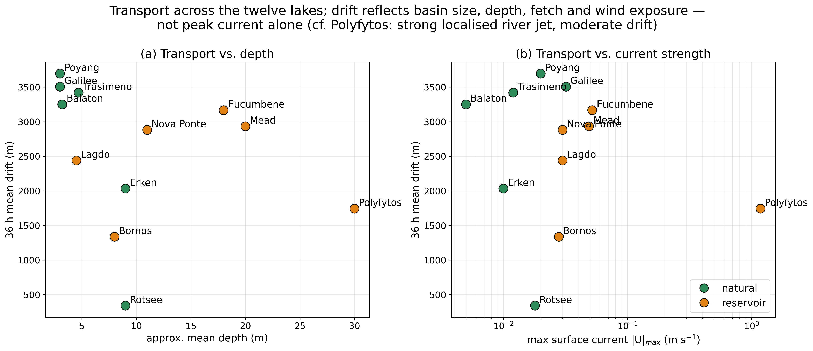
Figure 7. Physical consistency of the demonstration: 36 h mean drift versus (a) approximate mean depth and (b) maximum surface current. With only twelve lakes these are rank tendencies, not fits: the drift correlates negatively with depth (Spearman ρ = −0.55 for mean depth and −0.57 for maximum depth, p ≈ 0.05–0.06) and positively with surface area (ρ = +0.63, p = 0.03) and fetch (ρ = +0.57). Only the area correlation is significant at n = 12, so transport is read as governed by basin size, fetch and wind exposure rather than peak current alone.

5.4 Quality control
Two complementary checks support the integrity of the dataset. First, every exported file was passed through an automated audit that verifies its structural and physical soundness: monotonic coordinate axes, current and wave magnitudes within physical bounds, correctly masked sub-bed z-levels, and a non-empty wet surface. All twelve files passed. Second, the audit isolated a single, well-localised artefact: in the shallowest, strongly insolated lakes (Trasimeno, Bornos, Poyang, Sea of Galilee) a few isolated near-shore cells reached surface temperatures of up to ~40 °C, because a very thin water column over a single solar-heated cell has negligible thermal inertia and overheats within one diurnal cycle. A physical temperature cap of 35 °C is applied in the export to suppress these spikes, while basin-interior temperatures — realistic throughout, for example 17–24 °C in Rotsee, 15–26 °C in Erken and 2–10 °C in the winter Eucumbene — are left unchanged. The artefact is confined to thin-cell shorelines and does not affect the currents or waves that drive transport; accordingly, although the drift statistics in Table 4 are computed on the exported (post-cap) fields, they are unaffected by the cap, because the advection is driven by the currents, the surface Stokes drift and the wind — none of which the temperature cap touches — and not by the temperature field itself. The cap is deliberately an interim, post-hoc safeguard: the principled fix is a minimum-depth (wetting–drying) threshold applied inside the FLOW solver, which we did not enable here because it requires per-lake tuning of the drying threshold and so would compromise the single, uniform, untuned configuration that is central to the generality claim; it is left to future work (Section 6).

5.5 Relation to existing tools
It is worth stating precisely what is, and is not, new here. Relative to hand-built, single-lake Delft3D studies (e.g., Papaioannou et al., 2025) and to inter-model comparisons of lake hydrodynamics (Ishikawa et al., 2022), the contribution is not a new hydrodynamic solver but the automation and coupling that turn a community-validated 3-D engine into a forcing generator for a generic particle tracker. Relative to site-specific transport frameworks such as CaMPSim-3D (Pilechi et al., 2022), which couple a particle model to one particular hydrodynamic engine on a per-study basis, LakeForcing instead targets a generic CF reader: the exported forcing is written to the CF-NetCDF interface that generic Lagrangian readers consume, and the same workflow applies to any lake. Only the OpenDrift path is demonstrated and tested here (OpenDrift 1.14.9). We expect the same files to drive other CF-reading trackers such as Parcels (Delandmeter and van Sebille, 2019) by construction, since nothing in the export is OpenDrift-specific, but we have not verified a Parcels run and therefore leave that compatibility as a stated expectation and an item of future work rather than a demonstrated result; Parcels is not listed as a tested dependency. Of the pipeline's parts, the σ-to-z export has the broadest independent reach, since it is independent of run configuration and can make any existing Delft3D-FLOW/WAVE lake model OpenDrift-ready by being pointed at its output. Finally, we are explicit about scope: the present results establish physical plausibility and internal consistency across a wide range of lakes, together with a same-group model-to-model consistency check (Section 5.6) and an independent satellite check of the exported surface-temperature field (Section 5.7), rather than full validation against in-situ drifter or current observations. Such quantitative hydrodynamic validation is the natural next step, and it is enabled — not foreclosed — by releasing the forcing openly.

5.6 Consistency check against an expert-built reference model from the same group
To test the automated forcing against an external reference model, we ran the pipeline's auto-generated closed-lake configuration on the exact grid of the peer-reviewed, expert-built Polyfytos model (Papaioannou et al., 2025) and compared the two over their shared 54,520-cell wet domain (Fig. 8). We state at the outset that this reference is not an independent third-party model: Papaioannou et al. (2025) is the present authors' own previously published, hand-built model of the same reservoir. The comparison is therefore best read as an internal consistency check — does the automated configuration reproduce a careful, manually configured realisation of the same basin built by the same group? — rather than as an independent validation, and we have been careful not to let it carry more evidential weight than that. The hand-built model is expert-configured and includes the reservoir's river discharges; the auto configuration applies only the pipeline's standard closed-lake defaults (Table 2), with no hand tuning and no discharge. We are equally explicit about the standing of this reference as a modelling reference. The model of Papaioannou et al. (2025) is an expert-configured Delft3D-FLOW/WRF model whose meteorological forcing was validated against two local meteorological stations and whose surface-temperature dynamics were calibrated against high-frequency in-situ measurements, while a formal validation of its currents and water levels against measured hydrodynamics is identified there as ongoing work. We therefore treat it as a like-for-like modelling reference — a careful, independent realisation of the same basin — rather than as observational ground truth, and frame the comparison as model-to-model consistency; its authority for this purpose rests on its expert construction and the calibration just described, not on its publication venue. Where the physics is shared, the 48 h mean surface fields agree closely: surface temperature is reproduced to an RMSE of 0.85 °C (bias +0.30 °C), and the surface-current speed to an RMSE of 1.5 cm s⁻¹ with a Pearson correlation of r = 0.80. The current direction, by contrast, agrees poorly (complex vector correlation |ρ| = 0.10). The two configurations share the grid and the meteorological forcing but differ in several respects — the hand-built model includes the reservoir's river discharges and a calibrated, site-specific configuration (turbulence closure, numerical and initialisation choices), whereas the auto configuration applies only the standard closed-lake defaults (Table 2) — and the detailed surface circulation of a deep basin is sensitive to such differences. The benchmark therefore confirms that the automated forcing reproduces the thermal field and the current magnitude of an expert-built model, while the directional field, which depends on the full model configuration, is not reproduced by the standard closed-lake default. To probe the role of the omitted inflow specifically, we re-ran the auto configuration with the reservoir's river discharge enabled (the pipeline supports it as an optional boundary condition) and recomputed the comparison on the shared grid: the directional agreement does not improve — the complex vector correlation remains |ρ| ≈ 0.09 — which indicates that the difference reflects the broader configuration of the calibrated reference (its closure and numerical choices) rather than the river inflow alone. We are therefore explicit about what this benchmark does and does not establish: it validates the auto-generated thermal field and current magnitude against an expert-built reference, but it does not validate the current direction of the closed-lake configuration, because the only directional reference available here is itself shaped by the calibrated, site-specific setup of the hand-built model — its river discharges and its closure and numerical choices — which the standard defaults do not replicate. The satellite comparison of Section 5.7 likewise constrains the thermal field rather than the currents. Independent validation of current direction — the quantity that most directly governs where particles go — against in-situ drifters or ADCP moorings is thus the single most valuable next step, and is enabled by releasing the forcing openly. The benchmark is confined to currents and temperature because the reference is a hydrodynamic (FLOW) model: its wind-wave field was itself produced by the present pipeline — on the separate counter-clockwise grid the pipeline generates for SWAN — so there is no independent wave field against which to compute an Hs bias. This detail also makes Section 2.2 concrete: the FLOW grid reused here is clockwise, which Delft3D-FLOW tolerates, so the wave step must run on the pipeline's counter-clockwise grid rather than the FLOW grid — exactly the orientation the automated grid generation enforces by construction. This raises no additional grid-mapping error in the export, because the two engine outputs are never interpolated onto each other: the σ-to-z exporter regrids the FLOW fields and the SWAN fields independently onto the common regular longitude/latitude raster of Section 2.5 (the FLOW currents from their curvilinear grid, the wave parameters from SWAN's counter-clockwise grid), so the only horizontal interpolation either field undergoes is the single curvilinear/CCW-to-regular step already discussed there. There is no back-mapping of the SWAN output onto the FLOW domain, and hence no extra interpolation error beyond the one bounded in Section 2.5. On a standard multi-core desktop workstation the per-lake cost is dominated by the Delft3D run: this 236×233×14, 48 h FLOW simulation completed in about 19 min of wall-clock time, while grid construction, ERA5 retrieval and automated model generation each add well under a minute and the stationary SWAN wave step 1–2 min. The σ-to-z export is heavier than these ancillary steps — of order a few minutes (about 1.8 min for the small Rotsee grid and about 4 min for Erken, each 49 output times), dominated by the per-cell vertical reconstruction and the horizontal curvilinear-to-regular interpolation and scaling with the wet-cell count and the number of output times; it is nonetheless small beside the FLOW run, so a small-to-medium lake is still processed end-to-end in well under an hour. The exporter is a pure-Python reference implementation whose per-cell loops are not yet vectorised, so this is an implementation ceiling rather than an algorithmic one, and is straightforward to reduce by an order of magnitude with array vectorisation (Section 6).
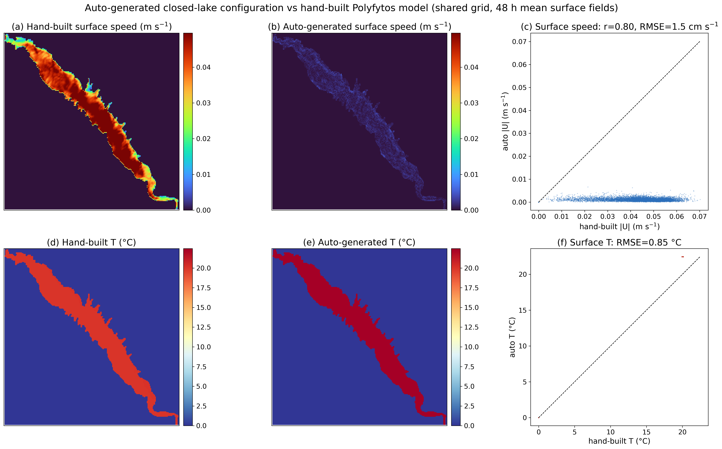
Figure 8. Benchmark of the auto-generated closed-lake configuration against the peer-reviewed, expert-built Polyfytos model on the shared grid (48 h mean surface fields): (a, b) surface-current speed and (c) its scatter; (d, e) surface temperature and (f) its scatter. The automated forcing reproduces the thermal field (RMSE 0.85 °C) and current magnitude (RMSE 1.5 cm/s, r = 0.80); the weaker auto currents reflect the absence of the river discharge that the hand-built model includes.

5.7 Independent validation against satellite surface temperature
The benchmark of Section 5.6 is model-to-model; to test the exported fields against genuine observations we compared the auto-generated surface temperature with satellite lake surface water temperature (LSWT). For four of the demonstration lakes — Bornos (Spain), Lake Mead (USA), Trasimeno (Italy) and the Southern-Hemisphere winter reservoir Nova Ponte (Brazil) — a near-cloudless Landsat-8/9 Collection-2 Level-2 thermal-band overpass (Vermote et al., 2016) falls within, or within two days of, the 1–3 July 2022 simulation window. From each scene we took the Collection-2 Level-2 surface-temperature (thermal) band, converted the digital numbers to kelvin with the standard Landsat scaling, and built a clear-water skin-temperature field by retaining only pixels flagged water-and-clear in the QA_PIXEL bit mask (rejecting cloud, shadow, cirrus and land). The native thermal field — loaded in geographic coordinates at roughly 30–60 m depending on basin size — was then aggregated onto the coarser model grid by averaging all satellite pixels falling within each model cell (an area-mean bin, not nearest-neighbour), giving a like-for-like basin field. We compared this against the exported surface temperature at the model time step of maximum basin-mean temperature — the model's own diurnal warming peak, which falls close to the early-afternoon Landsat overpass — with the satellite UTC stamp shifted into the lake's local time zone (the model's time axis, Section 2.3) before matching. One systematic difference is left uncorrected and should be borne in mind: the satellite measures a radiometric skin temperature, whereas the model carries a bulk surface temperature, and we applied no skin-to-bulk adjustment; under daytime insolation the skin typically runs of order 0.2–0.5 K cooler than the bulk, a systematic that is small against the 4–5 °C warm-lake offset discussed below but is comparable to the sub-0.2 °C agreement at the winter control and so should not be over-interpreted there. The four lakes are all auto-generated, so this tests the pipeline's own heat-flux forcing rather than the prescribed temperature of the hand-built reference.
The comparison is informative precisely because it is unflattering in one respect and reassuring in another. The three Northern-Hemisphere summer lakes run cold relative to the satellite skin temperature by about 4–5 °C (mean 4.8 °C), whereas the Southern-Hemisphere winter lake, where no comparable anomaly exists, matches to within 0.2 °C. This pattern is the signature of the initialisation rather than of the heat-flux physics: July 2022 was a severe European and North-American heatwave, and a surface initialised from a climatological monthly temperature and integrated for only 48 h cannot reach the anomalously warm 2022 skin values, while the unanomalous winter lake — initialised close to the prevailing temperature — is reproduced almost exactly. The agreement at the control lake therefore indicates that the exported temperatures are physically correct in regime and that the warm-lake offset is an initialisation cost, not a forcing error; it quantifies, in observational terms, the basin-mean dependence on the initial temperature noted in Section 4.2 and motivates initialising from an observed (e.g., satellite) temperature, which the pipeline supports. The test constrains the basin mean rather than the fine spatial structure: because each lake is driven by a single, spatially uniform ERA5 column, the modelled surface temperature is nearly uniform over the basin (spatial standard deviation 0.0–0.6 °C versus 1.2–4.0 °C in the satellite field), so where the model does develop structure — in the shallow, fetch-exposed basins (Bornos, Trasimeno) — it correlates positively with the observed pattern (r ≈ 0.7), while in the near-uniform deep basins (Mead) the per-cell correlation is uninformative and is not interpreted.
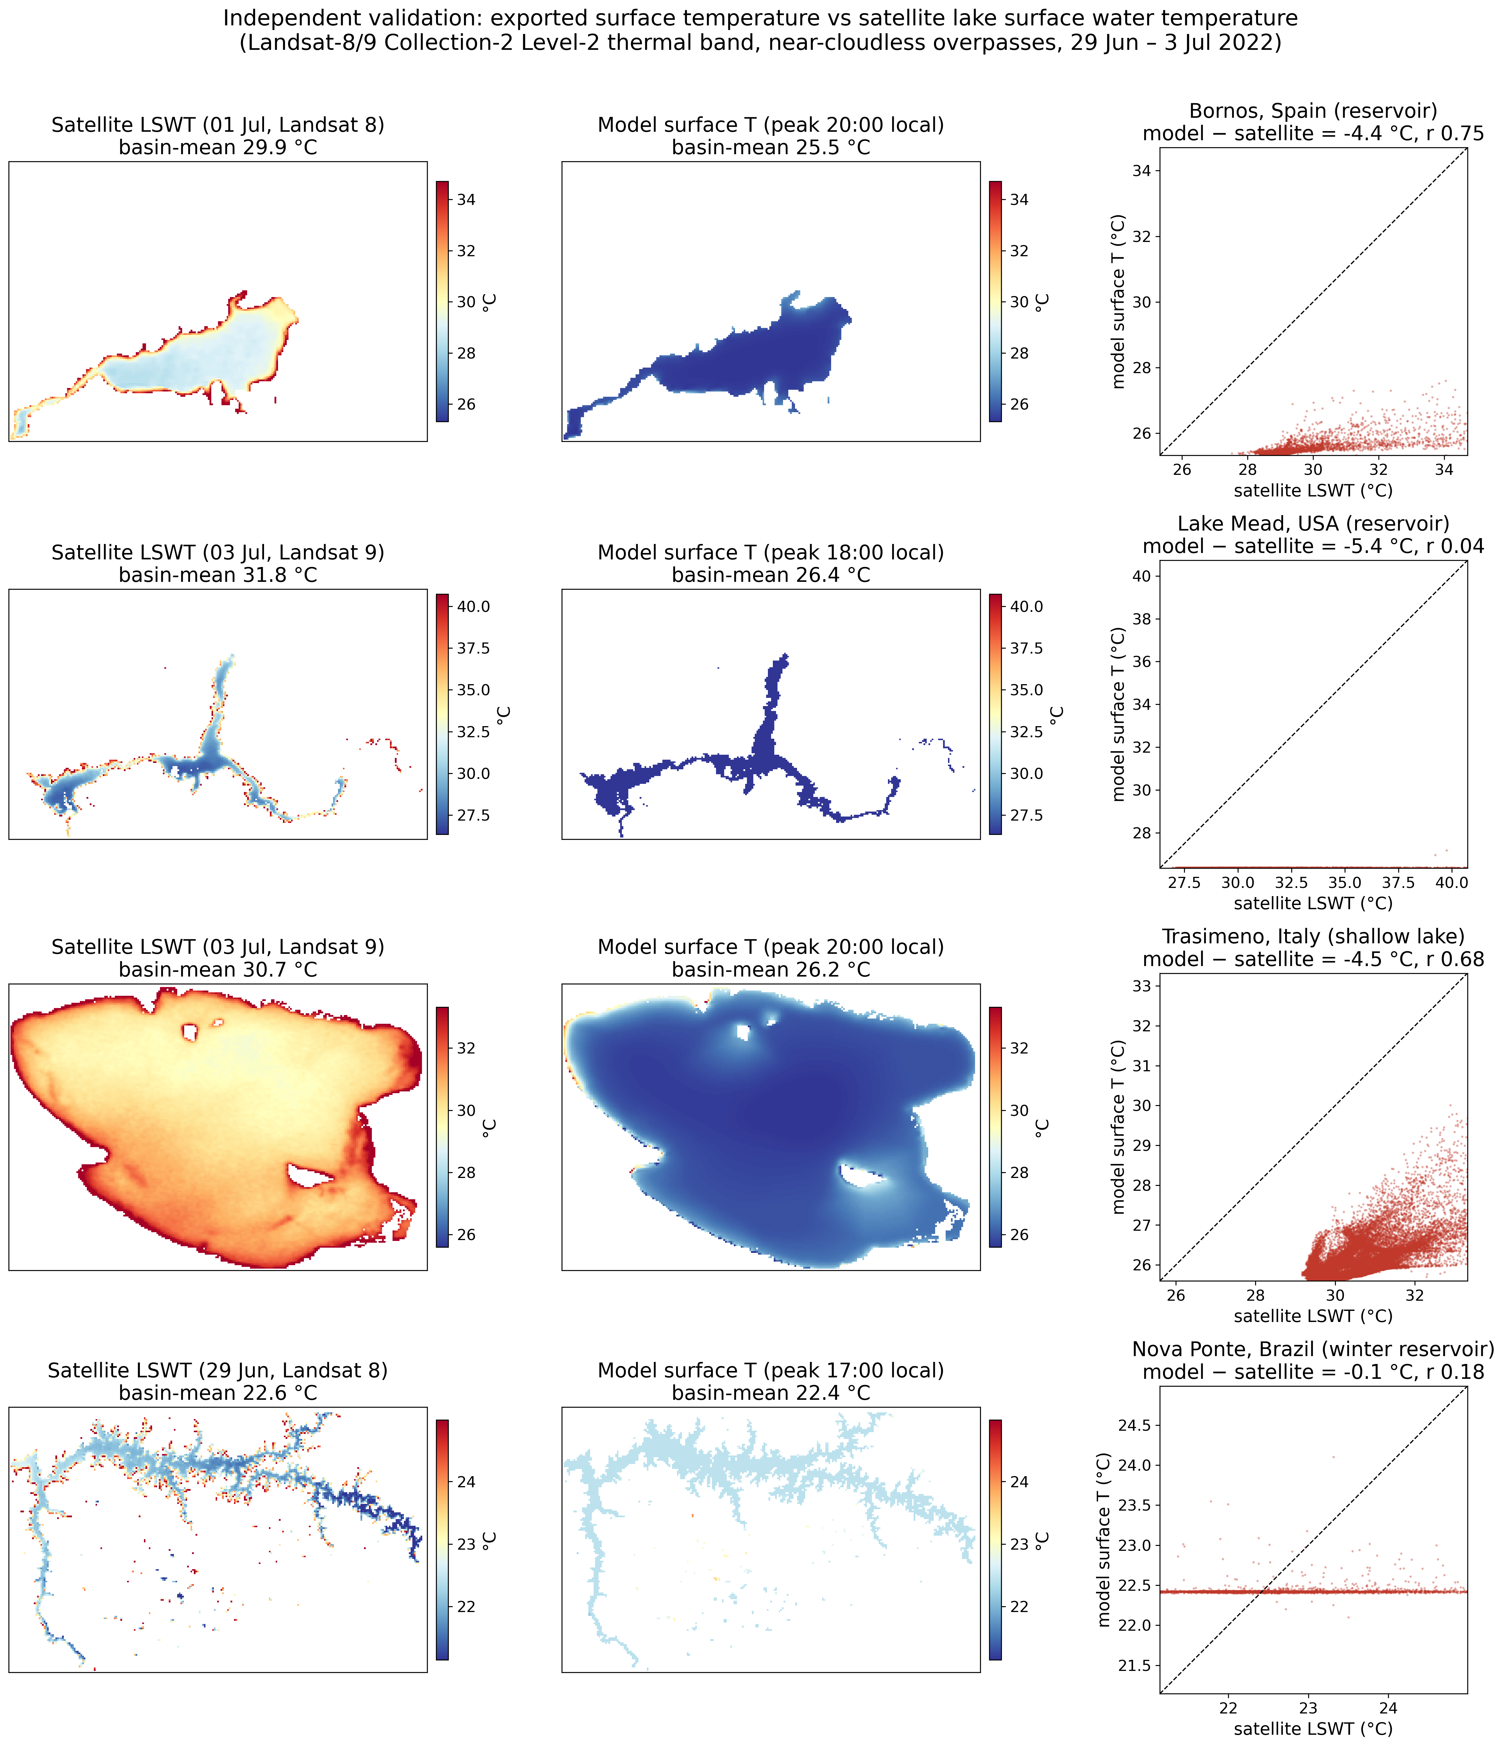
Figure 9. Independent validation against satellite lake surface water temperature (Landsat-8/9 Collection-2 Level-2 thermal band, near-cloudless overpasses around 1-3 July 2022): for each lake, the satellite skin temperature, the exported model surface temperature at the diurnal peak, and their scatter. The three Northern-Hemisphere summer lakes run several °C cold of the 2022 heatwave skin temperature — a climatological-initialisation effect — while the Southern-Hemisphere winter control (Nova Ponte) matches to below 1 °C, indicating the heat-flux forcing is sound and the bias is in the initialisation.

6. Limitations and future work
Several limitations bound the present implementation, most of them deliberate simplifications that trade physical completeness for automation and generality. The most consequential concerns the atmospheric forcing. Each lake is driven by a single ERA5 column sampled at its centroid, so the wind, heat and mass-balance forcing is spatially uniform over the basin. For the small and medium lakes that dominate the global inventory this is an acceptable approximation, because the basin is far smaller than the synoptic scale on which the wind varies; but on the largest lakes — at the scale of the Laurentian Great Lakes or the Caspian Sea — spatial wind gradients drive an appreciable part of the circulation, and a single column cannot represent them, as recent complex-wind-field lake modelling makes clear (Li et al., 2025). The same reanalysis also sets a resolution floor: ERA5's native ~31 km grid (or the ~9 km high-resolution sub-set) under-resolves the near-shore wind and the lake–land breeze (Crosman and Horel, 2010), smoothing precisely the gradients that matter most along the shoreline where floating material tends to accumulate. Both limitations are addressable within the existing file interface, by ingesting a spatially distributed wind field in place of a point time series.
A second group of limitations concerns the wave field. For computational economy the demonstration uses a stationary SWAN solution — the wave field is computed for representative wind states rather than continuously coupled in time — which is adequate for the slowly varying wind-seas of enclosed lakes but cannot capture the transient growth and decay of waves under a rapidly veering storm; a fully time-varying wave run is supported by the same generator at greater cost. The surface Stokes drift is, in turn, reconstructed from bulk wave parameters through a deep-water, monochromatic approximation (Section 2.5), which reproduces the magnitude and direction of the surface drift but not its vertical decay; for deeply submerged or weakly buoyant tracers a spectral or depth-resolved Stokes profile (Breivik et al., 2014, 2016; van den Bremer and Breivik, 2018) would represent the near-surface shear more faithfully.
Two further limitations stem from the input data and the physical configuration. Where bathymetry is derived from satellite altimetry, the DAHITI product captures the depth band the altimeter has observed over its mission, which need not coincide with the absolute maximum depth of the basin; the resulting grid is therefore conservative in the deepest, least-sampled parts of such lakes, the Sea of Galilee being the clearest case here. And because inland lakes are modelled with a freshwater density reference and no active salinity transport, the configuration does not apply as-is to hypersaline or strongly saline waterbodies such as the Dead Sea, which would require the salinity transport and a corresponding equation of state to be enabled — both available in Delft3D, but switched off by default in the automated closed-lake setup. A final, localised numerical artefact, already noted in Section 5.4, bears restating here: in very thin near-shore cells under strong insolation the negligible thermal inertia of a one-cell-deep column can produce unphysical surface-temperature spikes. The export suppresses these with a 35 °C cap and they affect neither the currents nor the waves that drive transport, but a more principled remedy — a minimum-depth (wetting–drying) threshold that removes such cells before they overheat — is preferable and is planned.
A further limitation, made quantitative by the satellite comparison of Section 5.7, concerns the temperature initialisation. The surface temperature is initialised from a single climatological monthly value and integrated for only 48 h, so during an anomalously warm period — such as the July-2022 heatwave that coincided with the simulation window — the modelled surface runs several degrees cold of the observed skin temperature, even though the heat-flux forcing itself is sound (the Southern-Hemisphere winter control lake, with no anomaly, matches the satellite to better than 1 °C). Initialising from an observed (e.g., satellite) surface temperature, and extending the integration, would remove this bias and is a small change within the existing interface. This thermal offset is not expected to propagate appreciably into the reported 36-h surface transport: the demonstration shift is a wind- and wave-driven near-surface response, and over the short integration the weak, slowly developing summer stratification exerts only a second-order influence on the surface current, so a several-degree error in the absolute surface temperature leaves the surface drift largely unchanged. Quantifying this insensitivity directly — by re-running an affected summer lake from an observed initial temperature and reporting the resulting change in 36-h drift — would place a firm bound on it and is left to future work.
Together these limitations define a clear development path. Future work will introduce spatially distributed wind for large lakes, time-varying wave forcing, observed-temperature initialisation, an explicit salinity and temperature equation of state for saline systems, a minimum-depth treatment for thin shoreline cells, a depth-dependent Stokes profile, and vectorisation of the σ-to-z exporter's per-cell reconstruction loops, which currently dominate its few-minute runtime (Section 5.6) and can be reduced by an order of magnitude without changing the algorithm. Beyond these refinements, the natural next step is quantitative validation against in-situ drifter or tracer observations for individual lakes (Section 5.5) and, at scale, application of the workflow to a HydroLAKES sub-sample (Messager et al., 2016; Lehner and Döll, 2004; Verpoorter et al., 2014) to build a standing, openly distributed archive of lake forcing for community reuse.

7. Conclusions
We have presented LakeForcing, an open and reproducible pipeline that converts open global data — HydroLAKES, GLOBathy and DAHITI bathymetry together with ERA5 meteorology — into hydrodynamic and wind-wave forcing for an arbitrary inland lake, and delivers it as CF-compliant NetCDF that drives the OpenDrift particle tracker without modification. Its methodological core is a fully specified σ-layer to z-level coupling which, together with the curvilinear-to-geographic velocity rotation, the horizontal regridding and the surface Stokes-drift derivation, resolves the vertical-coordinate mismatch that otherwise prevents terrain-following Delft3D output from being read by a generic ocean tracker. Combined with the automated generation of closed-lake Delft3D models, this turns a community-validated three-dimensional engine into a forcing generator and greatly reduces the per-lake setup cost that has kept Lagrangian transport modelling out of reach for most inland waters.
Demonstrated unchanged across twelve morphologically and climatically diverse lakes spanning all inhabited continents (36°S–60°N), the pipeline yields physically coherent and internally consistent forcing in every case. The surface circulation organises into basin-scale, wind-driven patterns with realistic vertical shear; surface temperatures track the seasonal heat forcing across both hemispheres, from 2–10 °C in the Southern-Hemisphere winter to 26–35 °C in the tropical and Mediterranean lakes; and the fetch-limited wind-sea produces significant wave heights of H_{s} = 0.14–0.51 m that scale correctly with fetch and exposure. The 36-h surface drift spans an order of magnitude, from 0.34 km in the small, deep, sheltered Rotsee to 3.7 km in the large, shallow, fetch-exposed Poyang, and varies in a manner consistent with — though, with only twelve lakes, not statistically established by — basin size, fetch and wind exposure rather than peak current. The one unambiguous diagnostic is that the strongest local current, the river-driven Polyfytos, does not yield the largest drift; the accompanying morphometric ordering — a significant positive rank correlation of drift with surface area (ρ = +0.63, p = 0.03) and weaker tendencies with fetch and depth — reproduces the directions reported observationally for lake-plastic retention (Nava et al., 2023; Chen et al., 2024); with twelve lakes only the area correlation is significant — and it weakens to marginal (ρ = +0.54, p = 0.09) once the one hand-built lake, Polyfytos, is excluded — so the weaker tendencies are presented as physically coherent rank tendencies rather than as established laws. An automated audit confirmed the structural and physical integrity of all twelve exported datasets, and an independent satellite comparison bounded the absolute accuracy of the exported surface-temperature field (Section 5.7).
By removing the forcing bottleneck and releasing the complete toolchain and the twelve-lake forcing dataset under permissive licences, the work lowers the barrier to lake-scale studies of plastics, oil spills, harmful algal blooms and ecological transport, and provides a reusable bridge — the σ-to-z exporter — that can make any existing Delft3D lake model OpenDrift-ready. The present results establish physical plausibility and generality rather than per-lake validation; coupling the openly released forcing to in-situ observations, and scaling the workflow toward a global, HydroLAKES-wide forcing archive (Messager et al., 2016; Verpoorter et al., 2014), are the natural next steps.

Software availability
Software name | LakeForcing
Version | v1.2.0
Developers | V. Papaioannou, C. G. E. Anagnostopoulos, A. Moumtzidou, I. Gialampoukidis, S. Vrochidis, I. Kompatsiaris (CERTH-ITI)
Contact | Vassilios Papaioannou — vaspapa@iti.gr; CERTH-ITI, 6th km Charilaou-Thermi, 57001 Thessaloniki, Greece
Year first available | 2025
Programming language | Python 3.11
Software dependencies | Pinned in requirements.txt (conda-forge Python 3.11 recommended): opendrift==1.14.9, plus xarray, numpy, scipy, pyproj, rasterio (GDAL/PROJ via conda-forge), netCDF4, cdsapi, matplotlib, cartopy
External hydrodynamic engine | Delft3D 4.07.01 (FLOW + WAVE/SWAN), installed separately. Reported runs used the official Deltares pre-built Windows-x64 binary, release tag 4.07.01, from oss.deltares.nl/web/delft3d (no local build; vendor compiler/flags)
External data services | ERA5 via cdsapi (dataset reanalysis-era5-single-levels, product_type: reanalysis; variable short-names listed in §3.2 and the README; Copernicus CDS account and ~/.cdsapirc required); HydroLAKES; GLOBathy; DAHITI
Operating systems | Windows 11 (64-bit) for the reported runs; also runs on 64-bit Linux
Hardware requirements | Standard workstation; a multi-core CPU is recommended for the Delft3D-FLOW/WAVE runs
Optional features | River-discharge open boundary (used in §5.6, configured via _build_river_config.py); supported but not exercised by the CI test
Source-code size | approximately 0.2 MB (excluding generated data)
Code versioning system | git
Documentation | Repository README (Delft3D version/tag, ERA5/CDS variable names and credential setup, fixture provenance, and the build_docx.py manuscript-rebuild command) and the present manuscript
Source repository | https://github.com/vaspapa79/LakeForcing
Permanent archive | Zenodo (concept DOI, latest version): https://doi.org/10.5281/zenodo.20627160
Reproducible test capsule | A versioned, checksummed Erken subset in tests/fixtures/ (trim-erken_mini.nc, 125×52 grid, 14 σ-layers, 2 time steps, EPSG:32634; wavm-erken_mini.nc), built by tests/build_fixture.py, runs the σ-to-z exporter via pytest/GitHub-Actions CI with no Delft3D install and asserts CF compliance and the headline variables (§3.2); full hydrodynamic runs require the external engine
Licence | MIT (source code); CC-BY-4.0 (generated forcing dataset)
Availability and cost | Free and open source

CRediT authorship contribution statement
V.P.: Conceptualization, Methodology, Software, Validation, Visualization, Writing – original draft. C.G.E.A.: Software, Validation, Visualization, Writing – original draft. A.M.: Data curation, Writing – review & editing. I.G.: Methodology, Writing – review & editing. S.V.: Supervision, Writing – review & editing. I.K.: Supervision, Project administration, Funding acquisition.

Declaration of competing interest
The authors declare that they have no known competing financial interests or personal relationships that could have appeared to influence the work reported in this paper.

Data availability
The generated twelve-lake forcing dataset (CC-BY-4.0) consists of the twelve exported CF-compliant NetCDF files (<lake>_forcing.nc, one per lake of Table 4; about 0.9 GB uncompressed). It is distributed as a versioned GitHub release asset of the source repository (LakeForcing-OpenDrift_forcing_dataset_v1.0.0.zip, about 0.7 GB compressed), accompanied by a manifest (DATASET_MANIFEST.txt) that lists each file's size and SHA-256 checksum so that the contents can be verified against Section 4. Each file is self-describing and interoperable: it declares the CF-1.8 conventions and carries CF standard_name and udunits units on every variable (Section 2.5), so the dataset is readable by any CF-aware tool without accompanying code, and a citable dataset-level DOI can be minted on request for users who require one distinct from the software archive. The source code is separately archived on Zenodo at https://doi.org/10.5281/zenodo.20627160 (concept DOI), which deposits the repository snapshot under the MIT licence; the forcing dataset, being a large generated product under a different licence (CC-BY-4.0), is released alongside the code as the GitHub release asset rather than embedded in the software archive. All input datasets (HydroLAKES, GLOBathy, DAHITI, ERA5) are openly available from their respective providers.

Code availability
The source code is openly available at https://github.com/vaspapa79/LakeForcing under the MIT licence and is archived on Zenodo at https://doi.org/10.5281/zenodo.20627160. A continuous-integration test on a small bundled Delft3D fixture exercises the σ-to-z exporter from a clean checkout with no Delft3D installation.

Funding
This research did not receive any specific grant from funding agencies in the public, commercial, or not-for-profit sectors. The work was carried out using the existing research infrastructure of the Information Technologies Institute, Centre for Research and Technology Hellas (CERTH-ITI).

Acknowledgements
The authors thank the developers of Delft3D (Deltares) and OpenDrift, and the providers of the open datasets used here (HydroLAKES, GLOBathy, DAHITI and ERA5). This work was carried out in the context of the AINature project (Interreg) and the AQUAMON project (Horizon Europe), which provided the broader research environment within which it developed. The authors received no direct funding from either project for the work reported here.

References
Alduchov, O.A., Eskridge, R.E., 1996. Improved Magnus form approximation of saturation vapor pressure. J. Appl. Meteorol. 35, 601–609. https://doi.org/10.1175/1520-0450(1996)035<0601:IMFAOS>2.0.CO;2
Booij, N., Ris, R.C., Holthuijsen, L.H., 1999. A third-generation wave model for coastal regions: 1. Model description and validation. J. Geophys. Res. Oceans 104(C4), 7649–7666. https://doi.org/10.1029/98JC02622
Breivik, Ø., Allen, A.A., Maisondieu, C., Roth, J.C., 2011. Wind-induced drift of objects at sea: the leeway field method. Appl. Ocean Res. 33, 100–109. https://doi.org/10.1016/j.apor.2011.01.005
Breivik, Ø., Janssen, P.A.E.M., Bidlot, J.-R., 2014. Approximate Stokes drift profiles in deep water. J. Phys. Oceanogr. 44, 2433–2445. https://doi.org/10.1175/JPO-D-14-0020.1
Breivik, Ø., Bidlot, J.-R., Janssen, P.A.E.M., 2016. A Stokes drift approximation based on the Phillips spectrum. Ocean Modell. 100, 49–56. https://doi.org/10.1016/j.ocemod.2016.01.005
Chen, D., Wang, P., Liu, S., Wang, R., Wu, Y., Zhu, A.-X., Deng, C., 2024. Global patterns of lake microplastic pollution: insights from regional human development levels. Sci. Total Environ. 954, 176620. https://doi.org/10.1016/j.scitotenv.2024.176620
Chenillat, F., Huck, T., Maes, C., Grima, N., Blanke, B., 2021. Fate of floating plastic debris released along the coasts in a global ocean model. Mar. Pollut. Bull. 165, 112116. https://doi.org/10.1016/j.marpolbul.2021.112116
Cózar, A., Echevarría, F., González-Gordillo, J.I., Irigoien, X., Úbeda, B., Hernández-León, S., Palma, Á.T., Navarro, S., García-de-Lomas, J., Ruiz, A., Fernández-de-Puelles, M.L., Duarte, C.M., 2014. Plastic debris in the open ocean. Proc. Natl. Acad. Sci. USA 111, 10239–10244. https://doi.org/10.1073/pnas.1314705111
Crosman, E.T., Horel, J.D., 2010. Sea and lake breezes: a review of numerical studies. Bound.-Layer Meteorol. 137, 1–29. https://doi.org/10.1007/s10546-010-9517-9
Dagestad, K.-F., Röhrs, J., Breivik, Ø., Ådlandsvik, B., 2018. OpenDrift v1.0: a generic framework for trajectory modelling. Geosci. Model Dev. 11, 1405–1420. https://doi.org/10.5194/gmd-11-1405-2018
Delandmeter, P., van Sebille, E., 2019. The Parcels v2.0 Lagrangian framework: new field interpolation schemes. Geosci. Model Dev. 12, 3571–3584. https://doi.org/10.5194/gmd-12-3571-2019
Espenes, H., Carrasco, A., Dagestad, K.-F., Christensen, K.H., Drivdal, M., Isachsen, P.E., 2024. Stokes drift in crossing windsea and swell, and its effect on near-shore particle transport in Lofoten, Northern Norway. Ocean Modell. 191, 102407. https://doi.org/10.1016/j.ocemod.2024.102407
Free, C.M., Jensen, O.P., Mason, S.A., Eriksen, M., Williamson, N.J., Boldgiv, B., 2014. High-levels of microplastic pollution in a large, remote, mountain lake. Mar. Pollut. Bull. 85, 156–163. https://doi.org/10.1016/j.marpolbul.2014.06.001
Hersbach, H., Bell, B., Berrisford, P., Hirahara, S., Horányi, A., Muñoz-Sabater, J., Nicolas, J., Peubey, C., Radu, R., Schepers, D., Simmons, A., Soci, C., Abdalla, S., Abellan, X., Balsamo, G., Bechtold, P., Biavati, G., Bidlot, J., Bonavita, M., De Chiara, G., Dahlgren, P., Dee, D., Diamantakis, M., Dragani, R., Flemming, J., Forbes, R., Fuentes, M., Geer, A., Haimberger, L., Healy, S., Hogan, R.J., Hólm, E., Janisková, M., Keeley, S., Laloyaux, P., Lopez, P., Lupu, C., Radnoti, G., de Rosnay, P., Rozum, I., Vamborg, F., Villaume, S., Thépaut, J.-N., 2020. The ERA5 global reanalysis. Q. J. R. Meteorol. Soc. 146, 1999–2049. https://doi.org/10.1002/qj.3803
Hipsey, M.R., Bruce, L.C., Boon, C., Busch, B., Carey, C.C., Hamilton, D.P., Hanson, P.C., Read, J.S., de Sousa, E., Weber, M., Winslow, L.A., 2019. A General Lake Model (GLM 3.0) for linking with high-frequency sensor data. Geosci. Model Dev. 12, 473–523. https://doi.org/10.5194/gmd-12-473-2019
Ishikawa, M., Gonzalez, W., Golyjeswski, O., Sales, G., Rigotti, J.A., Bleninger, T., Mannich, M., Lorke, A., 2022. Effects of dimensionality on the performance of hydrodynamic models for stratified lakes and reservoirs. Geosci. Model Dev. 15, 2197–2220. https://doi.org/10.5194/gmd-15-2197-2022
Iskandar, M.R., Cordova, M.R., Park, Y.-G., 2022. Pathways and destinations of floating marine plastic debris from 10 major rivers in Java and Bali, Indonesia: a Lagrangian particle tracking perspective. Mar. Pollut. Bull. 185, 114331. https://doi.org/10.1016/j.marpolbul.2022.114331
Khazaei, B., Read, L.K., Casali, M., Sampson, K.M., Yates, D.N., 2022. GLOBathy, the global lakes bathymetry dataset. Sci. Data 9, 36. https://doi.org/10.1038/s41597-022-01132-9
Kukulka, T., Proskurowski, G., Morét-Ferguson, S., Meyer, D.W., Law, K.L., 2012. The effect of wind mixing on the vertical distribution of buoyant plastic debris. Geophys. Res. Lett. 39, L07601. https://doi.org/10.1029/2012GL051116
Lehner, B., Döll, P., 2004. Development and validation of a global database of lakes, reservoirs and wetlands. J. Hydrol. 296, 1–22. https://doi.org/10.1016/j.jhydrol.2004.03.028
Lehner, B., Liermann, C.R., Revenga, C., Vörösmarty, C., Fekete, B., Crouzet, P., Döll, P., Endejan, M., Frenken, K., Magome, J., Nilsson, C., Robertson, J.C., Rödel, R., Sindorf, N., Wisser, D., 2011. High-resolution mapping of the world's reservoirs and dams for sustainable river-flow management. Front. Ecol. Environ. 9, 494–502. https://doi.org/10.1890/100125
Lesser, G., Roelvink, J., van Kester, J., Stelling, G., 2004. Development and validation of a three-dimensional morphological model. Coastal Eng. 51, 883–915. https://doi.org/10.1016/j.coastaleng.2004.07.014
Li, J., Zhang, Y., Li, Y., Ma, K., Wang, Z., Zhang, X., Yi, Y., Lu, P., Gao, Z., Wang, M., 2025. Wind-generated flow modeling and future circulation prediction of lakes under complex wind field — a case study of Qinghai Lake. Environ. Model. Softw. 187, 106371. https://doi.org/10.1016/j.envsoft.2025.106371
Magnus, G., 1844. Versuche über die Spannkräfte des Wasserdampfs. Ann. Phys. 137, 225–247. https://doi.org/10.1002/andp.18441370202
Maurer, C., Rensheng Qi, Raghavan, V., 2003. A linear time algorithm for computing exact Euclidean distance transforms of binary images in arbitrary dimensions. IEEE Trans. Pattern Anal. Mach. Intell. 25, 265–270. https://doi.org/10.1109/TPAMI.2003.1177156
Messager, M.L., Lehner, B., Grill, G., Nedeva, I., Schmitt, O., 2016. Estimating the volume and age of water stored in global lakes (HydroLAKES). Nat. Commun. 7, 13603. https://doi.org/10.1038/ncomms13603
Nava, V., Chandra, S., Aherne, J., Alfonso, M.B., Antão-Geraldes, A.M., Attermeyer, K., Bao, R., Bartrons, M., Berger, S.A., Biernaczyk, M., Bissen, R., Brookes, J.D., Brown, D., Cañedo-Argüelles, M., Canle, M., Capelli, C., Carballeira, R., Cereijo, J.L., Chawchai, S., Christensen, S.T., Christoffersen, K.S., de Eyto, E., Delgado, J., Dornan, T.N., Doubek, J.P., Dusaucy, J., Erina, O., Ersoy, Z., Feuchtmayr, H., Frezzotti, M.L., Galafassi, S., Gateuille, D., Gonçalves, V., Grossart, H.-P., Hamilton, D.P., Harris, T.D., Kangur, K., Kankılıç, G.B., Kessler, R., Kiel, C., Krynak, E.M., Leiva-Presa, À., Lepori, F., Matias, M.G., Matsuzaki, S.-I.S., McElarney, Y., Messyasz, B., Mitchell, M., Mlambo, M.C., Motitsoe, S.N., Nandini, S., Orlandi, V., Owens, C., Özkundakci, D., Pinnow, S., Pociecha, A., Raposeiro, P.M., Rõõm, E.-I., Rotta, F., Salmaso, N., Sarma, S.S.S., Sartirana, D., Scordo, F., Sibomana, C., Siewert, D., Stepanowska, K., Tavşanoğlu, Ü.N., Tereshina, M., Thompson, J., Tolotti, M., Valois, A., Verburg, P., Welsh, B., Wesolek, B., Weyhenmeyer, G.A., Wu, N., Zawisza, E., Zink, L., Leoni, B., 2023. Plastic debris in lakes and reservoirs. Nature 619, 317–322. https://doi.org/10.1038/s41586-023-06168-4
Onink, V., Wichmann, D., Delandmeter, P., van Sebille, E., 2019. The role of Ekman currents, geostrophy, and Stokes drift in the accumulation of floating microplastic. J. Geophys. Res. Oceans 124, 1474–1490. https://doi.org/10.1029/2018JC014547
Oswald, S.B., Ragas, A.M.J., Schoor, M.M., Collas, F.P.L., 2025. Plastic transport in rivers: bridging the gap between surface and water column. Water Res. 269, 122768. https://doi.org/10.1016/j.watres.2024.122768
Papaioannou, V., Mantsis, D.F., Anagnostopoulos, C.G., Vlachos, K., Moumtzidou, A., Gialampoukidis, I., Vrochidis, S., Kompatsiaris, I., 2025. Integrated hydrodynamic and atmospheric modelling of Polyfytos Lake for substance dispersion using Delft3D and WRF. Open J. Civ. Eng. https://doi.org/10.4236/ojce.2025.152013
Pilechi, A., Mohammadian, A., Murphy, E., 2022. A numerical framework for modeling fate and transport of microplastics in inland and coastal waters (CaMPSim-3D). Mar. Pollut. Bull. 184, 114119. https://doi.org/10.1016/j.marpolbul.2022.114119
Schwatke, C., Dettmering, D., Bosch, W., Seitz, F., 2015. DAHITI – an innovative approach for estimating water level time series over inland waters using multi-mission satellite altimetry. Hydrol. Earth Syst. Sci. 19, 4345–4364. https://doi.org/10.5194/hess-19-4345-2015
Snyder, J.P., 1987. Map Projections — A Working Manual. U.S. Geological Survey Professional Paper 1395. U.S. Government Printing Office, Washington, D.C. https://doi.org/10.3133/pp1395
Tramoy, R., Gasperi, J., Colasse, L., Tassin, B., 2020. Transfer dynamic of macroplastics in estuaries — new insights from the Seine estuary: Part 1. Long-term dynamic based on date-prints on stranded debris. Mar. Pollut. Bull. 152, 110894. https://doi.org/10.1016/j.marpolbul.2020.110894
Umlauf, L., Burchard, H., 2003. A generic length-scale equation for geophysical turbulence models. J. Mar. Res. 61, 235–265. https://doi.org/10.1357/002224003322005087
van den Bremer, T.S., Breivik, Ø., 2018. Stokes drift. Phil. Trans. R. Soc. A 376, 20170104. https://doi.org/10.1098/rsta.2017.0104
van Sebille, E., Aliani, S., Law, K.L., Maximenko, N., Alsina, J.M., Bagaev, A., Bergmann, M., Chapron, B., Chubarenko, I., Cózar, A., Delandmeter, P., Egger, M., Fox-Kemper, B., Garaba, S.P., Goddijn-Murphy, L., Hardesty, B.D., Hoffman, M.J., Isobe, A., Jongedijk, C.E., Kaandorp, M.L.A., Khatmullina, L., Koelmans, A.A., Kukulka, T., Laufkötter, C., Lebreton, L., Lobelle, D., Maes, C., Martinez-Vicente, V., Morales Maqueda, M.A., Poulain-Zarcos, M., Rodríguez, E., Ryan, P.G., Shanks, A.L., Shim, W.J., Suaria, G., Thiel, M., van den Bremer, T.S., Wichmann, D., 2020. The physical oceanography of the transport of floating marine debris. Environ. Res. Lett. 15, 023003. https://doi.org/10.1088/1748-9326/ab6d7d
Vermote, E., Justice, C., Claverie, M., Franch, B., 2016. Preliminary analysis of the performance of the Landsat 8/OLI land surface reflectance product. Remote Sens. Environ. 185, 46–56. https://doi.org/10.1016/j.rse.2016.04.008
Verpoorter, C., Kutser, T., Seekell, D.A., Tranvik, L.J., 2014. A global inventory of lakes based on high-resolution satellite imagery. Geophys. Res. Lett. 41, 6396–6402. https://doi.org/10.1002/2014GL060641
Wagner, M., Scherer, C., Alvarez-Muñoz, D., Brennholt, N., Bourrain, X., Buchinger, S., Fries, E., Grosbois, C., Klasmeier, J., Marti, T., Rodriguez-Mozaz, S., Urbatzka, R., Vethaak, A.D., Winther-Nielsen, M., Reifferscheid, G., 2014. Microplastics in freshwater ecosystems: what we know and what we need to know. Environ. Sci. Eur. 26, 12. https://doi.org/10.1186/s12302-014-0012-7
Wüest, A., Lorke, A., 2003. Small-scale hydrodynamics in lakes. Annu. Rev. Fluid Mech. 35, 373–412. https://doi.org/10.1146/annurev.fluid.35.101101.161220
Wynne, T.T., Stumpf, R.P., 2015. Spatial and temporal patterns in the seasonal distribution of toxic cyanobacteria in western Lake Erie from 2002–2014. Toxins 7, 1649–1663. https://doi.org/10.3390/toxins7051649
Zhou, X., Rowe, M., Liu, Q., Xue, P., 2023. Comparison of Eulerian and Lagrangian transport models for harmful algal bloom forecasts in Lake Erie. Environ. Model. Softw. 162, 105641. https://doi.org/10.1016/j.envsoft.2023.105641

