C# OOP Team "Blueberry"

# **Team members:**

|  |  |  |  |
| --- | --- | --- | --- |
| vassildinev  Васил Динев | Ivaylo3  Ивайло Петров | frowstyl  Александър Марков | dimiter.gg  Димитър Гайдарджиев |
| beliconfused  Илия Беличев | maryakach  Мария Качарава | konstantin.popo  Константин Попов | K.Terziev  Кристиян Терзиев |

# **Application description:**

The main purpose of the application “**JustBlueberry”** is to demonstrate implementation of the OOP principles. Heroes of our project is Alien race of Blueberries from far away “Galaxy Blue”, very ancient with strong inheritance of a **Composite Design Pattern**. The father of them all a Particle Hadron, who is a father of has 10 successors, below is their family tree:

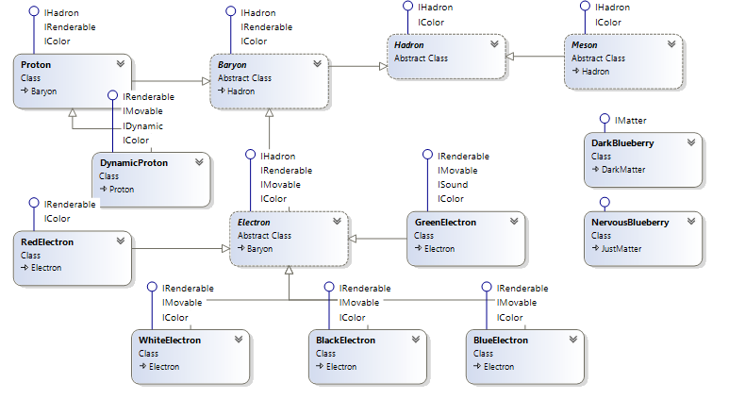

As Universe is a very overcrouded place, war for new therritories is a common thing. When attacked, Bluerries form battle structures of three types:

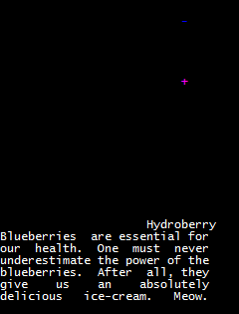Defense – **Hydroberry**, formed by Electron who is guarding Proton:

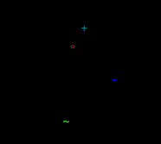

Intelligance and battle – **NervousBlueberry,**

Formed by ***RredElectron, Electron, DynamicProton***

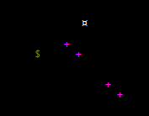***GreenElectron*** allerts with beep signal and rushes for reenforcement

Guarding prisoners – **DarkBlueberry**

Formed by

# **How world of Blueberries works:**

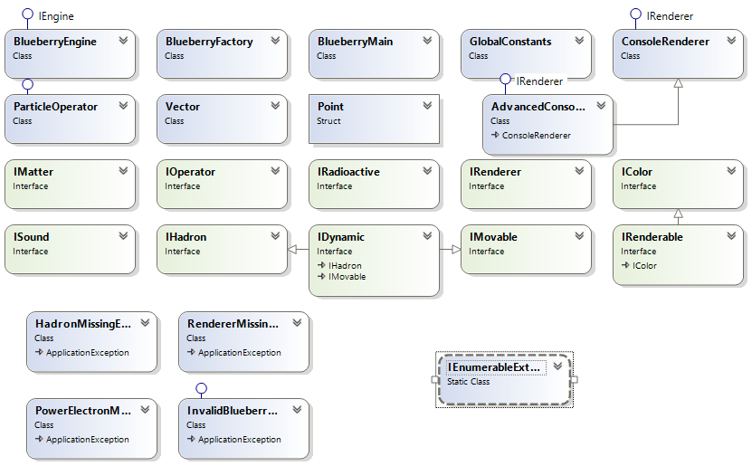

**IEnumerable**

**9 Interfaces**

**Mechanism of blueberry production**

**Exceptions**

# Git repository: https://github.com/vassildinev/CSharp-OOP-Team-Project