C# OOP Team "Blueberry"

# **Team members:**

|  |  |  |  |
| --- | --- | --- | --- |
| vassildinev  Васил Динев | Ivaylo3  Ивайло Петров | frowstyl  Александър Марков | dimiter.gg  Димитър Гайдарджиев |
| beliconfused  Илия Беличев | maryakach  Мария Качарава | konstantin.popov.10  Константин Попов | K.Terziev  Кристиян Терзиев |

# **Application description:**

The main purpose of the application “**JustBlueberry”** is to build an application based on the OOP principles. Heroes of our project is the Alien race of Blueberries from far away “Galaxy Blue”, a very ancient civilization . The father of them all, Particle Hadron, has 10 descendants. Below is their family tree:

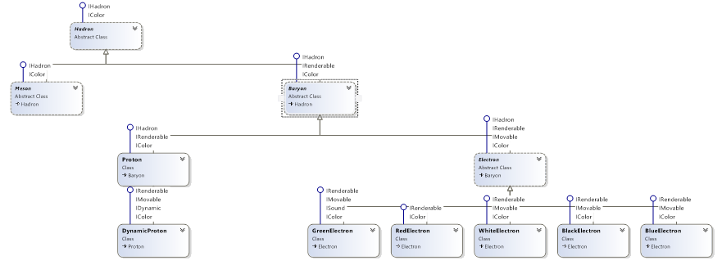

As Universe is a very overcrouded place, war for new therritories is a common thing. When attacked, Bluerries form battle structures of three types:

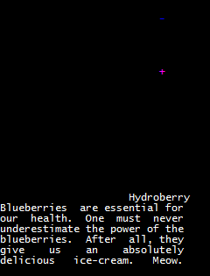

It’s-Party-Time principle followers – **Hydroberry**, formed by

an Electron, who is guarding Proton. They just enjoy life as

it is – no pressure whatsoever. Or there is a special kind of Hydroberries that aren’t as lazy an engage in the battle to save us all from misery. Thank you Hydroberries!

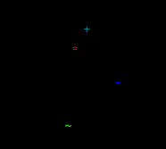

Enemies of the known Universe – **NervousBlueberry,**

Formed by ***RredElectron, Electron, DynamicProton***

***GreenElectron*** attacks with beep signal and creeps in on the good gyus.

Just have to be careful when you’re around them!

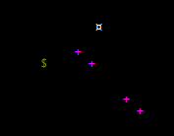

Guarding prisoners – **DarkBlueberry**

Formed by 4 baseliners – the Proton Army of Four and the big Black Electron with it’s ally the White Electron, engage in the battle without hesitation.

# **How world of Blueberries works:**

**Mechanism of blueberry production**

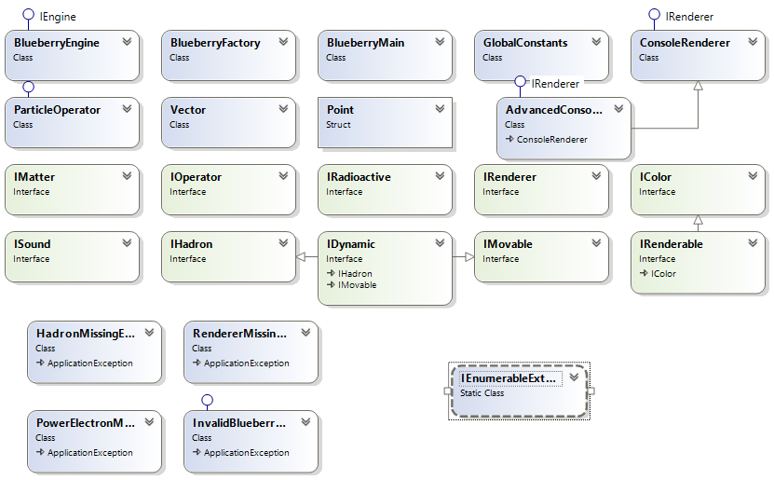

**IEnumerableExtension**

**Exceptions**

Now, seriously. Go Hydroberry!!!

The next step in the development of our project is by using the property MeaningOfLife to render a ‘battle’ simulation, e.g. in one cycle of frames to engage the three types of lifetime goals in one scenario – the Savers of the Universe battle against the Enemies using their properties – accepting energy elements for the good guys (not yet implemented) and the letting-go of radioactive stuff for the bad guys. The EnjoyTheShow implementators will just sit back and enjoy the battle, maybe some popcorn can be implemented, and so on. Maybe not the most interesting thing ever, but…who we are is what we do, I guess…

# Git repository: https://github.com/vassildinev/CSharp-OOP-Team-Project