3. Data Mining

After the design and population of the data warehouse and the development of the OLAP cube, the final stage of the project focuses on the application of data mining techniques on the StatsBomb dataset. In this stage, data exported from the warehouse is used as input for machine learning algorithms that produce useful insights. This way we demonstrate how a data warehouse can serve not only as a reporting and visualization backend, but also as a data source for predictive and exploratory modeling.
To achieve that, we implemented two models: one supervised and one unsupervised. We used Python with the following libraries: Pandas for data handling, scikit-learn for model development, and Matplotlib for visualization.

3.1 Supervised Learning Model – Shot Outcome Prediction
The first data mining task addresses a supervised learning problem. Using historical shot data, a classification model is developed to estimate the probability that a shot results in a goal based on its characteristics. The target variable indicates whether a shot was successful and the input features are descriptive aspects of each attempt. This model corresponds to an expected goals-type approach.
Data Preparation and Feature Selection
After loading our data on a pandas dataframe, we prepare it for machine learning. Since the data originates from the data warehouse, it is already cleaned and structurally consistent, but additional preprocessing is required to make it suitable for our specific model.
Boolean attributes related to shot context (such as whether the shot was taken under pressure, first time, or in a one-on-one situation) are initially encoded as categorical values ('t' / 'f'). These values are converted to binary numerical form (1/0). The target variable indicating whether a shot resulted in a goal is also explicitly converted to an integer type.
To prevent data leakage, the column containing the original StatsBomb expected goals value is excluded from the feature set (we are trying to predict the same metric).
Finally, the input features and target variable are defined. The feature set includes numerical attributes describing shot location and geometry, binary contextual indicators, and categorical attributes related to shot execution. The target variable represents the shot outcome. The final set of features that we will use for the predictions is: shot_x, shot_y, distance_to_goal, shot_angle, under_preasure, shot_first_time, shot_one_on_one, shot_body_part, shot_type, shot_technique.
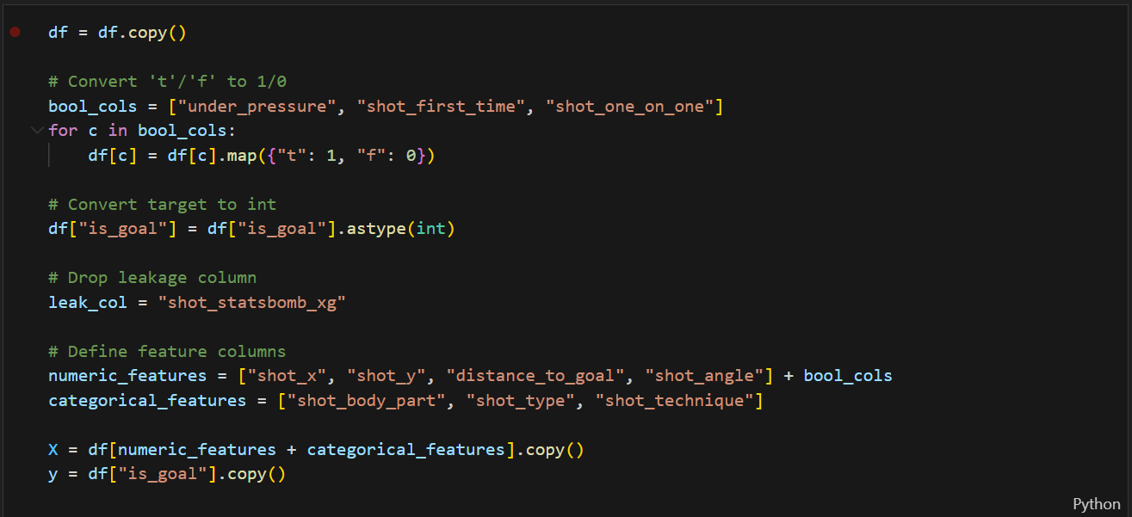

Train–Test Split
The dataset is split into training and test sets at the match level rather than at the individual shot level. All shots from the same match are assigned exclusively to either the training or the test set. This prevents information leakage caused by correlations between shots within the same match.
An 80/20 split is applied based on unique match identifiers. After the split, the number of shots and the goal rate in each subset are reported to ensure that the class distribution remains similar between training and test data.
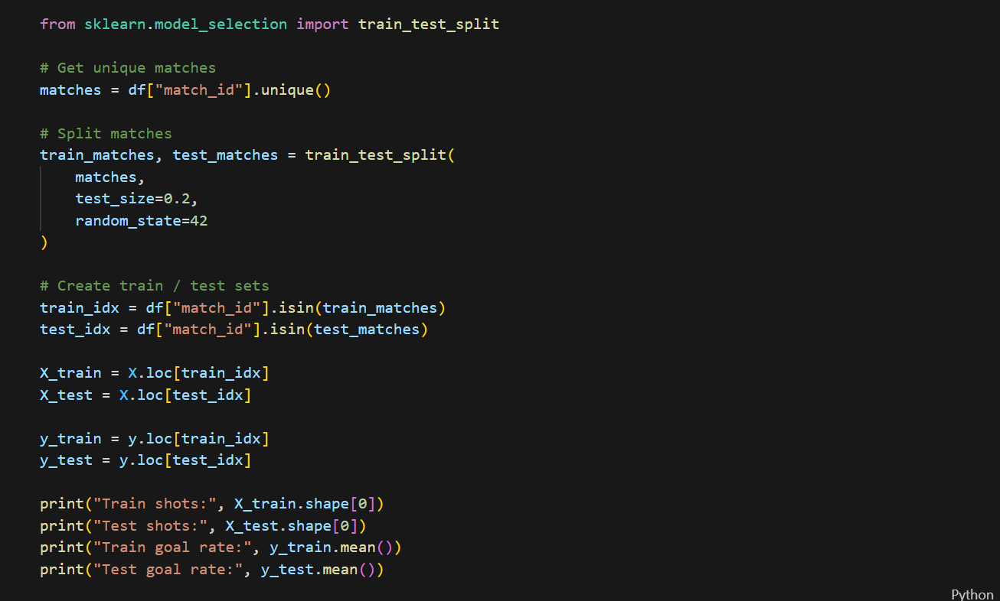

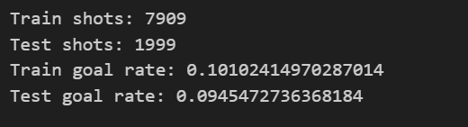

Feature Preprocessing
Before training the models, feature preprocessing is applied. Numerical features are standardized to ensure comparable scales, and categorical features are converted into numerical form using one-hot encoding. The preprocessing is implemented through a column-wise transformer, which applies the appropriate transformation to each feature type.

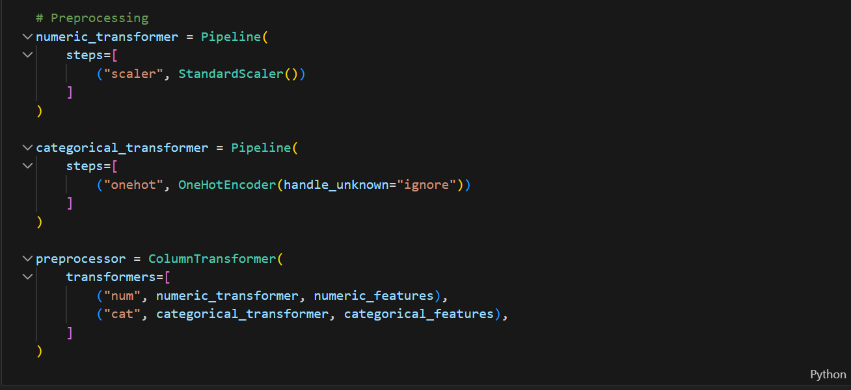

Baseline Model: Logistic Regression
As a baseline supervised learning approach, a logistic regression classifier is trained to estimate the probability that a shot results in a goal. Logistic regression is a widely used linear classification method that provides interpretable probabilistic outputs and serves as a strong reference model for comparison with more complex ones.
The maximum number of optimization iterations (max_iter) is increased to ensure convergence of the training process. Since goals are relatively rare compared to non-goals, class weighting is applied so that misclassifying goal events is penalized more heavily during training. The model is trained using the L-BFGS optimization algorithm, which is well suited for this type of convex optimization problem.
The model outputs probabilities and NOT binary predictions. Its performance is evaluated using three complementary metrics:
- ROC-AUC: shows how well the model can tell good shots from bad shots by ranking goal shots higher than non-goal shots.
- Log Loss: measures how close the predicted probabilities are to the actual outcomes, giving higher penalties when the model is confident but wrong.
- Brier Score: measures how well the predicted probabilities match what actually happens, by comparing predicted chances with real goal frequencies.

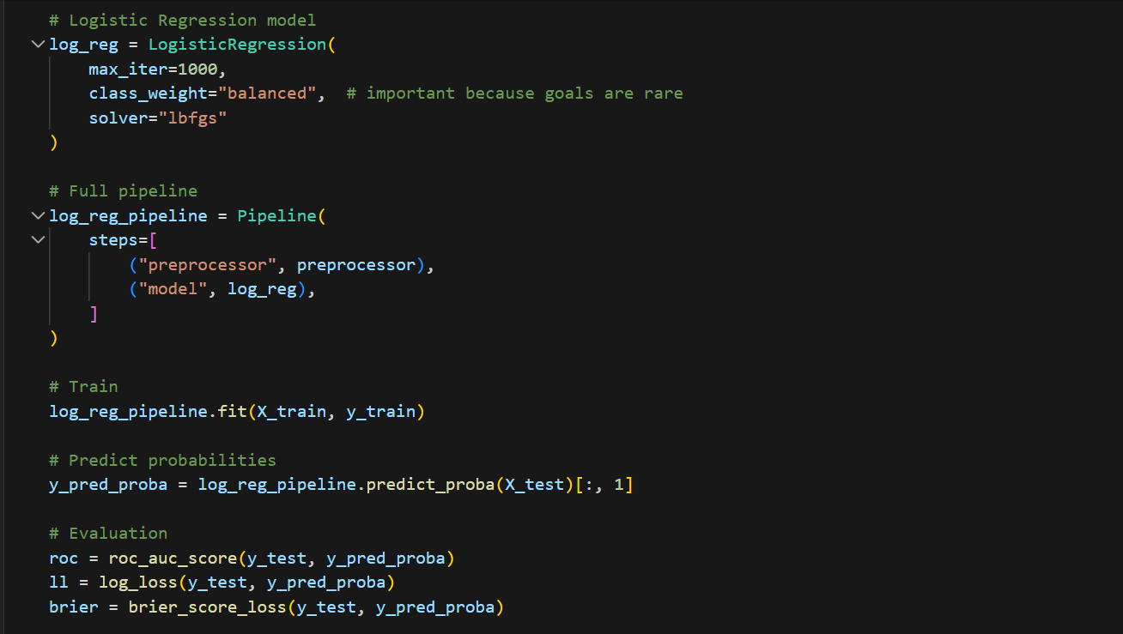

Baseline Model Results and Motivation for Advanced Modeling
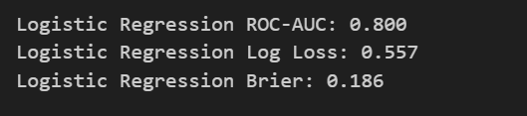
The logistic regression model achieves a ROC-AUC of 0.80, indicating that it is able to distinguish effectively between goal and non-goal shots by ranking higher-quality chances above lower-quality ones. However, the relatively high log loss and Brier score suggest that, although the model ranks shots well, its predicted probabilities are not always accurate or well calibrated.
This behavior is expected from a linear model such as logistic regression, which cannot fully capture complex, non-linear relationships between shot characteristics. As a result, while the baseline model provides a solid reference point, there is room for improvement in the estimations.
Therefore, a more advanced, non-linear model based on gradient-boosted decision trees (XGBoost) is implemented next.

Advanced Model: XGBoost Classifier
Unlike logistic regression, XGBoost can capture non-linear relationships and interactions between features.
The model is built as an ensemble of many small decision trees. Each tree focuses on correcting the errors made by the previous ones, gradually improving the overall prediction. A relatively large number of trees is used (300), and their individual impact is controlled through a small learning rate (0.05) to ensure stable training and reduce the possibilities for overfitting. The depth of each tree is also limited (4) to avoid overfitting, and random subsampling of both rows and features is applied to further improve generalization.
The model is trained to directly predict the probability that a shot results in a goal, using log loss as the optimization objective. As with the baseline approach, the XGBoost model is integrated into a pipeline with the preprocessing steps describer earlier, to ensure consistent handling of the input data.
Model performance is evaluated on the test set using the same metrics as before (ROC-AUC, log loss, and Brier score).
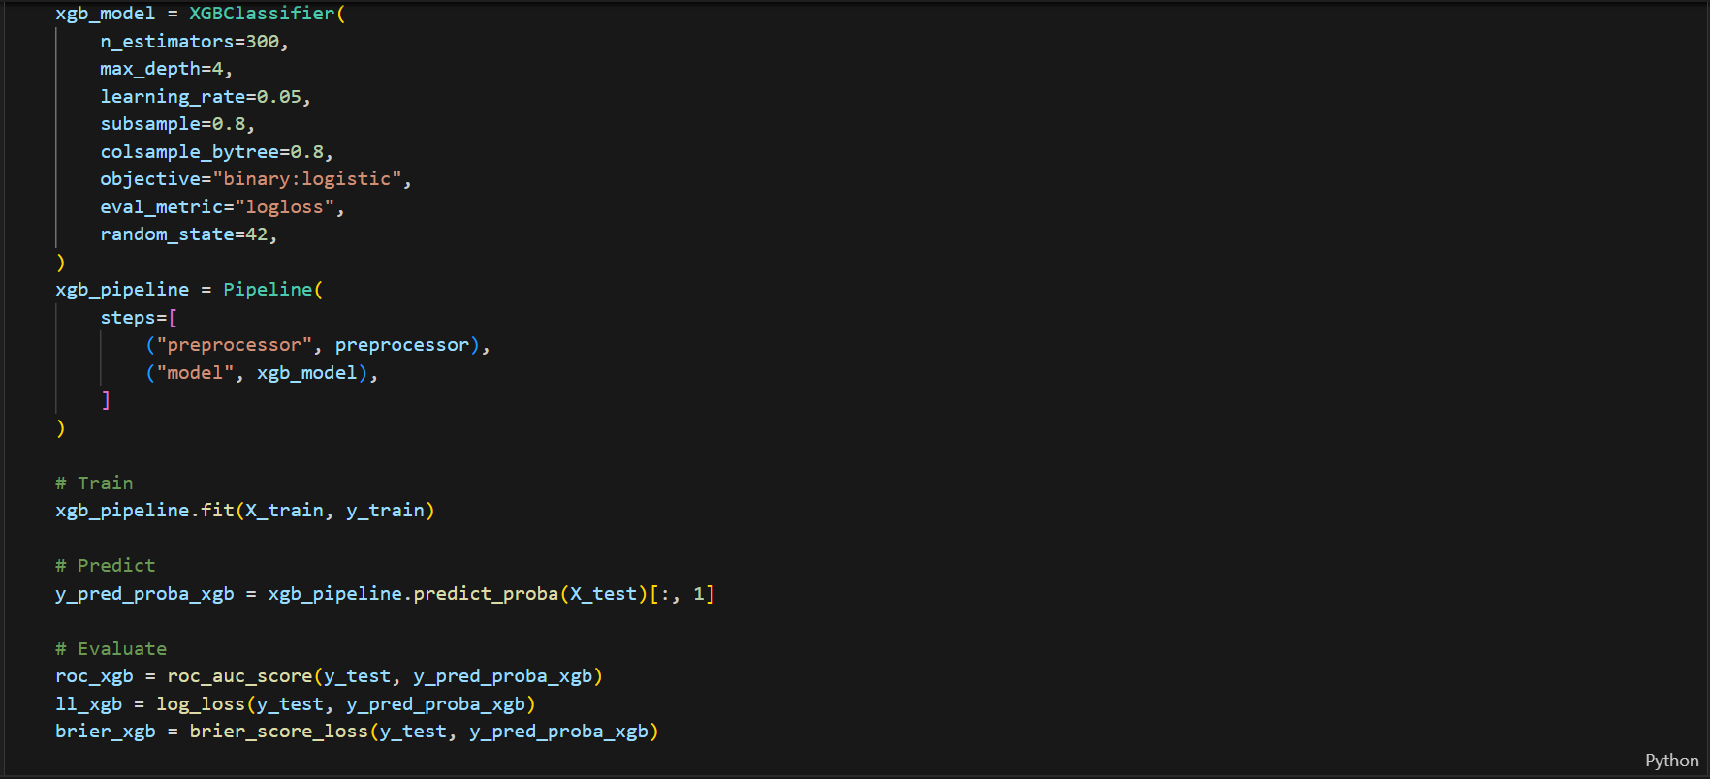

XGBoost Model Results
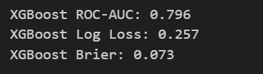
The XGBoost model achieves a ROC-AUC of 0.796, which is comparable to the baseline logistic regression model and indicates strong ability to distinguish between goal and non-goal shots. This shows that the more complex model maintains high ranking performance.
At the same time, XGBoost significantly improves the quality of the predicted probabilities. The much lower log loss indicates that the probability estimates are more accurate, while the also lower Brier score shows that the predicted probabilities are better calibrated and more consistent with observed outcomes.
Overall, these results confirm that the XGBoost model provides a clear improvement over the baseline approach in terms of probability estimation.

Calibration Curve Analysis
The calibration curve is used to examine how well the predicted probabilities correspond to actual goal frequencies. While the evaluation metrics quantify overall performance, this plot provides a visual validation on whether predicted probabilities can be interpreted as true likelihoods (e.g. whether shots predicted with a 30% probability result in goals approximately 30% of the time).
The results show that the logistic regression model consistently underestimates goal probabilities, especially for higher-quality chances. On the other hand, the XGBoost model follows the ideal calibration line more closely, indicating better-calibrated probability estimates.

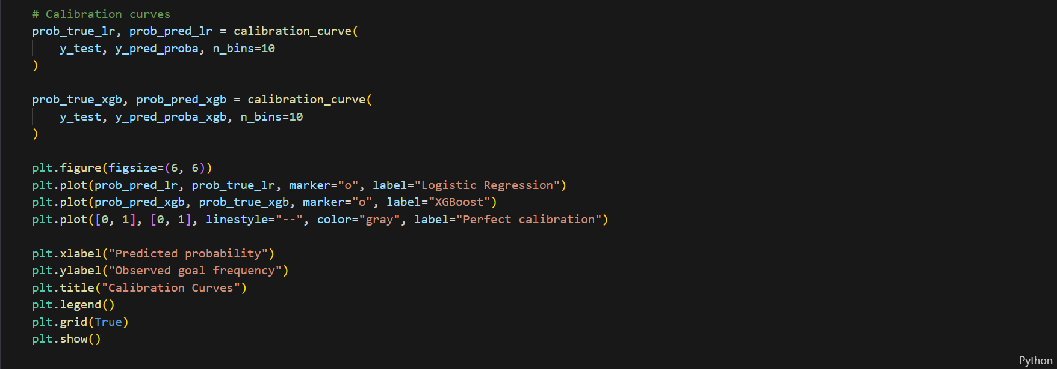
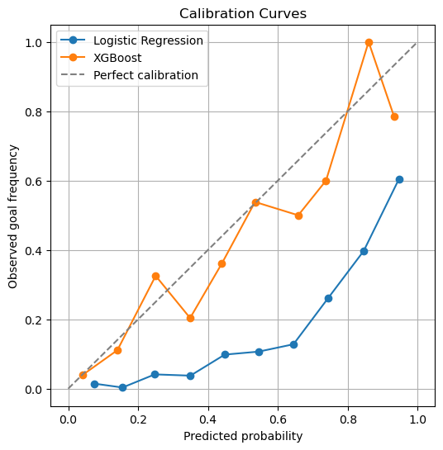

Comparison with StatsBomb Expected Goals
To provide a reference point for our results, the performance of the models is compared with the official StatsBomb expected goals (xG) values included in the dataset. StatsBomb xG represents a professionally developed model that uses additional information and has been extensively validated in real-world applications.
The comparison shows that StatsBomb xG achieves slightly better performance across all evaluation metrics. However, the differences between StatsBomb xG and the XGBoost model are relatively small, particularly for log loss and Brier score. This indicates that our model produces probability estimates that are close to those of a professional xG model.
