ROS Assignment

Vasileios Papadopoulos

## Binaries
{
/opt/ros/noetic/bin
}

## Create catkin package
{
cd ~/desktop/ros-assignment/src
catkin_create_pkg ros_assignment std_msgs rospy roscpp
cd ~/desktop/ros-assignment
catkin_make
. ~/desktop/ros-assignment/devel/setup.bash
rospack depends1 ros_assignment
}

## Start ros core infrastructure
{
roscore
}

## Launch turtle bot
{
#rosrun turtlesim turtlesim_node
roslaunch turtle_tf turtle_tf_demo.launch
}

## Display topic messages
{
rostopic list
rostopic echo turtle1/cmd_vel
}

## Launch teleoperation
{
rosrun turtlesim turtle_teleop_key
}

## Change background
In order to change the background color of turtlesim we use the rosparam command.
Particularly, we set RGB colors individually and then we use rosservice command to
apply the changes.

{
rosparam set /sim/background_r 45
rosparam set /sim/background_g 150
rosparam set /sim/background_b 120
##apply changes
rosservice call /clear

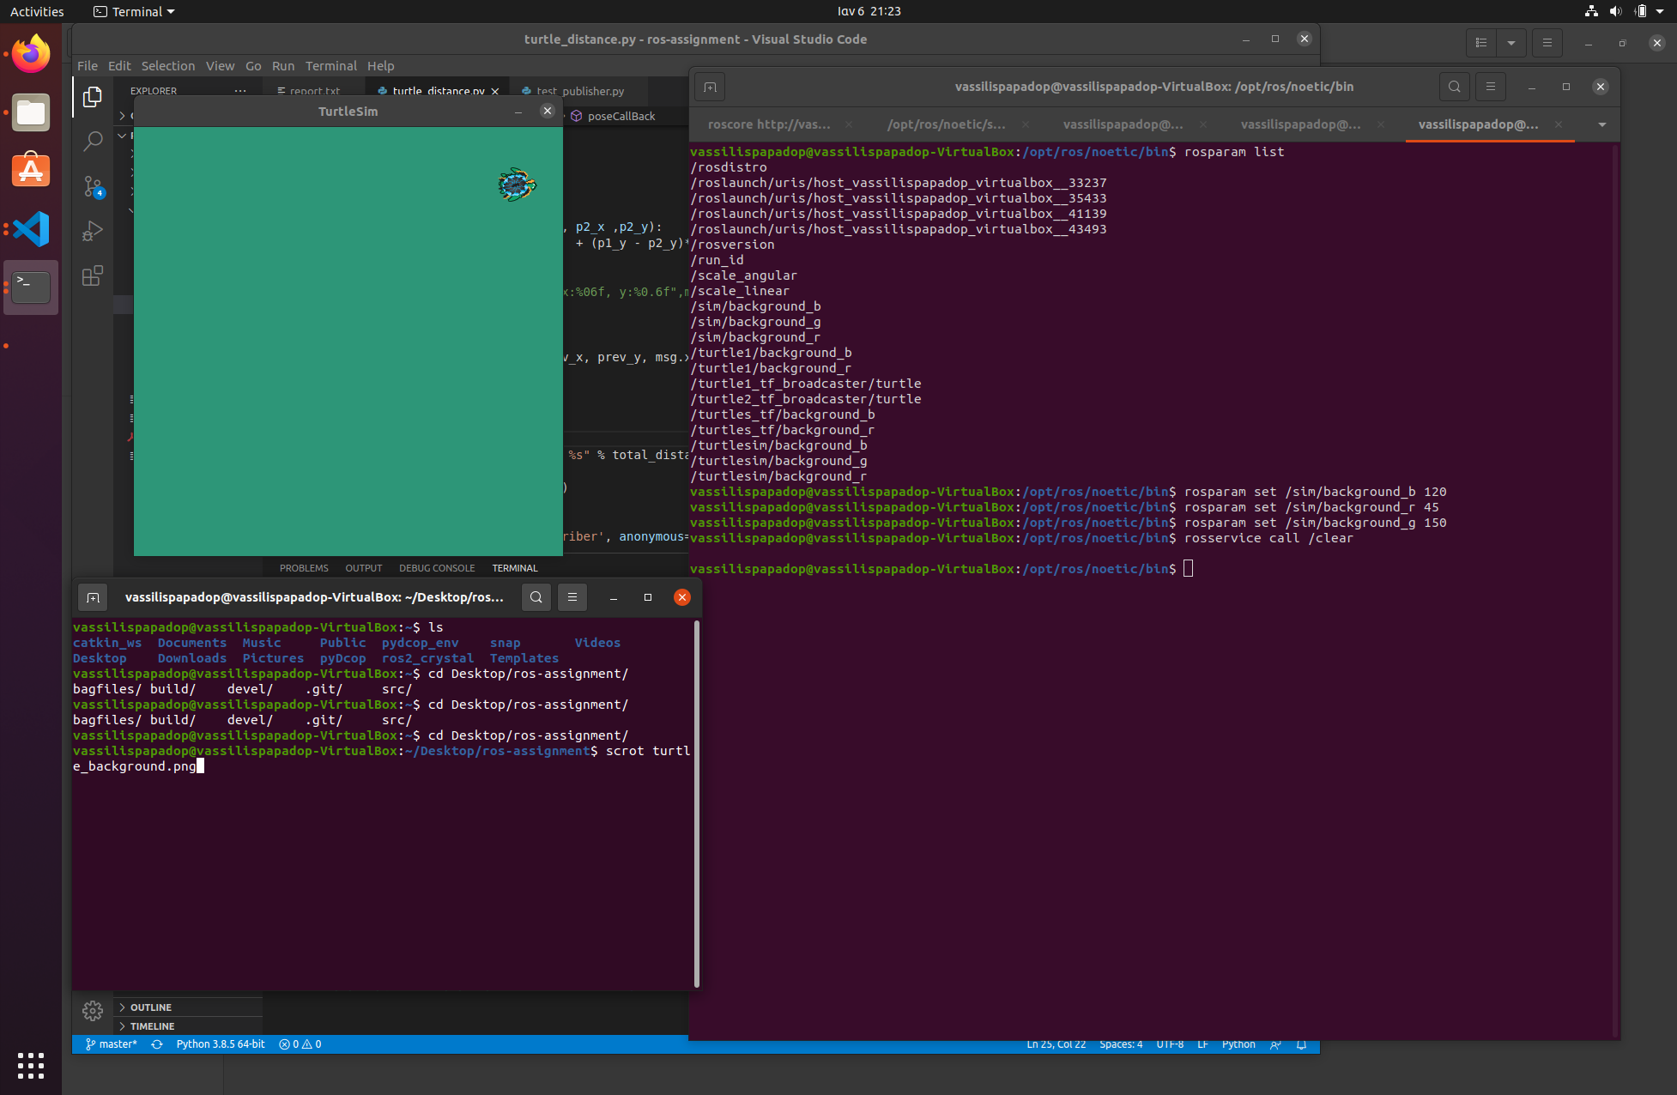
}

## Inspect tf tree
In order to run tf view_frames command I had to change line 89 in /opt/ros/noetic/lib/view_frames to avoid TypeError: cannot use a string pattern on a bytes-like object
line 89 replaced with :
decoded = vstr.decode('utf-8')
m = r.search(decoded)

{
rosrun tf view_frames
OR
rosrun rqt_tf_tree rqt_tf_tree
#view pdf
evince frames.pdf
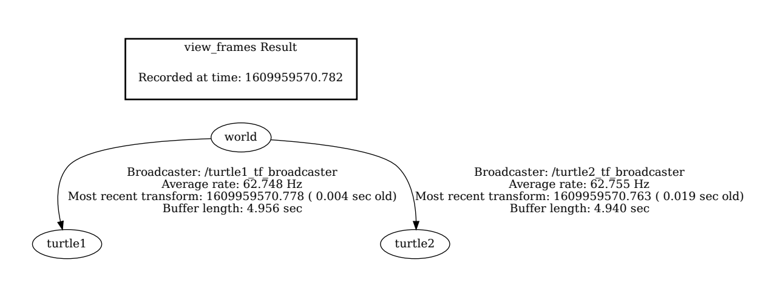
}

## Record/Play playback
{
rosbag record -O subset /turtle1/cmd_vel /turtle1/pose
rosbag play subset.bag
}

