ROS Assignment

Vasileios Papadopoulos

## Binaries

{

/opt/ros/noetic/bin

}

## Create catkin package

{

cd ~/desktop/ros-assignment/src

catkin_create_pkg ros_assignment std_msgs rospy roscpp

cd ~/desktop/ros-assignment

catkin_make

. ~/desktop/ros-assignment/devel/setup.bash

rospack depends1 ros_assignment

}

## Start ros core infrastructure

{

roscore

}

## Launch turtle bot

{

#rosrun turtlesim turtlesim_node

roslaunch turtle_tf turtle_tf_demo.launch

}

## Display topic messages

{

rostopic list

rostopic echo turtle1/cmd_vel

}

## Launch teleoperation

{

rosrun turtlesim turtle_teleop_key

}

## Change background

In order to change the background color of turtlesim we use the rosparam command.

Particularly, we set RGB colors individually and then we use rosservice command to

apply the changes.

{

rosparam set /sim/background_r 45

rosparam set /sim/background_g 150

rosparam set /sim/background_b 120

##apply changes

rosservice call /clear

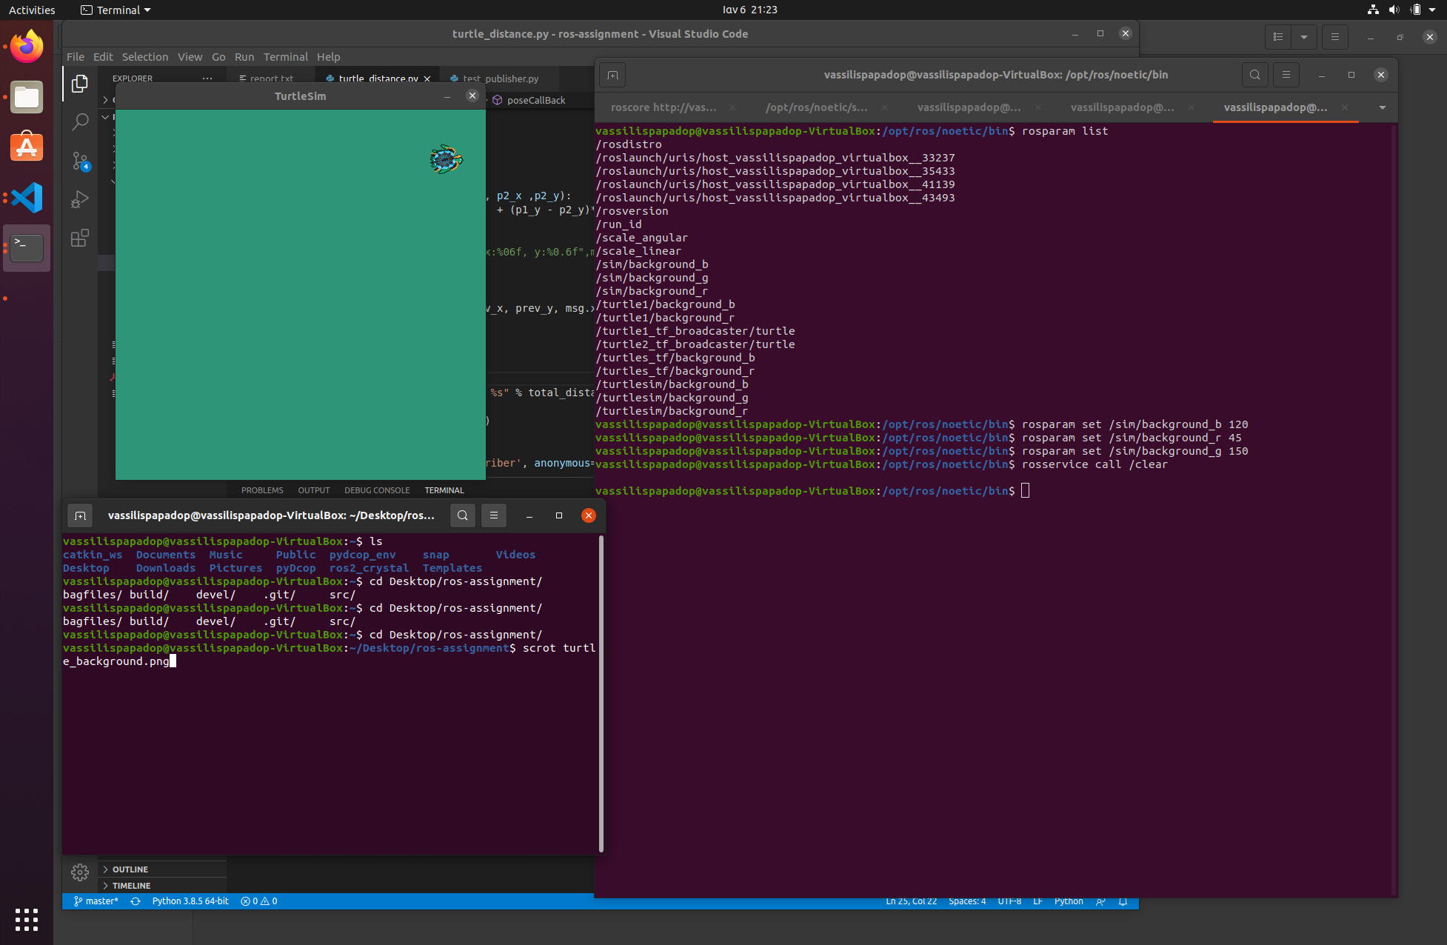

}

## Inspect tf tree

In order to run tf view_frames command I had to change line 89 in ***/opt/ros/noetic/lib/view_frames*** to avoid **TypeError: cannot use a string pattern on a bytes-like object**

line 89 replaced with :

decoded = vstr.decode('utf-8')

m = r.search(decoded)

Distributor ID: Ubuntu

Description: Ubuntu 20.04.1 LTS

Release: 20.04

Codename: focal

{

rosrun tf view_frames

OR

rosrun rqt_tf_tree rqt_tf_tree

#view pdf

evince frames.pdf

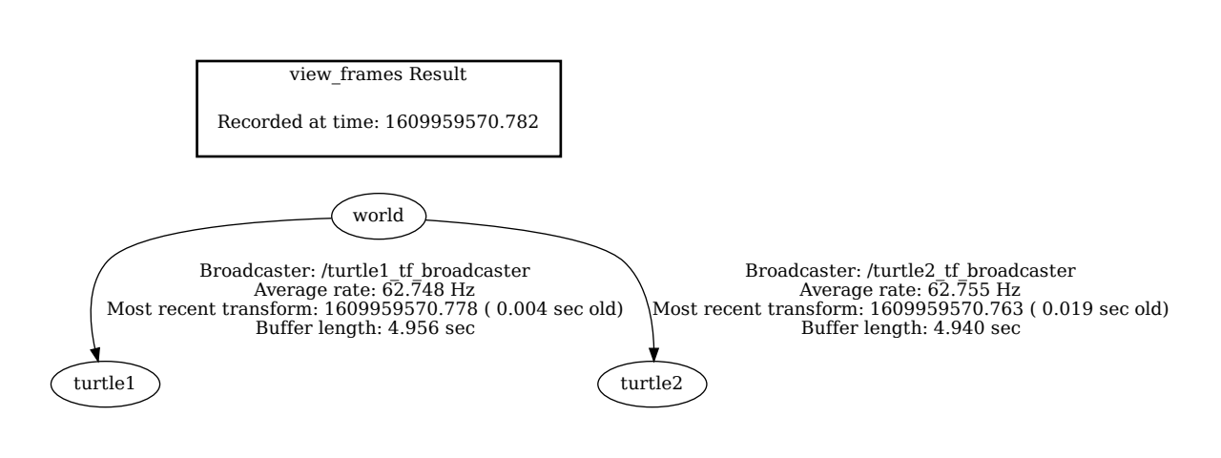

}

## Record/Play playback

{

rosbag record -O subset /turtle1/cmd_vel /turtle1/pose

rosbag play subset.bag

}

## Calculate Distance(subscribe/publish)

import rospy

from turtlesim.msg import Pose

from std_msgs.msg import String

from math import sqrt

from threading import Thread, Lock

prev_x = 0.0

prev_y = 0.0

total_distance = 0.0

# Euclidean distance

def calculate_distance(p1_x, p1_y, p2_x ,p2_y):

return sqrt((p1_x - p2_x) **2 + (p1_y - p2_y)**2)

def poseCallBack(msg, publisher):

#rospy.loginfo("turtle pose: x:%06f, y:%0.6f",msg.x , msg.y)

global prev_x

global prev_y

global total_distance

step = calculate_distance(prev_x, prev_y, msg.x, msg.y)

total_distance += step

prev_x = msg.x

prev_y = msg.y

#publish distance

publish_msg = "Total distance %s" % total_distance

rospy.loginfo(publish_msg)

publisher.publish(publish_msg)

def subscriber():

rospy.init_node('turtle_subscriber', anonymous=True)

publisher = rospy.Publisher('turtle_publisher', String, queue_size=10)

rospy.Subscriber('/turtle1/pose', Pose, poseCallBack, publisher)

rospy.spin()

# print

print('Total travelled distance', total_distance)

if __name__ == '__main__':

subscriber()

## Test publisher

import rospy

from std_msgs.msg import String

def callback(data):

rospy.loginfo(rospy.get_caller_id() + 'received %s', data.data)

def listener():

# In ROS, nodes are uniquely named. If two nodes with the same

# name are launched, the previous one is kicked off. The

# anonymous=True flag means that rospy will choose a unique

# name for our 'listener' node so that multiple listeners can

# run simultaneously.

rospy.init_node('listener', anonymous=True)

rospy.Subscriber('turtle_publisher', String, callback)

# spin() simply keeps python from exiting until this node is stopped

rospy.spin()

if __name__ == '__main__':

listener()