Job-Oriented Programming and Pointers in a Scripting Language

In this article we are going to talk about using job-oriented programming and pointers in a scripting language.

As a scripting language we are going to use CSCS (Customized Scripting in C#). This is an easy and a lightweight open-source language that has been described in previous CODE Magazine articles: https://www.codemag.com/article/1607081 introduced it, https://www.codemag.com/article/1711081 showed how you can use it on top of Xamarin to create cross-platform native mobile apps, and https://www.codemag.com/article/1903081 showed how you can use it for Unity programming. CSCS resembles JavaScript with a few differences, e.g., the variable and function names are case insensitive.

In this article we will be talking about “job-oriented programming” implemented in CSCS.
Every real job, like 'print invoice', 'create offer', 'manage customer data', 'manage products data', 'print accounting list', etc. is a standard job in almost every business or accounting office. Every such a program module is a standalone program, but in any line of code you can 'chain' a part of the code to another program in order to execute another job. When the job is done, you return to the next line of the parent job, the one that executed the ‘chain’ command.

You can also send any parameters to the 'chained-to' program (the child), and return any data from the child program. This way you can 'chain' from one program to another, any level deep.
Don’t worry that children never listen to you; worry that they are always watching you.
-- Robert Fulghum
This gives developers a freedom to work on a program, independently from one another.
To communicate between scripts, it is enough to define parameters that will be used for communication between them. This feature enables making any modifications of the whole application very easy, changing only one module.

All this functionality has been made with only two functions: Chain and Param.
The syntax is simple:

CHAIN programName WITH arguments;

And the chained-to program (the child program) can listen for arguments with:

PARAM parameters;

The arguments can be constants, variables or expressions, or any combination of them. Parameters can be a single variable, an array, or a tuple. From a child program you can access any variable from a previous (parent) program programmatically.
You can also return any value from child to parent programmatically.

In this article we are going to see how to use CHAIN/PARAM scripting commands in a C# project, taking as an example a WPF (Windows Presentation Foundation) project.

In addition to the CHAIN/PARAM functionality we are also going to take a look at how to use pointers in a scripting language.
It’s important to note that usually the main piece of code is in a compiled language (C#). But only a part of the project is done in CSCS scripting. With an obvious benefit: you don’t have to re-compile anything if you change scripting code.

Another benefit of scripting, that we have not discussed in our previous articles, is that you can load scripts, xaml files, and images on the fly from your server. This way you can get a new version of your client without a formal release! We are also going to show how to do this in this article.

Let’s start by looking at definition of a Chain and how Chains can be used in scripting.

Setting Up CSCS Scripting Environment

Probably the simplest way to start using CSCS scripting is to download the source code from GitHub (see https://github.com/vassilych/cscs) and add the source code directly to your C# .NET project. The license lets you modify and use the code without restrictions.

As an example of adding CSCS scripting to a WPF project, take a look at https://github.com/vassilych/cscs_wpf. This is already a preset WPF project with scripting added. There you can also consult the full implementation of the functionality that we are going to see in this article.

Take a look at a previous CODE Magazine article: https://www.codemag.com/Article/2008081. It explains how to use WPF with CSCS scripting.

Once you set up the project structure, we can explore the possibilities of the customized scripting, that we have not explored before.

Using Chains in Scripting

In this section we are going to see a cool feature of starting new scripts from a parent script. Also, we are going to see how to pass parameters between them.

Running Child Scripts in the Same Process Space
A sample code for a simple CHAIN functionality is the following:

CHAIN "D:/scripts/scriptName.cscs";

What this does is just to run the specified script and wait till it finishes.

We can also specify the default scripts folder in the standard C# project appSettings configuration file (.config).
Here is an example:

<add key="ScriptsPath" value="D:/scripts/"/>

In this case you can use the path above with the special tpath() function:

CHAIN tpath()+"scriptName.cscs";

(tpath() is a CSCS function that will return the corresponding "ScriptsPath" path from the config file).
Note that the spaces are not allowed inside of an argument (e.g., in tpath()+"scriptName.cscs") because the spaces are the argument separators (as you will see in examples below).

We can also provide parameters for the chained-to script in a simple way:

CHAIN "scriptName.cscs" WITH arg1 arg2 arg3;

Example:

CHAIN tpath()+"scriptName.cscs" WITH "string1" variable2 userFunction(arg);

Here string1 is a string constant, variable2 can be variable of any type, and it may be even an array variable of any size.
userFunction() can be any user defined function.

Running Child Scripts in a New Process Space
All chained (child) scripts in the previous section will be running in the same process space. If you want to run the script in another process, there is another syntax of the CHAIN command:

CHAIN tpath()+"scriptName.cscs" NEWRUNTIME WITH
"arg1" "arg2" "arg3" "arg4";

In the command above, the NEWRUNTIME keyword tells the interpreter to run the script in another process.
Later on, we will see an example of a script started in a new runtime environment.

Receiving arguments in the Child Script and Passing Them Back to the Parent Script

Consider a child script scriptName.cscs started from the parent’s script CHAIN command in the previous section.
That example contains 4 arguments, passed from the parent, namely strings “arg1”, “arg2”, “arg3”, and “arg4”.
In the chained (child) script, the arguments from the parent script are received as follows:

PARAM(param1, param2, param3, param4);

After running the PARAM command above the chained script will have set its local variables as follows:

param1 = "arg1"; param2 = "arg2";
param3 = "arg3"; param4 = "arg4";

These four variables will be local to the chained script and won’t be known to the parent.

It is also possible a two-way exchange of the parameters between the child and the parent script.
The syntax is as follows:

ResetFiled(scriptName, variableName);

For example:

ResetFiled("scriptName.cscs", "varNameInParent");

After running this command, the chained script will have access to the variable defined in the parent script, with the name “varNameInParent”. Not only is it going to have access to it, but also all of the modifications done to “varNameInParent” will be visible in the parent script as well.

So, using the ResetField() command the child can do both – to have access to all of the variables in the parent script, and also to set any variable in the parent, so that after the child is finished, the parent will have all of its variables modified.

Note that the “varNameInParent” variable doesn’t have to exist – the child can just create it in the parent space and set it to whatever value (including a number, a string, a tuple, etc.).

Hello, World! Example in Chaining

In this section we are going to see an example of chaining scripts using CSCS scripting language in a WPF C# project.
The entry point of the first script to be executed is defined in the project .exe.config configuration file using the “CSCS_Init” key. Here is what we use in our example:

<add key="CSCS_Init"
value="C:/cscs_wpf/scripts/demoMenu.cscs"/>

The full code of the demoMenu.cscs is shown in Listing 1.
Note that the first thing that the script does, is to create a new WPF window:

CreateWindow(tpath() + "demoMenuWindow.xaml");

The full code of the demoMenuWindow.xaml file is shown in Listing 2.
As you can see this is a typical xaml file used in any WPF project. Basically, it just creates a WebView based on the https://github.com/vassilych/cscs website and a simple menu.

This entry window is shown in Figure 1:

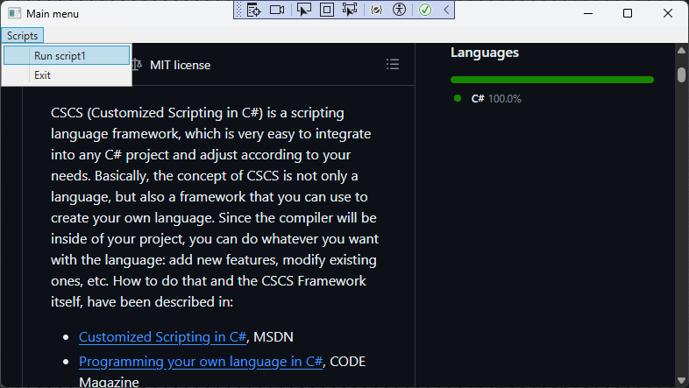
Figure 1: The entry Window after starting a sample project.

At the next step, choose “Run script1” menu entry. The demoMenu.cscs initializes the menus as follows:

function demoMenuWindow_OnDisplay() {
AddMenuItem("mainMenuDC", "ScriptsDC", "Scripts");
AddMenuItem("ScriptsDC", "demoScript1.cscs",
"Run script1", "runScript");
AddMenuItem("ScriptsDC", "exit", "Exit",
"runScript");
}

AddMenuItem() is an auxiliary CSCS function that adds an entry to a particular menu.
Here is the CSCS definition of the RunScript function that it is using:

function runScript(sender, load) {
if (sender == "exit") {
exit;
}

// execute a script from the sender.
CHAIN tpath()+strTrim(sender);
}

Once the user clicks “Run Script1” menu option, the demoScript1.cscs will be triggered (see Listing 3).
That script will create a new window (see Listing 4.). That window is shown in Figure 2.

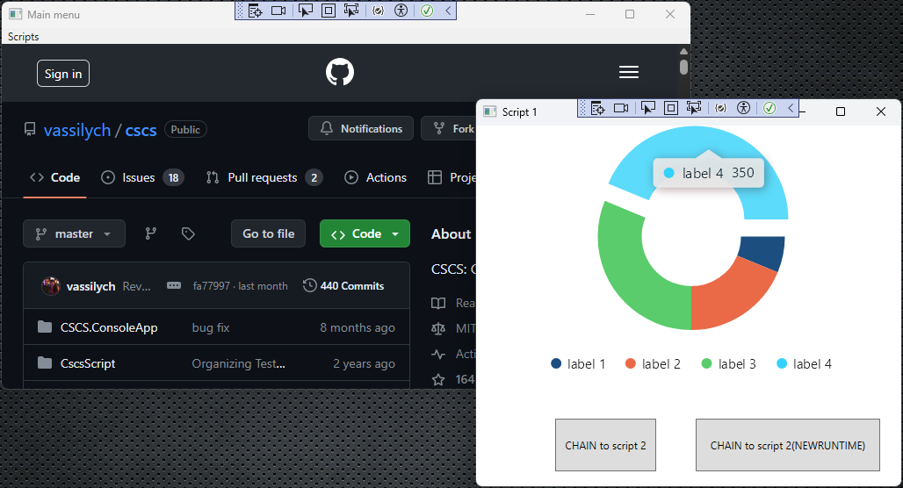
Figure 2: The result of clicking Run Script1 menu

Here we have two buttons, both of them will trigger the execution of the demosScript2.cscs script (see Listing 5).
The left button will trigger it in the same process and the right one in a new process space.
In any case, as you can see from the Listing 5, the first thing the script does is to create a new window, demoScript2.xaml (see Listing 6).

The new window, created after the chaining, is shown in Figure 3.

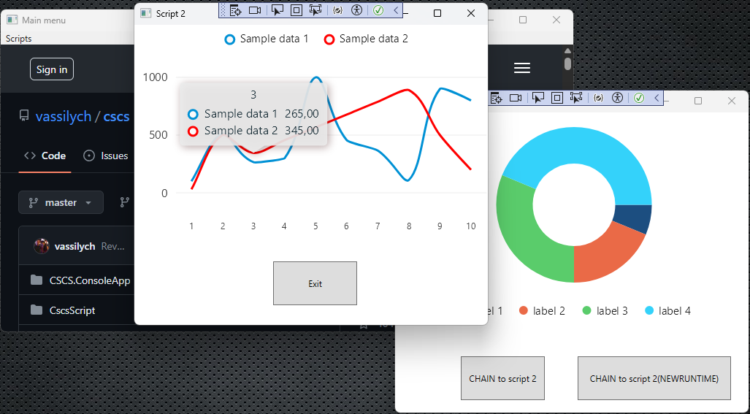
Figure 3: The chained script (the child)

Both windows (in Figure 2 and in Figure 3) show some graphics.
These graphics are parts of the LiveCharts (https://v0.lvcharts.com), an MIT license package that can used as a NuGet package.
You can check out how you can create cool graphics from this package in Listing 3 (Pie Chart) and Listing 5 (Normal line chart)).

Downloading Resources From the Internet
In this section we are going to see how to get the resources (all text, .cscs, .xaml files, and any images) from the internet.
The CSCS function to access a file, located somewhere on the internet, is the following:

Download(fullFilename);

Note that the webserver where you store your files for downloading, must be configured to treat .xaml and .cscs files as text files.
Usually this is already done by default for the .xaml files.

The webserver, where you store files for downloading, must be configured to treat .cscs files as text files.

For the .cscs files you should change the MIME types on the IIS Manager page, as shown in Figure 4.
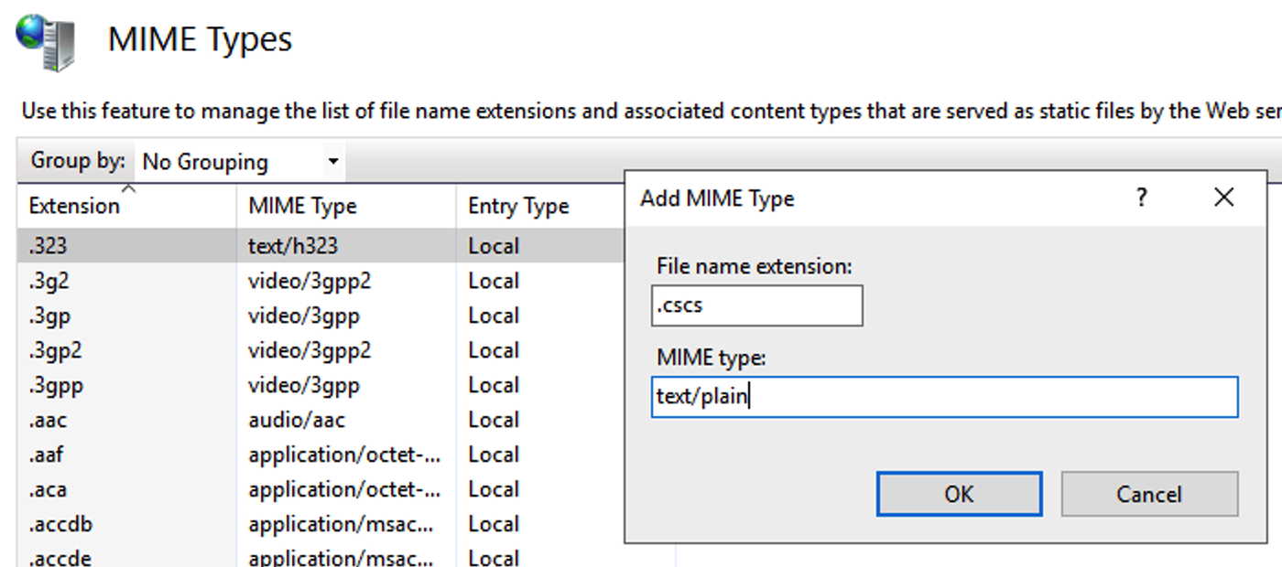
Figure 4: Changing MIME types on the server IIS Manager

After setting up your webserver for downloading the .cscs fies, you can access them as follows:

newXamlFile = Download(
"http://185.32.126.169/shared/
winWithButtons.xaml");

You can also do the CHAINing, that we explored in the previous section, using scripts from the internet:

CHAIN Download(
"http://185.32.126.169/shared/script5.cscs");

This statement means that script5.cscs will be downloaded from an internet location and will be immediately started with just one line of code!

Alternatively, you can download the version of your program and then, if it is not up to date, you can download a new version of the CSCS and /or the xaml files.
Below is a simple pseudo-example how to do it in CSCS:

v = Download(
"http://185.32.126.169/shared/version.txt");
lines = readfile(v);
version = lines[0];
if (myVersion < version) {
newScriptFile = Download(
"http://185.32.126.169/shared/script5.cscs");
copy(newScriptFile, programScriptsDir);
newXamlFile = Download(
"http://185.32.126.169/shared/win5.xaml");
copy(newXamlFile, programXamlDir);
}

In the same way you can download images or any other files as well.

Introduction to Pointers in Scripting
Another nice feature that we’d like to introduce in CSCS scripting language, is pointers.
They work and look similar to the C/C++ pointers (but not the same though: to dereference a pointer, e.g., to access the value of a variable that it points to, we use “&” instead of “*”). An important difference is that you don’t have to explicitly allocate and delete the memory where your pointer points to.

Basically, after a pointer is defined and initialized to point to a variable, as soon as you change the value of a pointer, the value of a variable, to which it points to, will be changed as well. Also, if you change the value of a variable, the pointer value will be changed as well.

Here is an example from Listing 5:

// A pointer must be first defined with
// a DEFINE keyword
DEFINE aPointer type f;

aPointer -> var1;
// aPointer points now to a variable var1

var1 = 100;
// Now the value of &aPointer will be 100
&aPointer = 200;
// Now the value of var1 will be 200

Wrapping Up

In this article we saw how one can use Chains in a scripting language.
It is possible to use script chaining to any level deep, i.e., you can script from the MainMenu script to script1 then from script1 to script2, and so on.

When you quit any script (using the Quit command) the script execution will proceed from the next line after the Chain command in the previous (parent) script.
Such a way will enable even huge application to be split into many isolated scripts. This is a great advantage for developers as they can independently develop a script without conflicting with scripts from other developers.
In addition, updating any application may be very easy with simple change of a single script and not of the whole application

We’re looking forward to your feedback: specifically, your experience in scripting with Chains and Downloading scripts from internet. Also, we will be excited to hear what other features in CSCS you would like to see.

References

CSCS Repository:
https://github.com/vassilych/cscs

CSCS WPF Repository:
https://github.com/vassilych/cscs_wpf

CSCS Visual Studio Code Debugger Extension:
https://marketplace.visualstudio.com/items?itemName=vassilik.cscs-debugger

Nevio Medančić
nevio@aurasoft.hr

Bio of Nevio.

Enzo Grubiša
enzo@aurasoft.hr

Bio of Enzo.

Vassili Kaplan
VassiliK@gmail.com

Vassili was a Microsoft Lync developer between 2008 and 2011.
He also worked on the Microsoft Maquette Mixed Reality Prototyping tool between 2018 and 2020. During that time, he adapted CSCS scripting language to Microsoft Maquette.

Vassili has a Masters in Applied Mathematics with Specialization in Computer Science from Purdue University, West Lafayette, Indiana and a Bachelor in Applied Mathematics from ITAM, Mexico City.

Vassili currently lives in Zurich, Switzerland. His hobbies are traveling, biking, badminton, and enjoying a glass of a good red wine.

Listing 1: demoMenu.cscs : Main Menu Script
// Create main menu window;
// tpath gets the location of the scripts folder
CreateWindow(tpath()+"demoMenuWindow.xaml");

define mainMenuDC type a;

function demoMenuWindow_OnDisplay(){
AddMenuItem("mainMenuDC", "ScriptsDC", "Scripts");
AddMenuItem("ScriptsDC", "demoScript1.cscs",
"Run script1", "runScript");
AddMenuItem("ScriptsDC", "exit",
"Exit", "runScript");
}

// function for starting scripts from main menu
function runScript(sender, load){
if(sender == "exit"){
// exits the exe program
exit;
}
CHAIN strTrim(tpath())+strTrim(sender);
}

Listing 2: demoMenuWindow.xaml: Main Menu Window
<Window xmlns=
"http://schemas.microsoft.com/winfx/2006/xaml/
presentation"
xmlns:x=
"http://schemas.microsoft.com/winfx/2006/xaml"
xmlns:d=
"http://schemas.microsoft.com/expression/blend/2008"
xmlns:mc=
"http://schemas.openxmlformats.org/
markup-compatibility/2006"
xmlns:local="clr-namespace:WpfCSCS"
xmlns:WPF=
"clr-namespace:Microsoft.Web.WebView2.Wpf;
assembly=Microsoft.Web.WebView2.Wpf"
mc:Ignorable="d"
Title="Main menu" Height="450" Width="800"
WindowStartupLocation="CenterScreen">
<Grid>
<Grid.RowDefinitions>
<RowDefinition Height="auto" />
<RowDefinition Height="*" />
</Grid.RowDefinitions>
<WPF:WebView2 Grid.Row="1"
x:Name="WebView1"
Margin="0,0,0,0"
Source= "https://github.com/vassilych/cscs" />
<Menu Grid.Row="0"
DataContext="mainMenuDC"
Name="mainMenuDC" />
</Grid>
</Window>

Listing 3: demoScript1.cscs: First Script triggered from the Menu
CreateWindow(tpath()+"demoScript1.xaml");

function demoScript1_onDisplay(){
PieChart("dougnutChart1", "init");
PieChart("dougnutChart1", "values", 50,
"label 1", 50);
PieChart("dougnutChart1", "values", 150,
"label 2", 50);
PieChart("dougnutChart1", "values", 250,
"label 3", 50);
PieChart("dougnutChart1", "values", 350,
"label 4", 50);
PieChart("dougnutChart1", "colors",
{ "#1C4E80", "#EA6A47", "#5acc6b", "#34d2fa" });
}

// button clicked event, starts a new script and
// sends parameters("Hello" - constant
// and var1 - variable)
function button1@clicked(){
var1 = " World!";
CHAIN strTrim(tpath())+"demoScript2.cscs"
WITH "Hello" var1;
}

// Same as function above but starts a script in
// a new process
function button2@clicked(){
var1 = " World!(NEWRUNTIME)";
CHAIN strTrim(tpath())+"demoScript2.cscs"
NEWRUNTIME WITH "Hello" var1;
}

Listing 4: demoScript1.xaml: Window of Script1
<Window xmlns=
"http://schemas.microsoft.com/winfx/2006/xaml/
presentation"
xmlns:x=
"http://schemas.microsoft.com/winfx/2006/xaml"
xmlns:d=
"http://schemas.microsoft.com/expression/blend/2008"
xmlns:mc=
"http://schemas.openxmlformats.org/
markup-compatibility/2006"
xmlns:local="clr-namespace:WpfCSCS"
xmlns:lvc="clr-
namespace:LiveChartsCore.SkiaSharpView.WPF;
assembly=LiveChartsCore.SkiaSharpView.WPF"
mc:Ignorable="d"
Title="Script 1" Height="450" Width="500"
WindowStartupLocation="CenterScreen">
<Grid>
<lvc:PieChart LegendPosition="Bottom"
Name="dougnutChart1"
VerticalAlignment="Top"
HorizontalAlignment="Left"
Width="490"
Height="289"
FontSize="10"
Margin="0,0,0,0" />
<Button Name="button1"
Content="CHAIN to script 2"
HorizontalAlignment="Left"
Margin="90,334,0,0"
VerticalAlignment="Top"
Height="60"
Width="115" />
<Button x:Name="button2"
Content="CHAIN to script 2(NEWRUNTIME)"
HorizontalAlignment="Left"
Margin="250,334,0,0"
VerticalAlignment="Top"
Height="60"
Width="210" />
</Grid>
</Window>

Listing 5: demoScript2.cscs: script triggered by demoScript1.cscs
CreateWindow(tpath()+"demoScript2.xaml");

DEFINE aPointer type f; // pointer type
DEFINE var1 type i size 10; // integer variable

function demoScript2_onInit() {
// PARAM will recieve parameters sent from
// the previous script.
// They will be named arg1 and arg2 in this script
PARAM(arg1,arg2);
// Show arguments
MessageBox(arg1 + arg2);

// aPointer points to var1
aPointer -> var1;

var1 = 100;
MessageBox("var1 = " + var1 + ",
&aPointer = " + &aPointer);
&aPointer = 200;
MessageBox("var1 = " + var1 + ",
&aPointer = " + &aPointer);
}

function demoScript2_onDisplay(){
Chart("LineChart", "init");
// x labels first, with font size of 12 px
Chart("LineChart", "labels","x", 12,
{"1", "2", "3", "4", "5", "6", "7", "8", "9", "10"});
Chart("LineChart", "SeparatorStep", 1);
// set of values for the first line chart
Chart("LineChart", "values", "line",
{100, 512, 265, 300, 1000, 456, 365, 111, 900, 800},
"Sample data 1");
// set of values for the second line chart
Chart("LineChart", "values", "line",
{30, 500, 345, 456, 567, 678, 789, 890, 500, 200},
"Sample data 2");
// define colors of the first and the second line
Chart("LineChart", "Color.Series",
{ "#0091D5", "red"});
}

function exitButton@clicked(){
// exit from the script and return to the
// previous(parent) script
quit;
}

Listing 6: demoScript2xaml: Window of Script2
<Window xmlns=
"http://schemas.microsoft.com/winfx/2006/xaml/
presentation"
xmlns:x=
"http://schemas.microsoft.com/winfx/2006/xaml"
xmlns:d=
"http://schemas.microsoft.com/expression/blend/2008"
xmlns:mc=
"http://schemas.openxmlformats.org/markup-
compatibility/2006"
xmlns:local="clr-namespace:WpfCSCS"
xmlns:lvc=
"clr-namespace:LiveChartsCore.SkiaSharpView.WPF;
assembly=LiveChartsCore.SkiaSharpView.WPF"
mc:Ignorable="d"
Title="Script 2" Height="450" Width="500"
WindowStartupLocation="CenterScreen">
<Grid>
<lvc:CartesianChart LegendPosition="Top"
x:Name="LineChart"
Margin="0"
Height="294"
Width="500"
HorizontalAlignment="Left"
VerticalAlignment="Top" />
<Button Name="exitButton"
Content="Exit"
HorizontalAlignment="Left"
Margin="190,324,0,0"
VerticalAlignment="Top"
Height="60"
Width="115" />
</Grid>
</Window>

