Refactoring Documentation for Project “Cows & Bulls”

**Team "Molybdenum"**

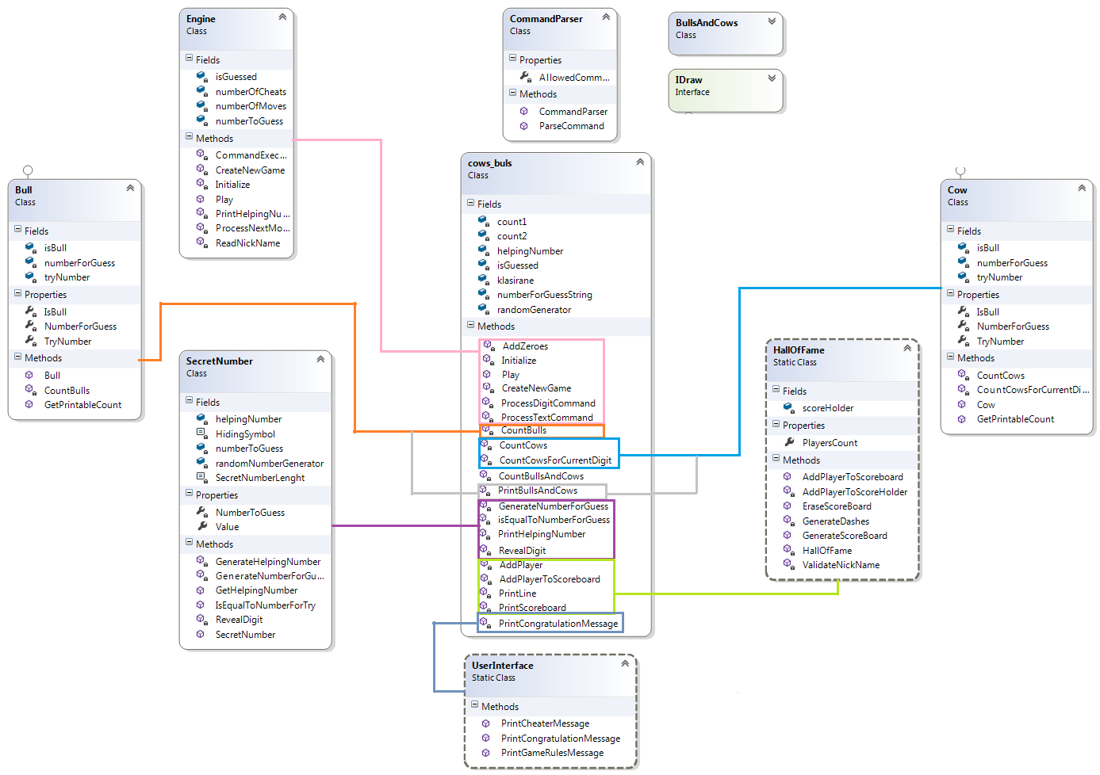

1. Redesigned the project structure:

Project name cows_buls renamed to BullsAndCows.

Project Main class renamed From BullsAndCowsTest to BullsAndCows

Divided the project into separated files, that contains only one class, with name, that describes his purpose. The idea is to create a new classes that were a part of the code of an old big file. The new classes/interfaces are:

* **Bull.cs**
* **CommandParser.cs**
* **Cow.cs**
* **Engine.cs**
* **IDraw.cs**
* **SecretNumber.cs**
* **UserInterface.cs**
* **HallOfFame.cs**
* **SecretNumber.cs**

1. **Reformatted source code:**

Mainly StyleCop standarts are applied for code format and documentation.

Code formatting applied at 100%.

XML documentation presented only for public Methods, properties, fileds and classes. XML comments will be added to private members if those members aren't already obvious from their names.

1. **Class Structurs**

***Bull class***

Counting Bull logic not changed.

Variable manipulation:

numberForGuessString 🡪 numberForGuess

tryNumberString 🡪 tryNumber

bulls 🡪 isBull

***Cow class***

Counting cows logic changed for good. Bug for incorrect cow counting in some special cases fixed was found and fixed.

Variable manipulation:

numberForGuessString 🡪 numberForGuess

tryNumberString 🡪 tryNumber

bulls 🡪 isBull

‘For cycle’ indexers naming changed: I 🡪 nubmerIndex

J 🡪 currNumberIndex

Implemented IDraw interface for both Cow and Bull clases 🡪 Method PrintCowsAndBulls deleted.

***CommandParser class***

This class ‘translate’ the user command for the Engine class.

It has one public method ParseCommand that returns user command to the Engine after reformatting it in readable format for the Engine.

Variables manipulations:

Presented property AllowedCommads holding the commands that Engines can understand.

***Engine class***

Determs the game flow.

Method ProcessTextCommand 🡪 CommandExecution

Method ProcessDigitCommand 🡪 ProcessNextMove

Presented PrintHelpingNumber, ValidateNickName

AddZeroes method deleted. Logic of the secret number(numberToGuess) changed.

Method CountCowsAndBulls deleted for being unessesry.

Variable manipulation:

count1 🡪 numberOfCheats

count2 🡪 numberOfMoves

numberForGuessString 🡪 numberForGuess

tryNumberString 🡪 tryNumber

***HallOfFame class***

Methods for printing messages on the console in are presented in HallOfFame class.

***IDraw interface***

Implemets method GetPrintableCount

***PlayerInfo class***

Not changed.

***SecretNumber class***

Method GenrateNumberForGuess logic changed.

Presented methods: GenerateHelpingNumber,GetHelpingNumber

Variables manipulation:

bool flag 🡪 bool isRevealed

numberForGuessString 🡪 numberForGuess

Presented constants:

HidingSymbol

SecretNumberLenght