1. **Abstract :**

The main purpose of the food ordering management system is to use it in the food –services industry .This features helps hotels an restaurants to increase their online food ordering system .Customer can choose from wide range of food menu items within just few minutes . In todays modern food business it’s food ordering management system simplifies the ordering process . The proposed solution presents a user interface and changes the menu to include all available options, creating customer work easier . Allows customer to order any item that they like and adjust the quantity of food items .The order confirmation is displayed to the customer homepage of the website . The order is put to the queue , updated across both the databases and the admin panel and provide in real time .This system aids staff with cheking over orders in real time and executing them

effectively and easily with few errors.

1. **Introduction :**

The food industry is highly labour intensive and the biggest expense in the food industry is the cost of employing the right kind of people to do the work. Labour rates are steady rising year in and year out , making it difficult to hire labour. One of the ways to reduce this expense is to use modern technology to replace some of the jobs done by human beings and make machine do the work. Here we purpose an “Online Food Ordering System”. Online food real-time ordering system’s objective is to give customer a way to order food over internet .The primary reason for all this is because it is beneficial to both the client and vendor

1. **Literature Review :**

In food delivery business Service Encounter does not happen frequently because in online food ordering and delivery business there is no direct interaction with restaurants. Consumers usually rely on information updated on restaurant search engine portals. Customer make their choices, perception by reading quality given by critics and seasoned customers. Sometime phone encounters happen, but that happens between foodordering & delivery Service Company and customer.

1. **Methodology:**

In the restaurant industry, an online ordering system is a software that allows a restaurant to accept and manage orders sent through the internet. Customer orders are received and processed by the restaurant through an administrative interface, which is typically comprised of two components: a website or app that allows customers to view the menu and place an order, and an administrative interface that allows the restaurant to receive and process customer orders.The following are some of the steps that are taken to complete this online ordering portal:

**A. Requirement Analysis**

In this step, the features and requirements were gathered, analyzed, refined, and scrutinized. The following three steps were undertaken in requirement analysis:

1. **Zero level Data Flow Diagram (0 Level DFD):** A zero-level DFD or context diagram is a simple model that helps us identify and define the interfaces and boundaries of the external world with the system that is proposed. It can be used to identify the entities that are outside the system proposed that in any manner interacts with the system. Figure 1 is a zero-level DFD for the portal.

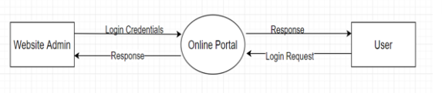DFD 0

1. **Modeling the Requirements:**After the modeling of zero level DFD, we constructed models that include level-1, level-2 DFD, and Entity-relationship diagrams to help find missing, incorrect, superfluous, and inconsistent requirements. Figure 2 represents level-1 DFD.

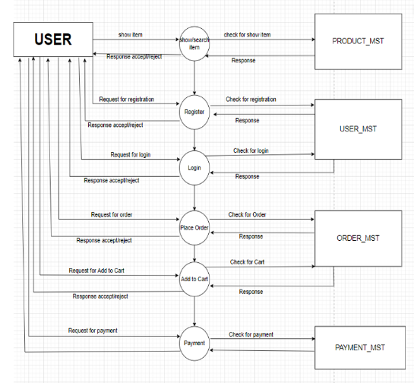

DFD 1

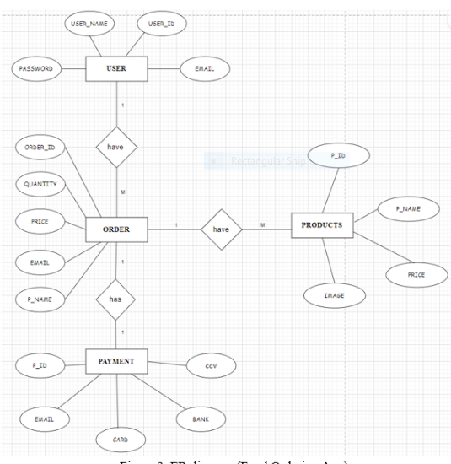

ER DIAGRAM

1. . **Finalizing the Requirement*s:***

 After having a better understanding of the system and its behavior and after resolving the ambiguities and inconsistencies, we finalize the requirements. The entity-relationship diagram of the proposed work is shown in Figure 3 which shows various entities involved and their attributes

**B.Product Description- Mobile Food Ordering System**

The Mobile Food Ordering System is available on the web as well as on the Android and iOS platforms as an application that allows customers to place food orders on the go. It is developed with a variety of features for users, such as the location of the nearest available restaurant and thorough menus for ordering food quickly and easily. It also has a feature that allows you to phone nearby restaurants. The suggested system is divided into two primary sections: one for administration and another for customers. The customer feature is comprised of a profile section that contains information about orders, ratings, favorite orders, delivery options, settings, and other features, as well as other sections. Business Management, Analytics & Report Generation, Customer Relationship Management, and Supervise the Action are the features that are required for the administration sector. When a consumer orders any type of food, all of the information related to the order will be kept in a database. After placing an order, a confirmation message will be provided to the customer, along with an option to track your order, indicating that your transaction has been successfully placed..

**1. Main Interface***:* This is the landing page of the portal and the website. This is a homepage where the users can access various resources and have access to various functionalities. Figure 4 showcases the main interface and the landing page.

**2. Register and Login:** First, if anyone wants to use our website to order food they have to register first then they can login to order anything they want and use all the other functionalities provided by application. Figure 5 shows the GUI of the register and login page.

1. **System Design:**

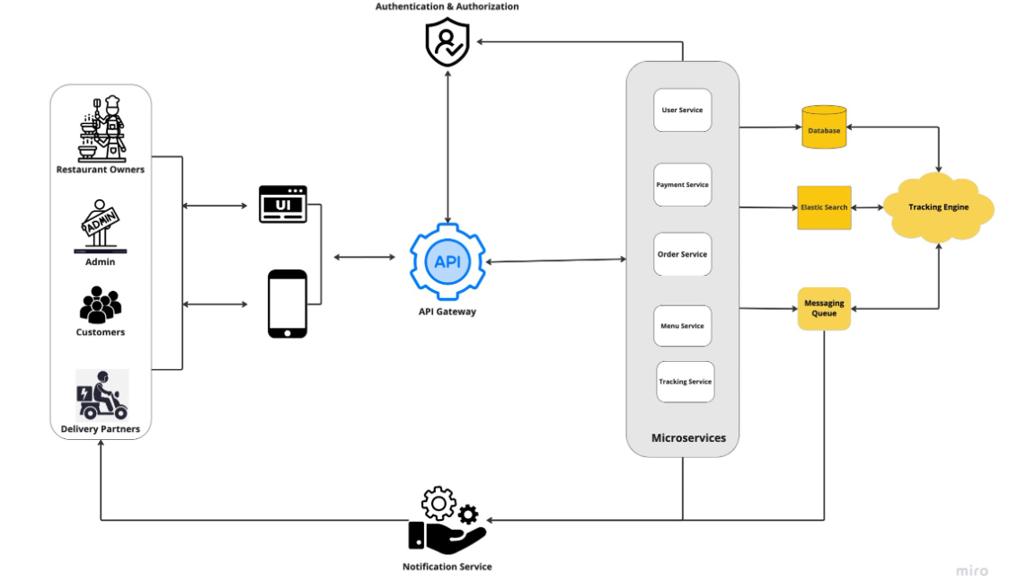

1. **Implementation :**

Online food ordering system is fast becoming a popular method to serve customers better, generate more revenue and enhance a restaurant’s growth. Online ordering systems enables a restaurant to offer its customers the convenience of ordering food online through the restaurant app or website and getting it delivered wherever they want. Apart from offering this convenience the customers, your restaurant can also reap many other benefits from having an online food ordering system. Below are 8 reasons why having an online ordering system can help your restaurant growth.

**Improved order accuracy**

An online ordering system eliminates many problems that can happen in conventional call-in-orders. Bad connections, background disturbances, mix-ups due to miscommunications, incorrect delivery orders, etc, are some of the things which can be avoided with an online ordering system thus enabling better customer ordering experience resulting in repeat sales.

**Smooth management of orders**

With an online ordering system, a restaurant can manage online, takeaway, dine-in and phone-in orders all through one system. Since all the processes are aligned, everything can be managed easily without wasting valuable time.

**Enhances your restaurant’s digital presence**

An online food ordering system is a cost-effective way to reach out to a larger audience base, providing you with digital accessibility that can play a huge role in your business success. With a digital presence, you not only have an edge over your competition, but you can also reach out to a wider base of potential clients.

**Increased employee productivity**

An online ordering system when properly implemented streamlines all processes thus helping employees perform other key services effectively and achieve a better output.

**Helps in building up a customer database**

When your customer’s orders online through your ordering service, their information is stored in the Point of Sales (POS) every time they order. The data collected can be used to build a database that can be used for personalized campaigns to boost sales.

**Data analytics**

Analysis of the customer information data collected through the POS can help understand customer behaviour better thus helping to actively respond to your customer’s requirements, optimize services and gain a competitive advantage.

**Facilitates up-selling**

An online ordering system can be customized to influence your customers to order more or order more expensive items from the menu thus helping to generate more revenue.

**Maximizes restaurant efficiency**

Implementing an online ordering system makes it possible to deliver food to customers easier, faster, accurately and in accordance to their tastes and buying habits, thus helping to provide a great customer experience that will keep bringing in customers and boost sales.

If you are a restaurant owner looking to enhance your brand presence, increase sales and provide better customer experience, then look no further. Takeaway Max, one of the best food online ordering systems in the UK can help boost sales, streamline operations and help your business grow profitably.

Get in touch with us today to outfit your restaurant with an affordable online food ordering system that works best for your business.

1. **Testing and Evaluation :**

**Test Cases For Online Food Ordering System :**

In this article, we will discuss about the test Cases for food ordering system. Nowadays, online food applications are most popular. so, we have tried to cover maximum test Cases for online food ordering application like Swiggy or Zomato. We have mentioned the test cases for login screen, home screen, search functionality for food items or restaurants, ordering page, order preparation page and order summary page.

1. Verify that user is able to search online food ordering application name from the store or not.
2. Verify that application should view webpage without any error.
3. Verify that user should be able to access the application without any error or not.

**Test Cases For Login Screen**

1. Verify that when user open online food ordering application then it should be asked for the user’s location.
2. Verify that user is able to login in the application without registration or not.
3. Verify that user is able to sign up or login with mobile number or not.
4. Verify that user is able to sign up or login with email address or not.
5. Verify that user is able to redirect on home page screen without login or not.
6. Verify that logo of the online food ordering application on the login screen.
7. Verify that application name is displayed on the login page or not.
8. Verify that user is able to login with invalid credentials or not.
9. Verify that user is able to skip login screen or not.
10. Verify that links on the login page should be working properly or not.

**Test Cases For Home Screen Without Logged In**

1. Verify that user’s current location should be displayed on the home screen of the online food ordering application.
2. Verify that search field box should be displayed properly or not.
3. Verify that filters buttons should be displayed properly or not.
4. Verify that filters buttons should be clickable on the home screen.
5. Verify that if any sliding bar is available then it should be working properly.
6. Verify that all images should be displayed as per specification or not in the sliding bar.
7. Verify that all top brands restaurant names should be displayed or not.
8. Verify that all restaurants should be displayed within the range or not.
9. Verify that food categories are displayed properly or not on the application.

Verify that log of the branded restaurants is displayed properly or not.

**Home Screen with Logged In Test Cases**

1. Verify that user is able to access all the modules of the application.
2. Verify that user is able to access profile page of the application.
3. Verify that user is able to make online food order.
4. Verify that user is able to edit and update profile page or not.

Verify that user has all access to application with logged in mode.

1. **Result and Disussion :**

The final output is a complete web based Restaurant Management System, which can be used in any kind of restaurant. This Restaurant Management System can help to manage the Restaurant more effectively, efficiently and smoothly. This is more secured and there will be speedy and well ordered authentication procedure for the maintenance of records. At present time, in this technology based world, people likes and wants everything to be smooth and efficient through the use of data and information. In this perspective, our Restaurant Management System can be an ideal platform for the users. Its user friendly interface can help the customers to find his/her desired menu item and place order with a few click. Customers can easily place an online order by browsing the menu options, pick what they want sitting at home. And can also receive their food in a short period of time.

1. **Conclusion :**

Finally , an online food ordering system is presented that may be used in small family run eateries as well as location such as college canteens ,etc. This project has the potential to be scaled up in the future. It is designed for restaurants to help them to reduce their everyday management operational tasks while also improving their customer’s eating satisfaction .By offering relative quality services ,restaurants operators may also build strong customer connections. The technology also allows the restaurant to see what food are on sale in real modifications to their food beverage inventory depending on orders submitted and orders processed.

1. **References:**
2. PHP THE BEGINNERS GUIDE by author ‘Vikram Vaswani’.
3. W3 schools.