Column-Family Data Stores: Concept, Architecture, and Characteristics

1. Introduction
A column-family data store is a type of NoSQL database that organizes data into rows and columns. Unlike a traditional relational database, it allows different rows to contain different columns.
Column-family databases are designed to handle:
- Large volumes of data.
- Distributed storage across multiple servers.
- High-speed read and write operations.
- Horizontal scaling.
- Flexible and non-uniform data structures.
Examples:
- Apache Cassandra
- Apache HBase
- Hypertable
- Amazon DynamoDB (column-family concepts are related to some distributed NoSQL designs, but DynamoDB is primarily a key-value and document database).

2. Concept of Column-Family Data Stores
A column-family data store organizes information using the following elements:
- Column
- Row
- Column Family
- Super Column
- Keyspace

2.1 Column
A column is the basic storage unit. It generally contains:
- Column name
- Column value
- Timestamp
Example:
Column Name | Value | Timestamp
Name | Ravi | T1
Age | 21 | T2
Course | CSM | T3
The timestamp helps manage data updates, resolve conflicts, and identify older data.

2.2 Row
A row is a collection of columns associated with a unique row key.
Example:
Row Key: Student101

Name = Ravi
Age = 21
Course = CSM
Each row can contain different columns.
Row Key: Student102

Name = Sita
Department = AIML
Here, both rows do not need to contain the same columns.

2.3 Column Family
A column family is a collection of related rows.
Student Column Family

Student101 → Name, Age, Course
Student102 → Name, Department
Student103 → Name, Age, Email
Column families group related data and are designed according to the application's query requirements.

2.4 Super Column
A super column contains a collection of columns and can be used to organize related groups of information.
For example, customer information may be organized into groups such as:
Customer101
├── Personal Information
│ ├── Name
│ └── Age
└── Contact Information
├── Email
└── Phone
Super column structures are part of the traditional column-family model.

2.5 Keyspace
A keyspace is a logical container for related column families. It is similar to a database in a relational database management system.
Relational Database | Column-Family Database
Database | Keyspace
Table | Column family
Row | Row
Column | Column

3. Architecture of Column-Family Data Stores
Column-family databases are generally designed using a distributed, peer-to-peer architecture.

3.1 Distributed Architecture
Data is distributed across multiple servers called nodes.
Application
|
-----------------------
| | |
Node 1 Node 2 Node 3
| | |
Data A Data B Data C
Each node stores a portion of the data. Depending on the replication configuration, copies of data may also be stored on other nodes.

Advantages
- Data is distributed across servers.
- Storage capacity can be increased by adding nodes.
- Failure of one node does not necessarily stop the entire system.
- Large workloads can be handled across multiple machines.

3.2 Peer-to-Peer Architecture in Cassandra
Cassandra uses a peer-to-peer architecture.
In this architecture:
- There is no single master node.
- Any node can accept read or write requests.
- Nodes communicate with each other.
- Data is distributed across the cluster.
- Replicas can be maintained on multiple nodes.
Node 1 -------- Node 2
| \ / |
| \ / |
| \ / |
Node 3 -------- Node 4
This architecture reduces dependence on a single central server.

3.3 Data Replication
Replication means maintaining copies of data on multiple nodes.
For example, if the replication factor is 3, three copies of the data are maintained.
Original Data
|
--------------------
| | |
Node 1 Node 2 Node 3
Copy 1 Copy 2 Copy 3

Benefits
- Improved data availability.
- Better fault tolerance.
- Reduced risk of data loss.
- Support for distributed read operations.

3.4 Write Architecture
In Cassandra, data is generally written through the following stages:
Client
|
v
Commit Log
|
v
Memtable
|
v
SSTable
|
v
Compaction

Explanation
- Commit Log: The write is recorded for recovery.
- Memtable: The data is stored in an in-memory structure.
- SSTable: Data is periodically written to disk.
- Compaction: Multiple files are merged, and unnecessary data is removed.
This process supports efficient write operations and data management.

4. Characteristics of Column-Family Data Stores

4.1 Flexible Data Structure
Rows do not need to contain identical columns.
Row 1 → Name, Age, Email
Row 2 → Name, Department
Row 3 → Name, Phone, Address
This flexibility is useful when different records contain different attributes.

4.2 Horizontal Scaling
Horizontal scaling means increasing system capacity by adding more servers or nodes.
Initial Cluster:
Node 1 + Node 2

Expanded Cluster:
Node 1 + Node 2 + Node 3 + Node 4
It allows the database to manage increasing amounts of data and workload.

4.3 High Availability
Column-family databases can continue operating even when some nodes fail, depending on replication and consistency settings.
Cassandra does not depend on a single master node for all operations, which supports availability in distributed environments.

4.4 Distributed Data Storage
Data is divided and distributed across multiple nodes. This enables the database to manage large datasets across a cluster rather than relying on one server.

4.5 Configurable Consistency
Cassandra provides different consistency levels, including:
- ONE: A response from one replica is sufficient.
- QUORUM: A majority of replicas must respond.
- ALL: All replicas must respond.
The choice affects the balance between availability, speed, and consistency.

4.6 Replication Support
Replication factor determines how many copies of data are maintained.
For example:
Replication Factor = 3
This means that three replicas of the data are maintained within the configured replication arrangement.

4.7 Fast Read and Write Operations
Column-family stores are designed for efficient operations on known access patterns. They commonly optimize data organization based on how applications retrieve information.
However, they may not provide the same rich querying capabilities as relational databases.

4.8 Query-Based Data Modeling
The structure of a column family is usually designed according to the queries the application needs to perform.
For example, an event logging application may organize data using:
Row Key: ApplicationName:Timestamp
This arrangement supports efficient retrieval of events associated with an application and time period.

4.9 Limited Transaction Support
Column-family databases generally do not provide traditional multi-operation ACID transactions in the same way as relational databases.
Cassandra supports atomicity at the row level, but applications requiring complex multi-row transactions may need additional solutions.

4.10 Support for Special Applications
Column-family databases are suitable for applications such as:
- Event logging: Storing application events and activity records.
- Content management systems: Managing posts, tags, categories, and comments.
- Counters: Tracking counts such as page views or likes.
- Expiring data: Storing temporary data using time-to-live (TTL) values.

5. Advantages and Limitations
Advantages | Limitations
Flexible data structure | Limited complex query support
Horizontal scalability | Not ideal for complex joins
Distributed storage | Query patterns influence design
High availability | Traditional transactions are limited
Replication support | Aggregation may require client-side processing
Efficient read/write operations | Schema redesign may be needed when queries change

6. Summary
A column-family data store is a distributed NoSQL database model that organizes data into rows containing flexible sets of columns. Its architecture commonly uses multiple nodes, replication, and horizontal scaling.
Its major characteristics include:
- Flexible rows and columns.
- Distributed architecture.
- Peer-to-peer operation in Cassandra.
- Replication and configurable consistency.
- Horizontal scalability.
- Query-oriented data modeling.
- Support for high-volume applications such as logging, counters, and content management.
Conclusion: Column-family data stores are useful for large-scale distributed applications that require flexible data structures, scalability, and efficient access to predefined query patterns.
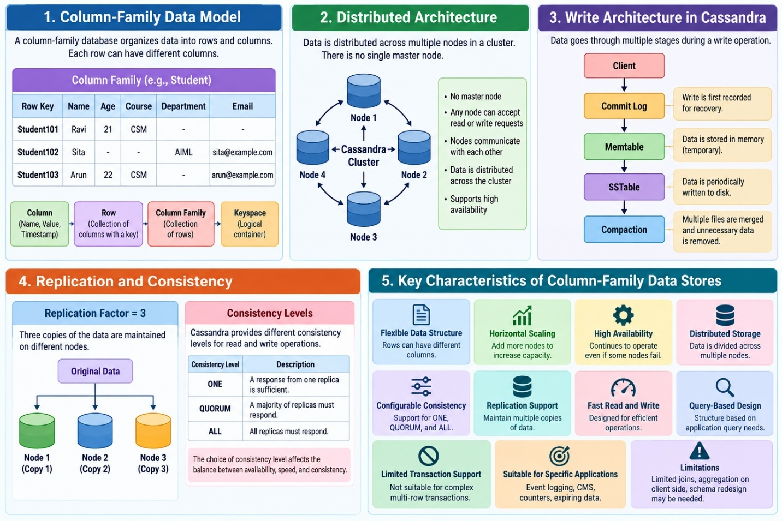

2

Structure of Columns, Rows, Column Families, Super Columns, and Keyspaces
A column-family data store organizes data using columns, rows, column families, super columns, and keyspaces. These structures provide a flexible way to store related data in distributed NoSQL databases such as Cassandra.

1. Column
A column is the basic storage unit in Cassandra. It consists of a name-value pair, and the name also acts as the key. Each column is stored with a timestamp.

Structure of a Column
Column
├── Name
├── Value
└── Timestamp

Example
{
"name": "fullName",
"value": "Martin Fowler",
"timestamp": 12345667890
}
Component | Description
Name | Identifies the column
Value | Stores the actual data
Timestamp | Records the time associated with the data

Importance of Timestamp
The timestamp is used to:
- Expire data.
- Resolve write conflicts.
- Handle stale data.
- Support data management during compaction.
Unused column data can later be reclaimed during the compaction process.

2. Row
A row is a collection of columns associated with a unique key. The key identifies the row, and the row contains the information stored in its columns.

Structure of a Row
Row Key: pramod-sadalage
├── firstName : Pramod
├── lastName : Sadalage
└── lastVisit : 2012/12/12

Example of Two Rows
Row Key: pramod-sadalage
├── firstName : Pramod
├── lastName : Sadalage
└── lastVisit : 2012/12/12

Row Key: martin-fowler
├── firstName : Martin
├── lastName : Fowler
└── location : Boston

Important Characteristics
- Each row has a unique row key.
- A row contains multiple columns.
- Different rows can have different columns.
- New columns can be added to one row without adding them to every other row.
This flexibility is a major difference from the fixed-column structure commonly used in relational tables.

3. Column Family
A column family is a collection of related rows. When the columns in a column family are simple columns, it is called a standard column family.

Structure
Column Family
├── Row 1
│ ├── Column 1
│ ├── Column 2
│ └── Column 3
│
├── Row 2
│ ├── Column 1
│ ├── Column 2
│ └── Column 3
│
└── Row 3
├── Column 1
└── Column 2

Example: Customer Column Family
{
"pramod-sadalage": {
"firstName": "Pramod",
"lastName": "Sadalage",
"lastVisit": "2012/12/12"
},

"martin-fowler": {
"firstName": "Martin",
"lastName": "Fowler",
"location": "Boston"
}
}
In this example:
- pramod-sadalage and martin-fowler are row keys.
- Each key is associated with a collection of columns.
- Both rows belong to the same column family.
- The rows contain different columns.

Column Family and Relational Table
Relational Database | Column-Family Store
Table | Column family
Primary key | Row key
Record | Row
Attribute | Column
A column family can be compared with a table, but its rows do not have to contain the same columns.

4. Super Column
A super column is a column whose value is a map of other columns. It can be understood as a container that groups multiple related columns.

Structure
Super Column
├── Name
└── Value
├── Column 1
├── Column 2
└── Column 3

Example
{
"name": "book:978-0767905923",
"value": {
"author": "Mitch Albon",
"title": "Tuesdays with Morrie",
"isbn": "978-0767905923"
}
}
Here:
- book:978-0767905923 is the super column name.
- author, title, and isbn are the columns inside its value.
- The super column groups related book information together.

Super Column Family
When super columns are used to create a column family, it is called a super column family.

Example: Customer Billing Information
Customer Row
├── Address
│ ├── fullName
│ ├── street
│ └── zip
│
└── Billing
├── creditcard
└── expDate
The address and billing information are grouped into separate super columns.

Limitation
Super columns can keep related information together. However, when only a few columns are required, Cassandra may still fetch and deserialize the entire group, which may reduce efficiency.

5. Keyspace
A keyspace is a logical container that stores related column families. It is similar to a database in a relational database management system.

Structure
Keyspace: ecommerce
│
├── Customer Column Family
├── Orders Column Family
├── Products Column Family
└── Billing Column Family
A keyspace groups the column families that belong to a particular application.

Example
CREATE KEYSPACE ecommerce
The uploaded material gives ecommerce as an example of a keyspace. Column families can then be assigned to that keyspace.

Keyspace and RDBMS Comparison
RDBMS | Cassandra
Database | Keyspace
Table | Column family
Row | Row
Column | Column
The keyspace provides a logical grouping for the application's related data structures.

6. Relationship Between All Structures

Column-Family Data Hierarchy
Keyspace
Container for related column families
Column Family
Collection of related rows
Row
Collection of columns associated with a key
Column
Name, value, and timestamp
Super Column (Optional)
Groups multiple related columns as its value
This hierarchy summarizes the key data structures. A super column is an optional grouping structure within the traditional column-family model.

7. Summary Table
Structure | Meaning | Example
Column | Name-value pair with timestamp | name: "Ravi"
Row | Collection of columns linked to a key | Student101
Column Family | Collection of related rows | Customer
Super Column | Name with a map of columns as its value | Address → street, zip
Keyspace | Container for related column families | ecommerce
Conclusion: Columns store individual values, rows group columns using a key, column families group related rows, super columns group related columns, and keyspaces organize column families for an application.
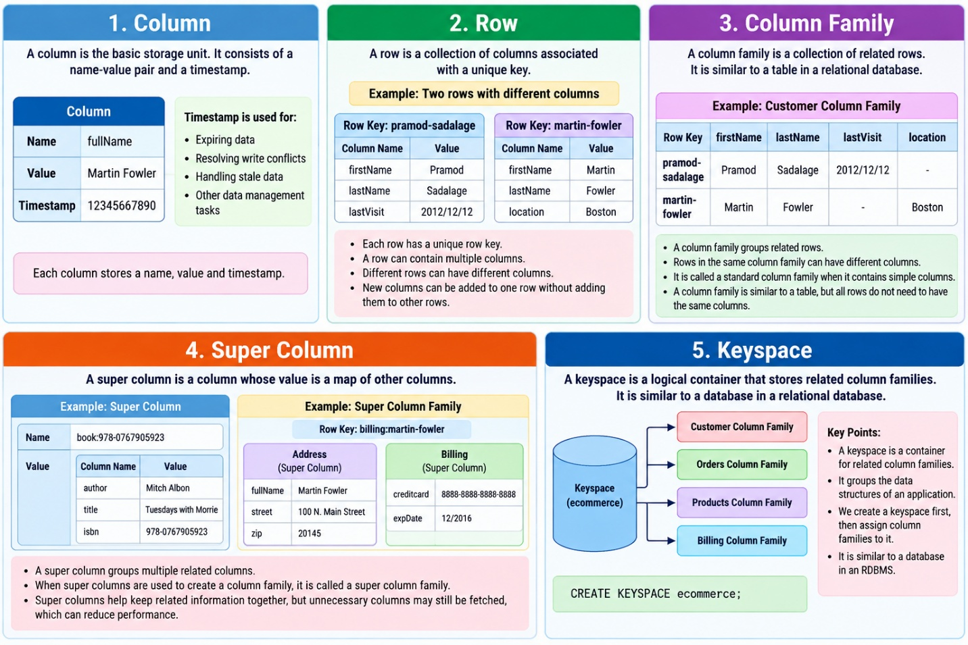

Cassandra’s Peer-to-Peer Architecture and Horizontal Scaling

1. Introduction
Apache Cassandra is a distributed NoSQL database designed to handle large amounts of data and support fast read and write operations. It uses a peer-to-peer architecture, where all nodes in the cluster work together without depending on a single master node.

2. Peer-to-Peer Architecture

Definition
A peer-to-peer architecture is a distributed architecture in which every node in the cluster acts as a peer. Cassandra does not have a master node, so any node can handle read and write requests.

Architecture Diagram
Application / Client
Node 1
Peer
Node 2
Peer
Node 3
Peer
Node 4
Peer
All nodes participate as peers in the Cassandra cluster.

Main Characteristics
- No master node: Cassandra does not depend on one central master server.
- Any node can handle requests: Read and write operations can be handled by any node.
- Distributed operation: Data and workloads are distributed across the cluster.
- Improved availability: The peer-based design avoids dependence on a single master node.
- Scalable write operations: Write operations are distributed across the cluster.

3. How Cassandra Handles Requests
Consider a cluster containing three nodes.
Client Request
|
v
Any Cassandra Node
|
v
Distributed Data / Replicas
A client can connect to a Cassandra node to perform a read or write operation. The cluster handles the operation according to its data distribution and consistency configuration.
Because Cassandra has no master node, a single node is not required to coordinate every operation.

4. Horizontal Scaling

Definition
Horizontal scaling means increasing the capacity of a system by adding more nodes or servers to the existing cluster.
In Cassandra, scaling is performed by adding nodes. Since no single node is a master, the additional nodes increase the cluster’s capacity to support more read and write operations.

Example

Before Scaling
Node 1
Node 2

After Scaling
Node 1
Node 2
Node 3
Node 4
New nodes are added to increase cluster capacity.

Steps in Horizontal Scaling
- Start with an existing Cassandra cluster.
- Add one or more new nodes.
- Allow the cluster to incorporate the additional nodes.
- Use the increased cluster capacity to support more read and write requests.
The source explains that Cassandra can continue serving client requests while new nodes are being added, supporting maximum uptime during scaling.

5. Advantages of Horizontal Scaling
Advantage | Explanation
Increased capacity | More nodes support additional read and write operations.
Distributed workload | Data and operations can be handled across the cluster.
Scalability | Capacity can be expanded by adding nodes.
Continued service | The cluster can continue serving requests while nodes are added.
No master dependency | Scaling does not depend on increasing the capacity of a single master node.
These characteristics are described in the scaling section of the uploaded unit.

6. Peer-to-Peer Architecture vs. Horizontal Scaling
Peer-to-Peer Architecture | Horizontal Scaling
Describes how nodes work together. | Describes how system capacity is increased.
There is no master node. | New nodes are added to the cluster.
Any node can handle read/write requests. | Additional nodes improve read/write capacity.
Supports distributed operation. | Supports expansion and continued service.

7. Conclusion
Cassandra uses a peer-to-peer architecture in which all nodes act as peers and any node can handle read and write requests. Horizontal scaling increases the cluster’s capacity by adding more nodes. Cassandra can continue serving client requests while new nodes are added, making this approach useful for applications requiring distributed storage and scalable operations
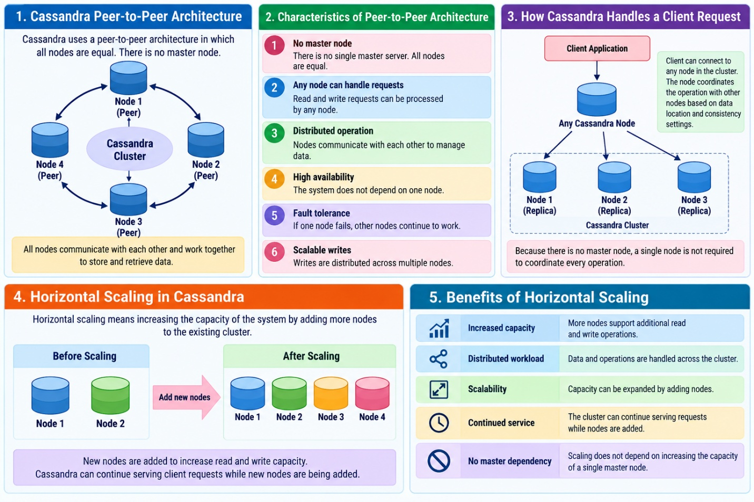

QUORUM in Cassandra
QUORUM is a consistency level in Cassandra that means:
A majority of the replicas must respond before the read or write operation is considered successful.

1. First understand Replication Factor
Suppose:
Replication Factor (N) = 3
The same data is stored on three nodes:
Data A
|
┌────────┼────────┐
↓ ↓ ↓
Node 1 Node 2 Node 3
Replica Replica Replica
So, there are 3 copies of the data.

2. What does QUORUM mean?
For 3 replicas:
\[ QUORUM = \lfloor N/2 \rfloor + 1 \]
Therefore:
\[ QUORUM = \lfloor3/2\rfloor + 1 = 2 \]
So 2 out of 3 replicas must respond.
N = 3

Node 1 ✓
Node 2 ✓
Node 3 ✗

2 replicas responded
↓
QUORUM achieved
↓
Operation succeeds
Notice that one node can be unavailable, and the operation can still succeed.

3. QUORUM for WRITE
Suppose we want to write:
Student_ID = 101
Name = Ravi
with:
RF = 3
Cassandra has three replicas:
WRITE
|
┌─────┼─────┐
↓ ↓ ↓
Node 1 Node 2 Node 3
✓ ✓ ✗
With QUORUM, Cassandra needs responses from 2 replicas.
Therefore:
2 replicas acknowledge
↓
WRITE SUCCESS
The third replica can be updated later.

4. QUORUM for READ
Now suppose the application requests:
READ Student_ID = 101
Again:
RF = 3
Cassandra contacts replicas and requires 2 responses.
READ
↓
┌──────┼──────┐
↓ ↓ ↓
Node1 Node2 Node3
✓ ✓ ✗
└──────┬──────┘
↓
2 responses
↓
QUORUM
Cassandra uses the responses to determine the latest value based on timestamps.

5. Why is QUORUM useful?
Consider three replicas:
Node 1 → Name = Ravi
Node 2 → Name = Ravi
Node 3 → Name = Raju ← old value
If we use ONE, Cassandra might receive the old value from Node 3.
With QUORUM, Cassandra obtains responses from a majority:
Node 1 → Ravi ✓
Node 2 → Ravi ✓
Node 3 → Raju
The majority provides the current value, and Cassandra can also perform repair mechanisms when replicas are inconsistent.

6. Compare ONE, QUORUM and ALL
Assume:
Replication Factor = 3
Consistency Level | Required responses | Node failure tolerance
ONE | 1 | Can tolerate 2 unavailable replicas
QUORUM | 2 | Can tolerate 1 unavailable replica
ALL | 3 | Cannot tolerate any unavailable replica
So remember:
ONE → 1 replica
QUORUM → majority
ALL → every replica

Easy classroom analogy
Imagine 3 teachers have copies of the same attendance record.
- ONE: Ask any 1 teacher.
- QUORUM: Ask at least 2 teachers.
- ALL: Ask all 3 teachers.
Therefore, QUORUM gives a balance between consistency and availability.

7. Important formula
If the replication factor is N:
\[ QUORUM = \lfloor N/2 \rfloor + 1 \]
Examples:
N (RF) | QUORUM
3 | 2
4 | 3
5 | 3
6 | 4
Replication Factor → ONE → QUORUM → ALL → R + W > N
Certainly. This is one of the most important sequences in Cassandra consistency, and I recommend teaching it as one connected story:
Replication Factor → ONE → QUORUM → ALL → R + W > N
The idea is: first create copies, then decide how many copies must participate in a read/write operation.

1. Replication Factor (RF)

What is Replication Factor?
Replication Factor (RF) tells us how many copies of the same data are stored in the Cassandra cluster.
Suppose:
RF = 3
Then Cassandra maintains 3 replicas of the data.
Student 101
Name = Ravi
|
┌─────────┼─────────┐
↓ ↓ ↓
Node 1 Node 2 Node 3
Replica 1 Replica 2 Replica 3
So:
RF = 3
N = 3
Here, N represents the number of replicas involved.

2. Consistency Level = ONE
Now we have 3 copies.
The question becomes:
When I read or write the data, how many replicas should respond?
With ONE, only one replica needs to respond.
RF = 3

Data
|
┌──────┼──────┐
↓ ↓ ↓
Node 1 Node 2 Node 3
✓ ? ?

Only 1 response required

Example
Node 1 → responds ✓
Node 2 → not required
Node 3 → not required
Therefore:
ONE = 1 replica response

Advantage
Very fast.

Disadvantage
The responding replica may contain stale data.
Your source specifically notes that ONE can return a stale value and is useful when stale data is acceptable and high read performance is desired.

3. Consistency Level = QUORUM
Now we increase the number of replicas that must respond.
For:
RF = 3
A quorum means a majority.
3 replicas
↓
Majority = 2
Therefore:
QUORUM = 2 responses
Data
|
┌──────┼──────┐
↓ ↓ ↓
Node 1 Node 2 Node 3
✓ ✓ ✗

2 responses
↓
QUORUM
The source states that with QUORUM, a majority of replicas respond, and the newest timestamped value is returned for reads.

Easy formula
For an odd replication factor:
\[ QUORUM = \left\lfloor\frac{N}{2}\right\rfloor+1 \]
For:
\[ N=3 \]
we get:
\[ QUORUM=2 \]
So:
ONE → 1
QUORUM → 2
ALL → 3

4. Consistency Level = ALL
Now we require every replica to respond.
For:
RF = 3
Data
|
┌──────┼──────┐
↓ ↓ ↓
Node 1 Node 2 Node 3
✓ ✓ ✓

3 responses
↓
ALL
Therefore:
ALL = 3 responses

Advantage
Strongest consistency among these three levels.

Disadvantage
If even one required replica is unavailable, the operation cannot complete.
Your source explicitly describes ALL as requiring all nodes and notes that it is not fault tolerant.
5. Now Put ONE → QUORUM → ALL Together
Assume:
RF = 3
Consistency Level | Responses required
ONE | 1
QUORUM | 2
ALL | 3
Think of it as a staircase:
ALL
↑
3 responses
↑
QUORUM
↑
2 responses
↑
ONE
↑
1 response
As we move upward:
More replicas participate → stronger consistency, but potentially less availability/faster response.

6. Now comes R + W > N
This is the most important part.
Here:
- R = number of replicas contacted during a READ
- W = number of replicas that must acknowledge a WRITE
- N = replication factor
The source gives the important relationship:
\[ \boxed{R+W>N} \]
This helps ensure that the read and write replica sets overlap.

7. Simple Example
Suppose:
N = 3
We choose:
R = 2
W = 2
Now calculate:
\[ R+W=2+2=4 \]
Since:
\[ 4>3 \]
we have:
\[ \boxed{R+W>N} \]
Therefore, the read and write sets overlap.

8. Visual Example
Suppose we have:
RF = 3

Node 1 Node 2 Node 3
| | |
● ● ●

WRITE
Suppose the write reaches:
Node 1 ✓
Node 2 ✓
Node 3
Therefore:
W = 2

READ
Later, the read contacts:
Node 2 ✓
Node 3 ✓
Node 1
Therefore:
R = 2
Notice something important:
WRITE → Node 1 + Node 2

READ → Node 2 + Node 3
↑
OVERLAP
Node 2 participates in both operations.
That overlap is the key idea behind:
\[ \boxed{R+W>N} \]

9. Why Is the Overlap Important?
Suppose a new value is written:
Student 101
Name = Ravi
The write reaches:
Node 1 → Ravi ✓
Node 2 → Ravi ✓
Node 3 → old value
Now a read asks two replicas:
Node 2 → Ravi
Node 3 → Old value
Because the read includes a replica that participated in the successful write, Cassandra can use the newer timestamped value and consistency mechanisms to identify the latest value.
So the basic idea is:
R + W > N ensures that the set of replicas involved in the read overlaps with the set involved in the write.

10. Very Important Comparison
For N = 3:

Case 1
R = 1
W = 1

R + W = 2

2 > 3 ? NO
So:
\[ R+W>N \]
is not satisfied.

Case 2
R = 2
W = 2

R + W = 4

4 > 3 ✓
So:
\[ \boxed{R+W>N} \]
is satisfied.

Case 3
R = 2
W = 3

R + W = 5

5 > 3 ✓
Also satisfied.

11. Board Explanation
REPLICATION
│
↓
RF = 3 → N = 3
│
┌────────────┼────────────┐
↓ ↓ ↓
ONE QUORUM ALL
│ │ │
1 replica 2 replicas 3 replicas
│ │ │
└────────────┼─────────────┘
↓
READ + WRITE
│
↓
R + W > N
│
↓
Read/Write overlap
Then give the students one numerical example:
N = 3
R = 2
W = 2

R + W = 4

4 > 3 ✓

12. One-Line
RF tells us HOW MANY COPIES.
ONE, QUORUM, ALL tell us HOW MANY REPLICAS MUST RESPOND.
R + W > N tells us WHETHER READ AND WRITE REPLICA SETS OVERLAP.

Final flow
RF = 3
↓
3 copies of data
↓
ONE → 1 response
↓
QUORUM → 2 responses
↓
ALL → 3 responses
↓
Choose R and W
↓
Check R + W > N
↓
Read/write sets overlap

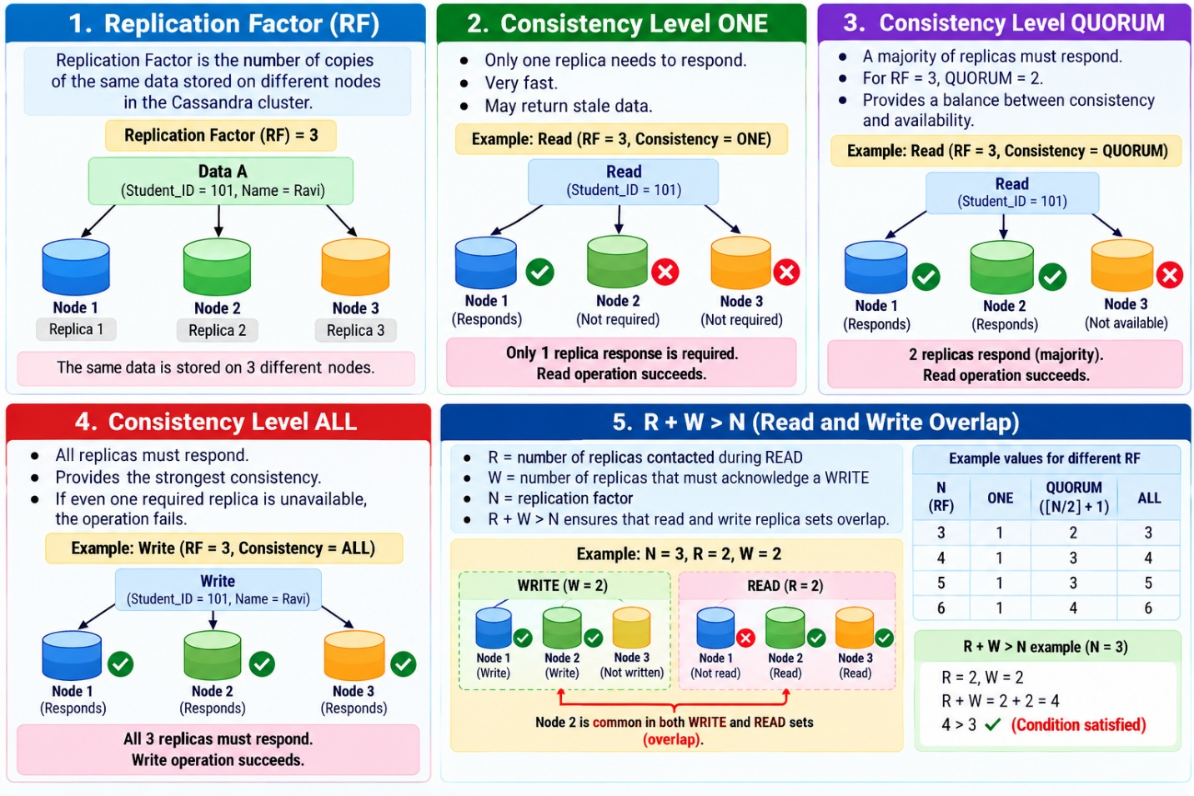
Certainly. In Section 10.2.1 of your uploaded Unit 10 file, Cassandra's write and read process is explained using Memtable, SSTable, compaction, and read repair. I will explain them in very simple words, with one common example.

1. First understand the complete picture
When a client writes data to Cassandra, the basic flow is:
Client
↓
Commit Log
↓
Memtable
↓
SSTable
↓
Compaction
When a client reads data:
Client
↓
Replica Nodes
↓
Check data
↓
Latest value
↓
Read Repair if replicas differ
Let's understand each one.

2. What is a Memtable?

Simple definition
A Memtable is an in-memory data structure where Cassandra temporarily keeps newly written data.
Think of it as a temporary working area in RAM.

Example
Suppose a student record is:
Student ID = 101
Name = Ravi
Department = CSE
The client sends this information to Cassandra.
The data is first written to the commit log and memtable.
Client
↓
Student 101
Name = Ravi
↓
┌─────────────────────┐
│ MEMTABLE │
│ │
│ 101 → Ravi │
│ Dept → CSE │
└─────────────────────┘
RAM
The source says that a write is considered successful once it has been written to the commit log and memtable.

Why RAM?
Because memory is fast.
So Cassandra can accept writes quickly.

3. What is an SSTable?
SSTable = Sorted String Table.
After data has been accumulated in the Memtable, Cassandra periodically writes it to disk as an SSTable.
Think:
Memtable = temporary data in memory
SSTable = persistent data on disk

Example
Initially:
MEMTABLE

101 → Ravi
102 → Sita
103 → Kumar
Cassandra periodically flushes this data to disk:
MEMTABLE
↓
↓ Flush
↓
┌──────────────────────┐
│ SSTABLE │
│ │
│ 101 → Ravi │
│ 102 → Sita │
│ 103 → Kumar │
└──────────────────────┘
DISK

Important point
An SSTable is not updated in place.
Suppose Ravi changes his department:
101 → CSE
to:
101 → AIML
Cassandra does not simply modify the old SSTable.
Instead, the changed data is written into a new SSTable.
The source specifically says that SSTables are not written to again after being flushed; changes result in a new SSTable.

4. Why do we need Compaction?
Now imagine that we have many SSTables.
Disk

SSTable 1
↓
SSTable 2
↓
SSTable 3
↓
SSTable 4
↓
SSTable 5
This can become inefficient.
Cassandra therefore performs compaction.

Simple definition
Compaction combines and cleans up SSTables and reclaims unused data space.
the unused SSTables are reclaimed by compaction.

5. Simple Compaction Example
Suppose we have:

SSTable 1
101 → Ravi
102 → Sita
Later Ravi changes his name:

SSTable 2
101 → RAVI KUMAR
103 → Kumar
Now Cassandra has two versions:
SSTable 1:
101 → Ravi

SSTable 2:
101 → RAVI KUMAR
During compaction, Cassandra combines the relevant data and removes obsolete information.
Conceptually:
SSTable 1 + SSTable 2
↓
COMPACTION
↓
New SSTable
↓
101 → RAVI KUMAR
102 → Sita
103 → Kumar
So the old unnecessary version can eventually be reclaimed.

6. What is Read Repair?
Now let's move from WRITE to READ.
Suppose Cassandra has three replicas:
RF = 3
And the data is:
Node 1 → Ravi
Node 2 → Ravi
Node 3 → Raju
Node 3 has old/stale data.
Student 101

Node 1 → Ravi ✓
Node 2 → Ravi ✓
Node 3 → Raju ✗
↑
stale value
Now the client performs a read.
Cassandra compares the data returned by the replicas.
It finds:
Ravi = latest value
Raju = old value
The stale replica can then be repaired.
This process is called:
Read Repair

7. Read Repair with QUORUM
This is especially easy to understand with your previous topic.
Suppose:
RF = 3
Consistency = QUORUM
Therefore:
QUORUM = 2
Cassandra reads from two replicas:
Node 1 → Ravi
Node 2 → Ravi
Node 3 → Raju
The two responding replicas indicate:
Ravi = latest value
Cassandra can identify that another replica has an older value and repair that replica.
Conceptually:
Before read repair:

Node 1 → Ravi
Node 2 → Ravi
Node 3 → Raju
↓
OLD DATA

↓
READ REPAIR

↓

Node 1 → Ravi
Node 2 → Ravi
Node 3 → Ravi
The uploaded material explicitly states that with QUORUM, the column with the newest timestamp is returned and replicas without the newest data are repaired through read repair.

8. Why does Cassandra use timestamps?
Suppose different replicas have different values:
Node 1 → Ravi timestamp 100
Node 2 → Raju timestamp 105
Node 3 → Ravi timestamp 100
Cassandra can determine that:
timestamp 105 > timestamp 100
Therefore:
Latest value = Raju
This helps Cassandra identify which value is newer.
the newest timestamped value is used when resolving the responses

9. One Complete Example
Let's put Memtable → SSTable → Compaction → Read Repair together.
Suppose a student registers:
Student ID = 101
Name = Ravi
Department = CSE

Step 1 — Write arrives
Client
↓
Student 101
↓
Commit Log + Memtable
The data is now safely recorded in the commit log and temporarily held in memory.

Step 2 — Memtable is flushed
After some time:
Memtable
↓
↓ Flush
↓
SSTable
The data is now stored on disk.

Step 3 — Student updates department
Later:
CSE → AIML
Cassandra does not modify the existing SSTable directly.
Instead:
New data
↓
New Memtable
↓
New SSTable
Now there may be multiple SSTables.

Step 4 — Compaction
Cassandra eventually performs:
SSTable 1
SSTable 2
SSTable 3
↓
COMPACTION
↓
New consolidated SSTable
Unnecessary/obsolete data can be reclaimed.

Step 5 — Read request
Suppose the data is replicated:
Node 1 → AIML
Node 2 → AIML
Node 3 → CSE
Node 3 has stale data.
READ
↓
Node 1 → AIML
Node 2 → AIML
Node 3 → CSE
Cassandra identifies the newest value:
AIML
Then read repair can bring the stale replica into agreement.
Before:

Node 1 → AIML
Node 2 → AIML
Node 3 → CSE

↓ READ REPAIR

After:

Node 1 → AIML
Node 2 → AIML
Node 3 → AIML

10. Very Easy Way to Remember

Memtable
“New data is temporarily kept in memory.”

SSTable
“Memtable data is eventually stored on disk.”

Compaction
“Multiple SSTables are cleaned and consolidated.”

Read Repair
“If replicas disagree during a read, stale replicas can be repaired.”

1. Complete Board Diagram
WRITE
│
↓
┌─────────────┐
│ Commit Log │
└─────────────┘
│
↓
┌─────────────┐
│ Memtable │
│ (RAM) │
└─────────────┘
│
Flush
↓
┌─────────────┐
│ SSTable │
│ Disk │
└─────────────┘
│
Many SSTables
↓
┌─────────────┐
│ Compaction │
└─────────────┘
│
↓
Cleaned SSTables

READ
│
↓
Multiple Replicas
│
Compare data
│
↓
┌────────────────────┐
│ Latest value found │
└────────────────────┘
│
↓
Read Repair
│
↓
Stale replica updated

⭐ One-line flow for students
Write:
Commit Log → Memtable → SSTable → Compaction
Read:
Replicas → Compare timestamps → Latest value → Read Repair

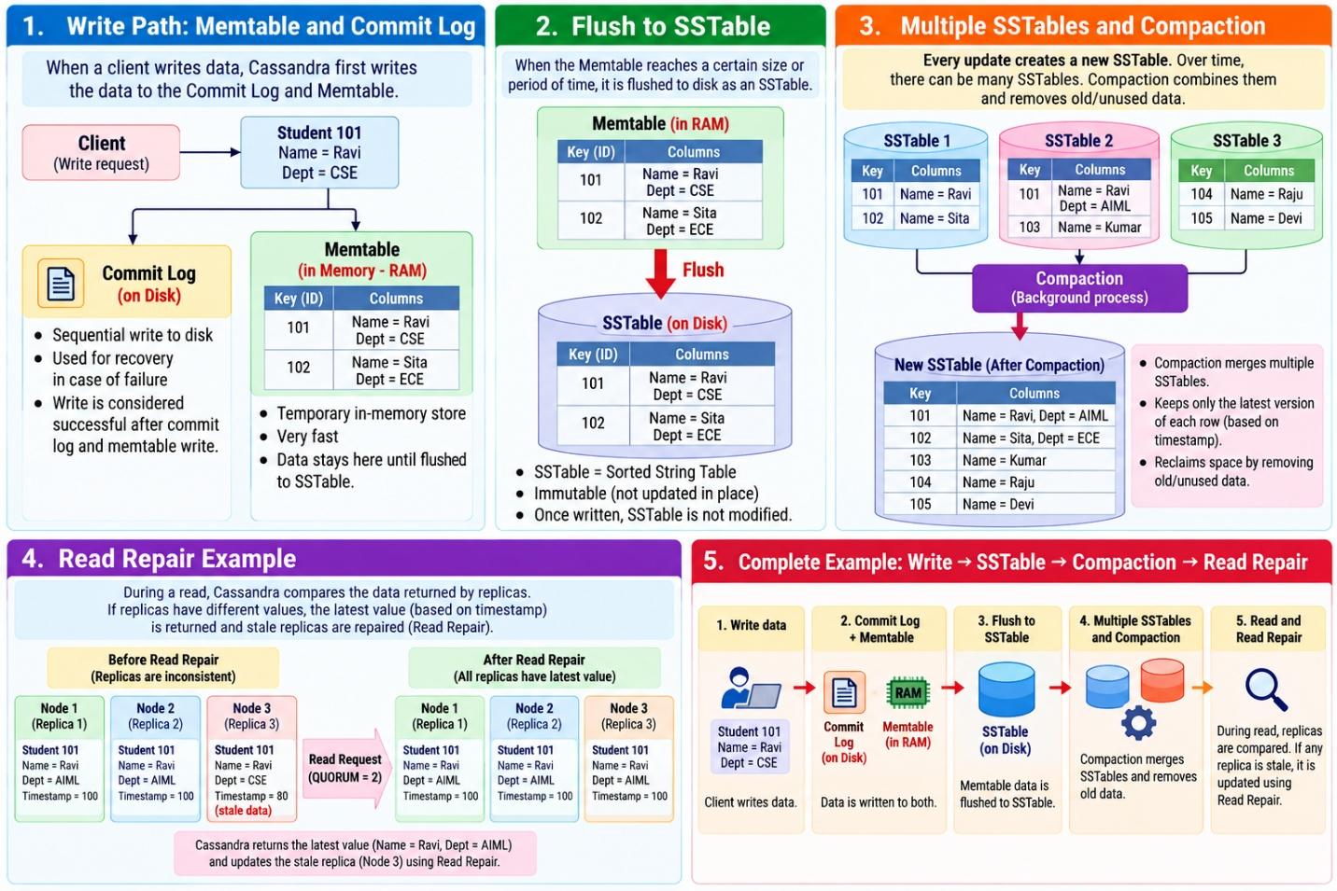

OVERLAP with a very simple real-life example.
The key idea is:
Overlap means that at least ONE node is common to both the WRITE group and the READ group.
the condition R + W > N to obtain better consistency.

1. Imagine 3 storage boxes
Suppose Cassandra stores the same student information in 3 nodes:
Node 1
Node 2
Node 3
This means:
Replication Factor (N) = 3
Suppose we store:
Student 101
Name = Ravi
So the data exists in all three nodes:
Node 1 → Ravi
Node 2 → Ravi
Node 3 → Ravi

2. A new value is written
Later, Ravi changes his name information.
Suppose the new value is:
Student 101
Name = Ravi Kumar
Assume Cassandra requires W = 2 nodes to acknowledge the write.
We can choose:
WRITE

Node 1 → receives new value ✓
Node 2 → receives new value ✓
Node 3 → not required
So the WRITE group is:
WRITE group = {Node 1, Node 2}
Think of these two nodes as:
WRITE
/ \
Node 1 Node 2

3. Now a READ request comes
Later, somebody asks:
"What is the name of Student 101?"
Suppose Cassandra uses:
R = 2
So it needs responses from 2 nodes.
Imagine Cassandra reads:
Node 2 → Ravi Kumar
Node 3 → Ravi
Therefore, the READ group is:
READ group = {Node 2, Node 3}

4. Now look carefully
We have:
WRITE group = {Node 1, Node 2}

READ group = {Node 2, Node 3}
Which node appears in both?
WRITE group = {Node 1, Node 2}
↑
│
READ group = {Node 2, Node 3}

Node 2 is common.
Therefore:
Node 2 is the OVERLAP.
That's all "overlap" means.

5. Why is Node 2 important?
Node 2 participated in the WRITE.
It therefore knows about the latest write:
Node 2 → Ravi Kumar
When the later READ also contacts Node 2:
READ
↓
Node 2 → Ravi Kumar ✓
Node 3 → Ravi
The read has contacted a node that participated in the write.
Therefore, the read can see the newer value.
Latest value
↓
Ravi Kumar
This is why having an overlap between the write and read replica sets is important.

6. Now understand the formula
We used:
N = 3
W = 2
R = 2
Therefore:
\[ R + W > N \]
Substitute the values:
\[ 2 + 2 > 3 \]\[ 4 > 3 \]
TRUE ✓
Therefore, the read and write sets must have at least one replica in common.

7. Why does R + W > N guarantee an overlap?
Let's use three students sitting in a row:
Node 1 Node 2 Node 3
There are only 3 nodes.
Suppose WRITE takes 2 nodes:
WRITE:

Node 1 ✓
Node 2 ✓
Node 3 -
Now suppose READ also takes 2 nodes.
Can we select two nodes for READ without using Node 1 or Node 2?
Only Node 3 is left.
Available outside WRITE:
Node 3 → only 1 node
But READ needs 2 nodes.
So READ must take either Node 1 or Node 2.
Therefore, there must be an overlap.

8. Compare this with NO overlap
Now suppose:
N = 3
W = 1
R = 1
Write only goes to:
WRITE:
Node 1 ✓
Node 2 -
Node 3 -
Read could go to:
READ:
Node 3 ✓
Now:
WRITE = {Node 1}

READ = {Node 3}
There is no common node.
WRITE → Node 1

READ → Node 3

Common node = NONE
This is NO OVERLAP.
And:
\[ R+W=1+1=2 \]
But:
\[ 2>3 \]
is false.
So:
R + W > N is not satisfied.
The read could therefore encounter a replica that did not participate in the latest write and may return stale data.

9. One more example using a college attendance system
This may be easier to remember.
Suppose the attendance record of Student 101 is replicated on:
Server A
Server B
Server C
So:
N = 3

Teacher records new attendance
Student 101 is marked:
PRESENT
Suppose:
W = 2
The write is acknowledged by:
Server A ✓
Server B ✓
So:
WRITE = {A, B}

Later HOD checks attendance
Suppose:
R = 2
Cassandra reads:
Server B ✓
Server C ✓
So:
READ = {B, C}
Now compare:
WRITE = {A, B}
READ = {B, C}
↑
COMMON
Server B is common.
Therefore:
Server B is the overlap.
Server B participated in the write and is also participating in the read.

10. The easiest way to explain
N = 3

WRITE (W = 2)
{ Node 1, Node 2 }

READ (R = 2)
{ Node 2, Node 3 }

Common node:
{ Node 2 }

Therefore → OVERLAP
Then write:
R + W > N

2 + 2 > 3
4 > 3 ✓
And tell students:
"Because the read needs 2 nodes and the write used 2 nodes, out of only 3 total nodes, at least one node must be common."

11. The most important point
Don't think of overlap as data physically overlapping or two databases merging.
It simply means:
WRITE set
{Node 1, Node 2}
and
READ set
{Node 2, Node 3}
have a common node:
↓
Node 2 = OVERLAP

Remember this sentence:
Overlap = at least one replica is involved in BOTH the write and the read.
And the condition is:
\[ \boxed{R+W>N} \]
For the common example:
\[ \boxed{2+2>3} \]
So:
Write 2 nodes + Read 2 nodes + Total 3 nodes → at least 1 common node.

