Unit 11: Graph Databases

1. What Is a Graph Database?
A graph database is a type of NoSQL database that stores data as entities and the relationships between those entities. It is particularly useful when the connections between data items are as important as the data itself.
For example, in a college management application, we may need to store students, faculty members, courses, and departments. We also need to represent relationships such as:
- A student enrolls in a course.
- A faculty member teaches a course.
- A faculty member works in a department.
- Two students are friends.
A graph database stores these entities and their relationships directly.

1.1 Fundamental components of a graph database
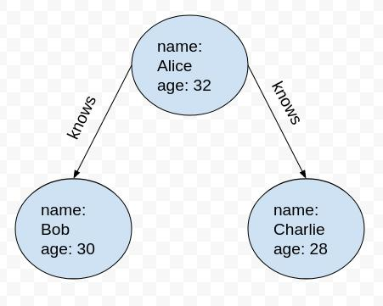
A. Nodes
Nodes represent entities or objects in an application. Each node can contain properties that describe the entity.
Example: A student node may contain name = Ravi, rollNo = 101, and department = CSM.
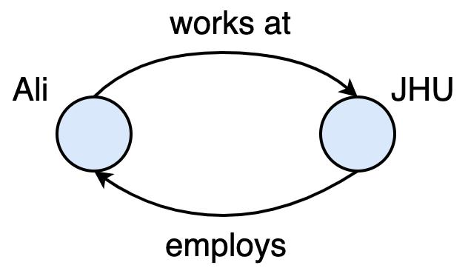
B. Relationships (Edges)
Relationships connect nodes and describe how entities are associated. They have types and directions, and may also contain properties.
Example: Ravi —ENROLLED_IN→ NoSQL.
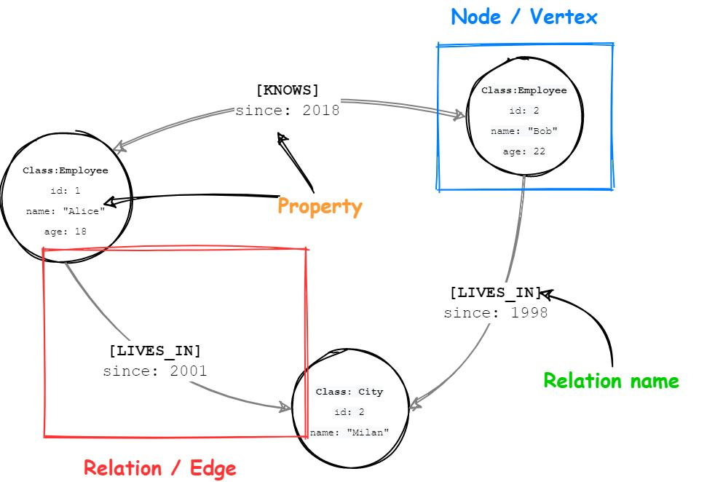
C. Properties
Properties are key-value pairs that describe a node or a relationship.
Example: A faculty node can have name = Sarma. A friendship relationship can have since = 2022.

1.2 Example of a graph structure
Consider three entities: Ravi, Priya, and a NoSQL course.
Illustration: student nodes connected by friendship and course-enrollment relationships.
In this graph:
- Ravi, Priya, and NoSQL are nodes.
- ENROLLED_IN and FRIENDS_WITH are relationship types.
- Each node can have additional properties, such as a name, roll number, or course code.

1.3 Direction of relationships
Relationships have directional significance.
For example:
Dawn —LIKES→ NoSQL
This means Dawn likes NoSQL. It does not automatically mean that NoSQL likes Dawn.
However, a friendship can be represented with two directed relationships when both directions must be explicitly stored:
Martin —FRIEND→ Pramod
Pramod —FRIEND→ Martin
The important point is that the meaning and direction of each relationship must be correctly modeled.

1.4 Graph traversal
Graph traversal is the process of moving through connected nodes by following their relationships to retrieve information.
Suppose a company wants to find all employees who like a particular database course.
The traversal can follow these steps:
- Find the node representing the company.
- Identify the employees connected to the company through EMPLOYEE relationships.
- Check which of those employees have a LIKES relationship pointing to the course.
- Return the matching employees.
A different query can start at the course node and find everyone who likes it. The same stored graph can support both queries without restructuring the data.

1.5 Advantages of graph databases
- Natural relationship representation: Connections are stored directly.
- Fast relationship traversal: Existing relationships can be followed without repeatedly calculating joins.
- Flexible data model: New relationship types can be introduced as application requirements change.
- Multiple relationship types: The same entities can be connected through friendship, employment, ownership, categories, and other relationships.
- Pattern discovery: Connected paths can reveal recommendations, fraud patterns, and indirect associations.
Example: A social networking application can find a friend's friends, common friends, or the shortest connection between two people.

2. Features of Graph Databases
Graph databases provide several features that help applications manage highly connected information. Neo4j serves as a representative example of a graph database.

2.1 Neo4j
Neo4j is a graph database management system that stores entities as nodes and their connections as relationships.
In Neo4j:
- Nodes represent entities.
- Labels can classify nodes, such as Student, Employee, or Product.
- Properties store information about nodes and relationships.
- Relationships connect nodes and specify how they are related.
- Query languages help retrieve information by following graph patterns.
For example, a college application may represent a student and a course as follows:
(Student: Ravi)
|
| ENROLLED_IN
v
(Course: NoSQL)
The student and course are stored as nodes, and their association is stored as a relationship.

2.2 Creating nodes and relationships
Consider two people, Martin and Pramod.
The nodes can store their names:
Node 1:
name = "Martin"

Node 2:
name = "Pramod"
A friendship can be represented using a relationship:
Martin ──FRIEND──> Pramod
If the relationship must exist in both directions, the reverse relationship is also created:
Martin ──FRIEND──> Pramod
Martin <──FRIEND── Pramod
The key idea is that creating two nodes does not automatically establish a relationship between them. The application must create the required relationship explicitly.

2.3 Incoming and outgoing relationships
A relationship has a starting node and an ending node.
Consider:
Ravi ──LIKES──> NoSQL
- Outgoing relationship from Ravi: Ravi likes NoSQL.
- Incoming relationship to NoSQL: Ravi is one of the entities that likes NoSQL.
This distinction is important when searching for information.
For example, to find everyone who likes a particular product, an application can start at the product node and examine its incoming LIKES relationships.

2.4 Properties of relationships
One important feature is that relationships can contain their own properties.
Consider the following graph:
Barbara ──FRIEND──> Elizabeth
|
├── since = 1989
└── share = books, movies, tweets
The relationship tells us that Barbara and Elizabeth are friends. Its properties provide additional information about their friendship.
Other examples include:
Relationship | Possible properties
FRIEND | Since when the friendship began
EMPLOYEE_OF | Role, joining date
CONNECTED_TO | Distance, connection strength
PURCHASED | Purchase date, quantity
These properties can also be used to filter queries.
Example: Find all friends of Barbara whose friendship began before 2000.
This requires examining the FRIEND relationships and their since properties.

2.5 Flexible relationship modeling
Suppose a college initially stores students and courses, connected by ENROLLED_IN.
Later, the application needs to represent:
- FRIEND_OF between students
- TAUGHT_BY between courses and faculty
- BELONGS_TO between courses and departments
These new relationships can be introduced without redesigning the entire graph.
However, changing existing nodes and relationships across a large database may still require a migration process. Therefore, careful relationship design remains important.

3. Consistency in Graph Databases
Consistency means that the database maintains valid and reliable data when nodes and relationships are created, modified, or deleted.
Graph databases must maintain consistency not only for individual nodes but also for the connections between nodes.

3.1 Why is consistency important?
Consider a college database with these nodes:
(Student: Ravi)
|
| ENROLLED_IN
v
(Course: NoSQL)
Suppose Ravi is enrolled in NoSQL. The relationship must connect two existing nodes.
If the course node is removed while the enrollment relationship remains, the graph contains an invalid or dangling relationship.
A dangling relationship is a connection whose starting node or ending node does not exist.
Graph databases use consistency rules and transactions to prevent such invalid states.

3.2 Consistency through transactions
A transaction groups related database operations into a single logical unit.
For example, an operation that creates a course and connects it to a department may need to ensure that all required changes succeed together.
If the operation fails, the database should not leave a partially updated graph.
The four ACID properties are relevant to transactional consistency:
Property | Meaning | Example
Atomicity | All operations succeed together or are rolled back | Creating a course and its required association
Consistency | Database rules remain satisfied | Relationships refer to valid nodes
Isolation | Concurrent transactions do not improperly interfere | Two faculty members updating different course records
Durability | Committed changes persist | A saved course remains after a restart

Neo4j is specifically described as ACID-compliant in the implementation under consideration.

3.3 Rules for deleting nodes
Graph databases do not allow dangling relationships; every relationship must connect existing nodes.. It also describes a rule under which nodes can be deleted only when they have no relationships attached to them.
Consider:
Ravi ──ENROLLED_IN──> NoSQL
The application should not simply delete the NoSQL node and leave the enrollment relationship behind. It must first handle the relationship according to the database's deletion rules.

3.4 Consistency in a clustered graph database
When graph data is distributed across a cluster, different servers may not receive updates simultaneously.
The described Neo4j cluster model works as follows:
- A write is committed at the master.
- The update is propagated to slave servers.
- Other slaves may receive the update later.
- During this propagation period, some reads from slaves may see older data.
This is an example of eventual synchronization between replicas. It is important to distinguish this cluster behavior from the strong consistency provided by a single-server transactional operation.
Example: If a student's department is changed at the master, one slave might temporarily return the old department until the update reaches it.

4. Transactions in Graph Databases
A transaction is a group of operations treated as one logical unit of work.
Transactions help ensure that related changes are completed successfully and that the graph does not remain in an invalid state when an operation fails.

4.1 Why are transactions required?
Suppose an application creates a new course and assigns it to a department.
The operations might be:
- Create the course node.
- Set the course name.
- Set the course code.
- Create the relationship with the department.
- Commit the changes.
If the application fails after creating the node but before completing the necessary relationship, the data may be incomplete. A transaction allows the database to manage these operations together.

4.2 Transaction processing in the described Neo4j API
An older Neo4j Java API uses the following sequence to manage a transaction:
1. Begin transaction
2. Create or modify nodes and relationships
3. Mark transaction as successful
4. Finish transaction
Changes are committed if the transaction succeeds
The older API uses methods such as beginTx(), success(), and finish().
The essential rules are:
- A transaction must be started before performing the relevant write operations.
- The application must mark the transaction as successful if the operations are completed correctly.
- The transaction must be finished.
- If success is not marked, the transaction is treated as unsuccessful and is rolled back when finished.
- Marking success without finishing the transaction does not complete the commit in the described API.
- Read operations, in the implementation discussed, can be performed without explicitly starting a transaction.
These method names are part of the older Neo4j API.; modern Neo4j applications use different transaction APIs.

4.3 Example of a transaction
Suppose we need to create a course node.
BEGIN TRANSACTION

Create node: NoSQL
Set property: name = "NoSQL"
Set property: published = "2012"

If all operations succeed:
Mark transaction successful
Finish transaction

Otherwise:
Roll back changes
This ensures that the database can distinguish successful changes from failed operations.

4.4 Practical example: Student enrollment
Suppose Ravi enrolls in a course.
The application needs to create the enrollment relationship:
Ravi ──ENROLLED_IN──> NoSQL
A transaction can ensure that the relationship is created only when the relevant nodes and required conditions are valid.
Advantages of transactions:
- Maintain data integrity.
- Prevent incomplete updates.
- Help preserve valid relationships.
- Support reliable concurrent operations.
- Allow failed operations to be rolled back.

5. Availability in Graph Databases
Availability refers to the ability of a database system to continue serving requests when a server fails or becomes unavailable.
Graph databases can improve availability by using replicated servers, although the exact behavior depends on the implementation and configuration.

5.1 Replication using a master and slaves
A master server coordinates write operations, while slave servers maintain replicated data and can handle read requests.
Master server
Coordinates writes
Slave 1
Replicated dataServes reads
Slave 2
Replicated dataServes reads
Conceptual master–slave replication architecture.

5.2 How does availability work?
Consider an online shopping application with one master and two slaves.
- A user changes a product's information.
- The change is committed at the master.
- The updated data is replicated to the slaves.
- Read requests can be handled by available slave servers.
- If the master fails, a cluster mechanism may elect another master, provided the system is configured to support failover.
ZooKeeper is used to manage coordination in the Neo4j cluster implementation under consideration.It tracks transaction IDs and helps identify the current master. When the master goes down, an available server can be elected as the new master.

5.3 Benefits of replication
- Read scalability: Several servers can serve read requests.
- Fault tolerance: Replicas can continue serving requests when an individual server fails, depending on the failure and configuration.
- Reduced dependence on one server: A cluster can elect a replacement master if supported.
- Improved service continuity: The application may continue operating during some server failures.

5.4 An important limitation
Replication does not automatically guarantee that every server has the latest data at every moment.
If the master commits an update but a slave has not received it yet, the slave may return an older value. Therefore, applications must consider the consistency and availability guarantees of their chosen database configuration.

6. Query Features in Graph Databases
A graph database query retrieves information from nodes, relationships, and their properties. Unlike a query that primarily searches rows and columns, a graph query can describe patterns of connections between entities.
Key topics include graph traversal, indexing, relationship filtering, path finding, graph algorithms, Gremlin, and Cypher..

6.1 Graph traversal using relationships
Suppose the following graph exists:
Barbara ──FRIEND──> Carol
Barbara ──FRIEND──> Elizabeth
Carol ──FRIEND──> Dawn
Dawn ──FRIEND──> Jill
If we want to find Barbara's immediate friends, we follow one level of FRIEND relationships.
The result is:
Carol
Elizabeth
If we want to find friends of friends, we traverse additional levels:
Barbara → Carol → Dawn → Jill
This demonstrates how the depth of a traversal determines which connected nodes are returned.

6.2 Indexing nodes and relationships
An index helps locate data using a property value without having to inspect every node.
For example, suppose the database contains thousands of student nodes.
Student node | Name | Department
S101 | Ravi | CSM
S102 | Priya | CSE
S103 | Kumar | CSM
S104 | Anu | IT
Without an appropriate index, finding a node by name may require examining many nodes. An index on the name property can help locate the required node more efficiently.
Example:
Find the node where name = "Priya"
The result is the node representing Priya.
Indexes may also be created on relationship properties, allowing the application to locate relationships by their stored values.
An older Neo4j indexing service used Lucene for indexing and searching graph data. Modern indexing facilities differ, but the general purpose of indexing remains the same.

6.3 Filtering by relationship direction
Consider this graph:
Ravi ──LIKES──> NoSQL
Priya ──LIKES──> NoSQL
Kumar ──LIKES──> Python
To find everyone who likes NoSQL:
- Locate the NoSQL node.
- Examine its incoming relationships.
- Select relationships of type LIKES.
- Return the starting nodes of those relationships.
The result is Ravi and Priya.
Direction and relationship type together make it possible to retrieve exactly the intended data.

6.4 Breadth-first and depth-first traversal
Graph traversal can follow different orders.
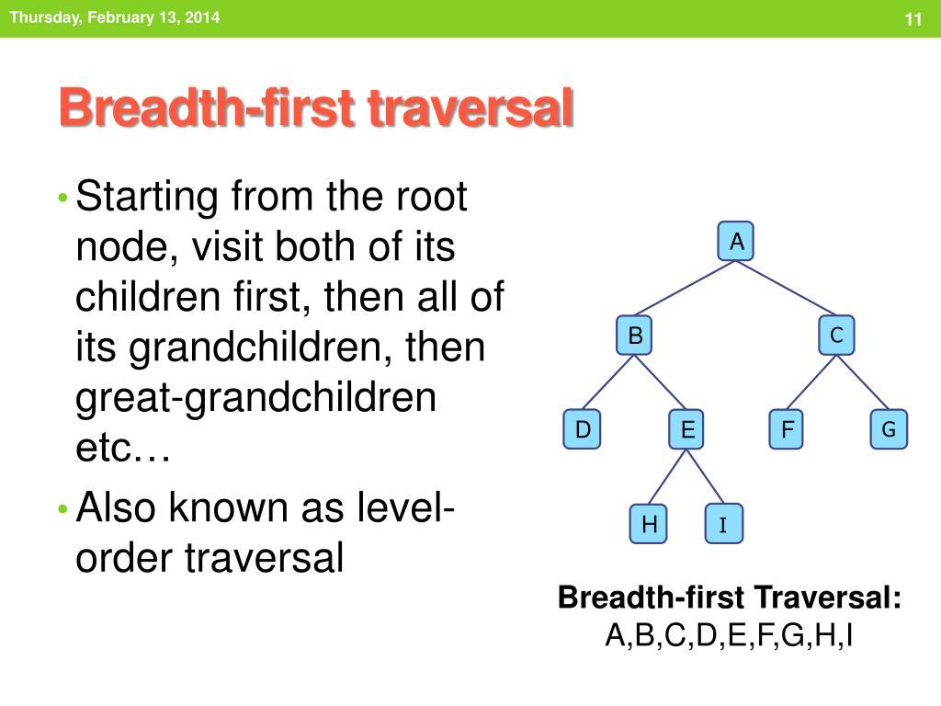
A. Breadth-first search (BFS)
Visits nearby nodes level by level before moving to deeper levels.
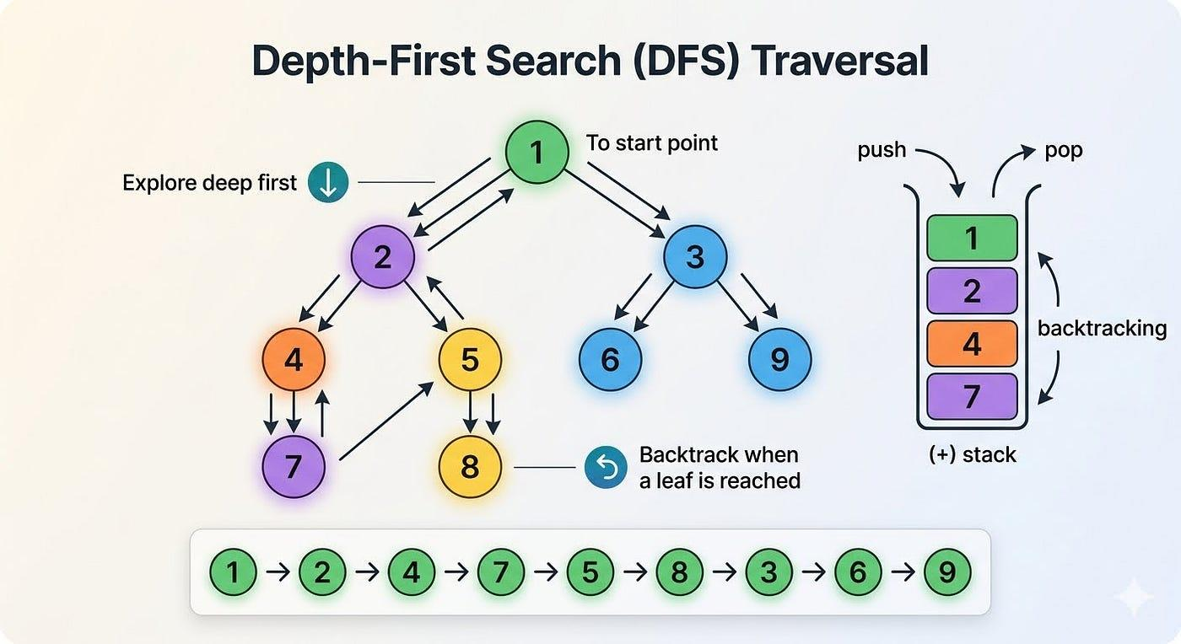
B. Depth-first search (DFS)
Follows one branch deeper before backtracking to explore other branches.
Consider:
A
/ \
B C
/ \ \
D E F
Starting from A:
- A breadth-first order is A, B, C, D, E, F.
- One possible depth-first order is A, B, D, E, C, F.
The exact depth-first order depends on the order in which neighboring nodes are explored.
Application: BFS is useful for exploring nearby connections and can help find shortest paths in unweighted graphs. DFS is useful for exploring connected structures and searching for paths.

6.5 Finding paths between nodes
A path is a sequence of connected nodes that links a starting node to a destination.
Consider:
Barbara → Carol → Dawn → Jill

Barbara → Elizabeth → Jill
There are two different paths from Barbara to Jill.
Path | Number of relationships (hops)
Barbara → Carol → Dawn → Jill | 3
Barbara → Elizabeth → Jill | 2
The second path is shorter because it contains only two relationships.
Path-finding operations can be used to:
- Find all paths between two nodes, within a specified depth.
- Find a shortest path.
- Determine the number of relationships separating two nodes.
- Identify alternative routes between locations.
The number of hops measures path length in terms of relationships, not necessarily physical distance.

6.6 Dijkstra's algorithm
Dijkstra's algorithm finds a shortest path from a starting node to other reachable nodes in a graph with non-negative edge weights.
Suppose a delivery application stores distances between locations:
A ──5 km──> B
B ──3 km──> D
A ──2 km──> C
C ──4 km──> D
Two routes connect A to D:
- A → B → D = 5 + 3 = 8 km
- A → C → D = 2 + 4 = 6 km
The shorter route is A → C → D, with a total distance of 6 km.
This type of algorithm is useful in navigation, delivery planning, and network routing. For a weighted graph, the shortest route by distance may differ from the route with the fewest hops.

6.7 Cypher query language
Cypher is a declarative query language associated with Neo4j. It allows users to describe patterns in a graph and specify which results should be returned.
The following are the key query components:
Keyword | Purpose
START | Identifies the starting node in the older syntax shown
MATCH | Specifies the graph pattern to find
WHERE | Filters results using conditions
RETURN | Specifies the output
ORDER BY | Sorts results
SKIP | Skips a specified number of results
LIMIT | Restricts the number of results
The older syntax uses START, whereas modern Neo4j Cypher generally uses MATCH and WHERE to identify starting patterns..

Example 1: Find a student's friends
MATCH (student:Student {name: 'Barbara'})
-[:FRIEND]->(friend)
RETURN friend.name;
Explanation:
- MATCH searches for a pattern.
- student:Student identifies a node with the Student label.
- {name: 'Barbara'} filters the starting node by name.
- -[:FRIEND]-> follows outgoing friendship relationships.
- RETURN friend.name returns the names of the matching friends.

Example 2: Find employees working for a company
MATCH (employee:Employee)-[:EMPLOYEE_OF]->(company:Company)
WHERE company.name = 'BigCo'
RETURN employee.name;
This query identifies employees connected to BigCo through EMPLOYEE_OF relationships.

Example 3: Find friends within one to three levels
MATCH path =
(person:Person {name: 'Barbara'})
-[:FRIEND*1..3]->(related)
RETURN related.name, length(path);
This illustrates a variable-length relationship pattern using the older Cypher syntax.
It finds paths containing between one and three friendship relationships and returns the connected nodes and path lengths. Exact syntax and behavior can vary across Cypher versions.

6.8 Gremlin
Gremlin is a graph traversal language used with graph systems that support the relevant traversal interfaces.
While Cypher commonly expresses graph patterns declaratively, Gremlin expresses a traversal as a sequence of operations.
For example, a conceptual Gremlin traversal can:
- Start with a person node.
- Follow outgoing FRIEND relationships.
- Retrieve the names of connected people.
The specific syntax and available operations depend on the graph implementation.

6.9 Summary of query features
Graph queries can retrieve immediate connections, traverse multiple levels, filter relationship properties, locate paths, and calculate shortest routes. These features are especially valuable when the required answer depends on how entities are connected rather than only on their individual attributes.

7. Scaling Graph Databases
Scaling means increasing a system's capacity to handle more data, users, and queries while maintaining acceptable performance.

Graph databases can be difficult to scale horizontally because relationships may connect nodes stored on different servers. Three common approaches can be used to address these scaling challenges.

7.1 Why is sharding difficult in graph databases?
Sharding divides a dataset into separate partitions stored on different servers.
In an aggregate-oriented database, data may be grouped into relatively independent aggregates. In a graph database, a node can connect to many other nodes, potentially located anywhere in the graph.
Suppose the following relationships exist:
Ravi → Priya → Kumar → Anu
If Ravi and Priya are on Server 1 while Kumar and Anu are on Server 2, traversing the entire path requires communication between servers.
Such cross-server traversal can increase latency and complicate query execution.
Therefore, graph partitioning must consider not only the amount of data on each server but also the relationships between nodes.

7.2 Three scaling approaches
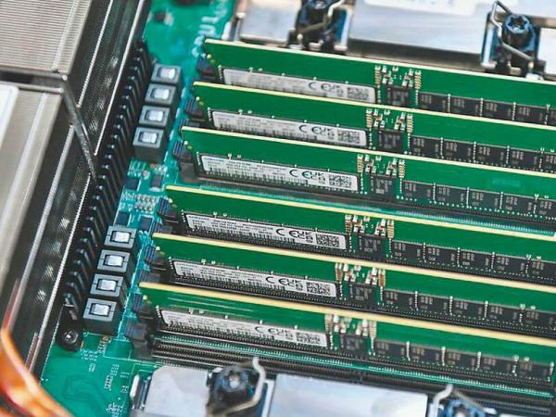
Approach 1: Increase RAM
Add more memory to a server so that the frequently used nodes and relationships can remain in memory.
Example: A university database fits its active student-course graph into the available memory after a RAM upgrade.
Limitation: This approach is practical only when the working dataset fits within a realistic amount of memory.
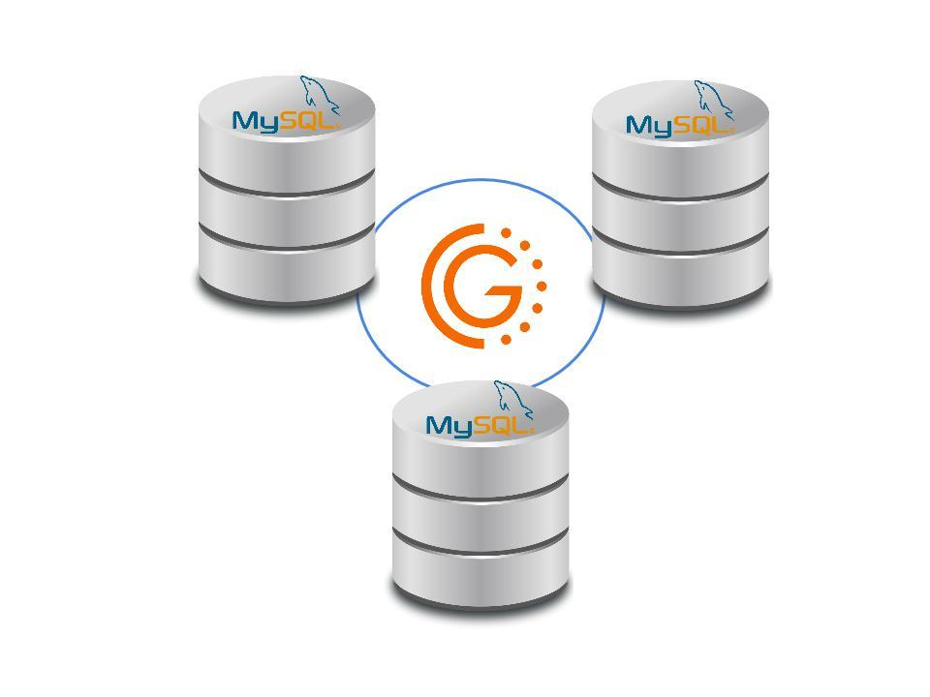
Approach 2: Add read replicas
Use a master for writes and multiple read-only replicas to distribute read requests.
Example: A shopping website receives thousands of product-view requests but relatively few product updates. Several replicas can handle the read workload.
Limitation: This increases read capacity but does not automatically distribute write processing across all replicas.
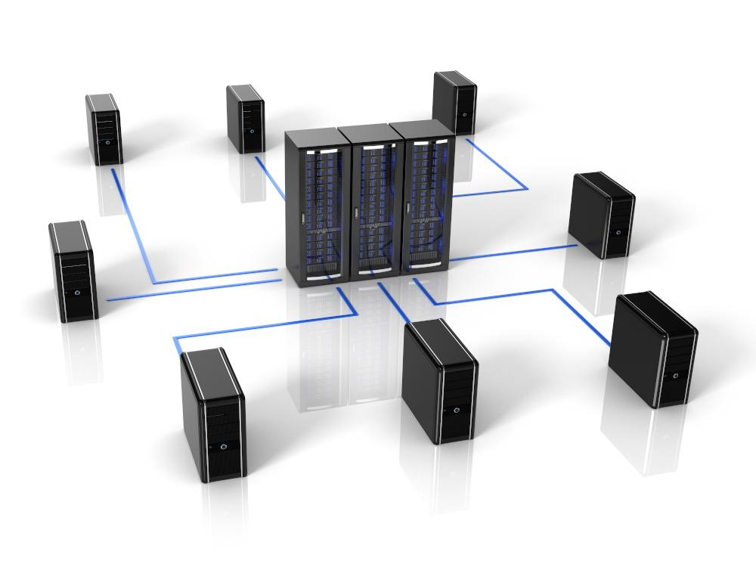
Approach 3: Application-level sharding
Divide the graph using knowledge of the application domain, with different groups of nodes stored on different servers.
Example: Nodes primarily associated with North America are stored on one server, while nodes primarily associated with Asia are stored on another.
Limitation: The application must know which server contains each node and handle relationships that cross server boundaries.

7.3 Application-level sharding example
Consider a global supply-chain system.
Application
Routes queries to the appropriate server
Server 1
North America
Regional suppliers and warehouses
Server 2
Asia
Regional suppliers and factories
Conceptual application-level partitioning based on geographical regions.
When a user requests information about an Asian supplier, the application can direct the query to Server 2.
However, if that supplier has a relationship with a North American warehouse, the application must also handle the cross-server connection.

7.4 Comparison of the three approaches
Approach | Main purpose | Main limitation
Increase RAM | Keep the working graph in memory | Limited by available memory
Read replicas | Increase read capacity and potentially availability | Writes remain concentrated at the master in this model
Application-level sharding | Distribute a large dataset across servers | Cross-server relationships complicate traversal
Key point: Graph database scaling must preserve efficient traversal of connected data. Distributing data without considering its relationships may reduce performance instead of improving it.

8. Suitable Use Cases for Graph Databases
Graph databases are especially suitable for applications in which entities have many meaningful relationships. Important use cases include connected data, routing and location-based services, and recommendation engines.
8.1 Connected data
Connected data refers to information in which entities are linked through multiple relationships.
Examples include social networks, employee collaboration networks, knowledge networks, and systems that combine information from different domains.
Example: Social networking application
Consider the following connections:
Ravi ──FRIEND──> Priya
Priya ──FRIEND──> Kumar
Kumar ──FRIEND──> Anu
Ravi ──WORKS_WITH──> Anu
A graph database can help answer questions such as:
- Who are Ravi's friends?
- Who are Ravi's friends of friends?
- How are Ravi and Kumar connected?
- Which people are connected through both friendship and work?
- Which employees have collaborated on the same projects?
The same graph can be traversed in different ways to answer different questions without creating a separate database structure for each query.
Applications: Social networks, employee collaboration, knowledge graphs, and relationship analysis.

8.2 Routing, dispatch, and location-based services
Graph databases can represent locations as nodes and routes between locations as relationships.
A relationship may contain properties such as distance, travel cost, or other route information.
Example: Delivery route planning
Consider a delivery company with four locations:
Warehouse ──5 km──> A
Warehouse ──2 km──> B
A ──3 km──> C
B ──4 km──> C
The distance from the warehouse to C can be calculated using two routes:
- Warehouse → A → C = 5 + 3 = 8 km.
- Warehouse → B → C = 2 + 4 = 6 km.
The second route is shorter, so the delivery application can select it if distance is the optimization objective and the routes are available.
Other applications include:
- Delivery dispatch systems.
- Road and transport networks.
- Nearby restaurant recommendations.
- Tourist attraction discovery.
- Location-based notifications.
- Navigation and route planning.
For example, a mobile application can identify restaurants near a user's current location and rank them using distance or other properties.

8.3 Recommendation engines
A recommendation engine suggests products, services, or activities based on relationships and patterns in the data.
Graph databases can connect users, products, purchases, ratings, and locations. These connections can be traversed to discover useful recommendations.
Example: E-commerce recommendation
Consider the following graph:
Ravi ──BOUGHT──> Laptop
Priya ──BOUGHT──> Laptop
Priya ──BOUGHT──> Mouse
Kumar ──BOUGHT──> Laptop
Kumar ──BOUGHT──> Mouse
When Ravi purchases a laptop, the application can examine other customers who purchased the same product.
It discovers that Priya and Kumar also purchased a mouse. The system may therefore recommend a mouse to Ravi.
The reasoning is:
- Find customers who bought the same product.
- Identify other products purchased by those customers.
- Exclude products Ravi has already purchased, if appropriate.
- Rank the remaining products and display recommendations.
Other examples include:
- “People who bought this product also bought these products.”
- “Travelers visiting this city often visit these attractions.”
- “Customers purchasing this item frequently purchase another item.”
- “Recommend friends based on mutual connections.”

8.4 Fraud detection
Graph databases can also help identify suspicious patterns involving customers, accounts, devices, and transactions.
Consider:
Account A ──USES──> Device X
Account B ──USES──> Device X
Account C ──USES──> Device X
If several apparently unrelated accounts use the same device and also share unusual transaction patterns, the system can flag those connections for investigation.
This does not automatically prove fraud. It helps investigators identify relationships that may deserve further examination.
Graph databases are useful here because they make it possible to examine multiple connected entities rather than evaluating each transaction in isolation.

8.5 Summary of suitable use cases
Use case | Important relationships | Example task
Social networks | People and friendships | Find mutual friends
Employee networks | Employees and projects | Find collaborators
Routing | Locations and routes | Find a shortest route
Location services | Users and nearby places | Recommend nearby restaurants
E-commerce | Customers and products | Recommend related products
Fraud detection | Accounts, devices, transactions | Identify suspicious connections

9. When Not to Use Graph Databases
Graph databases are powerful, but they are not the best solution for every application. Bulk property updates and challenges associated with very large global graph operations are important considerations.
9.1 Applications requiring bulk updates
Suppose a university changes a common property for every student record.
For example:
Every Student:
academicYear = 2026-2027
If the application must update a property on millions of nodes, a graph database may not be the most convenient or efficient choice, depending on its implementation and workload.
This is especially relevant when the application mainly performs large-scale updates rather than exploring relationships.
Example: A batch-processing application changes a status field for millions of independent records. A relational or another database designed for the workload may be a better fit.

9.2 Applications with few relationships
Consider a database that stores only the following information:
Product ID | Product Name | Price
P101 | Keyboard | ₹800
P102 | Mouse | ₹500
P103 | Monitor | ₹8,000
If the application only needs to insert products, update prices, and retrieve records by product ID, the relationships between entities may not be important.
A relational database or a key-value store may be simpler and more suitable.
A graph database becomes more attractive when the application needs to explore relationships, such as which customers bought which products and which products are frequently purchased together.

9.3 Very large global graph operations
A global graph operation examines a large part of the graph or the entire graph.
For example, an application may need to recalculate a property for every node or analyze connections across a massive worldwide network.
Such operations can be expensive, especially when data is distributed across servers.

Some graph databases may struggle with very large datasets, particularly when performing global graph operations.

9.4 When relationships cross many servers
If connected nodes are distributed across different servers, traversal may require repeated network communication.
For example:
Server A: Ravi → Priya
Server B: Priya → Kumar
Server C: Kumar → Anu
Finding a path from Ravi to Anu may require accessing all three servers. This can increase latency and complicate query execution.
The suitability depends on how the data is partitioned, the database implementation, and the frequency of cross-server traversals.

9.5 Decision guide
Requirement | Graph database suitability
Many interconnected entities | High
Multi-level relationship traversal | High
Path finding and connected-pattern analysis | High
Recommendations based on connections | High
Mainly independent records with simple lookups | Often lower
Large bulk updates of common properties | Depends on the workload; may be lower
Massive global graph calculations | Requires careful performance evaluation
Important: These are general guidelines, not absolute rules. The correct database depends on the data model, query patterns, scale, consistency requirements, and performance objectives.

10. Overall Summary
Graph databases represent connected information through nodes, relationships, and properties. They are particularly effective when applications need to traverse relationships, find paths, and discover patterns across connected entities.
The following table summarizes the major concepts.
Topic | Main concept
Graph database | Stores entities and relationships
Nodes | Represent entities
Edges | Represent directed relationships
Properties | Describe nodes and relationships
Graph traversal | Moves through connected nodes
Neo4j | A graph database management system
Consistency | Maintains valid data and relationships
Transactions | Group operations into a logical unit
Availability | Helps a system continue operating during failures
Query features | Retrieve nodes, relationships, paths, and patterns
Scaling | Increase capacity using memory, replicas, or sharding
Connected data | Represents rich networks of entities
Routing | Finds paths between locations
Recommendation engines | Suggest items using relationships
When not to use | Workloads dominated by bulk updates or unsuitable global operations

Quick revision: Five important concepts
- Graph databases store relationships directly, making relationship traversal a central operation.
- Relationship direction matters: A → B does not automatically mean B → A.
- Transactions help preserve consistency by grouping related operations and handling failures.
- Scaling requires careful planning because connected nodes may be distributed across servers.
- The strongest use cases involve connected data, including social networks, route planning, recommendations, and fraud analysis.-[,’
- [3456y7u8i9o0p-[op[]
- +}’ SDF678OP;’

