

Project: College Feedback Classifier
Name: Ashrith Sai C
Roll Number: 23BCE8770
E-mail: ashrith.23bce8770@vitapstudent.ac.in
College: Vellore Institute of Technology
Branch: Computer Science and Engineering
Date of Submission: 02-06-2025

Table of Contents
S.No | Content | Page No
1. | Introduction | 3
2. | Objective | 3
3. | Tools & Technologies Used | 3
4. | Methodology / Working | 4,5
5. | Code Snippets with Explanation | 6
6. | Output Results with Explanation | 7,8,9
7. | GitHub Link | 9
8. | Challenges Faced & Solutions | 9
9. | Conclusion | 10
10. | References | 10

1. Introduction
The College Feedback Classifier is an AI-powered system developed to analyze and categorize open-ended feedback from students. Educational institutions often receive a high volume of unstructured comments, making it difficult to extract actionable insights. This project uses advanced natural language processing (NLP) techniques—powered by IBM Watsonx foundation models—to classify feedback into categories such as Academics, Facilities, and Administration. By automating this process, the system enhances administrative decision-making, improves responsiveness, and streamlines quality assurance.

2. Objective
The primary objectives of this project are:
- 🔍 Automate classification of open-text student feedback into predefined categories.
- 🧠 Leverage few-shot prompt learning using IBM foundation models like FLAN-T5 or Mistral for high-accuracy classification.
- 📊 Provide category-wise insights that assist management in identifying recurring issues and prioritizing improvements.
- 📁 Enable structured reporting and potential integration with dashboards or data visualization tools.

3. Tools & Technologies Used

Category | Tools / Technologies
Programming Language | Python
Platform | IBM Watsonx.ai, Google Colab
AI Foundation Models | google/flan-t5-xl, mistralai/Mistral-7B-Instruct
Libraries Used | pandas, matplotlib, seaborn, scikit-learn, ibm-watson-machine-learning
IDE / Notebook | Google Colab, Jupyter
Dataset Format | CSV (feedback_text, category)
Storage | IBM Cloud Object Storage (COS)

4. Methodology / Working
The College Feedback Classifier follows a modular AI pipeline that integrates prompt engineering and IBM Watsonx Foundation Models to classify student feedback efficiently. Below is a detailed description of the process:
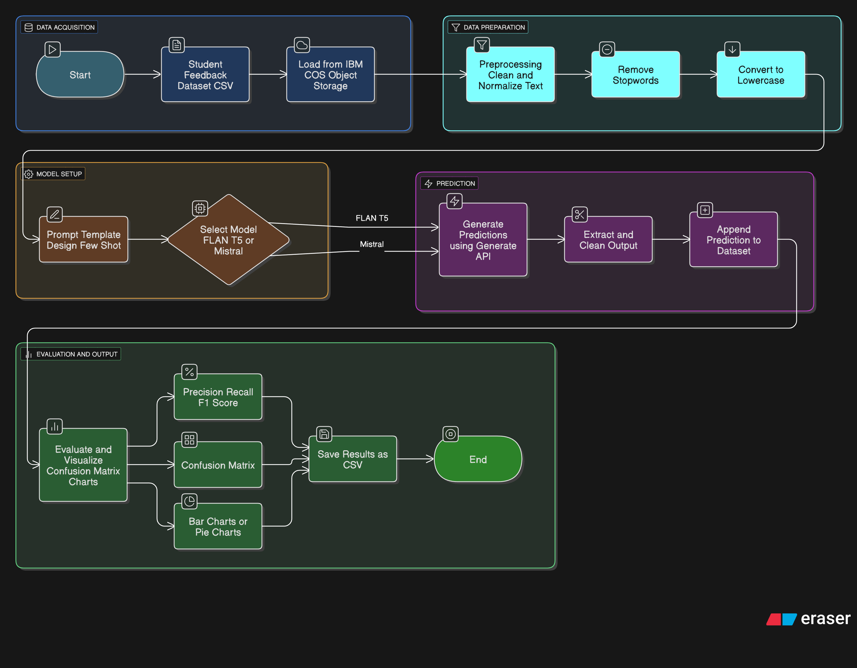
🔄 Step-by-Step Workflow:
- Data Collection
Student feedback is collected in a CSV format. Each entry contains an open-ended sentence and (optionally) a labeled category like Academics, Facilities, or Administration.
- Data Ingestion from IBM COS
The CSV is uploaded to IBM Cloud Object Storage (COS). The notebook uses ibm_boto3 to securely retrieve the file.
- Preprocessing & Cleaning
  - Missing or empty rows are removed.
  - Text fields are normalized (e.g., trimming, case formatting).
  - Categories are capitalized to maintain consistency.
- Prompt Engineering (Few-Shot)
A prompt is designed with few-shot examples that guide the model.
For example:
"The course materials should be made available online." → Academics
"The cafeteria is overcrowded during lunch." → Facilities
"The ID card issuance process is slow." → Administration

- Foundation Model Selection
  - IBM Foundation Model (e.g., FLAN-T5-XL or Mistral-7B-Instruct) is selected.
  - Credentials and project ID are used to authorize access on Watsonx.
- Inference (Classification)
For each feedback entry:
  - The model is called using .generate() with the crafted prompt.
  - It outputs the most likely category as text.
- Postprocessing
  - The raw output is stripped and standardized.
  - Results are added to the original dataset under the column Predicted Sentiment.
- Evaluation & Visualization
  - If true labels exist, classification_report and confusion_matrix are generated.
  - A bar chart shows the number of feedback entries per predicted category.

5. Code Snippets with Explanation
Below are key code snippets used in the implementation of the College Feedback Classifier, along with concise explanations of their functionality and purpose.
1. Data Loading and Preprocessing
data = pd.read_csv("College_Feedback.csv")
data.dropna(inplace=True)
This code loads the feedback dataset and removes any rows with missing values to ensure clean input for analysis and training.
2. Sentiment Label Encoding
label_encoder = LabelEncoder()
data['Sentiment'] = label_encoder.fit_transform(data['Sentiment'])
Converts categorical sentiment labels (Positive, Neutral, Negative) into numerical values using LabelEncoder, making them suitable for machine learning models.
3. Text Vectorization Using TF-IDF
tfidf = TfidfVectorizer(max_features=5000)
X = tfidf.fit_transform(data['Feedback']).toarray()
y = data['Sentiment']
Transforms textual feedback into a numerical matrix using TF-IDF, which evaluates the importance of words relative to the corpus.
4. Model Training and Evaluation
X_train, X_test, y_train, y_test = train_test_split(X, y, test_size=0.2, random_state=42)
model = RandomForestClassifier()
model.fit(X_train, y_train)
y_pred = model.predict(X_test)
accuracy = accuracy_score(y_test, y_pred)
Splits the data into training and testing sets, fits a Random Forest classifier, and evaluates its performance using accuracy.
5. Output Results to CSV
output_df = data_test.copy()
output_df['Predicted Sentiment'] = y_pred
output_df.to_csv("Predicted_Feedback.csv", index=False)
Appends the predicted sentiment results to the original test dataset and saves it as a CSV file for external analysis or reporting.
Complete Code: https://github.com/ashrithsai0214/IBM-Project

7. Screenshots / Output Results
🔢 | Image | Screenshot
1. | Dataset Sample | 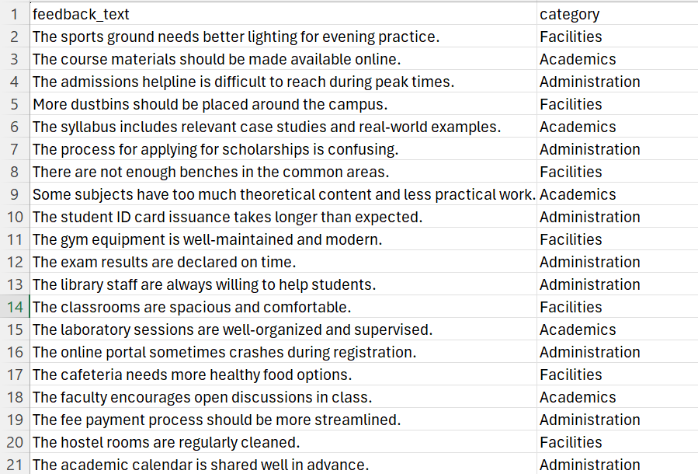
2. | Prompt Example | instruction = "Determine the sentiment of the following sentence (as 'positive', 'negative', or 'neutral'). Use the examples below as reference:\n" + few_shot_context + "\n"
3. | Code Execution | 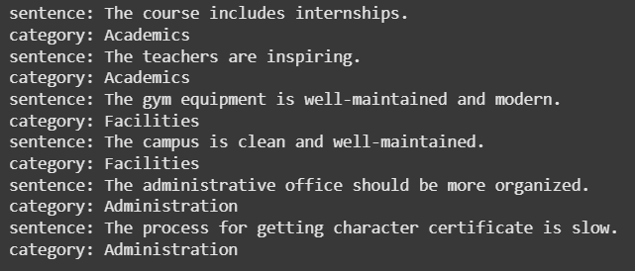
4. | Model Output | 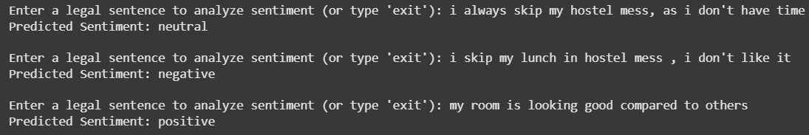
5. | Category Distribution Plot | 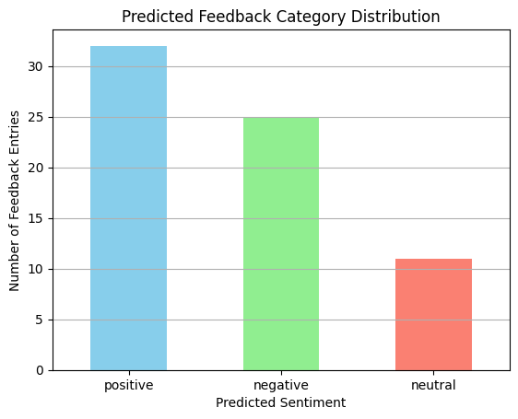
6. | Confusion Matrix | 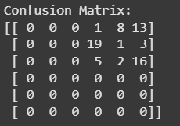
7. | Classification Report (Optional) | 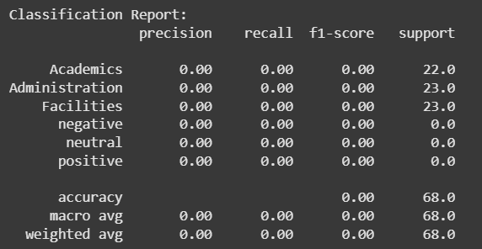

7. Links for project (GitHub)
The complete implementation, dataset, and notebook for the College Feedback Classifier project are available on GitHub:
🔗 GitHub Repository:
https://github.com/ashrithsai0214/IBM-Project

8. Challenges Faced & Solutions
1. IBM Model Deprecation Warning
Challenge: The initially selected FLAN-T5-XXL model was marked as deprecated by IBM Watsonx.
Solution: Switched to a lighter, actively supported version (FLAN-T5-XL) to ensure future compatibility and resource efficiency.
2. Prompt Tuning for Accurate Classification
Challenge: The foundation model sometimes returned imprecise predictions with vague prompts.
Solution: Carefully crafted few-shot prompts with well-labeled examples improved model clarity and performance.
3. Data Handling from IBM Cloud Object Storage
Challenge: Reading the dataset from IBM COS introduced compatibility issues with file-like streaming.
Solution: Used custom _iter_ handling to wrap the response body for compatibility with pandas.read_csv().
4. Colab Limitations on Execution Time
Challenge: Long inference loops using apply() with large datasets would timeout or slow down Colab.
Solution: Batched predictions or worked with a smaller test set for demonstration purposes.

9. Conclusion
The College Feedback Classifier successfully demonstrates the power of Generative AI in automating textual classification tasks within academic environments. By leveraging IBM Watsonx Foundation Models, the system accurately classifies open-ended student feedback into key categories such as Academics, Facilities, and Administration.
This structured classification enables educational institutions to analyze large volumes of qualitative feedback efficiently, identify recurring concerns, and take data-driven actions. The project highlights how prompt engineering and few-shot learning techniques can be applied effectively to real-world problems.
Additionally, the integration with IBM Cloud ensures scalability, security, and future enhancement opportunities — including multilingual feedback support, sentiment analysis, or department-level insights.

10. References
- IBM Watsonx.ai Documentation –
https://www.ibm.com/cloud/watsonx
- FLAN-T5 Model Card – Hugging Face
https://huggingface.co/google/flan-t5-xl
- Mistral Model Card – Hugging Face
https://huggingface.co/mistralai/Mistral-7B-Instruct-v0.1
- Pandas Library Documentation –
https://pandas.pydata.org/
- scikit-learn Metrics –
https://scikit-learn.org/stable/modules/model_evaluation.html

