**A**

**Project Report**

**on**

**“CyberGuard: An Immersive CyberSecurity Simulation Platform”**

Submitted by

**Vasu Tyagi (B23303129)**

**Akash Sundararaju (B23303130)**

**Siddharth Nair (B23303117)**

**Aditya Khera (B23303118)**

Under the guidance of

Dr. Vishal Patil

In partial fulfillment of the requirements for the degree of Bachelor of Technology in Computer Engineering of D. Y. Patil University.



**DEPARTMENT OF COMPUTER ENGINEERING/IT/AIDS**

**Academic Year 2023-2024**



**DEPARTMENT OF COMPUTER ENGINEERING/IT/AIDS**

**Academic Year 2023-2024**

##### CERTIFICATE

*This is to certify that the project entitled* ***“CyberGuard: An Immersive CyberSecurity Simulation Platform”*** *is a record of bonafide work carried out by* ***Akash Sundararaju, Vasu Tyagi, Siddharth Nair*** *and* ***Aditya Khera*** *under my supervision and guidance, in partial fulfillment of the requirements for the award of Degree of Bachelor of Technology in Computer Engineering from D. Y. Patil University for the year 2023-24.*

**Dr. Vishal Patil Dr. Moresh Mukhedkar**

*(Guide) (Project Coordinator)*

**Prof. Malayaj Kumar Prof. Vivek Patil**

*(H.O.D)*  *(External Examiner)*

**Prof. Dr. Pranav Charkha**

*(Dean SOET)*

**Acknowledgement**

We express our sense of gratitude towards our project guideDr. Vishal Patilfor the valuable guidance at step of study of this project and for the necessary guidelines and timely co-operation during the completion of project.

We are thankful to our Project Coordinator Dr. Moresh Mukhedkar, Head of the DepartmentProf. Malayaj Kumar and all the staff member who extended their support for the project.

We are very thankful to respected Dean Prof. Dr. Pranav Charkha for their support and providing all facilities to complete the Project.

Finally, we want to thank to all of my friends for their support and suggestions. Last but not the least we want to express thanks to our family for giving us support and confidence at each and every stage of completion of Project.

Date:   
Place: Pune

**Vasu Tyagi**

**Akash Sundararaju**

**Siddharth Nair**

**Aditya Khera**

**INDEX**

* ***Abstract***
* ***Preface***
* ***List of Figures***

|  |  |  |
| --- | --- | --- |
| **Chapter No.** | **Title** | **Page No.** |
| Chapter No. 1 | Introduction | 1 |
| Chapter No. 2 | Literature Survey | 2 |
| Chapter No. 3 | Proposed System | 12 |
| Chapter No. 4 | Methodology | 14 |
| Chapter No. 5 | Schematic | 21 |
| Chapter No. 6 | Flowchart/Algorithm | 23 |
| Chapter No. 7 | Applications | 24 |
| Chapter No. 8 | Conclusions | 27 |
|  | Bibliography | 28 |
|  |  |  |

**ABSTRACT**

In today's increasingly digital world, the ever-growing threat of cyberattacks poses a significant risk to organizations of all sizes and industries. The need for effective cybersecurity solutions has never been more critical. To address this urgent demand, we present "CyberGuard," a state-of-the-art training simulation software designed to significantly enhance user preparedness. "CyberGuard" transcends traditional cybersecurity training tools by providing a comprehensive, hands-on approach to both defensive and offensive cybersecurity strategies. This innovative platform not only allows users to defend against simulated cyber threats but also enables them to launch controlled attacks, providing a deeper understanding of the tactics used by adversaries and how to counter them effectively.

One of the key features of "CyberGuard" is its emphasis on real-time threat detection and mitigation. Users are placed in realistic scenarios where they must identify, analyze, and respond to a variety of cyber threats as they unfold. This immersive experience ensures that participants develop critical thinking and decision-making skills essential for responding to actual cyber incidents. Additionally, "CyberGuard" offers a range of customizable scenarios of varying complexity, allowing organizations to tailor the training to their specific needs and threat landscape.

Moreover, "CyberGuard" integrates advanced analytics and feedback mechanisms, enabling users to track their performance, identify areas for improvement, and continuously refine their skills. By fostering a proactive learning environment, "CyberGuard" equips users with the comprehensive knowledge and practical experience needed to safeguard their organizations against an ever-evolving landscape of cyber risks. In sum, "CyberGuard" represents a significant advancement in cybersecurity training, preparing users to navigate and defend against the complex and dynamic threats of the digital age.

Keywords—cybersecurity, training, simulation, malware, virus, cyber defence, preparedness

**PREFACE**

In an era marked by rapid digital transformation and escalating cyber threats, the need for robust cybersecurity solutions and skilled professionals has never been more critical. "CyberGuard: an immersive cybersecurity simulation platform" emerges as a timely and essential resource designed to address the evolving challenges faced by organizations and individuals alike in safeguarding their digital assets and operations.

This comprehensive platform is meticulously crafted to provide users with a realistic, hands-on experience in navigating the intricate landscape of cybersecurity threats, vulnerabilities, and defence mechanisms. Through immersive simulations, CyberGuard empowers users to "war-game" against potential cyberattacks, test their defences, and refine their strategies in a controlled, risk-free environment.

The genesis of CyberGuard stems from a collaborative effort involving cybersecurity experts, academics, and industry professionals committed to advancing the field through innovation, research, and education. Their collective insights, expertise, and dedication have culminated in a platform that transcends traditional training methodologies, offering a dynamic, customizable, and scalable solution tailored to meet the diverse needs of today's cybersecurity landscape.

This preface serves as an introduction to CyberGuard's foundational principles, objectives, and capabilities. As you delve deeper into this platform, you will discover its multifaceted features, from representative environment building and risk analysis to training exercises and human-centric simulations. Each component is designed to equip users with the knowledge, skills, and confidence required to navigate the complex and ever-changing cybersecurity landscape effectively.

As you embark on this immersive journey with CyberGuard, we invite you to explore, learn, and collaborate in shaping a safer, more resilient digital future. Together, let us harness the power of simulation, innovation, and education to defend against cyber adversaries and secure our interconnected world. Welcome to CyberGuard, your trusted partner in cybersecurity preparedness and excellence.

**LIST OF FIGURES**

|  |  |  |
| --- | --- | --- |
| **Fig. No.** | **Figure Caption** | **Page No.** |
| 4.1 | Login Screen | 16 |
| 4.2 | Main Menu | 16 |
| 4.3 | Organisational Component Screen | 17 |
| 4.4 | Malware Database Screen (Phishing) | 17 |
| 4.5 | Malware Database Screen (DDOS) | 18 |
| 4.6 | Assistant Preparing an Answer | 18 |
| 4.7 | Assistant Answering Question | 19 |
| 4.8 | Malware Database Screen | 19 |
| 4.9 | Website Loading Due to DDOS Attack | 20 |
| 5.1 | Level 0 Data Flow Diagram for CyberGuard | 21 |
| 5.2 | Level 1 Data Flow Diagram for CyberGuard | 21 |
| 5.3 | CyberGuard Assistant Workflow | 22 |
| 6.1 | Flowchart for CyberGuard processes | 23 |

***Chapter 1***

***Introduction***

In today's increasingly digital world, the ever-growing threat of cyberattacks poses a significant risk to organizations of all sizes and industries. The need for effective cybersecurity solutions has never been more critical. To address this challenge, we introduce "CyberGuard: Organizational Resilience Simulation Platform." This innovative web application is designed to provide a comprehensive, hands-on experience in the realm of cybersecurity by simulating an entire organizational environment, including websites, databases, and other critical assets, all within a user-friendly graphical user interface (GUI).

"CyberGuard" goes beyond traditional cybersecurity training tools by not only allowing users to defend against simulated cyber threats but also enabling them to launch attacks and learn how to fortify their defences. With an emphasis on real-time threat detection and mitigation, this platform equips users with the skills and knowledge needed to safeguard their organizations against an ever-evolving landscape of cyber risks. Whether you are an aspiring cybersecurity professional looking to hone your skills or an organization seeking a robust training and testing solution, "CyberGuard" empowers you to proactively strengthen your cybersecurity posture and respond effectively to potential threats.

***Chapter 2***

***Literature Survey***

In the paper “Simulation for cybersecurity: state of the art and future directions”, the authors introduce simulation for cybersecurity and focus on three themes: (1) an overview of the cybersecurity domain; (2) a summary of notable simulation research efforts for cybersecurity; and (3) a proposed way forward on how simulations could broaden cybersecurity efforts. The overview of cybersecurity provides readers with a foundational perspective of cybersecurity in the light of targets, threats, and preventive measures. The simulation research section details the current role that simulation plays in cybersecurity, which mainly falls on representative environment building; test, evaluate, and explore; training and exercises; risk analysis and assessment; and humans in cybersecurity research. The proposed way forward section posits that the advancement of collecting and accessing sociotechnological data to inform models, the creation of new theoretical constructs, and the integration and improvement of behavioural models are needed to advance cybersecurity efforts.

The authors of the paper “design and Implementation of a Devs-Based Cyber-Attack Simulator for Cyber Security” focus on the necessity of conducting business processes of institutions and individuals with information technologies has brought risks and threats. Cyber-attacks may lead to hard-to-recover results. Although many security systems have been developed against to these attacks, attacks and security breaches of information systems are increasing rapidly. In this study, it is aimed to understand the security weaknesses and vulnerabilities, which is one of the most important issues at the point of providing cybersecurity, and to detect cyber-attacks. Using physical networks to test cyber-attack methods is a very costly and time-consuming process. In this paper, as a different method, a cyber-attack simulation model has been developed using the DEVS modelling approach to simulate and test cyber-attack scenarios and evaluate the results. An application has been developed that simulates an attack scenario in a virtual network and evaluates detector alerts by generating appropriate intrusion detection system signals. The DEVS-Suite simulation environment was used as a development environment. Comparisons were made with different cyber-attack simulation applications and their differences were revealed.

Cloudshare’s glossary tells us how cybersecurity simulation training replicates IT environments to prepare organizations for cyberattacks. Providing real-life experience, it enhances defences and strategy resilience. With varied scenarios, it equips teams against cybercriminals. Amid rising cyber threats, businesses focus on comprehensive training. Rigorous hands-on training in cyber range, virtual labs, and practice environments ensures staff gains practical experience in handling complex attacks. A collective approach fosters a cybersecurity culture, improving training efficiency, enabling safer testing, gathering data-driven insights, and ensuring organization-wide readiness against cyber threats.

In their paper, "A Malware Distribution Simulator for the Verification of Network Threat Prevention Tools," Hwang and Kim introduce a simulator tailored specifically for verifying the efficacy of network threat prevention tools in combating malware distribution. By simulating various malware distribution scenarios, this tool aids in testing the robustness of network defenses and the effectiveness of preventive measures against evolving cyber threats.

Harley, Myers, and Willems in their work, "Test Files and Product Evaluation: the Case for and against Malware Simulation," delve into the nuances of using malware simulation in product evaluation. They discuss the benefits and limitations of employing simulated malware samples for testing security products, shedding light on the complexities involved in accurately assessing cybersecurity solutions.

Holdsworth and Apeh, in their paper "An Effective Immersive Cyber Security Awareness Learning Platform for Businesses in the Hospitality Sector," highlight the importance of immersive learning platforms in raising cybersecurity awareness among businesses in the hospitality sector. Their research emphasizes the need for tailored training solutions to address sector-specific cybersecurity challenges effectively.

Chouliaras et al., in "Cyber Ranges and TestBeds for Education, Training, and Research," explore the role of cyber ranges and testbeds in facilitating cybersecurity education, training, and research. By providing controlled environments for hands-on exercises and experimentation, these platforms enhance cybersecurity learning outcomes and contribute to the development of effective defense strategies.

Dewan et al., in their review titled "Immersive and Non-Immersive Simulators for the Education and Training in Maritime Domain," delve into simulators tailored for education and training in the maritime domain. Their research underscores the importance of immersive learning experiences in preparing maritime personnel to address cybersecurity challenges effectively within their operational context.

Workman, in "An Exploratory Study of Mode Efficacy in Cybersecurity Training," conducts an exploratory study to evaluate the efficacy of different modes of cybersecurity training. Through empirical research, Workman provides insights into the effectiveness of various training approaches, informing the development of evidence-based cybersecurity training programs.

Jaber and Fritsch, in "Towards AI-powered Cybersecurity Attack Modeling with Simulation Tools," review attack simulators and explore the potential of AI-powered cybersecurity attack modeling. Their research sheds light on the evolving landscape of cybersecurity simulation tools and their integration with advanced technologies like artificial intelligence.

Veksler et al., in "Simulations in Cyber-Security: A Review of Cognitive Modeling of Network Attackers, Defenders, and Users," offer a comprehensive review of cognitive modeling approaches in cybersecurity simulations. By examining the cognitive processes of network attackers, defenders, and users, their work contributes to the development of more realistic and effective cybersecurity simulations.

The Indian Computer Emergency Response Team (CERT-In), Ministry of Electronics & Information Technology (MeitY), in their "Annual Report 2022," provide insights into cybersecurity trends, threats, and incidents in India. Their report serves as a valuable resource for understanding the evolving cybersecurity landscape and informing policy and strategy formulation.

The Economic Times, in their article "India sees sharp increase in cyberattacks in Q1 2023: report," highlight the growing prevalence of cyberattacks in India and their impact on various sectors. This report underscores the urgency of bolstering cybersecurity measures to mitigate the risks posed by cyber threats effectively.

Shambare and Simuja, in "A Critical Review of Teaching with Virtual Lab," explore the use of virtual labs in addressing challenges faced by rural schools in South Africa, particularly in conducting practical experiments in science subjects. Their review emphasizes the potential of virtual labs as a solution for enhancing science education in resource-constrained environments.

Anthony Jr. and Noel, in "Examining the adoption of emergency remote teaching and virtual learning during and after COVID-19 pandemic," investigate the adoption of emergency remote teaching and virtual learning in response to the COVID-19 pandemic. Their research offers insights into the challenges and opportunities associated with virtual education in times of crisis.

Metcalf, in "Core War: Creeper & Reaper," delves into the history of computer viruses, exploring early instances of malware such as the Creeper and Reaper programs. By tracing the origins of computer viruses, Metcalf provides valuable historical context for understanding contemporary cybersecurity challenges.

Chen and Robert, in "The Evolution of Viruses and Worms," examine the evolution of computer viruses and worms over time. Their research sheds light on the changing tactics and strategies employed by malware creators, contributing to our understanding of the cybersecurity threat landscape.

Raymond, in "wabbit," discusses the wabbit virus and its impact on computer systems. By analyzing specific instances of malware, Raymond highlights the technical intricacies involved in cyber attacks, providing insights into the methods used by malicious actors.

The articles "Prank starts 25 years of computer security woes," "First virus hatched as a practical joke," and "Brain - the first PC virus in the wild" delve into the early history of computer viruses, tracing their origins and the impact they had on early computing systems. These articles offer historical perspectives on the emergence of malware and its implications for cybersecurity.

IBM's paper on "Virus Distribution Strategies" explores various strategies employed by malware creators to distribute viruses effectively. By understanding these distribution methods, cybersecurity professionals can better anticipate and mitigate the spread of malware.

Maher, in "The Scene," provides insights into the underground community of hackers and malware creators known as "the Scene." By examining the social dynamics and motivations driving these individuals, Maher offers valuable insights into the human factors influencing cyber threats.

Scott, in "A Christmas Computer Bug, and the Future of Files," discusses the Christmas computer bug and its implications for file management systems. This historical analysis sheds light on early instances of software vulnerabilities and their impact on computing systems.

"Cascade" is a virus discussed in cybersecurity literature, highlighting its behavior and impact on infected systems. By examining specific malware variants like Cascade, researchers gain insights into the technical aspects of cyber threats.

Lyons, in "CyberAIDS warning--a real virus," warns about the CyberAIDS virus and its potential risks to computer systems. This early warning underscores the importance of proactive cybersecurity measures in mitigating the spread of malware.

Spafford, in "An analysis of the worm," provides a detailed analysis of computer worms, including their propagation methods and potential impact on networked systems. By dissecting the technical aspects of worms, Spafford offers valuable insights into the mechanisms driving cyber threats.

"The Computer Virus That Haunted Early AIDS Researchers" recounts the story of the CyberAIDS virus and its impact on early AIDS researchers. This historical account underscores the real-world consequences of cyber threats on critical infrastructure and research initiatives.

Bates, in "High Level-Programs & the AIDS Trojan," examines the AIDS Trojan virus and its implications for high-level programming. By analyzing specific instances of malware, Bates offers insights into the technical challenges posed by cyber threats to software development practices.

"CERT Advisory CA-1992-02" provides guidance on mitigating the risks associated with the Michelangelo computer virus. By disseminating actionable information, CERT aims to empower individuals and organizations to defend against cyber threats effectively.

"Michelangelo Computer Virus (6.3.1992)" highlights the emergence of the Michelangelo virus and its impact on computer systems. This historical event underscores the need for proactive cybersecurity measures to mitigate the risks posed by malware.

"The Morris Worm Turns 30" commemorates the 30th anniversary of the Morris Worm, a seminal event in the history of cybersecurity. By reflecting on this milestone, cybersecurity professionals gain insights into the evolution of cyber threats and defense strategies over the past three decades.

"Virus

: DOS/CIH" discusses the DOS/CIH virus and its destructive capabilities. By examining specific instances of malware, researchers gain insights into the technical intricacies of cyber attacks and the challenges they pose to computer systems.

"Tech talk - Happy99 Virus" provides technical insights into the Happy99 virus and its impact on computer systems. By analyzing specific malware variants, cybersecurity professionals gain a deeper understanding of the tactics employed by malicious actors.

The FBI's information on the "Melissa Virus" highlights the severity of this malware threat and the importance of proactive cybersecurity measures. By disseminating information about malware threats, law enforcement agencies aim to protect individuals and organizations from cyber-attacks.

"ILOVEYOU worm" discusses the ILOVEYOU worm and its widespread impact on computer systems worldwide. This historical account underscores the need for robust cybersecurity measures to mitigate the risks posed by malware.

"Sadmind" is a malware variant discussed in cybersecurity literature, highlighting its behavior and impact on infected systems. By examining specific malware variants like Sadmind, researchers gain insights into the technical aspects of cyber threats.

"Information about the Network Worm 'Nimda'" provides insights into the Nimda worm and its propagation methods. By understanding the behavior of worms like Nimda, cybersecurity professionals can better anticipate and mitigate the spread of malware.

"SQLExp SQL Server Worm Analysis" offers a detailed analysis of the SQLExp SQL Server worm and its impact on networked systems. By dissecting the technical aspects of worms, researchers gain valuable insights into the mechanisms driving cyber threats.

"Win32/Mydoom" discusses the Win32/Mydoom malware and its widespread impact on computer systems. This analysis sheds light on the technical intricacies of malware propagation and its implications for cybersecurity.

"Stuxnet Dossier" provides insights into the Stuxnet worm, a sophisticated cyber weapon targeting industrial control systems. By analyzing the Stuxnet worm, cybersecurity professionals gain valuable insights into the evolving tactics and strategies employed by nation-state actors in cyber warfare.

"Storm chaos prompts virus surge" highlights the surge in malware activity following severe weather events. By examining the correlation between natural disasters and cyber threats, researchers gain insights into the opportunistic nature of cybercriminals.

"Protect yourself from the Conficker computer worm" offers guidance on mitigating the risks associated with the Conficker worm. By disseminating actionable information, cybersecurity experts aim to empower individuals and organizations to defend against cyber threats effectively.

"Microsoft Security Intelligence Report: Volume 10" provides insights into cybersecurity trends, threats, and vulnerabilities based on data collected by Microsoft. By analyzing cybersecurity data, Microsoft aims to inform stakeholders and enhance collective efforts to combat cyber threats.

"Microsoft Security Intelligence Report: Volume 11" continues the tradition of providing insights into cybersecurity trends and threats based on Microsoft's data. By leveraging data-driven insights, Microsoft aims to empower individuals and organizations to strengthen their cybersecurity defenses.

"Nasty New Worm Targets Home Routers, Cable Modems" discusses the emergence of a new worm targeting home routers and cable modems. By highlighting emerging threats, cybersecurity experts aim to raise awareness and prompt proactive measures to mitigate risks.

"Psyb0t Evolves, Targets Unprotected Linux Mipsel Routers" provides insights into the evolving tactics of malware creators targeting unprotected Linux routers. By analyzing specific malware variants, researchers gain valuable insights into the techniques employed by cybercriminals.

"The ZeroAccess Botnet: Mining and Fraud for Massive Financial Gain" examines the ZeroAccess botnet and its dual objectives of cryptocurrency mining and fraud. By dissecting the behavior of botnets like ZeroAccess, cybersecurity professionals gain insights into the economic motivations driving cybercrime.

"Flamer: Highly Sophisticated and Discreet Threat Targets the Middle East" offers insights into the Flamer malware, a sophisticated cyber weapon targeting entities in the Middle East. By analyzing the Flamer malware, cybersecurity researchers gain valuable insights into the tactics employed by state-sponsored actors in cyber espionage.

"sKyWIper: A Complex Malware for Targeted Attacks" provides insights into the sKyWIper malware, a sophisticated cyber weapon with advanced capabilities for targeted attacks. By analyzing the sKyWIper malware, cybersecurity professionals gain insights into the evolving tactics of advanced persistent threats (APTs).

"'Operation Tovar' Targets 'Gameover' ZeuS Botnet, CryptoLocker Scourge" recounts the collaborative efforts of cybersecurity experts to dismantle the Gameover ZeuS botnet and disrupt the CryptoLocker ransomware campaign. By highlighting successful cyber defense operations, this article underscores the importance of international cooperation in combating cyber threats.

"Regin White Paper" offers insights into the Regin malware, a sophisticated cyber espionage tool attributed to nation-state actors. By analyzing the Regin malware, cybersecurity researchers gain valuable insights into the capabilities and objectives of advanced persistent threats (APTs).

"Experts Unmask 'Regin' Trojan as NSA Tool" sheds light on the attribution of the Regin malware to the NSA, highlighting the involvement of nation-state actors in cyber espionage. By uncovering the origins of malware, cybersecurity experts aim to enhance attribution capabilities and strengthen defenses against state-sponsored threats.

"First attacks using shellshock Bash bug discovered" discusses the emergence of cyber attacks exploiting the Shellshock Bash bug. By highlighting vulnerabilities in software systems, cybersecurity experts aim to prompt proactive measures to mitigate risks and protect against exploitation.

"BASHLITE Malware Uses ShellShock to Hijack Devices Running BusyBox" provides insights into the BASHLITE malware and its exploitation of the ShellShock vulnerability in devices running BusyBox. By analyzing specific malware variants, cybersecurity professionals gain insights into the tactics employed by cybercriminals to exploit software vulnerabilities.

"Technical Analysis of Pegasus Spyware" offers insights into the Pegasus spyware, a sophisticated surveillance tool used for targeted attacks. By dissecting the behavior of spyware like Pegasus, cybersecurity researchers gain valuable insights into the techniques employed by state-sponsored actors in cyber espionage.

Reading research papers and articles about the simulation of cybersecurity scenarios played a pivotal role in inspiring us to develop a cyber defense training simulation. These articles illuminated the transformative potential of simulations in preparing organizations for the ever-evolving landscape of cyber threats. They highlighted how simulations can create realistic environments, allowing users to "war-game" against potential attacks, fostering experiential learning for IT professionals and security staff.

The rich insights gained from these articles underscored the critical need for comprehensive, hands-on training that goes beyond theoretical knowledge. They not only encouraged us to delve deeper into this field but also fueled the motivation to contribute to the cybersecurity domain by developing a training simulation that empowers individuals and organizations to defend against cyber adversaries effectively.

***Chapter 3***

***Proposed System***

**Main Dashboard:**

1. Display user options:

a. Blue Team Training

b. Red Team Simulation

c. Malware Simulation

d. Performance Analysis

e. Assistant

f. Administrator Control

**Blue Team Training:**

1. Customize training scenarios or select predefined ones.

2. Simulate real-world cyber threats.

3. Analyse blue team's performance.

4. Provide feedback and scores.

5. Store user progress.

**Red Team Simulation:**

1. Customize attack scenarios or select predefined ones.

2. Simulate cyberattacks.

3. Analyse red team's actions.

4. Provide feedback and scores.

5. Store user progress.

**Malware Archive:**

1. Access the malware database.

2. Select a malware sample for simulation.

3. Simulate malware behaviour.

**Performance Analysis:**

1. Assess the performance of both red and blue teams.

2. Calculate scores and metrics.

3. Identify areas for improvement.

4. Generate detailed reports.

***Chapter 4***

***Methodology:***

1. Project Initiation and Planning: Define the overall vision and objectives of CyberGuard, including its target audience, key features, and goals. Create a project plan that outlines the scope, timeline, and resource requirements for the initial development phase. Formulate a roadmap for subsequent iterations and updates.
2. Initial Prototype (Iteration 1): Develop a basic prototype of CyberGuard with essential features to validate the concept. Gather user feedback to understand their needs and preferences. Identify and prioritize key features for subsequent iterations based on user feedback.
3. Iterative Development and Enhancement (Subsequent Iterations): Each iteration focuses on adding or improving specific features of CyberGuard. Features related to customization, gamification, threat scenarios, feedback mechanisms, and security should be developed and refined in stages. Conduct regular testing and gather user feedback after each iteration. Emphasize security throughout the development process, ensuring that user data and practice environments are secure.
4. Continuous Integration and Testing: Implement a continuous integration (CI) and continuous delivery (CD) pipeline to automate testing and deployment. Automated testing should include security testing to identify vulnerabilities. Regularly review and enhance the threat scenarios and learning content to reflect emerging cybersecurity threats and best practices.
5. User Feedback: Maintain open communication channels with the project guide Encourage guide to provide feedback, report issues, and suggest improvements. Act on guide’s feedback to prioritize and implement changes in subsequent iterations.
6. Security and Compliance: Regularly assess and update the security measures within CyberGuard to ensure it remains resilient against emerging threats. Comply with industry standards and regulations related to data privacy and cybersecurity.
7. Project Submission: Release updated versions of CyberGuard at the end of each iteration, incorporating new features and improvements. Ensure that deployment processes are secure and do not introduce vulnerabilities.
8. Documentation and Knowledge Sharing: Maintain comprehensive documentation that covers both user guides and technical documentation for system administrators. Share knowledge about emerging threats and cybersecurity practices through CyberGuard's platform.

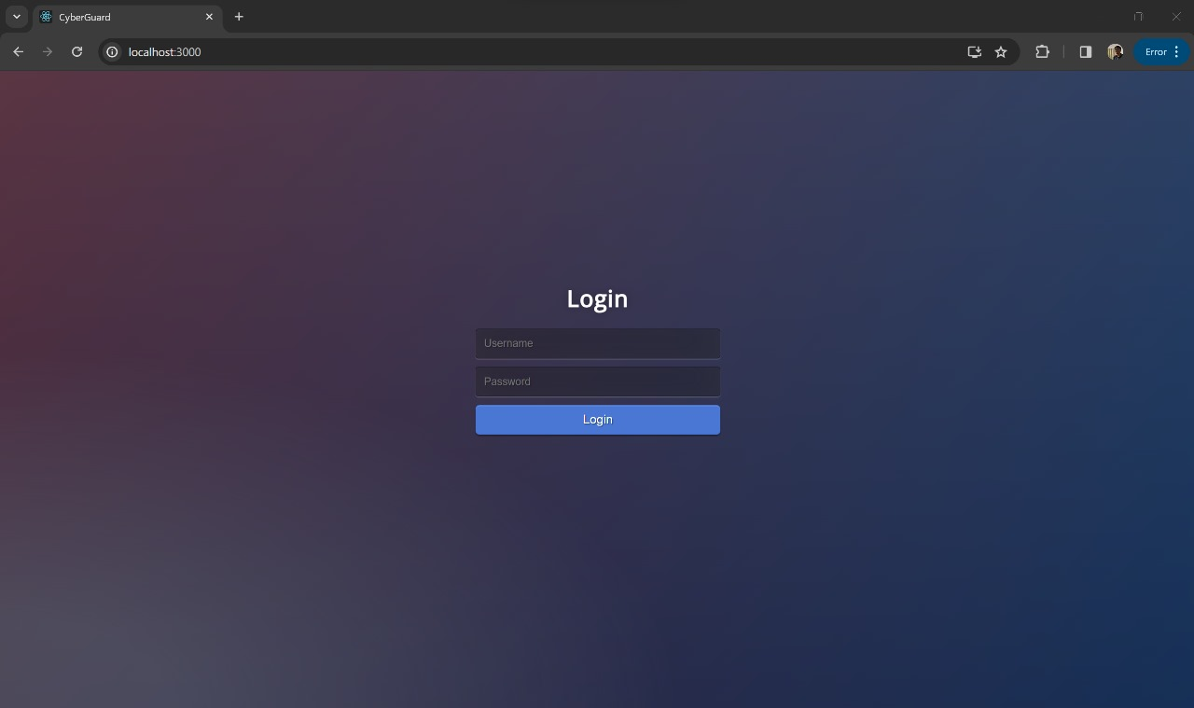

Fig 4.1 Login Screen

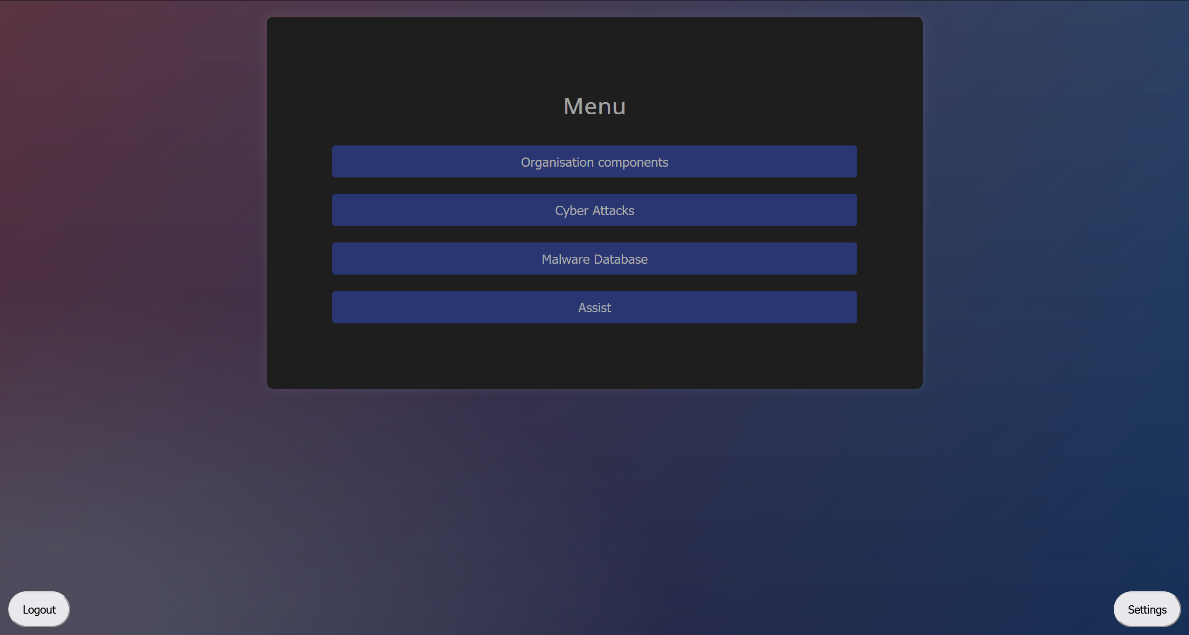

Fig. 4.2 Main Menu

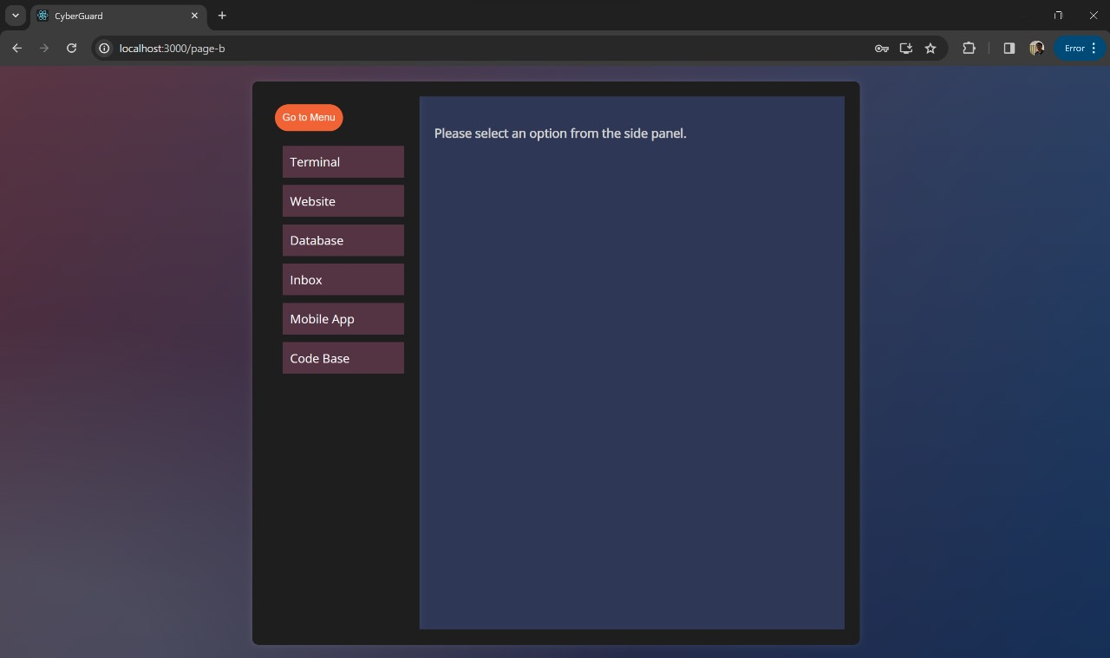 Fig. 4.3 Organisational Component screen

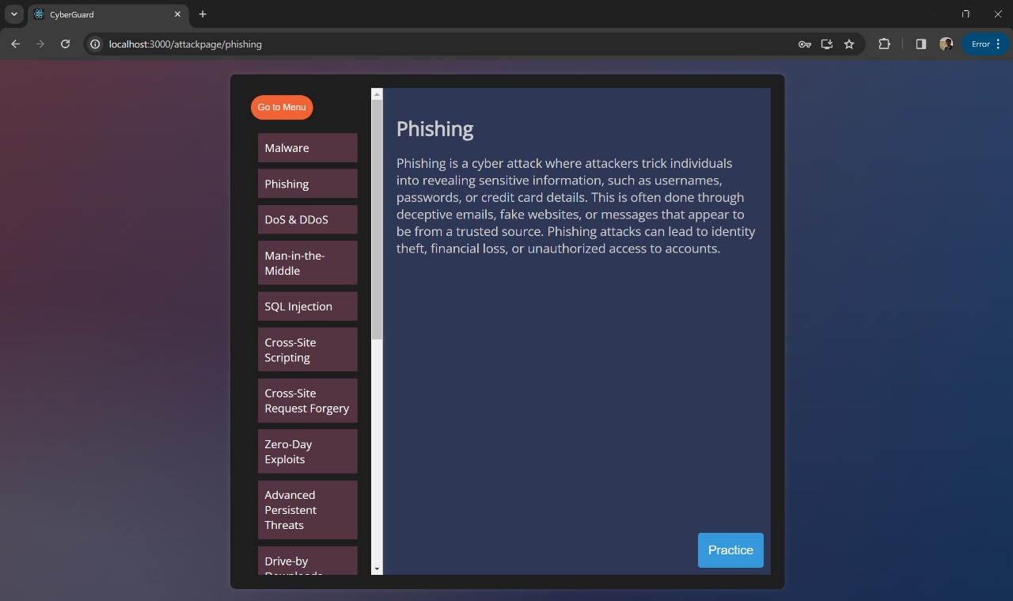

Fig 4.4 Malware Database Screen (Phishing)

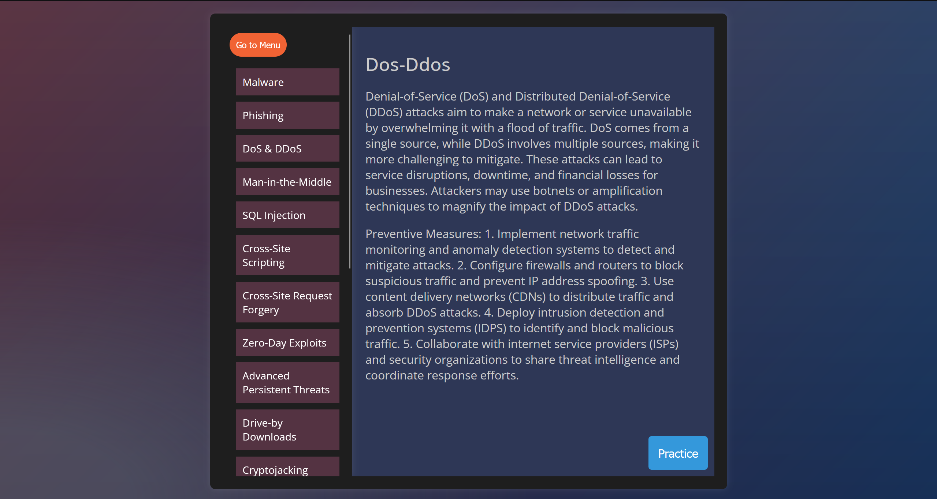

Fig 4.5 Malware Database Screen (DDOS)

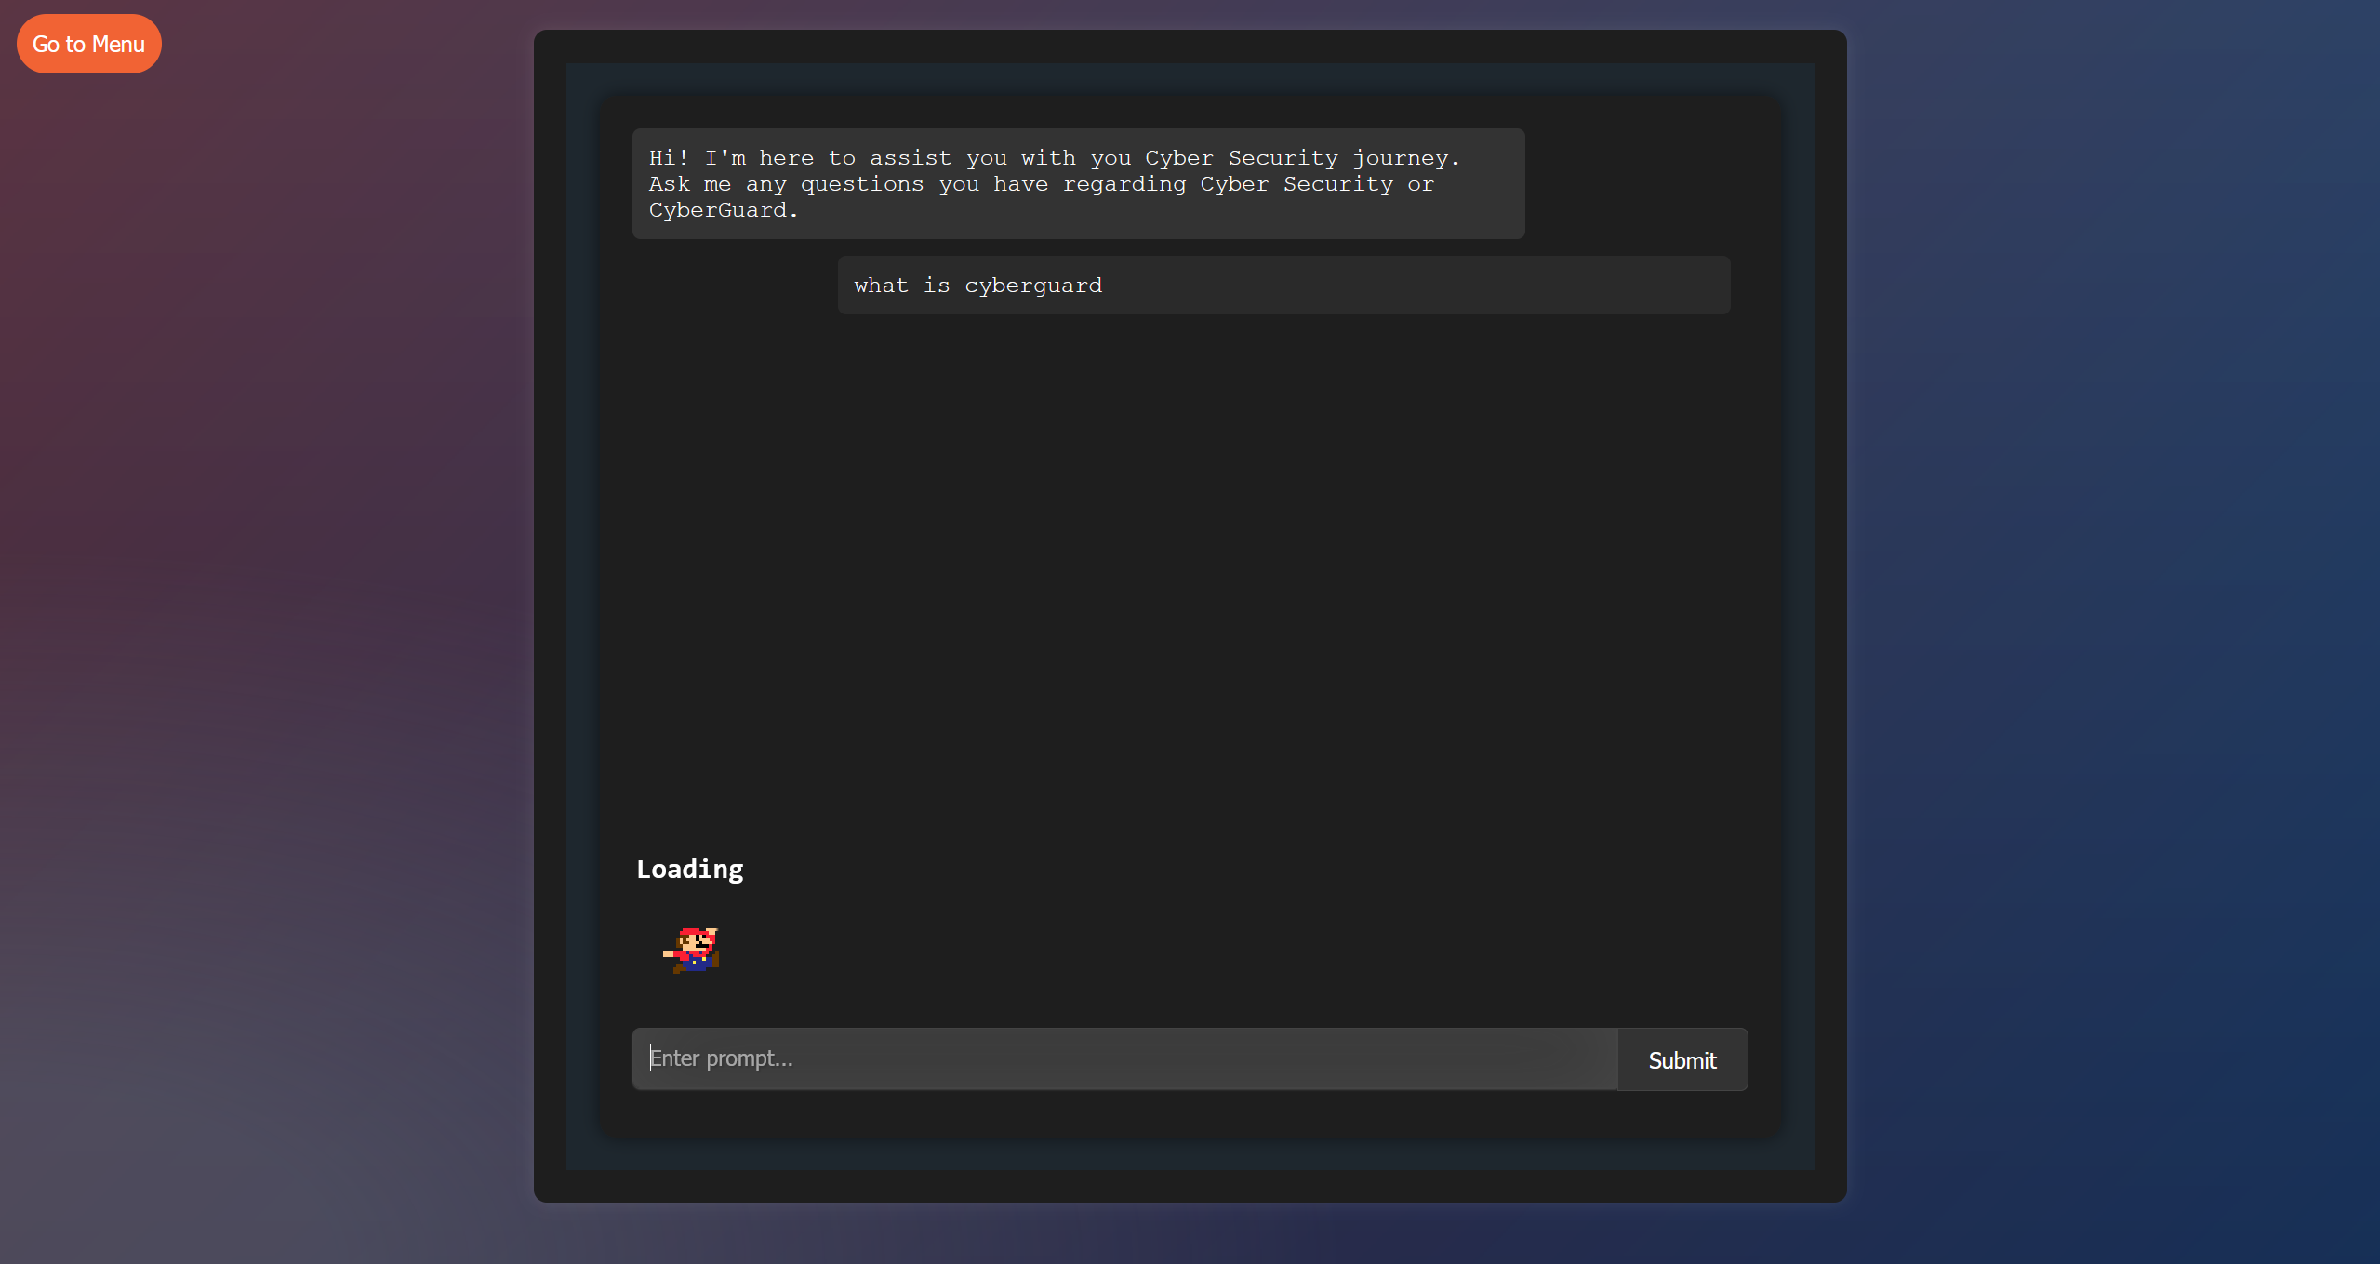 Fig 4.6 Assistant Preparing an Answer

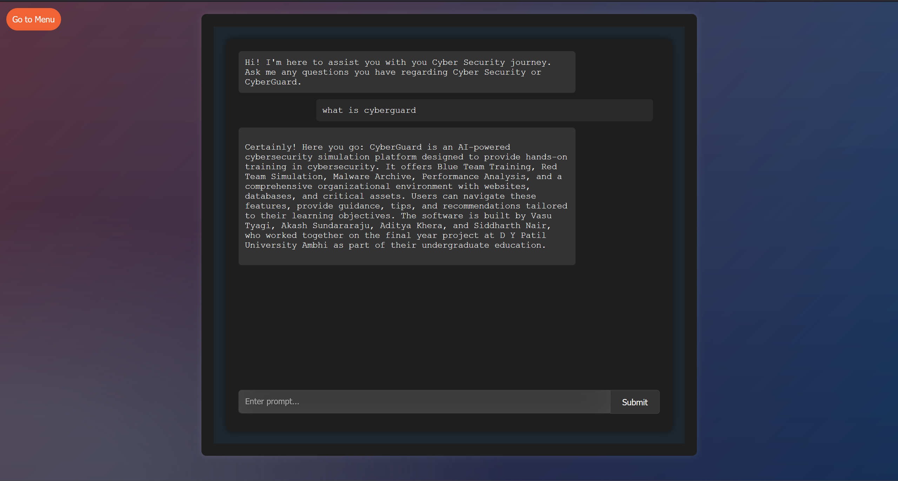

Fig 4.7 Assistant Answering Question

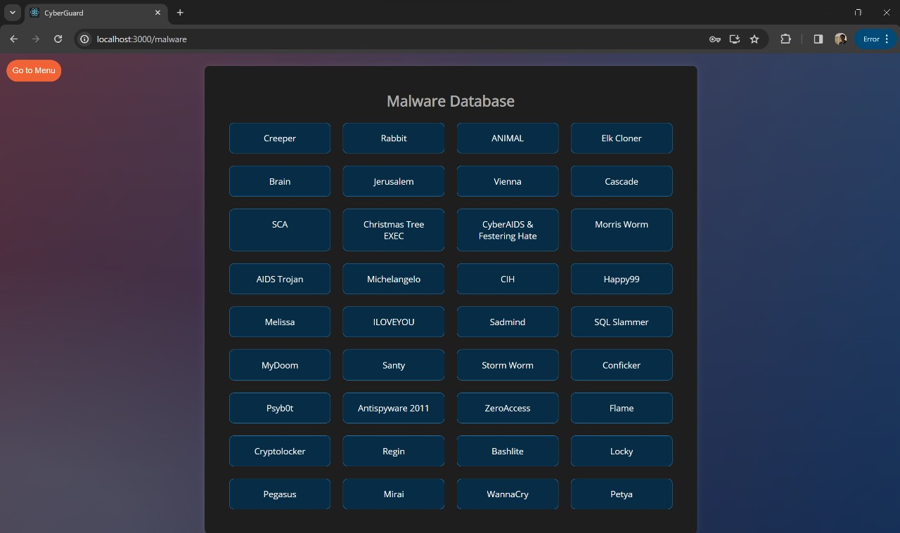

Fig. 4.8 Malware Database Screen

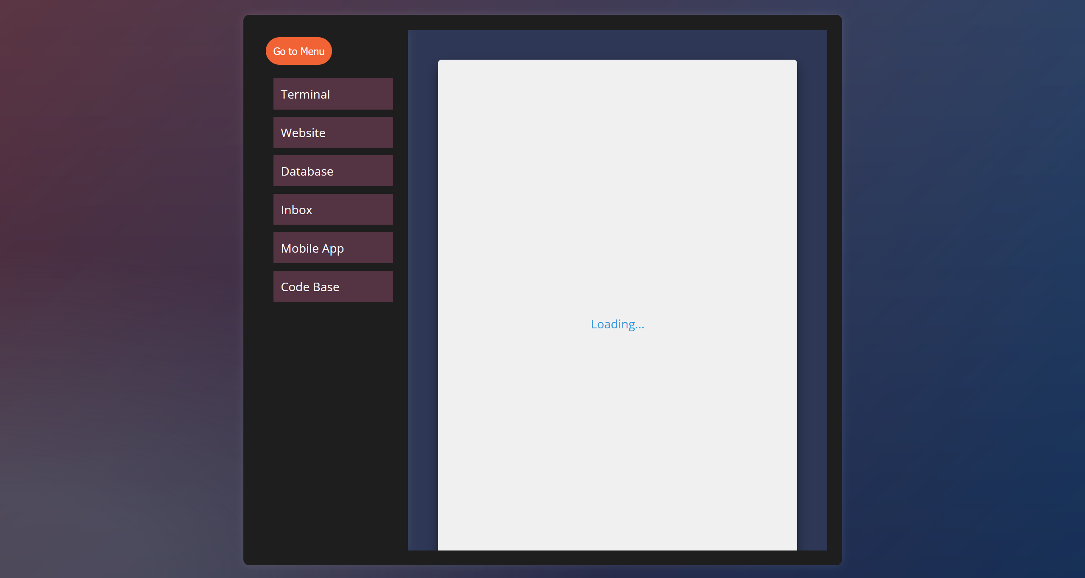

Fig. 4.9 Website Loading Due to DDOS Attack

***Chapter 5***

***Schematic***

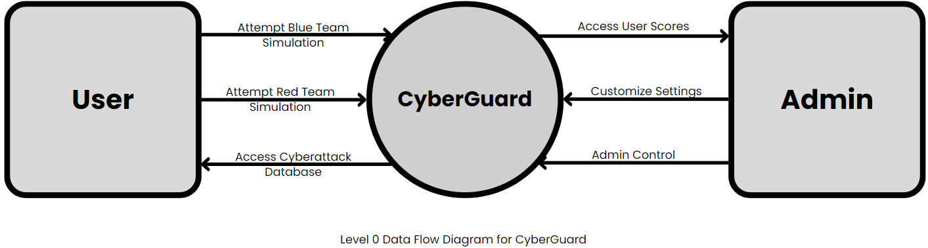

Fig. 5.1 Level 0 Data Flow Diagram for CyberGuard

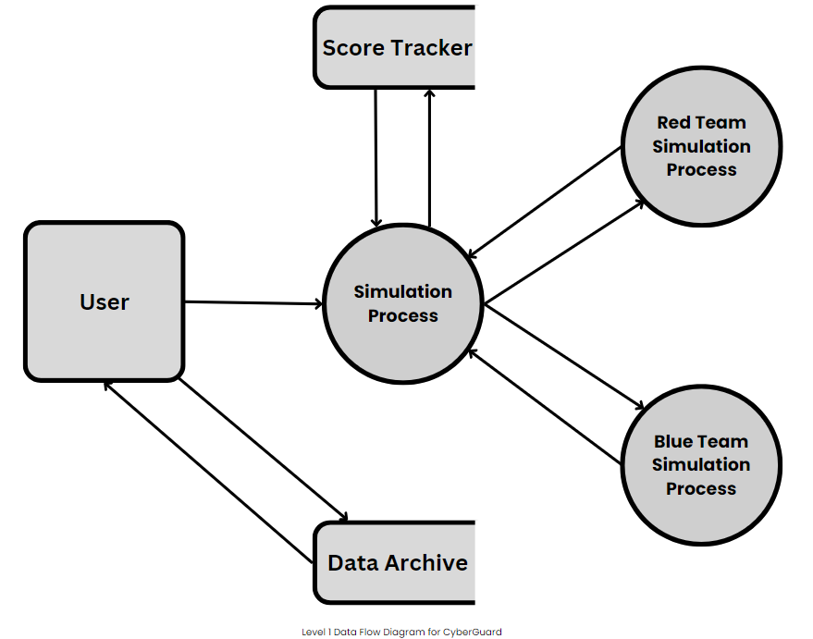

Fig. 5.2 Level 1 Data Flow Diagram for CyberGuard

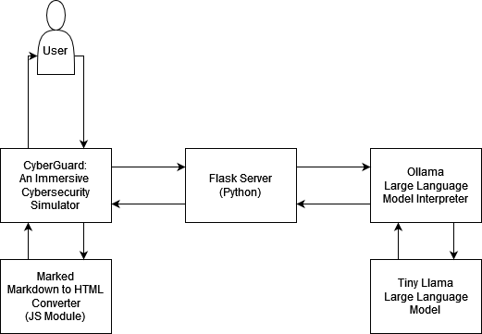

Fig. 5.3 CyberGuard Assistant Workflow

***Chapter 6***

***Flowchart and Algorithm***

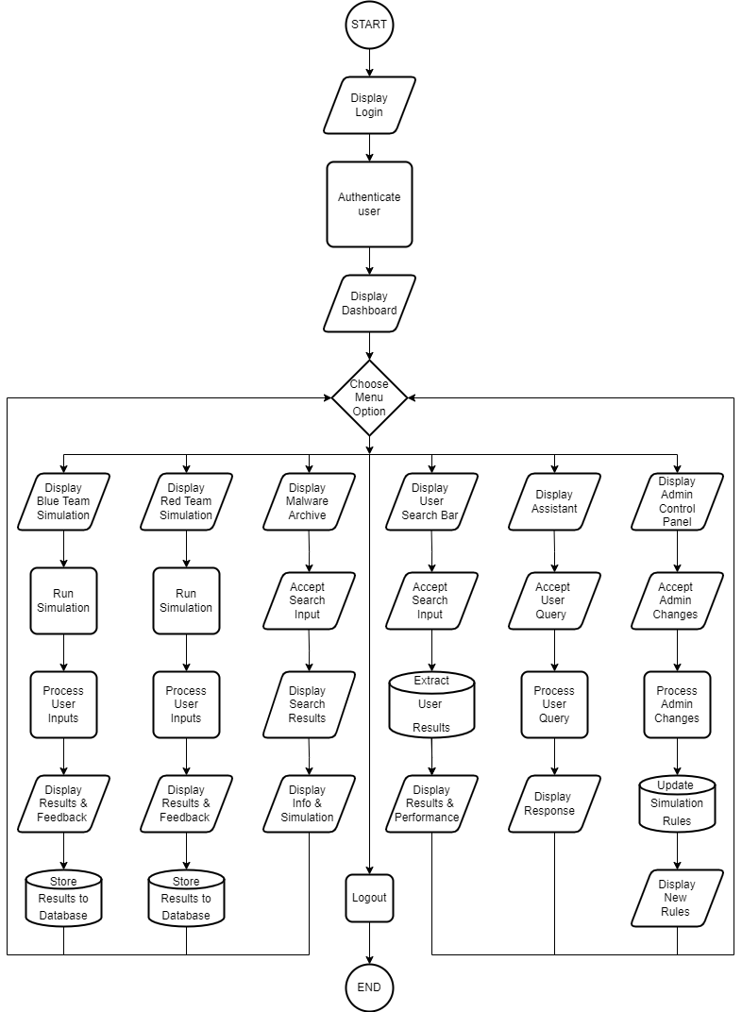

Fig 6.1 Flowchart for CyberGuard processes

***Chapter 7***

***Application, Advantages and Disadvantages***

7.1 Advantages:

1. Hands-On Learning: Provides a realistic, hands-on learning experience in cybersecurity, allowing users to actively practice and improve their skills.
2. Realistic Threat Scenarios: Offers a diverse library of realistic threat scenarios, preparing users for a wide range of cyberattacks they may encounter in the real world.
3. Immediate Feedback: Provides instant feedback on user actions, enabling rapid learning and skill improvement.
4. Customization: Allows users to create and customize threat scenarios to match their organization's unique needs and security challenges.
5. Gamification: Gamifies the learning process with challenges, scores, and rewards, enhancing user engagement and motivation.
6. Safe Environment: Provides a safe and controlled environment for users to practice without risking real data or systems.
7. Continuous Updates: Stays up-to-date with evolving cyber threats and industry best practices through regular updates.

7.2 Disadvantages:

1. Resource Intensive: Developing and maintaining a realistic cybersecurity simulation platform can be resource-intensive, requiring significant time, expertise, and investment.
2. Learning Curve: Users, especially beginners, may face a learning curve when navigating the platform and understanding complex threat scenarios.
3. Limited Realism: While striving for realism, simulations may not perfectly replicate the complexity and unpredictability of real-world cyberattacks.
4. Overemphasis on Gamification: Overuse of gamification elements may distract from the seriousness of the subject matter.

7.3 Applications:

1. Cybersecurity Training and Education: "CyberGuard" can serve as a vital tool for cybersecurity training programs in educational institutions, corporate settings, and professional training courses.
2. Incident Response Training: It can be employed for training incident response teams to effectively handle and mitigate cyberattacks.
3. Security Awareness Programs: "CyberGuard" can be part of security awareness programs, helping employees understand and recognize potential threats.
4. Competitive Training: Organizations can use the platform for competitive cybersecurity training, fostering a sense of competition among security professionals to enhance skills.
5. Cybersecurity Competitions: "CyberGuard" can serve as the foundation for cybersecurity competitions, both locally and globally, to challenge and evaluate participants' skills.
6. Certification Preparation: Individuals preparing for cybersecurity certifications (e.g., CISSP, CEH) can use the platform to hone their skills and knowledge.
7. Cyber Range for Government and Defence: Government agencies and military organizations can use "CyberGuard" for cyber warfare training and preparedness.
8. Security Consulting and Services: Security consulting firms can leverage the platform to assess and improve their clients' cybersecurity posture.

***Chapter 8***

***Conclusion***

In conclusion, CyberGuard represents a groundbreaking leap in the realm of cybersecurity education and skill development. This ambitious project aims to empower users, from enthusiasts to seasoned professionals, by providing a dynamic and immersive learning environment. Its standout features, including customization, gamification, and immediate feedback, make learning both engaging and effective.

CyberGuard's commitment to safety is commendable, offering users a secure and controlled space to practice their skills without putting real systems or data at risk. As we venture further into the digital age, the need for capable cybersecurity professionals has never been greater. CyberGuard's innovative approach promises to fortify individuals and organizations alike against the rising tide of cyber threats, ultimately contributing to a safer and more secure digital future for us all.

***Bibliography***

1. Indian Computer Emergency Response Team (CERT-In) Ministry of Electronics & Information Technology (MeitY) Government of India, *Annual Report 2022*
2. The Economic Times (May 09, 2023), India sees sharp increase in cyberattacks in Q1 2023: report, https://economictimes.indiatimes.com/tech/technology/sharp-increase-in-cyberattacks-in-india-in-q1-2023-report/articleshow/100096450.cms
3. Shambare, B.; Simuja, C. A Critical Review of Teaching with Virtual Lab: A Panacea to Challenges of Conducting Practical Experiments in Science Subjects Beyond the COVID-19 Pandemic in Rural Schools in South Africa. *J. Educ. Technol. Syst.* **2022**, *50*, 393–408.
4. Anthony, B., Jr.; Noel, S. Examining the adoption of emergency remote teaching and virtual learning during and after COVID-19 pandemic. *Int. J. Educ. Manag.* **2021**, *35*, 1136–1150.

Kavak, H., Padilla, J. J., Vernon-Bido, D., Diallo, S. Y., Gore, R., & Shetty, S. (2021). Simulation for cybersecurity: state of the art and future directions. *Journal of Cybersecurity*, *7*(1), tyab005.

Kara, S.; Hizal, S. & Zengin, A., “Design and Implementation of a Devs-Based Cyber-Attack Simulator for Cyber Security,” International Journal of Simulation Modelling, Volume 21, Number 1, March 2022

“Cyber Security Simulation Training.” Cloudshare. https://www.cloudshare.com/ virtual-it-labs-glossary/cyber-security-simulation-training/ Accessed 3 September 2023.

Song-Yi Hwang and Jeong-Nyeo Kim, “A Malware Distribution Simulator for the Verification of Network Threat Prevention Tools”, Sensors 2021, 21(21), 6983

Sarah Gordon, “Are Good Virus Simulators Still a Bad Idea?”, Elsevier Advanced Technology 1995.

Chouliaras N, Kittes G, Kantzavelou I, Maglaras L, Pantziou G, Ferrag MA. Cyber Ranges and TestBeds for Education, Training, and Research. Applied Sciences. 2021; 11(4):1809. <https://doi.org/10.3390/app11041809>

1. Dewan MH, Godina R, Chowdhury MRK, Noor CWM, Wan Nik WMN, Man M. Immersive and Non-Immersive Simulators for the Education and Training in Maritime Domain—A Review. Journal of Marine Science and Engineering. 2023; 11(1):147. https://doi.org/10.3390/jmse11010147

J. Holdsworth and E. Apeh, "An Effective Immersive Cyber Security Awareness Learning Platform for Businesses in the Hospitality Sector," 2017 IEEE 25th International Requirements Engineering Conference Workshops (REW), Lisbon, Portugal, 2017, pp. 111-117, doi: 10.1109/REW.2017.47.

Workman, Michael D. (2021) "An exploratory study of mode efficacy in cybersecurity training," Journal of Cybersecurity Education, Research and Practice: Vol. 2021: No. 1 , Article 2. Available at: <https://digitalcommons.kennesaw.edu/jcerp/vol2021/iss1/2>

1. John Metcalf (2014). "Core War: Creeper & Reaper"
2. Thomas Chen, Jean-Marc Robert (2004). "The Evolution of Viruses and Worms"
3. Raymond, Eric S. (October 1, 2004). "wabbit".
4. Prank starts 25 years of computer security woes". CTV. Associated Press.
5. "First virus hatched as a practical joke". The Sydney Morning Herald
6. <https://www.f-secure.com/v-descs/brain.shtml>
7. [https://web.archive.org/web/20010211122852/http://www.research.ibm.com/antivirus/SciPapers/White/VB95/vb95.distrib-node10.html](https://web.archive.org/web/20010211122852/http:/www.research.ibm.com/antivirus/SciPapers/White/VB95/vb95.distrib-node10.html)
8. Maher, Jimmy "The Scene". The Future Was Here: The Commodore Amiga. MIT Press.
9. Tom Scott “A Christmas Computer Bug, and the Future of Files" (video)
10. <https://www.f-secure.com/v-descs/cascade.shtml>
11. David A. Lyons (1988-07-24). "CyberAIDS warning--a real virus (Weishaar)"
12. “The Morris Worm Turns 30". Global Knowledge Blog
13. Spafford, Eugene (December 8, 1988). "An analysis of the worm"
14. "The Computer Virus That Haunted Early AIDS Researchers". The Atlantic.
15. J. Bates, "High Level-Programs & the AIDS Trojan," In: Wilding E, Skulason F (eds) Virus Bulletin.
16. <http://www.cert.org/advisories/CA-1992-02.html>
17. " 6.3.1992: Michelangelo Computer Virus", today-in-history.de.
18. "What is the Chernobyl Virus? (with pictures)". Easy Tech Junkie
19. "Virus:DOS/CIH". F-Secure Labs.
20. "Tech talk - Happy99 Virus". The Courier-Mail.
21. "Virus: W32/Melissa Description | F-Secure Labs"
22. "Melissa Virus". Federal Bureau of Investigation.
23. "What is the ILOVEYOU worm, what does it do, and how do I detect and remove it?". University Information Technology Services.
24. "Sadmind". F-secure.
25. "Information about the Network Worm "Nimda"". Kaspersky Lab. Kaspersky.com.
26. "SQLExp SQL Server Worm Analysis" DeepSight™ Threat Management System Threat Analysis.
27. "Win32/Mydoom". Microsoft. November 9, 2004.
28. "Mydoom threat still high;Microsoft offers reward". NBC News.
29. "W32.Stuxnet Dossier” Symantec
30. "Researchers Infiltrate and 'Pollute' Storm Botnet". Darkreading.com
31. Protect yourself from the Conficker computer worm, Microsoft, 9 April 2009
32. Microsoft Security Intelligence Report: Volume 10, Microsoft, 2010
33. Microsoft Security Intelligence Report: Volume 11, Microsoft, 2011
34. "Nasty New Worm Targets Home Routers, Cable Modems". PC World.
35. "Psyb0t Evolves, Targets Unprotected Linux Mipsel Routers". OStatic.
36. "The ZeroAccess Botnet: Mining and Fraud for Massive Financial Gain” Sophos.
37. "Flamer: Highly Sophisticated and Discreet Threat Targets the Middle East". Symantec
38. "sKyWIper: A Complex Malware for Targeted Attacks". Budapest University of Technology and Economics.
39. "'Operation Tovar' Targets 'Gameover' ZeuS Botnet, CryptoLocker Scourge". Krebs on Security.
40. "Regin White Paper". Symantec
41. "Experts Unmask 'Regin' Trojan as NSA Tool". Spiegel.de
42. "First attacks using shellshock Bash bug discovered". ZDNet.
43. "BASHLITE Malware Uses ShellShock to Hijack Devices Running BusyBox". SecurityWeek.com
44. “Technical Analysis of Pegasus Spyware” Lookout