- STRENGTHS:
- Follows very good variable naming convention
- implements publisher-subscriber design well
- implement observer design pattern ... ??

- File Name -- ControlDesk.java and Party.java
Changes -- Moving functions like registorPatron(), addPartyQueu(), getPartyQueue into the Party class
Why – ControlDesk is a very big class and already very complex. It seems to have no relation with the bowler and it doesn’t makes sense for it to interact with it (which it currently does in in all three of these functions) . Thus moving these functions reduce coupling. Moving them into Party makes sense since a party is made of Bowlers. Thus doing so also increases cohesion. Also currently Party class is doing no shit.
Also earlier getPartyQueue() violated demitter’s law

- File Name – ControlDeskView.java
Changes – removing dead code
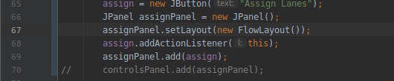


- File Name – pinsetter.java
Changes – removed an unnecessary if condition on line 145

- File Name - Lane.java
Changes – removed unnecessary else condition on line 333. removed unncessary else if condition in function receivepinsetterevent

- File Name – ControlDeskView.java
Changes – reduced the length of constructor functions by calling functions from it
Why – constructor function initially too big. Separation of concerns. Reduce complexity

- File Name – Panels.java (will prolly change name of file and class later)
Changes – new class
Why – A lot of repetitive code in creating panels and button which was increasing code length of two classes – ControlDeskView and AddPartyView (changes in AddPartyView are not yet done)
Able to reduce code length of ControlDeskView.java, AddPartyView.java, LaneStatusView.java NewPatronView.java. This made a piece of code heavily reusable. NewPatronView.java’s and EndGamePrompt.java’s code length is now low according to CodeMR

- File Name – LaneStatusView.java and NewPatronView.java EndGameReport.java EndGamePrompt.java
Changes – removed unused import statements
removed unused variables like fLabel and buttonMargin

- File Name – EndGameReport.java
Changes – removed main function as it was doing nothing

- File Name – LaneView.java
Changes – removed unused variable and used Panel class to add a button

- File Name – Lane.java
Changes – removed all scoring related functions from Lane class to Scoring class(new)
Why – Lane class was insanely long. I couldn’t even get myself to read it properly. Also it seemed to be handling lane as well seemed to be calculating score. Calculation of score does not seem to the role of Lane class. It deserves a separete class(especially considering the big code of getScore() function)
According codeMR, complexity of Lane reduced from medium high to low-medium( coupling increased though)

- File Name – PinsetterView
Changes – Removed dead code (main function);
Reduced code lenth by using loops

- File Name – PrintableText
Changed – Removed C Style array declaration on line 35

- File Name – Scoring.java
Changed – broke into two classes Scoring and Throws. Helped reduce complexity of Scoring a lot.

- File Name – ControlDesk.java
Changes – Broke into two classes
Why – According to codeMR(metrics), the lack of cohesion in ControlDesk was medium high. This probably beacuse of their exists two types of function:--- handling the playing party queue and assigning lanes.. all in the same class. These two types of functions are not at all related to each other. So making a new class for handling the queue of playing parties.
Reduced code size as well as cohesion in codeMR

- File Name – AddPartyView.java
Changes -
  - removed unused import java.swing.border.*
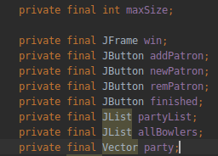
  - removed deprecated API usage – win.show() and win.hide()
  - made a lot of variables final

- File Name – Alley.java
Changes – made ControlDesk field final.

- File Name – Bowler.java
Changes – made 3 variables final

- File Name – ControlDesk.java
Changes --
  - removed unused import java.io.*
  - made many variables final

- File Name – ControlDeskEvent.java
Changes – Made partyQueue final

- File Name – ControlDeskObserver.java
Changes – removed redundant public modifier from interface method (same is true for all other interfaces”

- File Name – ControlDeskView.java
Changes --
  - removed deprecated API usage win.show() and win.hide() [replaced by win.setVisible(bool)]
  - added final modifier to a lot of variables
  - removed unused field “assign”

- File Name – drive.java
Changes – removed unused imports

- File Name – EndGamePrompt.java
Changes --
  - Removed unused imports
  - Added final modifier to some vairables
  - Removed unused fields

- File Name – EndGameReport.java
Changes --
  - Removed deprecated API usage
  - Add final modifier to some variables
  - Removed unused imports
  - make memberList local variable in constructor instead of a class field.

- File Name – LaneEvent.java
Changes --
  - removed unused field “frame” and unused getter “getFrame()”
  - Parameter list of LaneEvent is veryyy long. Removed “theCurScores” from the parameter list as it was of no use and removed the assosciated field “curScores”
  - Code smell found -- “ Indecent Exposure “ . Made all the fields private and added final modifier.

- File Name – LaneStatusView.java
Changes --
  - Removed deprecated API usage Integer()
  - Removing unnecessary else condition reduce cyclomatic complexity in method according to metric (that’s why a clor change)
  - Removed unncessary field laneNum (which was set but never used)
  - Added final modifier to a lot of fields
  - Made field “foul” a local variable in constructor
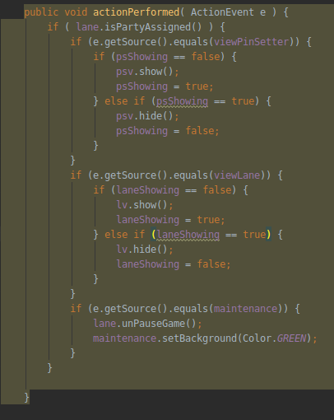
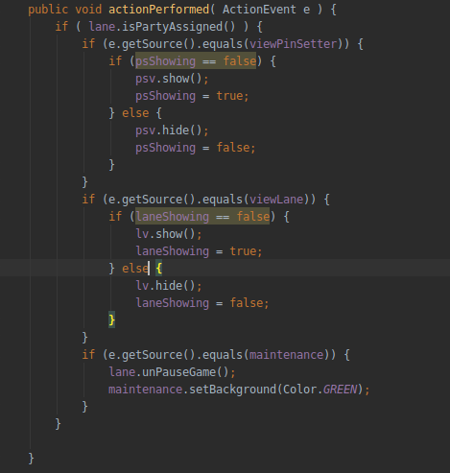

- File Name – LaneView.java
Changes --
  - removed deprecated API usage.
  - Made a lot of fields private
  - converted many fields to local variables

- File Name – Pinsetter.java
Changes – Removed unused imports

- File Name – PinSetterView.java
Changes --
  - removed deprecated API usage
  - removed unused imports

- File Name – PrintableText.java
Changes – Made fields private

- File Name – Lane.java
Changes – bad method name pause and unpause game.

- File Name – Lane.java
Changes --
  - After implementing new features, its complexity, cohesion and coupling all increased. Moving endGame to a different class, as it alone interacts with two three class.
  - Removing unused function unsuscribe()
  - Moved continue game also to the same class as endGame. Metrics look a little better now

