Module | Field | Table Name | Field in Eracent | Image Number
Contract | Vendor | Select Company Vendor Name | Company Name | Image-1
PO | Purchased From | Companies | Company Name | Image-2
Catalog | Make | Companies | Company Name | Image-3
Catalog | Suppliers | Companies | Company Name | Image-4
Assets | Make | Comes from Catalog. | Company Name | xxx
Relationship of the company name with the modules in Eracent.

Image-1 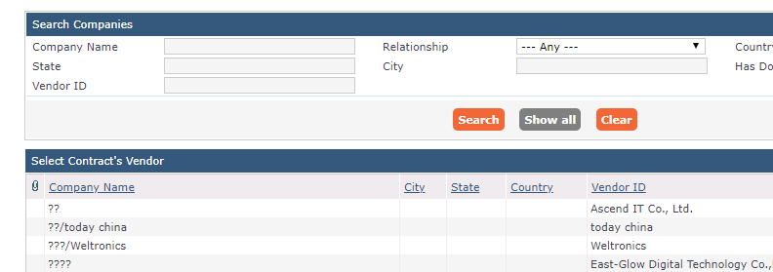
Image-2 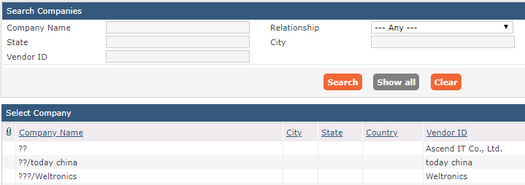
Image-3
Image-4

