**Capacity For a Team**

**Steps to Execute Sprint Planning**

* Excel Upload the Number of Holidays and leaves available in Year
* Create a Module of employee individual availability and hours of works
* Sprint Planning 3 weeks before
* Calculate the Total Available Capacity and Installed Capacity
* Show results on their individual dashboards

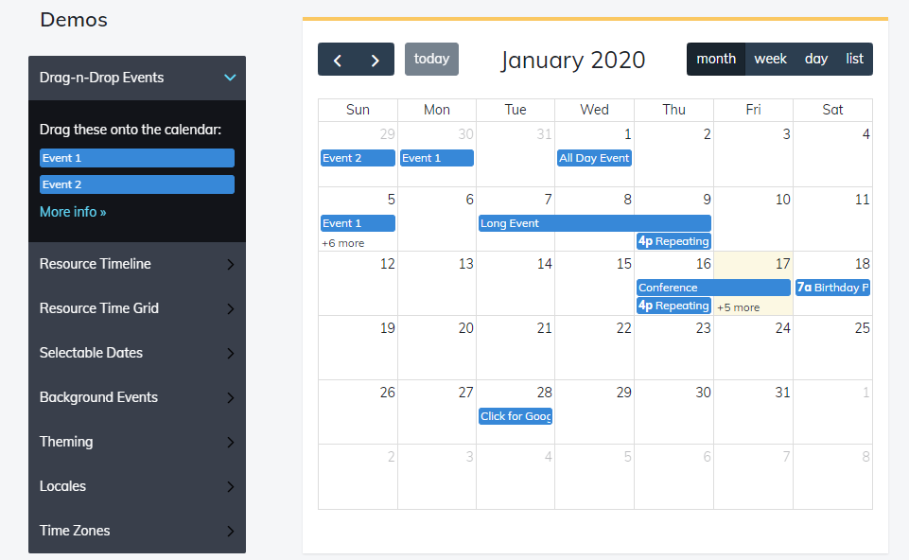

* Individual calendar and their time-table and their given taks will

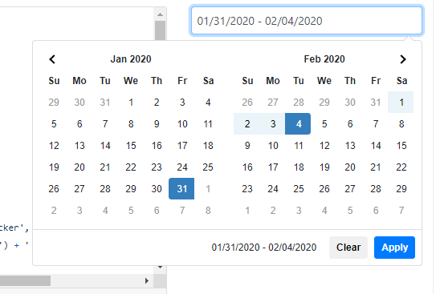

* Taking the leave from-to date for tacking availability of the employee
* Expected result for the Sprint Planning

|  |  |  |  |  |
| --- | --- | --- | --- | --- |
| Sno | Name | Total Expected | Available Hours | Result |
| 1 | Sainath | 160 hrs | 152 hrs | -8 hrs |
| 2 | Santhosh | 160 hrs | 168 hrs | +8 hrs |
| 3 | Sandesh | 160hrs | 176 hrs | +16 hrs |

**Total Installed capacity= No of days in a month – Saturdays – Sundays – holiday plan**

**Total Avl capacity = Total Installed capacity- Leave**

**Actual Work hours = Total Tasks Time**

**Meetings**