**Eracent Implementation Help Guides**

**Use Case: How to Import New Contract with Different categories of Contract Type and Auto-Generate Contract Number through Data Sharing and Importing from Excel Sheet.**

The user gets the contract data ready as per the below excel.

* Create a New Excel Sheet with the contract data as per the below screenshot.

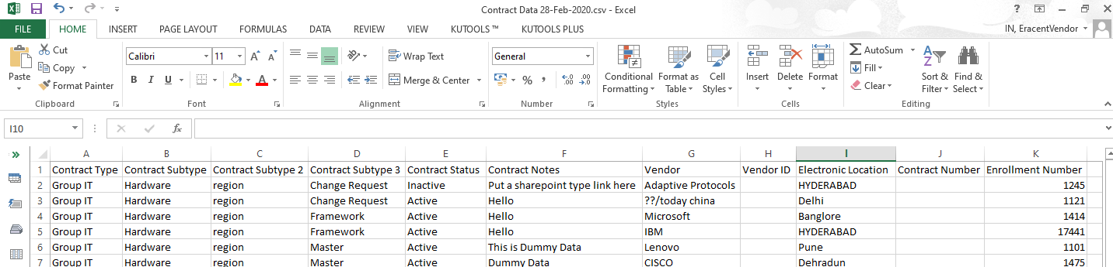

The user logs into the Eracent Tool>Lifecycle>DataSharing>Import data select text file and click on Import.

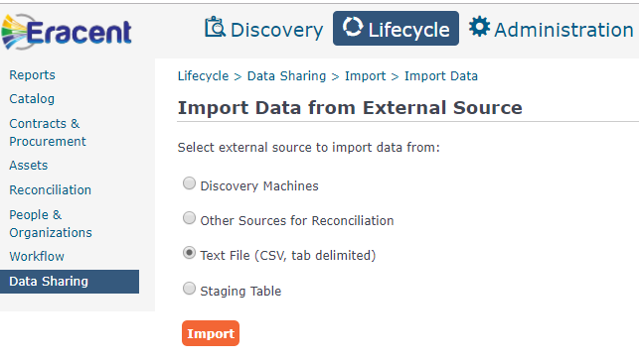

CSV Import Wizard screen opens up. Once the File is selected click on the Next Button.

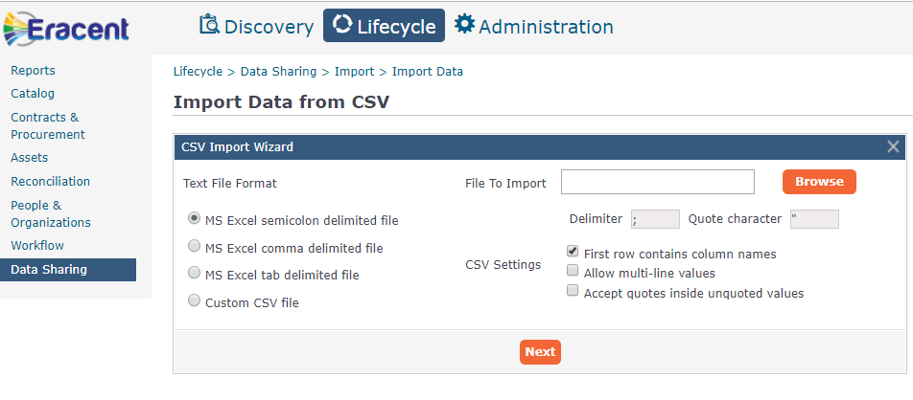

By clicking on the Browse button the xls sheet is located and selected.

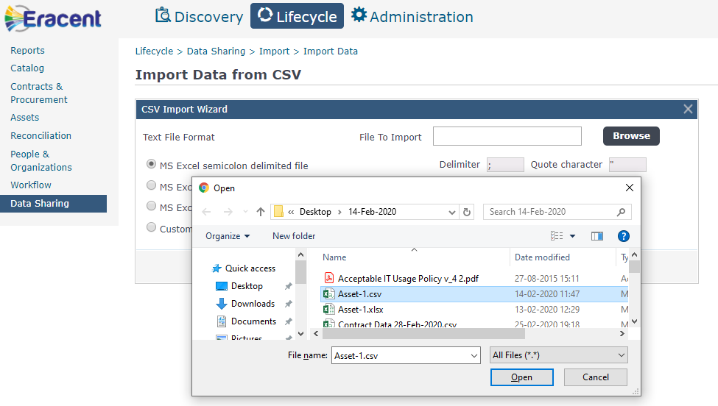

Once the xls sheet is selected it appears on the File to Import Field

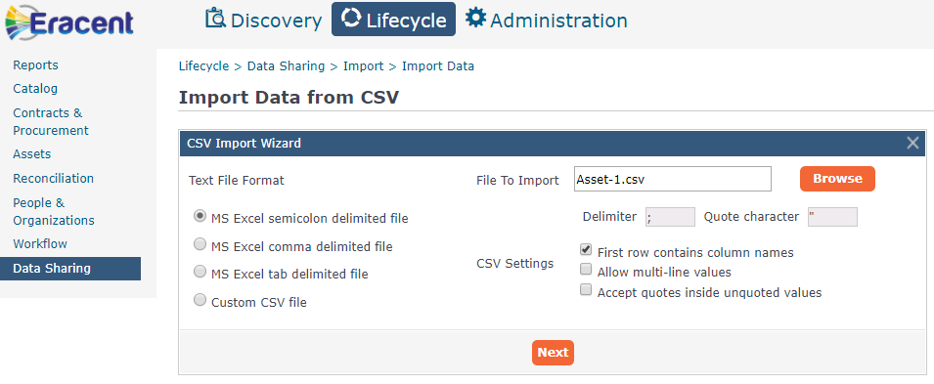

Click Next. Once the Next Button is clicked the below mentioned screen appears 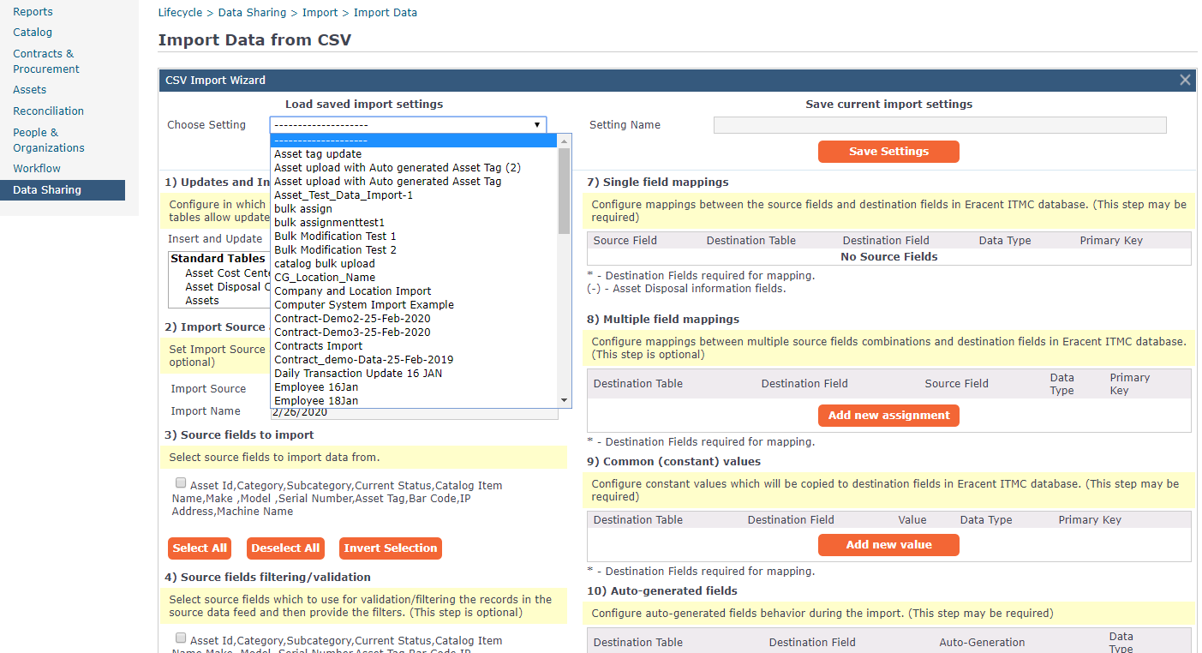

Select the Setting if you have already saved a setting from the list or create a new setting.

Mapped the data as per the below screenshot. 