**Steps to Reproduce Bugs:**

**Issue 1:**

Go to Task Management Application,

Under Requirements Tab:

1. Add New Requirements
2. Refer a Requirement added: REQ-ID: PJ6REQ0002; Project : Nixs Mobile
3. Click on the + symbol to expand and to perform the Action **Edit** to this Requirement
4. A database error is displayed as shown in the Screen Shot below.

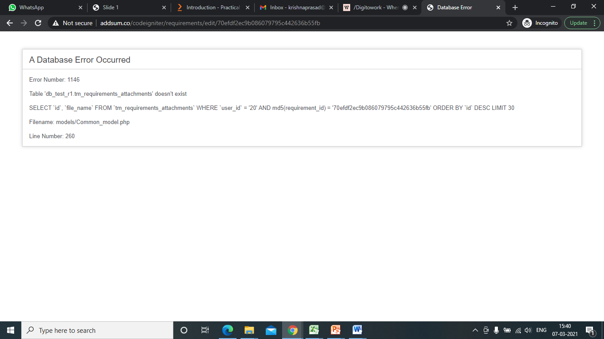

**Issue 2:**

Go to Task Management Application,

Under Requirements Tab:

1. Add New Requirements
2. Refer a Requirement added: REQ-ID: PJ6REQ0002; Project : Nixs Mobile
3. Click on the + symbol to expand and to perform the Action **View** to this Requirement
4. No requirement details are shown, it is not displaying any project requirement details but going to Assigned Tasks and is empty as below screenshot:
5. 