**Difference between Category user fields and Catalog user fields**

This document is intended to provide the differences between a Category user fields and Catalog user-fields in Catalogs.

**Category User-Fields**: Category User-Fields assigned to the Catalog based on the category of the Catalog. Each catalog has Category User Fields assigned based on the category of the catalog. Category user fields can be assigned at the time of creating the catalog category by selecting the “Manage Category User Fields”.

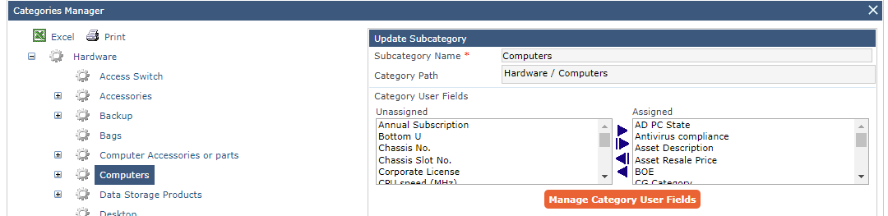

We cannot change the template(format) of category user fields in the Catalog item details view window.

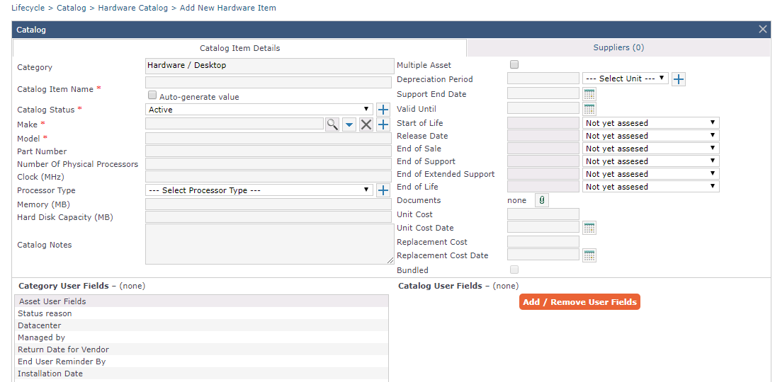

Note: We can also assign and un-assign category user fields after creating the catalog item but we may loose data assigned to the fields.

Creating Category user fields:

Administration> Lifecycle Administration> Reference Tables> User Fields> Category User Fields

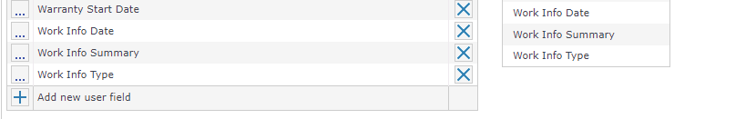

After selecting “add new user field” a new table will pop up where we can create a new category user field.

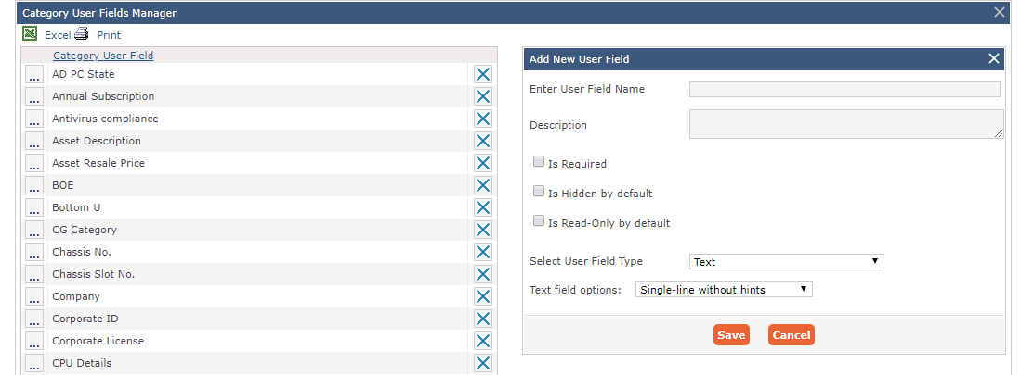

**Catalog User-Fields:** Catalog user fields can be at the Catalog item details view window. Catalog user fields can be defined for the specific catalog item. It will be vary for item to item for the same category.

**Creating catalog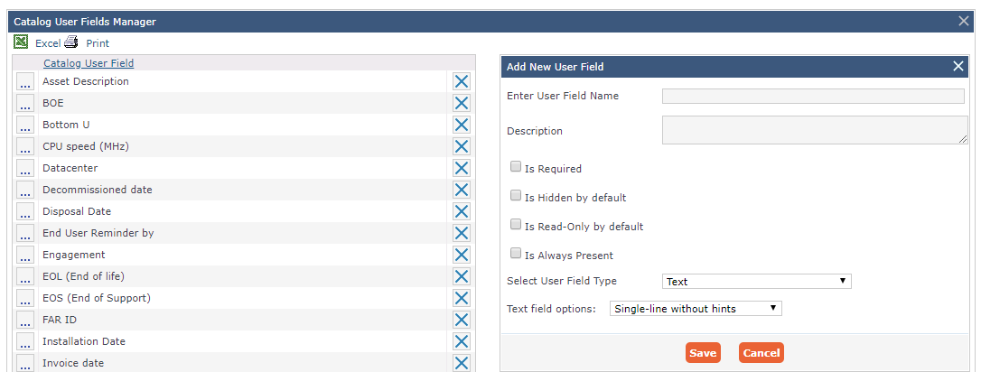 user fields**:

Administration> Lifecycle Administration> Reference Tables> User Fields> Catalog user fields

Assigning Catalog user fields:

