Steps to Update Mapping in Catalog:-

Step:- 1

• [Lifecycle](http://frparvm87385207/EnterpriseLM/LifecycleReportsMenu)

•  > [Catalog](http://frparvm87385207/EnterpriseLM/CatalogMenu)

•  > [Software Catalog](http://frparvm87385207/EnterpriseLM/CatalogMenu/Catalog_3/SoftwareCatalog)

•  > [View/Edit Software Items](http://frparvm87385207/EnterpriseLM/BrowseCatalogs.aspx?category=Software&restore=y)

•  > [Catalog Item](http://frparvm87385207/EnterpriseLM/ViewCatalog.aspx?id=21542&backURL=%2fEnterpriseLM%2fBrowseCatalogs.aspx%3fcategory%3dSoftware)

* Go to Catalog > Software Catalog > View / Edit Software Items > Catalog Item.
* Click on **Edit** > **License Reconciliation Knowledgebase Mapping**[**Edit**](http://frparvm87385207/EnterpriseEM/EEM_Mappings/CatalogItemMapping.aspx?Catalog_ID=21542)

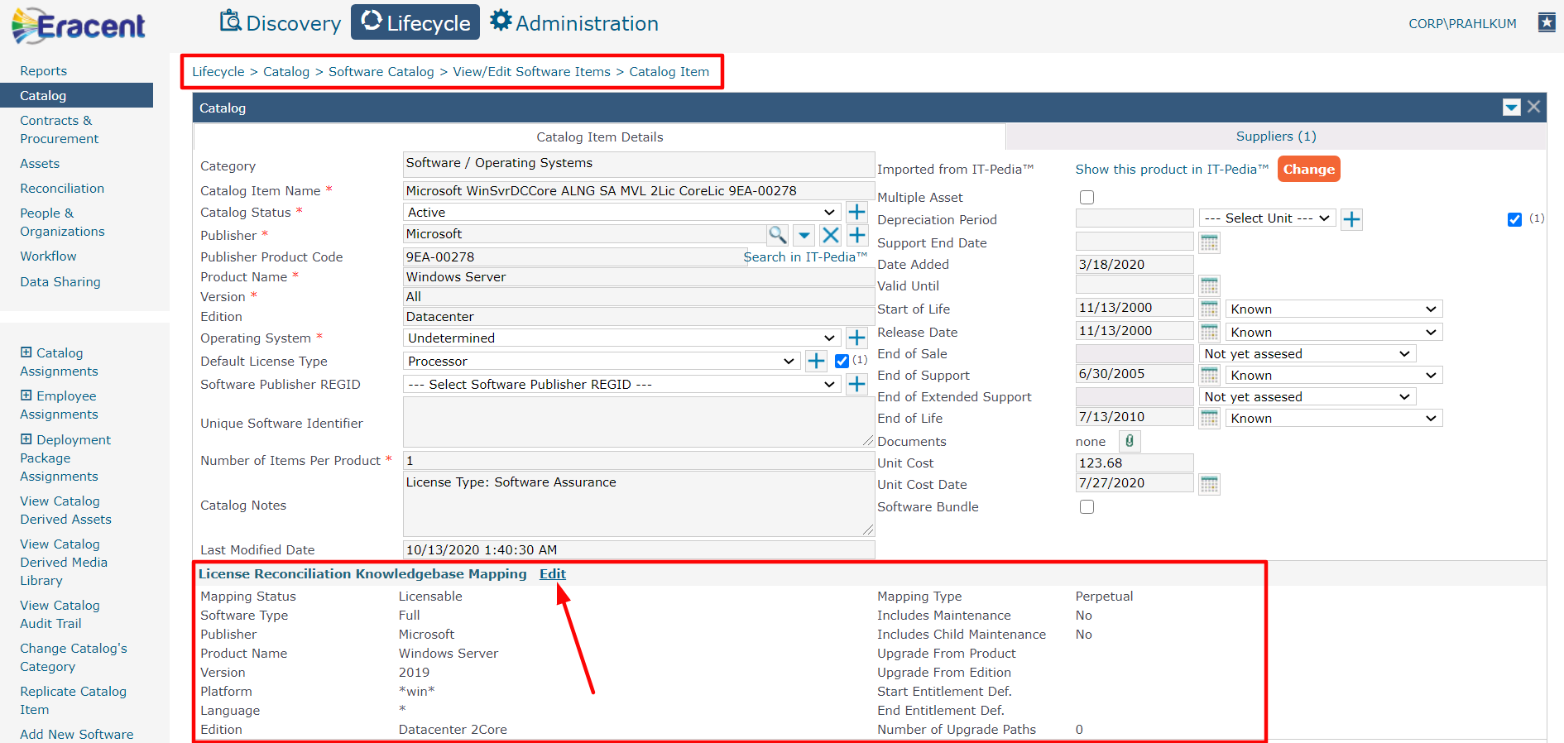

Step: - 2

* According to Entitlement Definition We can change **Mapping Status and Mapping Type.**
* We can filter as per different Criterion.

**Publisher Filter**, **Product Filter** and **Version Filter.**

* After Filtered the Product select **Version** from the **Version Filter** List.
* Click on **Map** button.
* According to below attached Screenshot.

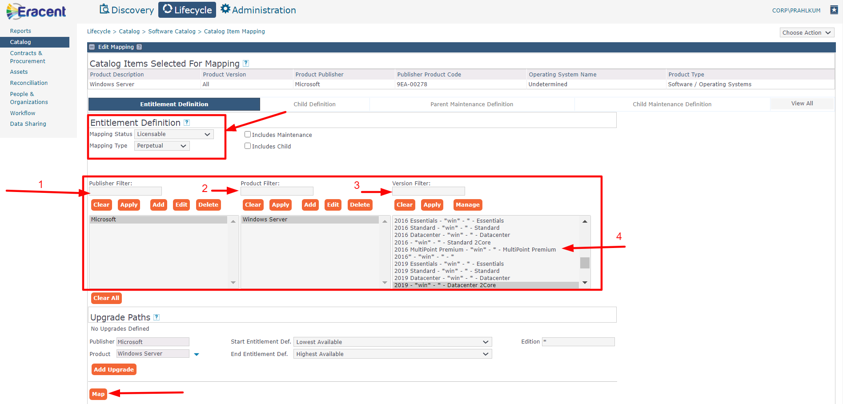

Step: - 3

* After that Click on **Apply** Or **Save and Close** Button.
* It will Ask you “Catalog field value will be propagated to the Asset level.
* Click on **Yes.**

