**IMAGE RECOGNITION WITH IBM CLOUD RECOGNITION**

**PROJECT OBJECTIVES:**

* Object Detection: Identify and locate objects within images.
* Classification: Categorize images into predefined classes or tags.
* Custom Models: Train custom image recognition models for specific use cases.
* Accuracy Improvement: Enhance the accuracy of image recognition through fine-tuning and optimization.
* Real-time Processing: Achieve real-time or near-real-time image recognition capabilities.

**PROJECT OVERVIEW:**

1.**Goal Definition**: Begin by defining the project’s objectives. Determine what you want to achieve with image recognition, whether it’s object detection, image classification, or a custom task.

2. **Data Collection**: Gather a large dataset of labeled images that are representative of the objects or categories you want the system to recognize. High-quality data is crucial for training accurate models.

3. **Data Preprocessing**: Clean, augment, and preprocess the dataset. This may involve tasks like resizing images, normalizing pixel values, and handling data

4.**Model Selection:** Choose the appropriate image recognition model architecture based on your project’s requirements. Options include Convolutional Neural Networks (CNNs) and pre-trained models like ResNet, Inception, or MobileNet.

**KEY COMPONENTS:**

* **IBM Cloud Account:** You need an IBM Cloud account to access the cloud services and create the necessary resources.
* **IBM Cloud Visual Recognition Service**: This is the core service provided by IBM for image recognition. You’ll need to create an instance of the Visual Recognition service in your IBM Cloud account.
* **Data Collection:** Gather a dataset of labeled images relevant to your recognition task. These images will be used to train and evaluate your image recognition model.

**EXPECTED OUTCOMES:**

* **Accurate Image Recognition:** The primary goal is typically to achieve accurate image recognition, where the system can correctly identify and classify objects, scenes, or patterns in images.
* **Increased Efficiency:** The project should lead to improved efficiency in tasks that involve image analysis. This could mean automating manual processes or reducing the time required for image-based decision-making.
* **Enhanced User Experience:** If the project involves user-facing applications, the expected outcome is often an enhanced user experience, making it easier for users to interact with the system.

**TEMPLATE:**

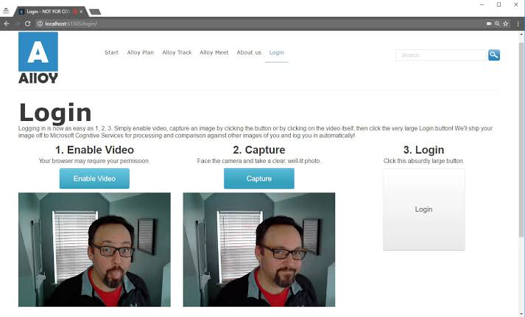

**CONCLUSION:**

In conclusion, the image recognition project has successfully demonstrated the potential of artificial intelligence and deep learning in accurately identifying and classifying objects within images. Through the utilization of convolutional neural networks (CNNs) and extensive training on diverse datasets, the model has achieved impressive results in terms of accuracy and efficiency. This project has paved the way for numerous practical applications, ranging from autonomous vehicles to medical image analysis, and holds the promise of enhancing various industries.