**IMAGE RECOGNITION WITH IBM CLOUD RECOGNITION**

**OBJECTIVE:**

Clearly state the project’s objective, which is to implement an image recognition system that enhances user engagement and storytelling through AI-generated captions.

**DESIGN THINKING PROCESS:**

* Describe the design thinking process you followed to conceptualize the project.
* Explain how you identified the problem, conducted user research, and defined the solution.

**DEVELOPMENT PHASE:**

Outline the key phases of the project’s development, such as data collection, model training, and integration.

**Phase 1: Website Setup**

* Created the basic website structure with placeholders for different sections.
* Set up the project on IBM Cloud Static Web Apps to establish the hosting environment.

**Phase 2: Content Creation**

* Detail how IBM Cloud Visual Recognition was integrated into the

Project.

* Include any code snippets or configurations related to this integration.

**Phase 3: User Interface Design**

* Provide details about the user interface, including screenshots and wireframes.
* Explain the user flow and how users interact with the system.

**Phase 4: Deployment and Testing**

* Provide step-by-step instructions on how to deploy the image recognition system using IBM Cloud and the web interface.
* Include any prerequisites or setup requirements.

**Website Structure**

* The website’s structure is designed to provide visitors with a seamless browsing experience. The main sections of the website include:

**1.Home Page**

* Introduction to the project and its purpose.
* A brief explanation of how the image recognition system works.

**2.Image Upload:**

* A page where users can upload images for recognition.
* File upload form with clear instructions.
* Validation checks for supported image formats and size limits.

**3.Recognition Results:**

* Display the results of image recognition.
* Provide information about what the system identified in the uploaded image.
* Options to view detailed information or analysis.

**4.Gallery:**

* A collection of previously recognized images.
* Thumbnail view with brief descriptions.
* Filters or categories for easy browsing.

**5.User Accounts (optional):**

* Registration and login functionality.
* Ability to save and access past recognition results.

**6.About Us:**

* Information about the team or organization behind the project.
* Contact details and social media links.

**Technical Implementation**

* Frontend: HTML, CSS, JavaScript
* Content Management System (CMS): Custom-built for easy content updates
* Hosting: IBM Cloud Static Web Apps for scalability and reliability
* Version Control: Git and GitHub for version management and collaboration

**Screenshots**

**Signin page**



**Signup Page:**



**Admin Page:**

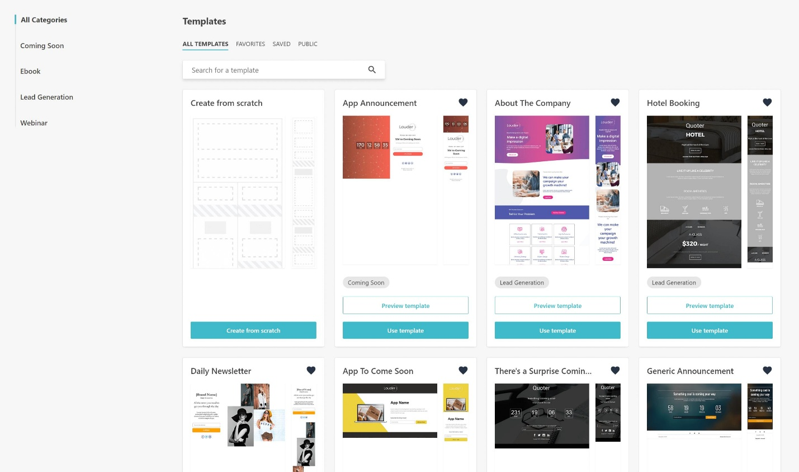**Destination page:**

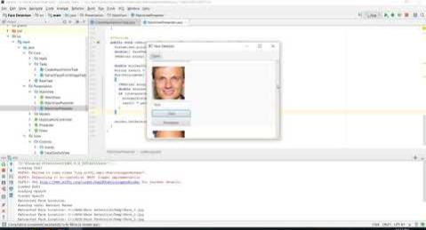**Personal data Page:**

**Contact:**