Air Quality Analysis And prediction in tamilnadu

Phase5

**Proj_216159_Team1**

**Vasudevan.V.P (team member)**

* Analyzing air quality in Tamil Nadu, or any other region, is an important task for environmental monitoring and public health. Here are the steps you can take to define project objectives, analysis approach, visualization techniques, and code implementation for an air quality analysis project in Tamil Nadu

**1. Project Objectives:**

Define your project's specific objectives. For instance, you might want to:

* + Monitor and assess the air quality in different regions of Tamil Nadu.
  + Identify trends and patterns in air quality data.
  + Understand the impact of various factors (e.g., industrial activity, traffic) on air quality.
  + Develop predictive models for air quality.
* **Air Quality Monitoring:** Monitor and assess air quality in various regions of Tamil Nadu.
* **Trend Identification:** Identify trends and patterns in air quality data.
* **Impact Analysis:** Understand the impact of factors like industrial activity and traffic on air quality.
* **Predictive Modeling:** Develop predictive models for air quality.

**2. Data Collection:**

* Gather air quality data for Tamil Nadu. You can collect data from government agencies, research institutions, or use sensor networks.
* Ensure data quality and consistency.

**3. Analysis Approach:**

* Preprocess the data by cleaning, handling missing values, and transforming it into a suitable format for analysis.
* Perform exploratory data analysis (EDA) to understand the data distribution, correlations, and outliers.
* Use statistical and machine learning techniques to analyze the data. Potential analyses could include:
  + Time series analysis to identify temporal trends.
  + Spatial analysis to identify regional variations.
  + Regression analysis to identify factors affecting air quality.
* Develop predictive models if needed, such as regression models or time series forecasting.

**Data Collection:** Gather air quality data from reliable sources.

**Data Preprocessing:** Clean and transform the data for analysis.

**Exploratory Data Analysis (EDA):** Use statistical and visual methods to understand data distribution and correlations.

**Statistical and Machine Learning Analysis**: Analyze data using techniques such as time series analysis, spatial analysis, and regression analysis. Develop predictive models if needed.

**4. Visualization Techniques:**

* Data visualization is crucial for conveying insights. Use libraries like Matplotlib, Seaborn, or Plotly in Python to create visualizations.
* Common visualizations for air quality analysis include time series plots, heatmaps, scatter plots, and choropleth maps. You can visualize:
* Temporal trends in air quality over time.
* Spatial distribution of air quality across regions.
* Relationships between air quality and other variables (e.g., weather data, industrial activities).
* Use color-coding, legends, and annotations to make your visualizations informative.

**Code implementation:**

* Ensure you have the necessary data sources, Python libraries, and tools for this project. Additionally, consider using Jupyter notebooks or similar tools for an interactive and well-documented analysis process.
* This is a simplified overview of the steps involved in an air quality analysis project in Tamil Nadu. The specific implementation may vary based on your objectives, data sources, and the depth of analysis you wish to perform.

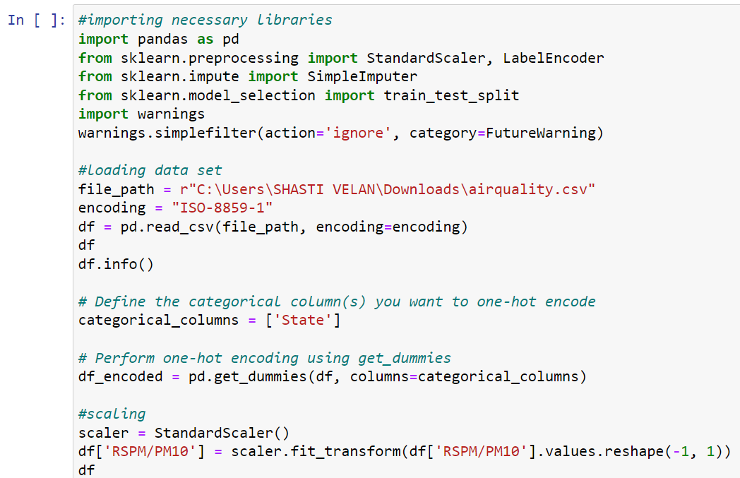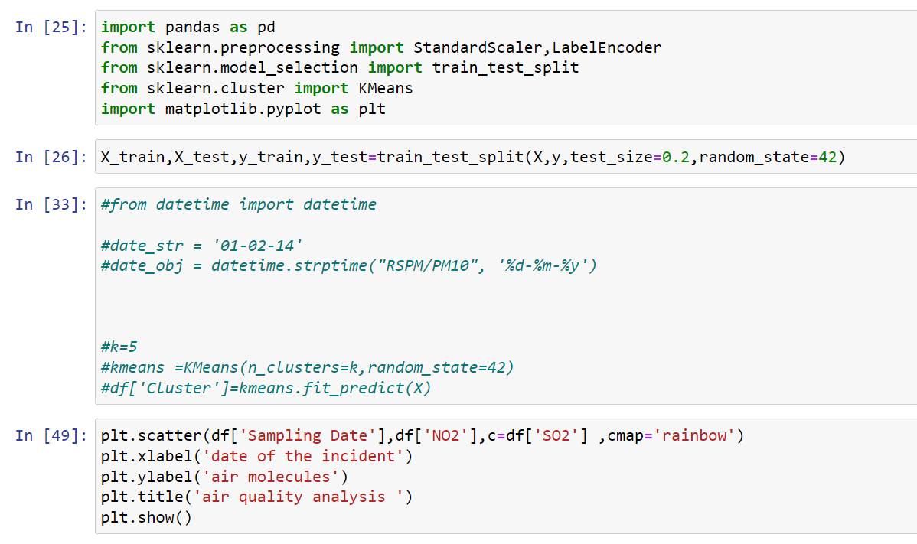

**Outputs Of Data Analysis And Visualization**:

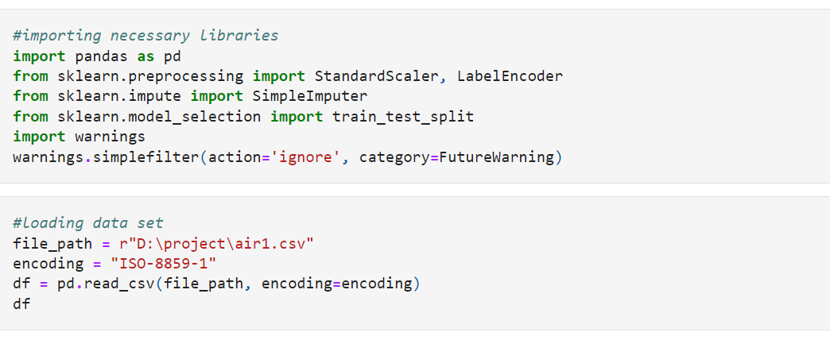

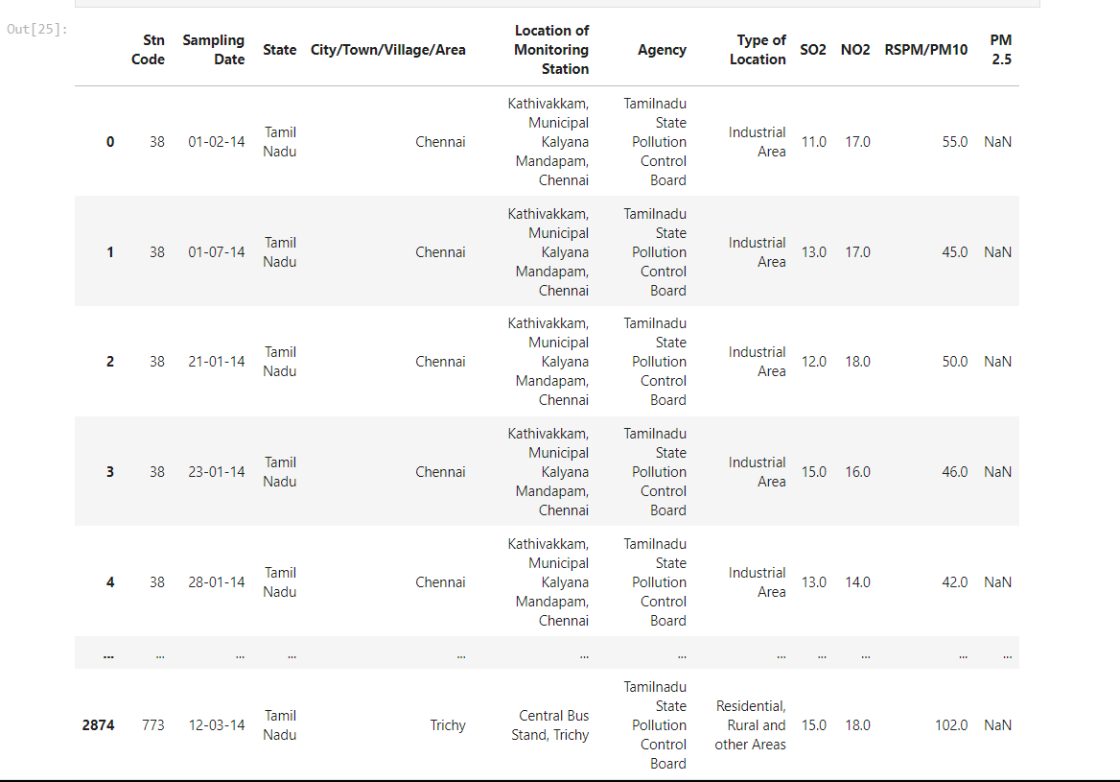

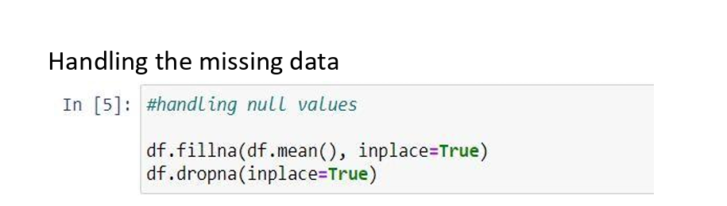

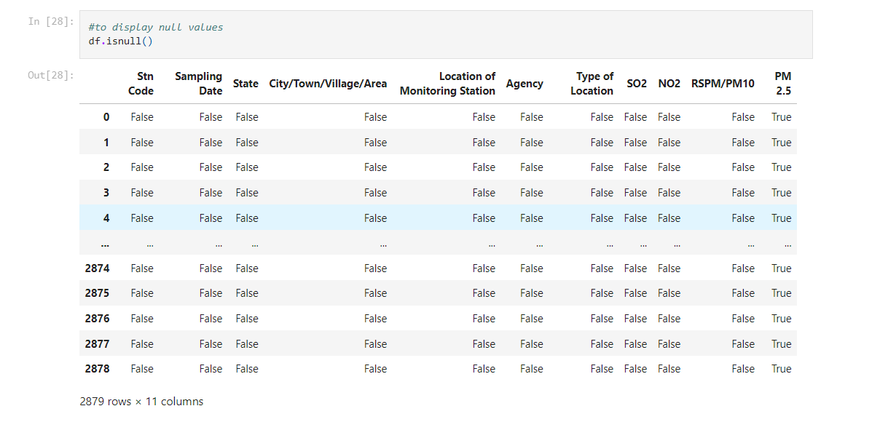

**Label Encoder:**

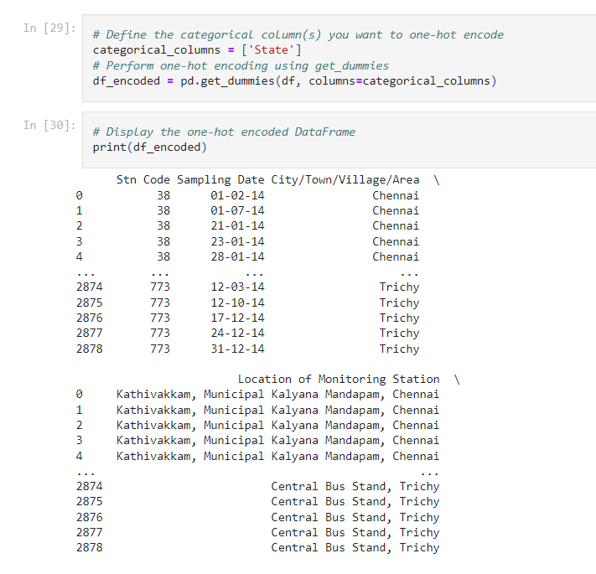

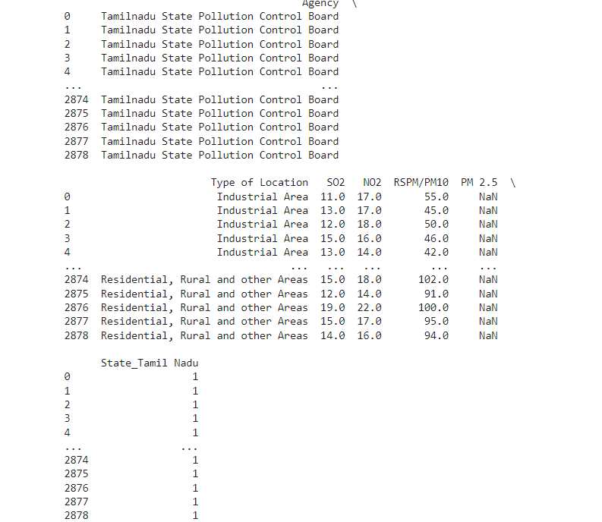

**Feature Scaling using StandardScaler:**

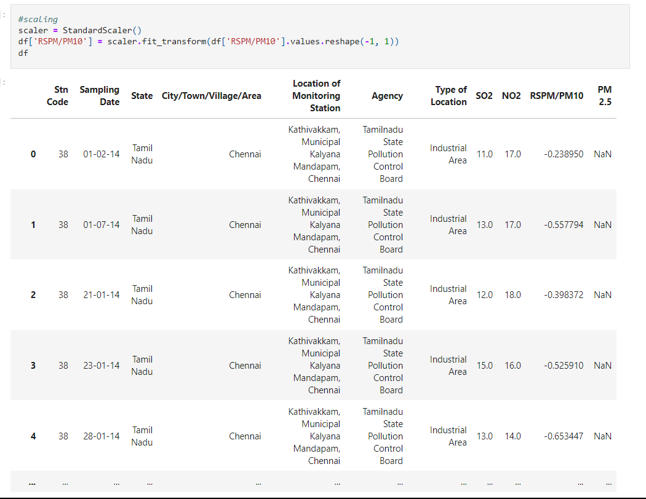

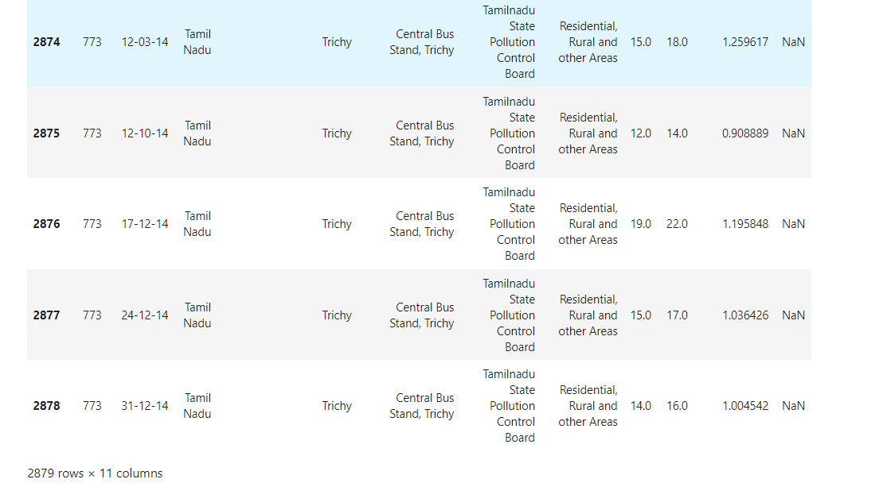

**Splitting the data into a training set and a test:**

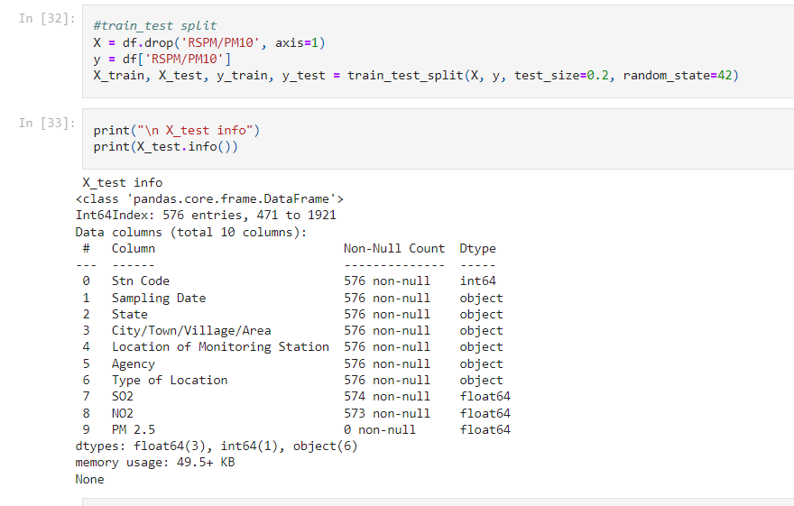

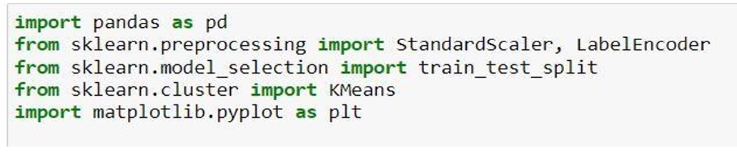

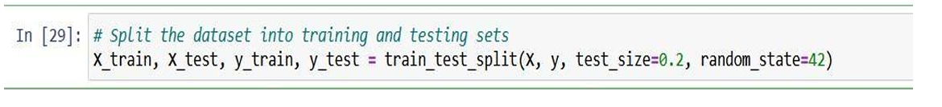

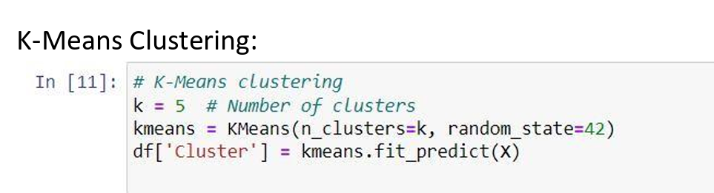

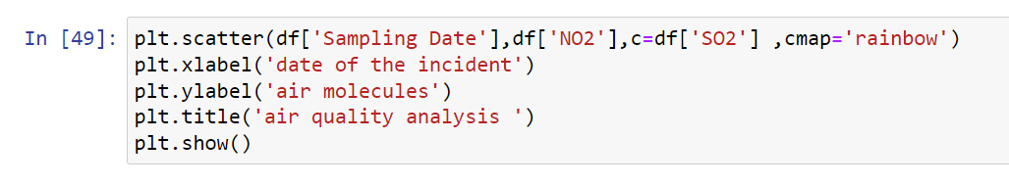

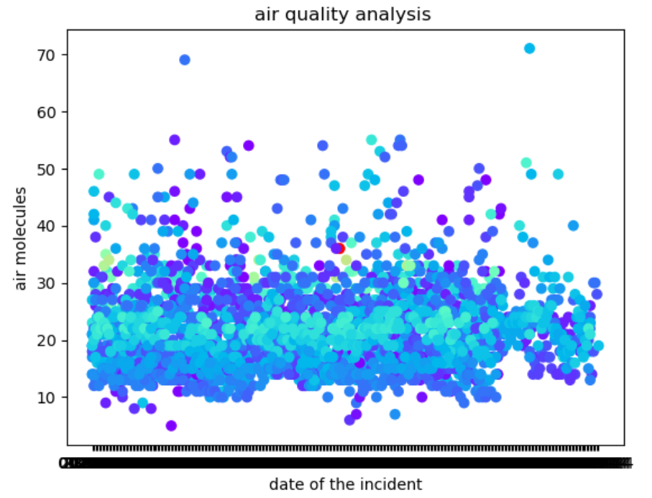

**How the analysis provides insights into air pollution trends and levels:**

An analysis of air quality data in Tamil Nadu can provide valuable insights into air pollution trends and pollution levels in the region by using the objectives, approach, and visualization techniques mentioned earlier. Here's how the analysis can provide these insights:

1. **Temporal Trends in Air Pollution:**
   * By creating time series plots of air pollutants over a period of time, you can identify temporal trends. For example, you may notice seasonal variations in pollution levels, with higher levels during certain months.
   * These trends can help in understanding the impact of factors like weather conditions, industrial activities, and traffic on air quality.
2. **Spatial Distribution of Pollution:**
   * Using heatmaps and choropleth maps, you can visualize the spatial distribution of pollution levels across different regions in Tamil Nadu.
   * This analysis can reveal "hotspots" of pollution, areas where air quality is consistently poor. Identifying these areas can inform targeted pollution control measures.
3. **Correlation Analysis:**
   * Analyzing the correlation between air quality and various factors (e.g., weather data, industrial emissions, traffic density) can help identify the main drivers of air pollution in specific regions.
   * For instance, you might find a strong positive correlation between pollution levels and industrial emissions, indicating that industrial activity is a significant contributor to pollution in certain areas

.

1. **Predictive Modeling:**
   * If you develop predictive models, you can forecast future pollution levels based on historical data and the identified factors. This can be valuable for early warning systems and decision-making.
   * By analyzing model outputs, you can gain insights into how pollution is likely to evolve in the coming weeks or months.
2. **Policy and Mitigation Recommendations:**
   * Based on the analysis, you can make recommendations for air quality improvement. For instance, if traffic congestion is a major contributor to pollution in urban areas, you might suggest measures such as improved public transportation, congestion pricing, or vehicle emission standards.
   * Insights from the analysis can inform policy decisions and help prioritize pollution control efforts in specific regions.
3. **Public Awareness and Education:**
   * The visualizations and findings from your analysis can be used to raise public awareness about air pollution. Visual representations are often more impactful in conveying the severity of the issue to the general public.
   * Educational materials can be developed to help people understand the factors affecting air quality and what individuals can do to reduce their contribution to pollution.