1.To check a Swap Two Numbers
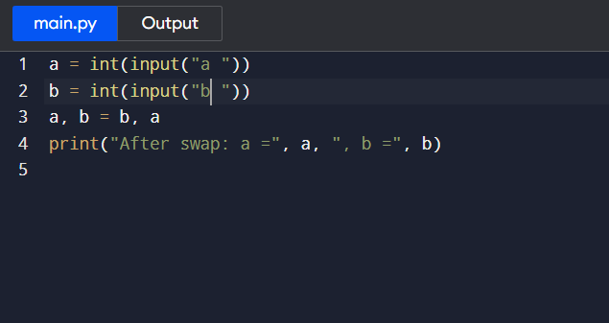

2.Find Largest of Three Numbers
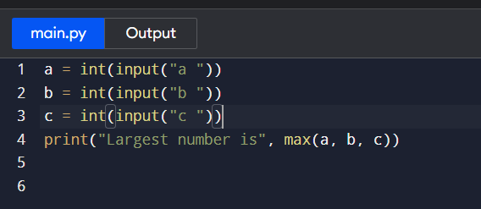

3.Multiplication Table
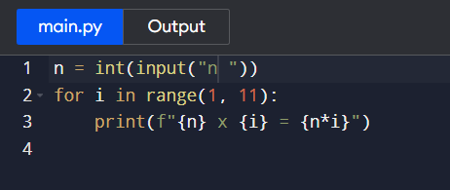

4.Count Digits in a Number
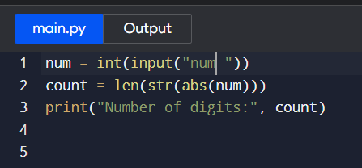

5. Sum of Digits
