1.Palindrome String
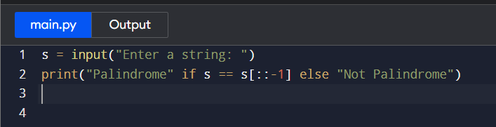
2.Count Vowels in String
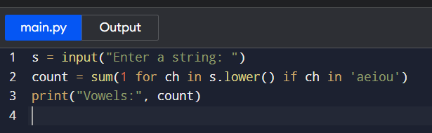
3. Armstrong Numbers in Range
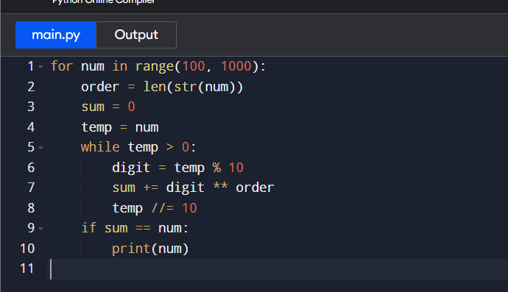

4. Prime Numbers in Range
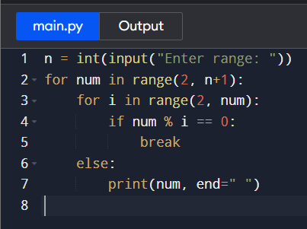
5. Sum of Natural Numbers
