1.To check the given number is palindrome or not.
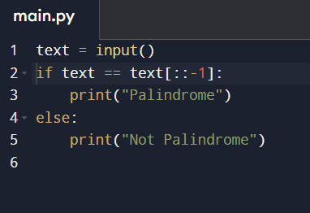

2.to check the given number is Armstrong or not.
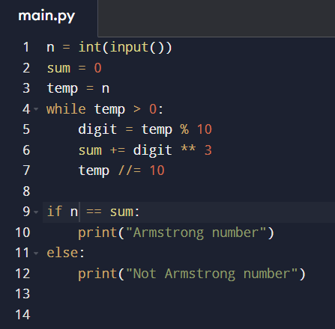

3. write a program program to reverse a string.

