Heart Disease Risk Prediction

An End-to-End MLOps Pipeline

MLOps AIMLCZG523 — Assignment 01
Name:
[STUDENT: insert your name and BITS ID here]

Table of Contents

1. Project Overview
This project builds a binary classifier that predicts presence of heart disease from 13 patient features in the UCI Heart Disease (Cleveland) dataset, and operationalizes it as a monitored, containerized, CI/CD-deployed API — covering the full MLOps lifecycle from data acquisition through production deployment.
Problem statement: given patient health measurements (age, blood pressure, cholesterol, ECG results, etc.), predict the risk of heart disease and serve that prediction through a production-ready API.

2. Setup / Install Instructions
Full instructions are in README.md. Summary:
- pip install -r requirements.txt
- python data/download_data.py
- python src/eda.py && python src/train.py
- uvicorn src.api.main:app --port 8000 (or: docker build/run — see README)
- pytest tests/ -v

3. Exploratory Data Analysis
The dataset contains 303 patients and 13 predictive features plus a 5-level target collapsed to binary (0 = no disease, 1 = disease present) per the assignment's binary-target requirement. Two features had missing values: ca (4 rows) and thal (2 rows).
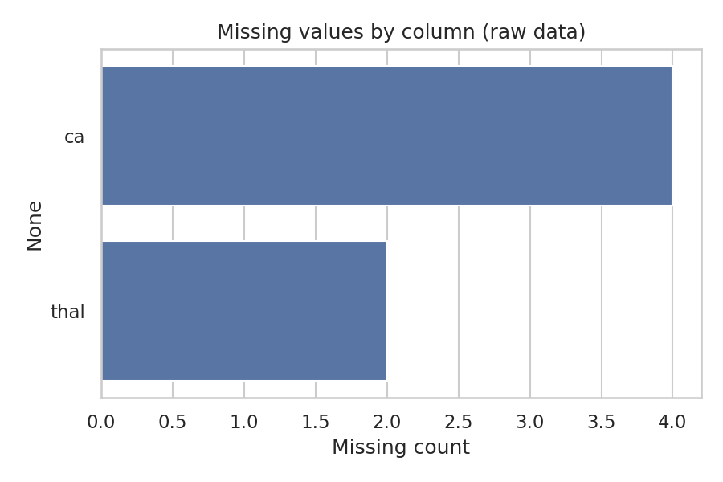
Figure 1. Missing values by column (raw data).
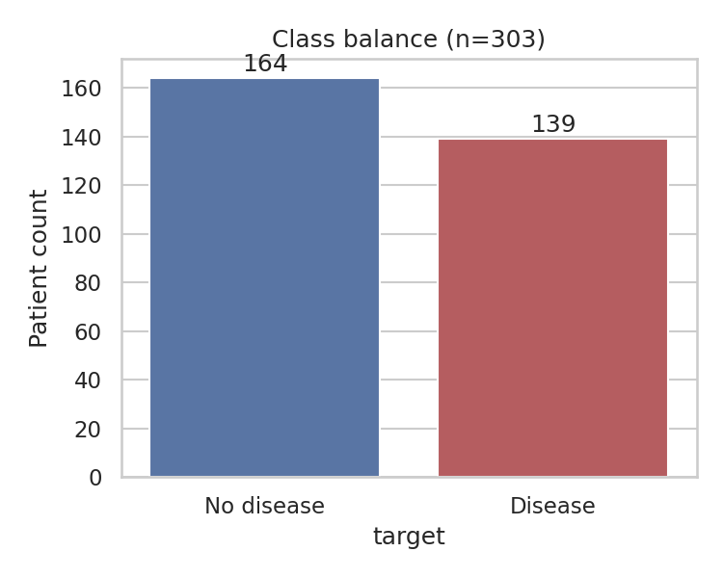
Figure 2. Class balance: 164 no-disease vs. 139 disease.
[STUDENT: describe in your own words whether you consider this class balance acceptable, and why you did or didn't apply class weighting / resampling.]
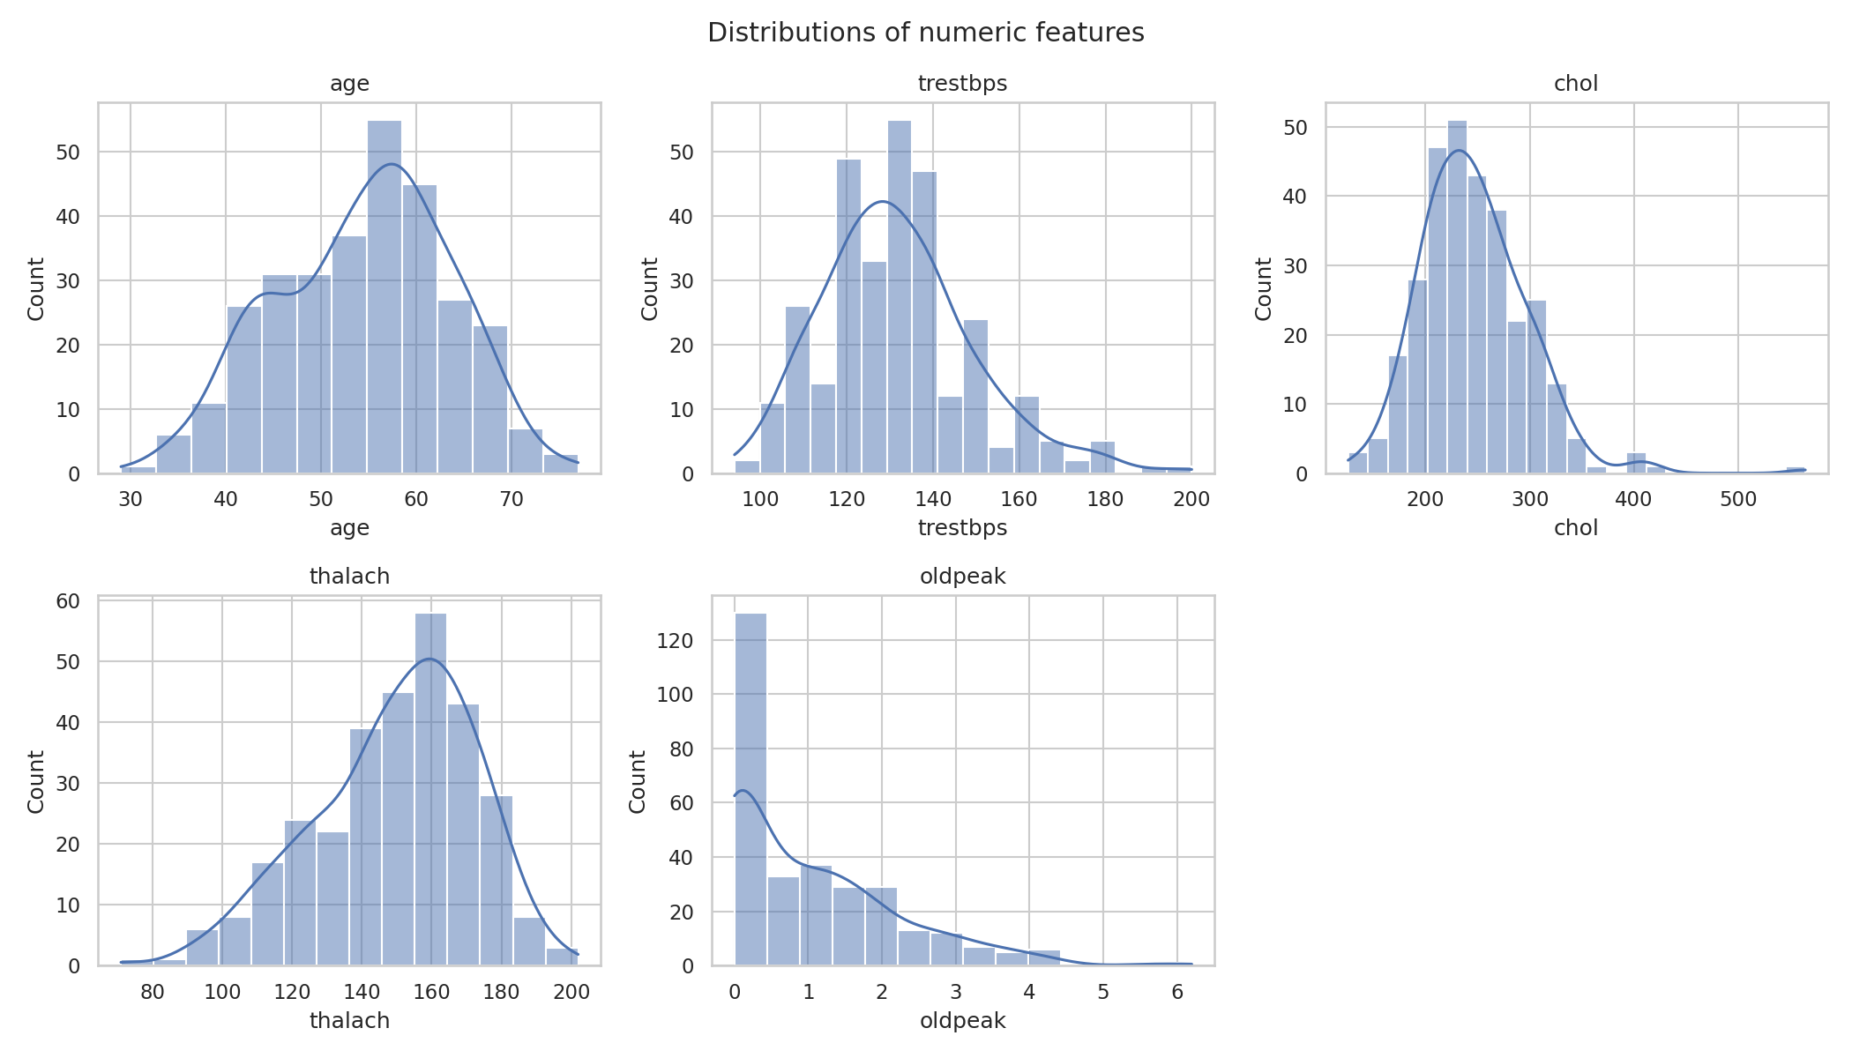
Figure 3. Distributions of numeric features.
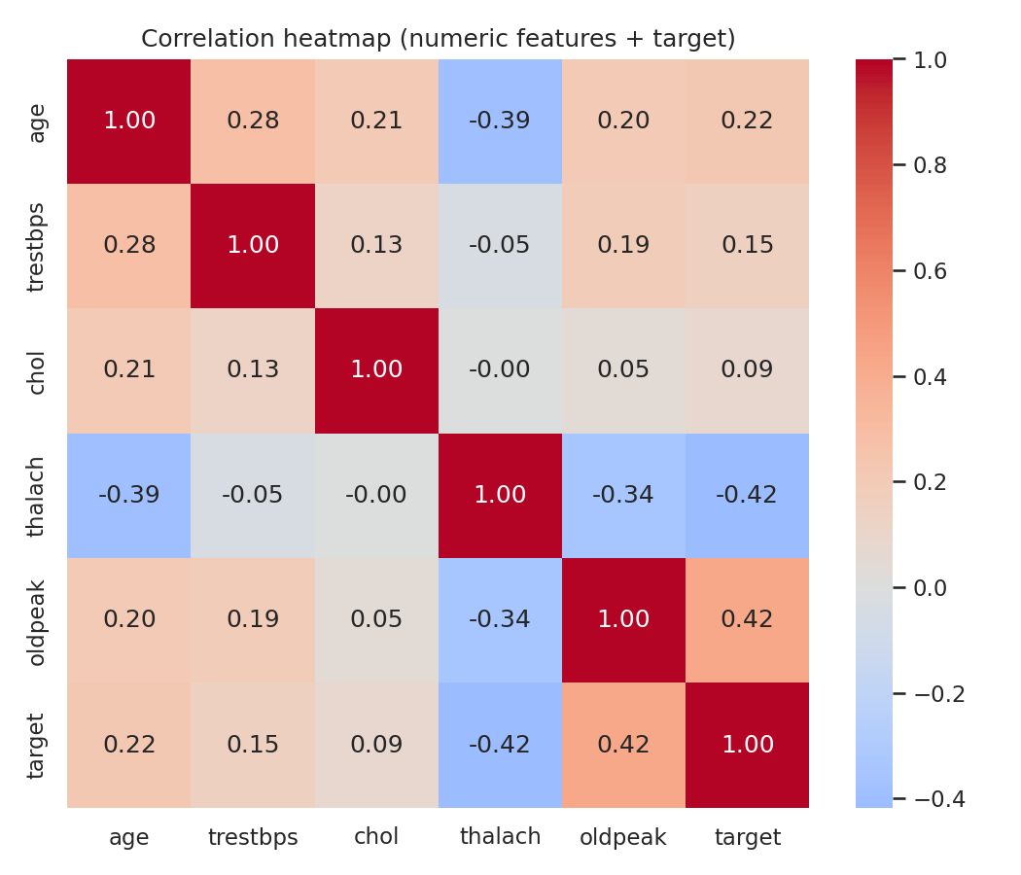
Figure 4. Correlation heatmap (numeric features + target).
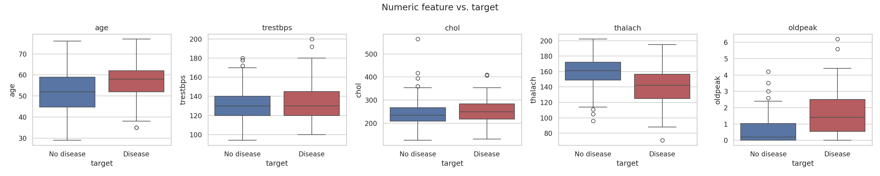
Figure 5. Numeric feature distributions split by target class.
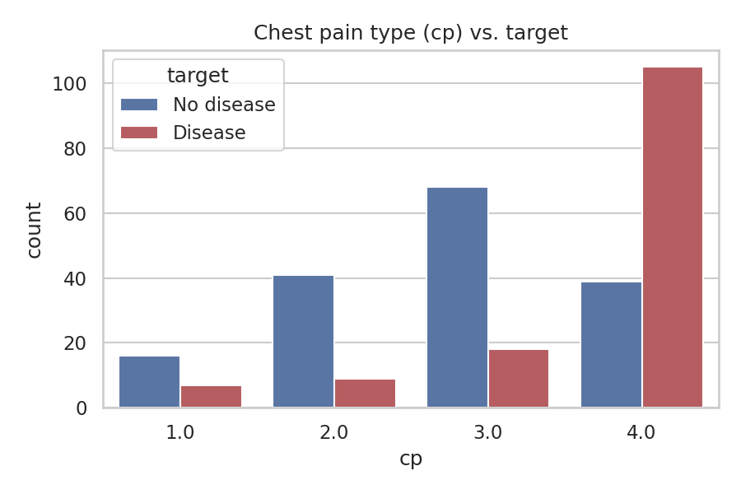
Figure 6. Chest pain type (cp) vs. target.
[STUDENT: add your own clinical/statistical interpretation of at least 2 of the figures above — which features look most separable by eye, and does that match the correlation heatmap?]

4. Feature Engineering & Model Development
Preprocessing: numeric features (age, trestbps, chol, thalach, oldpeak) are median-imputed and standard-scaled; categorical features (sex, cp, fbs, restecg, exang, slope, ca, thal) are mode-imputed and one-hot encoded. Both live inside a single sklearn Pipeline together with the classifier, so the exact fitted transformer is what gets serialized and served — there is no separate preprocessing artifact to fall out of sync.
Three classifiers were trained and tuned via GridSearchCV (5-fold, scoring=roc_auc): Logistic Regression, Random Forest, and XGBoost.
Model | Accuracy | Precision | Recall | F1 | ROC-AUC | CV best ROC-AUC
Logistic Regression (best) | 0.885 | 0.839 | 0.929 | 0.881 | 0.965 | 0.898
XGBoost | 0.885 | 0.862 | 0.893 | 0.877 | 0.949 | 0.882
Random Forest | 0.852 | 0.828 | 0.857 | 0.842 | 0.947 | 0.904

Logistic Regression was selected as the final model based on held-out test ROC-AUC (0.965). Notably, Random Forest had the highest cross-validation score (0.904) but the lowest test-set ROC-AUC (0.947) of the three — with only ~61 test rows, CV rank order and test rank order are not guaranteed to agree; this is sampling variance, not a modeling error.
[STUDENT: add your own discussion here: would you trust CV score or test score more for model selection on a dataset this small, and why? Would nested cross-validation change your answer?]

5. Experiment Tracking (MLflow)
All three models' parameters, metrics (accuracy, precision, recall, F1, ROC-AUC, CV best ROC-AUC), confusion matrices, ROC curves, and serialized pipelines are logged to MLflow under the experiment 'heart-disease-classification', using a SQLite-backed tracking store (sqlite:///mlflow.db).
[STUDENT: run `mlflow ui --backend-store-uri sqlite:///mlflow.db`, screenshot the experiment comparison view, and paste it here.]

6. Model Packaging & Reproducibility
The winning pipeline (preprocessing + classifier bundled together) is saved via joblib to models/model.joblib, alongside models/metadata.json recording which model won and its metrics. Dependencies are pinned in requirements.txt against versions verified by an actual clean-environment run (not just copied from a tutorial).

7. CI/CD Pipeline & Automated Testing
GitHub Actions (.github/workflows/ci-cd.yml) runs on every push/PR: lint (ruff) -> download data -> train -> EDA -> pytest -> upload model as a build artifact -> a second job downloads that artifact and builds + smoke-tests the Docker image. Any failing step halts the pipeline with a red status and that step's log, satisfying the 'must fail clearly on errors' requirement.
[STUDENT: screenshot a green (and, once, deliberately a red) GitHub Actions run and paste both here.]

8. Model Containerization
The FastAPI serving app exposes POST /predict (JSON in, prediction + probability + model name out), GET /health (readiness/liveness target), and GET /metrics (Prometheus scrape target). The Dockerfile bakes in the trained model and runs as a non-root user.
[STUDENT: screenshot `docker build` succeeding and a successful `curl /predict` against the running container, and paste both here.]

9. Production Deployment
Kubernetes manifests (k8s/deployment.yaml, k8s/service.yaml) define a 2-replica Deployment with readiness/liveness probes on /health, and a LoadBalancer Service. An optional Helm chart is provided under k8s/helm/heart-disease-api/.
[STUDENT: deploy to Minikube or your cloud account of choice, screenshot `kubectl get pods,svc`, and paste your access URL/instructions here.]

10. Monitoring & Logging
The API logs every prediction request/response to stdout. Prometheus scrapes /metrics (request rate, latency histogram, error rate); a docker-compose stack (monitoring/docker-compose.yml) runs the API + Prometheus + Grafana together for a fully local demo, decoupled from whichever deployment target was used above.
[STUDENT: screenshot your Grafana dashboard after sending it a few requests, and paste it here.]

11. Architecture
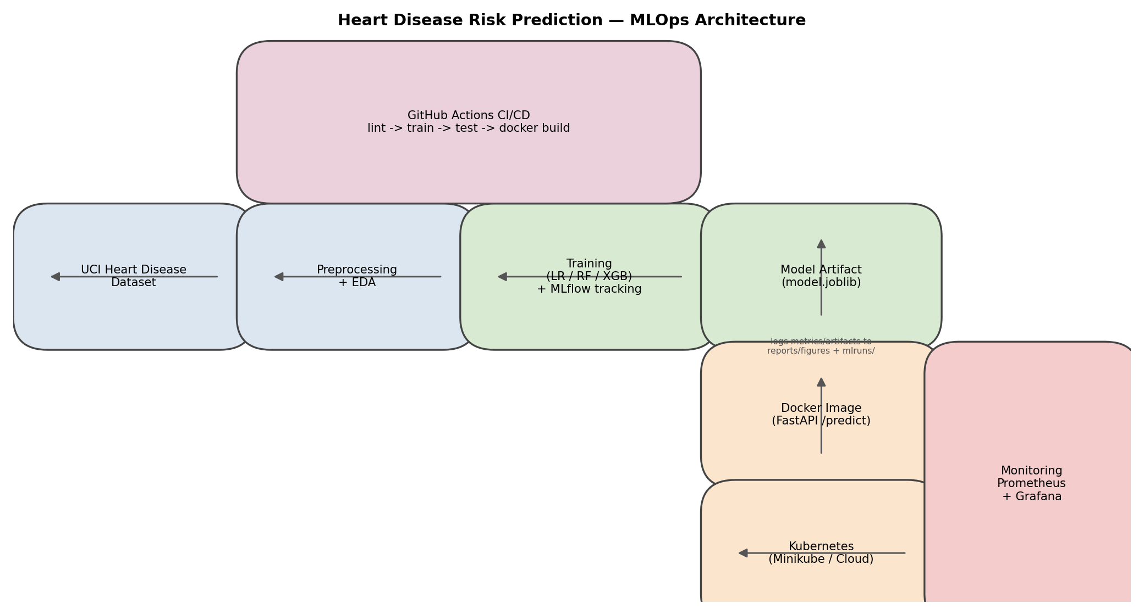
Figure 7. End-to-end architecture.

12. Repository & Video
[STUDENT: insert your GitHub repository URL here.]
[STUDENT: insert the link to your short video walkthrough here.]

13. Conclusion & Reflection
[STUDENT: write your own closing reflection: what was hardest, what you'd do differently with more time, and one thing you'd change about this pipeline if this were a real production system.]

