AI WEATHERWISE – DELIVER INTELLIGENT WEATHER FORECASTS AND INSIGHTS
────────────────────────────────────────────────────────
Project Title
AI Weatherwise – Deliver Intelligent Weather Forecasts and Insights
Team Details
Team ID: SWTID-2026-7148
Team Leader:
PRIYADHARSINI M – mpriyadharsini215@gmail.com
Team Members:
MIRUTHULA G – miruthula1113@gmail.com
SHAYANA G – shayanagee061@gmail.com
VASANTHRA M – vasanthramurugesan@gmail.com
────────────────────────────────────────────────────────
Description
AI Weatherwise is a RESTful backend application developed using Node.js and Express.js, with MongoDB and Mongoose for data storage.
The application retrieves current weather information using the OpenWeatherMap API and combines it with Google Gemini AI to provide intelligent weather summaries and personalized recommendations.
The system also includes an AI-powered weather chatbot that allows users to ask weather-related questions using natural language.
For security, the application uses JWT authentication and bcrypt password hashing. Authenticated users can manage their favourite locations and access protected weather and AI services.
The application also includes fallback responses to maintain basic functionality when external AI services are unavailable.

Scenario-Based Case Study
Background
Priya frequently travels to different cities and needs a simple way to check the current weather before planning her activities. She wants more than just temperature values and weather conditions. She also needs useful suggestions based on the current weather.
Problem
Users may face difficulties when:
- Checking weather conditions for multiple cities.
- Managing several favourite locations.
- Understanding raw weather information such as temperature, humidity and wind speed.
- Deciding suitable activities or clothing based on current conditions.
- Getting weather information through a natural conversational interface.
Solution
AI Weatherwise provides a centralized backend service for retrieving current weather information and generating useful AI-based insights.
Users can securely register and log in, save favourite locations, retrieve weather information, request AI-generated summaries and recommendations, and communicate with the AI weather assistant through the chatbot.
Usage
User Usage
Registered users can:
- Register and log in to the application.
- Add favourite locations.
- View and manage saved locations.
- Retrieve current weather information.
- Generate AI-based weather summaries.
- Request personalized weather recommendations.
- Interact with the AI weather chatbot.
Developer/Admin Usage
The backend can be used to:
- Verify API availability.
- Test authentication and protected routes.
- Check MongoDB connectivity.
- Verify weather API integration.
- Test Gemini AI integration.
- Monitor server responses and errors.
Public Weather Usage
The weather endpoint can be used to retrieve current weather information for a specified city without requiring the user to manage favourite locations.
Outcome
AI Weatherwise combines real-time weather information with AI-generated insights to make weather data easier to understand and use.
The system provides weather summaries, recommendations and conversational assistance while maintaining secure authentication and organized database management.

1. Software Requirements
Operating System
Windows 10/11, macOS, or Linux.
Node.js
Node.js is used as the runtime environment for executing the backend application.
npm
npm is used to install and manage the required Node.js packages.
Express.js
Express.js is used to create the REST API, handle HTTP requests and define application routes.
MongoDB
MongoDB is used as the NoSQL database for storing user information and favourite locations.
Mongoose
Mongoose is used as the ODM to define database schemas and communicate with MongoDB.
Google Gemini AI
Google Gemini AI is integrated to generate weather summaries, recommendations and chatbot responses.
OpenWeatherMap API
OpenWeatherMap is used to retrieve current weather information such as temperature, humidity, wind speed and weather conditions.
Thunder Client
Thunder Client is used to test and verify the REST API endpoints.
Visual Studio Code
Visual Studio Code is used as the development environment for creating and managing the project.

2. Hardware Requirements
Processor
Intel Core i5 / AMD Ryzen 5 or equivalent.
RAM
Minimum 8 GB RAM.
Storage
At least 1 GB of available storage for the project files, dependencies and database-related operations.
Internet Connection
A stable internet connection is required to access OpenWeatherMap and Gemini AI services.

Epic 1: PROJECT ARCHITECTURE
AI WeatherWise follows a modular backend architecture using Node.js, Express.js and MongoDB.
The application separates routes, controllers, services, middleware and database models to make the system easier to understand, maintain and extend.
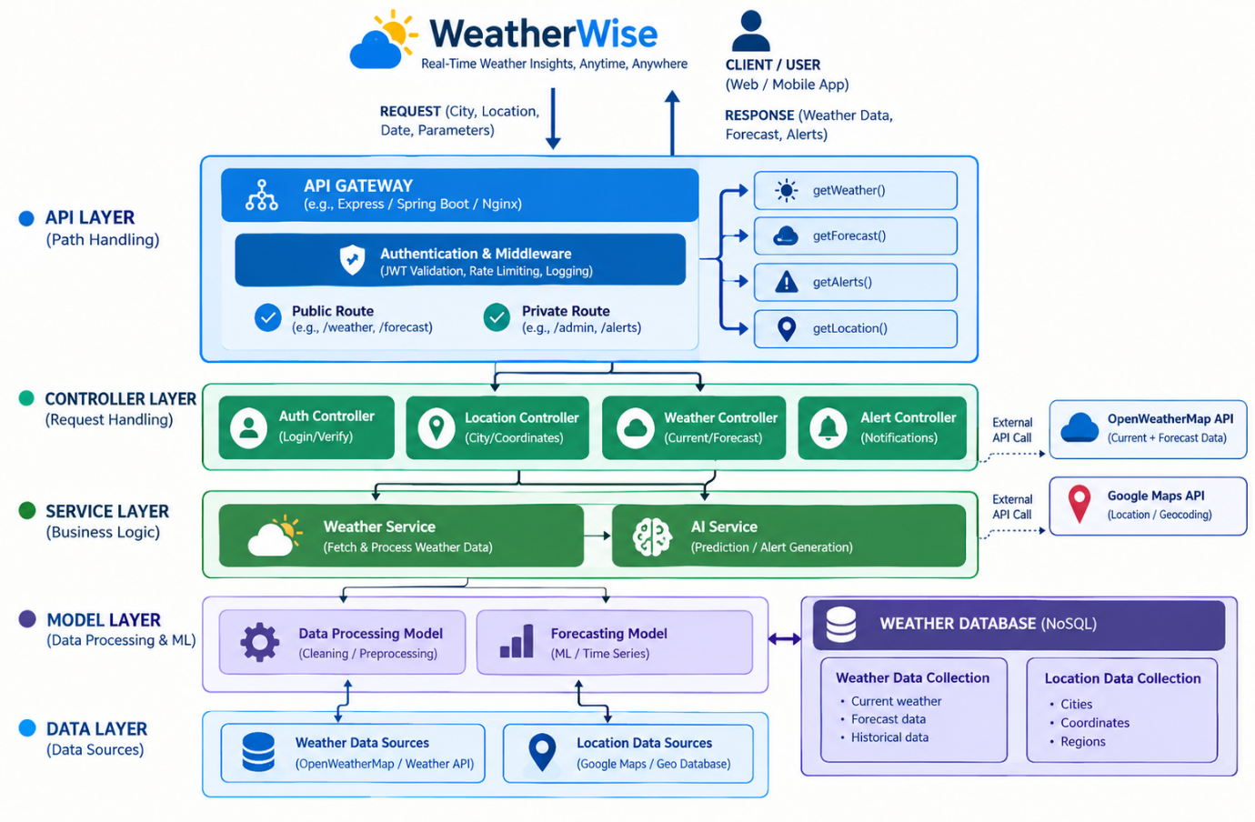
Components Definition
API Interface
The REST API provides endpoints through which clients such as Thunder Client can send requests and receive JSON responses.
Express Server
The Express server receives HTTP requests, processes the appropriate routes and returns responses to the client.
Authentication Middleware
JWT authentication is used to verify protected requests and identify authenticated users.
Controller Layer
Controllers process incoming requests and coordinate operations such as authentication, location management and weather-related requests.
Service Layer
The service layer contains the main application logic for communicating with external services such as OpenWeatherMap and Gemini AI.
Database Layer
Mongoose provides communication between the Node.js application and MongoDB.
Weather Service
The weather service retrieves current weather information from the OpenWeatherMap API.
AI Service
The AI service communicates with Gemini AI to generate weather summaries, personalized recommendations and chatbot responses.

Entity-Relationship Diagram Description
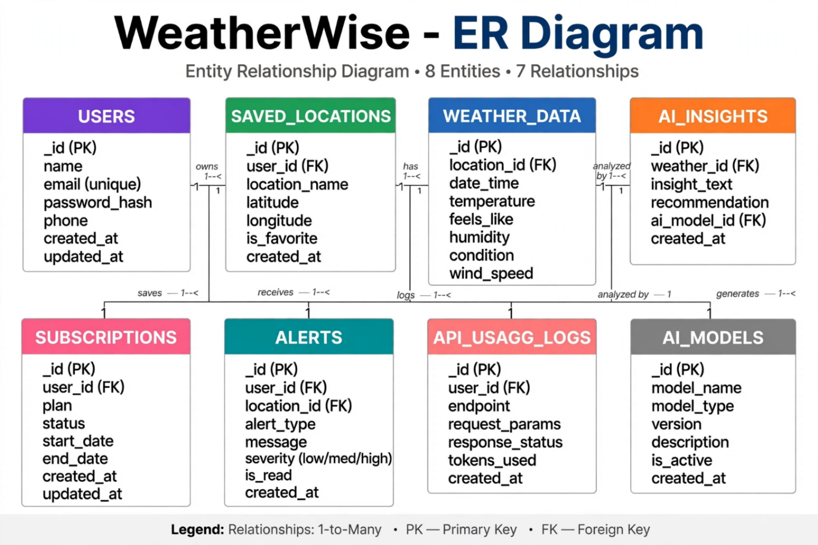
The database architecture mainly contains two entities:
- User
- Location
The User entity stores registered user information, while the Location entity stores the favourite locations associated with each user.
1. User Entity
- _id – Primary Key
- name – String, Required
- email – String, Required and Unique
- password – String, Hashed
- role – String
2. Location Entity
- _id – Primary Key
- user – Reference to User
- city – String, Required
- country – String, Required
- createdAt – Date
Key Structural Mapping
User to Location
One registered user can save multiple favourite locations.
Therefore, the relationship is:
One User → Many Locations
Each saved location is associated with the user who created it.

Key Features
- User registration and login.
- JWT-based authentication.
- Password hashing using bcrypt.
- Favourite location management.
- Current weather retrieval.
- AI-generated weather summaries.
- AI-generated weather recommendations.
- AI-powered weather chatbot.
- MongoDB data persistence.
- Protected API routes.
- Error handling and fallback responses.

Roles and Responsibilities
Admin
The admin role can be used for system-level management and monitoring activities.
Responsibilities include:
- Monitoring user accounts.
- Checking application functionality.
- Monitoring API and database connectivity.
- Maintaining system data.
Registered User
Registered users can:
- Create and manage their account.
- Add favourite locations.
- View and manage saved locations.
- Request weather information.
- Generate AI weather summaries.
- Request weather recommendations.
- Interact with the AI weather chatbot.

User Flow
- The user registers or logs into the application.
- The system validates the user's credentials.
- A JWT token is generated after successful authentication.
- The user can save a favourite city.
- The location is stored in MongoDB.
- The user requests current weather information.
- The backend retrieves weather data from OpenWeatherMap.
- The user can request an AI-generated weather summary or recommendation.
- Relevant weather information is processed by Gemini AI.
- The AI response is returned to the user.
- The user can also send a natural-language question to the AI chatbot.
- The chatbot returns a weather-related response
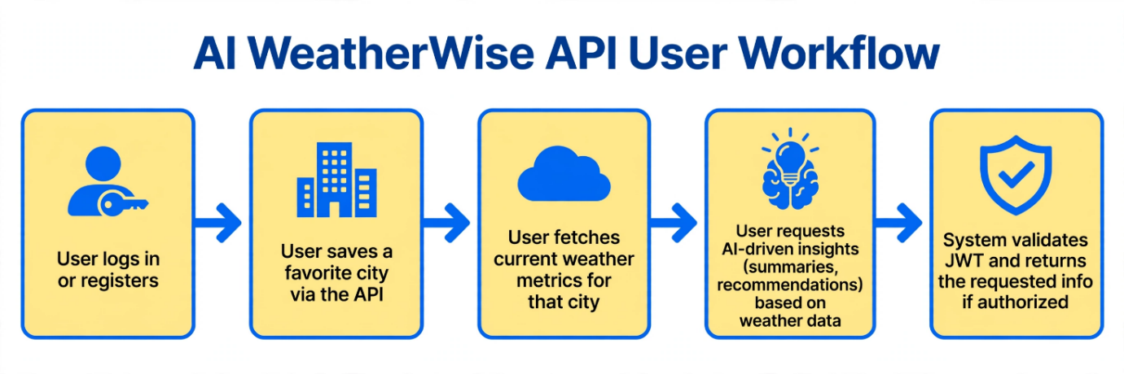
MVC Architecture Pattern

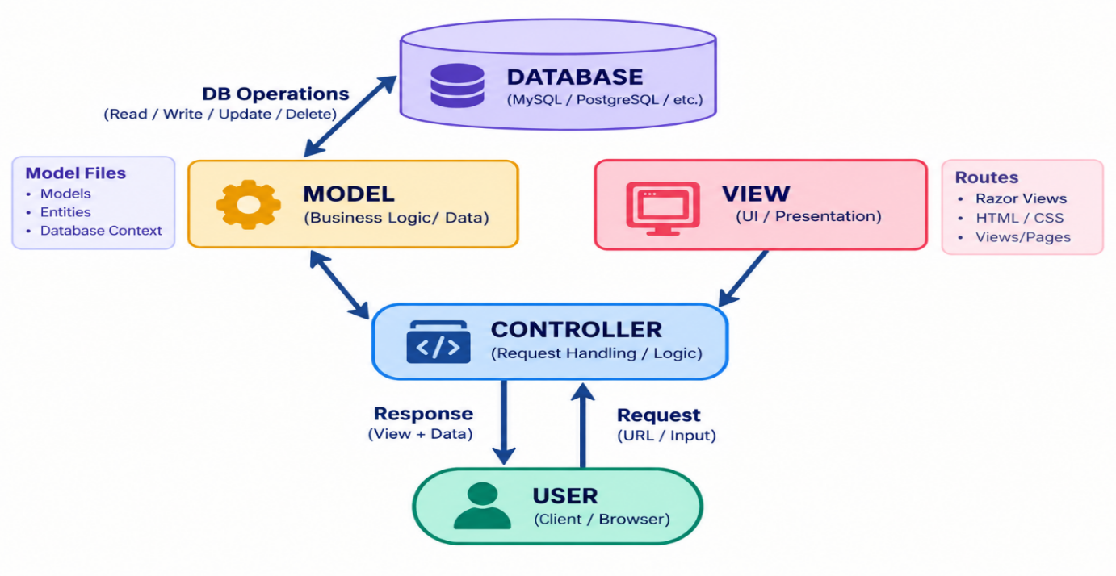
AI Weatherwise follows the MVC architectural approach to separate different responsibilities within the backend.

Model Layer
The Model layer defines the structure of data stored in MongoDB using Mongoose schemas.
The main models include:
- User
- Location
Controller Layer
The Controller layer handles incoming API requests and coordinates the required application operations.
Controllers are responsible for:
- User registration.
- User login.
- Location management.
- Weather retrieval.
- AI weather summaries.
- AI recommendations.
- AI chatbot requests.
View Layer
AI WeatherWise is a backend-only REST API and does not contain a traditional graphical user interface.
The API response acts as the interface between the backend and API testing tools or future frontend applications.

Epic 2: Project Setup and Configuration
Creating the Project Folder
A project folder named AI Weatherwise was created and opened in Visual Studio Code.
The project was initialized as a Node.js application and the required dependencies were installed using npm.
Project Initialization
Open the project folder in the VS Code terminal and execute:
Install the Required Dependencies
The project uses major dependencies such as:
- Express.js
- Mongoose
- bcryptjs
- JSON Web Token
- dotenv
- Google Generative AI
- CORS
Install Nodemon for Development
Nodemon is used to automatically restart the server whenever changes are made during development.
Create the Following Files
- package.json
- .env
- .gitignore
- src/server.js

Project Folder Structure
The project is organized into separate folders for routes, controllers, models, middleware, services and configuration.
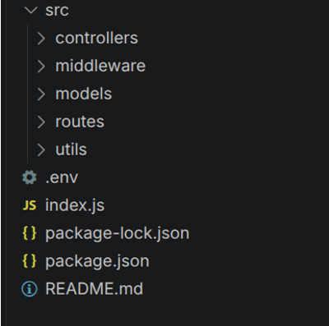
Environment Configuration
A .env file is used to store configuration values and API keys securely.
Example:
PORT=5001
MONGO_URI=your_mongodb_connection_string
JWT_SECRET=your_jwt_secret
OPENWEATHER_API_KEY=your_openweather_api_key
GEMINI_API_KEY=your_gemini_api_key
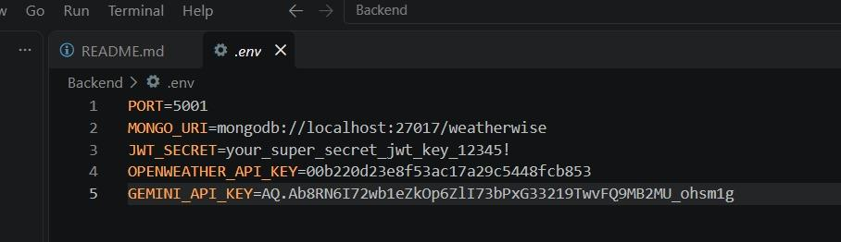

Epic 3: Backend Development
The AI WeatherWise backend is developed using Node.js and Express.js, with MongoDB used for data persistence.
The application follows a modular structure that separates routes, controllers, middleware, models and services.
The backend provides REST APIs for:
- User authentication.
- Favourite location management.
- Weather information.
- AI weather summaries.
- AI weather recommendations.
- AI chatbot conversations.
Backend Structure
The project contains separate modules for authentication, locations, weather services and AI services.
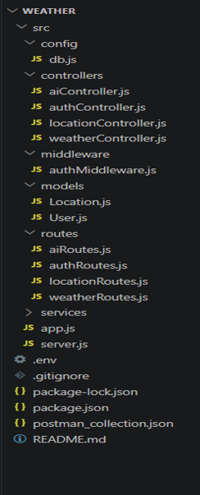

Core System Script Implementations
1. Application Entry Point – server.js
The server.js file acts as the main entry point of the application.
It loads environment variables, initializes Express, establishes the MongoDB connection, registers API routes and starts the backend server.

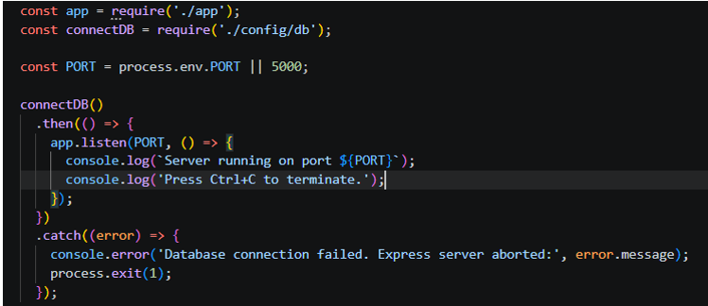

Epic 4: Database Configuration
API Testing Demo
MongoDB is used to store user and favourite location information.
Mongoose is used to define schemas and establish communication between the Node.js application and MongoDB.
1. Configure MongoDB
Mongoose is installed and configured in the project.
The application connects to MongoDB using the connection string stored in the .env file.
Mongoose Schema Definitions

Location Schema
The Location schema stores the user's favourite city and country along with the associated user reference.
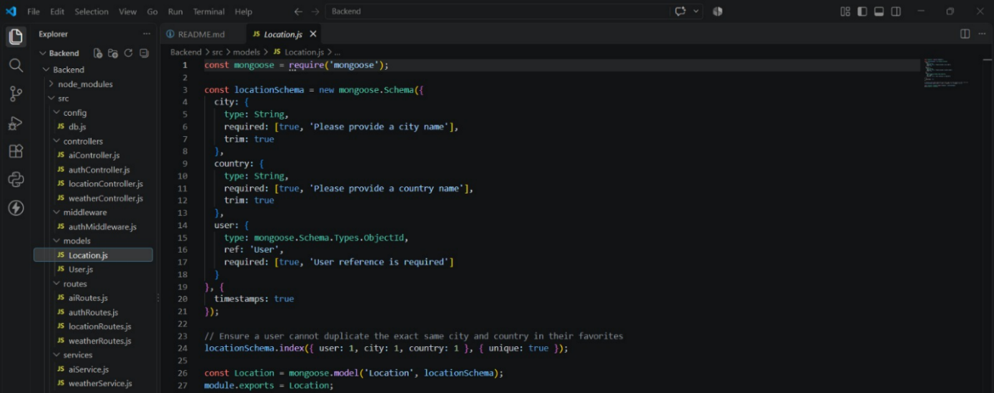

User Schema
The User schema stores user information such as name, email, password and role.
Passwords are hashed before being stored in the database.
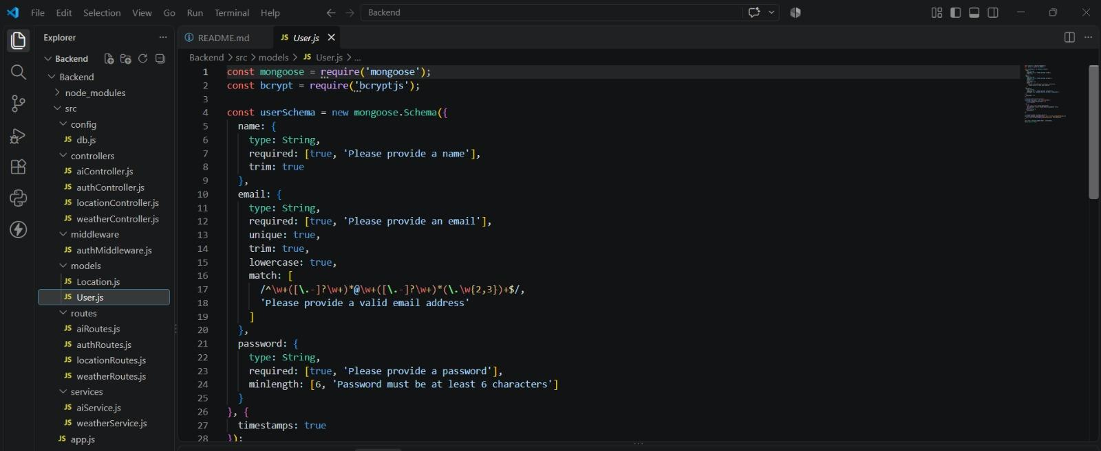

Database Connection
The database connection module establishes communication between the backend application and MongoDB using Mongoose.
A successful connection allows the application to store and retrieve user and location information.
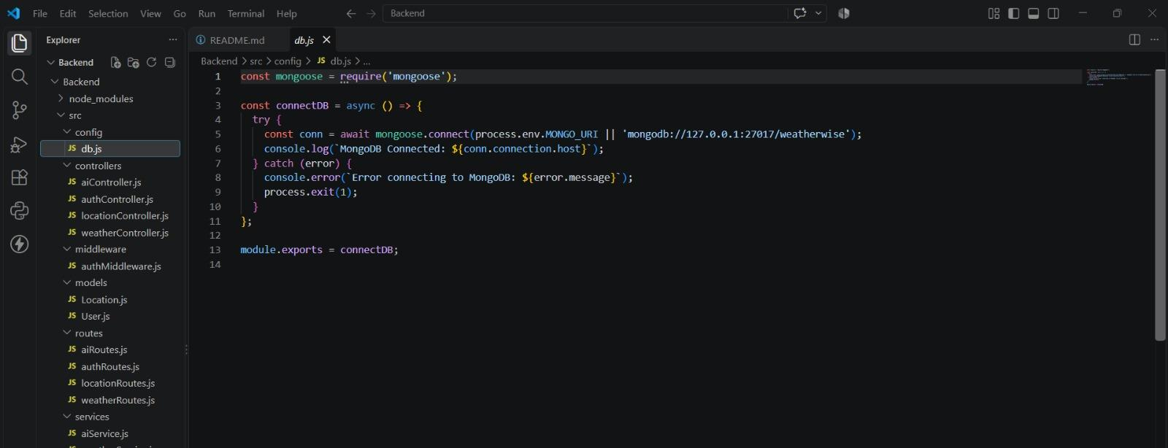

Epic 5: Project Execution
The AI WeatherWise backend can be executed locally using Node.js.
Before starting the application, MongoDB must be running and the required environment variables must be configured.
Running the Backend Server
Install all required dependencies:
npm install
Start the development server:
npm run dev
After successful execution, the application connects to MongoDB and starts listening for API requests.
Example:
MongoDB Connected: localhost
Server running on port 5001

API Testing
The REST APIs are tested using Thunder Client in Visual Studio Code.
1. Register API
The Register API is used to create a new user account.
The user provides the required registration details, and the information is stored securely in MongoDB.
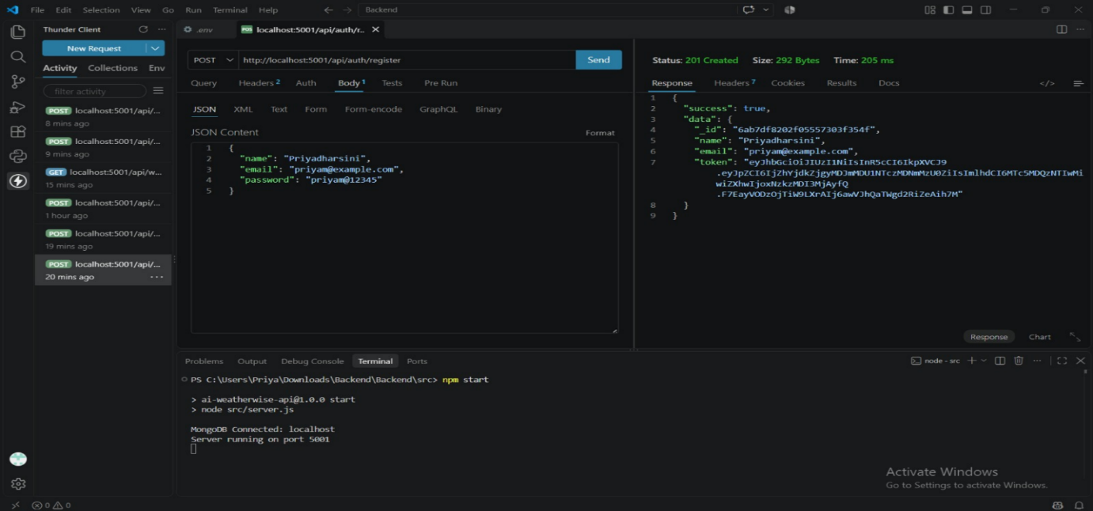
2. Login API
The Login API verifies the user's credentials.
After successful authentication, a JWT token is generated and used to access protected routes.
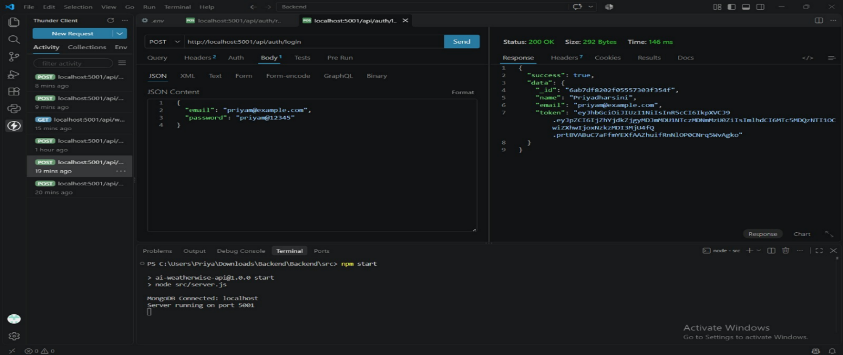

3. Weather API
The Weather API retrieves current weather information for a specified city.
Example:
GET /api/weather/Chennai
The response contains weather information such as temperature, humidity, wind and weather conditions.
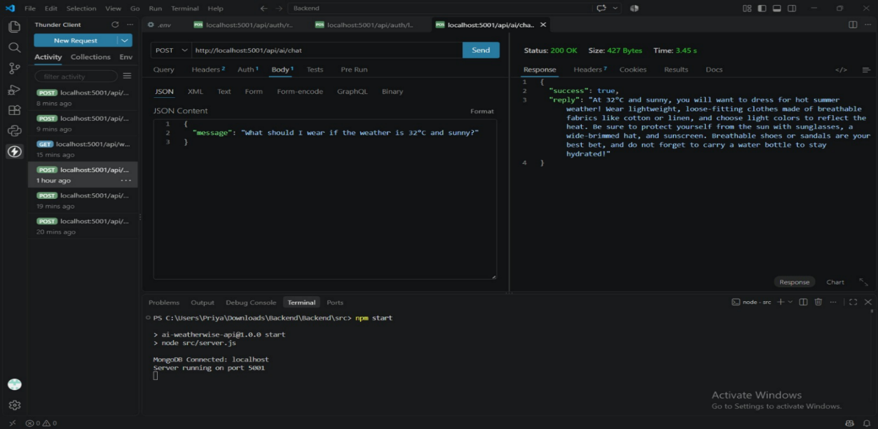
4. AI Weather Summary API
The AI Weather Summary API generates a simplified explanation of the current weather conditions using Gemini AI.
Example:
POST /api/ai/weather-summary
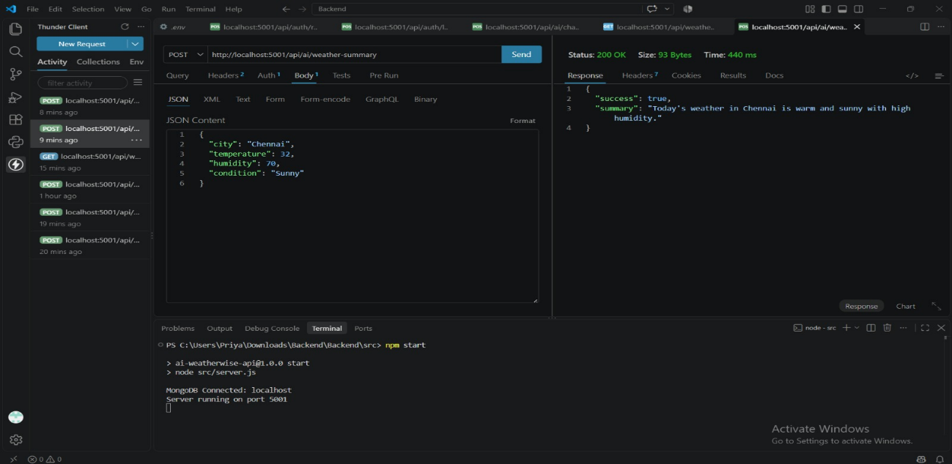
5. AI Weather Recommendation API
The AI Weather Recommendation API generates useful suggestions based on the current weather.
The recommendations may include suitable activities, clothing suggestions or general weather precautions.
Example:
POST /api/ai/weather-recommendation
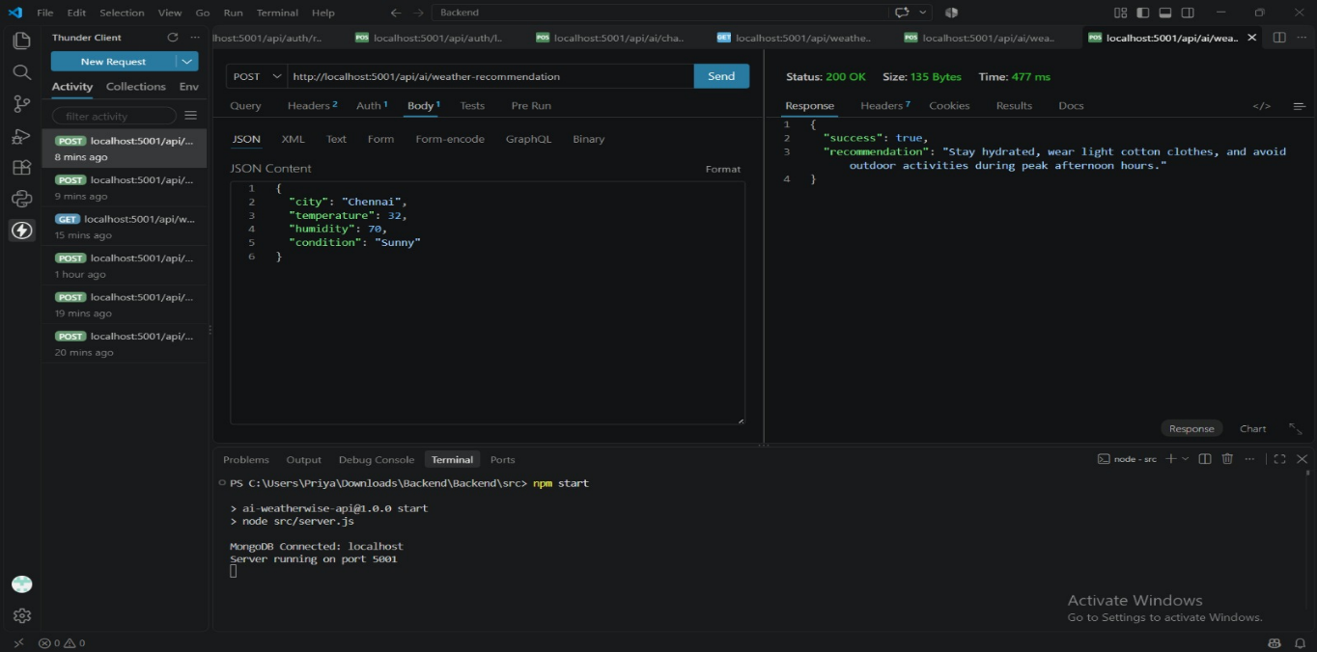
6. Favourite Location API
The Favourite Location API allows authenticated users to save and manage their preferred cities.
Users can add, view, update and delete their saved locations.
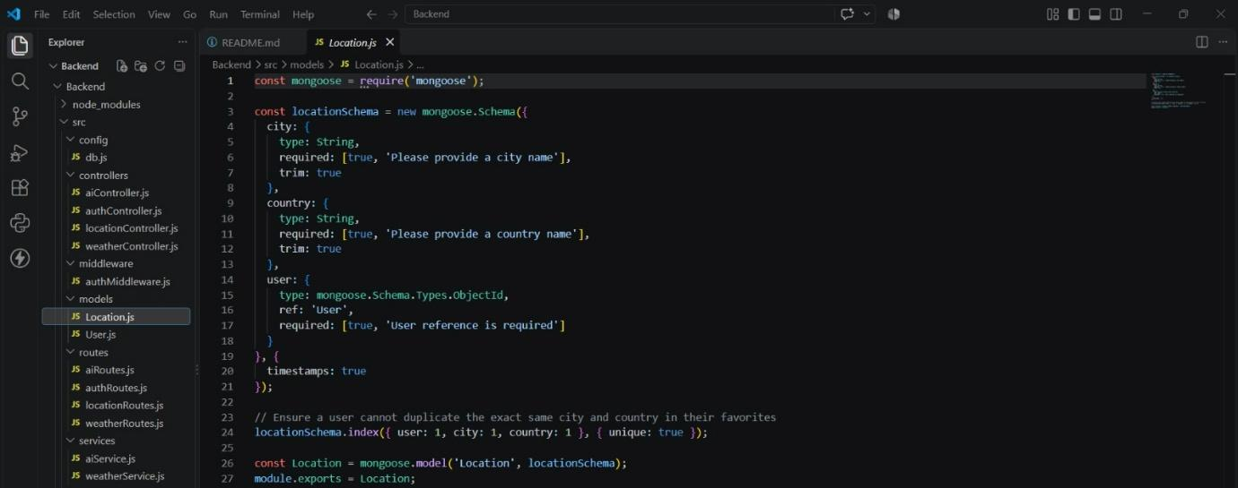

7. AI Chatbot API
The AI Chatbot API provides a conversational interface for weather-related questions.
Example:
POST /api/ai/chat
The endpoint requires JWT authentication.
Users can send natural-language messages to the weather assistant. The backend processes the request through the AI service and returns a weather-related response.
The chatbot uses Gemini AI and provides a fallback response when the external AI service is unavailable.
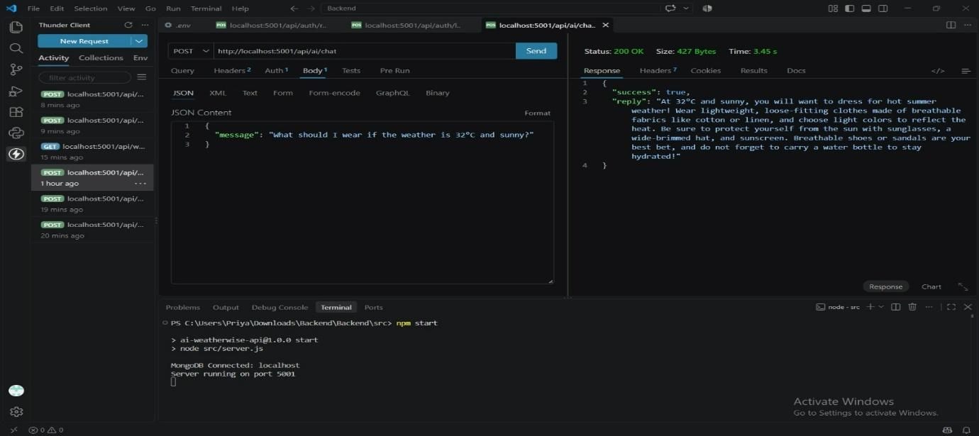

API Testing Video Link
Video Link: API TESTING VIDEO - Google Drive
Demo Video Link
Demo Link: PROJECT DEMO VIDEO - Google Drive
CodeDrive
CodeDrive Link: AI WEATHER WISE - BACKEND PROJECT - Google Drive

