AUTOMATIC BACKUP AND RESTORE FOR AWS RDS
A Summer Internship Report submitted in partial fulfillment of the requirements for the award of degree of

BACHELOR OF TECHNOLOGY
In
COMPUTER SCIENCE and ENGINEERING

Submitted by:
RONGALA VASU
22A91A0557


Department Of Computer Science and Engineering
ADITYA ENGINEERING COLLEGE (A)
Approved by AICTE, Permanently affiliated to JNTUK & Accredited by NAAC with ‘A’ Grade
Recognized by UGC under the sections 2(f) and 12(B) of the UGC act 1956
Aditya Nagar, ADB Road –Surampalem 533437, E.G. Dist., A.P., 2024-2025.

ADITYA ENGINEERING COLLEGE (A)
Approved by AICTE, Permanently Affiliated to JNTUK & Accredited by NAAC with ‘A’ Grade Recognized by UGC under the sections 2(f) and 12(B) of the UGC act 1956
Aditya Nagar, ADB Road - Surampalem – 533437, E.G.Dist., A.P.,

Department Of Computer Science and Engineering



CERTIFICATE

This is to certify that the Internship report entitled “AUTOMATIC BACKUP AND RESTORE FOR AWS RDS” is being submitted by

RONGALA VASU (22A91A0557)

In partial fulfillment of the requirements for award of the B.Tech degree in Computer Science and Engineering for the academic year 2024-2025.

Internship Coordinator Head of the Department
Dr.T.Prabhakar Rao, Dr.K.Swaroopa,
M.Tech,Ph.D, M.Tech,Ph.D,
Associate Professor Associate Professor
Department of CSE Department of CSE

DECLARATION

We hereby declare that the project entitled “AUTOMATIC BACKUP AND RESTORE FOR AWS RDS” is a genuine project. This work has been submitted to the ADITYA ENGINEERING COLLEGE, Surampalem, permanently affiliated to JAWAHARLAL NEHRU TECHNOLOGICAL UNIVERSITY, KAKINADA in partial fulfillment of the B.Tech degree. We further declare that this project work has not been submitted in full or part of the award of any degree of this or any other educational institutions.

By
Rongala vasu
(22A91A0557)

Internship Completion Certificate

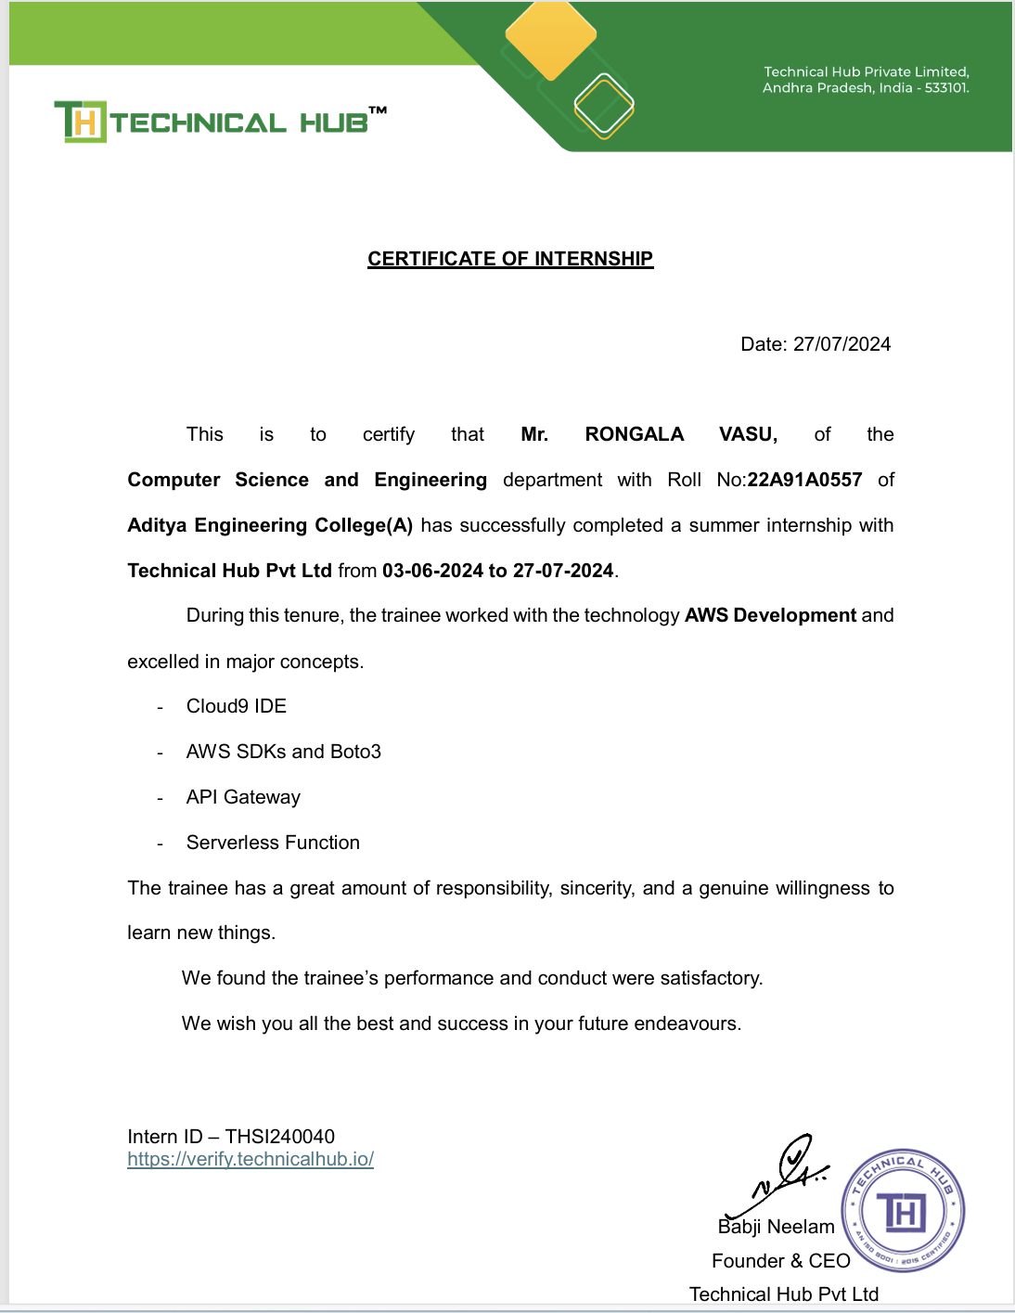

ACKNOWLEDGEMENT

First I would like to thank the Director of TECHNICAL HUB, SURAMPALEM for giving me the opportunity to do an internship within the organization. I also would like all the people that worked along with me in TECHNICAL HUB, SURAMPALEM with their patience and openness they created an enjoyable working environment.
It is with immense pleasure that we would like to express our indebted gratitude to our Internship coordinator MD SHAIFU,MENTOR, who has guided us a lot and encouraged us in every step of the intern project work, his valuable moral support and guidance throughout the Intern project helped us to a greater extent.
Our deepest thanks to Dr. K.SWAROOPA, Associate Professor & Head of the Department for inspiring us all the way and for arranging all the facilities and resources needed for our project.
We wish to thank Dr. S. Rama Sree, Professor in CSE and Dean(Academics) for
her support and suggestions during our project work.

We owe our sincere gratitude to Dr. M. Sreenivasa Reddy, Principal for providing a great support and for giving us the opportunity of doing the project.
We are thankful to our College Management for providing all the facilities in time to us for completion of our project.
Not to forget, Faculty, Lab Technicians, non-teaching staff and our friends who have directly or indirectly helped and supported us in completing our project in time.

Abstract

This abstract provides an overview of my summer internship focused on AWS development, under the mentorship of Md Shaifu. My name is Samineedi Sriram, and I am a student with roll number 22A91A0554 and my teammates are Peddireddi Panasa Ramanna with roll number 23A95A0508, Belam Shyam with roll number 22A91A0510, Rongala Vasu with roll number 22A91A0557 During this internship, I gained practical experience in AWS technologies, contributing to a project aimed at developing and optimizing cloud-based solutions. The project involved deploying and managing scalable infrastructure using AWS services such as EC2, S3, and Lambda. Through hands-on application and guidance from my mentor, I enhanced my technical skills, understood industry practices, and explored various career paths within cloud computing. This experience has significantly contributed to my professional growth and prepared me for future challenges in the field of AWS development.

- Purpose and Goal: The project aims to implement an automated backup and restore system for AWS RDS using AWS services such as snapshots and Lambda functions. The objective is to ensure data availability and recovery through automated processes. We will use Lambda functions to trigger RDS snapshots at scheduled intervals and implement a restore mechanism in case of failures. The system will be designed to streamline backup management and enhance disaster recovery procedures efficiently.

Learning Objectives/Internship Objectives

  - Internships are generally thought of to be reserved for college students looking to gain experience in a particular field. However, a wide array of people can benefit from Training Internships in order to receive real world experience and develop their skills.
  - An objective for this position should emphasize the skills you already possess in the area and your interest in learning more
  - Internships are utilized in a number of different career fields, including architecture, engineering, healthcare, economics, advertising and many more.
  - Some internships are used to allow individuals to perform scientific research while others are specifically designed to allow people to gain first-hand experience working.
  - Utilizing internships is a great way to build your resume and develop skills that can be emphasized in your resume for future jobs. When you are applying for a Training Internship, make sure to highlight any special skills or talents that can make you stand apart from the rest of the applicants so that you have an improved chance of landing the position.

WEEKLY OVERVIEW OF INTERNSHIP ACTIVITIES

1st WEEK | DATE | DAY | NAME OF THE TOPIC/MODULE COMPLETED
1st WEEK | 10/6/24 | Monday | Introduction of Computer Architecture
1st WEEK | 11/6/24 | Tuesday | Operating Systems
1st WEEK | 12/6/24 | Wednesday | Virtualization
1st WEEK | 13/6/24 | Thursday | Networking
1st WEEK | 14/6/24 | Friday | Cloud Fundamentals
1st WEEK | 15/6/24 | Saturday | Cloud Services

2nd WEEK | DATE | DAY | NAME OF THE TOPIC/MODULE COMPLETED
2nd WEEK | 17/6/24 | Monday | Cloud Development
2nd WEEK | 18/6/24 | Tuesday | AWS Cloud9
2nd WEEK | 19/6/24 | Wednesday | Cloud Storage
2nd WEEK | 20/6/24 | Thursday | Cloud Security
2nd WEEK | 21/6/24 | Friday | Flexible No SQL Solutions
2nd WEEK | 22/6/24 | Saturday | AWS RDS

3rd WEEK | DATE | DAY | NAME OF THE TOPIC/MODULE COMPLETED
3rd WEEK | 24/6/24 | Monday | APIs in Cloud
3rd WEEK | 25/6/24 | Tuesday | API Deployment
3rd WEEK | 26/6/24 | Wednesday | Serverless Solutions
3rd WEEK | 27/6/24 | Thursday | Container Services
3rd WEEK | 28/6/24 | Friday | Messaging Services
3rd WEEK | 29/6/24 | Saturday | Deployment using CI/CD Pipelines

4th WEEK | DATE | DAY | NAME OF THE TOPIC/MODULE COMPLETED
4th WEEK | 30/6/24 | Monday | Automation
4th WEEK | 1-10/7/24 | Left over days | Discussion on left over Topics
4th WEEK | 10-19/7/24 | Left over days | Discussion on left over Topics
4th WEEK | 20/7/24 | Saturday | Group Planning
4th WEEK | 22/7/24 | Monday | Creation of a website
4th WEEK | 23/7/24 | Tuesday | Designing of a website
4th WEEK | 24/7/24 | Wednesday | Hosting the website through ec2 instance
4th WEEK | 25/7/24 | Thursday | Hosting the website using mobaxterm
4th WEEK | 26/7/24 | Friday | Documentation
4th WEEK | 27/7/24 | Saturday | Submission of Project abstract & Presentation

INDEX

S No. | Contents | Page
no.
1. | Introduction of AWS | 1
2. | AWS History | 2
3. | Definition and Key Features of AWS | 2
4. | Architecture of Website | 3
5. | Applications | 4
6. | Components Used
6.1 | AWS S3 | 4
6.2 | Cloud 9 environment | 4
6.3 | AWS RDS | 5
6.4 | VS code | 6
7. | Full Stack Website | 7
8. | Hosting the Website | 8
9. | Advantages & Disadvantages | 9
10. | Requirements
11. | Project Implementation
11.1 | Through AWS Console
11.2 | Through Cloud9 Environment | 10
12. | Source Code | 11
14. | Output | 15
15. | Conclusion | 15

1. Introduction:

→ AWS (Amazon Web Services): Amazon Web Services (AWS) is a comprehensive cloud computing platform offered by Amazon. It provides a broad range of cloud-based services, including:

- Computing Power: Services like Amazon EC2 (Elastic Compute Cloud) allow users to run virtual servers and manage scalable computing resources.
- Storage: Services such as Amazon S3 (Simple Storage Service) offer scalable and durable storage solutions.
- Databases: Managed database services like Amazon RDS (Relational Database Service) support various database engines.
- Networking: AWS includes services for networking and content delivery, such as Amazon VPC (Virtual Private Cloud) and CloudFront.
- Machine Learning: AWS provides tools for machine learning and artificial intelligence, including Amazon Sage Maker.

AWS is known for its scalability, flexibility, and global infrastructure, making it a popular choice for businesses of all sizes to build, deploy, and manage applications and services.

2. AWS History:

Amazon Web Services (AWS) has a rich history marked by significant milestones:
- 2002: AWS was officially launched with the release of Amazon's first web services, including Amazon S3 (Simple Storage Service) and Amazon EC2 (Elastic Compute Cloud). These initial services aimed to provide scalable storage and computing capabilities over the internet.

- 2006: The introduction of Amazon EC2 marked a significant development in cloud computing, allowing users to rent virtual servers on-demand. This innovation played a crucial role in the evolution of cloud infrastructure.

- 2008: AWS introduced Amazon S3's “Availability Zones,” improving reliability and fault tolerance by distributing data across multiple data centers within a region.

- 2010: The launch of AWS Elastic Beanstalk provided a platform-as-a- service (PaaS) solution, simplifying the deployment and management of applications.

- 2014: AWS announced Amazon Aurora, a high-performance, MySQL- compatible relational database engine. This year also saw the introduction of Amazon Lambda, which pioneered serverless computing by allowing users to run code without provisioning or managing servers.

- 2016: AWS made significant strides with the introduction of Amazon Polly (text-to-speech) and Amazon Rekognition (image and video analysis), expanding its suite of artificial intelligence and machine learning services.

- 2018: AWS reached a major milestone with the opening of its AWS Outposts, allowing customers to extend AWS infrastructure and services to on-premises locations, blending cloud and on-premises environments.

- 2021: AWS expanded its global infrastructure with new regions and

availability zones, reinforcing its commitment to global presence and low- latency services.

Definition of AWS:

AWS (Amazon Web Services) is a comprehensive cloud computing platform provided by Amazon. It offers a wide range of services, including computing power, storage, and databases, delivered on-demand to businesses and individuals. AWS enables scalable and flexible IT infrastructure through its global network of data centers. It supports a variety of workloads, from web applications to machine learning. With a pay-as- you-go pricing model, AWS allows users to optimize costs and resources effectively.

- Key Features:
- Amazon S3 (Simple Storage Service): is a scalable object storage service offered by AWS. It provides durable and secure storage for data, accessible from anywhere on the internet. S3 supports storing any type of data, such as documents, images, and backups, and it is designed to deliver 99.999999999% durability. Users can manage access permissions, versioning, and lifecycle policies to optimize storage costs. With integration into other AWS services, S3 serves as a fundamental building block for many cloud applications and services.

- Web Development: Web development is the process of creating and maintaining websites and web applications. It involves front-end development, which focuses on the user interface and experience, using technologies like HTML, CSS, and JavaScript. Back-end development handles server-side logic, databases, and application integration using

languages such as Python, Ruby, or PHP. Web developers ensure websites are functional, responsive, and accessible across different devices and browsers. The field encompasses various disciplines, including web design, programming, content creation, and network security.

- Website Hosting: Website hosting is a service that allows individuals and organizations to make their websites accessible via the internet. It involves storing website files on servers, which are powerful computers that deliver these files to users' browsers when they access the site. Hosting providers offer various plans, including shared, dedicated, and cloud hosting, to accommodate different needs and traffic levels. They also provide additional services like domain registration, email hosting, and security features. Reliable hosting ensures a website's availability, performance, and security for its visitors.

- AWS Cloud9: AWS Cloud9 is a cloud-based integrated development environment (IDE) provided by Amazon Web Services. It allows developers to write, run, and debug code directly in a web browser, supporting multiple programming languages and frameworks. Cloud9 comes with a built-in terminal, code editor, and collaborative features, enabling real-time code sharing and editing. It integrates seamlessly with other AWS services, facilitating development and deployment within the AWS ecosystem. This IDE helps streamline the development process by offering a fully configured environment accessible from anywhere.

Architecture of Website:

The architecture of a website refers to the structured layout and design of its components to ensure functionality, performance, and scalability. Key elements include:
    - Frontend (Client-Side): The part of the website users interact with directly, including HTML, CSS, and JavaScript, which handle the visual layout and user experience.
    - Backend (Server-Side): The server, application, and database that process and manage data, handle user requests, and generate dynamic content. Common technologies include server-side languages (e.g., PHP, Node.js), web servers (e.g., Apache, Nginx), and databases (e.g., MySQL, PostgreSQL).
    - Database: Stores and retrieves data required by the website, ensuring data integrity and security.
    - APIs (Application Programming Interfaces): Enable communication between different parts of the website and external services or applications.
    - Hosting and Infrastructure: The physical or cloud-based servers and services that host the website and provide resources like storage, bandwidth, and computing power.

Additionally, website architecture includes considerations for security, scalability, performance optimization, and user experience design.

Applications:

AWS (Amazon Web Services) provides a variety of applications and services that can be used for hosting websites. Some of the key AWS services used in website hosting include:

- Amazon EC2 (Elastic Compute Cloud): Provides resizable compute capacity in the cloud, allowing you to run virtual servers to host your website.

- Amazon S3 (Simple Storage Service): Used for storing and retrieving any amount of data, often used for hosting static website content like HTML, CSS, and images.

- Amazon RDS (Relational Database Service): Manages relational databases such as MySQL, PostgreSQL, MariaDB, Oracle, and SQL Server, providing scalable and reliable database hosting.

- Amazon Route 53: A scalable Domain Name System (DNS) web service that routes end users to internet applications by translating human-readable names like www.example.com into IP addresses.

- Amazon CloudFront: A content delivery network (CDN) that distributes your website content globally, improving load times and reducing latency.

- AWS Lambda: Serverless compute service for running code in response to events.

- Amazon Elastic Load Balancing (ELB): Automatically distributes incoming application traffic across multiple targets, such as Amazon EC2 instances, to ensure high availability and reliability.

- Amazon DynamoDB: A fast and flexible NoSQL database service for all applications that need consistent, single-digit millisecond latency at any scale.

Components Used:

  - AWS S3 (Amazon Simple Storage Service):
Purpose: Object storage service for storing and retrieving any amount of data at any time.
Features:
    - Scalable storage with high availability and durability.
    - Flexible data storage for a variety of use cases, including backups, content storage, and big data analytics.
    - Supports data management features such as versioning, lifecycle policies, and access control.
    - Integrates with many AWS services, enabling a broad range of applications.

  - Cloud 9 Environment:
Purpose: Integrated development environment (IDE) that runs in the cloud.
Features:
    - Provides a full-fledged code editor, debugger, and terminal.
    - Enables collaborative development, allowing multiple users to work on the same project simultaneously.
    - Supports a variety of programming languages, including JavaScript, Python, and PHP.

    - Preconfigured with essential tools and libraries, reducing setup time.
- Seamless integration with AWS services, facilitating development and deployment of applications on AWS.

  - AWS RDS (Amazon Relational Database Service):
Purpose: Managed relational database service supporting multiple database engines.
Features:
    - Supports database engines such as MySQL, PostgreSQL, MariaDB, Oracle, and SQL Server.
    - Automates administrative tasks like backups, patching, and scaling.
    - Provides high availability and durability through Multi-AZ deployments and automated backups.
    - Enables read replicas for read-heavy workloads and improved performance.
    - Simplifies database management and reduces operational overhead.

  - VS Code (Visual Studio Code):
Purpose: Free, open-source code editor developed by Microsoft. Features:
    - Lightweight and fast with a rich set of features including syntax highlighting, code completion, and debugging.
    - Extensible through a vast library of extensions, allowing customization and addition of functionality.
    - Integrated terminal and Git support for streamlined development

workflows.
    - Cross-platform support, running on Windows, macOS, and Linux.
    - Supports a wide range of programming languages and development frameworks.

EXECUTIVE SUMMARY

This report provides an overview of my 8-week internship program focused on AWS technology. Throughout the internship, I gained hands-on experience with various AWS services, including EC2, S3, Lambda, RDS, Elastic Beanstalk, Cloud9, and CloudFront.

During this period, I deepened my understanding of cloud computing and its practical applications in real-world scenarios.

The internship offered valuable insights into AWS infrastructure and services, equipping me with the skills to deploy and manage cloud-based solutions efficiently. I have documented all key learnings and technical experiences comprehensively in this report.

ABOUT THE COMPANY

Technical Hub, located at Aditya Engineering College in Surampalem, Andhra Pradesh, was established in 2015. It is an ISO 9001:2015 certified organization dedicated to providing technical education and hands-on training to students. Over the years, Technical Hub has gained recognition for its contributions in the fields of cloud

computing, software development, and emerging technologies. The hub has successfully mentored students, helping them secure internships and placements in reputed companies. Through its innovative projects and industry collaborations, Technical Hub continues to be a leading center for technical excellence and practical learning in Andhra Pradesh.

Mission: "To provide quality technical education and hands-on training in emerging technologies, empowering students with the skills and knowledge necessary to excel in the competitive tech industry.".

Vision: “"To be a leading institution that bridges the gap between academic learning and industry needs, fostering innovation and excellence in the field of technology for future-ready professionals."

OPPORTUNITIES:

During these two months of the internship, I was given the opportunity to perform the following role:
Intern:

  - Coordinating with the team members and team leads on a regular basis to keep a track of the activities like the meetings held and about the work to be done.
  - I learned about developing and managing cloud-based applications using various AWS services.
  - To gain in-depth knowledge, I referred to AWS documentation and resources related to services like EC2, S3, Lambda, and RDS.
  - I gathered the technical requirements for deploying cloud solutions effectively.They also provide us the opportunity to voluntarily interact in other projects as well.
  - The internship provided opportunities to collaborate and voluntarily engage in other cloud computing projects.
  - I was assigned different tasks, such as configuring and managing AWS services, automating tasks, and optimizing cloud infrastructure.
  - Finally, I completed tests and evaluations that certified the successful completion of my internship program..

TRAINING:

In these 8 weeks of the training, I received extensive hands-on experience in AWS cloud technology using various tools and services. The internship provided training in several key AWS technologies, including:

- EC2
- S3
- Lambda
- RDS
- CloudFront

EC2:
Amazon EC2 (Elastic Compute Cloud) provides scalable computing capacity in the cloud. During the internship, I learned how to launch and configure EC2 instances, set up security groups, and deploy applications. Key tasks included:

- Setting up EC2 instances.
- Configuring security groups and key pairs.
- Launching and managing virtual servers.
- Monitoring and scaling instances.
- Automating tasks using EC2 features.

S3:
Amazon S3 (Simple Storage Service) is used for object storage. I learned how to store and manage data securely in the cloud. This included:

- Creating and managing S3 buckets.
- Uploading, accessing, and securing data.
- Implementing lifecycle policies for data management.
- Configuring permissions and versioning.
- Integrating S3 with other AWS services.

Lambda:
AWS Lambda is a serverless compute service. I worked on automating tasks by writing functions that execute in response to events. Key tasks involved:

- Writing and deploying Lambda functions.
- Setting up event triggers.
- Debugging and optimizing function performance.
- Automating backups using Lambda.
- Integrating Lambda with other AWS services.

RDS:
Amazon RDS (Relational Database Service) helps in setting up, operating, and scaling relational databases in the cloud. I learned to:

- Launch and manage RDS instances.
- Configure backups and security.
- Monitor performance and troubleshoot issues.
- Automate backup and restore operations.
- Integrate RDS with applications.

This comprehensive training enabled me to acquire practical skills in cloud computing and AWS service management, preparing me to deploy and maintain cloud-based solutions efficiently.

5.CHALLENGES FACED:

- At the beginning of internship, I faced difficulty for understanding the applications and different tools.
- I faced difficulty in installing the software.
- I faced difficulty in managing college and internship timings.
- I faced difficulty in understanding the advanced topics in android.
- I faced difficulty in managing the memory in pc.
- Even with these difficulties, I am able to complete the internship and it helps me in securing a new job.

