**Underwater Image Enhancement using CLAHE**

**Introduction :**

In recent years, underwater images have been widely used in marine energy exploration, marine environment protection, marine military, marine life research and other fields. In these applications image acquisition is carried at varied depths of water, an artificial light is used to capture the underwater object. The physical properties of the water make light behave differently, changing the appearance of a same object with variations of depth, organic material, currents, temperature etc. This results in colour distorted images and hazy images with very low contrast. Hence, there is a need to enhance the underwater images in light of the above applications.

Aim of this project is to enhance the underwater images which are affected by color distortion, contrast reduction and haziness. Initially, the original image is pre-processed by the white balance algorithm for colour correction. White balance algorithm involves the process of removing unrealistic colour casts in an underwater image. This colour corrected image is treated with dark channel prior dehazing method to obtain contrast enhancement. These two input images viz., i. Colour corrected and ii. Contrast enhanced are further processed by multiscale fusion strategy. Multiscale fusion strategy entails the restoration of image which is based on the weighted maps constructed by combining the features of global contrast, local contrast, saliency, and exposedness. Experimentation can be carried out on standard database RUIE of 400 images and U45 dataset to evaluate the performance of this approach in terms of mean square error, peak-signal-to-noise-ratio. The Proposing methodology in this project can be utilized to enhance the underwater images by using **MATLAB** Software. Further these enhanced images can be used for various applications such as consumer underwater photography, marine life research, and underwater exploration.

**Methodology :**

The flow chart of the proposed approach implementation is shown. The proposed approach is composed of three parts, that is, design input images, calculate the weight of input images, and multiscale fusion. First, the first input image (input 1) is obtained by utilizing the WB algorithm to correct color from the original image and the second input image (input 2) is obtained by applying the DCP algorithm to input 1 to reduce the degradation due to particle scattering. In our experiments, input 1 was first obtained by applying a simple and efficient WB operation to an original image. The simple WB algorithm based on the shades of grey with gain factor is more computationally effective.

This WB method derives the first input of the fusion process from the original underwater image efficiently.However, the WB method is insufficient for the amelioration of visibility. To obtain a better-enhanced image, the second input of the fusion process is defined to enhance the contrast of the underwater image.

DCP algorithm is another major processing step that aims to enhance the contrast of the color-corrected image by dehazing due to volume scattering. To achieve an optimal contrast level of the image, input 2 was obtained by applying the DCP dehazing algorithm.The DCP dehazing algorithm derives the second input of the fusion process from the color-corrected version. It takes into account the underwater image degradation process; it can effectively eliminate the partial reddish effect and enhance the contrast of the underwater image.

To improve the quality of under water image restoration,this attracts the information of two input signals, thereby defining the fusion weight map, that is, the global contrast weight map (WG), the local contrast weight map (WL), the saliency weight map (WS),and the exposedness weight map (WE). The calculation results of these weight maps are shown.

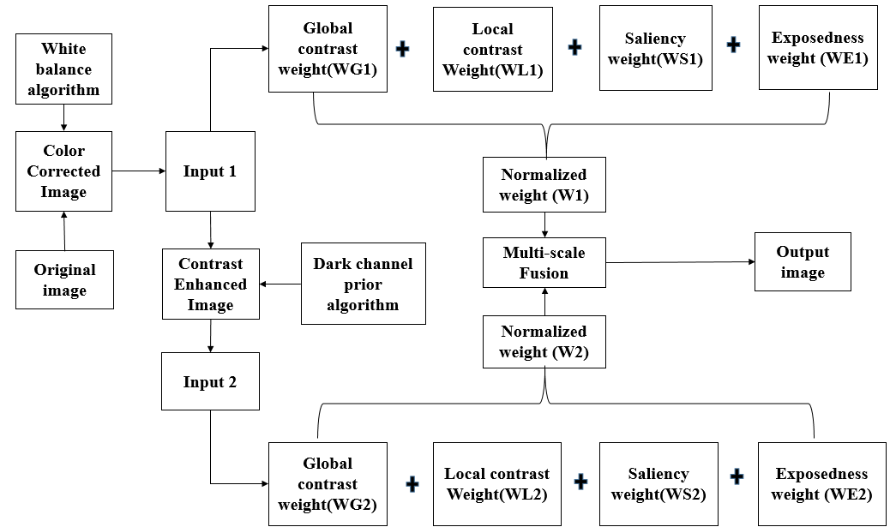

**White Balancing :**

White balancing is an important processing step that aims to enhance the image appearance by discarding unwanted color casts, due to various illuminants. In water deeper than 30 ft, white balancing suffers from noticeable effects since the absorbed colors are difficult to be restored. Additionally, underwater scenes present significant lack of contrast due to the poor light propagation in this type of medium.

**Color Correction:**

Controls the overall brightness of an image. Highlights edges and fine details in an image. Our approach minimizes this effect of color shifting for the entire scene. As a result, in our framework, the illumination is estimated by the value μI that is computed from the average of the scene μref and adjusted by the parameter λ

**μI= 0.5 + λ μref**

**Global contrast weight (GL)** :

It deals with global contrast by applying a Laplacian filter on each input luminance channel and computing the absolute value of the filter result. This straightforward indicator was used in different applications such as tone mapping and extending depth of field since it assigns high values to edges and texture.

For under water image restoration task, this weight is not sufficient to recover the contrast, mainly because it can not distinguish between a ramp and flat regions.To handle this problem, we searched for an additional contrast measurement that independently assess the local distribution.

**Local contrast weight (WLC):**

It comprises the relation between each pixel and its neighborhoods average.The impact of this measure is to strengthen the local contrast appearance since it advantages the transitions mainly in the highlighted and shadowed parts of the second input The (WLC) is computed as the standard deviation between pixel luminance level and the local average of its surrounding region:

**WLC(x, y) =|| Ik  - Ikwc  ||**

where Ik represents the luminance channel of the input ,Ikwc represents the low-passed version of it. The filtered version Ikwc is obtained by employing a small 5 × 5, ([1, 4, 6, 4, 1]/16) separable binomial kernel with the high frequency cut-off value whc = π/2.75

**Saliency weight (WS):**

It aims to emphasize the discriminating objects that lose their prominence in the underwater scene.This computationally efficient saliency algorithm is straightforward to be implemented being inspired by the biological concept of center-surround contrast. However, the saliency map tends to favor highlighted areas.

To increase the accuracy of results, we introduce the exposedness map to protect the mid tones that might be altered in some specific cases.

**Exposedness weight (WE)** :

It evaluates how well a pixel is exposed. This assessed quality provides an estimator to preserve a constant appearance of the local contrast, that ideally is neither exaggerated nor understated. Commonly, the pixels tend to have a higher exposed appearance when their normalized values are close to the average value of 0.5.

This weight map is expressed as a Gaussian-modeled distance to the average normalized range value (0.5): **WE(x, y) = exp(− $\frac{\text{(}\text{Ik}\text{(x, y) - 0.5)2}}{2σ}$)**

where I k (x, y) represents the value of the pixel location (x, y) of the input image I k, while the standard deviation is set to σ = 0.25.

**Contrast Limited adaptive histogram equalization:**

Ordinary AHE tends to over amplify the contrast in near constant regions of the image.CLAHE is a variant of adaptive histogram equalisation in which contrast amplification is limited, so as to reduce this problem of noise amplification.In order to limit the noise amplification we use CLAHE.

In CLAHE, the contrast limited procedure has to be applied for each neighbourhood from which a transformation function is derived. Rather than taking the whole image, CLAHE prevents over amplification by dividing the image into small data regions called Tiles and then it performs contrast enhancement.

**Normalized weights:**

To yield consistent results, we employ the normalized weight values W (for an input k the normalized weight is computed as

**Wk = Wk/∑kk=1 Wk**

By constraining that the sum at each pixel location of the weight maps W equals one.

**Progress till now:**

The Original is applied to White Balancing and then to Color Correction. This Color Correction is divided into Different weights like Global Contrast,Local contrast, Saliency, Exposedness and all this weights are Calculated as one Normalized weight. Now need to use the **Optimum CLAHE** for input2 replacing the normal **CLAHE.** And need combine the two inputs Normalized weights in one color image using Fusion.

**BATCH No. - (B9)**

M.Pallavi - 19A95A041 N.Vasu - 18A91A0498 K.Sudheer - 18A91A0488 T.Siva Ram - 17A91A04B3

**Project Guide:** Dr. Gulivindala Suresh M.TECH., Ph.D. Professor, Department of ECE, Aditya Engineering College(A), Surampalem, East Godavari (Dt). A.P

**Project Guide Signature:**