SQL final project

## Task 1: Identifying the Top Branch by Sales Growth Rate

Walmart wants to identify which branch has exhibited the highest sales growth over time. Analyze the total sales for each branch and compare the growth rate across months to find the top performer.

Ans:

-- get the initial required data

WITH monthly_sales AS (

SELECT

Branch,

DATE_FORMAT(STR_TO_DATE(Date, '%d-%m-%Y'), '%Y-%m') AS month,

SUM(Total) AS total_sales

FROM walmartsales_dataset

GROUP BY Branch, month

),

-- Aggregate total sales per branch per month

growth_calc AS (

SELECT

Branch,

month,

total_sales,

LAG(total_sales) OVER (PARTITION BY Branch ORDER BY month) AS prev_month_sales

FROM monthly_sales

),

-- Calculate the month-over-month growth rate

growth_rate_per_month AS (

SELECT

Branch,

month,

ROUND(((total_sales - prev_month_sales) / prev_month_sales) * 100, 2) AS monthly_growth

FROM growth_calc

WHERE prev_month_sales IS NOT NULL

),

-- Average (or sum) the growth rates per branch

branch_avg_growth AS (

SELECT

Branch,

ROUND(AVG(monthly_growth), 2) AS avg_monthly_growth

FROM growth_rate_per_month

GROUP BY Branch

)

-- Find the branch with the highest average/sum of growth rates

SELECT

Branch,

avg_monthly_growth

FROM branch_avg_growth

ORDER BY avg_monthly_growth DESC

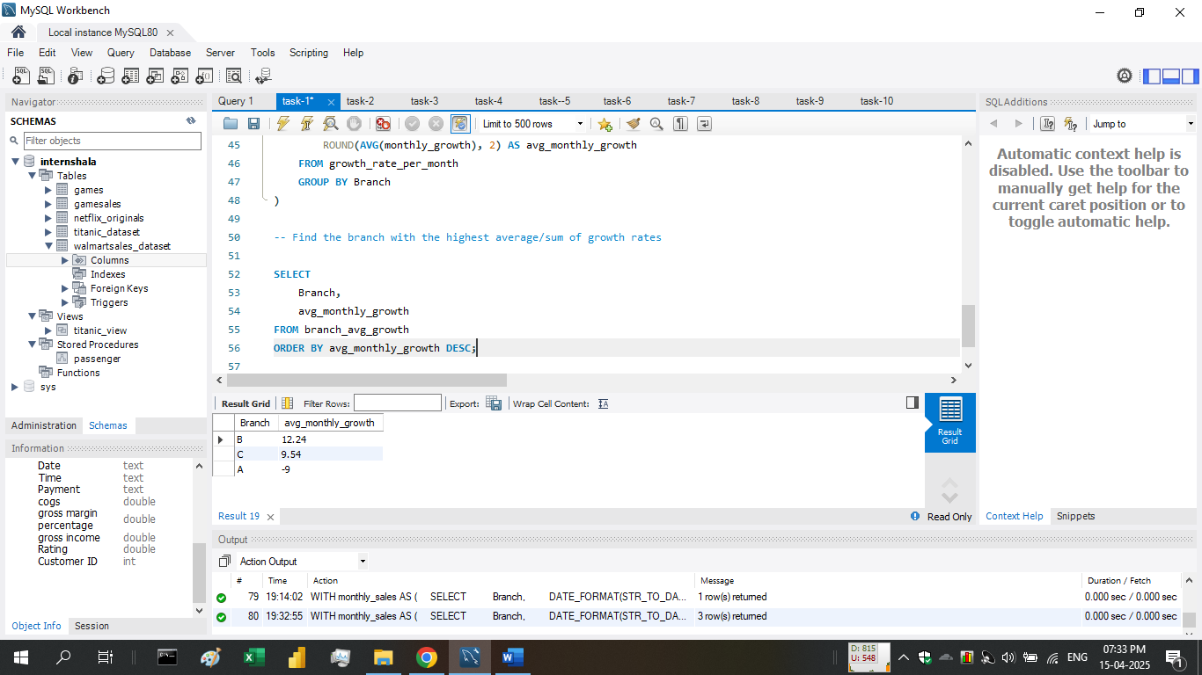LIMIT 1;

**We find Branch - B is the top branch by sales growth**

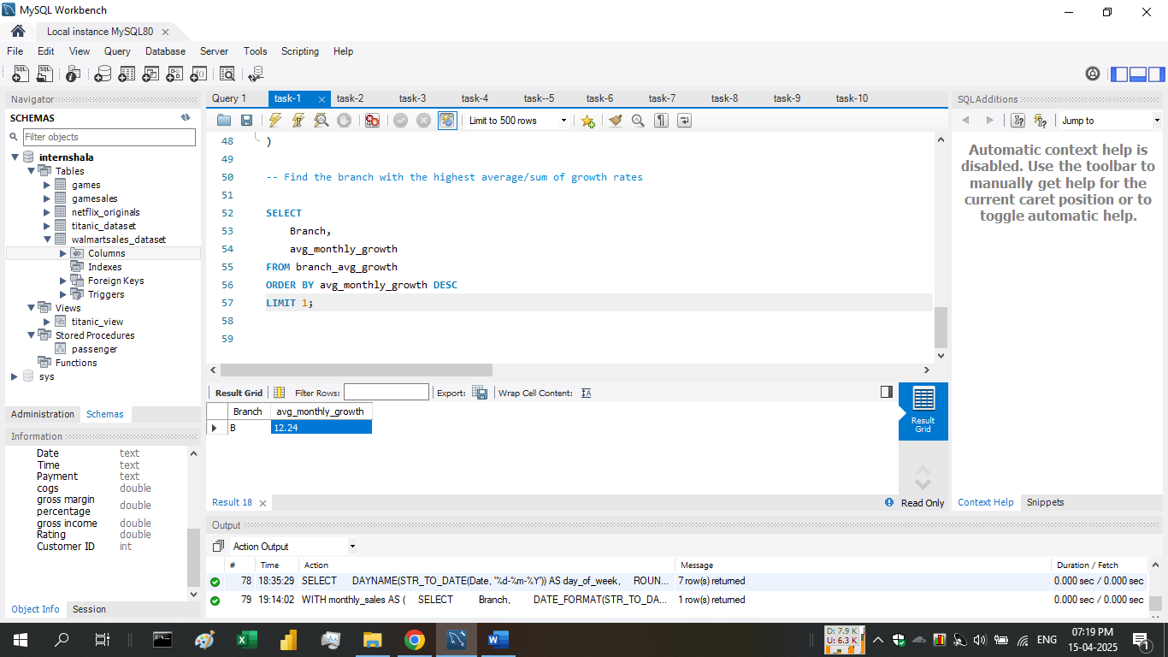

## Task 2: Finding the Most Profitable Product Line for Each Branch

Walmart needs to determine which product line contributes the highest profit to each branch. The profit margin should be calculated based on the difference between the gross income and cost of goods sold.

WITH product_profit AS (

SELECT

Branch,

`Product line` AS product_line,

SUM(`gross income`) AS total_profit

FROM walmartsales_dataset

GROUP BY Branch, product_line

),

-- ranking every product line in term of total_profit in every branch and giving it a rank

ranked_profit AS (

SELECT *,

RANK() OVER (PARTITION BY Branch ORDER BY total_profit DESC) AS rnk

FROM product_profit

)

-- Selecting all branches top 1 rank product line

SELECT

Branch,

product_line,

ROUND(total_profit, 2) AS total_profit

FROM ranked_profit

WHERE rnk = 1;

query result

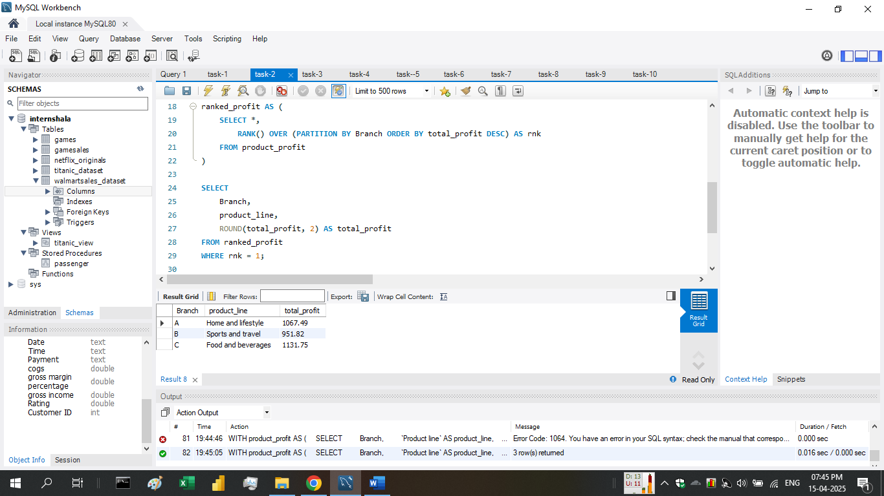

## Task 3: Analyzing Customer Segmentation Based on Spending

Walmart wants to segment customers based on their average spending behavior. Classify customers into three tiers: High, Medium, and Low spenders based on their total purchase amounts.

Ans:

WITH customer_avg AS (

SELECT

`Customer ID`,

AVG(Total) AS avg_spend

FROM walmartsales_dataset

GROUP BY `Customer ID`

),

min_max_vals AS (

SELECT

MIN(avg_spend) AS min_val,

MAX(avg_spend) AS max_val

FROM customer_avg

),

/* 1/3, 2/3 divides the range in equal parts for every case */

classified_customers AS (

SELECT

c.`Customer ID`,

c.avg_spend,

m.min_val,

m.max_val,

(m.max_val - m.min_val) AS range_val,

CASE

WHEN c.avg_spend <= m.min_val + (m.max_val - m.min_val) * 1/3 THEN 'Low'

WHEN c.avg_spend <= m.min_val + (m.max_val - m.min_val) * 2/3 THEN 'Medium'

ELSE 'High'

END AS spending_tier

FROM customer_avg c

JOIN min_max_vals m

)

--- list all the records

SELECT `Customer ID`, ROUND(avg_spend,2) AS avg_spend, spending_tier

FROM classified_customers

ORDER BY avg_spend DESC;

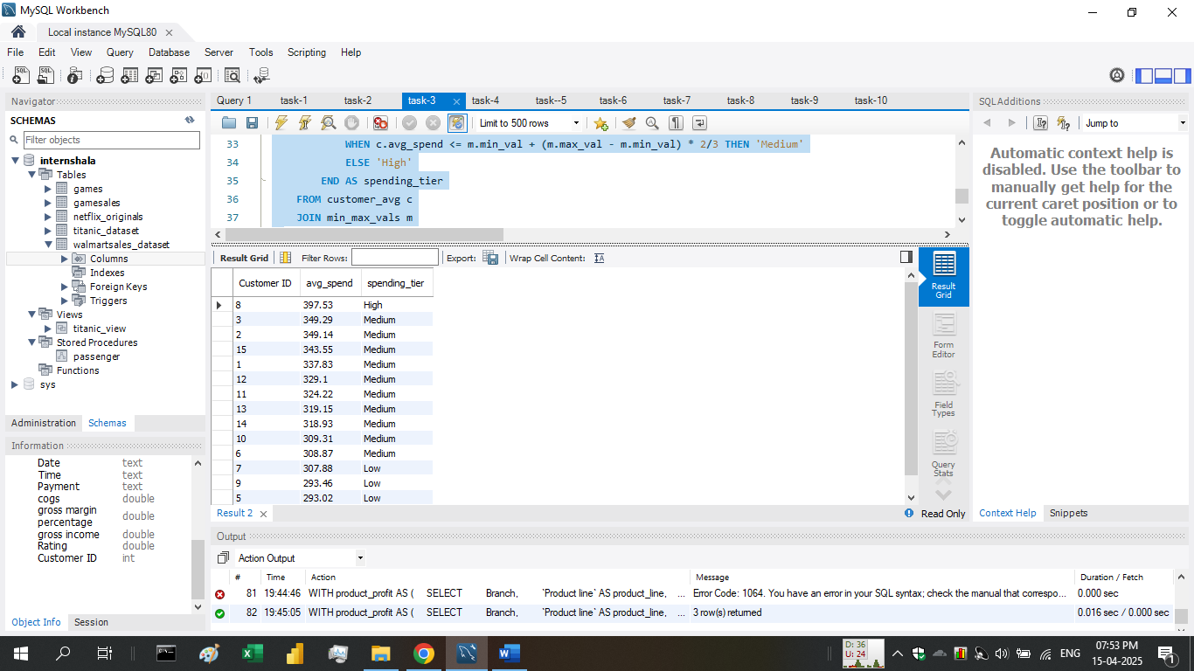

## Task 4: Detecting Anomalies in Sales Transactions

Walmart suspects that some transactions have unusually high or low sales compared to the average for the product line. Identify these anomalies.

Ans:

select

`Invoice ID`,

`Product line`,

Total,

(select avg(Total) from walmartsales_dataset as w2 where w2.`Product line` = w1.`Product line`) as avg_total

FROM walmartsales_dataset as w1

WHERE

Total > (SELECT avg(Total) from walmartsales_dataset as w2 where w2.`Product line` = w1.`Product line`) * 2

or

Total < (SELECT avg(Total) from walmartsales_dataset as w2 where w2.`Product line` = w1.`Product line`) * 0.01;

If deviation is almost 100% from average we classify it as an anomalie.

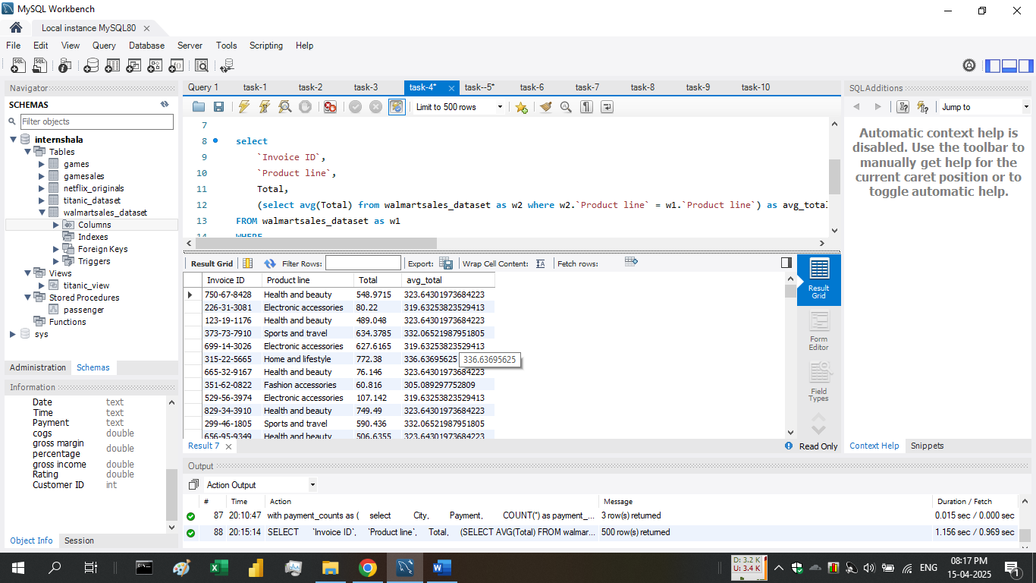

## Task 5: Most Popular Payment Method by City

Walmart needs to determine the most popular payment method in each city to tailor marketing strategies.

Ans:

with payment_counts as (

select

City,

Payment,

COUNT(*) as payment_count

from walmartsales_dataset

group by City, Payment

),

ranked_payments as (

select

*,

rank() OVER (partition by City order by payment_count desc) as payment_rank

from payment_counts

)

select

City,

Payment as most_popular_payment,

payment_count

from ranked_payments

where payment_rank = 1

order by City;

query result

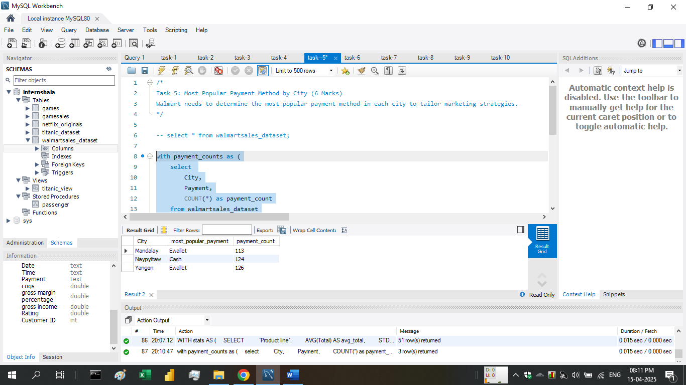

## Task 6: Monthly Sales Distribution by Gender

Walmart wants to understand the sales distribution between male and female customers on a monthly basis.

Ans:

with monthly_sales as (

select

DATE_FORMAT(STR_TO_DATE(Date, '%d-%m-%Y'), '%Y-%m') as month,

Gender,

SUM(Total) as total_sales

from walmartsales_dataset

group by month, Gender

)

select

month,

Gender,

total_sales

from monthly_sales

order by month, Gender;

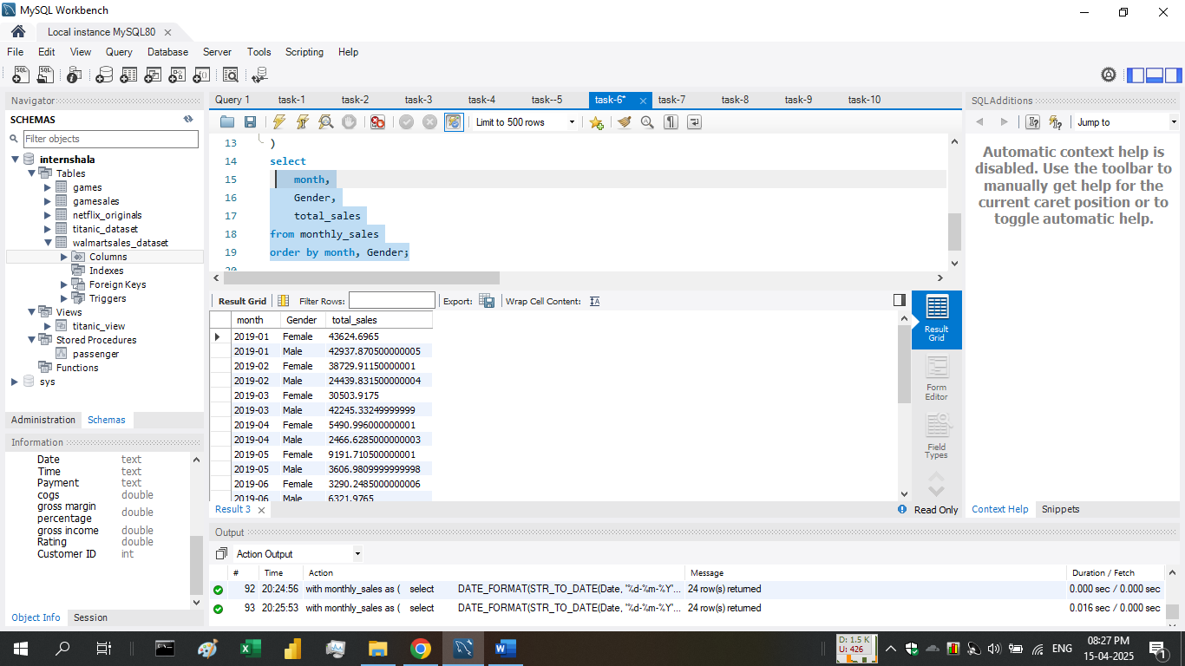

## Task 7: Best Product Line by Customer Type

Walmart wants to know which product lines are preferred by different customer types(Member vs. Normal).

Ans:

-- times each product line was bought by each customer type.

with product_popularity as (

select

`Customer type`,

`Product line`,

count(*) as purchase_count

from walmartsales_dataset

group by `Customer type`, `Product line`

),

-- Rank the product lines by their popularity within each customer type.

ranked_products as (

select

*,

rank() OVER (PARTITION BY `Customer type` order by purchase_count desc) as product_rank

from product_popularity

)

select

`Customer type`,

`Product line` AS most_preferred_product_line,

purchase_count

from ranked_products

where product_rank = 1

order by `Customer type`;

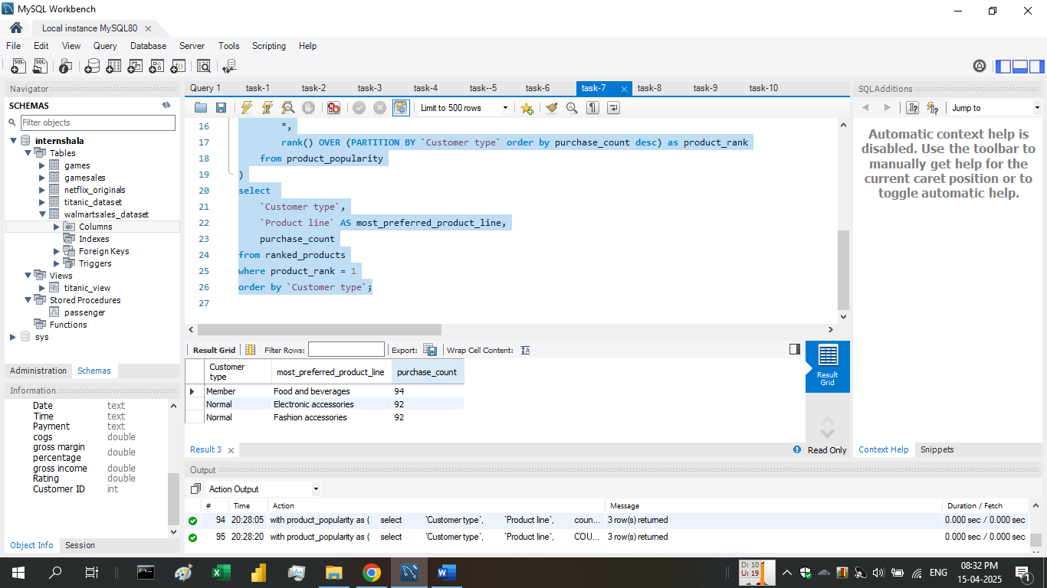

## Task 8: Identifying Repeat Customers

Walmart needs to identify customers who made repeat purchases within a specific time frame (e.g., within 30 days).

Ans:

select distinct a.`Customer ID`

from walmartsales_dataset a

join walmartsales_dataset b

on a.`Customer ID` = b.`Customer ID`

and a.`Invoice ID` != b.`Invoice ID`

and ABS(DATEDIFF(STR_TO_DATE(a.Date, '%d-%m-%Y'), STR_TO_DATE(b.Date, '%d-%m-%Y'))) <= 30;

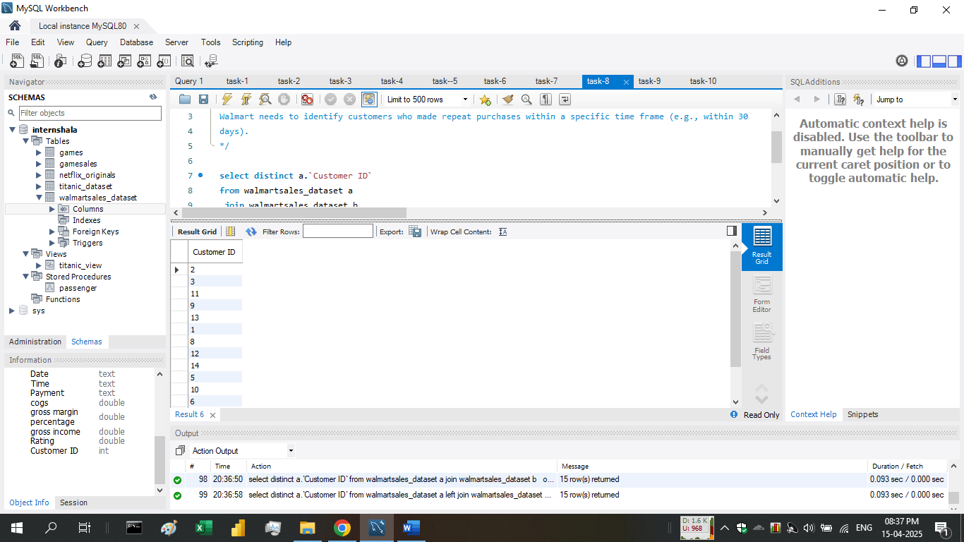

## Task 9: Finding Top 5 Customers by Sales Volume

Walmart wants to reward its top 5 customers who have generated the most sales Revenue.

Ans:

select

`Customer ID`,

round(SUM(Total), 2) as total_revenue

from walmartsales_dataset

group by `Customer ID`

order by total_revenue DESC

limit 5;

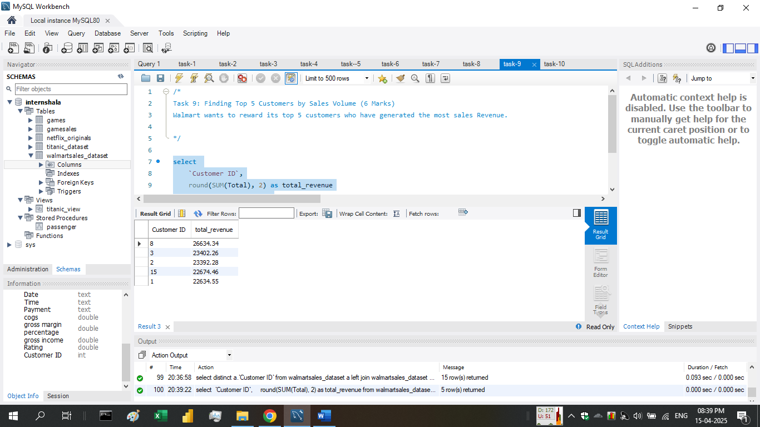

## Task 10: Analyzing Sales Trends by Day of the Week

Walmart wants to analyze the sales patterns to determine which day of the week brings the highest sales.

Ans:

select

dayname(STR_TO_DATE(Date, '%d-%m-%Y')) as day_of_week,

round(SUM(Total), 2) as total_sales

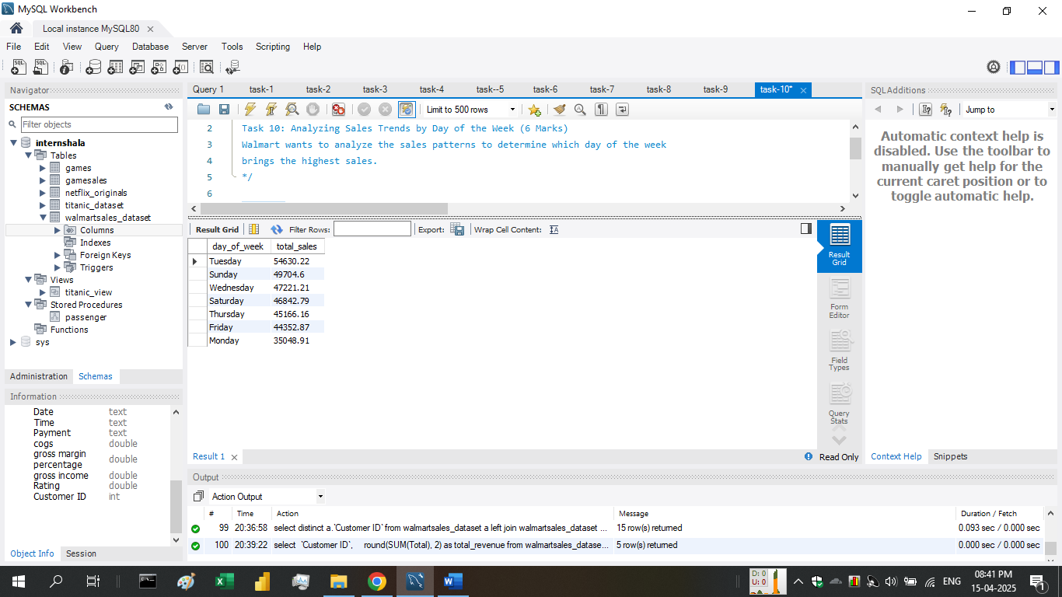from walmartsales_dataset

group by day_of_week

order by total_sales desc;

result shows that Tuesday is most profitable day of the week in most cases.