PULSE
ANALYTICS
SaaS Product Analytics & User Behavior Dashboard
Business Analysis • KPI Engineering • Funnel • Cohort Retention • Power BI

Project purpose: Transform user, subscription, and product-event data into a business-facing SaaS analytics solution covering acquisition, engagement, conversion, monetization, churn, and retention.

1. Executive Summary
PULSE Analytics is an end-to-end SaaS product analytics project built to demonstrate how raw customer, subscription, and product-event data can be converted into decision-ready business metrics and an interactive Power BI analytics product.
The dataset contains 2,000 users, 2,000 subscription records, and 33,987 user-event records. The analysis follows the customer lifecycle from acquisition to engagement, paid conversion, recurring revenue, churn, and cohort-based activity retention.
The final dashboard is organized into four pages: Executive Overview, Growth & Acquisition, Revenue & Monetization, and Retention & Engagement.
KPI | Current / Overall View | Business Question
MAU | 2,000 overall | How many users are active?
MRR | ≈ ₹2M latest snapshot | What recurring revenue base is represented?
ARPU | ≈ ₹3,274 latest snapshot | What recurring revenue is generated per paid user?
Churn Rate | 28.8% overall | How much of the user base has churned?
Paid Conversion | 49.4% | How many users convert to paid?
Paid Users | 988 | How large is the paid customer base?
Active Subscribers | 1,429 latest snapshot | How many subscriptions are active?
Avg Session Duration | 15.5 min | How deeply are users engaging?

2. Business Problem
SaaS businesses generate data across acquisition, product usage, subscriptions, and customer lifecycle events. Examining these sources independently makes it difficult to understand where users enter the funnel, how they engage, what drives paid conversion, how recurring revenue changes, and where retention weakens.

Business questions addressed
- How large and active is the user base?
- How many users move from signup to engagement and then to paid subscription?
- Which acquisition channels generate users and paid conversions?
- How does recurring revenue change month by month?
- What is the revenue contribution of each subscription plan?
- What is ARPU for paid users?
- How much churn is occurring?
- How does activity vary across signup cohorts?
- How does product engagement relate to retention?

Business value
- Creates one analytical view of acquisition, engagement, conversion, revenue, and retention.
- Turns raw records into explicit business KPIs.
- Separates executive monitoring from diagnostic analysis.
- Highlights funnel drop-offs and channel-level conversion differences.
- Provides cohort visibility into user activity over time.
- Creates a reusable structure for future SaaS datasets.

3. Dataset & Data Model
The solution is built around three source tables and four analysis-ready tables prepared for Power BI.
Table | Grain | Key Fields | Purpose
users | 1 row/user | user_id, signup_date, country, acquisition_channel | User and acquisition analysis
subscriptions | 1 row/subscription | user_id, plan_type, start_date, monthly_price, end_date | Plan, revenue and churn
events | 1 row/event | user_id, event_date, event_type, session_duration | Product engagement
user_360 | 1 row/user | Profile + subscription + event summaries | Unified user layer
monthly_metrics | 1 row/month | MAU, MRR, ARPU, churn, signups | Monthly KPI layer
funnel_metrics | 1 row/stage | Users, conversion, drop-off | Funnel analysis
cohort_retention | 1 row/cohort-month | Signup month, cohort index, retention | Cohort heatmap
- 2,000 users
- 2,000 subscriptions
- 33,987 events
- Plans: Free, Basic, Pro
- Monthly prices: Free ₹0, Basic ₹2,000, Pro ₹5,000

4. Analytical Methodology
The workflow was designed as an end-to-end analytics pipeline: source understanding → data preparation → KPI engineering → Power BI modeling → visualization → QA.
- Profile the users, subscriptions, and events datasets.
- Create user-level summaries for activity, sessions, event types, subscription status, and plan.
- Build monthly metrics for MAU, MRR, subscribers, paid users, ARPU, churn, session behavior, and signups.
- Build Signups → Engaged → Paid funnel metrics.
- Build signup-cohort monthly activity retention.
- Load analysis-ready datasets into Power BI.
- Create intentional relationships, DateTable, and DAX measures.
- Build four business-focused dashboard pages.
- Validate calculations, filters, formatting, labels, and visual consistency.

Metric definitions
Metric | Definition
MAU | Distinct users appearing in events within the relevant time context.
MRR | Recurring revenue from subscriptions active in the relevant month; headline card uses the latest monthly snapshot.
ARPU | MRR divided by paid users for the relevant monthly snapshot.
Paid Users | Distinct users with monthly_price > 0.
Active Subscribers | Latest monthly active-subscriber snapshot.
Churn Rate | Overall churned users divided by total users for the headline KPI; monthly trend comes from monthly_metrics.
Paid Conversion | Paid users divided by total users.
Avg Session Duration | Average session_duration across event records.

5. Power BI Data Model
- user_360[user_id] → subscriptions[user_id]: 1-to-many, single direction, active.
- user_360[user_id] → events[user_id]: 1-to-many, single direction, active.
- DateTable[Date] → events[event_date]: 1-to-many, single direction, active.
- users remains disconnected in the final model; channel-level user analysis uses user_360 where shared user-level filtering is needed.
- DateTable is marked as the model date table.
- monthly_metrics, funnel_metrics, and cohort_retention provide analysis-ready metric layers.
The model deliberately avoids unnecessary relationships so that filter propagation remains predictable instead of connecting every table simply because a common key exists.

6. Key DAX Measures
Measure | Logic
Total Users | DISTINCTCOUNT(user_360[user_id])
MAU | DISTINCTCOUNT(events[user_id])
Paid Users | CALCULATE(DISTINCTCOUNT(subscriptions[user_id]), subscriptions[monthly_price] > 0)
Paid Conversion Rate | DIVIDE([Paid Users], [Total Users])
Paid Users by Channel | CALCULATE(DISTINCTCOUNT(user_360[user_id]), user_360[monthly_price] > 0)
Channel Paid Conversion Rate | DIVIDE([Paid Users by Channel], DISTINCTCOUNT(user_360[user_id]))
Total Events | COUNTROWS(events)
Avg Session Duration | AVERAGE(events[session_duration])
MRR | Latest month value from monthly_metrics[MRR]
ARPU | Latest month value from monthly_metrics[ARPU]
Active Subscribers | Latest month value from monthly_metrics[active_subscribers]
Churn Rate | Churned distinct users / total distinct users

7. Dashboard Architecture
Page | Purpose | KPIs | Core Visuals
01 — Executive Overview | Executive snapshot | MAU, MRR, ARPU, Churn Rate | Monthly Active Users; Monthly Recurring Revenue; Conversion Funnel; Revenue by Plan
02 — Growth & Acquisition | Acquisition and conversion | New Signups, Paid Conversion, Paid Users, Channels | Acquisition Channels; Monthly New Signups; Acquisition → Paid Conversion; Paid Conversion Rate by Channel
03 — Revenue & Monetization | Recurring revenue and plan economics | MRR, ARPU, Paid Users, Active Subscribers | Monthly Recurring Revenue; Revenue by Plan; Monthly ARPU; Paid User Mix by Plan
04 — Retention & Engagement | Churn and user activity retention | Churn Rate, Avg Session Duration, Active Subscribers | Monthly Active-User Retention; Monthly Churn Rate

Dashboard screenshots
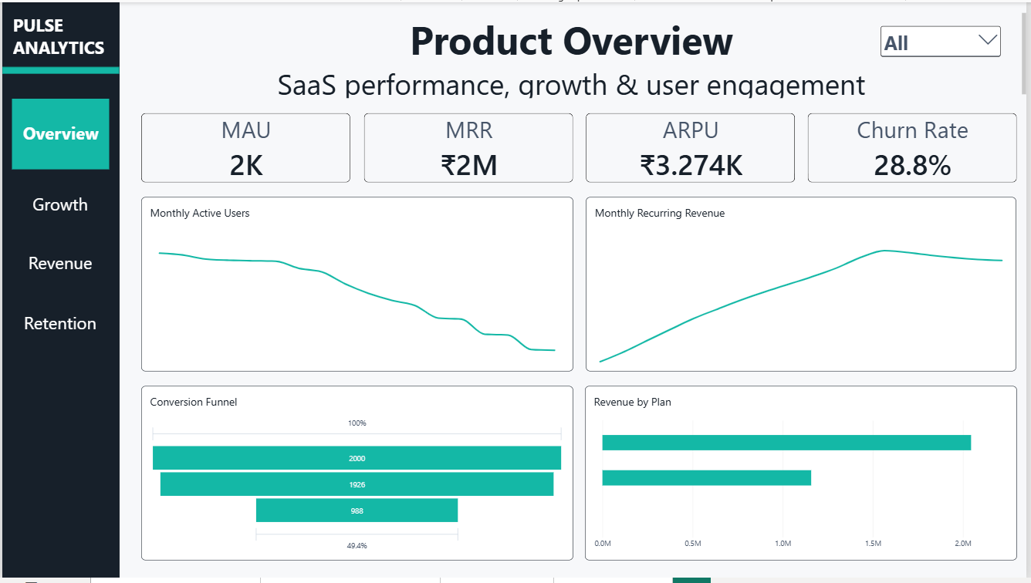
Figure 1. Executive Overview
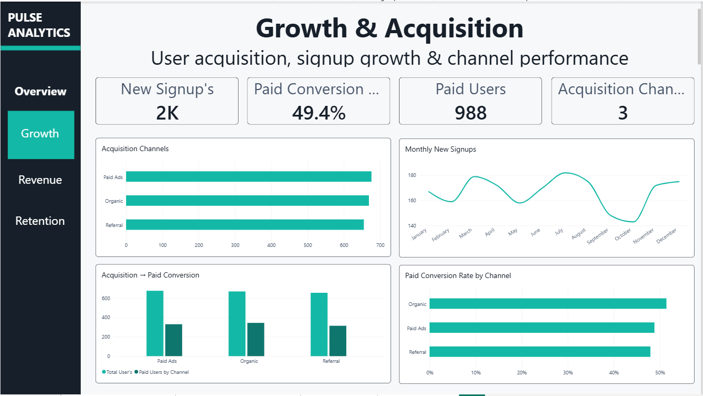
Figure 2. Growth & Acquisition
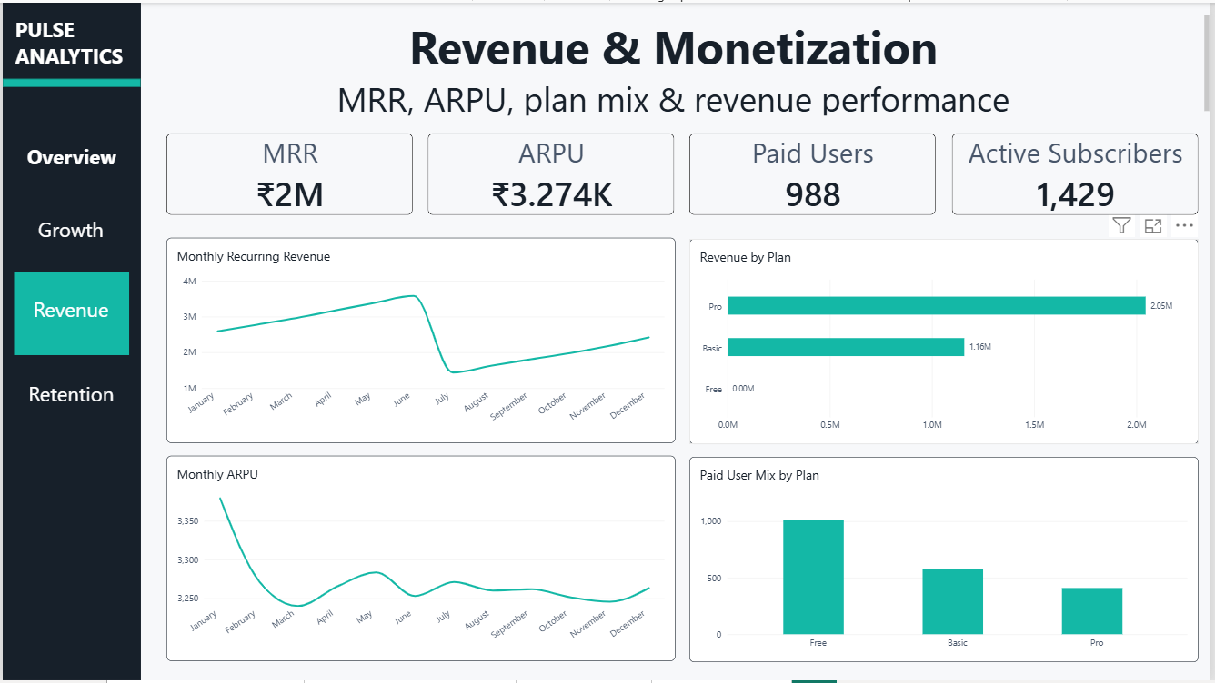
Figure 3. Revenue & Monetization
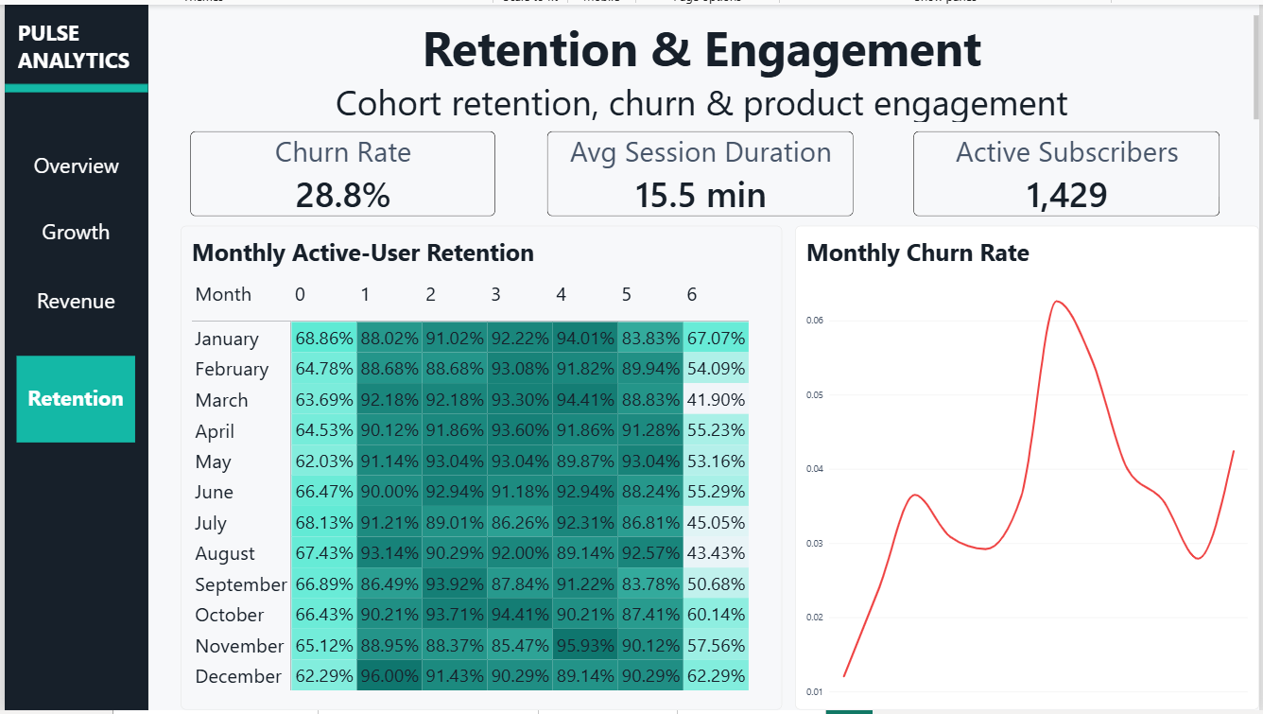
Figure 4. Retention & Engagement

8. Key Analytical Observations
Area | Observation
Conversion | 2,000 users enter the funnel, 1,926 reach the engaged stage, and 988 are paid; signup-to-paid conversion is 49.4%.
Acquisition | The three channels are Paid Ads, Organic, and Referral; the Growth page compares volume and paid conversion.
Revenue | MRR rises through the first part of the year, drops sharply around July, and then recovers toward December.
Plan Mix | Pro contributes the largest recurring subscription value, followed by Basic; Free contributes ₹0.
ARPU | Latest monthly ARPU is approximately ₹3,274 per paid user.
Churn | Overall churn is approximately 28.8%; monthly churn varies across the year.
Engagement | Average session duration is approximately 15.5 minutes.
Cohorts | Monthly active-user retention varies by signup cohort and elapsed month.

9. Analytical Definitions & Limitations

Cohort retention definition
The cohort heatmap represents monthly active-user retention, not conventional subscription-survival retention. A user is counted as active when qualifying event activity occurs in a month. Therefore Month 0 is not forced to 100%.

Other considerations
- The headline Churn Rate is an overall user-level KPI; the Retention page separately shows the monthly churn trend.
- MRR, ARPU, and Active Subscribers are represented as latest-month snapshot KPIs.
- The dataset is synthetic/portfolio-oriented and should not be interpreted as production company data.
- The observation period limits how far long-term retention can be measured.
- Currency is represented in Indian Rupees.

10. Dashboard Design System
Element | Implementation
Brand | PULSE ANALYTICS
Primary Accent | #14B8A6
Navigation | #17202A
Secondary Accent | #0F766E
Negative / Churn | #EF4444
Canvas | #F7F8FA
Typography | Segoe UI-style hierarchy
Layout | 16:9, consistent KPI cards, two-column analytical layout
Navigation | Overview, Growth, Revenue, Retention
The dashboard was intentionally designed as a lightweight SaaS analytics product rather than a generic collection of Power BI charts. The visual system uses a dark navigation rail, light analytical canvas, teal accent, restrained typography, whitespace, and consistent card/chart containers.

11. End-to-End Technical Workflow
Stage | Work Completed
Source | Users, subscriptions, and product events.
Python / Pandas | Data loading, aggregation, user summaries, monthly KPIs, funnel and cohort preparation.
Exports | users.csv, subscriptions.csv, events.csv, user_360.csv, monthly_metrics.csv, funnel_metrics.csv, cohort_retention.csv.
Power BI | Import, relationships, DateTable, DAX, formatting.
Visualization | Four business-oriented pages with a consistent design system.
QA | Metric validation, formatting, labels, filters, plan mix and visual consistency.

12. Portfolio / Interview Story
The project can be presented as an end-to-end product analytics case study rather than simply as a dashboard.
Suggested interview narrative:
“I built a SaaS product analytics solution to understand the full customer lifecycle from acquisition to engagement, conversion, monetization, and retention. I started with user, subscription, and event-level data, prepared analysis-ready datasets using Python and Pandas, then modeled the data in Power BI and created DAX measures for core SaaS KPIs. The final report has four pages covering executive health, growth and acquisition, revenue and monetization, and retention and engagement. I also used funnel and cohort analysis to move beyond simple KPI reporting and identify where users progress or drop off across the product lifecycle.”

Skills demonstrated
- Python and Pandas data preparation
- Data cleaning and aggregation
- SaaS KPI definition
- Power BI data modeling
- DAX
- Funnel analysis
- Cohort analysis
- Retention and churn analysis
- Business dashboard design
- Data storytelling

13. Potential Future Extensions
- Add subscription-survival retention alongside activity retention.
- Add plan-level churn and upgrade/downgrade analysis.
- Add LTV and CAC if reliable cost data is available.
- Add user segmentation based on engagement frequency and session behavior.
- Add anomaly detection for MRR or MAU changes.
- Add drill-through from channel/cohort into user-level detail.

14. Project Deliverables
- Power BI dashboard: PULSE Analytics — SaaS Product Analytics & User Behavior
- users.csv
- subscriptions.csv
- events.csv
- user_360.csv
- monthly_metrics.csv
- funnel_metrics.csv
- cohort_retention.csv
- Python/Jupyter analysis notebooks
- This documentation

Appendix — Final KPI Snapshot
KPI | Value | Notes
MAU | 2,000 | Overall distinct event users
MRR | ≈ ₹2M | Latest monthly snapshot
ARPU | ≈ ₹3,274 | Latest monthly snapshot
Churn Rate | 28.8% | Overall user-level KPI
Paid Users | 988 | Paid subscription users
Active Subscribers | 1,429 | Latest monthly snapshot
Paid Conversion | 49.4% | Paid users / total users
Avg Session Duration | 15.5 min | Average event session duration
Total Events | 33,987 | Source event records

STATUS: COMPLETE
PULSE ANALYTICS • SaaS Product Analytics & User Behavior Dashboard

