

**DEAKIN University**

**MAX VOICE**

Team 25

Wey Hong, Weiqi Zhang, Vasu Batra, Alush Selimi, Abdulrahman Baali, Mahedi Raz and Xueting Jiang

Project Handover Document

Trimester 1 2018

Project Client

Reece Max Australia

Project Contact Person

Contact Name: Shane Laffin

Email: [shane.laffin@reece.com.au](mailto:shane.laffin@reece.com.au)

Phone: 0418 177 347

URL: https://www.reece.com.au

Project Mentor

Dr Nick Patterson

Project Team [Team# 25]

|  |  |  |
| --- | --- | --- |
| Student ID | Student Name | Role |
| 216235377 | Wey Hong | Developer |
| 216258442 | Weiqi Zhang | Developer |
| 216046517 | Vasu Batra | Web/Security |
| 215088485 | Alush Selimi | Developer/Leader/Web Development |
| 215194281 | Abdulrahman Baali | Architecture and Analyst Programmer |
| 215450675 | Mahedi Raz | UX/UI |
| 217457072 | Xueting Jiang | Developer |

# Document Purpose

This document records the transfer of all the information and artefacts produced during the course of this project in the first phase. The handover document and delivery package includes the following:

1. The business requirements planned to be delivered,
2. Location of project artefacts (both deliverables and documentation)
3. Link to project team’s task board (Trello)
4. List of business features planned
5. List of business features delivered
6. Plan for delivery of remaining business features
7. Lessons learnt
8. Open issues
9. High level product architecture
10. Location of source code
11. User manuals
12. Links to all relevant documentation
13. Documentation (as attachments to this document)

The overall purpose of this document is to handover all artefacts related to the progress made by the project date in a manner such that another team can commence the development on the project where our team has left off.

# Project Description

Reecetech would like an application that makes the lives of their customers (mainly plumbers) much easier, they feel that their customers are frustrated trying to navigate between their 580+ stores across Australia and New Zealand. The sheer number of stores are making it difficult for customers to find the store and thus the products they need. As a result, the client has devised a concept for a mobile application that can interface with its website to assist the customer in finding Reece branches and navigating their customers to them.

The client would like a mobile application that accepts voice commands, for example, if the customer asked where they can find their nearest branch, the application would interface with the client’s website and provide them with the address of said branch, and a way to get there.

# Business Features

The project’s focus has been to research the requirements of the various components of the application and finalize the architecture of the application. The area of voice commands, artificial intelligence, data analytics and natural language classifier has been new for the project team. Therefore, while the project team has made good progress in learning the artefacts, in terms of the actual mobile application deliverable, the project team has setup the application development environment and integrated with Google Maps. The classifier has also been implemented, although it is not perfect it requires some fixes to accuracy and automation. That is extent of business feature delivery at this stage.

|  |  |  |
| --- | --- | --- |
| User Story | Sprint # | Completed / In-Progress / Not Started |
| As a customer, I would like to ask the app where the nearest branch is, and be navigated to that branch. | 1 | In-Progress |
| The application will need to be able recognise the what the user is saying. | 1 | Completed |
| The application need to understand what the user is asking it to do | 2 | Completed |
| The app should know where the user is; that is, it should show the users current location on the map | 2 | Completed |
| As a customer, I would like to tell the app to call a specific branch, and have the app call that branch | 2 | In-Progress |
| As a user, I would like to ask the app who the manager of a branch is, and have the application tell me who it is. | 2 | In-Progress |
| Automate the process in which the app understands what the user is saying | 3 | Not started |
| As a user, I would like to know the trading hours of specific branches. | 3 | Not started |
| The above user stories suggest that information such as the branch manager and trading hours be available to the application. | 3 | Not started |
| The application should be able to utilize smart locations; that is if a customer asks for a branch, then it should be the branch closest to them and not one in another state. For example, if it’s Burwood, it should be able to identify that its Burwood Victoria. | 3 | Not started |
| The application must identify the correct postcode for that suburb. | 4 | Not started |
| As a user I would like to be able to speak to the app in a conversational manner.  This user story suggests that the user can have conversations with the app, and thus make the application launch the ringer of a phone and call a branch | 4 | Not started |

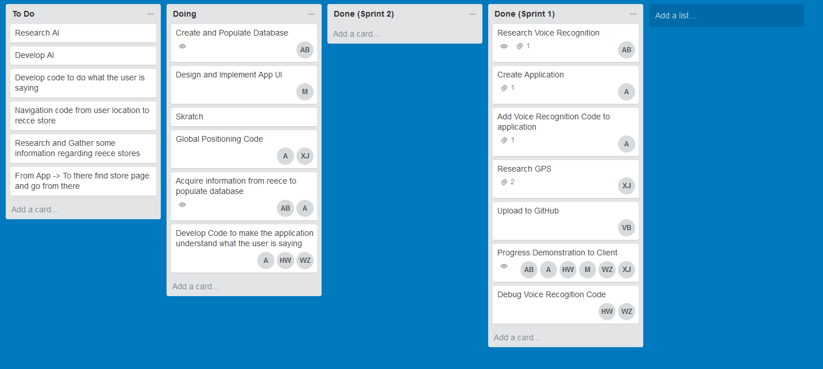

<https://trello.com/b/NGlPPRoW/sit374-max-voice>

# Planned work

|  |  |
| --- | --- |
| User Storey | Sprint # |
| As a customer, I would like to ask the app where the nearest branch is, and be navigated to that branch. | 3 |
| We need to automate the process the app uses to determine what the user has said. Currently, the users input is written to text file, and then this text file is loaded into a python shell. This needs to occur automatically. | 3 |
| As a customer, I would like to tell the app to call a specific branch, and have the app call that branch | 3 |
| As a user, I would like to ask the app who the manager of a branch is, and have the application tell me who it is. | 3 |
| As a user, I would like to know the trading hours of specific branches. | 3 |
| The above user stories suggest that information such as the branch manager and trading hours be available to the application. | 4 |
| The application should be able to utilize smart locations; that is if a customer asks for a branch, then it should be the branch closest to them and not one in another state. | 4 |
| This user story implies that the application can identify the correct postcode for a suburb. For example, if it’s Burwood, it should be able to identify that its Burwood Victoria. | 4 |
| As a user I would like to be able to speak to the app in a conversational manner. | 4 |

# Open issues

Client Liaison

It has been difficult to contact the client. There have been two meetings that were either cancelled or shortened due to last minute changes to their schedules. The client has also not responded to some of the questions from the team requesting information, e.g. requesting the store information in an excel sheet or another format; in fact, the information has not yet been supplied in any format. The project team has sent multiple reminders. The next step for the project team is to escalate the issue to the project supervisor. This was done as of (21/05/2018)

Technical skills in the group

The group skills are mostly in the web application development technologies, e.g. PHP and MySQL. The group members skills in mobile app development are good, but not great. There is an opportunity for the project team to develop their technical skills further. We are also hoping that we can welcome new team members with skills in mobile application development in the next trimester.

Working features

The project’s focus has to been to research the requirement of the various components of the application and finalize the architecture of application. The area of voice commands, artificial intelligence, data analytics and natural language classifier has been new for the project team. Therefore, while the project team has made good progress in learning and implementing the artefacts, in terms of the actual mobile application deliverable, the project team has setup the application development environment and integrated with Google Maps and implemented the language classifier. That is extent of the business feature delivery at this stage.

# Lessons Learned

Business features delivered in small increments

In this project, our focus has been on trying to prove that we can implement all of the features. We have spent considerable time in research and learning skills. More team members should instead have focused on delivering business features, e.g. even if it meant delivering the user interface of the application as a first cut for client feedback. This would have led to more business features being delivered, at the end of the first capstone unit.

Project team composition

We feel that we did not achieve the right project team composition. We have a number of team members looking to perform documentation and testing; but we do not have enough team members taking project lead or technical lead. We should have discussed this upfront and flagged the issue with the project supervisor at that stage. There was an initial reluctance from all team members, no one wanted to lead.

Different Approach to work  
Not all team members approach their work the same way. For example, some team members like to commence their work as soon as possible to give them enough time to solve any problems that may come up during say, development. Other students however, prefer to leave things to the last minute. This can and often will stress out the team leader, as this coupled by a lack of communication can make it seem as if the team member is not pulling their weight when in fact they are.

# High-level architecture of the product

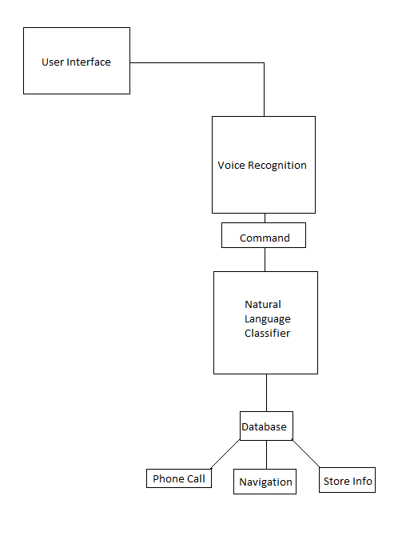

The following are explanations of what the above are and how they work.

User Interface: This is what the user sees and what they interact with. The user interface has a button that the user presses to speak to the application.

Voice Recognition: This section of the application, recognises what the user says and displays it to the user to ensure that it has accurately picked up what they have said.

Command: From the voice recognition, a command will be formed.

Natural Language Classification: The natural language classifier will pick up the command and then make the application do one of/all of the following.

Database: This is the database containing the relevant information, for instance store trading hours, branch manager etc.   
Navigation: If the user asks to be navigated to a store, the application will plot a course and guide them there.   
Phone Calls: If the user asks to call a specific store, the application will call that store.   
Store Information: Go to the database to retrieve some store information, e.g.: if the user asks for store trading hours, the app will retrieve and display this information to the user.

No login details are required. However the developers must have an apple developer account to develop this application. The project in its current state as well as any relevant documentation can be downloaded from the GitHub repository which is located at the following link:

<https://github.com/vasubatra/Reece-max>

The project must be developed in XCode. XCode requires an apple developer account.   
an account can be created at:  
<https://appleid.apple.com/account?localang=en_US&appId=632&returnURL=https%3A%2F%2Fidmsa.apple.com%2FIDMSWebAuth%2Flogin.html%3Flanguage%3DUS-EN%26rv%3D1%26path%3D%252Faccount%252F%26Env%3DUAT%26appIdKey%3D891bd3417a7776362562d2197f89480a8547b108fd934911bcbea0110d07f757#!&page=create>

The project is developed in the SWIFT language. It was tested on the emulator located within XCode.

Source code

Key Components  
Database Components: Important information (branch hours, locations, phone numbers) will be stored the database.   
Natural Language Classifier: (CoreML) This is what understands the user is saying. It picks up words and then will do as asked.   
Navigation: if the user asks to be navigated to a particular store, then the user will be navigated to that particular store.   
Classes  
DataViewController: this is the class that contains all our code. It contains the voice recognition code and some location determining code, it also contains the NLC code, as well as navigation code and any other relevant code that will be added to the application.

GitHub is our repository, it is set to public so no login information is required simply visit the following link to download the latest version.   
 <https://github.com/vasubatra/Reece-max>

# User manual

The following steps explain how the end user should use the application.   
**Step 1:** Launch the application on your iPhone.   
**Step 2:** Once the application has loaded you will be asked to allow some permissions.  
**Step 3:** Accept any relevant usage permissions (Microphone and Location usage)  
**Step 4:** Next, press the “Start Recording” button. This activates the microphone, and the app begins to listen.   
**Step 5:** Speak into the microphone. Say things like “Go to Reece Burwood”, “Call Reece Burwood” or ask “Which store is closest to me?”, “Who is the branch manager at Reece Burwood?” or “What are Burwood’s trading hours?”  
**Step 6:** The app from here will understand what you are saying/asking

**Step 7:** Once what the user says has been understood, the app will turn this into a command.   
**Step 8:** The application will then do as the command says.

# Other relevant documents

All documentation; project proposal, meeting minutes are all available on GitHub

# Appendices

# All artefacts, are available at the GitHub located at the following link:

# <https://github.com/vasubatra/Reece-max>