**MongoDB ASSIGNMENT 2**

* CREATE A DATABASE NAMED UNIVERSITY AND A COLLECTION NAMED STUDENT.INSERT MULTIPLE STUDENT DOCUMENTS WITH FIELDS:NAME,AGE,DEPARTMENT, AND GRADES.

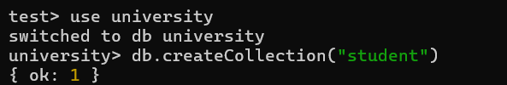

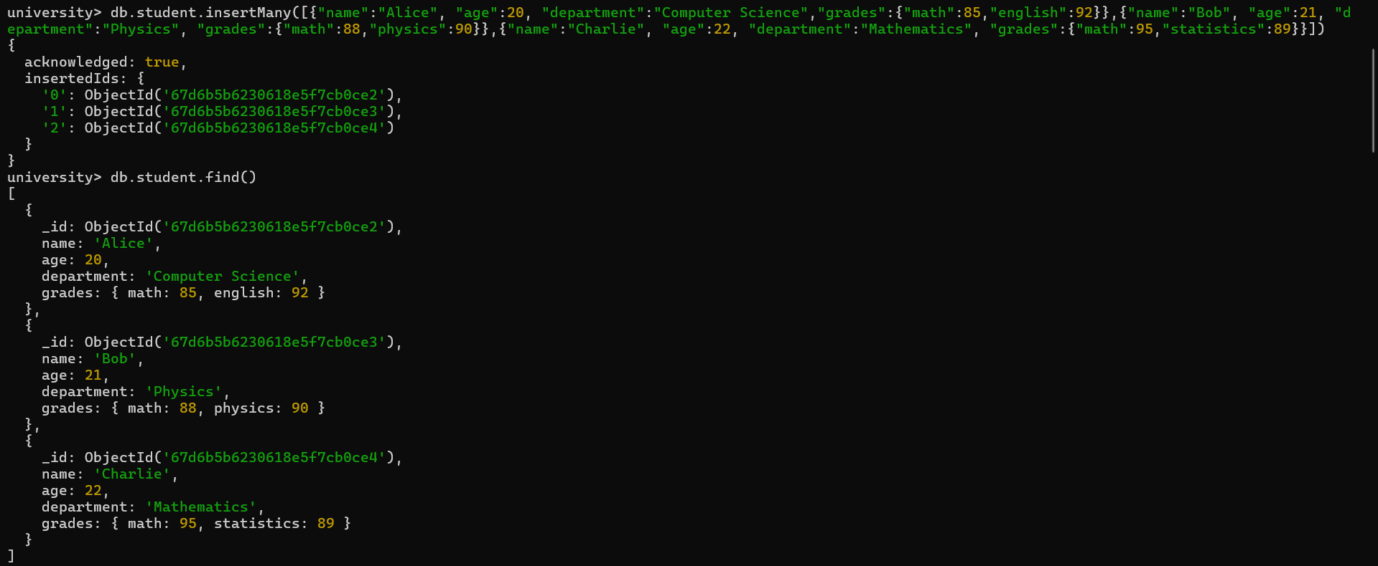

* WRITE A QUERY TO DISPLAY ALL STUDENTS WHO ARE IN THE COMPUTER SCIENCE DEPARTMENT.

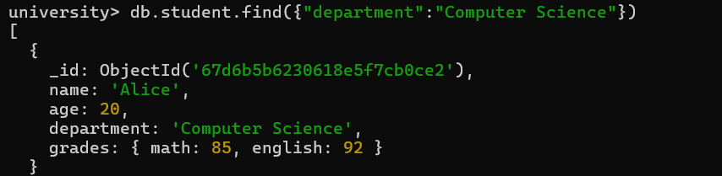

* WRITE A QUERY TO UPDATE THE GRADES OF A STUDENT NAMED ALICE BY ADDING A NEW SUBJECT PROGRAMMING WITH A GRADE OF 93.

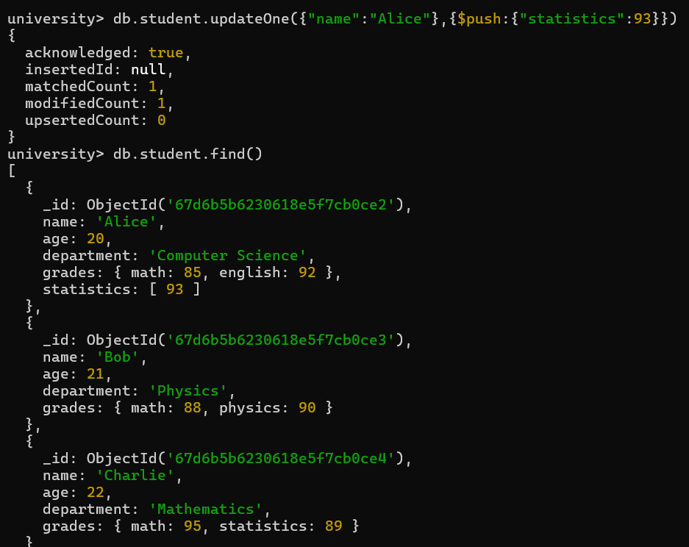

* WRITE A QUERY TO INCREMENT THE AGE OF ALL STUDENT BY 1.

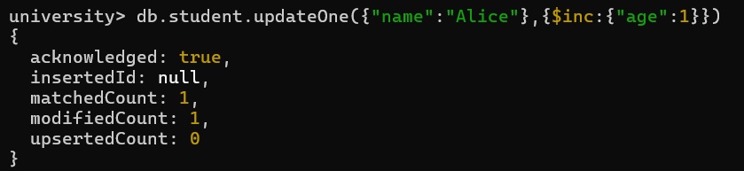

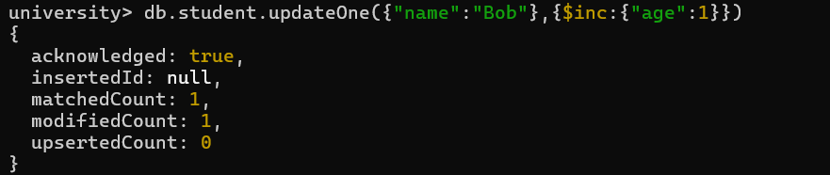

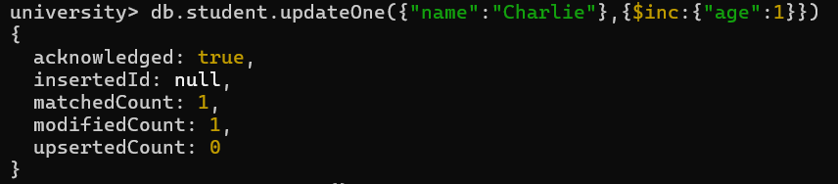

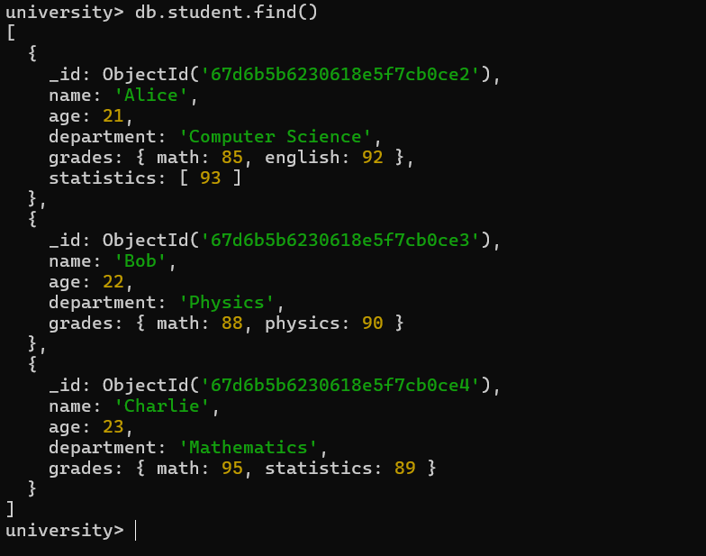

* WRITE A QUERY TO DELETE ALL STUDENTS WHO ARE 23 YEARS OLD.

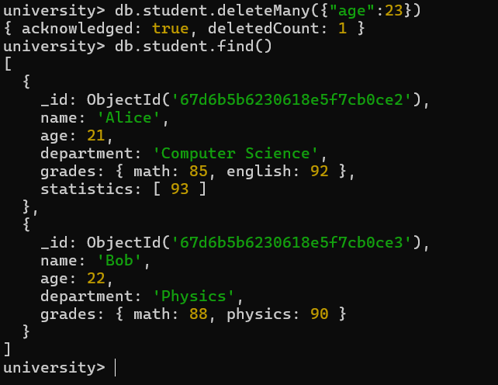

* WRITE A QUERY TO CREATE AN INDEX ON THE NAME FIELD OF THE STUDENTS COLLECTION.

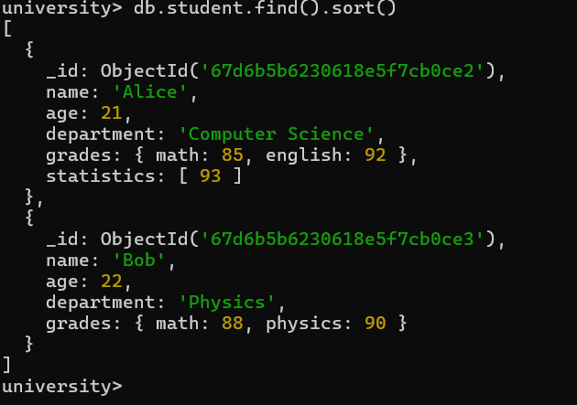

* WRITE A AGGREGRATION QUERY TO GROUP STUDENTS BY THEIR DEPARTMENT AND CALCULATE THE AVERAGE AGE IN EACH DEPARTMENT.



* WRITE A QUERY TO FIND ALL STUDENTS WHO HABE SCORED MORE THAN 90 IN ANY SUBJECT.

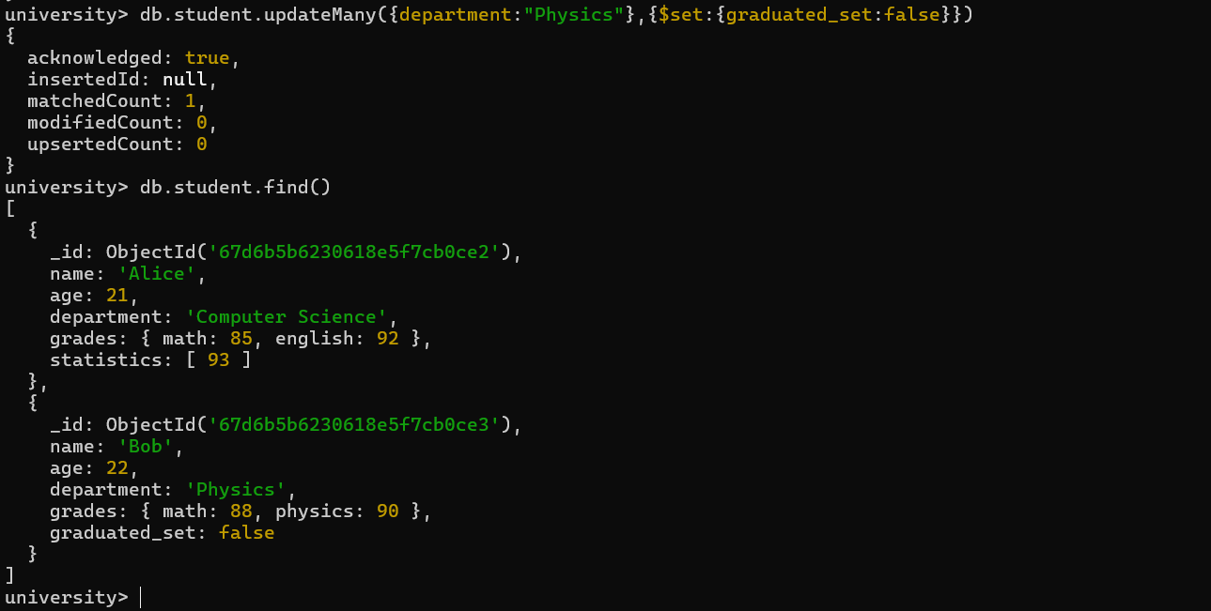

* HOW CAN YOU RETRIVE ONLY THE NAME AND DEPARTMENT FIELDS FOR ALL STUDENTS,EXCLUDING THE_ID FIELD?

