**Institutionalized Malpractice in Diagnosis and Treatment of Oral HSV2**

Zachary F. Burton, Ph.D.*

Department of Biochemistry and Molecular Biology, Michigan State University

*Corresponding Author: Department of Biochemistry and Molecular Biology, Michigan State University, 603 Wilson Rd., E. Lansing, MI 48824-1319, USA, 01-517-339-3704, FAX: 01-517-353-9334, [burton@msu.edu](mailto:burton@msu.edu)

**Abstract**

Diagnostic strategies to detect oral HSV2 infections are designed to ignore and dismiss oral HSV2 infections, which are very common, increasing in frequency, and much more severe than HSV1 infections. HSV2 oral infections can be life-threatening. Diagnostic approaches for oral HSV2 must be improved and applied broadly. There is a raging epidemic of oral HSV2 infections that physicians have deliberately ignored to the detriment of patients and society, and many sufferers will not know they are infected because they unwisely trust physicians who will not competently diagnose or treat them. Oral HSV2 infections can result in chronic and systemic disease and can progress to encephalitis, dementia and death. Treatment protocols for oral HSV2 are poorly designed and cause deliberate harm to patients and unrestrained spread of the disease. For oral HSV2, a massive gulf exists between patient needs and delivery of medical care. Deficiencies in medical protocols are planned and deliberate. Issues of oral HSV2 infection have been broadly raised for years in the medical community and society, but warnings were deliberately and irresponsibly ignored and suppressed. Physicians are content to conflate HSV2 (an aggressive and potentially lethal virus) and HSV1 (a less damaging virus), raising the question of whether physicians can count to two by integers.

**Introduction**

Physicians have institutionalized malpractice in the detection, care and containment of Herpes Simplex Virus serotype 2 (HSV2) (1). Strangely, as oral infections, physicians conflate HSV2 and HSV1. HSV2, however, causes dementia (2), chronic (1), and systemic infection. HSV2 causes encephalitis/meningitis (3). Even as an initial or sporadic illness, HSV2 makes people intolerably sick (3). HSV1 is painful enough, and HSV2 is so much worse than HSV1. Both HSV1 and HSV2 are remarkably infectious by casual contact, so oral HSV2 will spread throughout the population (1). False negative diagnosis is the rule in medical detection and treatment of oral HSV2.

So, in a professional capacity, physicians cannot count to two by integers: zero, one, two. Contrary to the beliefs of physicians, who believe HSV1==HSV2, HSV1=/=HSV2 (== means is precisely equal to; =/= means is not equal to) (1). 1=/=2, and HSV1=/=HSV2. HSV2 is a lethal virus. HSV1, probably, is not. HSV2 makes people very sick as an oral infection. HSV1 generally does not.

In diagnosis of HSV, physicians only recognize weeping cold sores as a symptom (1). There is a reason for deliberate institutionalized physician incompetence in diagnosis of oral HSV2, but it is not a good reason. The reason is that the diagnostic test, so rarely selected and so irresponsibly employed, is a polymerase chain reaction test that can only detect HSV1 or HSV2 DNA but cannot discriminate active infection from latency. Because all Americans have antibodies to HSV1, HSV2 or both, detecting virus DNA is not informative for an active infection, unless the patient presents with obvious external disease (i.e. weeping cold sores). Because only a small fraction of seriously afflicted patients (i.e. <1%) present with weeping cold sores at the time of a difficult-to-schedule doctor appointment, very few cases of oral HSV2 are documented, and patients are given false diagnoses (1). Thus, an epidemic that can be identified from weeping cold sores, on people in the street and on television, rages without detection. To a physician, nonetheless, oral HSV2 is antibiotic-resistant acne. In detection of oral HSV2, therefore, the patient must do the diagnosis. Only with patient demands will physicians confirm a diagnosis or provide care. If you are waiting for a competent diagnosis or treatment for oral HSV2 from a physician, you will wait beyond serious illness and possibly death. With chronic oral HSV2 becoming systemic, you may die before you are adequately diagnosed.

HSV causes latent infections, which do not result in disease. HSV remains quiescent and hidden within nerve cells, sequestered from the human immune system, sometimes for years, without causing active eruptions. In their wisdom, physicians count every infection, no matter how painful or dangerous, as “latent” unless the infection results in weeping cold sores, the only symptom short of encephalitis that physicians are willing or able to detect (1). Physicians have institutionalized malpractice in the diagnosis of HSV2. In clinic, physicians overlook ~100% of HSV2 cases. Physicians do this deliberately because physicians are incompetent and stupid. Incompetent diagnosis of HSV2 is willful institutionalized malpractice.

Because active HSV2 infections go deliberately undetected, the virus spreads. In 2019, the entire adult population of earth is exposed to HSV1. Very soon, the entire adult population of earth will be exposed to oral HSV2. Many people will get very sick with no access to competent medical care. Sufferers will go without accurate diagnosis and without adequate treatment. The medical industry wishes to meet this exploding challenge by deliberately giving false negative diagnoses and by allowing sufferers to spread the disease as widely and as rapidly as possible. Physicians’ intention is to force patients to suffer, spread the disease, and die. Physicians are deliberate and knowing sponsors of a lethal oral HSV2 epidemic.

**Results**

**Case Histories**

**Case 1**

(there is no editing of these communications except for removing identifying information)

Good day Mr Burton -

I read your Biochemistry article on Oral HSV2 and was hopeful you may be able to help!

I was exposed and infected with typical HSV2 as a young person. My occurrences were few and far between. However one year ago I began having symptoms of Oral HSV2. I am an otherwise healthy X yr old. I have been married for Y years without any other serious diagnosis. I cannot seem to find a Dr. that will even listen to what is happening. I feel like the I have chronic esophagitis and when very uncomfortable even can feel it in my lungs. When this first happened a year ago it followed with a severe tonsillitis and then a rash all over my body. The rash was oval shaped red spots that took about 4 months to go away. I have tried 1000mg of acyclovir BID but that did't help.

I am a (occupation—location). ANY recommendation for a Dr would be greatly appreciated. Obviously I am happy to travel to (location) if necessary. My biggest concern is that this will cause a secondary esophageal cancer or encephalitis.

Do you know if I am now at even greater risk of encephalitis with oral HSV2 than if I had HSV1 or just genital HSV2?

I apologize if I am coming across a bit desperate, but I feel desperate.

Thank you in advance for any assistance you may be able to provide,

**My response:**

Dear,

Unfortunately, I have no useful suggestion for access to better medical care at this time, although I am seeking this information, and will transmit it to you, if I can make this discovery.

Can I use your email (with your name removed) in communications on this subject? The depth of physician ignorance and denial on oral HSV2 cannot be overstated.

Have you tried sucking on 500 mg acyclovir per day to increase the local dose to the affected area (they taste terrible)? (I am not a physician, I’m a Ph.D., so I cannot legally make this prescription).

Possible beneficial effects will not be immediate.

Is your chin inflamed (i.e. noticeably hot to the touch)?

Acyclovir is absorbed through the skin and so can be applied directly to the chin and be effectively absorbed. This is more effective than swallowing pills or, I guess, intravenous whole body injection.

The virus pools in reservoirs, i.e. in the face, and, if not suppressed, spreads more freely to other places. If the reservoir is reduced by local application of the drug, this may alleviate other symptoms.

Injectable acyclovir is available and should be tested (or adjusted) for safety of local injection to local reservoirs of the virus. It appears that acyclovir is a low toxicity drug, particularly when delivered directly to affected areas.

Thanks very much for your communication.

Gratefully,

Zachary Burton, Ph.D.

Professor of Biochemistry and Molecular Biology

Michigan State University

E. Lansing, MI 48824-1319

**Letter #2:**

Thank you for your honest reply! Yes, you may certainly use my email (if you could just remove my name) as I would welcome any help and would be happy to validate this horrible disease. I have made an apt with an infectious disease Dr at UCLA. I hope he will be able to help get this under control. I just remember my micro teacher in school scaring me to death about ever getting oral HSV2 as it goes straight to the brain. She did have a flair for the extreme but still!! I feel like i'm living in the twilight zone...I just can't believe this has happened to me!

I will ask about antiviral mouthwash when I see the UCLA guy.

Fingers crossed!!

Thank you again for your caring email. I hope you find some exciting information to share with me :) If I learn anything from LA i'll let you know.

**Case 2**

I have suffered from genital herpes for decades. Now, I suffer from a severe and chronic oral HSV2 infection that threatens to become a systemic infection. I also have a spot of HSV2 infection on my stomach that I have had for decades similar to shingles. All of these infections are sensitive to treatment with acyclovir derivatives proving that they are due to HSV. I have been given a blood test that demonstrates that I am infected with HSV2. As a young child, I was also infected with HSV1, but this infection appears to have receded or been replaced by HSV2.

When I go to a doctor, they lie to me, offer false diagnoses, and give ineffective medical care. Physicians refer to HSV as a “nuisance” virus, meaning that physicians intend to ignore its severe effects. Physicians do not distinguish between HSV2 and HSV1 unless you request that they order tests. Physicians discount the blood test because, they argue, the blood test only tests for HSV2 infection, not active infection. For active infection, physicians can only diagnose weeping cold sores. Testing weeping cold sores, physicians use polymerase chain reaction to detect HSV2 DNA. The combination of external, active disease and PCR detection of the virus yields a diagnosis of active infection. The chances of displaying an active and sufficiently ripe cold sore, at the time of an appointment that may take months to schedule, are miniscule, particularly if you are taking medicine to suppress such outbreaks. Of course, because only ulcerated cold sores will be considered as a symptom by physicians, many obvious symptoms of HSV2 oral infection are simply ignored. Patients cough chronically, itch constantly, and suffer “burning mouth” symptoms. Physicians go out of their way to misdiagnose and incompetently treat oral HSV2.

Treatment for oral HSV2 infection is ineffective. Taking 1000 mg per day (the maximum allowed dose) of famcyclovir by mouth, for instance, becomes ineffective to suppress a chronic and/or systemic infection. Because the treatment reduces the size and duration of cold sores, however, physicians will not be able to improve on their self-serving and incompetent diagnosis. Physicians do not make clear how their identification of cold sores will improve the diagnosis or will inform treatment. It appears that an infection must progress to encephalitis before a physician would recognize the harm done to the patient. When patients progress to encephalitis, they are the victims of malpractice by the physician.

Physicians suggest that suffering patients stop treatment with acyclovir derivatives, so they can obtain a ripe sample of a weeping cold sore for diagnosis. It is not clear what benefit this is to the patient, who will become intolerably sick if they follow this stupid and irresponsible advice. Physicians indicate that, if the disease advances to encephalitis, the patient may qualify for more aggressive treatment.

My experience with medical practitioners is summarized in Table 1. I have been to 15 physicians of varying specialties, none of whom have known anything about oral HSV2 infections. These physicians are incompetent at: 1) diagnosis; 2) giving advice; and 3) treatments. Physicians pretend a patient is not sick when they are very sick. Physicians offer creative and false diagnoses. Physicians only consider ulcerated cold sores as a symptom, neglecting other symptoms. Physicians prescribe acyclovir derivatives without doing adequate diagnostics. Physicians are deliberately incapable of doing competent diagnostics. Treatments are not sufficiently effective. Physicians prescribe acyclovir derivatives, essentially accepting the diagnosis made by the patient. As my illness progressed, I did not know that physicians are completely incompetent and unknowledgeable about HSV2. I did not know that physicians confuse HSV1 and HSV2. This came as a surprise. I did not know that 5/5 infectious disease specialists do not know what a virus is. 5/5 infectious disease specialists do not understand viral infection, viral latency, viral diagnostics or viral epidemiology. Just what is it that these infectious disease specialists do know? 15/15 physicians offer poorly designed treatments that imperil the health and lives of their patients.

Table 1. 15/15 physicians are incompetent at oral HSV2 diagnosis, treatment and advice. Many physicians prescribe drugs based on the patient’s diagnosis without doing adequate diagnostics themselves. Many physicians make referrals to physicians who are deliberately unhelpful. When physicians do not prescribe acyclovir derivatives, it is generally because the prescription has been made by another physician.

|  |  |  |  |  |  |
| --- | --- | --- | --- | --- | --- |
| physician | specialty | diagnostics | acyclovir derivatives | fluorouracil | false referrals |
| 1 | internal medicine | none | yes | no | 0 |
| 2 | internal medicine | none | yes | no | 1 |
| 3 | internal medicine | none | yes | no | 4 |
| 4 | internal medicine | none | yes | yes | 0 |
| 5 | infectious diseases | none | no | no | 0 |
| 6 | infectious diseases | none | no | no | 0 |
| 7 | infectious diseases | useless | no | no | 0 |
| 8 | infectious diseases | yes | no | no | 0 |
| 9 | infectious diseases | useless | no | no | 0 |
| 10 | dermatology | none | no | no | 0 |
| 11 | dermatology | none | yes | yes | 0 |
| 12 | dermatology | none | no | no | 0 |
| 13 | dermatology | none | no | no | 1 |
| 14 | emergency | none | no | no | 0 |
| 15 | emergency | none | no | no | 0 |

My infection is threatening to become systemic, so it may progress to encephalitis and/or dementia. It appears to me that, if it does, I will be worse than dead before I will be offered accurate diagnosis or competent treatment. I know that HSV2 causes dementia. Physicians would know this, too, if they could read.

**Discussion**

**Symptoms of oral HSV2**

Symptoms of oral HSV2 infection include a persistent or chronic cough, black or red rings around the eyes, redness of the face and chin, cold sores (often diagnosed as acne or “antibiotic-resistant” acne), red blotches on the skin, chronic itching of the face, neck and skull (1). HSV2 may spread to the hands and cause symptoms similar to eczema. Of course, treatments for eczema will be ineffective. Oral HSV2 causes chronic over-pressuring of the ears and ringing of the ears. No physician on this planet recognizes any symptom except weeping cold sores, leading to ~100% inaccurate diagnoses of oral HSV2. Because HSV2 causes coughing, HSV2 is transmitted as an aerosol (1). HSV2 is transmitted by sharing coffee mugs, silverware, surfaces, and dishes (1). Infectious HSV2 persists on surfaces, certainly for days. HSV2 oral infection causes cold sores, but these must be of a particular “quality” to be diagnosed by a physician. Patients lose sleep because of chronic itching, over-pressuring of the ears, chronic coughing and illness.

**Promotion of the HSV2 epidemic**

The raging HSV2 epidemic in the United States of America is being actively and deliberately promoted by physicians. People are very sick. If these people present to a physician, the physician will lie to them, offer false but sometimes creative diagnoses, and give incompetent and/or unrelated treatment. This is very close to 100% of physicians. If there is a competent physician in the United States of America, this exception is unknown to me (1). The HSV2 epidemic could easily be confirmed through canvassing sufferers. These people are many and easy to find. I can identify many.

**Diagnosis of HSV2**

Diagnosis of HSV2 is medieval. To diagnose HSV2 as an oral infection, take biopsies from beneath the skin and do the assay using RNAseq (1). In this way, virus DNA can be distinguished from active virus infection. HSV1 can be distinguished from HSV2. Using these diagnostic techniques, physicians will quickly recognize an epidemic that physicians have deliberately and ignorantly driven out of sight and out of mind to the detriment of patients and society. Improved and cheaper diagnostics can be developed easily once the dimensions of the problem are realized. Currently, the problem is met with 100% physician ignorant denial.

**HSV2 treatment**

Treatment for oral HSV2 is medieval. If a patient is smart enough to diagnose themselves, the patient may be given up to 1 g acyclovir derivative per day to be taken orally. Oral HSV2 infection may shield itself from the drug administered orally, so that this treatment becomes largely ineffective with time. If pills prove ineffective, there is no adequate or competent backup plan. The only other approved treatment is intravenous administration of acyclovir, but this treatment is catastrophic and is rarely prescribed. Because of associated dangers, intravenous treatment is reserved for patients with advanced systemic disease and/or encephalitis. When the virus advances from a systemic disease to encephalitis, the patient is worse than dead. When HSV2 enters a patient’s central nervous system, the patient has been radically damaged by incompetent medical care. To prevent systemic infection from becoming encephalitis, there is a desperate need for HSV2 treatments intermediate between oral administration of acyclovir pills and intravenous drips. Anyone who disputes this is deliberately lying.

HSV2 pools, so local injection of acyclovir (i.e. with a slow peristaltic pump) would be safe and effective to clear life-threatening chronic HSV2 infections that, untreated, will advance to systemic infections and progress to encephalitis, dementia, and death. HSV2 causes chronic shingle-like symptoms across the stomach. HSV2 pools in the chin. An infection in the chin can spread to the entire face and over the skull. Physicians look at very hot and chronic HSV2 infections and deem them “latent” because the physician sees no weeping cold sores. Physicians are neither ethical, smart, nor competent.

HSV2 infection is suppressed using epigenetic inhibitors. Some of these drugs are approved for treatment of psychological disorders (4-16). These drugs might be applied directly to the skin and absorbed to the face. Famcyclovir as a paste in water (i.e. 500 mg famcyclovir) can be applied to the skin of the face and absorbed with repeated water applications, with little or no apparent toxicity. This treatment can be more effective than administration of pills. By contrast, 5% acyclovir cream is not effective to suppress HSV2 oral infections. 5% fluorouracil applied to the skin inhibits virus replication and is effective to suppress HSV2 infections. Fluorouracil can become toxic with repeated applications because fluorouracil inhibits replication of human cells (i.e. stem cells that replenish fibroblasts).

**Conflation of HSV2 and HSV1**

Physicians believe that HSV2==HSV1. In a professional capacity, physicians cannot count to two by integers. Physicians deliberately give false diagnoses to sufferers of oral HSV2 leading to spread of the virus. In the odd event that HSV2 is properly diagnosed, treatments are shamefully incompetent and ineffective, putting patient health and lives at risk. Because oral HSV2 generally goes undiagnosed and unreported, patients suffer and die without being properly diagnosed or treated. HSV2 victims are trivial to identify at autopsy, so victims of physician malpractice can easily and quickly be identified.

**Ignoring an epidemic**

Physicians consider a lethal virus to be a “nuisance”. As a result, many patients suffer and die unnecessarily. Physicians treat a lethal virus (HSV2) as a dirty joke (1). I will leave it to physicians to explain why this joke is so funny.

It is far past time to determine how many Americans infected with HSV2 are harmed and killed each year by deliberate and institutionalized physician malpractice. The author of this report is unable to determine this large number, but the analysis is trivial to do. Until accurate numbers are known, everyone who dies in America must be tested to determine whether HSV2 was contributing or causal and to determine physician culpability. Certainly, everyone who dies of dementia must be tested to determine whether dementia was HSV2-induced. If 100,000 Americans with intact immune systems are found to be killed each year by HSV2 and by deliberate physician malpractice, do not be surprised. Be surprised if you discover that anyone in America gets adequate care or diagnosis for oral HSV2.

**Accountability in medical care**

100 % of American physicians are incapable of diagnosing and treating oral HSV2 cases. The statistics behind this claim can be found in Table 1. Physicians cannot identify HSV2 infections until the infection has progressed to encephalitis. If the infection progresses to dementia without detected encephalitis (2), the physician will lie about the cause of disease and death on a death certificate. All of this information has been in the public domain for years, so I am not relating secrets (1). With the exception of legal malpractice suits, there does not appear to be accountability or rationality in the medical “profession”.

It is not only physicians who know this information. This information is fully known to law enforcement and many other relevant agencies. No one in their right mind would doubt one word that the author of this paper says about medical science or practice. If I express an opinion about medical science, I know what I am relating. I have 35 years of experience in molecular and biochemical research. I taught medical molecular genetics in medical school (The College of Osteopathic Medicine, Michigan State University, E. Lansing, MI; Lawrence G. Nassar’s school). Teaching medical school, I was told that *“less is more”* in medical instruction. What I took from that advice was, *“Don’t try to teach medical students anything, because it won’t help.”* Just herd medical students through molecular genetics as if you are herding sheep or cattle. I have done extensive reviewing for the National Institutes of Health. In contrast to medical students and physicians, I know what a virus is. I have used viruses in gene transfers. By stark contrast, no physician in the United States of America that I can identify knows what a virus is or how viruses infect people or cause disease. No Infectious Disease Specialist knows what a virus is, leading one to wonder just what it is that these *“specialists”* do know. Most of what physicians “know” is not accurate nor true. As currently practiced, the only useful care for oral HSV2 is alternative medicine. Current protocols are ineffective, dangerous, unethical, and deliberately so.

**Summary**

By choice, physicians are incompetent at diagnosis and treatment of oral HSV2, leaving patients to suffer and some to die. Physicians follow protocols that are incompetently designed and that endanger the health and life of patients. There is a tremendous gulf between administration of oral acyclovir derivatives (i.e. 1 g/day) and intravenous drips of acyclovir, so an intermediate treatment is absolutely necessary for chronic and systemic cases that fall short of full-blown encephalitis. Physicians follow ineffective protocols and take their actions deliberately and with full knowledge of the limitations of their approach. Physicians treat a potentially lethal viral infection as a dirty joke. Cover-ups in medical practice and by university administrations and police departments are common. For instance, see the Dr. Lawrence G. Nassar case, Michigan State University. It would be difficult to find a relevant administrator at Michigan State University who is unaware of the issues raised in this report. Why would it be necessary for me to convey this information to more than one person? I am an expert in medical science, molecular biology and virology. I know what I am relating. By contrast, HSV2 is a subject about which physicians know nothing and can learn nothing. In this regard, two response letters are shown in Figure 1. For further information (zacharyfromeburtonbooks.com).

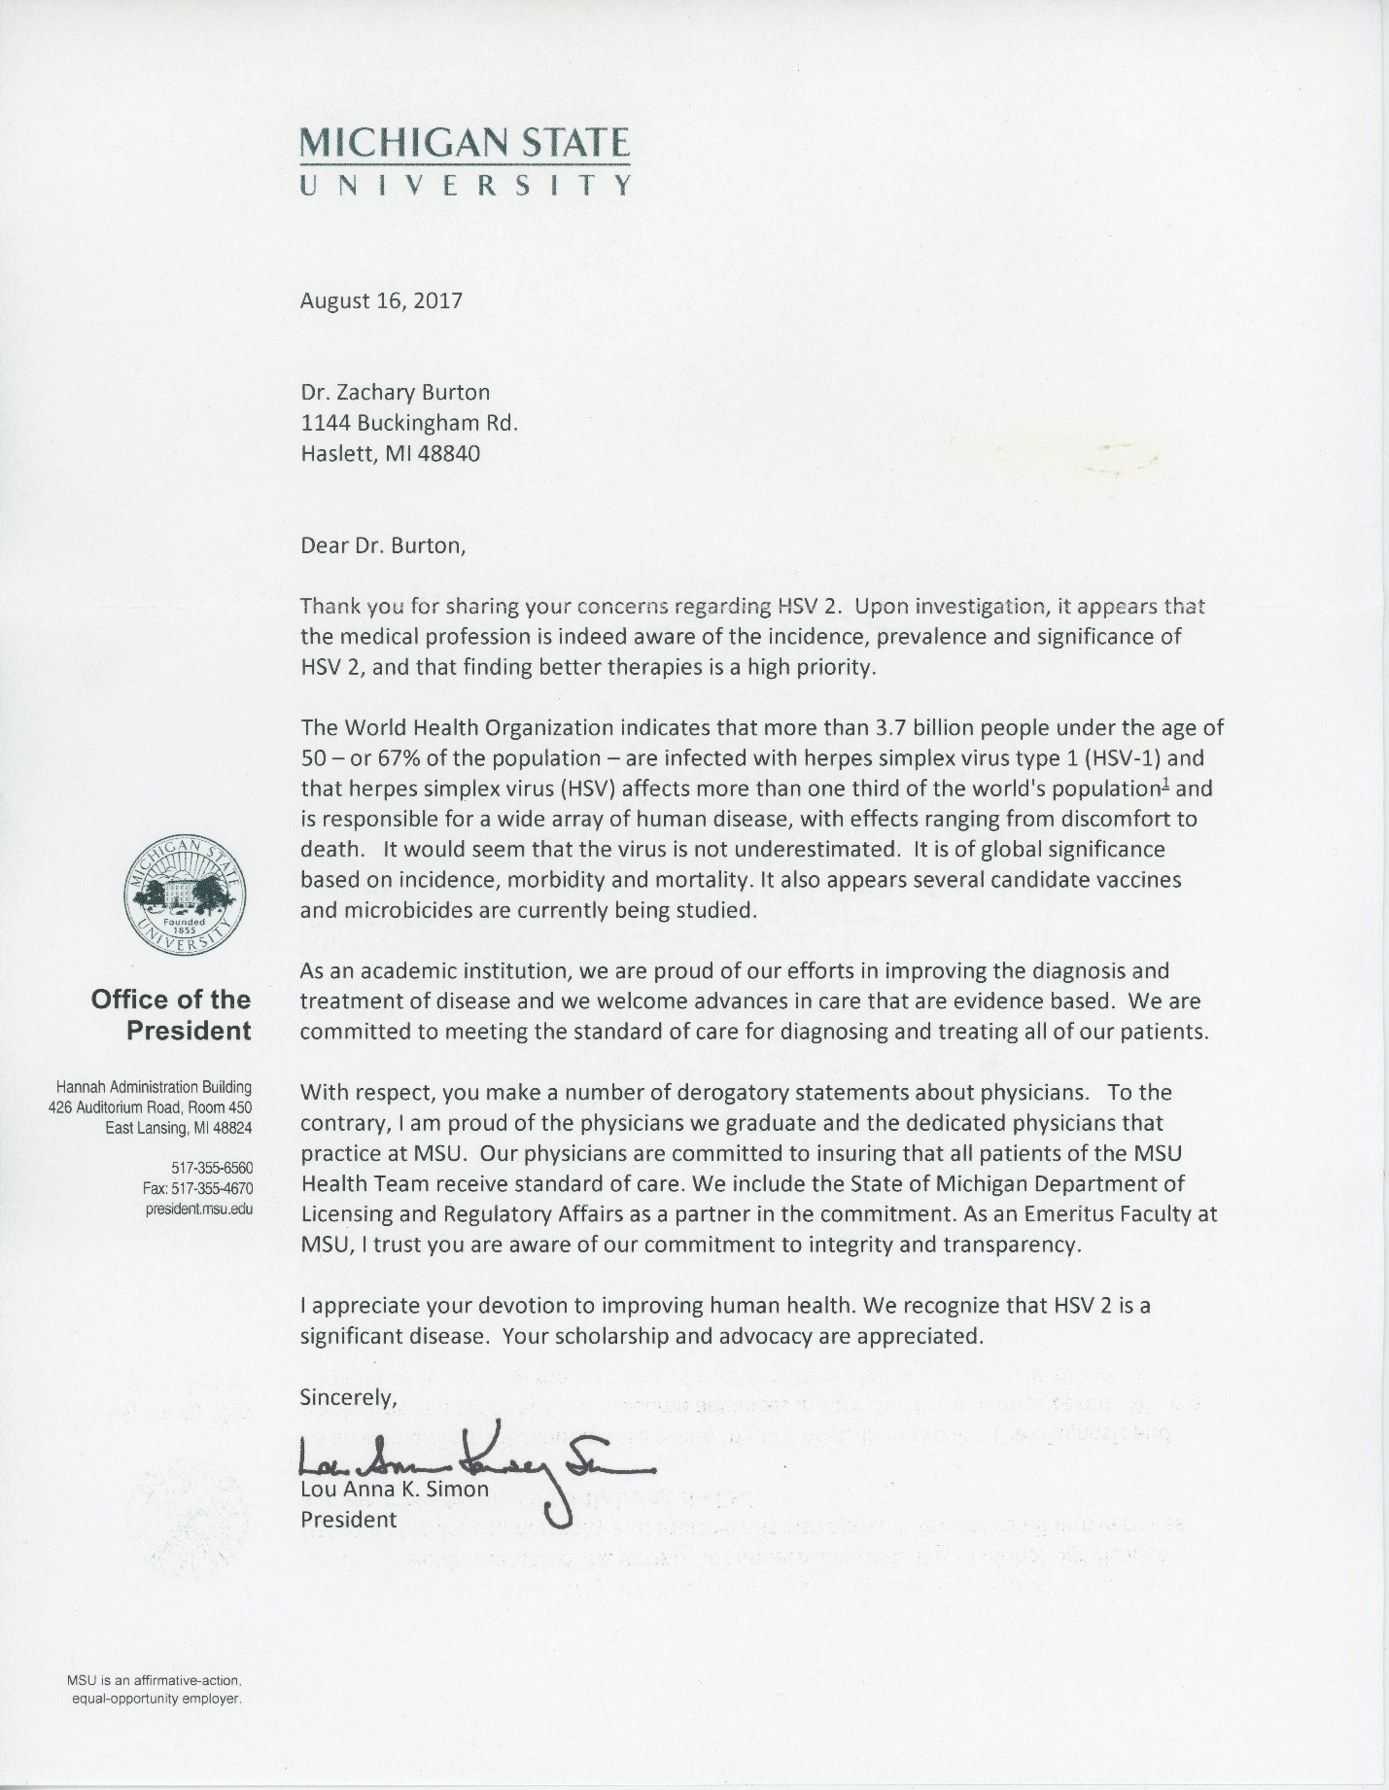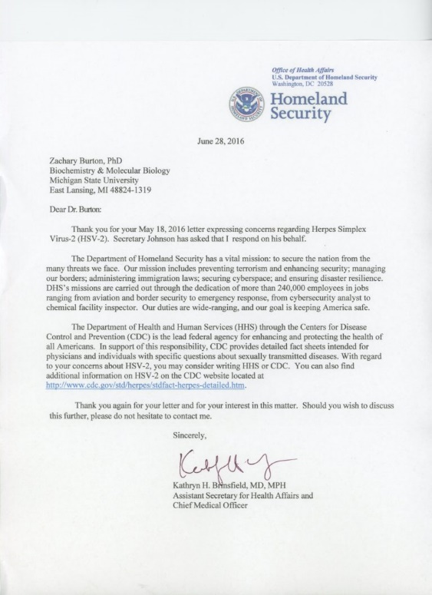

Figure 1. Two letters with regard to oral HSV2 infection.

**References:**

1. Burton ZF. Herpes Simplex Virus Serotype 2 Oral Infection. JSM Biochemistry and Molecular Biology. 2016;3(1):1015.

2. Nimgaonkar VL, Yolken RH, Wang T, Chang CC, McClain L, McDade E, et al. Temporal Cognitive Decline Associated With Exposure to Infectious Agents in a Population-based, Aging Cohort. Alzheimer Dis Assoc Disord. 2016;30(3):216-22.

3. Hall LK. What Happens When a Rape Goes Unreported. New York Times. 2017.

4. Alfonso-Dunn R, Turner AW, Jean Beltran PM, Arbuckle JH, Budayeva HG, Cristea IM, et al. Transcriptional Elongation of HSV Immediate Early Genes by the Super Elongation Complex Drives Lytic Infection and Reactivation from Latency. Cell Host Microbe. 2017;21(4):507-17 e5.

5. Kristie TM. Chromatin Modulation of Herpesvirus Lytic Gene Expression: Managing Nucleosome Density and Heterochromatic Histone Modifications. MBio. 2016;7(1):e00098-16.

6. Cliffe AR, Arbuckle JH, Vogel JL, Geden MJ, Rothbart SB, Cusack CL, et al. Neuronal Stress Pathway Mediating a Histone Methyl/Phospho Switch Is Required for Herpes Simplex Virus Reactivation. Cell Host Microbe. 2015;18(6):649-58.

7. Kristie TM. Dynamic modulation of HSV chromatin drives initiation of infection and provides targets for epigenetic therapies. Virology. 2015;479-480:555-61.

8. Hill JM, Quenelle DC, Cardin RD, Vogel JL, Clement C, Bravo FJ, et al. Inhibition of LSD1 reduces herpesvirus infection, shedding, and recurrence by promoting epigenetic suppression of viral genomes. Sci Transl Med. 2014;6(265):265ra169.

9. Arbuckle JH, Turner AM, Kristie TM. Analysis of HSV Viral Reactivation in Explants of Sensory Neurons. Curr Protoc Microbiol. 2014;35:14E 6 1-21.

10. Turner AM, Arbuckle JH, Kristie TM. Quantitative Analysis of HSV Gene Expression during Lytic Infection. Curr Protoc Microbiol. 2014;35:14E 5 1-27.

11. Arbuckle JH, Kristie TM. Epigenetic repression of herpes simplex virus infection by the nucleosome remodeler CHD3. MBio. 2014;5(1):e01027-13.

12. Vogel JL, Kristie TM. The dynamics of HCF-1 modulation of herpes simplex virus chromatin during initiation of infection. Viruses. 2013;5(5):1272-91.

13. Liang Y, Quenelle D, Vogel JL, Mascaro C, Ortega A, Kristie TM. A novel selective LSD1/KDM1A inhibitor epigenetically blocks herpes simplex virus lytic replication and reactivation from latency. MBio. 2013;4(1):e00558-12.

14. Liang Y, Vogel JL, Arbuckle JH, Rai G, Jadhav A, Simeonov A, et al. Targeting the JMJD2 histone demethylases to epigenetically control herpesvirus infection and reactivation from latency. Sci Transl Med. 2013;5(167):167ra5.

15. Kristie TM. The rise of epigenetic targets for the development of novel antivirals. Expert Rev Anti Infect Ther. 2012;10(12):1359-61.

16. Rai G, Kawamura A, Tumber A, Liang Y, Vogel JL, Arbuckle JH, et al. Discovery of ML324, a JMJD2 demethylase inhibitor with demonstrated antiviral activity. Probe Reports from the NIH Molecular Libraries Program. Bethesda (MD)2010.