Medullary Ischemic Infarction in an Extreme Premature Newborn

Authors : Clara Schori-Fortierª , MD, Corinne Boyerª , MD, Etienne Berard, MD^{a,b},
Sergio Eleni dit Trolli , MD MScª

Affiliations: ª Neonatal Intensive Care Unit Archet II Hospital, Nice Universitary Hospital, Nice ; and ^{b} University of Nice, Nice
Corresponding author: Eleni dit Trolli S, Neonatal Intensive Care Unit, Nice Universitary Hospital Archet II, 151, Route de Saint Antoine de Ginestière, 06200 Nice, France, + 33 4 92 03 64 36, elenidittrolli.s@chu-nice.fr,
Keywords: preterm, ischemic stroke, thoracic spinal cord, flaccid paralysis

Abstract:
A newborn, born at 26 gestational weeks displayed an acute paralysis in his upper body and diaphragm. These symptoms are caused by a medullary infarction, a rare pathology in the premature newborn of undetermined cause.

A premature newborn presented with a sudden acute flaccid paralysis of both arms and diaphragm at 22 days of life. He was born after an uneventful bichorial biamniotic twin pregnancy, by cesarean section after 26 weeks of gestation in tertiary perinatal center in a context of premature rupture of the membranes and failure of tocolytic treatment. He weighed 880 g and clinical examination, including neurologic exam, was normal and coherent with term. He was transferred in the NICU for a respiratory distress syndrome requiring twice an administration of exogenous surfactant and mechanical ventilation assistance. During the first three weeks of life, hemodynamic was stable. He remained under mechanical ventilation because of a patent ductus arteriosus unsuccessfully treated by two courses of Ibuprofen, and progressive bronchodysplasia. All cerebral ultra-sound exams were normal. Suddenly, at 22 days of life, his neurologic examination exhibited an areflexic flaccid paralysis of both arms and neck, disappearance of suction reflex with tongue fasciculations, and absence of spontaneous respiratory movement. Somesthesic sensibility of both arms was preserved, as well as spontaneous mobility of lower limbs. The next day, brain and medullary MRI scan showed a T1 hypersignal from the inferior extremity of bulb to thoracic spine, with an ischemic-hemorragic infarction in the anterior spinal artery territory (figure A and B). Otherwise, the cerebral parenchyma was normal. Hence, the cause of this medullary infarction could not be determined. The child was deceased 4 days after from cardio-respiratory failure. His sister had an uneventful development.
To our knowledge, only 2 cases of infarction in low cervical spinal cord have been reported in term newborns. First child could not be weaned from the ventilator, and a tracheostomy was performed at 2 months of age, he deceased when 5 months old. Second child was discharged from the hospital on nasal oxygen at 6 weeks complicated when 4 months old by an acute respiratory failure. The baby died just before age 5 months The autopsy revealed damages within the anterior and posterior spinal artery such as pseudo-calcification, peri-vascular fibrosis and sclerosis or an obliteration of specific vessels(1).
Some publications report on such pathology in other localisation yet in the context of arterial hypotension (2), perinatal anoxo-ischemia(3). In another case, lower medullar lumbar infarction was related to the use of umbilical arterial catheter and obstruction of the Adamkievicz’s artery (4). In our observation, vascular steal in ascendant aorta caused by patent ductus arteriosus could be advocated for the medullary infarction.
This research provides a framework for the exploration of this rare lethal pathology in newborn. Medullary infarction must be considered facing a flaccid paralysis of both arms associated with diaphragmatic paralysis. Such clinical presentation needs a cerebro-spinal MRI to exclude other treatable etiologies of spinal cord lesions
References:
1. de León GA, Radkowski MA, Crawford SE, Swisher CN, Uzoaru I, de León W. Persistent Respiratory Failure Due to Low Cervical Cord Infarction in Newborn Babies. J Child Neurol. 1995;10(3):200–4.
2. Sladky J, Rorke L. Perinatal Hypoxic/Ischemic Spinal Cord Injury. Fetal Pediatr Pathol. 1986;6(1):87.
3. Clancy RR, Sladky JT, Rorke LB. Hypoxic-ischemic spinal cord injury following perinatal asphyxia. Ann Neurol. 1989;25(2):185–189.
4. Haldeman S, Fowler GW, Ashwal S, Schneider S. Acute flaccid neonatal paraplegia: A case report. Neurology. 1983;33(1):93–93.

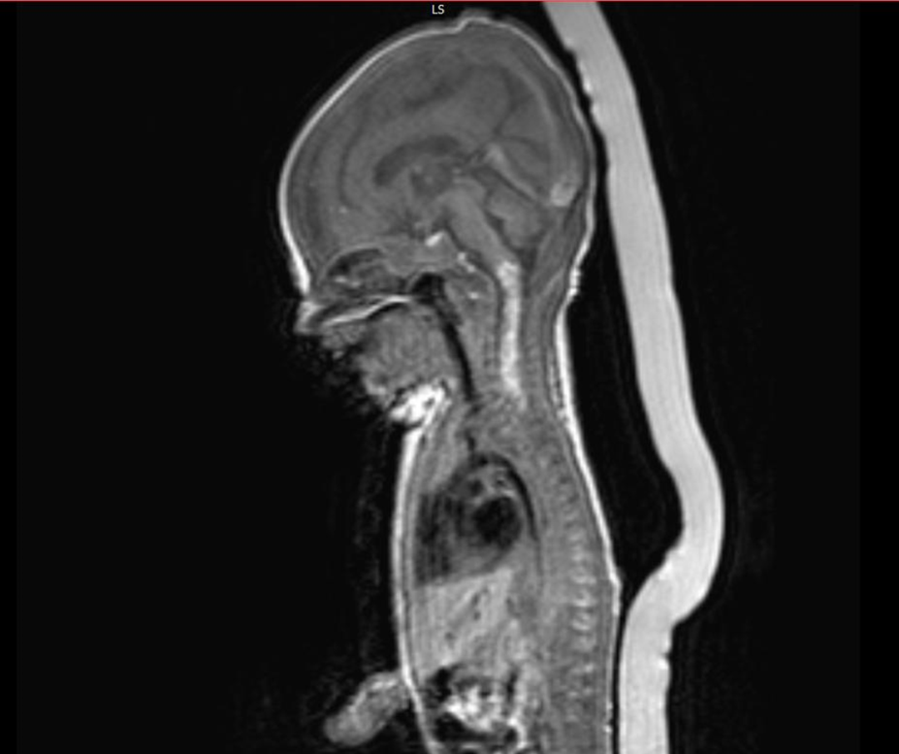
Figure 1: Cerebro-spinal MRI (sagittal plan): T1 hypersignal of the inferior extremity of bulb to thoracic spine.
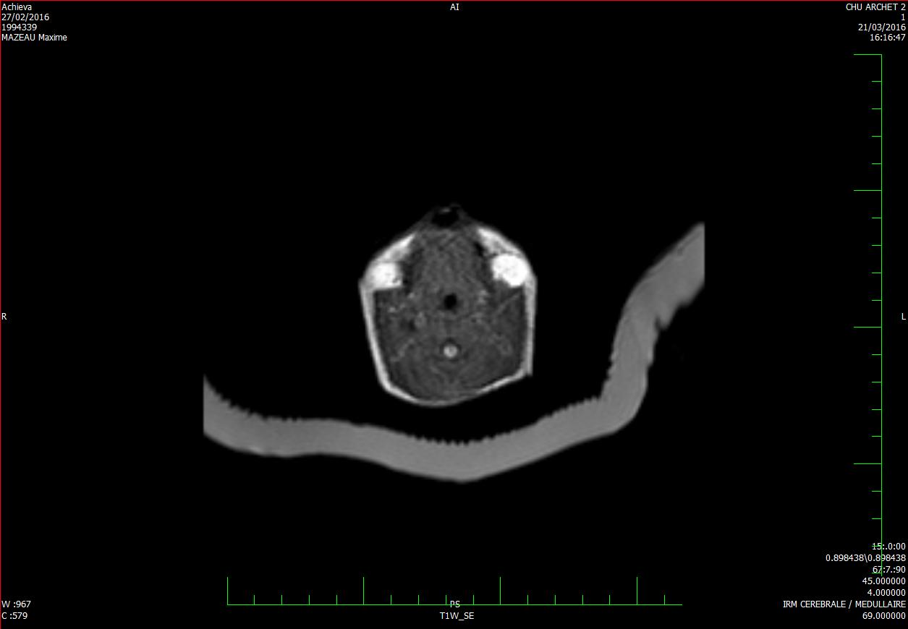
Figure 2: Cerebro-spinal MRI (transverse plane): T1 hypersignal of the bulb

