While fairly complete and reliable incident data on childhood cancers are available from the registries in India, mortality and survival information is not. Information concerning the latter was obtained by the Bangalore cancer registry through active follow-up involving visits to homes of patients. Between 1982 and 1989, 617 cases of cancers in childhood were registered, giving an age-standardized incidence rate of 84.8 and 48.4 per million in male and female children, respectively. Active follow-up provided mortality/survival information in 532 or 86.2 percent of these cases. Overall, observed five-year survival was 36.8 percent (both genders combined) with a relative survival of 37.5 percent when childhood mortality in the general population was taken into account. The five-year relative survival was best for thyroid carcinoma (100 percent) followed by Hodgkin's disease (73 percent) and retinoblastoma (72.9 percent). Survival was comparatively low, being 9.9 percent in acute nonlymphatic leukemia and less than 20 percent in rhabdomyosarcoma and the category grouped as ‘other malignant neoplasms.’ Survival in Hodgkin's disease was influenced by clinical stage at presentation, but was not statistically significant possibly due to small numbers.

**Number of New Cases and Deaths per 100,000:** The number of new cases of leukemia was 13.5 per 100,000 men and women per year. The number of deaths was 6.9 per 100,000 men and women per year. These rates are age-adjusted and based on 2009-2013 cases and deaths.

**Lifetime Risk of Developing Cancer**: Approximately 1.5 percent of men and women will be diagnosed with leukemia at some point during their lifetime, based on 2011-2013 data

Compared to other cancers, leukemia is fairly common.

|  | **Common Types of Cancer** | **Estimated New Cases 2016** | **Estimated Deaths 2016** |
| --- | --- | --- | --- |
| 1. | Breast Cancer (Female) | 246,660 | 40,450 |
| 2. | Lung and Bronchus Cancer | 224,390 | 158,080 |
| 3. | Prostate Cancer | 180,890 | 26,120 |
| 4. | Colon and Rectum Cancer | 134,490 | 49,190 |
| 5. | Bladder Cancer | 76,960 | 16,390 |
| 6. | Melanoma of the Skin | 76,380 | 10,130 |
| 7. | Non-Hodgkin Lymphoma | 72,580 | 20,150 |
| 8. | Thyroid Cancer | 64,300 | 1,980 |
| 9. | Kidney and Renal Pelvis Cancer | 62,700 | 14,240 |
| 10. | Leukemia | 60,140 | 24,400 |

Leukemia represents 3.6% of all new cancer cases in the U.S.



**3.6%**

In 2016, it is estimated that there will be 60,140 new cases of leukemia and an estimated 24,400 people will die of this 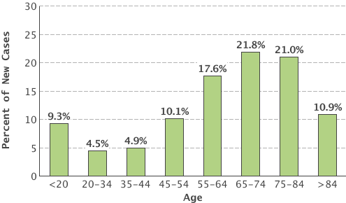disease.

National cancer institute survivellance and epi and end program data